1.6: Understanding the Problem

#### **Introduction**

Welcome back! In the last Exercise, we took a closer look at Design Thinking, its history, and the many ways in which we can apply the Design Thinking Process to our own products in order to form a more perfect user experience. We’ve discussed in detail the process used in finding the best possible solution to a problem, which means it’s now time to flip the coin and focus on the process involved in comprehending a problem. Only by understanding a problem and its every intricacy will you be able to craft a solid solution strategy.

Keep in mind that this isn’t a one-and-done process—you can’t follow these steps, then simply forget about it. Strategies are constantly evolving based on new research and changes in the industry. It’s also good to note that product-focused strategies, as opposed to solution- and user-focused strategies, can easily become stale. The goal of a strategy is, in essence, to predict the future, and that’s no easy task. There are many different factors that could come into play and affect the outcome. Luckily for us, however, designers have tools that make understanding the problem just a bit easier and that can help our strategies evolve according to the situation.

In this Exercise, we’ll start by looking at what it takes to properly define a problem. We’ll also introduce the **demo project** for this course, which you can use as a guide as you begin working on your own project.

TIP!  
If you haven’t made a decision yet on which course project to tackle, this is the place to do so. Many of the upcoming Tasks will tie directly into work for your project. Talk to your Tutor or Mentor if you’re still having trouble deciding.

#### **Defining the Problem**

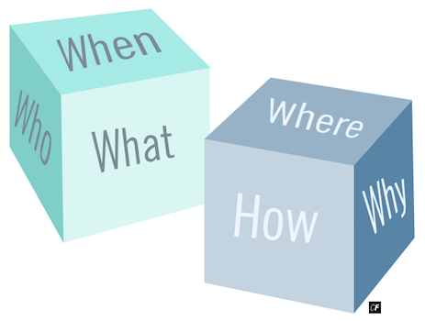

In order to design a product that solves a problem, it’s important to first define the problem, and doing so in the simplest terms possible will enable you to more easily engineer solutions that work. Before diving headfirst into your design process, try asking yourself some of the following basic questions to begin isolating and defining the core problem you want to address.

In UX Fundamentals, there were a few big steps you took prior to crafting the problem statement. In other types of UX processes or in different contexts, you may find different methods. All are correct. One may simply be more appropriate depending on the circumstance, time constraints, or budget.

In later Exercises, after you've conducted your interviews and created your personas, you should revisit your problem statement. Did you validate or invalidate any hypotheses? Were any results surprising?

##### **What Is the Business Objective?**

The **business objective** has everything to do with your client and their stakeholders. **Stakeholders** are individuals who may affect or be affected by any decisions made during a project and can include anyone from the CEO to customer service agents.

What is it they want to achieve with this product? What is their main goal? Their mission?

Let’s use the course demo project as an example. The project in question is a travel app that provides user-submitted travel recommendations for local spots as opposed to the typical touristy fare. As a designer, we must first recognize that travel apps are nothing new. A quick Google or App Store search alone will produce hundreds of results. This, in itself, is not a bad thing. In fact, most new products don’t create brand new markets. Rather, they improve on existing ones.

The main question, then, is how we can improve on a market already rife with established players such as Lonely Planet, TripAdvisor, and Yelp, among others. To answer that question, however, we need to ask ourselves other questions. Questions are key in obtaining answers, after all.

One of the first questions we might ask ourselves is:

What do travelers think of the current travel guides on the market?

The answer to this question could give us our first hint as to whether there’s a problem that needs to be solved. You may find that most travelers who use Lonely Planet or TripAdvisor are perfectly happy with their results. You may also find, however, that travelers are tired of the typical tourist spots recommended by these guides and would prefer lesser-known spots more popular with the locals.

By researching our product’s competitors, we can identify opportunities for creating solutions to problems that users encounter with existing products or services—in this case, travel guides. This, in turn, helps us to shape our business objectives, turning our focus towards ways in which the business could achieve success by taking advantage of weaknesses in existing products.

It’s important, however, to ensure that business objectives are closely aligned with user goals. For example, if a user goal for travel guides is to find lesser-known spots away from the touristy sites, a business objective of getting users to sign up for newsletters about the most popular tourist hotspots would likely fail as this doesn’t align with the goals that users want to achieve.

PRODUCT VS. SERVICE  
It’s important that you understand the distinction between a product and a service. A service provides an intangible benefit to a customer and is often a significant element of a tangible product. Adobe Photoshop, for example, is a product, but Adobe offers access to it as part of their “Creative Cloud” service, a monthly subscription to the software. That being said, the line between a product and a service isn’t always cut and dry, especially when it comes to digital products. Instagram’s product, for example, is a mobile app, but it’s also classified as a photo-sharing service.

It’s doubly important that you understand the distinction between a product and a service when it comes to identifying a problem. Is the problem you’re trying to solve related to a product? Or is it related to a service? It could also be that your problem relates to a bit of both!

Once you’re able to answer your initial question—“What do travelers think of the current travel guides on the market?”—predicting the future becomes just a little bit easier. By understanding our potential users’ problem, we can better predict if we’ll be able to solve that problem, which is key if we want to develop a product that not only works, but sells.

##### **In What Context Will This Product Be Used?**

This next question is where we answer the what, where, why, when, and how of our product or service. Imagine we’ve conducted user research to uncover insights about existing travel guides and are now ready to go ahead and build a prototype of the travel guide app. Here are some potential answers we may have uncovered to these questions:

**What is the product?**

* A service where travelers can find city guides and recommendations written by locals rather than organizations and large travel agencies.

**Where will it be used?**

* In transit. It would probably be most useful as a mobile app.

**Why would someone use your product?**

* They’re tired of seeing the same, tired sights and dining at the same, overpriced (and oftentimes overhyped) restaurants as everyone else. They want to live and experience the city like a local.

**When will this product be used?**

* Anytime someone is looking for off-the-beaten-path, local places (as opposed to overpriced, overcrowded tourist spots).

**How will this product be used?**

* Browsable, downloadable guides complete with maps and directions that can be opened on a user’s mobile device (with or without wifi).

Answering these questions takes us yet another step closer to understanding the problem we’re trying to solve and crafting a viable solution.

##### **What Are the User Goals?**

Now that we’ve uncovered the main needs of the business, we need to look at the needs of the users themselves. Business stakeholders can often be biased, so finding alignment between these two sets of needs is key. As a UX designer, you’ll often find yourself acting as a sort of liaison between businesses and users.

Let’s take a look at a few different methods you can use to uncover users’ goals and needs:

* **Surveys:** Ask your potential users travel-related questions to find out more about their needs as travelers.
* **Prototyping:** Create a basic prototype and gather feedback on how people are using it.
* **Competitive Analysis:** Take a look at other services similar to your own and try to identify any shortcomings or issues. This is where it really helps to be a potential user of your own product!

With those three overarching questions out of the way, you should now have enough information to begin formulating your problem statement, a statement that will provide you with a solid foundation for moving towards a solution.

#### **Using the Double Diamond Strategy**

A solution can’t exist without a problem. This is why it’s essential that you identify your problem before attempting to craft a solution. In order to use the information we’ve obtained via the above questions and create a problem statement that will concisely and accurately define our problem, we’ll be using a method known as the **Double Diamond Strategy**.

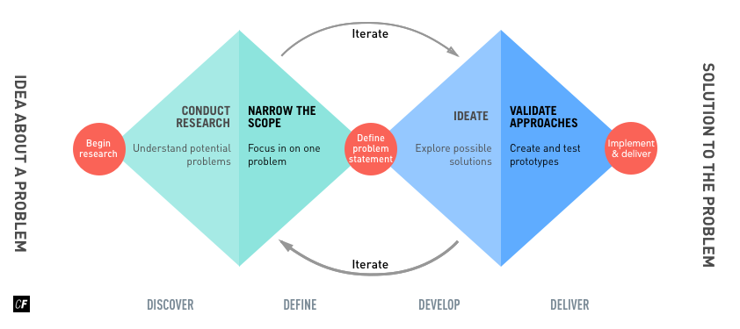

###### [**Click here**](https://s3.amazonaws.com/coach-courses-us/public/courses/ux-immersion/A1/E6/A1E6_doublediamondstrategy.png)**to zoom in**

The Double Diamond Strategy removes bias from the strategization process. It’s easy as a designer to focus in too closely on a particular product or idea rather than keep our focus wide and our eyes open to ideas. The Double Diamond Strategy helps us avoid this pitfall and come up with the best possible solution to a problem.

You’ll notice that the strategy starts with understanding. We’ve already taken steps to understand the problem by asking questions to uncover user frustrations and needs. From here, we need to define the problem via a **problem statement**. You may remember talking about problem statements in UX Fundamentals, where you saw them in this format:

[The name of your proto-persona]  
**needs a way to** [user’s need]  
**because** [insight].  
We will know this to be true when we see [this quantitative / qualitative measure].

The Double Diamond Strategy was created by the British Design Council and is used to map the divergent and convergent stages of the design process: Discover, Define, Deliver, and Develop. Why don’t we take a moment to dig deeper into each stage of the process?

##### **Discover**

The left side of the first diamond is where you discover and decipher what it is you’re trying to achieve. This often starts with some sort of initial inspiration or ideation phase and can include a number of market, user, and design research methods that will help define the problem you’re trying to solve.

##### **Define**

In this stage, discoveries from the first section are refined and turned into a well-defined problem statement that can then be translated into concrete business and user objectives. Think of the discover phase as being more about high-level thinking and brainstorming, while the define stage is more about setting concrete, lower-level business and user goals.

##### **Develop**

In this phase, you take the problem you'd like to solve, along with the business and user goals, and explore all the possible solutions that might meet both user and business goals. Once you identify a possible solution, it’s time to start creating prototypes that can be put in front of real or potential users for testing in order to gain insights into how well the product actually solves users’ problems and meets business goals.

##### **Deliver**

Once designs have been iterated upon based on feedback obtained during user testing, your product or service is finalized and launched into its corresponding market. Some common activities in this phase include final testing, approval and launch, targeting, evaluation, and feedback loops.

##### **Benefits of Using the Double Diamond Strategy**

The Double Diamond strategy helps bring structure to the problem-solution cycle, making it easier to define problems and identify solutions. In the first phases of understanding the problem, it can be surprisingly easy to lose focus. At this point, there are still countless directions the project could veer, and narrowing down to even a few can seem a daunting task indeed. This can create opportunities for distractions and tangents, which only waste valuable team time.

This is where the Double Diamond Strategy really shines. It allows for divergent thinking while still providing structure to keep teams on track. Upon reaching the next phase, this thinking converges back together and is turned into practical business requirements. What was once a hectic, chaotic process becomes organized and efficient.

Want a glimpse of the Double Diamond Strategy in action? Check out the video below, where Claire, your video instructor, uses the Double Diamond Strategy to better understand the underlying problem she needs to solve with her new app.

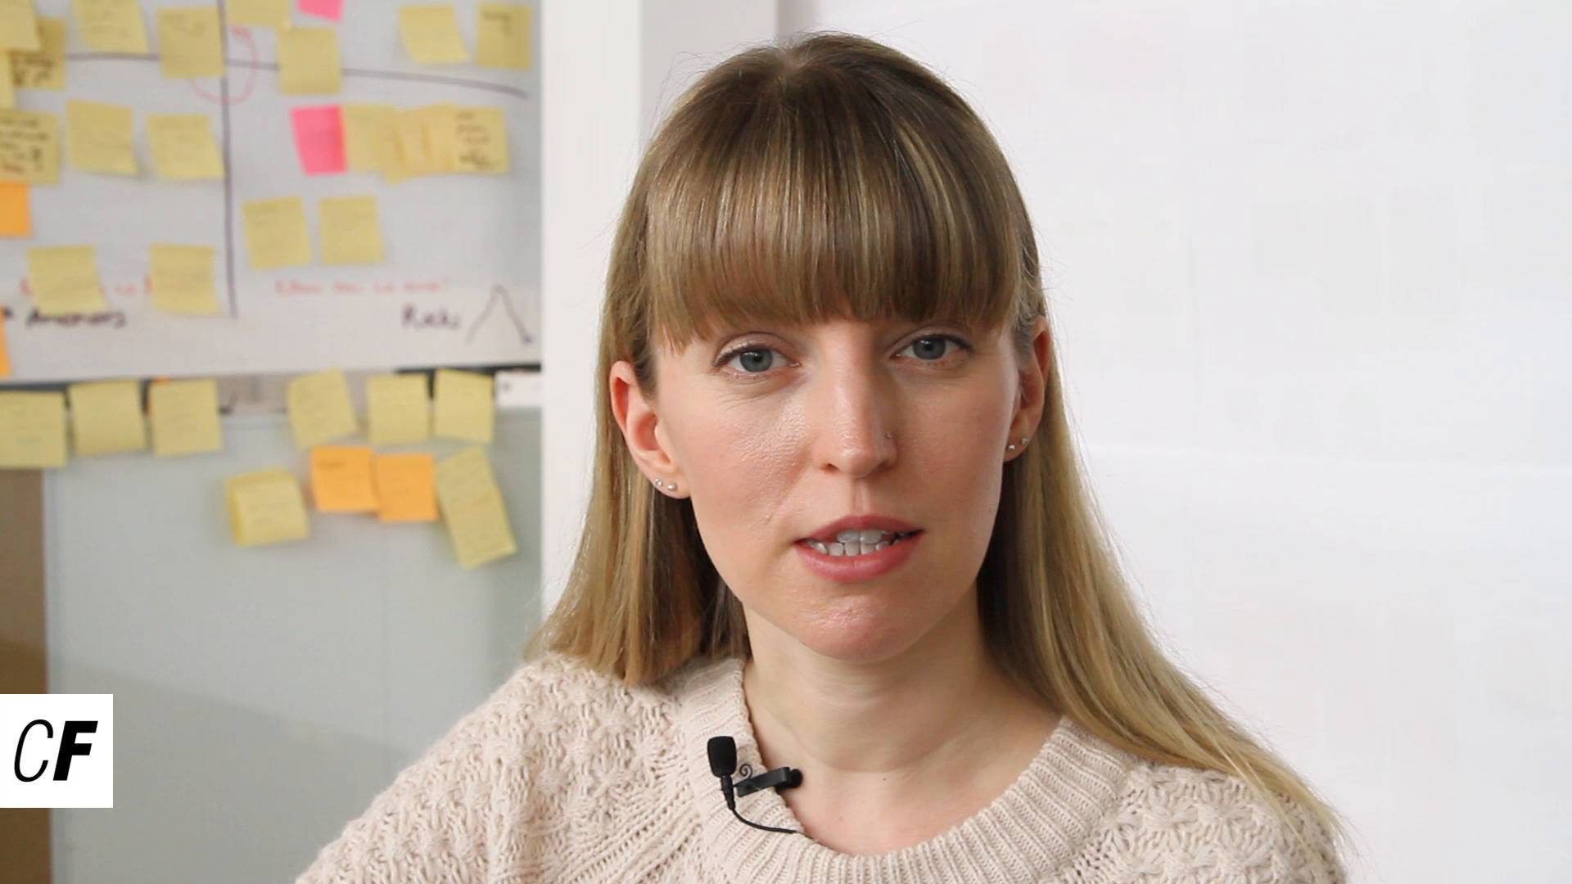

#### **Summary**

In this Exercise, we focused on problems. From defining a problem to finding solutions for a problem, it’s essential that UX designers (and teams) don’t get sidetracked. This is where processes and procedures that steer the Design Thinking Process in the right direction come in handy. Asking yourself basic questions regarding the project, its goals, and the current market can help you be more informed when it comes to defining the problem, which is exactly what you’ll do using the Double Diamond Strategy, a process that compartmentalizes each phase in the problem-solution cycle and ensures design teams stay aligned throughout the process.

Now that you have a good understanding of these concepts, let’s put them to use!

#### **Resources**

Before moving onto the Task for this Exercise, be sure to download the following template. We’ve already filled it in based on the course demo project to give you an idea of what it should look like.

* [Double Diamond Strategy Template](https://s3.amazonaws.com/coach-courses-us/public/courses/ux-immersion/A1/E6/A1E6_problemstatementtemplate.pdf)
* [Double Diamond Strategy for Course Demo Project](https://s3.amazonaws.com/coach-courses-us/public/courses/ux-immersion/A1/E6/A1E6_demoprojectexample.pdf)