1.7: Competitive Analysis

#### **Introduction**

Great to have you back! In the last Exercise, we talked about the importance of concretely identifying a problem before deciding on a solution. We looked at how to craft a problem statement that outlines the problem while also addressing the gap you’ve found in the market. You also learned about the Double Diamond Strategy and how it provides a framework for, first, understanding the problem, and then, designing a solution for it.

In this Exercise, we’re going to provide you with a new tool to add to your UX toolbox—competitive analysis. In UX Fundamentals, you did a very basic version of this analysis when you looked at the positive and negative features of competing vocabulary and flashcard apps. Now, let’s dig much deeper into what a competitive analysis is and how to do one. You’ll find competitive analyses to be extremely useful when designing a solution to a problem. They’re usually performed before any mockups, wireframes, or user flows have been created, and they help you take a good look at your future marketplace to give yourself a one-up on your competitors.

Let’s go ahead and dive right in with an in-depth discussion on just what a competitive analysis entails and how you can conduct your own competitive analysis to help guide your designs.

TIP!  
As you read through the information and instructions in this Exercise, refer to the [competitive analysis](https://s3.amazonaws.com/coach-courses-us/public/courses/ux-immersion/A1/E7/1.7TriposoCompetitiveAnalysis.pdf) we prepared for our demo app. Reading the description in the Exercise and seeing each part in use in our example will strengthen your understanding.

#### **What Is a Competitive Analysis?**

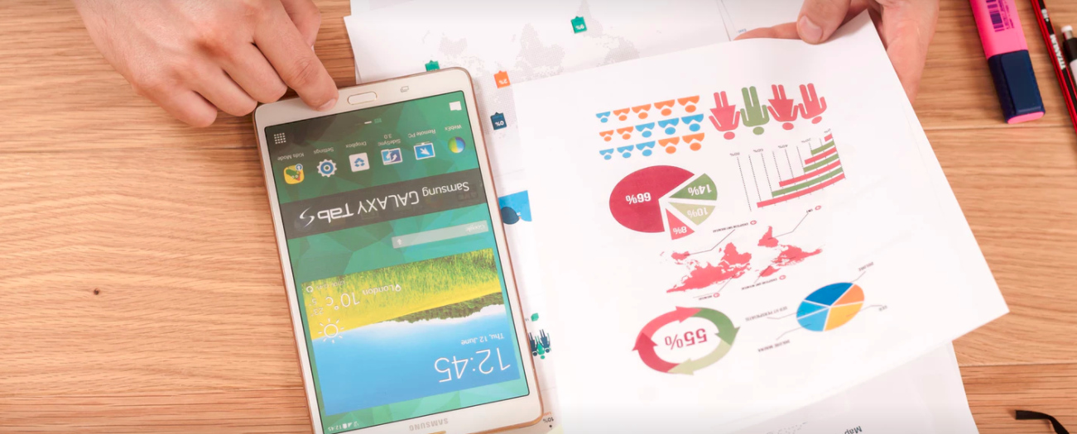

A **competitive analysis**, also referred to as a competitor analysis, is a tool that can be used to assess how competitors to your app or website design for their users. Getting to know the key competitors in the market can help you to get an idea of what users might expect from your website or app, which of your competitors are doing a good job at solving user problems (and which aren’t), and opportunities to meet an unfulfilled user need.

A good competitive analysis can help you:

* Identify underserved opportunities in the market
* Spot weaknesses in a competitor’s user experience and use this to your advantage to outperform them
* Develop a marketing strategy that makes your product stand-out against competitor offerings
* Make better-informed decisions about your overall strategy to ensure you can create sustainable competitive advantages

#### **Performing a Competitive Analysis**

The first step in performing a competitive analysis is identifying your competitors. These will be apps or services operating within or close to your space. In the previous Exercise, for example, we identified Lonely Planet, TripAdvisor, and Yelp as potential competitors of our demo app.

Keep the following questions in mind as you create your list of competitors:

* What are they selling?
* What are they communicating through their product?
* What are they missing in their messaging, product, and overall offering?

Now that we’ve identified our competitors, it’s time to walk through their software and make note of any issues you see within their user experience. Pay particular attention to stumbling blocks and points of frustration. Are there any aspects that could be simplified or drastically improved? Are there any smart or useful design patterns you could borrow for your own design? This is a good opportunity to look for market insights, as well. Are there ways your competitors aren’t properly supporting their users? Perhaps they’re missing a key feature, or perhaps they have too many features!

TIP!  
To ensure your competitive analysis is valid, try aiming for at least five to ten competitors. In this course, we’ll only ask you to focus on two (due to the scope and fast-paced nature of the course); however, if you have extra time, feel free to examine more competitors.

##### **Building a Competitor Profile**

**Overview**

A good competitor profile should begin with an overview that touches on three aspects—the competitor's key objectives, their overall strategy, and their market advantage.

* **Key Objectives:** A competitor's core message, the way in which they present themselves, and how they claim to set themselves apart from the competition
* **Overall Strategy:** A competitor's business strategy, the way in which they attract customers, and how they position themselves against other companies in their industry
* **Market Advantage:** What it is that makes a competitor better, faster, stronger, and/or more unique than the competition

Before moving on, try and determine the competitor's greatest asset. It could be an innovative design, the speed of the application, the user experience, or something completely different!

**Marketing Profile**

Once you've completed your overview, you'll want to find out as much as you can about a competitor's target market—their existing clients and what they have in common with each other—and their current marketing strategies (what a competitor does to make itself known to users).

Specifically, look at how the competitor markets itself. Do they advertise online? Try identifying what tools and social networks they use, as well as what practices they’ve put in place. If they have a blog, check what types of articles they write and where they focus their marketing efforts. Find out if and how they use Google ads, Facebook ads, and online marketing.

**SWOT Profile**

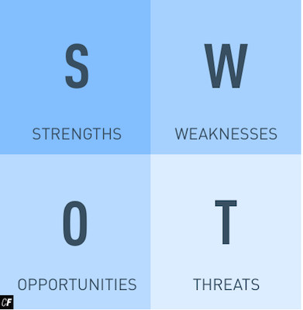

**SWOT** stands for strengths, weaknesses, opportunities, and threats. You'll want to fully analyze each of these aspects for your competitor profile.

* **Strengths:** The competitor's biggest strengths and what makes them special
* **Weaknesses:** The competitor's biggest weaknesses (price, poor design execution, complexity, low usability, etc.)
* **Opportunities:** A gap in the competitor's product or offerings that could be filled by your product
* **Threats:** An outside threat the competitor might be facing (for example, another more established competitor with a larger, more active community)

In the image below, you can view the SWOT profile we prepared for our demo travel app.

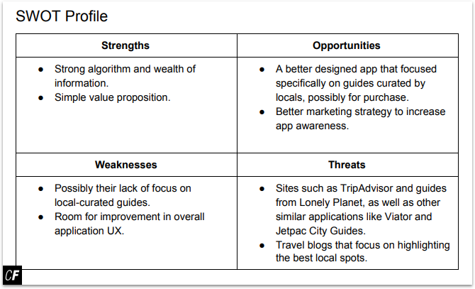

###### **From our**[**demo competitive analysis**](https://s3.amazonaws.com/coach-courses-us/public/courses/ux-immersion/A1/E7/1.7TriposoCompetitiveAnalysis.pdf)

By this point, you should have a good feel for your competitor’s product, as well as its surrounding market. Perhaps you already have some promising ideas on how your own product can outperform or satisfy a different function. From here, we'll be able to dive even further into specifics and take a look at factors such as user experience and content.

#### **Performing a UX Competitive Analysis**

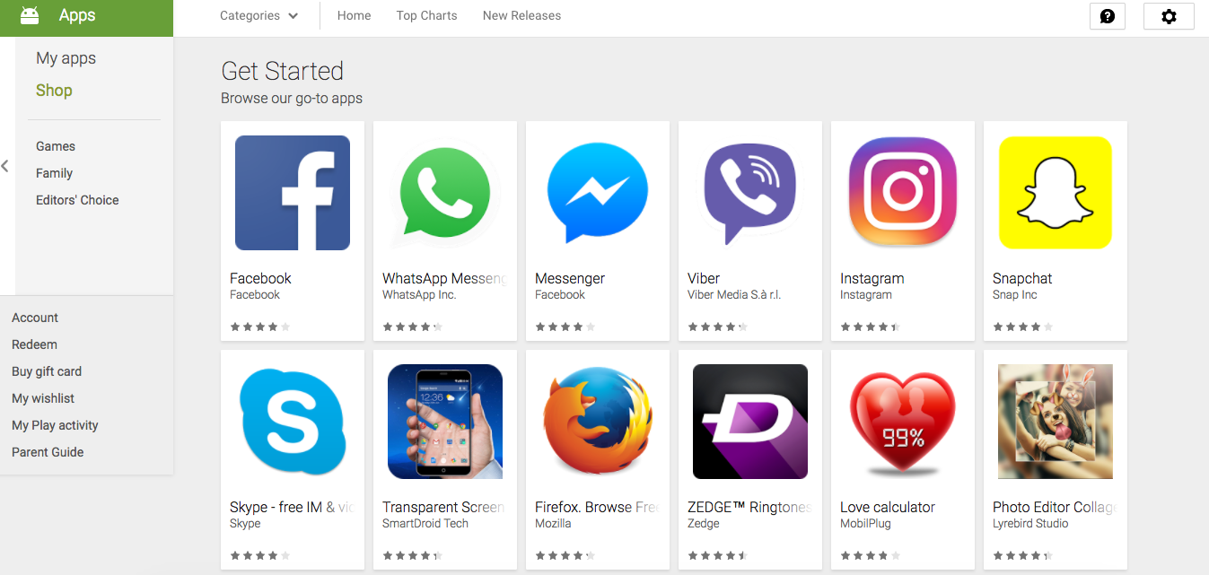

“If a man can write a better book, preach a better sermon, or make a better mousetrap than his neighbor, you will find a broad hard-beaten road to his house, though it be in the woods.”  
RALPH WALDO EMERSON

Now that you understand the basics of a marketing analysis, let’s talk about conducting a UX-focused competitive analysis. Ineffective UX (also known as bad UX) can mean the difference between the success and failure of your app. Identifying elements of ineffective UX in other businesses’ apps can allow you to improve on these issues within your own design and avoid making the same mistakes.

Instead of analyzing the market and how the product satisfies the market’s needs, let’s look more specifically at the user experience that the product provides and see where it’s lacking. Take one of the competitor profiles you made for your top competitors and analyze each of the following categories in detail. Keep in mind that the goal here is to find actionable snippets of information you can use to create a better product than your competitor.

* **Usability:** The ease with which you can interact with, navigate through, and find information via the interface
* **Layout:** The ease with which you understand the overall design, individual pages, and structure of the app or site
* **Navigation Structure:** The logic of the app's user flow and navigation structure (similar to usability, but with a greater focus on search engine optimization—how a search engine ranks your page in search queries). For example, is the home menu easy to find? Are the menu options organized logically? Did you struggle to find any particular page or function?
* **Compatibility:** The behavior and response of the app across devices (phones, tablets, computers), operating systems, and browsers (e.g., PC vs. Mac, Internet Explorer vs. Google Chrome). Does the product still work if you switch between browsers and devices? What operating systems do they support? Maybe there’s a chance to steal customers who aren’t supported!
* **Differentiation:** This portion of your competitive analysis works similarly to a summary. This is where you pull together the observations you've made regarding what makes the competitor unique to other apps on the market. Additionally, you'll want to add some suggestions on how you might position your own app ahead of the game based on your observations of what they may lack. This is a great place for you to draw out specific, actionable points.
* **Calls to Action:** Sign-up forms and contact forms where users can purchase a product, sign up for a service, or receive more information. Are they easy to find? Is it clear to you (or any other user) where you’ll be taken after submitting the form?

Keep in mind that this isn’t strictly a step-by-step process; it’s more about analyzing various UX aspects of a product or website and documenting and organizing your findings. Pay additional attention to your general impression of the overall design. Do you find yourself getting frustrated often? Does the interface feel cluttered? Too sparse? Is the atmosphere something you'd enjoy coming back to again and again or would you come to dread it? Be sure to take good notes!

##### **Analogous Inspiration**

A standard competitive analysis relies on examining similar products and services. An **analogous analysis** (say that five times fast!), on the other hand, attempts to draw inspiration from unlikely sources that might be completely unrelated to your business.

In the case of our travel app, one unlikely source of inspiration could be social networks. We’re not trying to build the next Facebook or Twitter, but there could be UX patterns within these services we can repurpose for our own app. Facebook, for example, offers instant chat between friends. Perhaps we could offer a similar chat between guide creators and their travelers. This would be a great way to get no-nonsense advice from a local!

An analogous analysis can open you up to ideas you might never have come across otherwise.

TRY IT!  
After spending so much time thinking about your competitors, take a break by conducting an analogous analysis and identifying a few “unlikely” sources of inspiration. Share your findings on Slack or in the communications sidebar.

#### **Summary**

In this Exercise, we discussed what a competitive analysis is and outlined the specific steps you can take to perform one for your own project. We also talked about how an analysis can give you clues and insights into what might resonate better with users in a certain market—teaching you how to build a better mousetrap, as it were. The value of competitive and UX analyses can’t be understated, and they’re one of the first key steps in planning a successful design.

With these lessons in mind, it’s time to conduct your very own competitive analysis.

#### **Resources**

* [How to Check Out the Competition](http://www.uxbooth.com/articles/how-to-check-out-the-competition/)
* [How to Conduct Competitive Research](https://www.inc.com/guides/2010/05/conducting-competitive-research.html)