3.3: Navigation for Mobile & Desktop

Learning Goals

Implement navigation for mobile and desktop apps

 Estimated Read Time: 30 Minutes.

Introduction

Welcome back! In Exercise 3.2, you looked at the pros and cons of card sorting before working on refining the sitemap of your app. Now that you have a polished sitemap, it's time to take a look at how information architecture can help inform a common yet very important element of user interface and its own design patterns: navigation.

Navigation is one of the most important aspects of UX design. After all, it’s what enables a user to get from point A to point B in an app! Without it, users would be lost before they even got started. Navigation comes with its own unique set of patterns and heuristics that, if not properly followed, can result in confused, frustrated users. Let’s take a look at a few real-life examples of navigation.

Navigation Patterns: Desktop vs. Mobile

Take a few moments to consider and visualize an application that you frequently use. When you think of navigating the app, what pops into your head? Something like this, perhaps?



Or something like this?

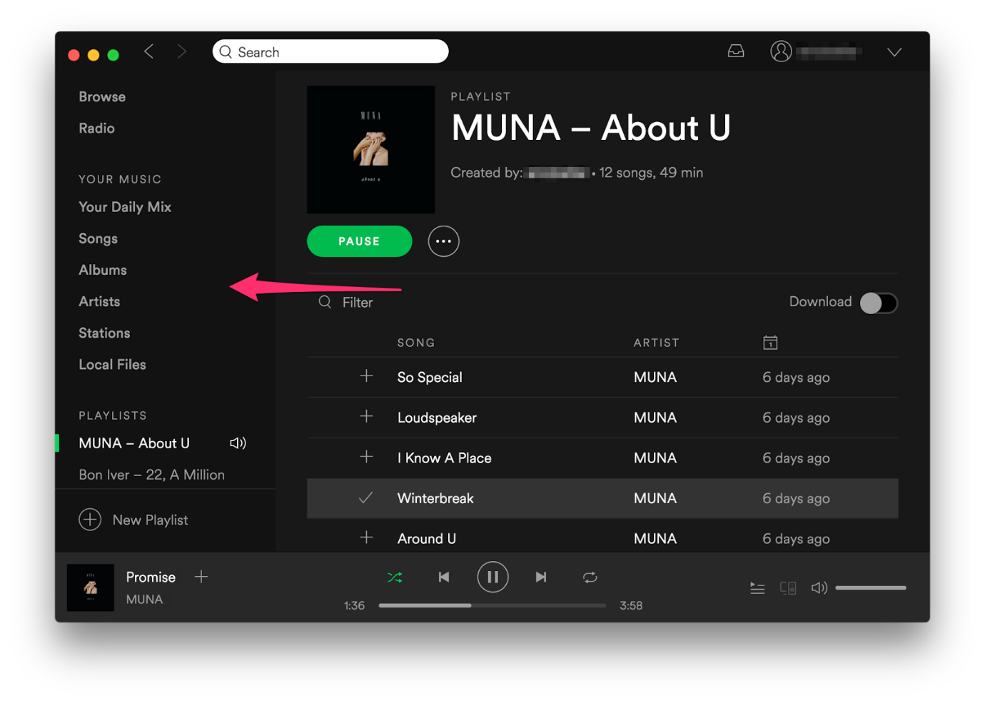

Both are perfectly viable solutions! Like most things in UX design, however, there’s a lot more to them than meets the eye. In Exercise 3.4: Usability Heuristics & Interaction Design, we'll look at the most common usability heuristics that can be applied to your entire application. In this Exercise, however, we'll be talking about heuristics focused solely on navigation. Abiding by these heuristics will ensure your navigation is intuitive and easy to use.

**Navigation patterns** are reusable and well-known solutions to usability problems that are specific to navigation. They also change drastically based on the platform. Let's take a look at our Spotify example again. Notice that, while general sections and features are present in both mobile and desktop versions, the method for *accessing* them is completely different?

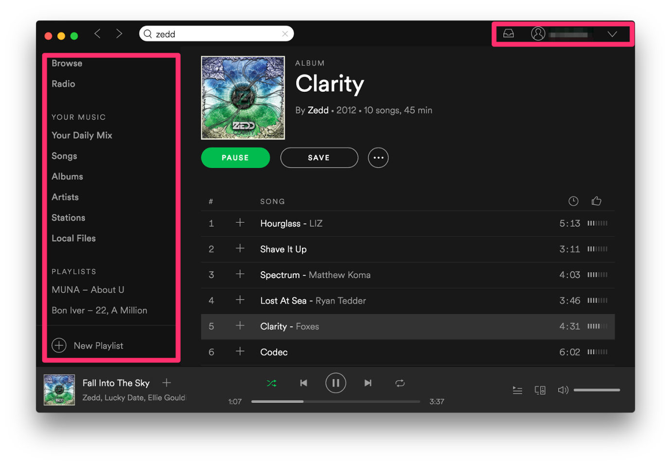

In the Spotify desktop application (shown above), you see a persistent sidebar that gives you access to a high-level navigation system that can take you to virtually any section of the app. On a desktop, you have a great deal more screen real estate to play with than on mobile, which is why this method makes sense. On mobile (shown below), however, it’s a different story. You can only fit five icons on the iOS tab bar (see the bottom of the Spotify app), so these sections have to be carefully selected.

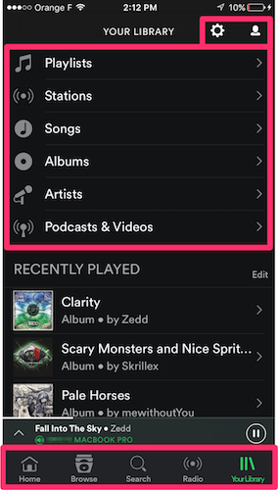

It’s also interesting to note that on both the desktop and mobile apps, settings and personal information can be accessed at the top right. While these sections might offer slightly different user experiences depending on the version, they still serve the same purpose. This placement is strategic—it adds a level of consistency across platforms and provides access points to important information without cluttering the screen.

Navigation Heuristics

It’s important to understand and remember these heuristics so that you can draw on them later when you’re designing professionally. Let’s go ahead and take a look at each one in detail.

Make it Visible

Always use the space you’re given. Menu systems shouldn’t hide from the user; they should be placed in familiar locations. On the desktop, high-level navigation menus typically live at the top of an application. On iOS, however, it’s common to use a tab bar at the *bottom* of the screen for high-level menu options. Android has its own navigation patterns, which involve drawers and tabs. Take a look at the two images below. The one on the left uses a drawer-style navigation (stacking them vertically), while the one on the right uses a tab-style navigation (laying them out horizontally).

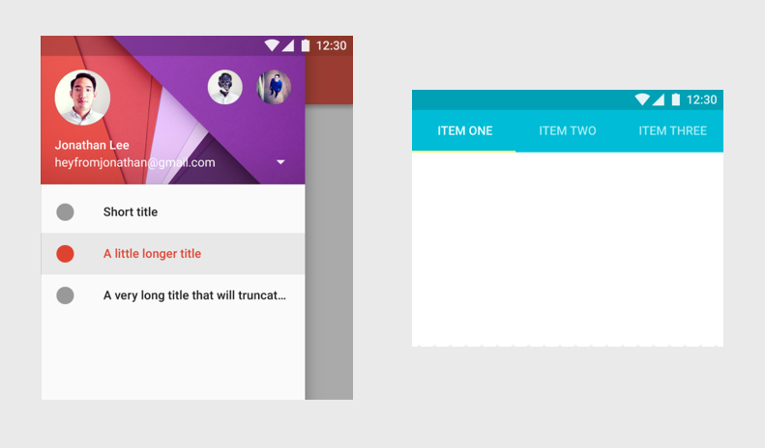

Source: [Material.io](https://material.io/guidelines/patterns/navigation.html#navigation-patterns)

Different scenarios call for different navigation solutions. The tab pattern makes sense for a small number of equally important pages, while the drawer pattern allows for many more pages and allows you to place more importance on certain pages in the hierarchy.

In addition to being placed where they're expected to be, menus should be bold, easy to read, and use appropriate contrast to stand out. The last thing you want is the user wondering where your menu even is!

Airbnb’s tabbed navigation on a home listing does a great job of standing out because the text is bigger than most of the other content in this section and uses color to indicate where you are (the blue-green color of “Overview”).

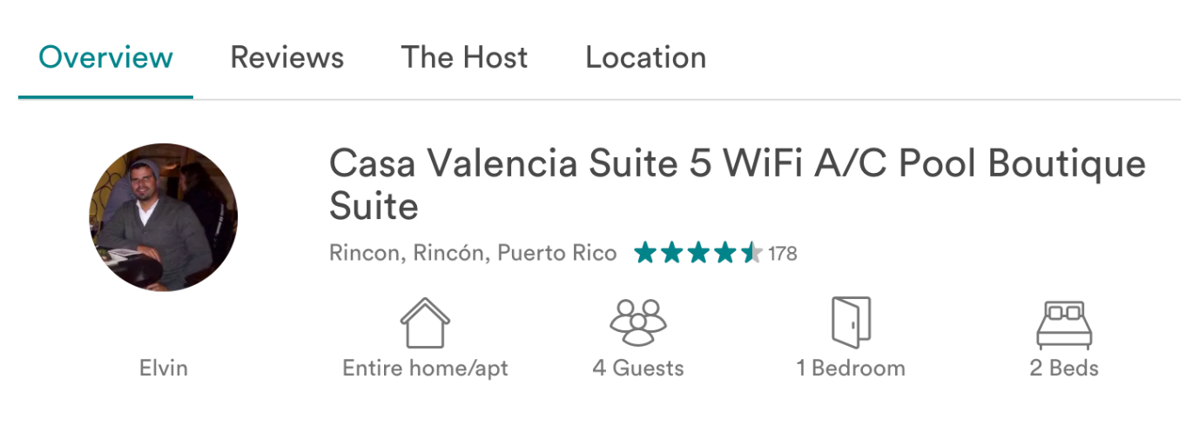

This leads us to the next heuristic:

Show Your Current Location

A good menu system always gives you an indication of where you currently are as well as where you came from. Take a look at the menu system below from Google Docs on Android. Even while traversing deeper into the menu, you always have an indication of where you came from—indicated with a gray highlight and layout that allows you to look back each step of the way.

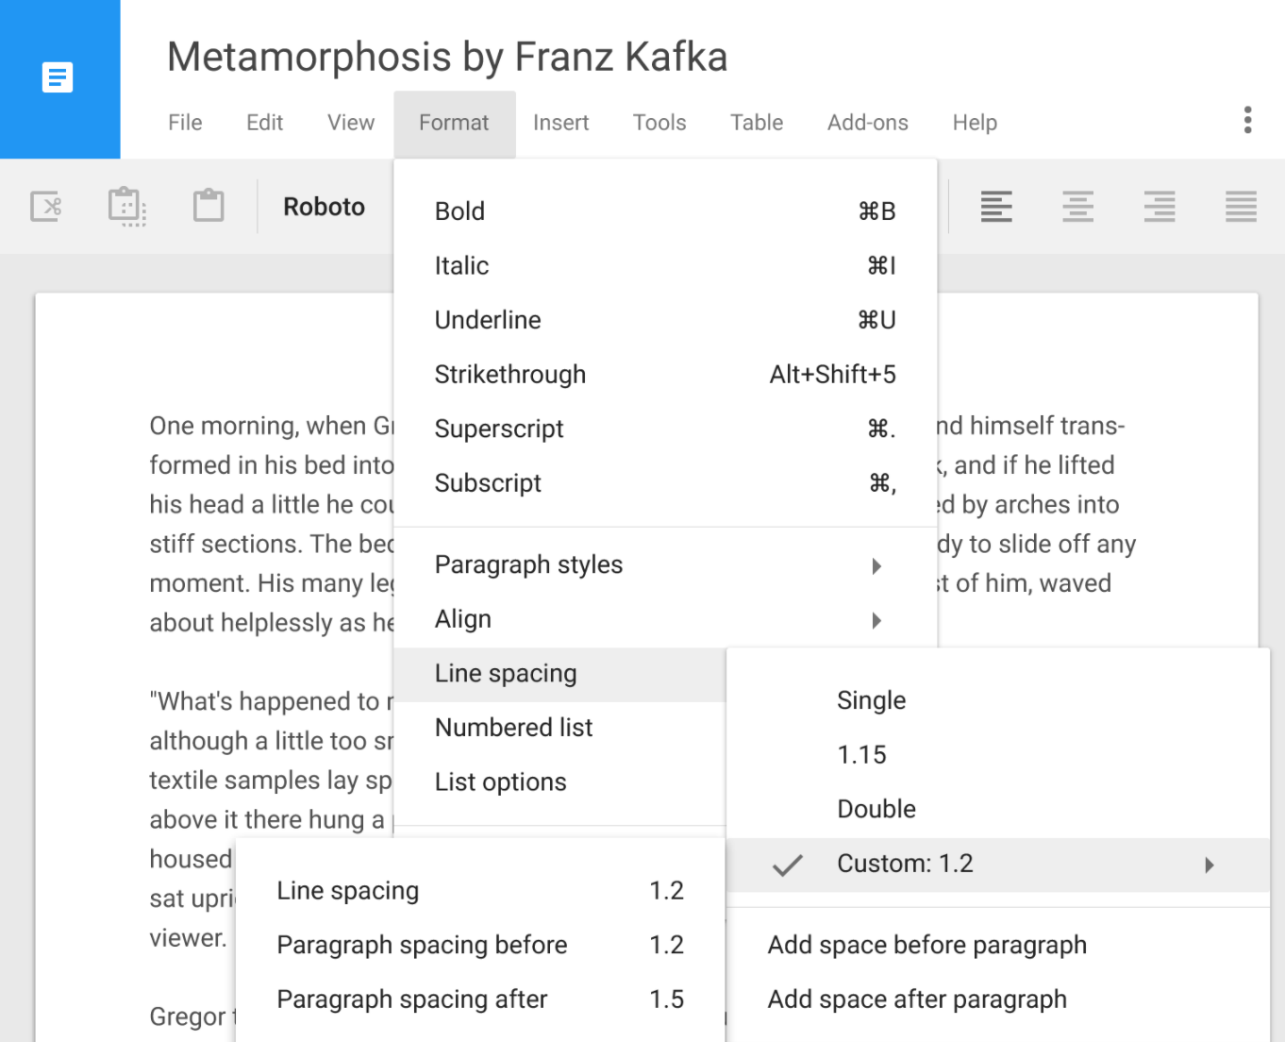

Easy to Read

Menu systems should use plain and consistent language that the user can understand rather than getting too technical. These navigation bars from Duolingo, for example, use simple language that’s very easy to understand and that describes the sections of the site in as few words as possible.

  


Big Enough to Tap

One important heuristic that’s very easy to overlook on both mobile and desktop is the size of navigational elements. On the desktop, if a link or icon is too small, it can be a challenge to click it. This is even *more* of an issue on mobile, where users are using their own fingers to interact with navigational elements. For this reason, mobile platforms offer their own guidelines specifying the minimum size for these elements.

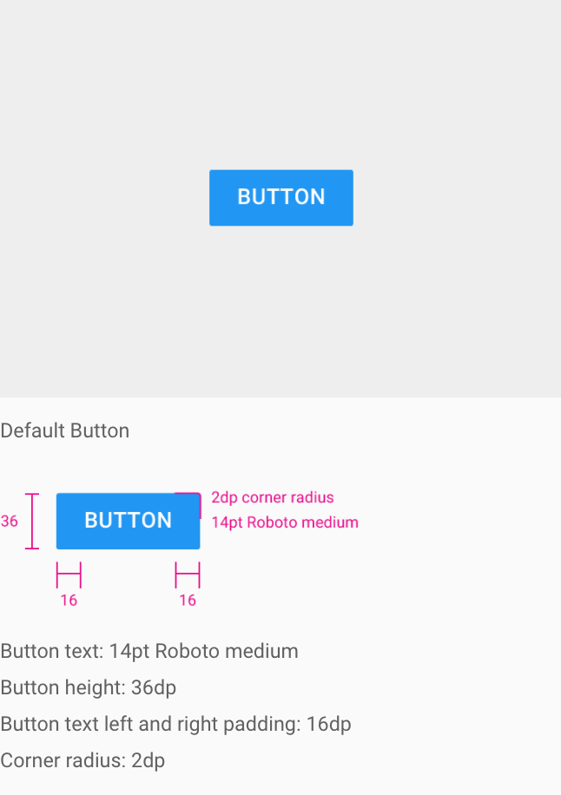

TRY IT!  
Fire up your favorite desktop or mobile app and analyze the navigation to see if you can spot these heuristics in action.

“My” vs “Your”

There’s an age-old question in the world of UX design: is it “My” stuff, or is it “Your” stuff? Analyze a handful of applications and you’ll quickly see how inconsistent designers are with this wording:

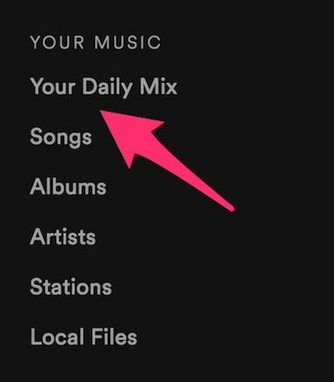  
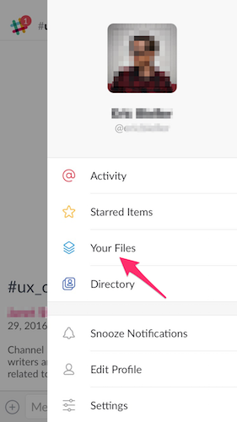  
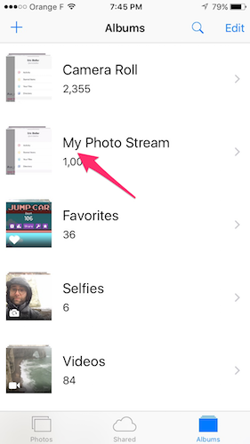  
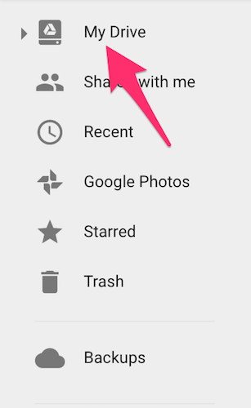

Nowhere is this issue more prevalent than in Microsoft Windows. Over the years, they’ve volleyed between various naming conventions, but why? Were users confused? Or maybe it was just inconsistent with other parts of the operating system?

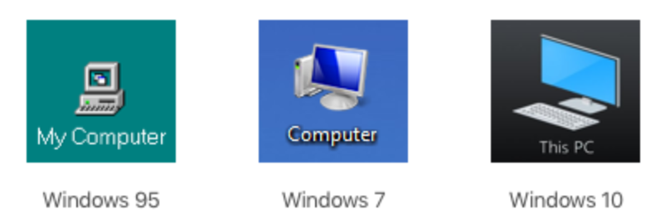

So, which is better? “Your” or “My”? Unfortunately, there’s no concrete rule here. “Your” implies the objective perspective of the software, almost as if it were a personal assistant. “My”, on the other hand, implies more personal ownership, so “My Library” or “My Files” makes sense given that these are objects actually do "belong" to you. If you’re specifically talking about something that the system has provided or created for you, on the other hand, then “Your” might make more sense (e.g., “Your Suggestions” of “Your Results”).

Summary

In this Exercise, you learned about common navigation heuristics such as ensuring visibility, always displaying the user’s current navigational position, making things legible, and creating touch points that are big enough to click or tap. You also learned about specific navigation patterns and what can be reused in order to solve common navigation usability problems. These patterns and heuristics can help ensure your navigation is usable. When designing your own navigation, be sure and refer back to make sure you’re abiding by them.

Now that you have a concrete understanding of these common navigational patterns and heuristics, you’re going to create your own desktop and mobile navigation solution.

Resources

* [Basic Patterns for Mobile Navigation by Nielsen Norman Group](https://www.nngroup.com/articles/mobile-navigation-patterns/)
* [Navigation Wireframe for Course Project Demo: Triply](https://s3.amazonaws.com/coach-courses-us/public/courses/ux-immersion/A3/E3/A3E3_navigationwireframes.png)
* [Material Design Guidelines](https://material.io/design/)
* [Apple Human Interface Guidelines](https://developer.apple.com/ios/human-interface-guidelines/overview/themes/)

Take the quiz to test your knowledge on this Exercise.

Take Quiz

Task

* [DIRECTIONS](https://careerfoundry.com/en/course/become-a-ux-designer/exercise/navigation-for-mobile-and-desktop#directions)
* [SUBMISSION HISTORY](https://careerfoundry.com/en/course/become-a-ux-designer/exercise/navigation-for-mobile-and-desktop#step_submission_history)

 Estimated Task Time: 4 Hours.

For this Task, you’ll wireframe your own navigation based on the sitemap you created earlier in this Achievement and the user flows you created in Exercise 2.6: Task Analysis & User Flows. This is a continual process that will also be repeated in Exercise 3.9: High-Fidelity Wireframes & Clickable Prototypes.

IMPORTANT!  
In this Task, you’ll be asked to sketch out your ideas into wireframes. You’ll learn about the intricacies of paper prototyping in Exercise 3.6: Low Fidelity Prototyping: Paper & Sketches, but for now, it is important for you to know that these first sketches:

* Are in grayscale (do not include any color at this stage)
* Include an indication of where text elements will be using squiggles or lines (do not write the actual app text right now)

The screens you select to sketch should be chosen to illustrate the navigational components of your app. Do not sketch every screen in your user flow at this stage.

You can also check out this example from the course demo project, Triply, to get a better idea of what is expected from you:  
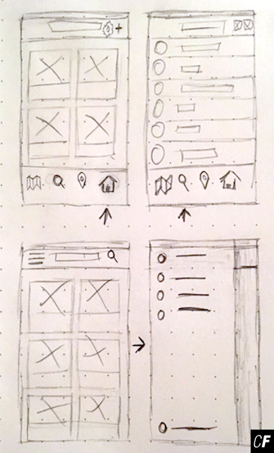

**Directions**

1. Study the sitemap and user flows you created for your app in order to understand how your navigation should be laid out.
2. Using pencil and paper, start sketching some ideas. Should you use a tab bar or a drawer? Where should your navigation live? Do you need sub-navigation elements or just high-level pages? Take a look at other apps to get inspiration and be sure you’re referencing the heuristics and patterns from this Exercise in order to create a usable navigation.
3. Take photos of your finalized navigation wireframes and upload them into a presentation program like PowerPoint or Keynote.
4. Write annotations or a summary next to your screens, explaining your design decisions.
5. Export the file as a PDF and upload it here to discuss with your Tutor.