3.5: Usability Heuristics & Interaction Design

Learning Goals

* Identify examples of heuristics of usability in practice
* Apply heuristics to interaction design

 Estimated Read Time: 30 Minutes.

Introduction

Welcome back! In the previous Exercise, we discussed the universal design patterns and looked at specific examples that help ensure that a user interface is adhering to principles that determine the quality and usability of an application. Now, we’ll shift gears slightly and step into the world of interaction design. Here, we’ll look at attributes of usability, Nielsen’s 10 Usability Heuristics, and how to perform a heuristic evaluation. You might notice some overlap between terms and concepts, and that simply goes to show that usability is and should be universal!

Interaction Design

**Interaction Design (IxD)** is typically considered a subset of UX design, focusing specifically on the way users interact with a product, environment, system, or service. While UX design is concerned with the experience, look, and feel of the software as a whole, IxD is concerned with the specific interactions that occur when *using* that software. Things like page transitions and buttons, touch-interactions, keyboard and mouse input, etc., all fall under the umbrella of interaction design.

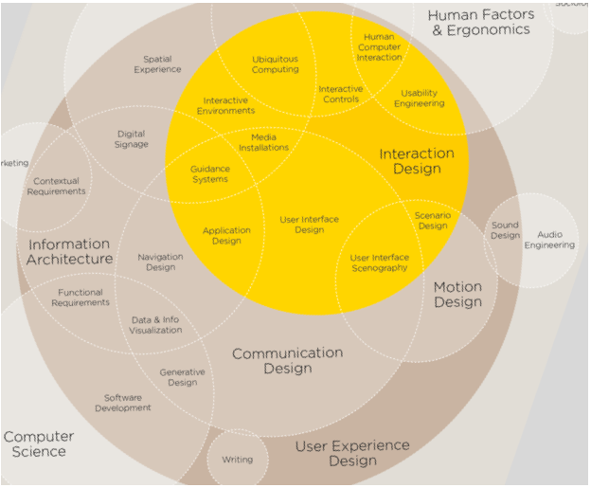

Adapted from [Thomas-pluralvonglas](https://de.wikipedia.org/wiki/Datei:Interaction-Design-Disciplines.png)

As you can see from the diagram above, the overarching term "UX design" actually encompasses a number of different things—information architecture, navigation layout, sitemaps, user research, user interface, and more. IxD, on the other hand, refers only to choreographing animations and interactions, making sure they’re pleasurable and quick, and ensuring that the user understands the consequences of their every action.

What Is Usability?

Usability refers to the ease with which users can navigate a user interface. If your app or website ranks high in usability, users can navigate it smoothly and accomplish their goals without trouble. Jakob Nielsen defines "usability" using five quality attributes:

1. **Learnability**: This refers to a user interface that makes it easy for users to accomplish their goals the very first time they see it. Apps or websites that feel familiar because they're easy to get around are “learnable.”
2. **Efficiency**: This refers to the speed at which a user can accomplish their goals after they're familiar with an app or website. In other words, after you’ve used an app once or twice, how fast can you navigate it?
3. **Memorability**: Have you ever gone through a period of time without using one of your favorite apps? Once you come back to it, is it still easy for you to use? Or, do you have to spend time re-learning its interface? This is memorability, or how easy it is for users to remember how to use an app or website after not doing so for some time.
4. **Errors**: How likely are users to make an error, and how many do they make? After making them, is it easy for them to get back on track? This deals with user errors, when they happen, why, and how to help users get around them.
5. **Satisfaction**: This refers to how enjoyable it is to use an app or website. Is it gratifying and fun? Or, do users feel miserable using it?

Website and apps that rank low in usability will have trouble succeeding. When users find a user interface puzzling, they’ll leave without hesitation. Keep in mind that of the myriad of websites and apps that exist across the Internet, many probably perform the same functions as yours (or close enough to it). Users know this, so if your website or app ranks low in usability, they may go ahead and spend a couple more minutes finding a better option.

Usability Heuristics

First off, what is a “heuristic?” A **heuristic** is a principle that isn’t exactly a rule, but isn't exactly not, either—think of it more as a rule of thumb or a guide. Heuristics, by nature, aren’t black and white rules to follow; instead, they offer guidelines that can be applied and tweaked based on a given scenario.

Heuristics allow us to standardize common methods we consider to be the “right way” of doing things. The reason usability relies on heuristics rather than rules is because design is art, and art doesn't always conform to rules. For example, red is typically a color reserved for negative actions and warnings, but take a look at [Yelp](https://www.yelp.com/) or [Pinterest](https://pinterest.com/) and you’ll see that all primary actions on their site use the color red.

Nielsen’s 10 Usability Heuristics

Usability Heuristics are a set of broad guidelines you’ll want to keep in mind while designing. **Nielsen's 10 Usability Heuristics** were developed by Nielsen and Rolf Molich back in 1990, and they're arguably the most used in the entire UI field. Nielsen has been given titles such as "the king of usability," "the guru of webpage usability," and "the usability Pope," amongst others by publications like The New York Times and Internet Magazine. Pretty legit, right? Nielsen’s principles are solid and a great set of guides to help push you in the right direction.

The 10 Usability Heuristics are:

1. Visibility of Systems
2. Match Between System & the Real World
3. User Control & Freedom
4. Consistency & Standards
5. Error Prevention
6. Recognition Rather than Recall
7. Flexibility and Efficiency of Use
8. Aesthetic & Minimalist Design
9. Help Users Recognize, Diagnose, & Recover from Errors
10. Help & Documentation

Read on for a more in-depth exploration of each one.

1. Visibility of Systems

The system should always keep users informed about what's going on through appropriate feedback within a reasonable period of time. The Dropbox desktop app, for instance, makes sure you know when it’s syncing a doc:

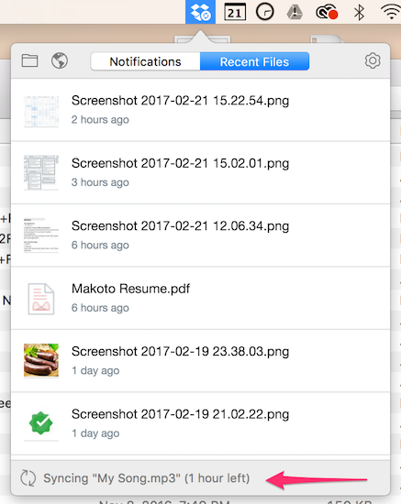

2. Match Between System & the Real World

The system should speak the users' language with words, phrases, and concepts familiar to the user rather than system-oriented terms. Follow real-world conventions, displaying information in a natural, logical order. In the image below, Slack uses plain language to help you understand how the app works:

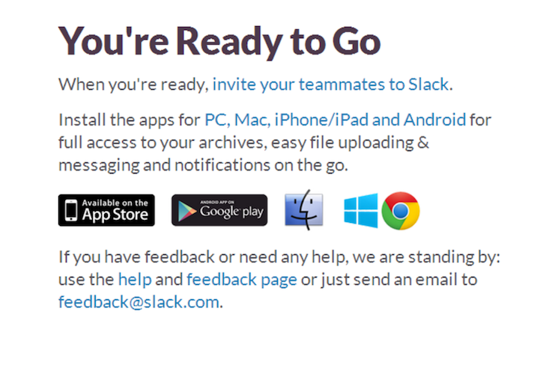

3. User Control & Freedom

Users often choose system functions by mistake and will need a clearly marked "emergency exit" to leave the unwanted state without having to go through an extended dialogue. Support undo and redo. Slack, for example, provides a large X so you immediately know how to close your preferences:

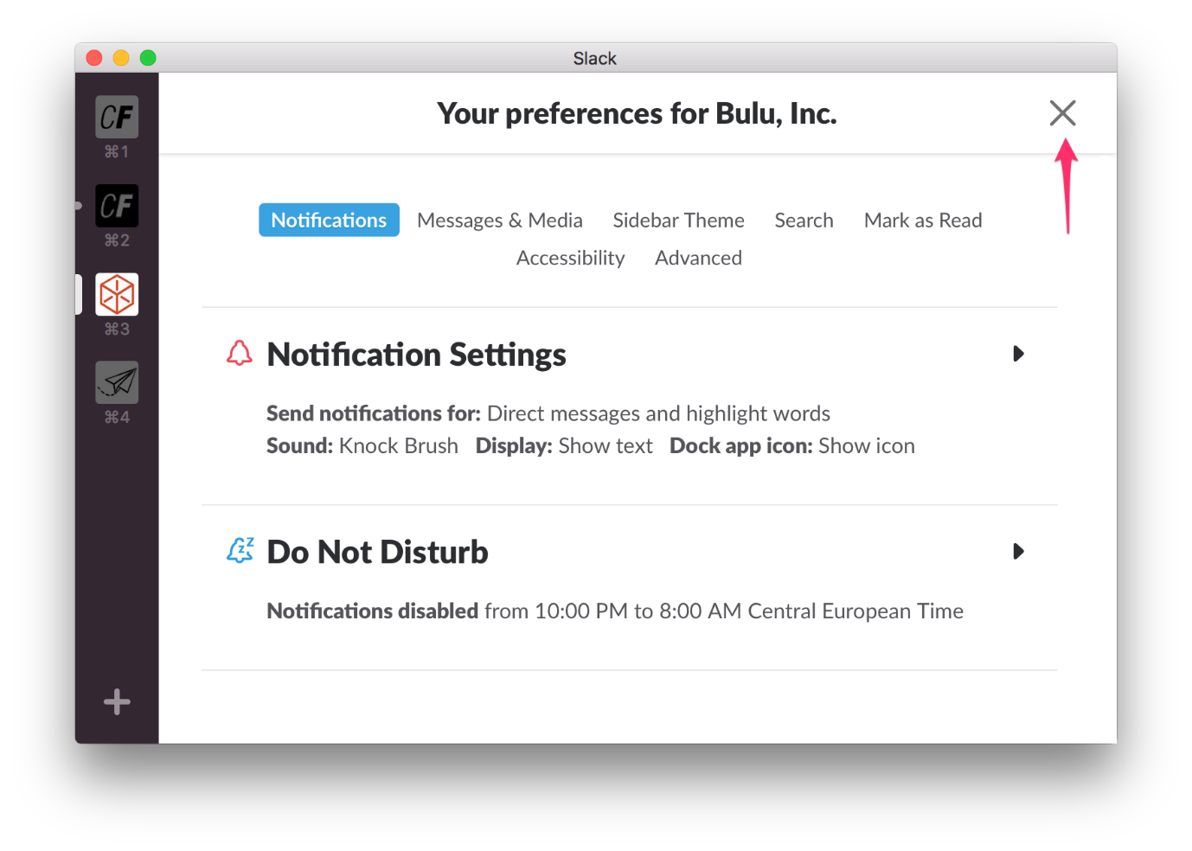

4. Consistency & Standards

Users shouldn't have to wonder whether different words, situations, or actions mean the same thing. Follow platform conventions. The image below is from the Material Design Spec and shows how action button shadows should be consistent across all apps:

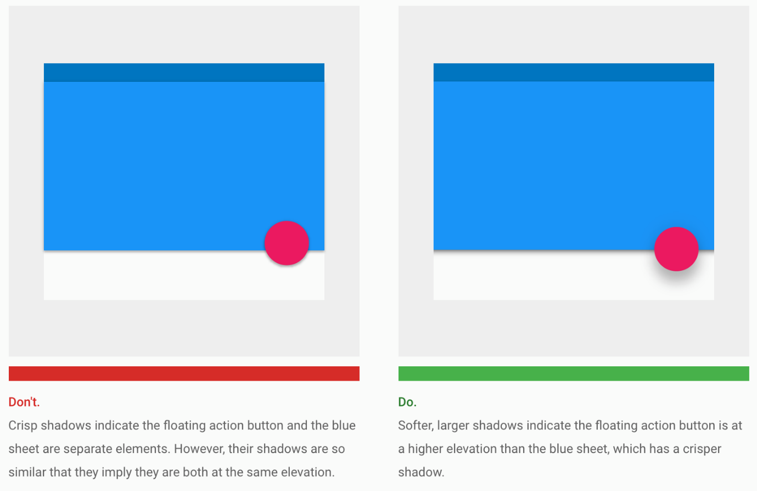

Source: [Material Design](https://material.io/guidelines/material-design/elevation-shadows.html#elevation-shadows-shadows)

5. Error Prevention

Even better than a good error message is a careful design that prevents a problem from occurring in the first place. Either eliminate error-prone conditions or check for them and present users with a confirmation option before they commit to the action. Instagram, for example, asks you to confirm before deleting a photo:

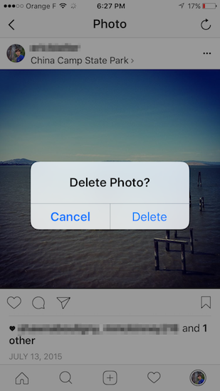

6. Recognition Rather than Recall

Minimize the user's memory load by making objects, actions, and options visible. The user shouldn't have to remember information from one part of the dialog to another. Instructions for use of the system should be visible or easily retrievable whenever appropriate. In the image below, the user is provided with their browsing history at the bottom (labeled "You viewed"), along with a list of recommendations above that (labeled "Inspired by your browsing history"):

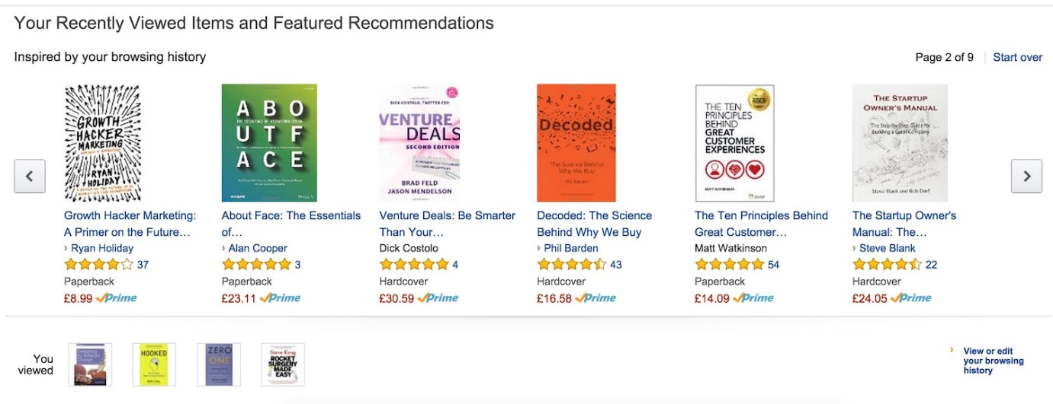

7. Flexibility & Efficiency of Use

Accelerators—unseen by the novice user—can often speed up the interaction for the expert user such that the system can cater to both inexperienced and experienced users. Allow users to tailor frequent actions. In Adobe Premier, you're able to add your own custom shortcuts, but only if you so desire:

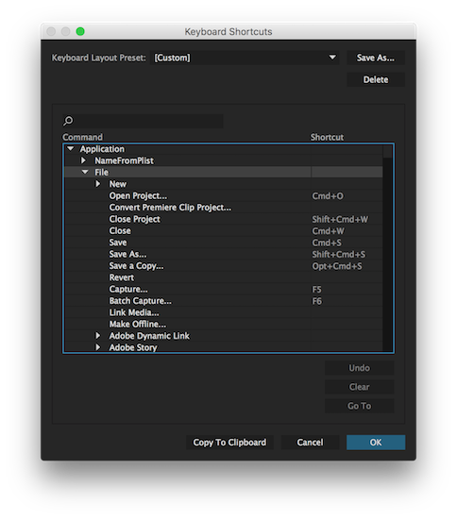

8. Aesthetic & Minimalist Design

Dialogs shouldn't contain irrelevant or rarely needed information. Every extra unit of information in a dialogue competes with the relevant units of information and diminishes their relative visibility. The Mailbox app uses a clean interface with only the buttons you need to accomplish common and important tasks:

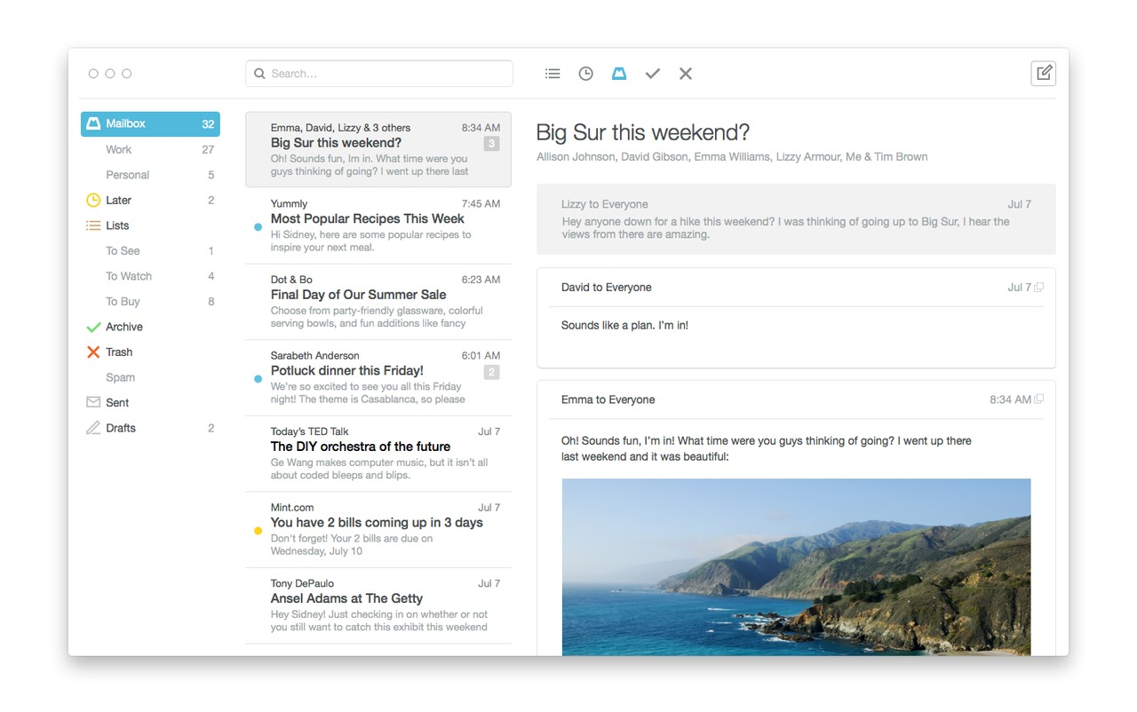

Source: [Wired](https://www.wired.com/2014/08/mailbox-mac/)

9. Help Users Recognize, Diagnose, & Recover from Errors

Error messages should be expressed in plain language (no codes), precisely indicate the problem, and constructively suggest a solution. Adobe Creative Cloud shows a noticeable error when there's a payment issue and provides information on how to rectify it:

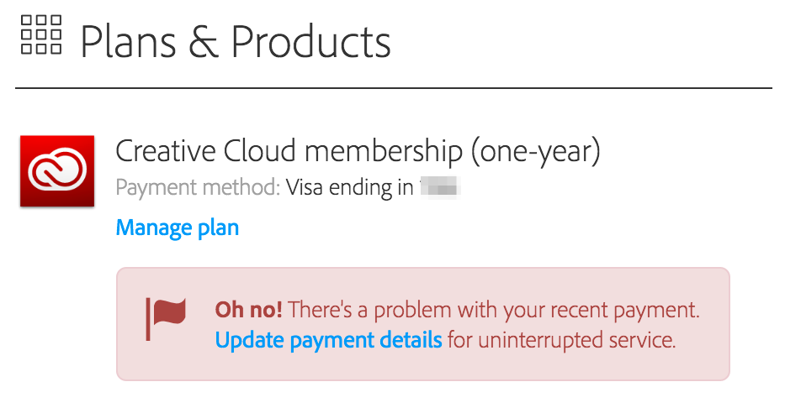

10. Help & Documentation

Ideally, a system could be used without documentation, but it's still sometimes necessary to provide it for your users. Any such information should be easy to search, focused on the user's task, list concrete steps to be carried out, and not be too large. Google Docs has a convenient help bar that makes it easy to find things that might be hidden within the menu system.

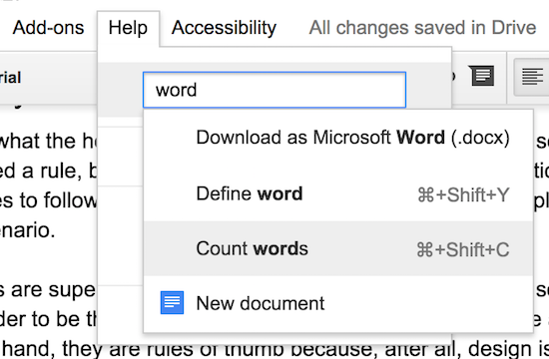

As you can see, these ten heuristics cover a wide range of functionality, and sticking to them can make all the difference in the usability of your app.

Performing a Heuristic Evaluation

A **heuristic evaluation** is a method used to uncover usability issues in a user interface so that they can be iterated and improved upon. It’s done by having a group of evaluators examine a given interface to see how well it adheres to the 10 Usability Heuristics listed above.

This is typically done with more than one person, as it would be difficult for only one person to find any and all issues that may exist within an interface. Everyone is different, so, naturally, they’ll find different usability issues within an interface.

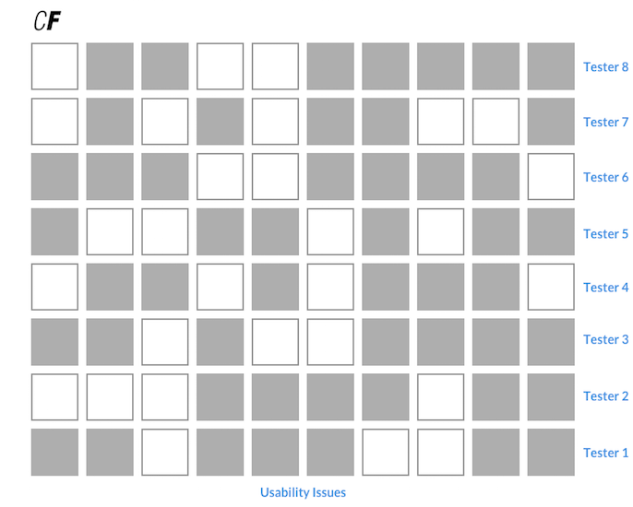

Take a look at the chart above, which represents a heuristic evaluation of banking software. The eight rows represent individual testers while each square in the 10 columns represents a usability issue. A filled-in square means an evaluator was able to identify this usability issue. If you look at any given result, you’ll see that each evaluator has uncovered a set of different usability issues. Therefore, it is generally a good idea to have a handful of testers when conducting a heuristic evaluation.

Conducting the Evaluation

To ensure unbiased evaluations, each evaluator should inspect the interface and conduct the evaluation alone. Only after all evaluators have completed their evaluation are they able to communicate and combine their results.

Evaluators can either write down their results directly or record their thoughts and findings out loud during the test. These recordings can then be used later for interpretation. A third option would be for an observer to take notes during the test. This observer wouldn’t answer any questions from the evaluator. Instead, they’d urge the evaluator to find the answer to their questions themselves via the interface.

A heuristic evaluation can last anywhere from one to two hours depending on the complexity of the software involved—any longer than that, and it should probably be broken up into multiple sessions. As for evaluators, three to five is usually enough to cover all the pertinent usability issues, though this can depend on the scope of the product.

As the evaluators go through the interface, they should continuously reference the 10 Usability Heuristics to ensure there are no violations. If they do find something, however, they should either talk through it out loud(if they’re being recorded) or write down their findings. By the end of the test, they should have a list of all the usability issues in the product as well as which usability heuristics were violated.

The heuristic evaluation itself isn’t meant to generate fixes for any issues that are found. Instead, its main goal is to simply identify them, as well as why they exist, so the designer can come up with the proper improvements.

Summary

In this Exercise, we discussed Interaction Design, how it differs from UX Design, as well as the 10 Usability Heuristics (the bridge that connects IxD with UXD) to improve user interactions in your own designs. We also dug into the specifics of how to conduct your own usability evaluation. Now that you’ve learned all this background information, you’re ready to prepare an evaluation of your own.

Resources

* [10 Tips on How to Conduct a Perfect Heuristic Evaluation](https://medium.muz.li/10-tips-on-how-to-conduct-a-perfect-heuristic-evaluation-ae5f8f4b3257)
* [Complete Beginner’s Guide to Interaction Design by UX Booth](http://www.uxbooth.com/articles/complete-beginners-guide-to-interaction-design/)
* [Nielsen's 10 Usability Heuristics Cheatsheet](https://s3.amazonaws.com/coach-courses-us/public/courses/ui/design-principles/E1/nielsens10usabilityheuristics.png)

Take the quiz to test your knowledge on this Exercise.

Take Quiz

Task

* [DIRECTIONS](https://careerfoundry.com/en/course/become-a-ux-designer/exercise/heuristics-and-ixd#directions)
* [SUBMISSION HISTORY](https://careerfoundry.com/en/course/become-a-ux-designer/exercise/heuristics-and-ixd#step_submission_history)

 Estimated Task Time: 3 Hours.

For this Task, you’ll be performing your own heuristic evaluation on a popular piece of software or application.

**Directions**

1. Select an app that’s similar to the one you’re designing (i.e. has similar functionality or a similar purpose). If you want to take a little break from your project, you also have the option of working with one of the following apps: Spotify, Instagram, YouTube, Yahoo.com, Duolingo, or Facebook.
2. Create a column for each of the 10 Usability Heuristics. Walk through the application you’ve chosen and keep an eye out for anything that violates any of the 10 Usability Heuristics. When you find something, write it down as thoroughly as possible beside the corresponding row. Alternatively, you can [download this worksheet](https://s3.amazonaws.com/coach-courses-us/public/courses/ux-immersion/A3/E5/UsabilityHeuristicEvaluationWorksheet.xlsx) or follow a similar format.
3. Export your results as a PDF and upload it here for you and your Mentor to discuss!