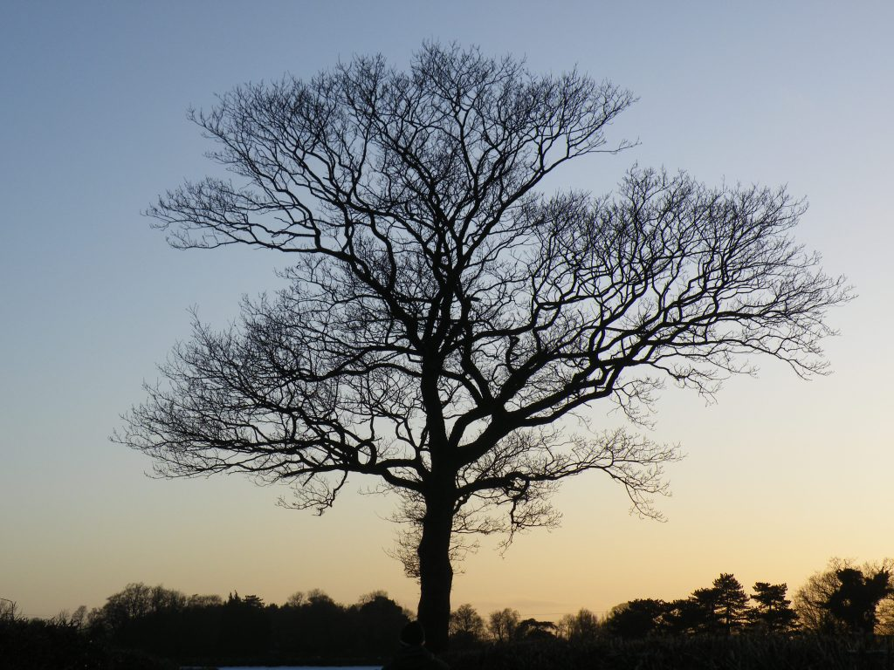**O’Meara lab**

**Postdoc & student space**

**425a Hesler**

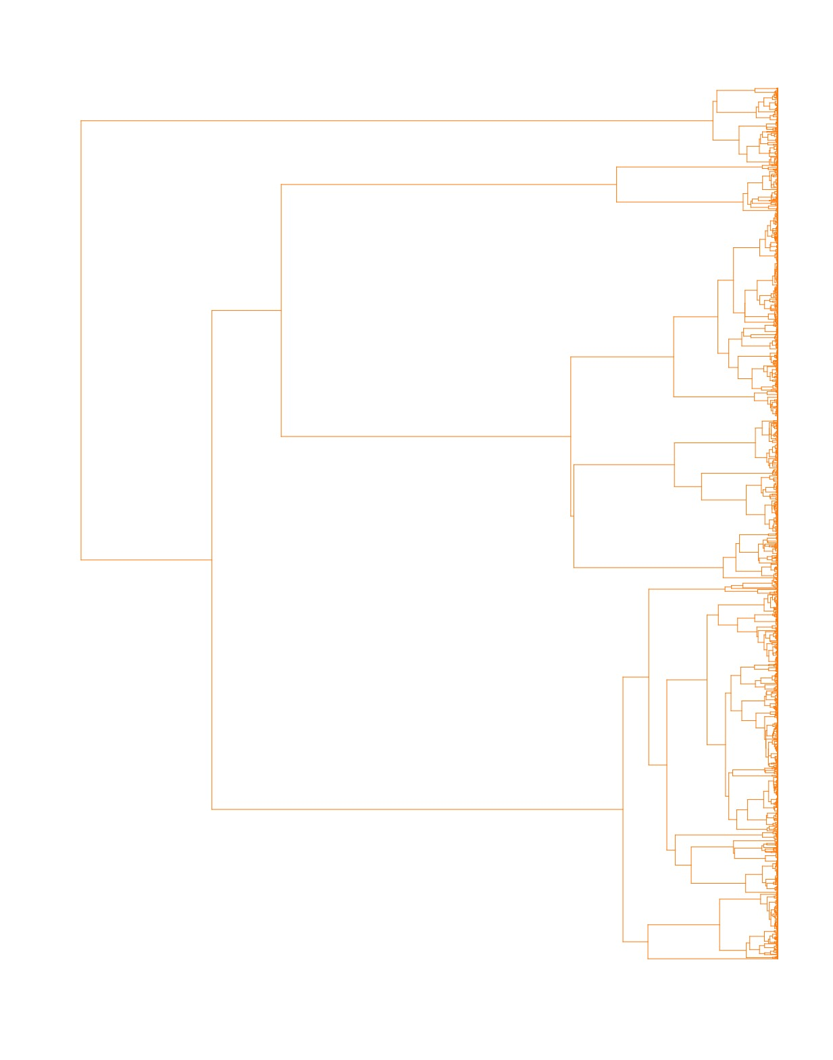

Dave Bapst (Texas)

Sam Borstein (Hesler 528)

Dominic Evangelista (France)

Luna Sánchez Reyes

Orlando Schwery

Sergei Tarasov (NIMBioS)

Sofia Tomov

**O’Meara lab**

**Faculty office**

**446 Hesler**

Our lab members address compelling evolutionary or ecological questions by developing and applying phylogenetic methods.

We have worked or are working on:

* Processes affecting speciation and extinction
* Long term selection on gene expression
* Dating phylogenetic trees
* Delimiting species
* And many more!

**http://www.brianomeara.info**