EEB587: Phylogenetic Methods

Spring, 2019: Tuesdays and Thursdays, 11:10AM-12:25PM

Brian O’Meara (brianomeara.info & phylometh.info)

By the time the class is over, you will know:

* Why to bother with trees
* How to answer questions in ecology, evolution, and related fields (conservation, linguistics, etc.) using phylogenies
* Why to move beyond dull hypothesis testing
* How to gather data for your analyses
* How to build a phylogeny
* How to understand trait evolution
* How to understand diversification
* How to build a method of your own
* Why and how to use R, git, and other software

This is largely a flipped class: course materials (textbook, recorded videos, etc.) are **all freely available online**; in class, we’ll work through readings, questions, and problems together.

Suggested requirements

* 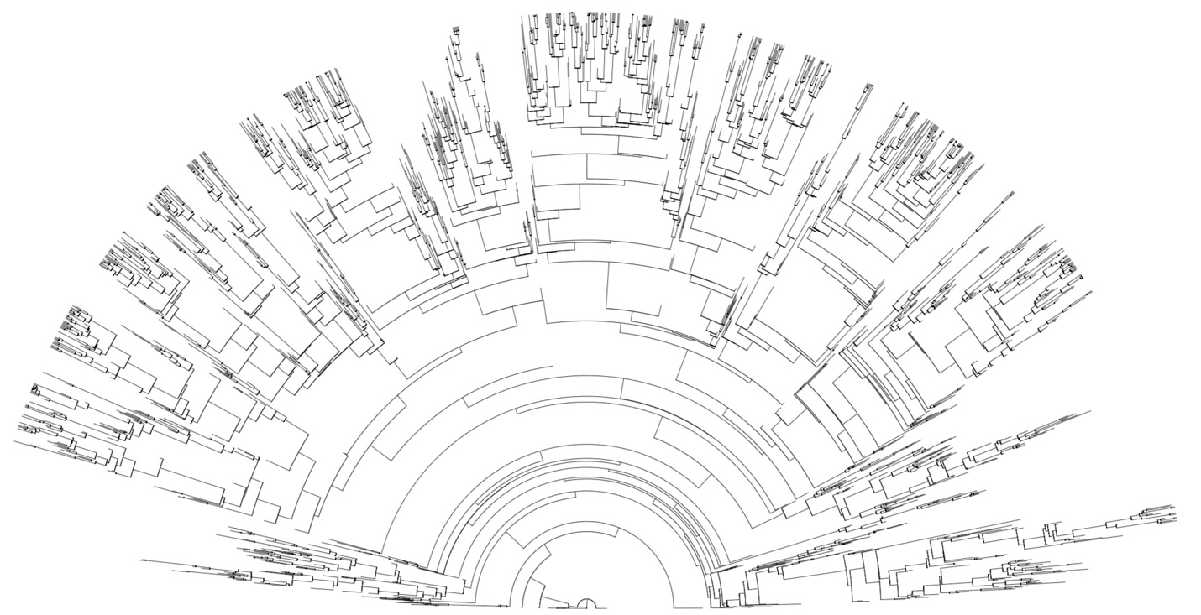A question that motivates you about evolution, ecology, or a related field
* Ability to learn and hack through problems
* Experience with R is useful, but as long as you’re not afraid to work and ask questions while learning it, extensive knowledge is not required (any students who have been through Core, Biometry, or similar will be fine)