My overall teaching goal is to develop students who have the skills of creative, skeptical scientists, curious about evolutionary processes, while being grounded with deep knowledge of biological patterns and mechanisms. This is accomplished through teaching a mixture of large introductory lecture courses, graduate seminars and courses, and most centrally, a mixed upper level undergraduate/introductory graduate student course in macroevolution.

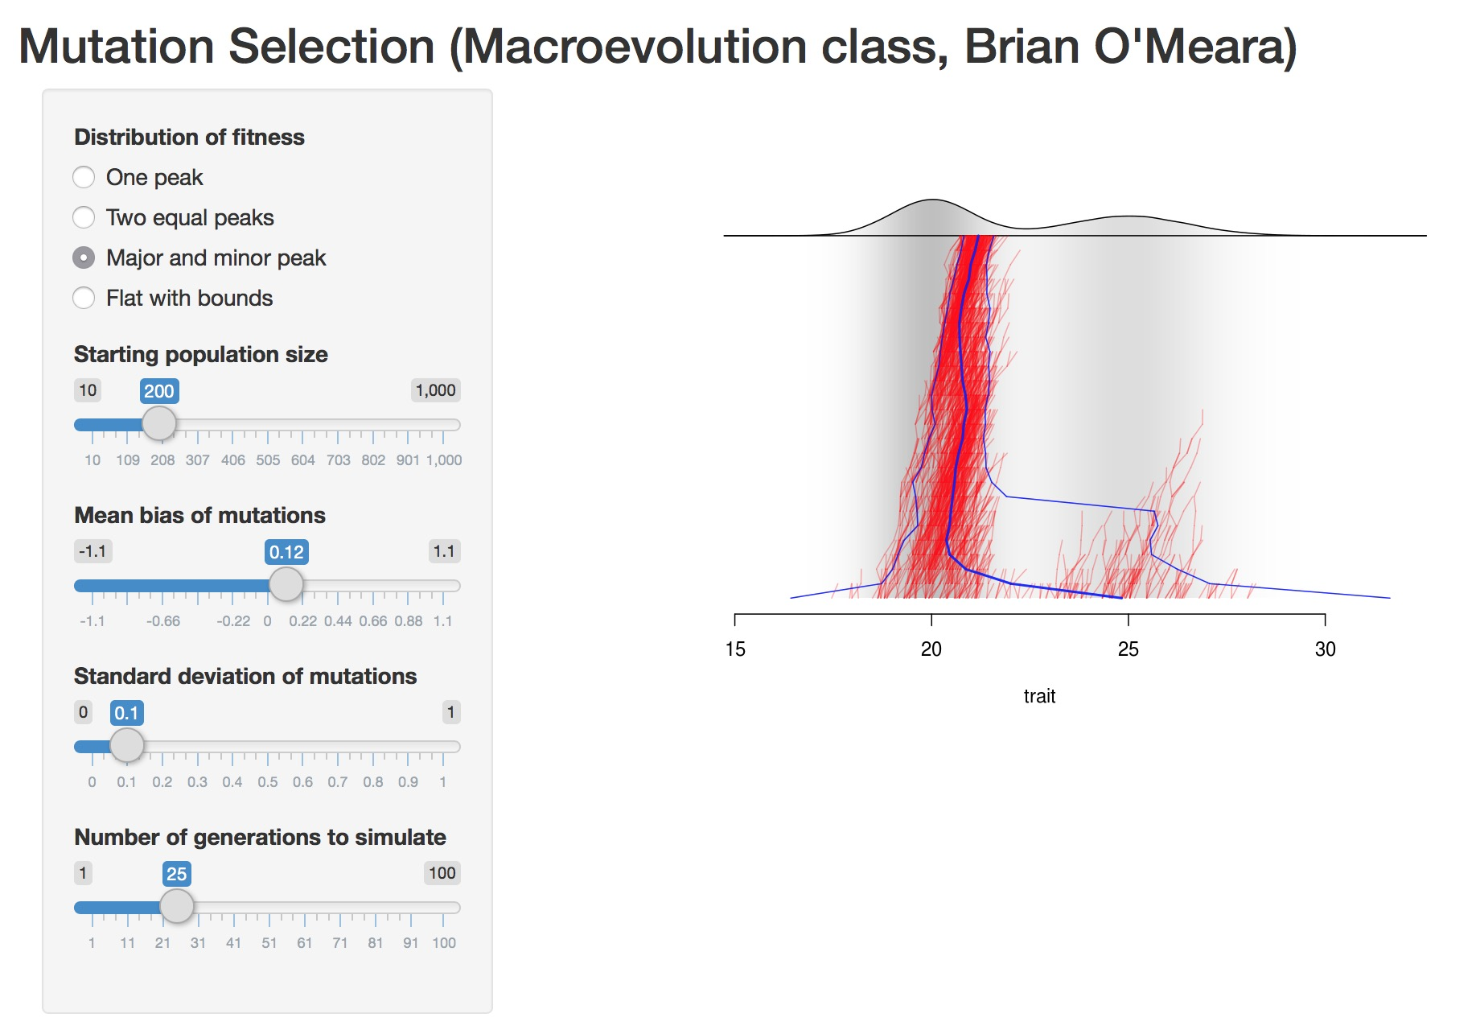One consistent teaching effort has been an upper level course on macroevolution. The class explicitly targets four Biology degree-level learning outcomes (“Evolution: Populations of organisms and their cellular components have changed over time through both selective and non- selective evolutionary processes”, “Formulate empirically-testable hypotheses”, “Interpret visual representations (figures and diagrams)”, and “Evaluate data and come to a conclusion (with evidence) (formulate an argument)”). The class is a mixture of lecture, small group discussions, class discussions, and investigations, both computational and empirical. Technology (laptops, clickers, homemade interactive white board for teaching in a classroom without a smart board, embedded videos, a custom web app) is used as appropriate to engage students and assess progress, but students also get hands on experience looking at fossils or other biological specimens. Lectures are recorded for students to review later if needed. For class discussions, I often will have them break into small groups to talk about an issue and then come together for an entire class discussion, so that students may try out their ideas on one or two peers before voicing them to the entire class. I also encourage class discussions to feature dialog with each other, rather than just response to me. Over the course of a semester the class covers various topics in macroevolution such as differential diversification and the history of life on earth. I emphasize how we know about these things, how to perform experimental tests of these ideas, and current work on the topics, so students see science as an ongoing process of discovery rather than a static set of facts. Students are assessed through clicker questions (some reviewing past topics, some based on a list of key taxa students are assigned to learn, some just to have students commit to hypotheses about data presented in class), essay-based tests, a report on a topic including what work still has to be done on it, and a pair presentation covering a graduate-level research proposal. In addition to positive reviews and growing numbers, one measure that shows the class’s impact is the number of graduate students from the EEB and Geology departments who are encouraged by their committees to take it. Committees justifiably want to protect students from taking courses at the cost of their research, but several faculty feel that the content in this course is worth the time it takes for students to take it.

Figure 1: Interactive web app I wrote for teaching about mutation, selection, and drift to macroevolution class. Hosted at https://brianomeara.shinyapps.io/mutation_selection_shiny/

I do extensive teaching at the graduate level. Some of this is for classes that are reading groups in speciation or phylogenetics, while another was for a shared multiple lab discussion group. This started as simply a joint meeting of four small but grew to an active discussion group with students from at least seven lab groups enrolled. It covered a mixture of work in progress as well as recent relevant papers to students’ research. My goal in all these classes is to encourage students to focus on the questions being addressed by their work or others: it is easy for students to adopt popular methods without considering whether those are the best way to address their questions. I have also been heavily involved in our department’s Evolution core course for graduate students, teaching that on top of regular teaching duties. I try to teach students to see the connections across methods (for example, all the methods that use a discrete state transition matrix, even though some are for inferring trees while others are for investigating biogeographic history). While maintaining creation of high impact research, I have taught extensively: in some semesters, as many as four seminars and other courses.

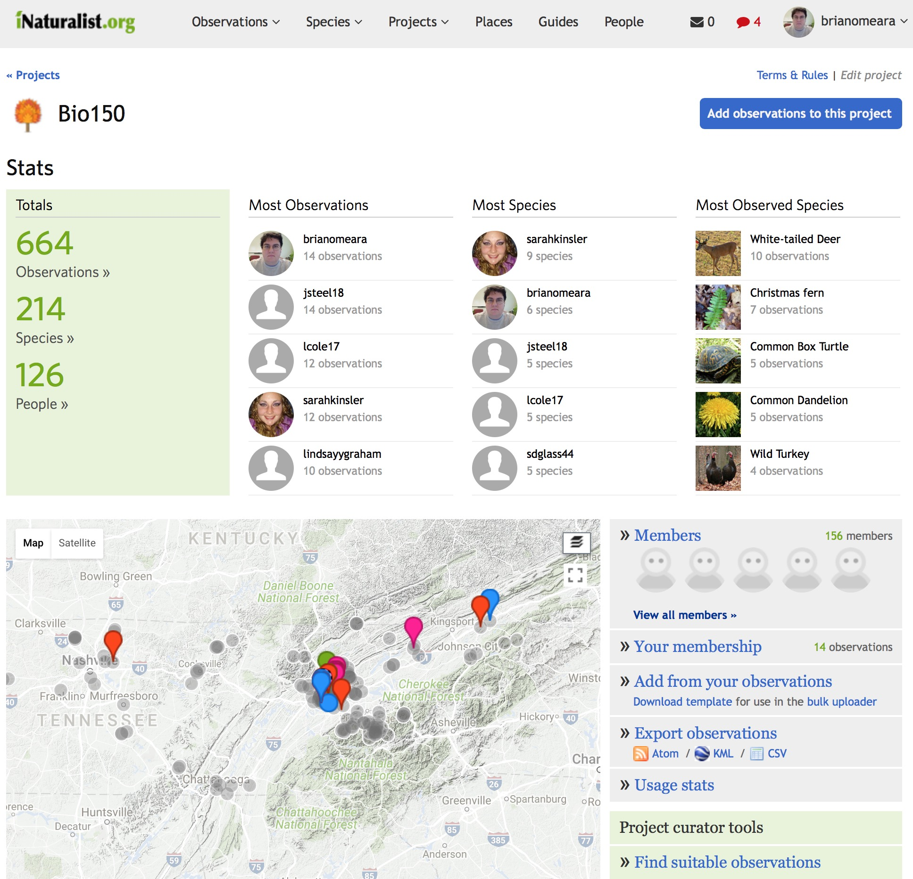In 2012, 2014, and 2016, I taught the large introductory biology class on biodiversity (Bio130 and its modified version of Bio150), which covers major concepts in evolution and ecology and walks students through the tree of life. I use readings, clicker questions, MasteringBiology assignments, and parts of lectures to teach basic material, and the remaining parts of lectures to having students learn to think about the material at higher levels of understanding. I also created a custom web app that would allow students to get lists of species nearby so they could experience biodiversity around them; in the most recent time I taught, I started using iNaturalist (a free app run by the California Academy of Sciences) instead so students could participate in a broader community of citizen scientists, including getting help identifying representatives of various groups of taxa. In addition to anonymous feedback during the class (see below), I embedded observers in the class to see how students were taking notes and engaging with the lectures.

Figure 2: iNaturalist page for Bio150: http://www.inaturalist.org/projects/bio150. 664 observations of 214 species.

Due to my expertise in the field I have frequently been asked to teach in short workshops (this is in addition to research talks). I often give these virtually to prevent disruption of regular duties as well as the expense and hassle of travel. I have taught in Sweden, Austria, North Carolina, Brazil, and Switzerland. I also organized and taught at a workshop at NIMBioS on computational resources for phylogenetics. This course included students from around the world and had a fairly even gender balance.

I have certain approaches I try to extend across all my classes. One is real time assessment of my teaching: I give students a link to an anonymous form they can use to give feedback on any part of the class at any time. This allows me to improve the class for the students in it rather than just waiting for official student-generated assessment reports at the end. I also try to use all the time students are in the room to promote learning, rather than just the assigned class times. For example, some students may show up half an hour early for some classes, and I typically have an educational video relevant to the day’s focal topic running they can learn from while waiting. One consistent theme in student reviews is my enthusiasm for the subject matter. Based on student reactions, my classes are also seen as a safe place to ask questions about confusing material. I also assess knowledge, including using standard reference questions to measure content acquisition during a course; information about the baseline knowledge of our department’s grad students, for example, comes from assessments I write and grade.

Mentoring of graduate students and postdocs is also an important part of my teaching. I have had a dozen postdocs come through my lab: some from internal funds (startup or NSF) and others as co-mentored NIMBioS postdocs. I also advise three graduate students and co-advise a fourth. In addition to my own students, I currently serve on a quarter of all graduate student committees in our department. With all of them, my goal has been to help the student or postdoc achieve her or his professional goals. This may require more teaching experience for some and more work on programming skills for others. I try to create a supportive environment where people are encouraged to propose new ideas but also know that they will receive constructive, honest feedback.

I seek funds to support my teaching, such as an internal grant to buy laptops to use for training students in R. I am currently PI on a proposal for a ~$3M NSF NRT grant (successor to the IGERT program) for graduate training in next generation biodiversity workers that spans faculty from three departments and two colleges (our team has passed UT’s internal competition); last year I was Co-PI on another proposal to the same program but with a different focus. My NSF CAREER grant also includes a significant teaching component through a new graduate level course in comparative methods. This is taught as a flipped, open class: videos and other materials are online, exercises are completed by local and remote students via github, and chat between local students, remote students, and me is encouraged. I will be teaching this class for the second time in Spring 2017; as part of growing that class, I am creating an open access textbook on comparative methods.