In assignment 1, you created the various tables that will be used in the practice problems for this course. One of those tables was **students.**Complete the problems that follow regarding the students table.

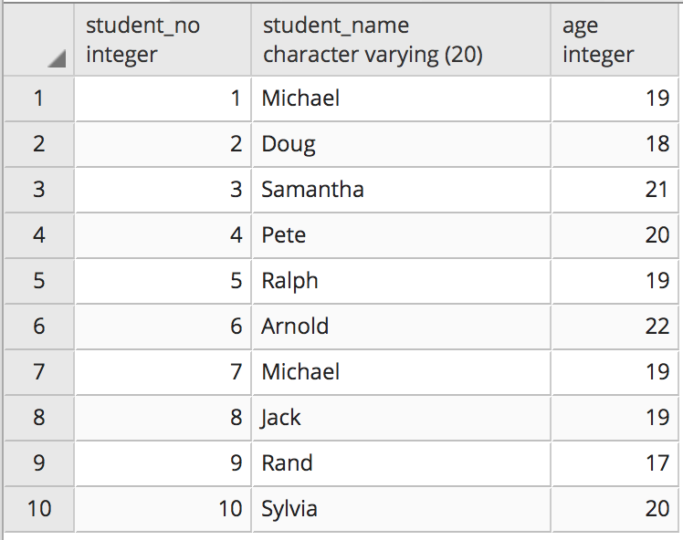

**Questions for this assignment**

**Write a query to display the names of those students that are between the ages of 18 and 20.**

**Write a query to display all of those students that contain the letters "ch" in their name or their name ends with the letters  "nd".**

**Write a query to display the name of those students that have the letters "ae" or "ph" in their name and are NOT 19 years old.**

**Write a query that lists the names of students sorted by their age from largest to smallest.**

**Write a query that displays the names and ages of the top 4 oldest students.**

**ADVANCED:**

**Write a query that returns students based on the following criteria:**

**The student must not be older than age 20 if their student_no is either between 3 and 5 or their student_no is 7. Your query should also return students older than age 20 but in that case they must have a student_no that is at least 4.**