On the bottom of this page, you'll find the link to a SQL script that you'll need to execute. After executing that script you'll have created the table shown below. This table is called **fruit_imports**and it contains data on importing various fruits from different states and things like **supply** and **cost_per_unit**. The problems that follow will involve querying this table.

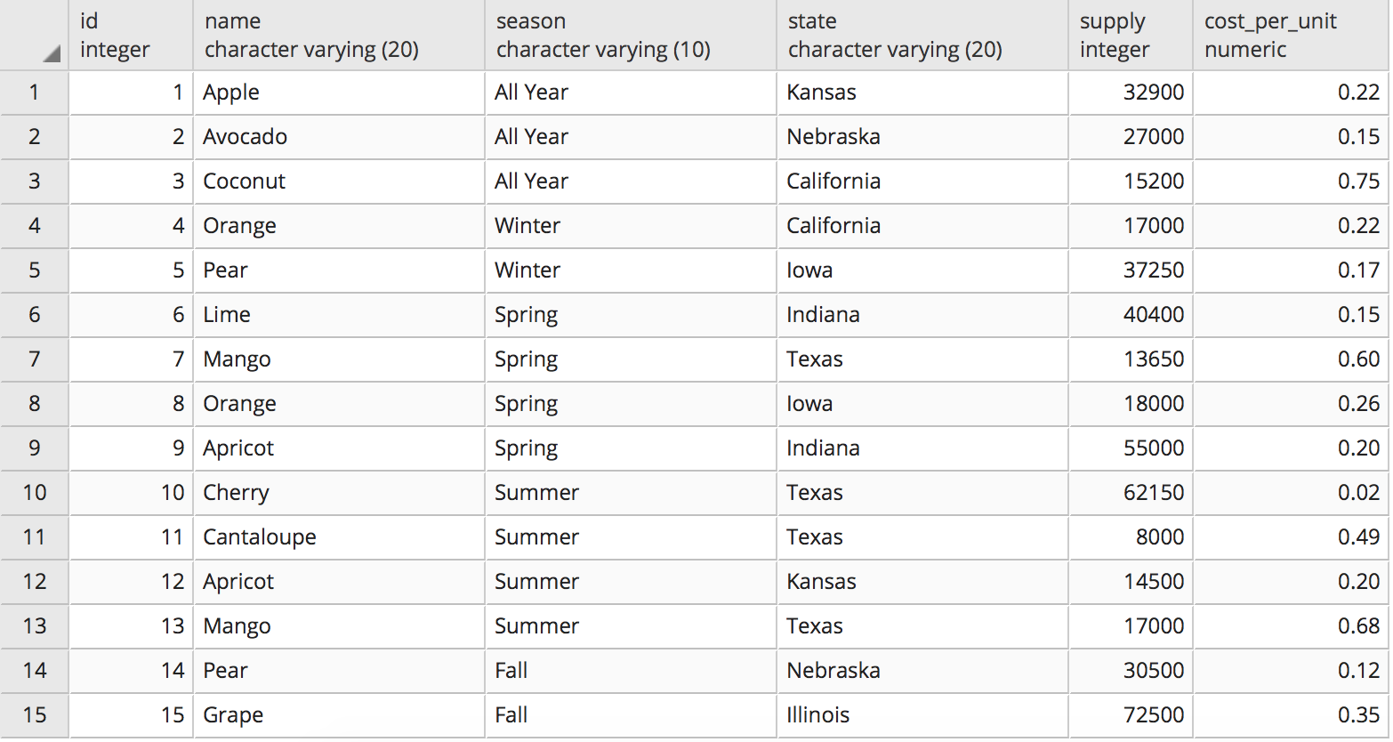

**Questions for this assignment**

**Write a query that displays only the state with the largest amount of fruit supply.**

**Write a query that returns the most expensive cost_per_unit of every season. The query should display 2 columns, the season and the cost_per_unit**

**Write a query that returns the state that has more than 1 import of the same fruit.**

**Write a query that returns the seasons that produce either 3 fruits or 4 fruits.**

**Write a query that takes into consideration the  supply and cost_per_unit columns for determining the total cost and returns the most expensive state with the total cost.**

**Execute the below SQL script and answer the question that follows:**

**CREATE table fruits (fruit_name varchar(10));  
INSERT INTO fruits VALUES ('Orange');  
INSERT INTO fruits VALUES ('Apple');  
INSERT INTO fruits VALUES (NULL);  
INSERT INTO fruits VALUES (NULL);**

**Write a query that returns the count of 4. You'll need to count on the column fruit_name and not use COUNT(*)**

**HINT: You'll need to use an additional function inside of count to make this work.**