In this section you'll practice working with subqueries. The questions that follow are based on the tables you created in assignment one. The image displays 3 of those tables you can use to solve the problems in this section. Reviewthese tables and understand how the data is related before moving on.

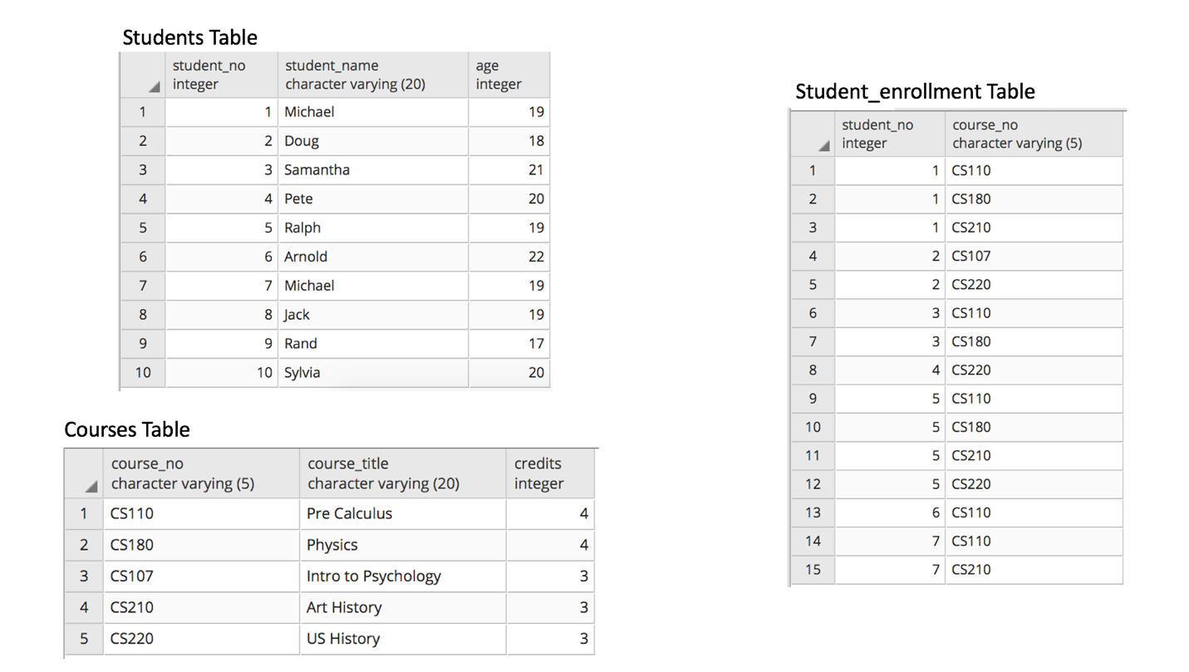

**Questions for this assignment**

**Is the students table directly related to the courses table? Why or why not?**

**Using subqueries only, write a SQL statement that returns the names of those students that are taking the courses  Physics and US History.**

**NOTE: Do not jump ahead and use joins. I want you to solve this problem using only what you've learned in this section.**

**Using subqueries only, write a query that returns the name of the student that is taking the highest number of courses.**

**NOTE: Do not jump ahead and use joins. I want you to solve this problem using only what you've learned in this section.**

**Answer TRUE or FALSE for the following statement:**

**Subqueries can be used in the FROM clause and the WHERE clause but cannot be used in the SELECT Clause.**

**Write a query to find the student that is the oldest. You are not allowed to use LIMIT or the ORDER BY clause to solve this problem.**