Distribution of customers by state (top 10)

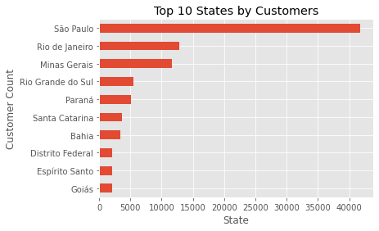

Distribution of sellers by state (top 10)

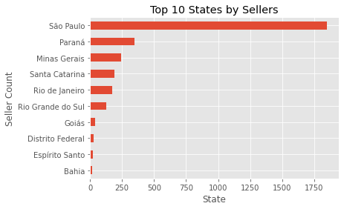

Proportion of Payment Types

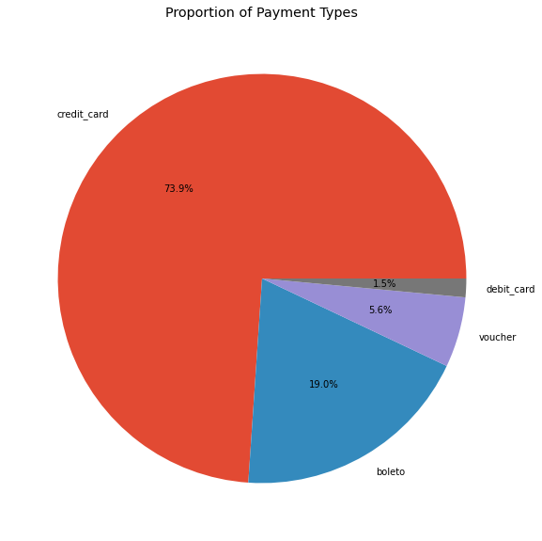

Merge order_items, products on product_id

Merge df_order_payments, df_order_reviews on=’order_id’