Dynamic Programming Applications in Healthcare: Optimal Decision Policies with Experimental Evaluation
Author:[Deepak Bommana] | Department of Computer Science and Engineering (AIML), Marwadi University, Rajkot, Gujarat, India | Academic Year 2026–2027

Abstract—Dynamic programming (DP) solves sequential decision problems by splitting them into overlapping subproblems and reusing their solutions. Healthcare is rich in such problems, including when to start a treatment, how often to screen a patient, and how to allocate scarce resources. This paper reviews how DP and its stochastic extension, the Markov decision process (MDP), are applied in clinical decision-making, healthcare operations, and computational biology, and then tests the method experimentally. A four-state, ten-year chronic-disease model is solved by backward induction and compared against four fixed treatment rules. The DP policy achieves 7.061 expected quality-adjusted life years (QALYs) for a patient starting in the Mild state, against 6.447 for never treating, 6.912 for always treating, 6.362 for treating only severe patients, and 6.950 for treating only mild and moderate patients. The optimal policy depends on the time remaining as well as on the disease state: treatment is optimal only while at least 4 years remain for Mild patients, 5 for Moderate patients, and 10 for Severe patients. The treatment window shrinks as side-effect cost rises. Compared with exhaustive enumeration of all 262,144 policies at a six-year horizon, DP returns the identical optimum in 0.09 ms instead of 18.7 s. The results support choosing among exact DP, approximate DP, and reinforcement learning according to the problem. All model parameters are illustrative and not clinical estimates.
Index Terms—dynamic programming, Markov decision process, healthcare operations, treatment optimization, backward induction, sequence alignment, approximate dynamic programming, reinforcement learning

I. Introduction
Many healthcare decisions are not isolated choices. A physician deciding whether to treat now or wait is also deciding which options will remain at the next visit. A hospital that admits a patient today changes how many beds are free tomorrow. These are sequential decisions made under uncertainty, and each choice shapes the state in which the next choice is made. Evaluating every possible sequence of choices is infeasible, because the number of sequences grows exponentially with the number of decision points.
Dynamic programming, introduced by Bellman in the 1950s [1], is the standard answer to this difficulty. Its core idea is the principle of optimality: whatever the initial state and first decision, the remaining decisions of an optimal policy must be optimal for the state that results. This allows a long decision horizon to be solved stage by stage, working backward from the end. When transitions are random, the same principle applies to Markov decision processes [2], and a growing literature uses them for treatment timing, screening, scheduling, and allocation [3], [4].
This paper asks three practical questions. How does an exactly solved DP policy compare with simple fixed treatment rules? How sensitive is the optimal policy to the side-effect cost of treatment and to the planning horizon? And how does the computational cost of DP compare with exhaustive search, and how does it grow with the number of states? A reference implementation in Python and NumPy [5] answers them, and every number in Sections V to VII was produced by that code.
The scope is discrete-time, finite-horizon problems with a small number of discrete states. The experiments use one hypothetical chronic-disease model with three living states, one absorbing Dead state, two actions, and annual decisions over ten years; its parameters are invented for demonstration. The contributions are: (i) a unified MDP formulation of healthcare decision problems; (ii) a survey of six application areas; (iii) a comparison of the DP-optimal policy with four fixed rules from every living starting state; (iv) a sensitivity analysis that reveals a threshold structure in the optimal policy; (v) a measured comparison of DP with exhaustive enumeration; and (vi) a decision framework for selecting a DP-based method.

II. Background

A. Principle of Optimality and the Bellman Equation
A finite-horizon MDP consists of states s, actions a, transition probabilities P(s′ | s, a), immediate rewards r(s, a), and T decision epochs. Let V_{t}(s) be the best expected total reward obtainable from state s at epoch t onward, with V_{T+1}(s) = 0. The Bellman equation is
V_{t}(s) = max_{a} { r(s, a) + Σ_{s′} P(s′ | s, a) V_{t+1}(s′) } (1)
The recursion is evaluated backward from the final epoch. At each stage the maximizing action is recorded, and the set of recorded actions is the optimal policy. The cost is proportional to T × |S|² × |A| operations [2], [6].

B. Markov Decision Processes in Medicine
The MDP framework fits medicine because disease progression is naturally described by stages, treatments change the transition probabilities, and outcomes are measured in life years, QALYs, or cost. A policy maps every state and time to an action, which makes it easy to read and to challenge clinically [3], [4].

C. Partially Observable Problems
In screening and diagnosis the true state is only partly observed through imperfect tests. The problem becomes a partially observable MDP (POMDP) whose state is a probability distribution over true disease states. Exact solution is much harder, and approximate methods are normally used [7].

D. Approximate DP and Reinforcement Learning
When the state space is too large, approximate dynamic programming replaces the exact value function with a compact approximation [8]. Reinforcement learning extends the idea to cases where the transition model is unknown and must be learned from experience [9]. Both trade a guarantee of optimality for tractability.

E. Deterministic DP in Bioinformatics
In computational biology DP appears in its original deterministic form. The Needleman–Wunsch algorithm [10] finds the best global alignment of two sequences by filling a score matrix, Smith–Waterman [11] does the same for local alignment, and the Viterbi algorithm [12] decodes the most likely state path of a hidden Markov model, as used in gene finding and profile searching [13].

III. Survey of Healthcare Applications
DP applications in healthcare fall into three groups: decisions about one patient over time, decisions about a population or facility, and sequence analysis in computational biology. Table I summarizes representative problems.
TABLE I
REPRESENTATIVE HEALTHCARE APPLICATIONS OF DP
Area | State; decision | Objective | Refs.
Treatment initiation | Disease stage; start or wait | Maximize QALYs | [14], [15]
Cancer screening | Belief about cancer status; screen or skip | Maximize QALYs net of false-positive harm | [16], [7]
Organ transplantation | Patient health, organ quality; accept or wait | Maximize expected life years | [17]
Patient scheduling | Queue length by priority; whom to book | Minimize waiting beyond target | [18]
Radiotherapy planning | Tumor and tissue response; dose per session | Control tumor, limit tissue damage | [19]
Sequence analysis | Position in two sequences; match, mismatch, or gap | Maximize alignment score | [10], [11]

Treatment and screening problems are the classic use of MDPs in medicine. Starting a drug early gives longer protection but exposes the patient to side effects and cost for longer, whereas starting late risks irreversible damage. Operational problems treat the queue or bed census as the state; Patrick et al. [18] schedule a diagnostic resource across priority classes using approximate DP. In radiotherapy each daily fraction is a stage, so later doses can adapt to the response observed so far [19]. In bioinformatics, DP is exact and deterministic [10], [11].

IV. Model and Experimental Setup
The framework compares four fixed treatment rules with the DP-optimal policy under one model. Rule A never treats. Rule B always treats every living patient. Rule C treats only Severe patients, imitating a practice of reserving treatment for advanced disease. Rule D treats only Mild and Moderate patients. Rule E is the DP-optimal policy. Every rule is evaluated by exact policy evaluation, a backward recursion that follows the rule instead of maximizing, so differences in value are due to the rule alone and contain no sampling noise.
The model describes a chronic disease. A patient is in one of four states: Mild, Moderate, Severe, or Dead. Each year the clinician chooses Wait or Treat. The yearly reward is a quality weight of 0.9 (Mild), 0.7 (Moderate), 0.4 (Severe), or 0 (Dead). Treatment subtracts a side-effect cost of 0.08 in any living state, so the base-case reward for treating a Mild patient is 0.82. Treatment slows progression and lowers mortality but does not reverse disease, and Dead is absorbing. There is no discounting, and the horizon is ten years with a decision at the start of each year. The transition probabilities are listed in Table II. All values are hypothetical.
TABLE II
ANNUAL TRANSITION PROBABILITIES (HYPOTHETICAL)
From | Action | Mild | Moderate | Severe | Dead
Mild | Wait | 0.80 | 0.17 | 0.02 | 0.01
Mild | Treat | 0.90 | 0.09 | 0.005 | 0.005
Moderate | Wait | 0 | 0.78 | 0.18 | 0.04
Moderate | Treat | 0 | 0.86 | 0.11 | 0.03
Severe | Wait | 0 | 0 | 0.85 | 0.15
Severe | Treat | 0 | 0 | 0.89 | 0.11

Backward induction was implemented as the loop below, where W and T are the transition matrices for waiting and treating, u is the vector of quality weights, c is the side-effect cost, and V is initialized to zero at the end of the horizon.
for t in range(H, 0, -1):
q_wait = u + W @ V
q_treat = u - np.where(living, c, 0) + T @ V
V = np.maximum(q_wait, q_treat)
policy[t] = q_treat > q_wait
Computation times are single runs on one machine, so only their ratios and growth are interpreted. The scaling experiment uses random transition matrices generated with a fixed NumPy seed of 0, two actions, and 50 backward steps.

V. Experimental Results
All values are rounded to three decimals.

A. Optimal Policy by Years Remaining
Table III gives the optimal action and the gain from treating for every state and number of years remaining. The gain is the expected QALYs from treating minus the expected QALYs from waiting, with optimal behavior afterward; a positive gain means treating is optimal. The policy has a threshold structure: treat while at least 4 years remain for Mild patients, at least 5 for Moderate patients, and 10 for Severe patients. Severe patients show a gain of only 0.002 QALYs even with ten years left, so the case for treating them is marginal (Figs. 1 and 2).
TABLE III
OPTIMAL ACTION AND GAIN FROM TREATING (QALYS)
Years left | Mild | Mod. | Severe | Gain (Mild) | Gain (Mod.) | Gain (Sev.)
10 | Treat | Treat | Treat | 0.209 | 0.108 | 0.002
9 | Treat | Treat | Wait | 0.175 | 0.092 | -0.002
8 | Treat | Treat | Wait | 0.142 | 0.075 | -0.008
7 | Treat | Treat | Wait | 0.108 | 0.057 | -0.014
6 | Treat | Treat | Wait | 0.075 | 0.038 | -0.021
5 | Treat | Treat | Wait | 0.041 | 0.018 | -0.029
4 | Treat | Wait | Wait | 0.009 | -0.003 | -0.039
3 | Wait | Wait | Wait | -0.022 | -0.026 | -0.050
2 | Wait | Wait | Wait | -0.052 | -0.052 | -0.064
1 | Wait | Wait | Wait | -0.080 | -0.080 | -0.080

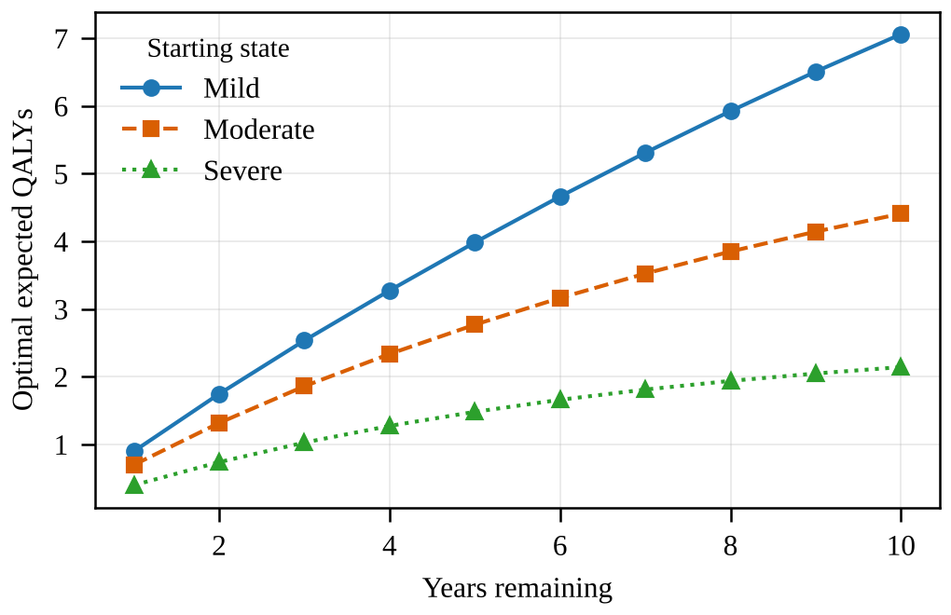
Fig. 1. Optimal expected QALYs by starting state and years remaining.
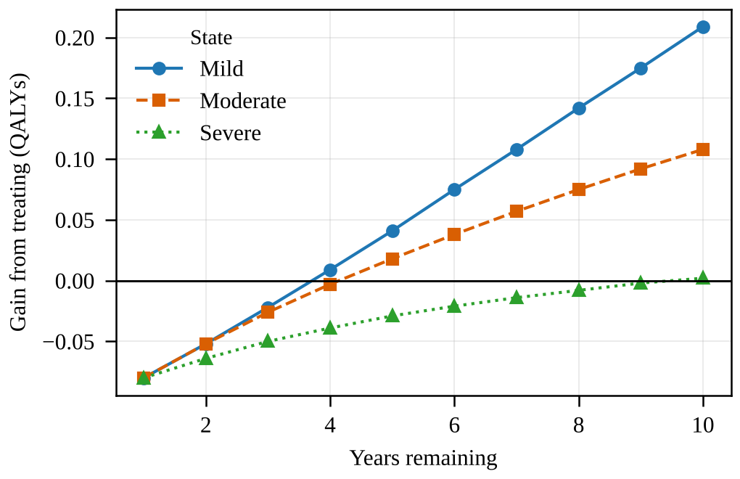
Fig. 2. Gain from treating relative to waiting, by state and years remaining. Treating is optimal where the gain is positive.

B. DP Policy Against Fixed Rules
Table IV compares the DP policy with the four fixed rules. By construction the DP policy cannot be worse than any fixed rule, and here it is better than every one from every starting state, although the margin from a Severe start is only 0.002 QALYs. From a Mild start it gains 0.614 QALYs over never treating, 0.149 over always treating, and 0.111 over the best fixed rule (treat mild and moderate). Treating only severe patients is the worst rule from Mild and Moderate starts and falls below even never treating (Fig. 3), which shows that reserving treatment for advanced disease can be a poor use of treatment in this model.
TABLE IV
EXPECTED QALYS BY POLICY AND STARTING STATE
Policy | Start Mild | Start Moderate | Start Severe
Never treat (A) | 6.447 | 4.138 | 2.142
Always treat (B) | 6.912 | 4.263 | 2.002
Severe only (C) | 6.362 | 4.011 | 2.002
Mild and moderate (D) | 6.950 | 4.364 | 2.142
DP optimal (E) | 7.061 | 4.410 | 2.144

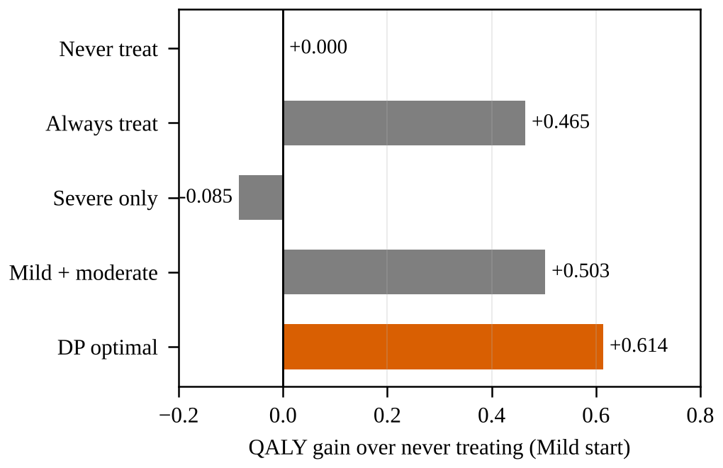
Fig. 3. QALY gain over never treating, from a Mild start, under each policy.

VI. Sensitivity Analysis
Two parameters were varied one at a time: the yearly side-effect cost of treatment and the planning horizon. Table V reports, for each cost, the number of epochs out of ten in which treating is optimal in each state.
TABLE V
EFFECT OF SIDE-EFFECT COST ON THE OPTIMAL POLICY
Cost | QALYs (Mild) | Years: Mild | Years: Mod. | Years: Sev. | Gain vs. never
0.02 | 7.494 | 9 | 9 | 8 | 1.047
0.05 | 7.261 | 8 | 8 | 6 | 0.814
0.08 | 7.061 | 7 | 6 | 1 | 0.614
0.12 | 6.837 | 6 | 4 | 0 | 0.390
0.16 | 6.668 | 4 | 2 | 0 | 0.221
0.20 | 6.545 | 3 | 0 | 0 | 0.097

As the side-effect cost rises from 0.02 to 0.20, the number of treatment years for a Mild patient falls from 9 to 3, for a Moderate patient from 9 to 0, and for a Severe patient from 8 to 0. The benefit of the DP policy over never treating falls from 1.047 to 0.097 QALYs. At high cost, treatment is worthwhile only for patients who are still mild and have many years ahead of them.
Table VI varies the horizon. Across all five horizons the same thresholds appear: Mild patients are treated except in the last 3 years, Moderate patients except in the last 4, and Severe patients only when at least 10 years remain. The stopping point is a property of the model and not of the horizon, so a clinician can apply the rule as a time-to-go threshold. Such threshold structure is common in MDPs with monotone dynamics, although it is not guaranteed in general.
TABLE VI
EFFECT OF THE PLANNING HORIZON
Horizon (years) | QALYs (Mild) | Years: Mild | Years: Mod. | Years: Sev.
5 | 3.985 | 2 | 1 | 0
10 | 7.061 | 7 | 6 | 1
15 | 9.375 | 12 | 11 | 6
20 | 11.032 | 17 | 16 | 11
30 | 12.955 | 27 | 26 | 21

VII. Computational Complexity
Exhaustive enumeration of every deterministic, time-dependent policy was compared with backward induction. With three living states and two actions there are 2^{3H} policies for horizon H, which is 262,144 at H = 6 (Table VII). Both methods returned the same optimal value in every case.
TABLE VII
BACKWARD INDUCTION VERSUS EXHAUSTIVE ENUMERATION
Horizon (years) | Policies | DP (ms) | Enumeration (ms) | Same optimum
2 | 64 | 0.023 | 1.6 | Yes
3 | 512 | 0.036 | 17.9 | Yes
4 | 4,096 | 0.063 | 192.5 | Yes
5 | 32,768 | 0.072 | 1,991.3 | Yes
6 | 262,144 | 0.091 | 18,697.3 | Yes

At H = 6 enumeration took about 18.7 s while DP took 0.09 ms, a ratio of roughly 200,000 to one, and the ratio grows exponentially with the horizon. DP time grew only slightly because its cost is linear in the horizon.
Table VIII reports the time for 50 backward steps as the number of states grows. The theoretical cost of a backward step is quadratic in the number of states. Measured times rise from 0.34 ms at 10 states to 12.03 ms at 800 states, but they do not follow the quadratic law exactly, because small sizes are dominated by overhead and vectorized matrix products behave differently at large sizes. The timings are single runs and should be read as indicative. The practical limit of exact DP is set by the state space: a model that tracks many patient variables multiplies the number of states and quickly exceeds memory and time budgets, which motivates approximate methods.
TABLE VIII
TIME FOR 50 BACKWARD STEPS VERSUS NUMBER OF STATES
States | 10 | 50 | 100 | 200 | 400 | 800
Time (ms) | 0.34 | 0.31 | 0.41 | 1.09 | 6.31 | 12.03

VIII. Method Selection Strategy
Table IX maps problem types to suitable methods, and the steps that follow turn the evidence into a practical procedure.
TABLE IX
CHOOSING A DP-BASED METHOD
Problem | Method | Behavior and interpretation
Small discrete state space, known probabilities | Exact backward induction | Exact optimum; 0.09 ms at H = 6 here. Cost linear in horizon, quadratic in states.
Hidden disease state (screening) | POMDP, approximate solution | Exact solution rarely feasible; belief space is continuous.
Large state vector (many covariates) | Approximate DP | Tractable but trades optimality for scale; validate on small exact cases.
Unknown transition model | Reinforcement learning | Learns from data or a simulator; needs much data and safety controls.
Two sequences to compare | Needleman–Wunsch, Smith–Waterman | Exact alignment in O(mn) time; no uncertainty, so no policy.
Queueing and scheduling | Approximate DP with simulation | Large queues make the state space explode; benchmark against heuristics.

The important point is that DP is a family of methods rather than a single algorithm. Its value emerges from the interaction between the size of the state space, the observability of the state, and the availability of a reliable transition model. The reference model is therefore a baseline for choosing among these methods and not evidence that exact DP suits every healthcare problem. A practical procedure follows.
- Define the problem. List states, actions, epochs, and the outcome measure, and confirm that the future depends mainly on the current state.
- Estimate transitions. Use trials, registries, or health records, and record the uncertainty of each estimate.
- Count the states. If the state space is small, solve by exact backward induction and keep the policy table.
- Check observability. If the true state is hidden, use a POMDP or a belief-state approximation.
- Scale only when needed. For large state vectors, use approximate DP and validate it against exact DP on a reduced version of the problem.
- Benchmark against clinical rules. Evaluate current practice as a fixed policy to show what the optimal policy adds.
- Run sensitivity analysis. Vary costs, probabilities, and horizon, and report the thresholds on which the policy depends.
- Validate clinically. Review the policy with clinicians and test it on held-out patient data before any use in care.

IX. Discussion and Limitations
The experiment shows that exact DP can add value even in a small model. The DP policy outperformed every fixed rule, yet the margin over the best simple rule was modest (0.111 QALYs from a Mild start). This suggests that the main benefit of DP in practice may be to identify which simple rule is nearly optimal and where it fails, rather than to replace the rule.
The optimal action also depends on the years remaining, so a policy that ignores the horizon can be wrong near its end. In the model the benefit of treating falls below its side-effect cost when too few years remain for the benefit to accrue. Static guidelines that depend only on the disease state would miss this effect, although a threshold on time to go would capture it.
Backward induction is exact, fast, and reproducible, and it produces a table that a clinician can inspect. These properties are valuable in a clinical setting and are lost when the problem must be pushed to approximate or learned methods, where the evidence for correctness is weaker.
The study has limitations. All transition probabilities and quality weights are invented and have no clinical validity. The model has only three living states and one treatment, whereas real problems involve many covariates and options. The Markov assumption and stationary transitions are simplifications, since real progression depends on history and age. Rewards are undiscounted and single-objective, so equity and cost constraints are not modeled. Parameter uncertainty is not propagated, so the robustness of the thresholds to estimation error is unknown. Timings are single runs on one machine, and the scaling test uses random rather than clinical matrices. Finally, the survey is selective and is not a systematic review.

X. Conclusion and Future Work
This paper surveyed and experimentally evaluated dynamic programming in healthcare. A formulation as a Markov decision process, solved by backward induction, produced an exact and readable optimal policy for a hypothetical chronic-disease problem. The policy outperformed four fixed treatment rules, with 7.061 expected QALYs from a Mild start against 6.912 for always treating and 6.950 for the best selective rule. It also exhibited a threshold structure in time remaining that is stable across horizons.
The strongest practical evidence concerns computation. DP matched exhaustive enumeration exactly while running about 200,000 times faster at a six-year horizon, yet its cost grows with the state space, which limits exact solution of realistic models. These observations support a method-selection perspective: use exact DP when the state space is small and the model is reliable, and move to approximate DP or reinforcement learning when it is not, validating each against the exact solution where possible.
Future work will estimate transition probabilities from a real cohort and compare the resulting policy with published guidelines; add parameter uncertainty through probabilistic sensitivity analysis; extend the model to partially observable settings and compare exact and approximate solutions; benchmark approximate DP on a larger scheduling problem; combine DP with reinforcement learning so that learned policies are verified on small exact models; add fairness constraints and multiple objectives; and build patient-specific digital twins that supply the states and transition estimates that DP requires.

References
[1] R. Bellman, Dynamic Programming. Princeton, NJ, USA: Princeton Univ. Press, 1957.
[2] M. L. Puterman, Markov Decision Processes: Discrete Stochastic Dynamic Programming. New York, NY, USA: Wiley, 1994.
[3] O. Alagoz, H. Hsu, A. J. Schaefer, and M. S. Roberts, “Markov decision processes: A tool for sequential decision making under uncertainty,” Med. Decis. Making, vol. 30, no. 4, pp. 474–483, 2010.
[4] A. J. Schaefer, M. D. Bailey, S. M. Shechter, and M. S. Roberts, “Modeling medical treatment using Markov decision processes,” in Operations Research and Health Care, M. L. Brandeau, F. Sainfort, and W. P. Pierskalla, Eds. Boston, MA, USA: Kluwer, 2004, pp. 593–612.
[5] D. Bommana, “Python/NumPy reference implementation of the treatment-timing MDP, policy comparison, and scaling experiments,” unpublished code written for this study, 2026.
[6] D. P. Bertsekas, Dynamic Programming and Optimal Control, vol. I, 4th ed. Belmont, MA, USA: Athena Scientific, 2017.
[7] T. Ayer, O. Alagoz, and N. K. Stout, “A POMDP approach to personalize mammography screening decisions,” Oper. Res., vol. 60, no. 5, pp. 1019–1034, 2012.
[8] W. B. Powell, Approximate Dynamic Programming: Solving the Curses of Dimensionality, 2nd ed. Hoboken, NJ, USA: Wiley, 2011.
[9] R. S. Sutton and A. G. Barto, Reinforcement Learning: An Introduction, 2nd ed. Cambridge, MA, USA: MIT Press, 2018.
[10] S. B. Needleman and C. D. Wunsch, “A general method applicable to the search for similarities in the amino acid sequence of two proteins,” J. Mol. Biol., vol. 48, no. 3, pp. 443–453, 1970.
[11] T. F. Smith and M. S. Waterman, “Identification of common molecular subsequences,” J. Mol. Biol., vol. 147, no. 1, pp. 195–197, 1981.
[12] A. J. Viterbi, “Error bounds for convolutional codes and an asymptotically optimum decoding algorithm,” IEEE Trans. Inf. Theory, vol. IT-13, no. 2, pp. 260–269, Apr. 1967.
[13] R. Durbin, S. Eddy, A. Krogh, and G. Mitchison, Biological Sequence Analysis. Cambridge, U.K.: Cambridge Univ. Press, 1998.
[14] S. M. Shechter, M. D. Bailey, A. J. Schaefer, and M. S. Roberts, “The optimal time to initiate HIV therapy under ordered health states,” Oper. Res., vol. 56, no. 1, pp. 20–33, 2008.
[15] B. T. Denton, M. Kurt, N. D. Shah, S. C. Bryant, and S. A. Smith, “Optimizing the start time of statin therapy for patients with diabetes,” Med. Decis. Making, vol. 29, no. 3, pp. 351–367, 2009.
[16] L. M. Maillart, J. S. Ivy, S. Ransom, and K. Diehl, “Assessing dynamic breast cancer screening policies,” Oper. Res., vol. 56, no. 6, pp. 1411–1427, 2008.
[17] O. Alagoz, L. M. Maillart, A. J. Schaefer, and M. S. Roberts, “Choosing among living-donor and cadaveric livers,” Manage. Sci., vol. 53, no. 11, pp. 1702–1715, 2007.
[18] J. Patrick, M. L. Puterman, and M. Queyranne, “Dynamic multipriority patient scheduling for a diagnostic resource,” Oper. Res., vol. 56, no. 6, pp. 1507–1525, 2008.
[19] M. Kim, A. Ghate, and M. H. Phillips, “A Markov decision process approach to temporal modulation of dose fractions in radiation therapy planning,” Phys. Med. Biol., vol. 54, no. 14, pp. 4455–4476, 2009.

