PRACTICAL EXPERIMENT – 20

Create a GitHub Repository and Implement Version Control

1. Aim
To create a GitHub repository, clone it to a local computer, modify the README.md file, and use version-control operations to commit and push the changes to GitHub.

2. Software and Tools Required
- GitHub account and a web browser
- Google Antigravity IDE
- Git version-control system
- Internet connection

3. Repository Details
Repository name | SE-Practicals
Visibility | Public
Default branch | main
File modified | README.md
Commit message | Updated README with project details

4. Procedure
Create a GitHub repository
Sign in to GitHub. Select the plus (+) menu and choose New repository. Enter SE-Practicals as the repository name, add a description, select Public visibility, enable Add a README file, and create the repository.
Copy the repository URL
Open the repository, click the green Code button, select HTTPS, and copy the repository URL.
Clone the repository
In Antigravity, open the Command Palette using Ctrl+Shift+P. Select Git: Clone, paste the HTTPS URL, choose a local destination folder, and open the cloned repository.
Edit README.md
Open README.md in the editor. Add the project description, technologies used, objective, and author information. Save the file using Ctrl+S.
Review the change
Open the Source Control panel using the branch-shaped icon. Confirm that README.md appears under Changes.
Commit the change
Enter 'Updated README with project details' in the commit-message box and select Commit. If prompted, stage the changes and continue.
Push the commit to GitHub
Use Push or Sync Changes in Source Control. Confirm if prompted and wait for synchronization to finish.
Verify the result online
Refresh the SE-Practicals repository in the browser. Open README.md and verify that the updated content is displayed.

5. README.md Content Used
# SE-Practicals
## About
This repository contains my Software Engineering
and DevOps practical experiments.
## Technologies Used
- Git
- GitHub
- Docker
- Kubernetes
- Jenkins
- Python
## Objective
To understand version control, collaboration,
containerization and CI/CD.
## Author
NAVEEN

6. Important Git Operations
Operation | Purpose
Clone | Creates a local copy of a remote repository.
Edit | Changes the contents of a file.
Stage | Selects changes to be included in the next commit.
Commit | Records staged changes in the local repository history.
Push | Uploads local commits to the remote repository.

7. Result
A GitHub repository named SE-Practicals was created and cloned to the local computer. The README.md file was edited and a local commit was created with the message 'Updated README with project details'. The push and online verification must be confirmed in GitHub before marking the experiment fully complete.

8. Viva Questions and Answers
What is Git?
Git is a distributed version-control system used to track file changes and coordinate work.
What is GitHub?
GitHub is an online platform for hosting Git repositories and collaborating on projects.
What is a repository?
A repository is a project directory whose files and change history are tracked by Git.
What is cloning?
Cloning copies a remote repository to a local computer.
What is staging?
Staging selects changes to be included in the next commit.
What is a commit?
A commit records a snapshot of staged changes in the local repository history.
What is pushing?
Pushing uploads local commits to a remote repository.
What is README.md?
README.md is a Markdown file that introduces a project and explains its purpose.
What is a branch?
A branch is an independent line of development in a Git repository.
What is the main branch?
The main branch is the primary branch of a repository, commonly named main.

9. Screenshots / Evidence
Insert the following screenshots in the spaces below:
Screenshot 1 – GitHub repository created (SE-LAB).
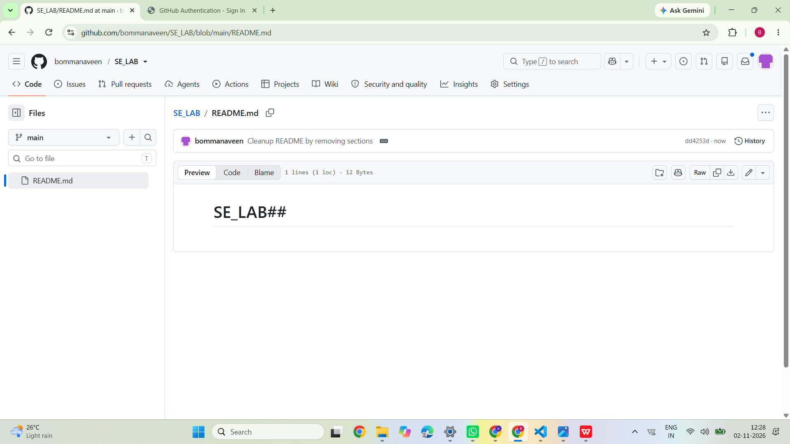
Screenshot 2 – VS Code showing README.md and the local commit.
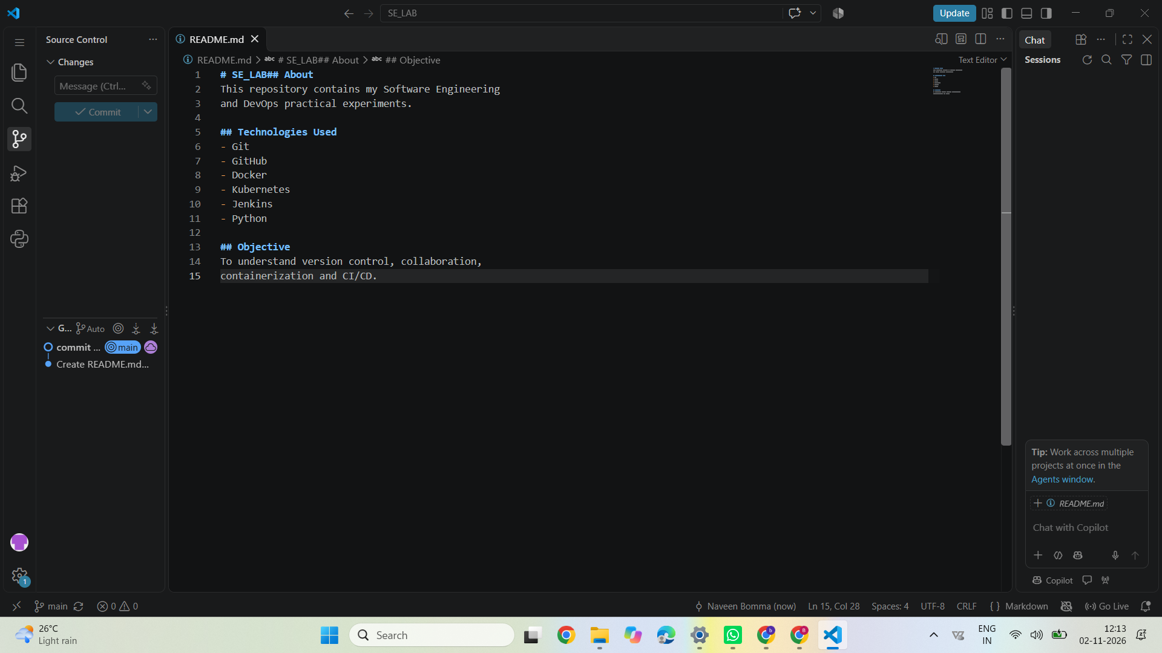
Screenshot 3 – Updated README displayed on GitHub after pushing.
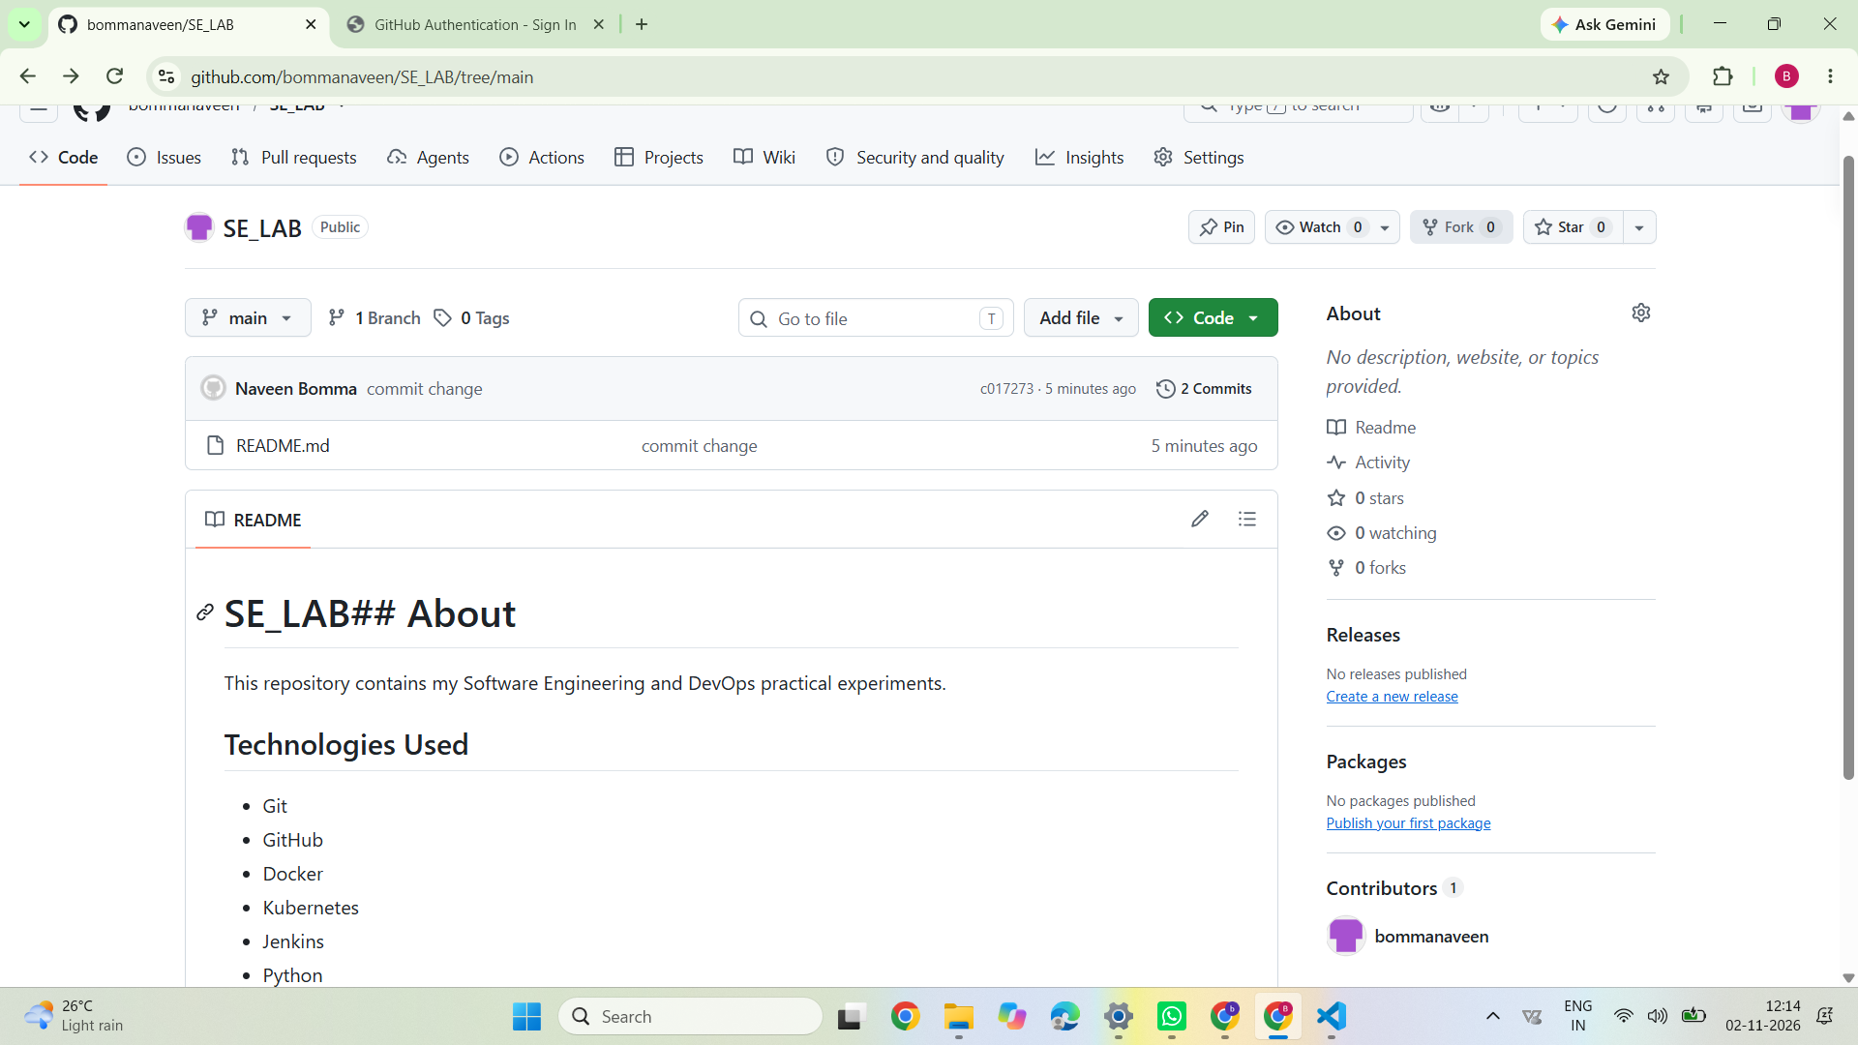
— End of Experiment 20 —

