PRACTICAL EXPERIMENT – 21

Clone an Existing GitHub Repository and Modify a File

1. Aim
To clone an existing public GitHub repository to a local computer, open a file in the repository, make a small modification, and save the modified file.

2. Software and Tools Required
- GitHub account and a web browser
- Vs codeIDE
- Git version-control system
- Internet connection

3. Repository Details
Repository | SE-LAB
Repository URL | https://github.com/bommanaveen/SE_LAB/blob/main/README.md
Local workspace example | Documents\Q21-Workspace
File modified | README.md
Modification | Added a Q21 experiment section

4. Procedure
Open the existing repository
Open the SE-Practicals repository on GitHub using a web browser.
Copy the repository URL
Click the green Code button, select HTTPS, and copy the repository URL.
Start the clone operation
Open Google Antigravity. Press Ctrl+Shift+P to open the Command Palette, search for Git: Clone, and select the command.
Clone the repository
Paste the copied HTTPS URL. Choose a new local destination folder, such as Documents\Q21-Workspace. Wait for the cloning operation to finish and open the cloned repository.
Open the file
In the Explorer panel, locate and open README.md.
Modify the file
Add the following section at the bottom of README.md:
Save the modification
Press Ctrl+S to save README.md.
Verify the modification
Check that the new Q21 section is visible in the editor and that the file is saved.

5. Text Added to README.md
## Q21 - Clone Experiment
This section was added while practising
Git repository cloning and file modification.

6. Expected Observation
The repository is available as a local copy in the selected workspace. The README.md file displays the added Q21 section after it is saved. The change is visible in the local working copy.

7. Result
The GitHub repository is to be cloned to the local computer, and a small change is to be made and saved in README.md. Confirm the successful clone and saved modification in Antigravity before recording the experiment as completed. This experiment does not require a commit or push.

8. Important Concepts
Concept | Meaning
Repository | A project folder whose files and history are tracked by Git.
Clone | Creates a local copy of a remote repository.
Working copy | The local files where changes can be made.
README.md | A Markdown file that describes the project.
Save | Writes the edited file to the local computer; it does not itself create a Git commit.

9. Viva Questions and Answers
What is Git?
Git is a distributed version-control system used to track changes in files.
What is GitHub?
GitHub is an online platform for hosting Git repositories and collaborating on projects.
What does git clone do?
It creates a local copy of a remote repository.
What is a remote repository?
A repository hosted on a server or platform such as GitHub.
What is a local repository?
A repository stored on the user's computer.
What is README.md?
A Markdown file that provides information about a project.
Does saving a file automatically push it to GitHub?
No. Saving updates the local file. A commit and push are separate operations.
Is a commit required in this experiment?
No. The stated task requires cloning, modifying a file, and saving the change.

10. Screenshots / Evidence
Insert screenshots showing the following evidence:
Screenshot 1 – Existing SE-LABrepository on GitHub.
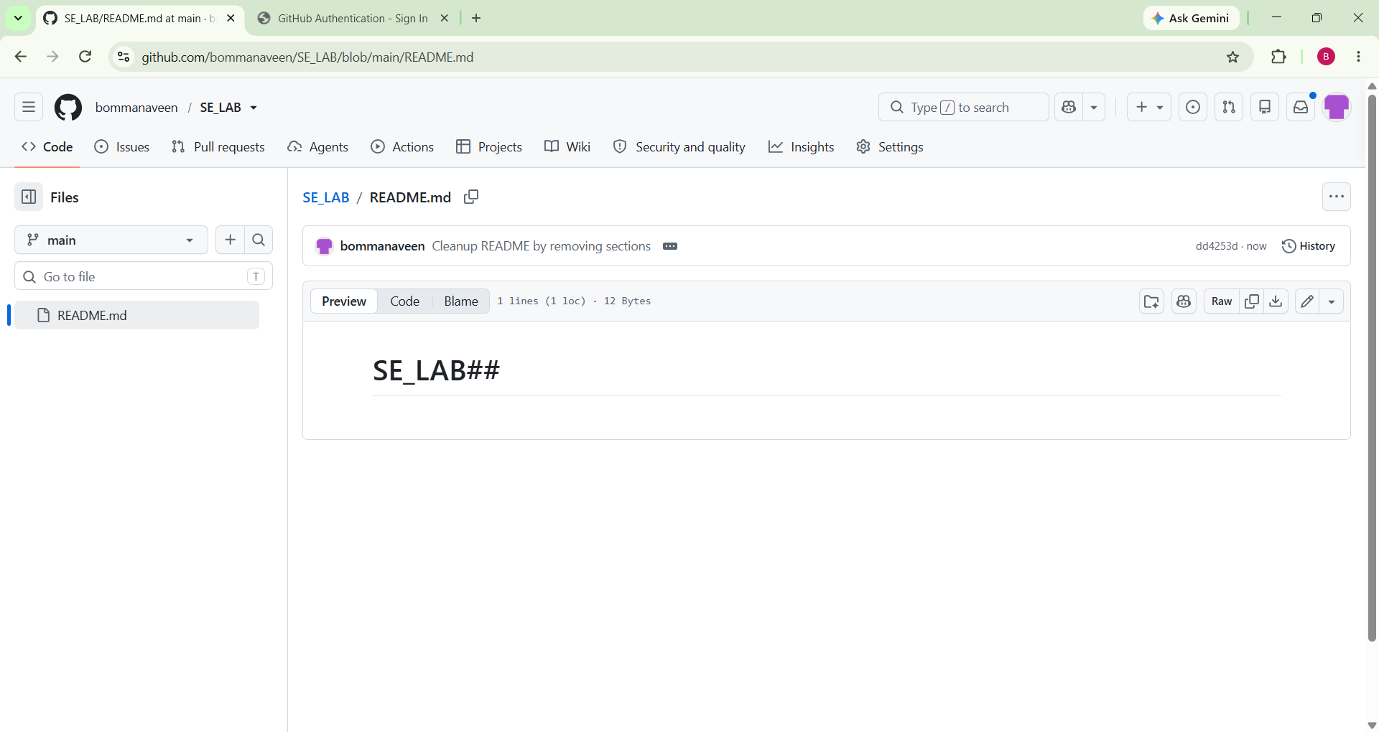
Screenshot 2 – Cloned repository open in vs code Explorer.
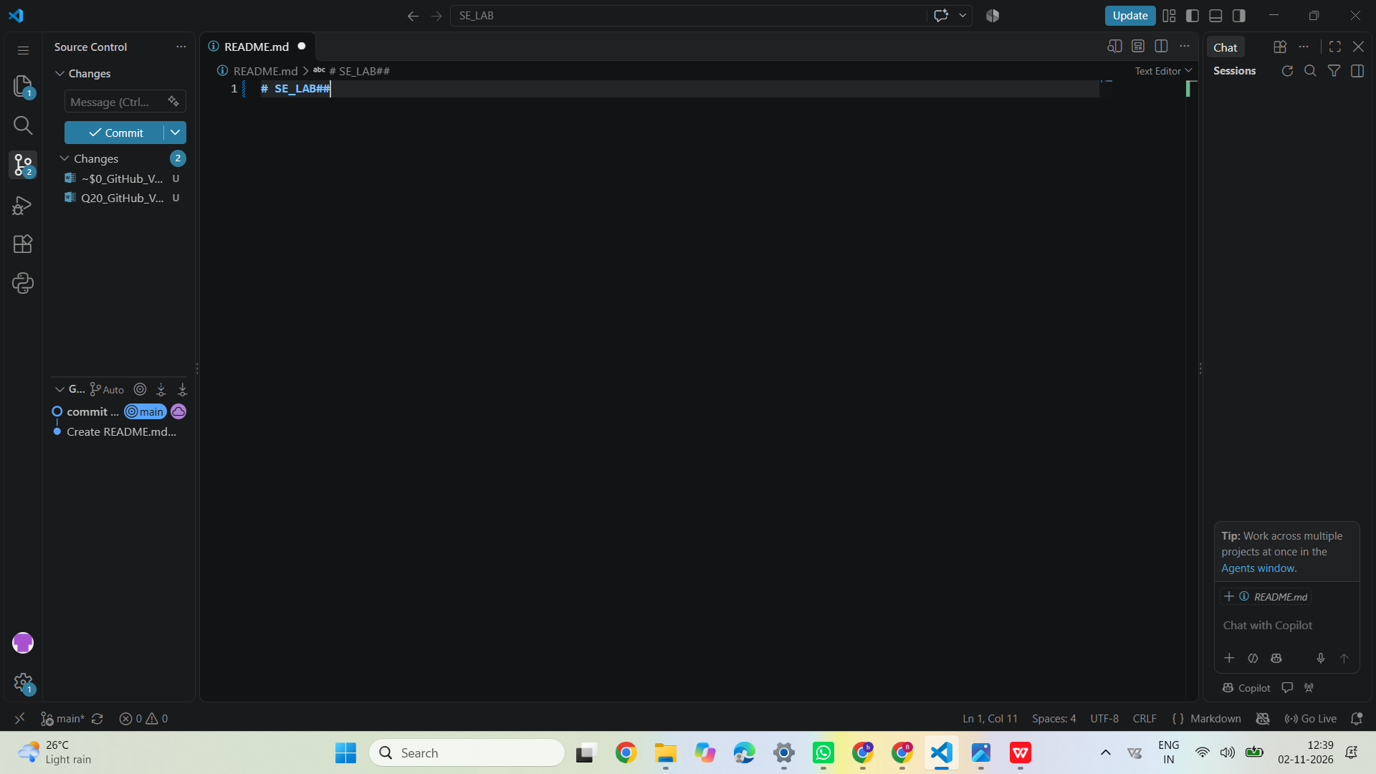
Screenshot 3 – README.md showing the added Q21 section.


