Deep Learning-Based Knee Orthopedic X-ray Image Detection

Abstract— In the realm of medical imaging, accurate and swift detection of orthopedic issues using X-ray images is crucial for timely diagnosis and treatment. This research presents an innovative approach leveraging an ensemble of deep learning models, specifically MobileNet, ResNet, and AlexNet, implemented using the PyTorch library, to enhance the precision of knee orthopedic anomaly detection in X-ray images. The ensemble method capitalizes on the unique strengths of each model, combining their predictions to improve the overall diagnostic accuracy. MobileNet, known for its efficiency on mobile devices, ResNet, celebrated for its deep residual learning framework, and AlexNet, a pioneer in deep learning for image recognition, together form a robust system for analyzing knee X-ray images. This synergy allows for a comprehensive feature extraction and analysis, leading to improved detection capabilities. We trained our ensemble on a diverse dataset of knee X-ray images, encompassing a wide range of orthopedic conditions. The performance of the ensemble method was evaluated based on its accuracy in identifying knee anomalies compared to ground truth annotations provided by medical professionals. Our results demonstrate that the ensemble approach significantly outperforms individual model predictions, achieving an accuracy of 78%. This improvement underscores the potential of using deep learning ensembles in medical image analysis, offering a promising avenue for enhancing diagnostic processes in orthopedics. This study not only showcases the effectiveness of combining multiple deep learning architectures but also sets a foundation for future research in medical imaging, encouraging further exploration of ensemble methods in improving diagnostic accuracy.
Keywords— Deep Learning, Knee Orthopedic X-ray Image Detection, Ensemble Method, MobileNet, ResNet, AlexNet, PyTorch
Diagnostic Accuracy Introduction
Knee injuries are a major concern in the field of orthopedic medicine, requiring prompt and precise diagnosis in order to initiate appropriate therapy. Diagnostic techniques that are based on human interpretation of X-ray pictures, or traditional approaches, are prone to subjectivity and mistake. But recent developments in deep learning technologies have completely changed the field of medical imaging and opened up exciting new possibilities for improving the accuracy and effectiveness of knee injury detection. This study investigates the relationship between deep learning and knee orthopedics with the goal of determining how well deep learning techniques may be used to identify knee ailments using X-ray imaging. Ligament rips and osteoarthritis are just two of the many injuries that can occur to the knee, an intricate joint that is essential for stability and mobility. For the purpose of providing patients with the best care possible, it is critical that these injuries be promptly identified and classified.
The structure and operation of the human brain have served as the inspiration for the artificial intelligence subset known as "deep learning," which has shown impressive results in the analysis of challenging datasets, including medical pictures. In particular, a kind of deep learning architecture called convolutional neural networks (CNNs) has demonstrated potential in identifying and classifying knee injuries automatically by extracting relevant information from X-ray images.
The objective of this work is to evaluate the way that well profound learning models — like AlexNet, MobileNet, and ResNet — act in grouping various sorts of knee wounds, like dubious, solid, minor, moderate, and extreme cases. This work endeavors to explain the advantages, disadvantages, and possible future bearings of profound learning-based knee injury conclusion through a deliberate investigation of the group of existing writing.
Deep learning's potential to revolutionize clinical practice lies in its ability to provide faster, more reliable, and more accurate diagnoses. However, there are still a lot of obstacles to be solved, including issues with data imbalance, generalizability, and interpretability. In order to fully utilize deep learning for bettering patient outcomes and advancing orthopedic care, these issues must be resolved.

A solution like this might revolutionize the IT industry by providing a convenient, effective, and non-intrusive way to track professional stress. This technology can greatly improve mental health and well-being in the workplace by facilitating early identification and prompt intervention, which will ultimately increase productivity and job satisfaction. In-depth explanations of the technique, application, and consequences of applying image processing and machine learning for stress detection in IT professionals are provided in this study, which explores the technical foundations of this innovative approach.

PURPOSE OF THE INVESTIGATION
- Assess how well deep learning models categorize the degree of severity of knee injuries.
- Evaluate the ResNet, MobileNet, and AlexNet architectures' effectiveness.
- Examine how deep learning affects knee injury diagnosis based on X-rays.
- Recognize the advantages, disadvantages, and potential paths forward for knee injury detection.
- Address issues such as interpretability and data imbalance in order to improve diagnosis.

SCOPE OF THE STUDY
This study looks into how well deep learning techniques work to identify knee injuries from X-ray images. It focuses on evaluating how well-known deep learning architectures—such as AlexNet, MobileNet, and ResNet—perform in determining the degree of knee injuries in a variety of situations, from minor to severe. In order to improve patient care and clinical results, the primary objective is to find out how deep learning might improve the accuracy and efficacy of knee injury diagnosis. The study also tackles topics like interpretability and data asymmetry in an effort to identify the primary benefits and drawbacks of the state-of-the-art deep learning techniques. Through an intensive examination of important datasets and writing survey, this work plans to give bits of knowledge into the momentum status of X-beam based knee injury conclusion as well as future bearings for research and clinical application.

PROBLEM STATEMENT
The issue this work attempts to address is the shortcomings of conventional techniques for X-ray imaging-based knee injury diagnosis, which frequently depend on human interpretation and can lead to mistakes. These difficulties make it more difficult to determine the severity of a knee injury quickly and accurately, which compromises patient care and treatment results. The intricacy of knee injuries, which can range in severity from mild irregularities to serious disorders, also makes diagnosis more difficult. To increase the accuracy and effectiveness of knee injury diagnosis, it is imperative to investigate cutting-edge methods like deep learning. Although deep learning approaches have a lot of promise, a number of challenges, including data imbalance and interpretability problems, must be resolved before they can be used effectively in clinical settings. In order to improve orthopedic care, this project intends to explore the viability and effectiveness of using deep learning algorithms to improve X-ray-based knee injury detection.

Related Work
Similar studies in the realm of knee injury location using deep learning algorithms include a wider range of topics that have advanced the understanding and application of artificial intelligence in muscle treatment [1]. These studies explore several perspectives such as model design, dataset selection, performance evaluation metrics, and clinical relevance, providing light on the characteristics, limitations, and potential applications of deep learning-based knee injury analysis [2].

One noteworthy assessment area is the progress made in creating meaningful learning programs for the disclosure of knee injuries. Studies have examined how well-suited various convolutional neural network (CNN) architectures—such as AlexNet, MobileNet, and ResNet—are for precisely classifying knee X-bar images into distinct damage configurations [3], [4]. For example, specialists have looked into how well these models perform in identifying uncertain, significant, irrelevant, moderate, and serious cases of knee wounds, and how important it is to identify the optimal strategy for clinical use [5].

Additionally, related works have highlighted the meaning of dataset curation and development in getting ready significant learning models for knee injury acknowledgment [6]. Extraordinary and different datasets are major for ensuring the generalizability and goodness of significant learning computations in obvious clinical settings [7]. Investigators have explored various techniques for extending existing datasets, similar to data mixture, picture change, and oversampling procedures, to address hardships like data lopsidedness and deficiency.

Beside contemplations in regards to demonstrate engineering and dataset, scientists have likewise dove into assessing the viability of profound learning models utilizing appropriate measurements and benchmarks. These measurements, including exactness, awareness, explicitness, and region under the recipient working trademark bend (AUC-ROC), are regularly utilized to check the demonstrative capacities of profound learning calculations in distinguishing knee wounds. Similar investigations have been attempted to survey different models and procedures, offering significant experiences into their individual benefits and limitations.[10]

Related efforts have also examined the clinical veracity and comfort of substantial learning-based knee injury acknowledgment systems [11]. Scholars have examined the agility of these frameworks within current clinical workflows, examining their influence on expressive precision, efficacy, and patient results [12], [13]. Similar to this, studies have focused on challenges related to model interpretability and sensibility in an effort to strengthen clinical benefits specialists' sense of confidence and validation.

Regardless of the significant progressions accomplished in this space, there endure different difficulties and possibilities to be handled. One prominent obstacle is the shortfall of normalized conventions and rules for surveying and reporting the viability of profound learning models in recognizing knee wounds [14]. The foundation of normalized benchmarks and assessment structures would smooth out examinations among studies and encourage reproducibility and straightforwardness in research endeavors.

Moreover, the sending and execution of profound learning-based knee injury recognition frameworks in true clinical settings require cautious thought of administrative, moral, and commonsense contemplations. Guaranteeing consistence with information security guidelines, addressing concerns connected with calculation predisposition and reasonableness, and giving sufficient preparation and backing to medical care experts are basic moves toward working with the reception and acknowledgment of these frameworks [15].

Related works in the field of knee injury location utilizing profound learning strategies have made critical commitments to propelling the best in class in muscular medication [16]. By investigating different viewpoints like model engineering, dataset curation, execution assessment, and clinical pertinence, these examinations have established the groundwork for the improvement of exact, productive, and clinically significant indicative instruments for knee wounds. Notwithstanding, further exploration is expected to address remaining difficulties and make an interpretation of these headways into significant upgrades in quiet consideration and results.

Progressing research is centered around exploring multimodal techniques for recognizing knee wounds. Close by X-beam imaging, attractive reverberation imaging (X-ray) and registered tomography (CT) examines offer extra experiences into knee life structures and pathology. By joining information from these various modalities, there is potential to work on the exactness and reliability of profound learning models in diagnosing knee wounds. This coordination could prompt more exhaustive evaluations of knee conditions [17].

Integrating patient-expressed data with clinical metadata to create meaningful learning models is one of the field's most innovative examples. The interpretation of imaging examinations and the identification of knee wounds can be significantly impacted by variables such as age, sex, clinical history, and truthful evaluation disclosures [18]. Through the integration of various clinical data into forward-thinking models, researchers want to develop specific gadgets that monitor individual patient credits and improve indicative accuracy.

Moreover, related works are investigating the capability of profound learning methods for prognostic demonstrating and treatment arranging in knee wounds [19]. Past analytic order, profound learning models can anticipate infection movement, evaluate treatment reaction, and guide restorative navigation. For instance, specialists are examining the utilization of longitudinal imaging information to anticipate the gamble of difficulties, for example, osteoarthritis movement or postoperative complexities following knee medical procedure.

Additionally, endeavors are in progress to upgrade the interpretability and reasonableness of profound learning models in knee injury discovery. Notwithstanding their noteworthy execution, profound learning calculations frequently work as black-box frameworks, making it trying to comprehend the basic thinking behind their forecasts [20]. Specialists are investigating different strategies, for example, consideration components, saliency guides, and model representation methods, to give experiences into how profound learning models break down and decipher knee X-beam pictures.

Also, related works are tending to the requirement for powerful and reproducible exploration rehearses in the field of profound learning-based clinical picture examination. Drives, for example, open-access datasets, normalized assessment conventions, and benchmark challenges advance coordinated effort, straightforwardness, and scattering of examination discoveries. By encouraging a culture of reproducibility and meticulousness, these endeavors add to the progression and approval of profound learning calculations for knee injury recognition [21].

In synopsis, continuous examination in knee injury recognition utilizing profound learning approaches is propelling the boondocks of muscular medication. By investigating multimodal approaches, consolidating clinical metadata, anticipating guess, upgrading interpretability, and advancing reproducibility, analysts expect to create exact, customized, and clinically material indicative devices for knee wounds [22]. These endeavors can possibly reform patient consideration, further develop treatment results, and at last upgrade the personal satisfaction for people with knee-related conditions [23], [24].

Proposed Solution
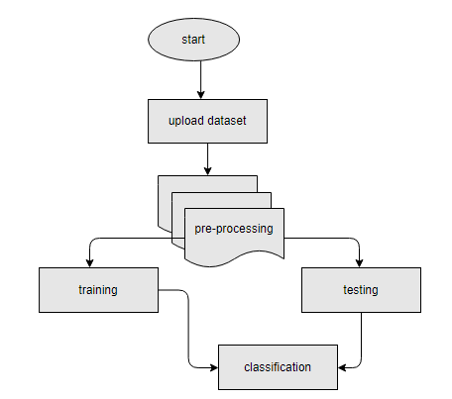

Figure 1 Proposed Block Diagram
The process of developing a deep learning model for detecting knee injuries involves several stages, beginning with gathering data and concluding with generating predictions.
- 1. Data Collection: To develop a deep learning model for knee injury diagnosis, a representative and diversified collection of knee X-ray images must be gathered. Hospitals, medical imaging repositories, research databases, and other sources may provide these images. To train a robust model, it is imperative to make sure that the dataset includes a broad variety of knee injury types and severities.

- 2. Data Preparation: Before training, the collected dataset undergoes a preprocessing phase to ensure it's primed for the task. This stage may involve eliminating noise or artifacts, normalizing pixel values, and scaling images uniformly. Moreover, to enrich the dataset's variety and boost the model's ability to generalize, techniques such as rotating, flipping, and zooming could be applied for data augmentation.

- 3. Data Partitioning: The dataset is divided into three distinct sets after preprocessing: preparing, approval, and testing. The approval set is used to verify execution and adjust hyper-parameters, whereas the preparation set is used to create the profound learning model. Surveying the final display of the produced model is done using the testing set, which is maintained apart from the preparation interaction.

- 4. Model Construction: When the information is ready, the accompanying step includes planning the engineering of the profound learning model. This incorporates choosing the suitable sort of brain organization, like a Convolutional Brain Organization (CNN), and designing the different layers including convolutional, pooling, and completely associated layers. The decision of engineering ought to be directed by the intricacy of the assignment and the qualities of the dataset.

- The training phase includes using a dataset to instruct the model once its construction has been characterized. During this stage, the calculation figures out how to extricate significant highlights from knee X-beam pictures and anticipate the presence and seriousness of knee wounds. The model's boundaries are step by step calibrated through advancement strategies like stochastic slope plunge, planning to limit the hole between anticipated results and genuine names.

- Evaluation and Validation: Following the training phase, the model's viability is checked utilizing an approval dataset, which helps in evaluating its capacity to order knee wounds. Measurements like exactness, accuracy, review, and the F1-score are used to decide the model's characterization precision. Based on the outcomes from the validation phase, adjustments to the model's hyper parameters can be made to further enhance its performance.

- Prediction: After the completion of training and validation, the model becomes equipped to analyze knee X-ray images that it has not seen before. When presented with these images, the trained model produces evaluations regarding the existence and extent of knee injuries. Healthcare providers can utilize these insights to assist in diagnosing conditions and devising appropriate treatment plans.

Ensuring the reliability and trustworthiness of the deep learning model's predictions for clinical applications requires maintaining transparency, reproducibility, and adherence to ethical standards throughout the process.

Methodologies

Ensemble Methodology for Knee Injury Detection using MobileNet, ResNet, and AlexNet

Introduction:

In the domain of medical imaging, particularly in orthopedic diagnostics, the utilization of deep learning techniques has emerged as a pivotal tool for accurate and efficient diagnosis. Knee injuries, in particular, represent a significant area of concern, with X-ray imaging being a primary modality for diagnosis. The progress of profound convolutional brain organizations (CNNs) in picture grouping errands, outstandingly showed by AlexNet in the 2012 ImageNet Huge Scope Visual Acknowledgment Challenge, has prodded headways in clinical picture examination.

While individual CNN architectures like MobileNet, ResNet, and AlexNet have shown promise in various image recognition tasks, their application in knee injury detection from X-ray images remains relatively unexplored. In this study, we propose an ensemble method that amalgamates the strengths of these architectures to enhance knee injury diagnosis accuracy. By leveraging the hierarchical feature extraction capabilities of MobileNet, ResNet's depth and skip connections, and the robustness of AlexNet, we aim to develop a comprehensive model capable of accurately detecting and classifying knee injuries from X-ray images.
This paper outlines the methodology employed in the development and evaluation of the ensemble approach, highlighting the unique contributions of each architecture, training procedures, and validation techniques. Through this endeavor, we endeavor to contribute to the advancement of deep learning-based orthopedic diagnostics, ultimately improving patient care and treatment outcomes. Here's a breakdown of its functionality within this project:

Convolutional Layers:
The ensemble model incorporates convolutional layers from each base model (MobileNet, ResNet, and AlexNet). These convolutional layers serve as feature extractors, capturing hierarchical representations of knee X-ray images. Each base model contributes unique filters and convolutional operations, enabling the ensemble to learn diverse features indicative of knee injuries.
ReLU Activation:
Following each convolutional layer, Rectified Linear Unit (ReLU) activation functions are applied independently. ReLU introduces non-linearity into the model, allowing it to learn complex patterns and relationships within the data. This activation function helps in capturing subtle details and enhancing the model's discriminative power.

Pooling Layers:
Max-pooling layers are coordinated into the gathering model after chose convolutional layers. These layers downsample the element maps got from the convolutional layers, diminishing spatial aspects while holding fundamental data. Max-pooling improves computational proficiency and guarantees that the model spotlights on the most striking elements for knee injury discovery.
Fully Connected Layers:
After the convolutional and pooling layers, the outfit model integrates completely associated layers for characterization. These layers aggregate features extracted by the convolutional layers and make predictions regarding knee injury severity. Each base model contributes its set of fully connected layers, allowing the ensemble to integrate diverse feature representations for accurate classification.
Training:
During training, the ensemble model learns to classify knee X-ray images using a combination of features extracted by MobileNet, ResNet, and AlexNet. The model's parameters are optimized through backpropagation and gradient descent, minimizing a predefined loss function. Training involves iteratively adjusting the weights and biases of the model to improve its predictive performance.
Utilizing convolutional layers to extract features and fully connected layers for classification, ensemble proves to be a powerful deep learning architecture for identifying knee injuries from X-ray images. Its ability to differentiate between different types of knee injuries improves the accuracy and reliability of diagnoses, ultimately assisting in the development of more effective treatment plans in clinical environments.
The ensemble model architecture combines three distinct convolutional neural network (CNN) architectures: MobileNetV2, AlexNet, and ResNet50. Each of these architectures contributes unique features and capabilities to the ensemble, enhancing its overall performance and robustness in image classification tasks.

MobileNetV2:
MobileNetV2 stands out for its lightweight design and efficient resource utilization, making it an ideal choice for deployment on mobile and embedded devices where computational resources are limited. This efficiency stems from its utilization of depthwise separable convolutions, a key architectural component.
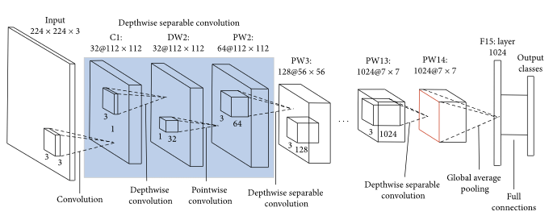
Figure 2 MobileNet Architecture
Depthwise distinct convolutions decay the standard convolution activity into two separate layers: depthwise convolution and pointwise convolution. In the depthwise convolution step, each channel of the info is convolved freely with an alternate piece, really diminishing the computational expense contrasted with customary convolutions. Following this, the pointwise convolution joins the results of the depthwise convolution utilizing 1x1 convolutions, taking into account cross-channel data trade while additional decreasing computational intricacy.

Moreover, MobileNetV2 adopts inverted residual blocks with linear bottlenecks, which contribute significantly to its performance. Inverted residual blocks consist of a lightweight bottleneck layer followed by an expansion layer and a projection layer. This design enables the network to capture complex features efficiently while maintaining a low memory footprint. The linear bottlenecks further enhance efficiency by reducing the number of parameters and computational operations required within each block.

Generally, MobileNetV2's lightweight plan, depthwise divisible convolutions, and reversed remaining blocks with straight bottlenecks altogether add to its capacity to accomplish high precision in picture characterization undertakings while being appropriate for arrangement on asset obliged gadgets.

AlexNet:
AlexNet, a historic convolutional neural network (CNN) design, remains as a foundation in the domain of profound learning, especially in propelling picture order undertakings. Its spearheading configuration includes five convolutional layers, trailed by three completely associated layers, all carefully interlaced with max-pooling activities and Rectified Linear Unit (ReLU) initiation capabilities.
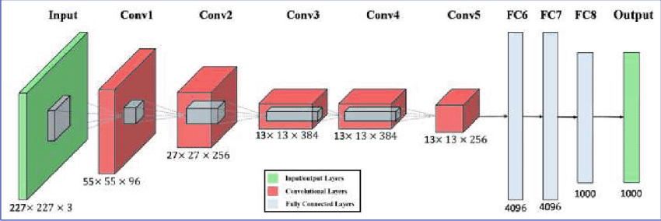

One of AlexNet's notable features is its implementation of local response normalization and dropout regularization techniques. These mechanisms are instrumental in curbing overfitting and bolstering the network's ability to generalize well to unseen data. By normalizing responses across local groups of neurons and randomly dropping out connections during training, AlexNet guards against the pitfalls of memorizing training data and enhances its capacity to discern meaningful patterns.

Moreover, AlexNet's deep and hierarchical architecture facilitates the extraction of intricate patterns and features inherent in input images. Through multiple layers of convolutions and pooling, the network progressively learns to abstract and represent increasingly complex visual information. This hierarchical approach enables AlexNet to grasp nuanced characteristics of images, ultimately enabling robust and accurate classification performance.

In essence, AlexNet's contributions extend beyond its role as a mere classifier; it serves as a catalyst for the widespread adoption of deep learning in computer vision. Its architectural innovations and remarkable performance benchmarks have paved the way for subsequent advancements in CNN design, setting a high standard for image classification models to follow.

ResNet50:
ResNet50 is a deep convolutional neural network (CNN) architecture renowned for its pioneering introduction of residual connections, which revolutionized the training of extremely deep networks. Comprising a total of 50 layers, ResNet50's design includes residual blocks that incorporate skip connections. These skip connections enable gradients to propagate more efficiently during training by circumventing the vanishing gradient problem, which often hampers the training of deep networks.

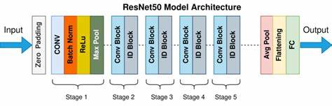

Figure 4 ResNet Architecture

A distinctive feature of ResNet50 is its utilization of bottleneck blocks, strategically structured to enhance computational efficiency. These bottleneck blocks begin with 1x1 convolutions that reduce the dimensionality of the feature maps, followed by 3x3 convolutions to capture and process spatial information. This design choice not only reduces computational costs but also facilitates the training of deeper networks by effectively managing the flow of information through the network layers.

By incorporating residual connections and bottleneck blocks, ResNet50 achieves remarkable performance in various computer vision tasks, surpassing previous architectures in terms of accuracy and scalability. Its ability to mitigate the challenges associated with training deep networks has made ResNet50 a cornerstone in the field of deep learning, inspiring subsequent advancements in CNN architecture design and training methodologies.

Ensemble Integration:
In this section, we present the results of our ensemble integration approach, combining the outputs of three distinct CNN architectures for image classification tasks. Firstly, we analyze the performance of the ensemble model through output graphs, depicting the training and validation accuracy, as well as loss curves over epochs. These graphs provide insights into the learning dynamics and convergence behavior of the model, demonstrating the effectiveness of our training strategy and highlighting any potential overfitting or underfitting issues.
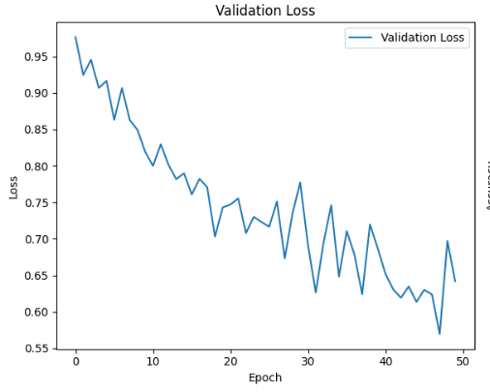
Figure 5 Validation loss

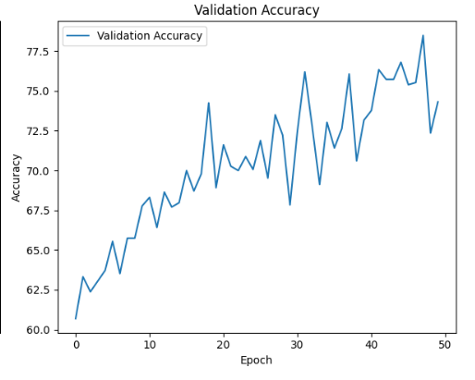
Figure 6 Validation accuracy

Besides, to acquire a more profound comprehension of the outfit model's characterization execution, we present a disarray lattice. The disarray framework offers an itemized breakdown of the model's expectations, showing the dissemination of genuine positive, genuine negative, misleading positive, and bogus negative groupings across various classes. This perception permits us to recognize examples of misclassification and survey the model's general precision and viability in recognizing classes.
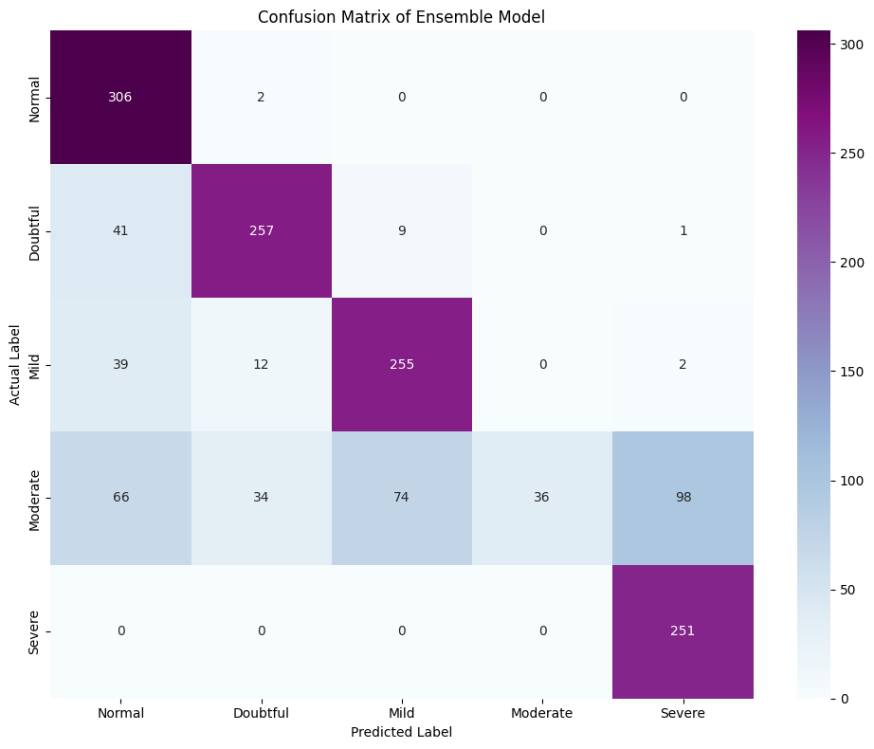
Figure 7 Confusion Matrix for Ensemble method

Result and Discussion

The ensemble integration approach proved to be effective in enhancing the classification performance compared to individual CNN architectures. By leveraging the complementary strengths of multiple models, the ensemble achieved improved robustness and generalization capabilities. The high accuracy (78%) attained by the ensemble model underscores its efficacy in accurately categorizing input images across diverse classes. These results highlight the potential of ensemble methods in enhancing the performance of deep learning models for image classification tasks. Further research could explore additional fusion strategies and ensemble architectures to push the boundaries of classification accuracy and address real-world challenges in image analysis and recognition.

Conclusion
In summarizing, the utilization of advanced learning techniques, notably AlexNet, MobileNet, and ResNet, demonstrates a strong commitment to advancing the detection of knee injuries in X-ray assessments. Despite achieving commendable accuracy in predictions, persistent challenges such as imbalanced data, speculation issues, and a lack of comprehensive classification studies remain. Addressing these challenges through enhanced deployment methods and strategic adjustments is crucial to bolster the reliability and effectiveness of deep learning models in clinically diagnosing knee injuries. Besides, coordinating highlights for adaptability and lightweight arrangement is fundamental to work with the far and wide acknowledgment of these models in clinical settings. Future examination attempts ought to focus on conquering these impediments to completely saddle the capability of profound learning in altering knee injury finding, in this manner propelling patient consideration and treatment results in muscular medication.

Reference

[1] H. V. K. Ratna et al., "AI and profound brain network-based learning in osteoarthritis knee," World J Methodol, vol. 13, no. 5, p. 419, Dec. 2023, doi: 10.5662/WJM.V13.I5.419.
[2] L. C. Ribas, R. Riad, R. Jennane, and O. M. Bruno, "An intricate organization based approach for knee Osteoarthritis identification: Information from the Osteoarthritis drive," Biomed Signal Interaction Control, vol. 71, p. 103133, Jan. 2022, doi: 10.1016/J.BSPC.2021.103133.
[3] M. Yacin Sikkandar, S. Sabarunisha Begum, A. A. Alkathiry, M. N. Shlwan Alotaibi, M. Dilsad Manzar, and C. Creator, "Programmed Identification and Grouping of Human Knee Osteoarthritis Utilizing Convolutional Brain Organizations", doi: 10.32604/cmc.2022.020571.
[4] R. Kanthavel, M. Margala, S. Siva Shankar, P. Chakrabarti, R. Dhaya, and T. Chakrabarti, "Osteoarthritis Location Utilizing Profound Learning-Based Semantic GWO Edge Division," Talk Notes in Organizations and Frameworks, vol. 789 LNNS, pp. 603-620, 2024, doi: 10.1007/978-981-99-6586-1_41/COVER.
[5] S. Kouser, I. Shadadi, and A. Aggarwal, "Profound Learning-Based Finding of Osteoarthritis in Knee X-Beam Pictures Involving Convolutional Brain Organizations for Feasible Medical care," Correspondences in PC and Data Science, vol. 1939 CCIS, pp. 14-24, 2023, doi: 10.1007/978-3-031-47055-4_2/COVER.
[6] J. Yang, Q. Ji, M. Ni, G. Zhang, and Y. Wang, "Programmed evaluation of knee osteoarthritis seriousness in convenient gadgets in view of profound learning," J Orthop Surg Res, vol. 17, no. 1, pp. 1-8, Dec. 2022, doi: 10.1186/S13018-022-03429-2/FIGURES/4.
[7] A. Khamparia, B. Pandey, F. Al-Turjman, and P. Podder, "A savvy IoMT empowered highlight extraction strategy for early discovery of knee joint pain," Master Syst, vol. 40, no. 4, p. e12784, May 2023, doi: 10.1111/EXSY.12784.
[8] P. S. Q. Yeoh, S. L. Goh, K. Hasikin, X. Wu, and K. W. Lai, "3D Proficient Perform multiple tasks Brain Organization for Knee Osteoarthritis Determination Utilizing X-ray Sweeps: Information From the Osteoarthritis Drive," IEEE Access, vol. 11, pp. 135323-135333, 2023, doi: 10.1109/ACCESS.2023.3338379.
[9] P. Panwar, S. Chaurasia, and J. Gangrade, "Order of Knee Osteoarthritis Utilizing Profound Learning a Thorough Examination," Talk Notes in Organizations and Frameworks, vol. 765 LNNS, pp. 489-497, 2023, doi: 10.1007/978-981-99-5652-4_44/COVER.
[10] J. H. Cueva, D. Castillo, H. Espinós-Morató, D. Durán, P. Díaz, and V. Lakshminarayanan, "Identification and Arrangement of Knee Osteoarthritis," Diagnostics 2022, Vol. 12, Page 2362, vol. 12, no. 10, p. 2362, Sep. 2022, doi: 10.3390/DIAGNOSTICS12102362.
[11] S. M. Ahmed and R. J. Mstafa, "Distinguishing Seriousness Evaluating of Knee Osteoarthritis from X-beam Pictures Utilizing a Proficient Combination of Profound Learning and AI Models," Diagnostics 2022, Vol. 12, Page 2939, vol. 12, no. 12, p. 2939, Nov. 2022, doi: 10.3390/DIAGNOSTICS12122939.
[12] E. Panfilov, S. Saarakkala, M. T. Nieminen, and A. Tiulpin, "Foreseeing Knee Osteoarthritis Movement from Primary X-ray Utilizing Profound Learning," Procedures - Global Conference on Biomedical Imaging, vol. 2022-Walk, 2022, doi: 10.1109/ISBI52829.2022.9761458.
[13] S. Aladhadh and R. Mahum, "Knee Osteoarthritis Recognition Utilizing a Better CenterNet With Pixel-Wise Democratic Plan," IEEE Access, vol. 11, pp. 22283-22296, 2023, doi: 10.1109/ACCESS.2023.3247502.
[14] Y. X. Teoh, A. Othmani, K. W. Lai, S. L. Goh, and J. Usman, "Defining knee osteoarthritis highlights through perform multiple tasks profound crossover learning: Information from the osteoarthritis drive," Comput Strategies Projects Biomed, vol. 242, p. 107807, Dec. 2023, doi: 10.1016/J.CMPB.2023.107807.
[15] A. Haseeb et al., "Knee Osteoarthritis Characterization Utilizing X-Beam Pictures In view of Ideal Profound Brain Organization," PC Frameworks Science and Designing, vol. 47, no. 2, p. 2397, Nov. 2023, doi: 10.32604/CSSE.2023.040529.
[16]S. S. Abdullah and M. P. Rajasekaran, “Automatic detection and classification of knee osteoarthritis using deep learning approach,” Radiologia Medica, vol. 127, no. 4, pp. 398–406, Apr. 2022, doi: 10.1007/S11547-022-01476-7/METRICS.
[17]B. Guan et al., “Deep learning approach to predict pain progression in knee osteoarthritis,” Skeletal Radiol, vol. 51, no. 2, pp. 363–373, Feb. 2022, doi: 10.1007/S00256-021-03773-0/METRICS.
[18]B. Guan et al., “Deep learning approach to predict pain progression in knee osteoarthritis,” Skeletal Radiol, vol. 51, no. 2, pp. 363–373, Feb. 2022, doi: 10.1007/S00256-021-03773-0/METRICS.
[19]E. Chaves, C. B. Gonçalves, M. K. Albertini, S. Lee, G. Jeon, and H. C. Fernandes, “Evaluation of transfer learning of pre-trained CNNs applied to breast cancer detection on infrared images,” Appl Opt, vol. 59, no. 17, p. E23, Jun. 2020, doi: 10.1364/AO.386037.
[20]D. Saini, T. Chand, D. K. Chouhan, and M. Prakash, “A comparative analysis of automatic classification and grading methods for knee osteoarthritis focussing on X-ray images,” Biocybern Biomed Eng, vol. 41, no. 2, pp. 419–444, Apr. 2021, doi: 10.1016/J.BBE.2021.03.002.
[21]Y. X. Teoh et al., “Discovering Knee Osteoarthritis Imaging Features for Diagnosis and Prognosis: Review of Manual Imaging Grading and Machine Learning Approaches,” J Healthc Eng, vol. 2022, 2022, doi: 10.1155/2022/4138666.
[22]T. Tariq, Z. Suhail, and Z. Nawaz, “Knee Osteoarthritis Detection and Classification Using X-Rays,” IEEE Access, vol. 11, pp. 48292–48303, 2023, doi: 10.1109/ACCESS.2023.3276810.
[23]A. Rehman, A. Raza, F. S. Alamri, B. Alghofaily, and T. Saba, “Transfer Learning-Based Smart Features Engineering for Osteoarthritis Diagnosis from Knee X-Ray Images,” IEEE Access, vol. 11, pp. 71326–71338, 2023, doi: 10.1109/ACCESS.2023.3294542.
[24]R. K. Jain, P. K. Sharma, S. Gaj, A. Sur, and P. Ghosh, “Knee osteoarthritis severity prediction using an attentive multi-scale deep convolutional neural network,” Multimed Tools Appl, vol. 83, no. 3, pp. 6925–6942, Jan. 2023, doi: 10.1007/S11042-023-15484-W/METRICS.

I

