DATA CLEANING AND
PRE-PROCESSING
Week 2 Internship Task | Python Data Analytics
Item | Details
Dataset | Iris Flower Measurements
Tools | Python, pandas, NumPy, Matplotlib, scikit-learn
Prepared by | [Your Full Name]
Internship / Organization | [Internship Name / Organization]
Submission date | [DD Month YYYY]

A reproducible report on data quality, cleaning decisions, feature engineering, encoding, scaling, and validation.

1. Executive Summary
This report presents a data cleaning and pre-processing workflow using the Iris flower dataset selected for Week 1. The original dataset contains 150 records, four numerical measurements, and a species label. To demonstrate common data-quality problems, a separate working copy was deliberately modified to contain two missing numeric values, one species label with trailing whitespace, and one duplicated row. These are simulated issues for demonstration and are not defects claimed about the original public dataset. The workflow checks data quality, standardizes category labels, removes the known duplicate, imputes missing numeric values using medians, screens possible outliers using the IQR rule, creates derived features, and demonstrates encoding and scaling for future modeling.

2. Objectives
- Inspect the dataset structure, data types, missing values, duplicates, inconsistent labels, and unusual numeric values.
- Apply suitable cleaning methods and explain why they were selected.
- Create an analysis-ready dataset while preserving the raw data for audit purposes.
- Demonstrate feature engineering, categorical encoding, and numerical scaling.
- Document a reproducible workflow for future analysts.

3. Dataset Overview
The Iris dataset is a public educational dataset available through the UCI Machine Learning Repository and scikit-learn. Each row represents a flower sample. Four numerical measurements are used to describe the flower, and species is the categorical label.
Variable | Type | Meaning | Role
sepal_length_cm | Numeric | Sepal length in centimetres | Input feature
sepal_width_cm | Numeric | Sepal width in centimetres | Input feature
petal_length_cm | Numeric | Petal length in centimetres | Input feature
petal_width_cm | Numeric | Petal width in centimetres | Input feature
species | Categorical | setosa, versicolor, virginica | Target label

3.1 Initial Inspection Code
from sklearn.datasets import load_iris
import pandas as pd
import numpy as np
iris = load_iris(as_frame=True)
df = iris.data.copy()
df.columns = [
"sepal_length_cm", "sepal_width_cm",
"petal_length_cm", "petal_width_cm"
]
df["species"] = pd.Series(iris.target).map(
dict(enumerate(iris.target_names))
)
print(df.head())
print(df.shape)
print(df.info())
print(df.isna().sum())
print(df.duplicated().sum())
print(df.describe(include="all"))
The original data has 150 rows and 5 columns. Run head(), info(), describe(), isna(), and duplicated() before cleaning so that the initial condition is recorded. Keep the raw dataset unchanged and perform modifications on a copy.

4. Demonstration Data-Quality Issues
For the purpose of demonstrating the required cleaning methods, a separate copy was created and four controlled issues were introduced: two missing numerical cells, one trailing space in a species label, and one repeated row. This makes it possible to document and test a complete cleaning process. Do not describe these simulated issues as defects in the original source.
Issue | Example in working copy | Potential effect
Missing values | Two numeric cells are NaN | Calculations and models may fail or drop rows
Duplicate record | One row is appended a second time | Repeated record can distort summaries
Inconsistent category | 'setosa ' includes a trailing space | Creates a false extra category
Potential outliers | Numeric values screened using boxplots and IQR | May be errors or valid extremes

4.1 Missing-Value Check
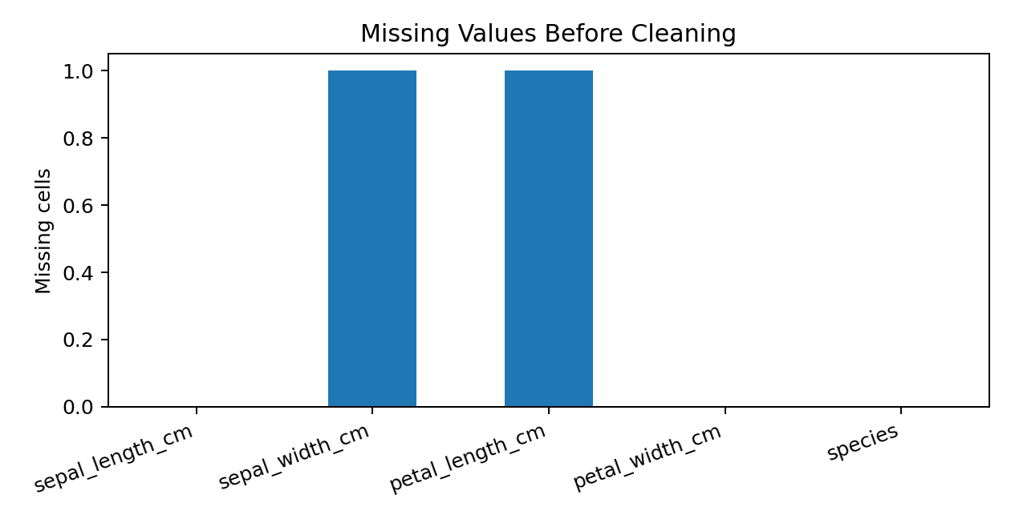
Figure 1. Missing-value counts in the demonstration copy before cleaning.

4.2 Visual Outlier Screening
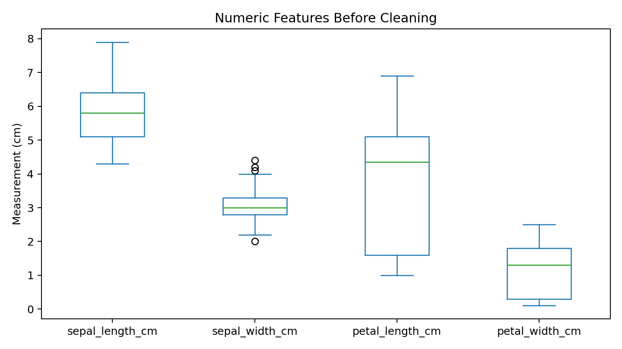
Figure 2. Boxplots show the spread of numerical features and help flag potential outliers. A point outside a whisker is not automatically a mistake; it must be investigated using context and source information.

5. Cleaning Methods and Justification

5.1 Handling Missing Values
The two missing numerical cells are filled using the median of the corresponding feature. The median is less sensitive to extreme values than the mean and is practical for a small dataset. Deleting the rows would discard otherwise useful measurements. In real projects, investigate why values are missing and whether the missingness is systematic before choosing a method.

5.2 Duplicate Removal
The demonstration copy contains 2 exact duplicate row before cleaning. Since this duplicate was intentionally added for the exercise, drop_duplicates() is appropriate. In real data, repeated records can sometimes be legitimate measurements; inspect unique IDs and business meaning before deleting them.

5.3 Standardizing Category Labels
The species field is converted to string, trimmed using strip(), and changed to lowercase. This ensures labels such as 'setosa' and 'setosa ' are treated consistently. The cleaned labels are validated against the allowed categories: setosa, versicolor, and virginica.

5.4 Outlier Treatment Using IQR
For each numeric feature, calculate IQR = Q3 − Q1. A value below Q1 − 1.5 × IQR or above Q3 + 1.5 × IQR is flagged for review. This report does not automatically delete or cap flagged values because genuine flowers may have unusual measurements. If a value is confirmed to be a data-entry error, correction should be based on the original source rather than guessing.
for col in numeric_cols:
q1 = df[col].quantile(0.25)
q3 = df[col].quantile(0.75)
iqr = q3 - q1
lower = q1 - 1.5 * iqr
upper = q3 + 1.5 * iqr
flagged = df[(df[col] < lower) | (df[col] > upper)]
print(col, len(flagged))

6. Reproducible Cleaning Code
# raw_df is the original dataframe
working = raw_df.copy()
numeric_cols = [
"sepal_length_cm", "sepal_width_cm",
"petal_length_cm", "petal_width_cm"
]
# Normalize category labels
working["species"] = (
working["species"].astype("string").str.strip().str.lower()
)
# Remove exact duplicates after review
working = working.drop_duplicates().copy()
# Fill missing numerical values with column medians
for col in numeric_cols:
working[col] = working[col].fillna(working[col].median())
# Fill missing category values with the mode if needed
if working["species"].isna().any():
working["species"] = working["species"].fillna(
working["species"].mode().iloc[0]
)
# Validate allowed categories
allowed = {"setosa", "versicolor", "virginica"}
assert set(working["species"].dropna().unique()).issubset(allowed)
# Final quality checks
print(working.isna().sum())
print("Duplicates:", working.duplicated().sum())
print("Shape:", working.shape)
This code should be run against the prepared working copy if reproducing the demonstration. If using the original Iris dataset directly, inspect its actual quality and do not introduce artificial issues.

7. Feature Engineering and Pre-processing

7.1 Creating Derived Features
Two additional features are created: sepal_area_proxy_cm2 = sepal length × sepal width, and petal_area_proxy_cm2 = petal length × petal width. These values are rectangular area proxies, not true biological surface areas. They may help explore whether combined measurements contain useful information; their value must be tested in later analysis.
working["sepal_area_proxy_cm2"] = (
working["sepal_length_cm"] * working["sepal_width_cm"]
)
working["petal_area_proxy_cm2"] = (
working["petal_length_cm"] * working["petal_width_cm"]
)

7.2 Encoding Categorical Variables
Many machine-learning algorithms require numeric inputs. One-hot encoding creates a separate binary column for each species. If species is the prediction target, it must not be included among input features; otherwise the model would receive the answer during training, causing data leakage.
species_encoded = pd.get_dummies(
working["species"], prefix="species", dtype=int
)
print(species_encoded.head())

7.3 Scaling and Normalization
StandardScaler transforms numerical features to approximately zero mean and unit standard deviation. MinMaxScaler maps values to a range from 0 to 1. Scaling can help distance-based and gradient-based algorithms, while tree-based models often do not require it. During model development, fit the scaler only on training data and then transform the test data to avoid data leakage.
from sklearn.preprocessing import StandardScaler, MinMaxScaler
standard_scaler = StandardScaler()
z_values = standard_scaler.fit_transform(working[numeric_cols])
minmax_scaler = MinMaxScaler()
range_values = minmax_scaler.fit_transform(working[numeric_cols])
# In a real train/test workflow, fit scalers on X_train only.
Technique | Purpose | Decision
Median imputation | Fill missing numeric cells | Applied to simulated missing values
Label normalization | Remove whitespace and unify case | Applied to species labels
Duplicate removal | Prevent repeated rows affecting analysis | Removed known artificial duplicate
IQR outlier screening | Flag unusual numerical values | Review only; no automatic deletion
Feature engineering | Create potentially useful combined measurements | Two area-proxy features created
One-hot encoding | Convert categories into binary columns | Demonstrated for modeling preparation
Standardization / Min-max scaling | Put measurements on comparable scales | Demonstrated; training-only fit in real modeling

8. Results After Cleaning
Quality check | Before cleaning | After cleaning
Rows | 151 | 149
Original variables | 5 | 5 original variables plus 2 engineered features
Missing numerical cells | 2 | 0
Exact duplicate rows | 2 | 0
Category formatting | One label contains trailing whitespace | Whitespace removed and case normalized
Category validity | Requires validation | Only the three allowed labels remain

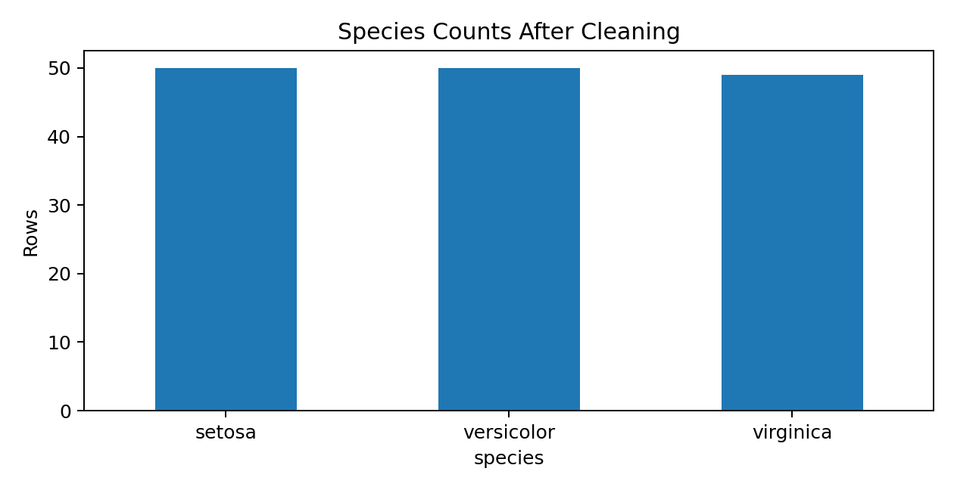
Figure 3. Species counts after cleaning. Counts reflect removal of the intentionally duplicated record.
The final working copy has no missing values in the selected numerical columns and no exact duplicate rows. The engineered features are added after the cleaning steps. Final validation is important before saving the data for later analysis.

9. Validation and Export
# Final validation
assert working[numeric_cols].isna().sum().sum() == 0
assert working.duplicated().sum() == 0
assert set(working["species"].dropna().unique()).issubset(
{"setosa", "versicolor", "virginica"}
)
# Export the cleaned dataset
working.to_csv("iris_cleaned_week2.csv", index=False)
Keep the raw and cleaned datasets as separate files. Before export, verify column types, plausible measurement ranges, valid labels, missing values, duplicate rows, and the reason for any change in row count.

10. Limitations and Good Practices
- The missing values, inconsistent label, and duplicate row were intentionally introduced for demonstration; they are not claims about the original dataset.
- Median imputation is simple but may reduce natural variation and does not explain why values were missing.
- IQR screening may flag valid observations, so unusual values should be reviewed rather than automatically deleted.
- The engineered area features are approximate and may not improve model performance.
- Scaling and imputation should be fitted on training data only during predictive modeling to prevent data leakage.
- Document each transformation and preserve a raw copy so the workflow can be audited and repeated.

11. Conclusion
This task demonstrates a complete introductory data cleaning workflow: inspection, missing-value treatment, duplicate handling, label standardization, outlier screening, feature engineering, encoding, scaling, and validation. Each decision is explained and supported with Python code and visual outputs. The resulting workflow prepares the dataset for future visualization, statistical analysis, and machine-learning tasks. Good data cleaning depends on understanding the data and documenting decisions, not applying transformations automatically.

12. References
- UCI Machine Learning Repository, Iris Data Set: https://archive.ics.uci.edu/dataset/53/iris
- scikit-learn Iris dataset documentation: https://scikit-learn.org/stable/auto_examples/datasets/plot_iris_dataset.html
- pandas documentation: https://pandas.pydata.org/docs/
- NumPy documentation: https://numpy.org/doc/
- Matplotlib documentation: https://matplotlib.org/stable/
- scikit-learn preprocessing documentation: https://scikit-learn.org/stable/modules/preprocessing.html

Appendix: Submission Checklist
- ☐ Replace cover-page placeholders with your actual details.
- ☐ Run the code in Jupyter Notebook or Google Colab and verify outputs.
- ☐ Keep the original dataset and cleaned dataset separate.
- ☐ Add notebook screenshots if required by your mentor.
- ☐ Read and understand each cleaning decision before submission.

