Executive Summary
This project combines six weeks of Python data analytics work using the Iris Flower Dataset. The purpose was to understand the data, improve data quality, visualize patterns, test statistical relationships, and build a machine-learning model to predict flower species.
The dataset contains 150 flower records, four numerical measurements (sepal length, sepal width, petal length and petal width), and three species: Setosa, Versicolor and Virginica. Each species has 50 records. Initial exploration showed no missing cells in the original dataset and one exact duplicate row under the Week 1 duplicate check. Week 2 demonstrated cleaning methods on a separate working copy with deliberately introduced issues; these simulated issues must not be mistaken for defects in the original dataset.
Visual analysis showed that Setosa has clearly smaller petal measurements, while Versicolor and Virginica have larger measurements with some overlap. Petal length and petal width have a very strong positive correlation (r = 0.963). Statistical tests supported meaningful differences between species: one-way ANOVA for petal length gave F = 1180.161 and p = 2.857 × 10⁻⁹¹. A Welch t-test also found a large difference between Setosa and Versicolor petal length.
A Support Vector Classifier (SVC) was trained using an 80:20 stratified train-test split. The best five-fold cross-validation accuracy was 97.5%, while test accuracy was 93.3% (28 correct predictions out of 30). Macro precision, recall and F1-score were each 0.933. The model classified all Setosa test samples correctly; the two errors occurred between Versicolor and Virginica.
Overall, petal measurements are useful predictors of Iris species in this dataset. The results are promising for an educational classification task, but the small, curated dataset limits generalization. Future work should validate the model on independent flower samples, compare additional classifiers, and document software versions and reproducible code.

Project at a Glance
Stage | Work completed | Main outcome
Week 1 – Exploration | Dataset structure, statistics, quality checks and problem definition | 150 records; 3 balanced species; 4 numerical features
Week 2 – Cleaning | Missing-value handling, label standardization, duplicate removal, outlier screening, encoding and scaling | Demonstrated a documented cleaning workflow on a simulated working copy
Week 3 – Visualization | Bar chart, line chart, scatter plot and correlation heatmap | Petal measurements show clear species patterns
Week 4 – Statistics | Welch t-test, one-way ANOVA, Pearson correlation, chi-square and linear regression | Strong statistical evidence of group differences and association
Week 5 – Machine learning | SVC pipeline, scaling, grid search, cross-validation and test evaluation | 93.3% test accuracy; 97.5% best CV accuracy
Week 6 – Integration | Combined findings, limitations, recommendations and reproducibility notes | Complete end-to-end report

1. Introduction
Data analytics is the process of collecting, inspecting, cleaning, analyzing and interpreting data to support decisions. This project applies a complete introductory analytics workflow to the Iris Flower Dataset using Python.

1.1 Problem Statement
The project investigates whether the physical measurements of an Iris flower can be used to identify its species. The task is treated as a supervised multi-class classification problem in the machine-learning stage.

1.2 Objectives
- Understand the dataset structure, variables and class distribution.
- Identify data-quality issues and demonstrate suitable cleaning methods.
- Create charts to explain distributions, group differences and feature relationships.
- Use statistical tests to evaluate selected hypotheses.
- Train and evaluate a machine-learning classifier.
- Combine the findings and provide practical recommendations.

1.3 Dataset Description
Variable | Type | Meaning | Role
sepal_length_cm | Numerical | Sepal length in centimetres | Input feature
sepal_width_cm | Numerical | Sepal width in centimetres | Input feature
petal_length_cm | Numerical | Petal length in centimetres | Input feature
petal_width_cm | Numerical | Petal width in centimetres | Input feature
species | Categorical | Setosa, Versicolor or Virginica | Target label

The Iris dataset is a standard educational dataset distributed with scikit-learn and also available through the UCI Machine Learning Repository. It contains 150 observations and four numerical input features.

2. Data Exploration – Week 1
The dataset was loaded into a pandas DataFrame. The first rows, shape, data types, summary statistics, missing values, duplicate records, distributions and feature relationships were inspected.
from sklearn.datasets import load_iris
import pandas as pd
import numpy as np
iris = load_iris(as_frame=True)
df = iris.data.copy()
df.columns = ['sepal_length_cm','sepal_width_cm',
'petal_length_cm','petal_width_cm']
df['species'] = pd.Categorical.from_codes(iris.target, iris.target_names)
print(df.head())
print(df.shape)
print(df.info())
print(df.describe())
Exploration check | Observed result | Interpretation
Dataset size | 150 rows × 5 analysis columns | Small structured dataset
Class distribution | 50 samples per species | Balanced target classes
Missing values | 0 missing cells | No missing values in original data
Duplicate rows | 1 exact duplicate reported in Week 1 check | Review duplicate context before removal
Numerical variables | 4 | All four measurements are numeric

The overall mean and median measurements provide a useful first summary. However, because the dataset combines three species, group-wise comparisons are important. The exploration suggested that petal length and petal width may be especially useful for separating species.

2.1 Descriptive Statistics
Feature | Mean (cm) | Median (cm) | Std. deviation | Minimum | Maximum
sepal_length_cm | 5.84 | 5.80 | 0.83 | 4.30 | 7.90
sepal_width_cm | 3.06 | 3.00 | 0.44 | 2.00 | 4.40
petal_length_cm | 3.76 | 4.35 | 1.77 | 1.00 | 6.90
petal_width_cm | 1.20 | 1.30 | 0.76 | 0.10 | 2.50

2.2 Initial Interpretation
- Setosa generally has shorter and narrower petals than the other two species.
- Versicolor and Virginica show larger petal measurements, but their ranges overlap.
- Petal length and petal width move together strongly.
- The dataset is balanced, so no species dominates the sample count.

3. Data Cleaning and Preprocessing – Week 2
The original Iris dataset is already relatively clean. To demonstrate common data-cleaning methods, a separate working copy was intentionally modified. Two numerical cells were made missing, one species label received trailing whitespace, and one row was duplicated. These were simulated examples created for the cleaning exercise, not defects in the original public dataset.
Issue in demonstration copy | Method | Reason
Missing numerical values | Median imputation | Keeps the row and is less affected by extreme values than the mean
Inconsistent category label | Strip whitespace and standardize case | Prevents false extra categories
Repeated record | Remove exact duplicate after inspection | Avoids counting the same record twice
Potential outliers | IQR / boxplot screening | Flags unusual values for review; does not automatically delete them
Different feature scales | StandardScaler or MinMaxScaler | Makes features comparable for scale-sensitive models
Categorical target | One-hot encoding demonstration | Converts categories into numerical indicator columns when required
Feature engineering | Create area-proxy features | Demonstrates combining measurements into additional features

3.1 Cleaning Code Summary
working = df.copy()
working['species'] = working['species'].astype(str).str.strip().str.lower()
numeric_cols = ['sepal_length_cm','sepal_width_cm',
'petal_length_cm','petal_width_cm']
working[numeric_cols] = working[numeric_cols].fillna(
working[numeric_cols].median())
working = working.drop_duplicates()
assert working[numeric_cols].isna().sum().sum() == 0
assert working.duplicated().sum() == 0
The demonstration report recorded 151 rows before cleaning and 149 rows after removing the known repeated record(s), with missing values reduced to zero. Outlier screening was used to identify values for investigation rather than removing them automatically. Raw and cleaned data should be saved separately to preserve an audit trail.

3.2 Preprocessing Good Practices
- Keep an unchanged copy of the raw data.
- Record each transformation and explain why it is needed.
- Investigate unusual values before deleting them.
- Fit imputers and scalers on training data only during model development.
- Validate row counts, missing values, data types and category labels after cleaning.

4. Data Visualization – Week 3
Four charts were prepared using Matplotlib and pandas. Each chart answers a different question and helps explain the dataset in a simple visual form.

4.1 Bar Chart – Samples by Species
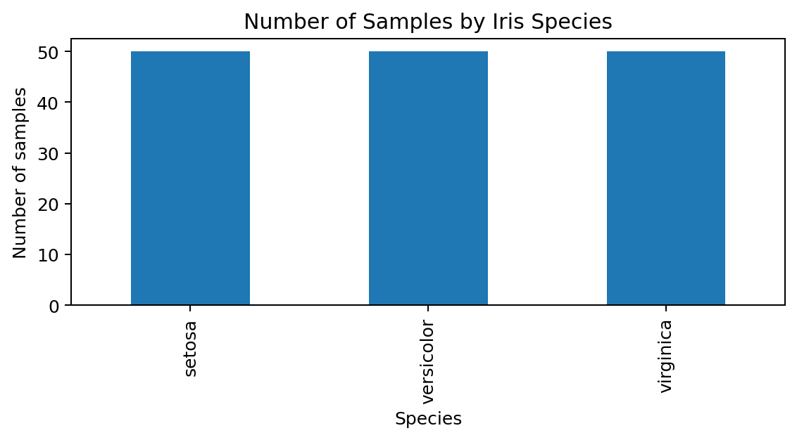
Figure 1. Each species contributes 50 samples, showing a balanced dataset.
The bar chart compares the number of records in each species. Equal bar heights confirm that the target classes are balanced.

4.2 Line Chart – Average Lengths
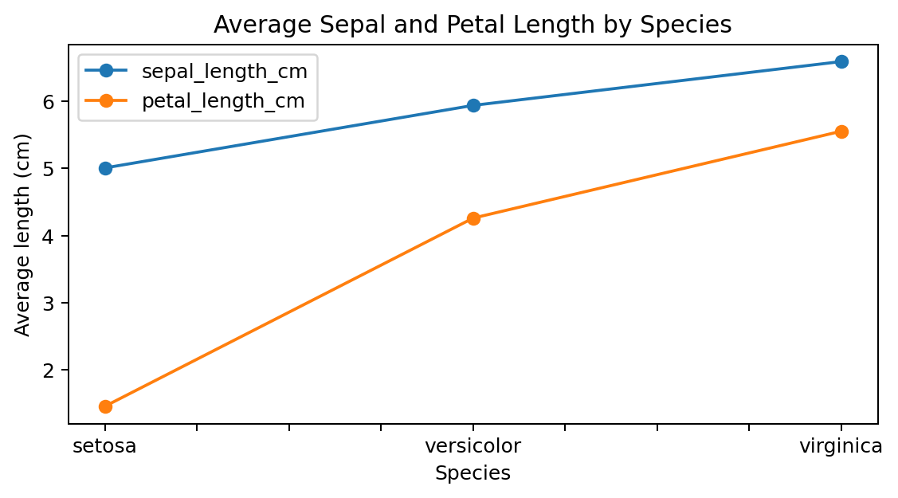
Figure 2. Average sepal and petal lengths across the three species.
Average petal length increases from Setosa to Versicolor and then Virginica. The line connects category averages only as a visual guide; species are categories, not time periods.

4.3 Scatter Plot – Petal Measurements
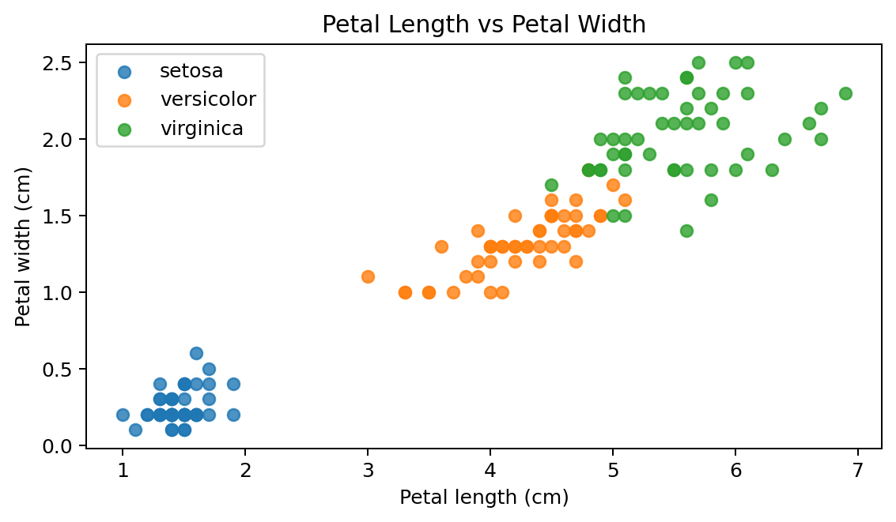
Figure 3. Petal length and width form species-related clusters.
Setosa forms a clearly separate cluster with small petals. Versicolor is mostly in the middle, while Virginica generally has larger petals. Some overlap between Versicolor and Virginica helps explain the model's two classification errors.

4.4 Correlation Heatmap
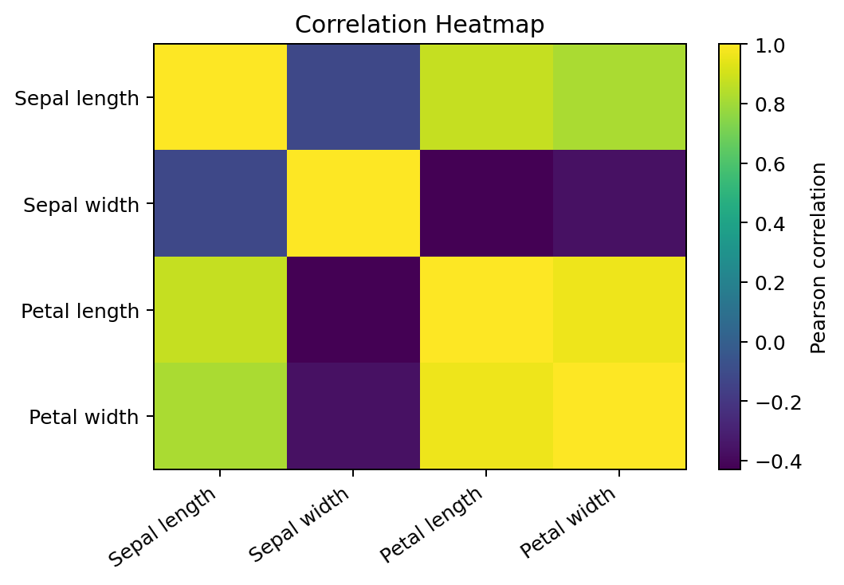
Figure 4. Correlation matrix for the four numerical measurements.
Petal length and petal width have a strong positive correlation. Sepal length is also positively related to petal measurements, while sepal width has weaker relationships. Correlation indicates association, not cause and effect.
import matplotlib.pyplot as plt
# Example: relationship between petal measurements
for species in iris.target_names:
part = df[df['species'] == species]
plt.scatter(part['petal_length_cm'], part['petal_width_cm'], label=species)
plt.xlabel('Petal length (cm)'); plt.ylabel('Petal width (cm)')
plt.legend(); plt.show()

5. Statistical Analysis and Hypothesis Testing – Week 4
Statistical tests were used to check whether the patterns seen in the charts are supported by evidence. A 5% significance level (alpha = 0.05) was selected. When p is below 0.05, the null hypothesis is rejected. Effect sizes and confidence intervals are also useful because a p-value alone does not show practical importance.
Test / question | Result | Conclusion
Welch t-test: Setosa vs Versicolor petal length | t = −39.493; p = 9.934 × 10⁻⁴⁶; mean difference = −2.798 cm; 95% CI [−2.940, −2.656]; Cohen's d = −7.899 | Strong evidence that the group means differ; very large standardized difference
One-way ANOVA: petal length across all species | F = 1180.161; p = 2.857 × 10⁻⁹¹; eta-squared = 0.941 | At least one species mean differs; species group accounts for about 94.1% of variation in this dataset
Pearson correlation: petal length vs width | r = 0.963; p = 4.675 × 10⁻⁸⁶ | Very strong positive linear relationship
Chi-square: species vs petal-length category | χ² = 248.522; df = 4; p = 1.355 × 10⁻⁵² | Species and petal-length category are associated; minimum expected count = 14
Linear regression: predict petal width from petal length | width = −0.363 + 0.416 × length; R² = 0.927; slope p = 4.675 × 10⁻⁸⁶ | Positive slope; petal length explains 92.7% of variation in petal width in this simple model

5.1 Example Statistical Code
from scipy import stats
# Welch's independent t-test
setosa = df[df.species == 'setosa']['petal_length_cm']
versicolor = df[df.species == 'versicolor']['petal_length_cm']
print(stats.ttest_ind(setosa, versicolor, equal_var=False))
# One-way ANOVA across the three species
groups = [df[df.species == s]['petal_length_cm']
for s in ['setosa','versicolor','virginica']]
print(stats.f_oneway(*groups))
# Pearson correlation
print(stats.pearsonr(df['petal_length_cm'], df['petal_width_cm']))

5.2 Interpretation and Assumptions
The tests consistently show that petal measurements differ across species and are strongly related to one another. The t-test compares two independent group means; Welch's version does not require equal variances. Classical one-way ANOVA assumes independent observations, approximate within-group normality and similar variances. Pearson correlation and linear regression are sensitive to non-linearity and extreme observations. The chi-square test requires suitable expected cell counts, which were checked in the Week 4 analysis.
These results describe the Iris dataset only. Statistical significance does not prove that one measurement causes another, and a significant ANOVA result does not identify every differing pair without an appropriate post-hoc test.

6. Machine Learning and Model Evaluation – Week 5
The machine-learning task was to predict the species from the four numerical flower measurements. A Support Vector Classifier (SVC) was selected because it can learn linear and non-linear decision boundaries and works well with numerical features in small classification problems.

6.1 Data Preparation
- Loaded the original Iris dataset from scikit-learn.
- Used the four measurement columns as input features and species code as the target.
- Split the data into 80% training and 20% testing using stratification.
- Placed StandardScaler inside a scikit-learn Pipeline to avoid fitting the scaler on test data.

6.2 Model Training and Tuning
GridSearchCV compared linear and RBF kernels, C values of 0.1, 1, 10 and 100, and gamma values of scale, 0.1 and 1. Five-fold StratifiedKFold cross-validation was used. The best settings from the recorded run were a linear kernel, C = 0.1 and gamma = scale. The best mean cross-validation accuracy was 97.5%.
from sklearn.model_selection import train_test_split, GridSearchCV, StratifiedKFold
from sklearn.preprocessing import StandardScaler
from sklearn.pipeline import Pipeline
from sklearn.svm import SVC
X, y = iris.data, iris.target
X_train, X_test, y_train, y_test = train_test_split(
X, y, test_size=0.20, random_state=42, stratify=y)
pipe = Pipeline([('scaler', StandardScaler()),
('model', SVC(probability=True, random_state=42))])
params = {'model__kernel':['linear','rbf'],
'model__C':[0.1,1,10,100],
'model__gamma':['scale',0.1,1]}
cv = StratifiedKFold(n_splits=5, shuffle=True, random_state=42)
search = GridSearchCV(pipe, params, cv=cv, scoring='accuracy')
search.fit(X_train, y_train)
best_model = search.best_estimator_

6.3 Evaluation Results
Metric | Result | Meaning
Test accuracy | 93.3% (28/30 correct) | Overall proportion of correct predictions
Macro precision | 0.933 | Average correctness of predicted classes
Macro recall | 0.933 | Average proportion of actual class samples identified
Macro F1-score | 0.933 | Balanced summary of precision and recall
Best 5-fold CV accuracy | 97.5% | Average accuracy across validation folds for the best settings
Macro one-vs-rest ROC-AUC | 0.990 | Strong ability to separate each species from the others

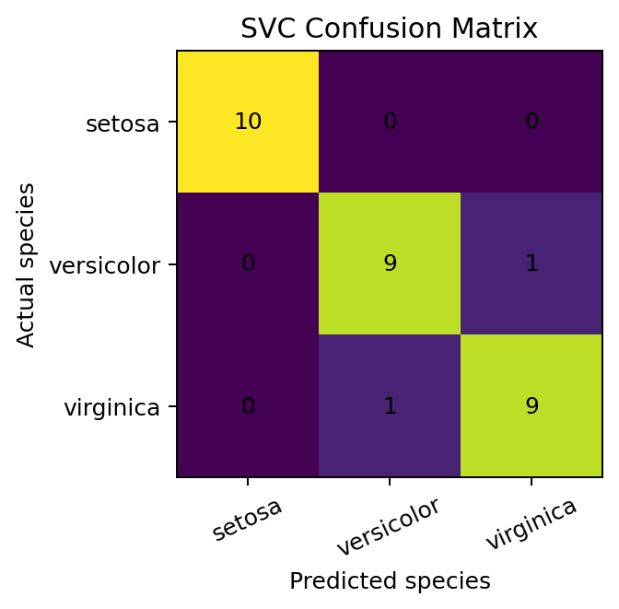
Figure 5. Confusion matrix: Setosa was classified correctly; one Versicolor and one Virginica were interchanged.
The classification report showed precision, recall and F1-score of 1.000 for Setosa and 0.900 for both Versicolor and Virginica. The confusion matrix contained 10 correct Setosa predictions, 9 correct Versicolor predictions and 9 correct Virginica predictions. One Versicolor was predicted as Virginica and one Virginica as Versicolor.

6.4 Model Interpretation
The model achieved strong results, but the remaining errors occurred between Versicolor and Virginica. This is consistent with the scatter plot, where these two species show some overlap in petal measurements. The perfect Setosa result on this test split reflects the clear separation of Setosa in this dataset; it should not be treated as a guarantee of perfect performance on all future samples.

6.5 Code for Final Evaluation
from sklearn.metrics import accuracy_score, precision_score, recall_score, f1_score
from sklearn.metrics import confusion_matrix, classification_report
y_pred = best_model.predict(X_test)
print('Accuracy:', accuracy_score(y_test, y_pred))
print('Precision:', precision_score(y_test, y_pred, average='macro'))
print('Recall:', recall_score(y_test, y_pred, average='macro'))
print('F1:', f1_score(y_test, y_pred, average='macro'))
print(confusion_matrix(y_test, y_pred))
print(classification_report(y_test, y_pred, target_names=iris.target_names))

7. Integrated Findings and Discussion
The six-week workflow shows how each stage supports the next. Exploration identified the variables and class balance. Cleaning demonstrated how to prepare a reliable working dataset. Visualization revealed group patterns and feature relationships. Statistical testing provided evidence that the differences and relationships were unlikely to be random in this sample. Machine learning then used the measurements to predict species.
Combined finding | Evidence | Importance
Petal measurements are highly informative | r = 0.963 between petal length and width; ANOVA eta-squared = 0.941 for petal length | Supports using petal measurements for species classification
Setosa is easier to distinguish | Separate Setosa cluster in scatter plot; 10/10 correct test predictions | Shows clear feature separation for this class
Versicolor and Virginica overlap | Some scatter-plot overlap; 2 test-set errors between these classes | Explains the main source of model mistakes
Model performance is promising | 93.3% test accuracy; 97.5% cross-validation accuracy | Demonstrates that a supervised model can learn useful patterns
Dataset scope is limited | 150 samples, 3 species and 4 measurements | Independent validation is needed before real-world use

8. Conclusion
This project completed an end-to-end data analytics workflow using the Iris Flower Dataset. The work covered problem definition, exploratory data analysis, data cleaning and preprocessing, visualization, statistical hypothesis testing, machine-learning implementation and model evaluation. The analysis found that petal measurements are strongly related and differ meaningfully among the three species. The tuned SVC model achieved 93.3% accuracy on the held-out test set and 97.5% mean cross-validation accuracy.
The project demonstrates how Python libraries can be combined to turn raw measurements into understandable findings and predictive results. The conclusions are limited to the selected educational dataset and should be validated with new data before being applied in a broader botanical setting.

9. Recommendations and Future Scope
- Collect a larger dataset with more samples, locations and measurement conditions.
- Test the trained model on an independent dataset that was not used during model development.
- Compare SVC with Logistic Regression, Decision Tree, Random Forest and k-Nearest Neighbours using the same stratified validation process.
- Use feature-importance methods and error analysis to understand which measurements contribute most to predictions.
- Check statistical assumptions and report confidence intervals and effect sizes alongside p-values.
- Preserve raw data, cleaned data, notebooks and model settings so the complete workflow can be repeated.
- Record Python and library versions and rerun the notebook from beginning to end before final submission.

10. Quality Assurance and Reproducibility
- Verify the dataset shape (150 records) and class counts (50 per species).
- Confirm that the original dataset has no missing cells and document the duplicate check accurately.
- Keep simulated Week 2 data-quality issues clearly separated from the original dataset.
- Regenerate charts and numerical outputs from code rather than editing figures manually.
- Use a stratified train-test split and keep preprocessing inside the training pipeline.
- Check that the test set is not used during parameter tuning.
- Review all tables, figure captions, units and interpretations for consistency.

11. References
- Fisher, R. A. (1936). The use of multiple measurements in taxonomic problems. Annals of Eugenics, 7(2), 179–188.
- UCI Machine Learning Repository. Iris Data Set. https://archive.ics.uci.edu/dataset/53/iris
- scikit-learn documentation. Iris plants dataset. https://scikit-learn.org/stable/auto_examples/datasets/plot_iris_dataset.html
- pandas documentation. https://pandas.pydata.org/docs/
- NumPy documentation. https://numpy.org/doc/
- Matplotlib documentation. https://matplotlib.org/stable/
- SciPy documentation. https://docs.scipy.org/doc/scipy/
- scikit-learn documentation. Model selection and evaluation. https://scikit-learn.org/stable/model_selection.html

Appendix A – Main Python Workflow
The following compact script summarizes the main analysis stages. Run it in Jupyter Notebook, Google Colab or VS Code with the required Python libraries installed. The report's detailed sections explain the individual methods and their interpretations.
from sklearn.datasets import load_iris
import pandas as pd
import matplotlib.pyplot as plt
from scipy import stats
from sklearn.model_selection import train_test_split, GridSearchCV, StratifiedKFold
from sklearn.preprocessing import StandardScaler
from sklearn.pipeline import Pipeline
from sklearn.svm import SVC
from sklearn.metrics import classification_report, confusion_matrix
# Load and inspect
iris = load_iris(as_frame=True)
df = iris.frame.copy()
df['species'] = df['target'].map(dict(enumerate(iris.target_names)))
print(df.shape, df.isna().sum(), df.duplicated().sum())
print(df.describe())
# Visualize petal relationship
for s in iris.target_names:
part = df[df['species'] == s]
plt.scatter(part['petal length (cm)'], part['petal width (cm)'], label=s)
plt.xlabel('Petal length (cm)'); plt.ylabel('Petal width (cm)')
plt.legend(); plt.show()
# Statistical tests
setosa = df[df.species == 'setosa']['petal length (cm)']
versicolor = df[df.species == 'versicolor']['petal length (cm)']
print(stats.ttest_ind(setosa, versicolor, equal_var=False))
groups = [df[df.species == s]['petal length (cm)'] for s in iris.target_names]
print(stats.f_oneway(*groups))
print(stats.pearsonr(df['petal length (cm)'], df['petal width (cm)']))
# Train and evaluate SVC
X, y = iris.data, iris.target
X_train, X_test, y_train, y_test = train_test_split(
X, y, test_size=0.20, random_state=42, stratify=y)
pipe = Pipeline([('scaler', StandardScaler()), ('model', SVC())])
params = {'model__kernel':['linear','rbf'], 'model__C':[0.1,1,10,100],
'model__gamma':['scale',0.1,1]}
cv = StratifiedKFold(n_splits=5, shuffle=True, random_state=42)
search = GridSearchCV(pipe, params, cv=cv, scoring='accuracy')
search.fit(X_train, y_train)
pred = search.best_estimator_.predict(X_test)
print(search.best_params_)
print(confusion_matrix(y_test, pred))
print(classification_report(y_test, pred, target_names=iris.target_names))

Appendix B – Final Submission Checklist
- ☐ Cover page contains the correct student details.
- ☐ All six weekly stages are included in the report.
- ☐ Charts and captions are readable.
- ☐ Statistical results and machine-learning metrics are explained.
- ☐ Limitations and future recommendations are included.
- ☐ Code snippets are readable and can be reproduced.
- ☐ The final DOCX is opened once to check page breaks and formatting.

