DATA EXPLORATION AND
PROBLEM DEFINITION
Week 1 Internship Task | Python Data Analytics

Item | Details
Dataset | Iris Flower Measurements Dataset
Tools | Python, pandas, NumPy, Matplotlib, scikit-learn
Prepared by | [Your Full Name]
Internship / Organization | [Internship Name / Organization]
Submission date | [DD Month YYYY]

A structured report covering dataset understanding, exploratory analysis, problem definition, hypotheses, methods, limitations, and next steps.

1. Executive Summary
This report presents an exploratory data analysis (EDA) of the Iris flower dataset, a well-known public dataset used for learning statistics and machine learning. The dataset contains 150 observations from three Iris species and four numerical flower measurements: sepal length, sepal width, petal length, and petal width. The analysis checks the dataset structure, data types, summary statistics, missing values, duplicate rows, distributions, and relationships among measurements. The initial exploration indicates that the species groups are equally represented and that petal measurements show a strong relationship with each other. The report defines a classification-oriented problem and proposes a reproducible analysis plan for the next stage.

2. Introduction and Objectives
Exploratory Data Analysis is the first stage of a data analytics project. It helps an analyst understand the data before applying statistical tests or predictive models. EDA can reveal data quality issues, patterns, unusual values, relationships, and questions that deserve further investigation.
Objectives of this task:
- Identify the dataset source, size, variables, and data types.
- Calculate descriptive statistics and compare measurements across species.
- Check missing values, duplicate records, and potentially unusual measurements.
- Use visualizations to understand distributions and relationships.
- Write a clear problem statement, research questions, hypotheses, and a feasible analysis plan.

3. Dataset Selection and Description
Dataset selected: Iris flower measurements. The dataset is publicly available through the UCI Machine Learning Repository and is also distributed with scikit-learn for educational use. Each row represents one flower sample. The target label is the flower species.
Dataset property | Description
Number of records | 150
Number of input features | 4 numerical measurements
Target variable | species (setosa, versicolor, virginica)
Measurement unit | Centimetres (cm)
Task type | Exploratory analysis; later, supervised classification may be explored
Data source | UCI Machine Learning Repository — Iris dataset; accessed through scikit-learn dataset loader

3.1 Variable Dictionary
Variable | Type | Meaning | Role
sepal_length_cm | Numeric (float) | Length of the sepal in centimetres | Input feature
sepal_width_cm | Numeric (float) | Width of the sepal in centimetres | Input feature
petal_length_cm | Numeric (float) | Length of the petal in centimetres | Input feature
petal_width_cm | Numeric (float) | Width of the petal in centimetres | Input feature
species | Categorical | Iris species: setosa, versicolor, or virginica | Target / grouping variable

The four measurement columns are continuous numerical variables. Species is a categorical variable with three classes. The dataset is small, structured, and suitable for practicing data cleaning, visualization, descriptive statistics, and introductory classification.

4. Tools and Environment
Tool / library | Purpose
Python | Main programming language
pandas | Loading, organizing, filtering, and summarizing tabular data
NumPy | Numerical calculations and array operations
Matplotlib | Creating charts and visual summaries
scikit-learn | Loading the public Iris dataset; can later support model evaluation
python-docx | Preparing the report document

Suggested environment: Jupyter Notebook, Google Colab, or VS Code with Python installed.

5. Exploratory Data Analysis (EDA)

5.1 Workflow and Basic Inspection
The dataset was loaded into a pandas DataFrame. The following commands are useful for reproducing the inspection:
from sklearn.datasets import load_iris
import pandas as pd
import numpy as np
import matplotlib.pyplot as plt
iris = load_iris(as_frame=True)
df = iris.data.copy()
df.columns = [
"sepal_length_cm", "sepal_width_cm",
"petal_length_cm", "petal_width_cm"
]
df["species"] = pd.Categorical.from_codes(
iris.target, iris.target_names
)
print(df.head())
print(df.shape)
print(df.info())
print(df.describe())
Observed shape: 150 rows × 5 columns. The first rows can be inspected with head(), while info() provides column types and non-null counts.

5.2 Summary Statistics
Feature | Mean | Median | Std. dev. | Minimum | Maximum
sepal_length_cm | 5.84 | 5.80 | 0.83 | 4.30 | 7.90
sepal_width_cm | 3.06 | 3.00 | 0.44 | 2.00 | 4.40
petal_length_cm | 3.76 | 4.35 | 1.77 | 1.00 | 6.90
petal_width_cm | 1.20 | 1.30 | 0.76 | 0.10 | 2.50

Interpretation: petal length and petal width have noticeably different ranges across the dataset. The means and medians provide a first view of central tendency, while standard deviation indicates how spread out the measurements are. These overall statistics combine all three species, so group-wise summaries are also important.

5.3 Class Distribution
The target labels are balanced: each species contributes 50 samples, or one-third of the dataset.
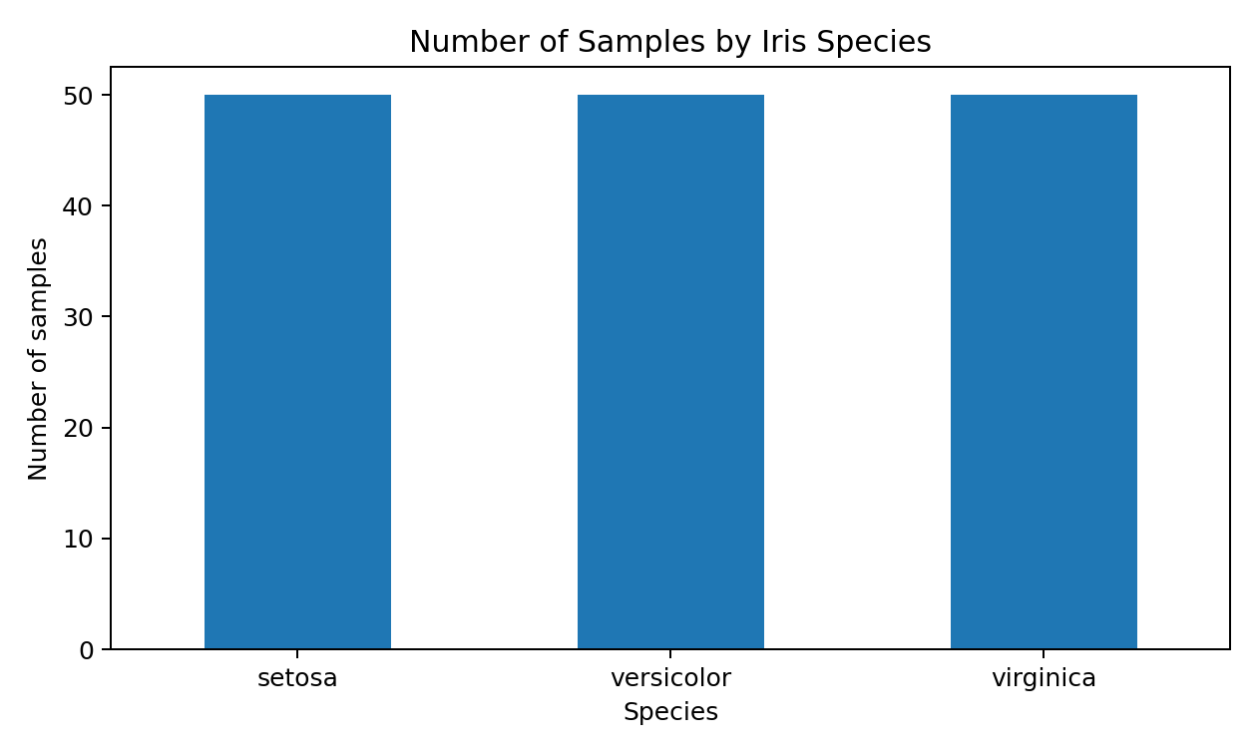
Figure 1. Number of samples for each Iris species.

5.4 Missing Values and Duplicate Records
Quality check | Result | Interpretation
Missing values | 0 total missing cells | No missing values were found in the selected data.
Duplicate rows | 1 | Exact duplicate rows should be reviewed; duplicates are not automatically errors in every dataset.
Data types | 4 numerical columns + 1 categorical column | Types match the intended meaning of the variables.

Data-quality note: no missing values were identified in the loaded dataset. The duplicate-row count is reported from an exact row comparison. A duplicate check is a screening step; if duplicates existed, the analyst would inspect them before deciding whether to remove them.

5.5 Distribution of Measurements
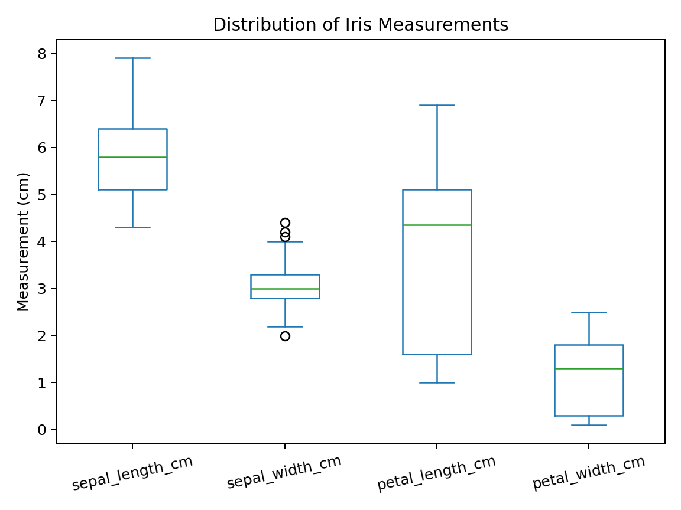
Figure 2. Boxplots summarize the distribution and spread of the four measurements. The box shows the middle half of the observations, the centre line is the median, and points beyond whiskers may indicate potential outliers. Potential outliers should be investigated in context rather than removed automatically.

5.6 Relationships Between Variables
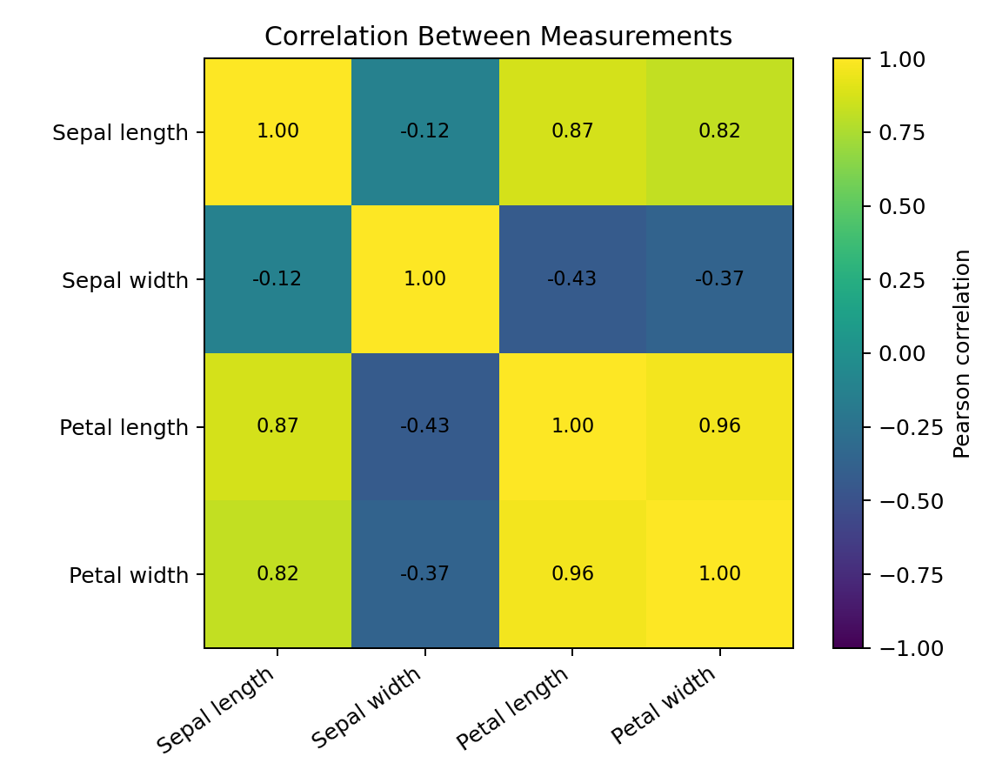
Figure 3. Pearson correlation heatmap for the four numerical measurements. Petal length and petal width have a strong positive correlation (approximately 0.96), meaning larger petal lengths generally occur with larger petal widths in this dataset. Correlation describes association and does not establish causation. Correlations can also be influenced by the differences among species.

5.7 Comparison by Species
Species | Mean sepal length | Mean sepal width | Mean petal length | Mean petal width
setosa | 5.01 | 3.43 | 1.46 | 0.25
versicolor | 5.94 | 2.77 | 4.26 | 1.33
virginica | 6.59 | 2.97 | 5.55 | 2.03

The group means show that setosa has much smaller average petal measurements than versicolor and virginica. Versicolor and virginica have larger petals on average, though their measurements can overlap. This pattern suggests that petal measurements may be useful for distinguishing species and should be examined further with grouped plots and a classification model.

6. Key Findings from Initial EDA
- The dataset contains 150 flower samples, four numerical features, and one categorical target variable.
- The three species are evenly represented, with 50 observations per class.
- No missing values were detected in the selected dataset.
- Descriptive statistics show meaningful variation in the measurements.
- Petal length and petal width are strongly positively associated.
- Mean petal measurements differ notably across species, especially between setosa and the other two species.
- The findings are exploratory and should be confirmed using suitable plots, statistical tests, and validation in later work.

7. Problem Definition

7.1 Problem Statement
The objective is to investigate whether the four physical measurements of an Iris flower contain useful patterns for distinguishing the three species: setosa, versicolor, and virginica. The analysis will first assess data quality and explore distributions and relationships, then compare measurements across species. In a subsequent stage, a supervised classification model may be trained and evaluated to determine how accurately species can be predicted from the measurements.

7.2 Business / Analytical Relevance
Although this is an educational dataset rather than a commercial business dataset, it represents a common analytics task: using measured attributes to identify categories. The same workflow—data validation, EDA, hypothesis testing, model building, and evaluation—can be adapted to practical classification problems such as quality inspection or species identification.

7.3 Research Questions
- How are the four flower measurements distributed across the complete dataset?
- Are average measurements different among the three Iris species?
- Which numerical features are most strongly associated with one another?
- Which measurements appear most useful for separating setosa, versicolor, and virginica?
- Can a simple classification model predict species accurately on unseen samples?

8. Hypotheses
ID | Hypothesis | How it will be assessed
H1 | Mean petal length differs among the three species. | Compare group summaries and use one-way ANOVA if assumptions are reasonable; otherwise consider Kruskal–Wallis.
H2 | Mean petal width differs among the three species. | Use group plots and an appropriate statistical test.
H3 | Petal length and petal width have a positive association. | Calculate Pearson correlation; inspect a scatter plot. Use Spearman correlation if monotonicity or outliers make it more suitable.
H4 | Petal measurements will help distinguish species better than relying on a single sepal measurement. | Compare feature plots and evaluate models using cross-validation and per-class metrics.

These are proposed hypotheses, not claims of statistical significance. Formal tests and model evaluation belong to the next stage.

9. Proposed Analysis Plan
Stage | Activity | Method / tool | Expected output
1. Data acquisition | Load the public dataset and record source information. | scikit-learn / UCI source; pandas | Reproducible dataset and source note
2. Data understanding | Inspect dimensions, columns, data types, labels, and units. | shape, head(), info(), value_counts() | Data dictionary and class counts
3. Data quality | Check nulls, duplicates, ranges, and unusual values. | isna(), duplicated(), describe(), boxplots | Data-quality summary
4. Univariate EDA | Study each measurement separately. | Histograms, boxplots, mean, median, standard deviation | Distribution patterns
5. Bivariate / group EDA | Compare measurements by species and inspect associations. | Grouped summaries, scatter plots, correlation matrix | Potentially informative features
6. Statistical analysis | Test selected group differences and relationships. | ANOVA / Kruskal–Wallis; correlation tests | Test statistics, p-values, effect-size discussion
7. Predictive modelling | Build a baseline species classifier. | Train/test split; logistic regression or decision tree; scikit-learn | Baseline predictions
8. Evaluation | Assess performance and errors. | Accuracy, precision, recall, F1-score, confusion matrix; cross-validation | Model comparison and error analysis
9. Reporting | Explain findings, limitations, and next steps. | Python notebook + DOC report | Reproducible report

9.1 Example Code for Further Analysis
# Data quality
print(df.isna().sum())
print("Duplicate rows:", df.duplicated().sum())
# Group comparison
print(df.groupby("species", observed=False).mean(numeric_only=True))
# Correlation
print(df.select_dtypes(include=np.number).corr())
# Example visualization
import seaborn as sns
sns.scatterplot(
data=df, x="petal_length_cm",
y="petal_width_cm", hue="species"
)
plt.show()

10. Limitations and Risks
- The dataset is small, with only 150 records, so results may not represent every real-world flower population.
- The dataset contains only three species and four measurements; additional visual, environmental, or geographic variables are not included.
- The measurements are already prepared in a clean educational dataset, so it does not fully represent the messy data often encountered in real projects.
- A correlation does not prove cause and effect.
- Species measurements may overlap, which can lead to classification errors.
- A high model score on this dataset would not automatically mean the model will work equally well on new data collected under different conditions.

11. Future Improvements
- Use a reproducible notebook and document software/library versions.
- Create histograms and scatter plots split by species to examine overlap more closely.
- Check assumptions before choosing statistical tests and report effect sizes alongside p-values.
- Compare a simple baseline classifier with one or two alternative models using stratified cross-validation.
- Use a confusion matrix and precision, recall, and F1-score to understand class-specific errors.
- For a more realistic follow-up project, use a larger dataset with more samples and broader measurement conditions.

12. Conclusion
This Week 1 task established a clear starting point for a data analytics project. The Iris dataset was inspected for its structure, variable types, descriptive statistics, missing values, duplicate rows, distributions, and feature relationships. The initial results suggest that petal measurements may be useful for distinguishing the three species, while further statistical testing and predictive evaluation are required before drawing stronger conclusions. The report provides a defined problem statement, research questions, hypotheses, methods, limitations, and next steps for the following internship tasks.

13. References
- Fisher, R. A. (1936). The use of multiple measurements in taxonomic problems. Annals of Eugenics, 7(2), 179–188.
- UCI Machine Learning Repository. Iris Data Set. https://archive.ics.uci.edu/dataset/53/iris
- scikit-learn documentation. Toy datasets: Iris plants dataset. https://scikit-learn.org/stable/auto_examples/datasets/plot_iris_dataset.html
- pandas documentation. https://pandas.pydata.org/docs/
- NumPy documentation. https://numpy.org/doc/
- Matplotlib documentation. https://matplotlib.org/stable/

Appendix A: Reproducibility Checklist
- ☐ Run the Python code from top to bottom in a fresh notebook.
- ☐ Verify the dataset shape, species counts, and data types.
- ☐ Regenerate the summary statistics and figures rather than manually editing values.
- ☐ Record any changes to the dataset or analysis decisions.
- ☐ Replace the cover-page placeholders with your real name, internship details, and submission date.
- ☐ Review the report and ensure you understand the results before submitting.

