WEEK 3 REPORT
DATA VISUALIZATION AND REPORTING
Dataset: Iris Flower Dataset | Tools: Python, Pandas, Matplotlib and Scikit-learn

1. Introduction
Data visualization presents information through charts and graphs. It helps people understand comparisons, patterns, trends and relationships. In this task, I used the Iris Flower Dataset from the previous weeks. It contains 150 flower records from three species: Setosa, Versicolor and Virginica. Each record includes sepal length, sepal width, petal length and petal width.

2. Objectives
- Create a bar chart, line chart, scatter plot and heatmap using Python.
- Identify patterns and relationships in the Iris dataset.
- Use clear titles, axis labels, legends and readable colors.
- Explain the findings in simple language.

3. Dataset and Tools
The dataset has 150 samples, with 50 samples from each species, and four numerical features measured in centimetres. Pandas was used to organize and summarize the data. Matplotlib was used to create the visualizations, and Scikit-learn was used to load the Iris dataset.

4. Visualization Strategy
Four charts were selected to answer different questions. The bar chart compares sample counts by species. The line chart compares average sepal and petal lengths. The scatter plot examines the relationship between petal length and petal width. The heatmap summarizes correlations among all four numerical measurements.

5.1 Bar Chart – Samples by Species
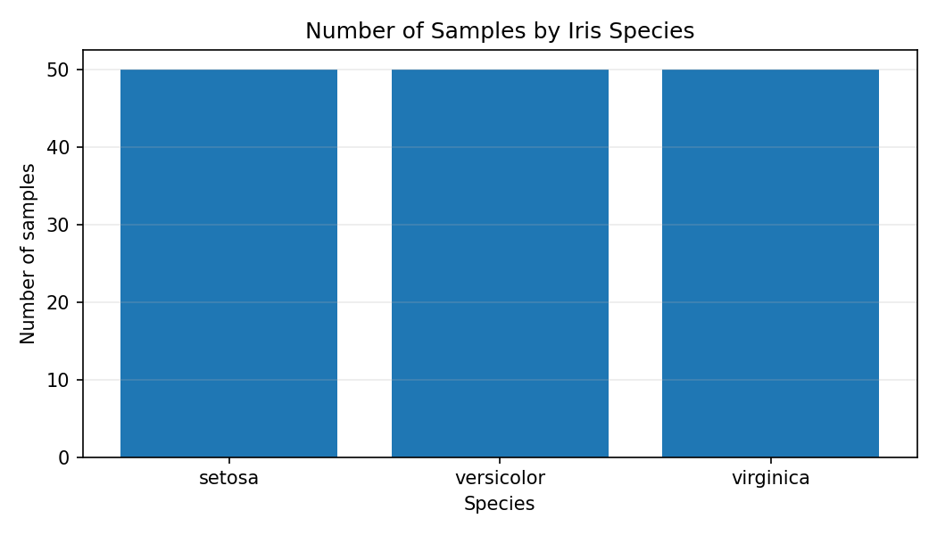
Interpretation and relevance: The chart shows 50 samples for each species. Therefore, the dataset is balanced across Setosa, Versicolor and Virginica. A bar chart is suitable for comparing values across categories and quickly checking the distribution of records.

5.2 Line Chart – Average Lengths
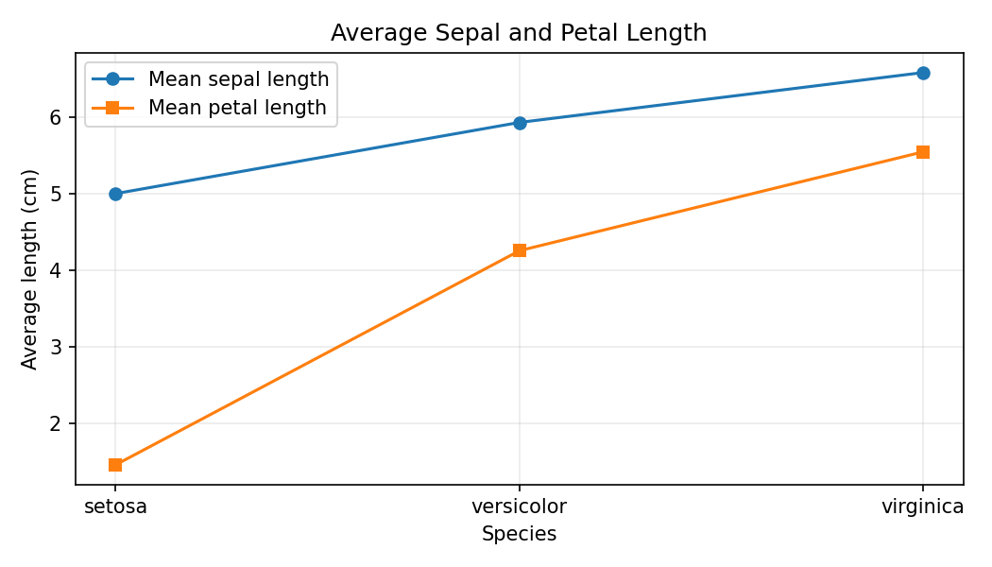
Interpretation and relevance: Average petal length increases from Setosa to Versicolor and then Virginica. Average sepal length also generally increases. This chart compares group averages. Since species are categories and not time periods, the connecting lines are only a visual guide, not a time-based trend.

5.3 Scatter Plot – Petal Measurements
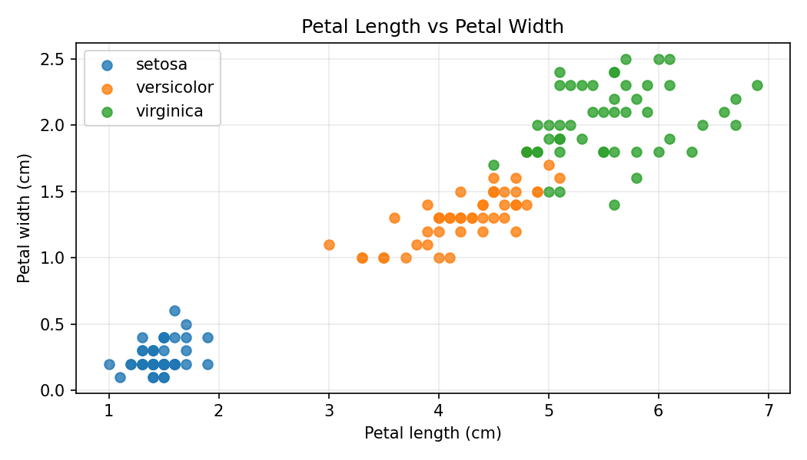
Interpretation and relevance: Petal length and petal width have a positive relationship: flowers with longer petals usually have wider petals. Setosa forms a separate cluster with smaller petal measurements. Versicolor is mostly in the middle, while Virginica generally has larger petals. Some overlap may occur between Versicolor and Virginica. A scatter plot is useful for identifying relationships and clusters in individual observations.

5.4 Heatmap – Correlations
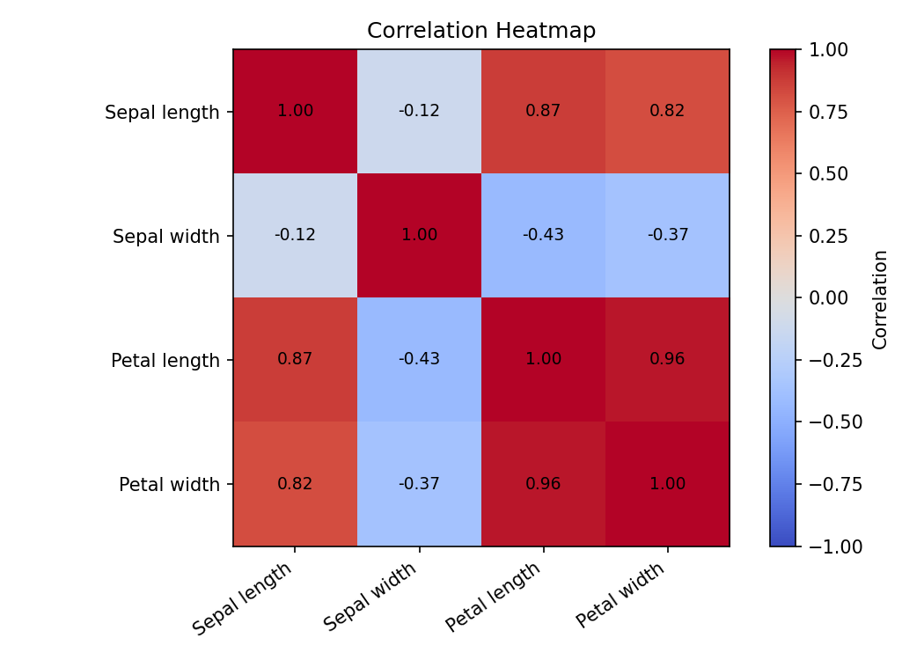
Interpretation and relevance: Petal length and petal width have a strong positive correlation. Sepal length is also positively related to petal measurements. Sepal width has weaker relationships with the other features. Correlation describes association; it does not prove that one measurement causes another. A heatmap makes several correlation values easy to compare at once.

6. Python Code
import pandas as pd
import matplotlib.pyplot as plt
from sklearn.datasets import load_iris
iris = load_iris(as_frame=True)
df = iris.frame
df["species"] = df["target"].map(dict(enumerate(iris.target_names)))
# Bar chart
df["species"].value_counts().plot(kind="bar")
plt.xlabel("Species"); plt.ylabel("Number of samples")
plt.title("Samples by Species"); plt.show()
# Line chart: average measurements
means = df.groupby("species")[["sepal length (cm)",
"petal length (cm)"]].mean()
means.plot(kind="line", marker="o")
plt.xlabel("Species"); plt.ylabel("Average length (cm)")
plt.show()
# Scatter plot
for name in iris.target_names:
part = df[df["species"] == name]
plt.scatter(part["petal length (cm)"],
part["petal width (cm)"], label=name)
plt.xlabel("Petal length (cm)"); plt.ylabel("Petal width (cm)")
plt.legend(); plt.show()
# Correlation heatmap
corr = df.iloc[:, :4].corr()
plt.imshow(corr, cmap="coolwarm", vmin=-1, vmax=1)
plt.colorbar(); plt.title("Correlation Heatmap"); plt.show()

7. Best Practices Followed
- Used meaningful chart titles and descriptive axis labels.
- Displayed measurement units where needed.
- Added legends to identify species and measurements.
- Used readable colors and a fixed correlation scale from -1 to +1.
- Added grid lines and correlation values to improve readability.
- Avoided treating correlation as proof of cause and effect.

8. Overall Findings
- The dataset contains 150 records, with 50 samples per species.
- Virginica generally has the largest average petal measurements.
- Setosa has the smallest petal measurements and forms a distinct cluster.
- Petal length and petal width are strongly positively related.
- Different chart types provide complementary views of the same dataset.

9. Conclusion
This task helped me understand how Python visualizations can turn numerical data into clear findings. The bar chart compared species counts, the line chart compared average measurements, the scatter plot showed relationships between petal dimensions, and the heatmap displayed correlations. Clear labels, titles and legends made the charts easier to understand. Data visualization is an important part of data analytics because it communicates results clearly and supports better decisions.

10. References
1. Scikit-learn Iris dataset documentation: https://scikit-learn.org/stable/auto_examples/datasets/plot_iris_dataset.html
2. Pandas documentation: https://pandas.pydata.org/docs/
3. Matplotlib documentation: https://matplotlib.org/stable/

