Agentic SDLC URL Shortener
Technical Review Board Briefing
A URL shortener built as the vehicle to demonstrate a governed agentic software engineering system - end-to-end SDLC orchestration with controlled autonomy, human approval gates, and audit-grade traceability.

1. Executive Summary
The assignment's own framing is the thesis of this build: "transform a requirement into a reviewable engineering outcome using an agentic execution model." The URL shortener is real, working, and production-minded - but it exists to be exercised by a governed process, not the other way around. That process is a custom dependency-graph orchestrator coordinating seven single-purpose agents through three enforced human approval gates, with bounded retry, rollback, safe-stop, and dependency-aware replanning all implemented as executable code, not written policy.
Three scenarios exercise it end to end - greenfield (the initial build), brownfield (a configurable-expiry enhancement with a real migration, refactor, and a regression bug caught and fixed under change control), and an ambiguous requirement ("make shortened links more secure") that pauses for genuine clarification before implementing anything. Every claim in this document has a corresponding test, log, or artifact behind it - this was validated by running it, not just writing it.

2. Assignment-to-Solution Map
Every core requirement from the assignment brief, mapped to why it was approached this way, how it was implemented, and where it lives.
Requirement | Why this approach | How it's implemented | Where
1. Requirement Understanding | Ambiguity has to be surfaced explicitly, not silently resolved. | Requirement Analysis Agent normalizes intent, lists FRs/NFRs, and enumerates 8 candidate interpretations for the ambiguous case before anything is built. | agentic/agents/requirement_analysis_agent.py
2. Task Decomposition | A plan that silently drops a requirement is worse than no plan. | Planning Agent generates one task per approved requirement ID and self-checks 100% coverage before returning. | agentic/agents/planning_agent.py
3. Codebase Reasoning (Brownfield) | A real enhancement has to touch a running system without breaking it. | Expiry enhancement: impact analysis, an additive migration, a refactor, and a real regression test that caught a boundary bug pre-commit. | app/services/expiry.py, scripts/run_brownfield.py
4. Workflow Orchestration (critical differentiator) | The brief explicitly asks for non-linear, stateful, governed execution. | Explicit dependency graph in code, persisted state, one genuine parallel branch with a join, conditional routing, bounded retry, rollback, safe-stop, replanning. | agentic/orchestrator.py, agentic/graph.py
5. Engineering Output Generation | "Production-quality" has to mean tested and typed, not just plausible-looking. | FastAPI application, Pydantic schemas end to end, 125 tests at 96% coverage, full architecture documentation. | app/, tests/, docs/architecture/
6. Validation & Risk Control | Risks stated after the fact are marketing; risks stated before building are engineering. | Every ADR has an "alternatives considered" section written before implementation; SECURITY.md states limitations directly. | docs/decisions/, SECURITY.md
7. Controlled Autonomy | "Agents execute, humans approve" needs to be structurally enforced, not a guideline. | Three graph nodes (HUMAN_GATE_*) block progress until a real decision is recorded in the approvals table; auto-approval is an explicit demo-only flag, never the default. | agentic/approvals.py
8. Final Engineering Summary | A retrospective is itself a deliverable, not an afterthought. | Plan, rationale, artifacts, risks, assumptions, and limitations, written as a standalone document. | docs/final-engineering-summary.md

3. System Architecture
One container, one process, two logical layers sharing one database. The application layer serves reviewer traffic; the orchestration layer is invoked by scenario scripts. Both persist through the same SQLAlchemy/Alembic/SQLite stack - deliberately simple, with the production evolution path documented rather than built prematurely.
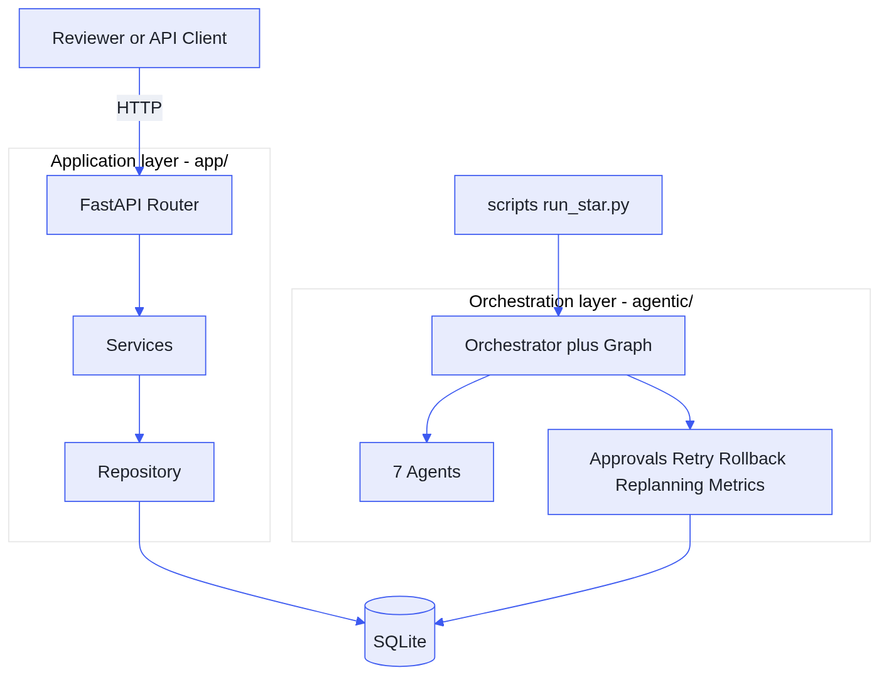
Component architecture

4. The Orchestration Model
This is the assignment's "critical differentiator," so it's built as literal, testable code rather than a described intention. The graph below is agentic/graph.py rendered - not a simplification of it.
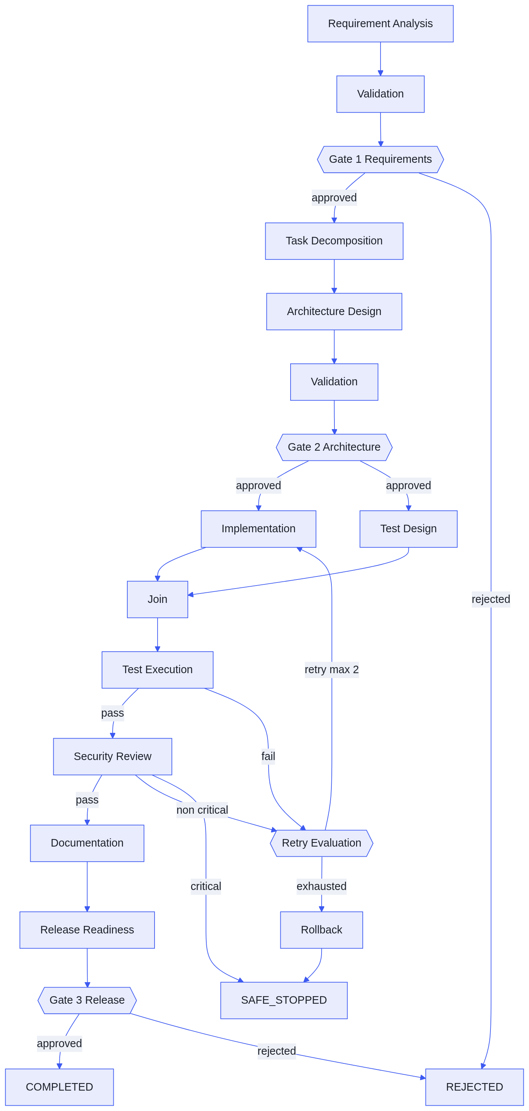
Dependency graph - gates, parallel branch, retry, rollback, safe-stop

Stateful and resumable
Every transition is persisted to workflow_runs/workflow_events before the process exits at a gate. Verified by stopping and restarting the process across three separate invocations and confirming it resumed from the exact right node.

Genuinely parallel
Implementation and test design run concurrently via a thread pool with an explicit join. This surfaced and fixed a real bug: two threads sharing one database session is not thread-safe - resolved by separating computation (threaded) from persistence (sequential).

Bounded retry, real rollback
Max two retries per retryable failure; exhaustion triggers rollback, which supersedes draft/stale artifacts (never an already-approved one) and always lands on SAFE_STOPPED - a state that can never be released.

Dependency-aware replanning
When a requirement changes, only downstream artifacts are marked stale and re-derived - demonstrated live using the exact expiry-configurability change the brief itself uses as its worked example.

5. The Seven Agents
Each agent is single-purpose, behind one shared contract (execute()/validate()), and self-checks its own domain-specific correctness before the orchestrator ever inspects the result.
Agent | Why it exists | How it works | Where in the flow
Requirement Analysis | Normalize intent and surface ambiguity before design starts. | Rule-based classification per scenario type; enumerates 8 candidate interpretations for the ambiguous case. | First node; feeds Gate 1
Planning | A traceable breakdown, not a guessed one. | One task per approved requirement ID; self-verifies 100% coverage. | After Gate 1
Architecture | "Don't overengineer" needs to be enforced, not hoped for. | Produces the design; output is checked against an automated denylist before acceptance. | Before Gate 2
Development | Runtime codegen for a whole app isn't meaningfully deterministic - but a narrow, pre-modeled change genuinely can be. | Hybrid model: greenfield code is engineered directly and recorded/self-reviewed; brownfield/ambiguous changes are small enough to be genuinely auto-applied at runtime. | Implementation (parallel branch)
Test | Test execution has no ambiguity to hide behind. | Designs one planned case per requirement ID, then actually invokes pytest and parses the real result. | Test design (parallel) + execution
Security & Quality Review | A gate that can only advise, never block, isn't a gate. | Runs real lint/security checks; a critical finding routes straight to safe-stop with zero retries spent. | Before Gate 3
Documentation & Release | Release readiness should be synthesized from evidence, not asserted. | Aggregates every upstream artifact into a readiness summary, limitations, and backlog. | Feeds Gate 3

6. Three Scenarios

Greenfield
The initial build - full graph walk, all three gates, all seven agents. Reaches COMPLETED, evidence retained.

Brownfield
Configurable expiry (1-365 days): an enhancement, a refactor, an additive migration, and a real regression bug caught by a test before it was ever committed - all three change types the brief names, in one coherent change. Live replanning demonstration included.

Ambiguous
"Make shortened links more secure" -> 8 interpretations enumerated -> workflow pauses for real clarification -> approved interpretation implemented selectively (only rate limiting was net-new; the rest already existed in the greenfield baseline).

7. End-to-End Flow — Building the System
This is what happens when a scenario script runs - the process the assignment is actually grading. It is separate from what a reviewer clicks through in Swagger (Section 8): this flow produces the application; it does not run underneath every API call.
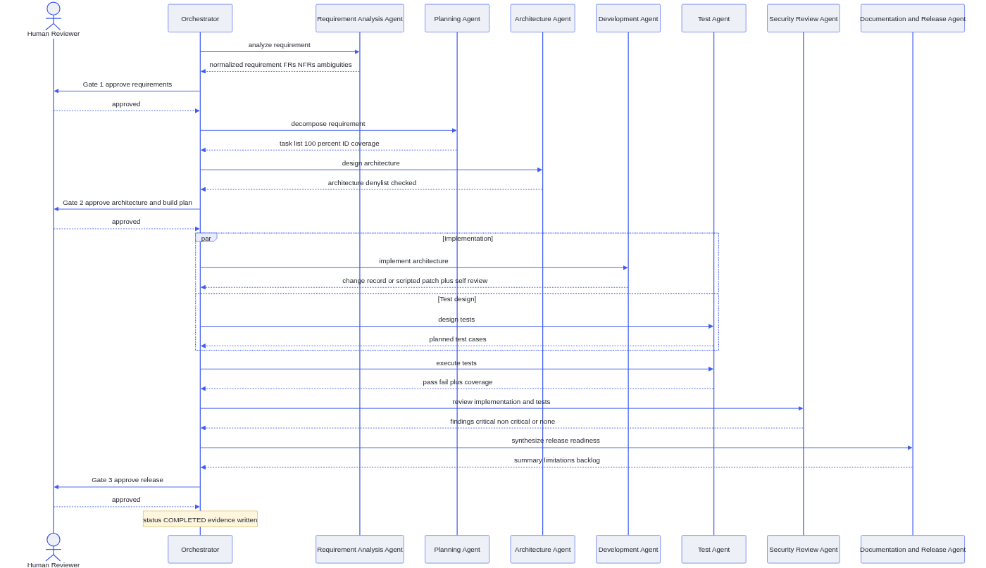
Agentic build flow (one full scenario run)

8. End-to-End Flow — Testing the API
This is what a reviewer actually clicks through in Swagger. It is deterministic FastAPI code - the finished artifact of the flow in Section 7, not agents running per request. No agent fires when you POST a URL; the agents already did their job when this code was built and governed into existence.
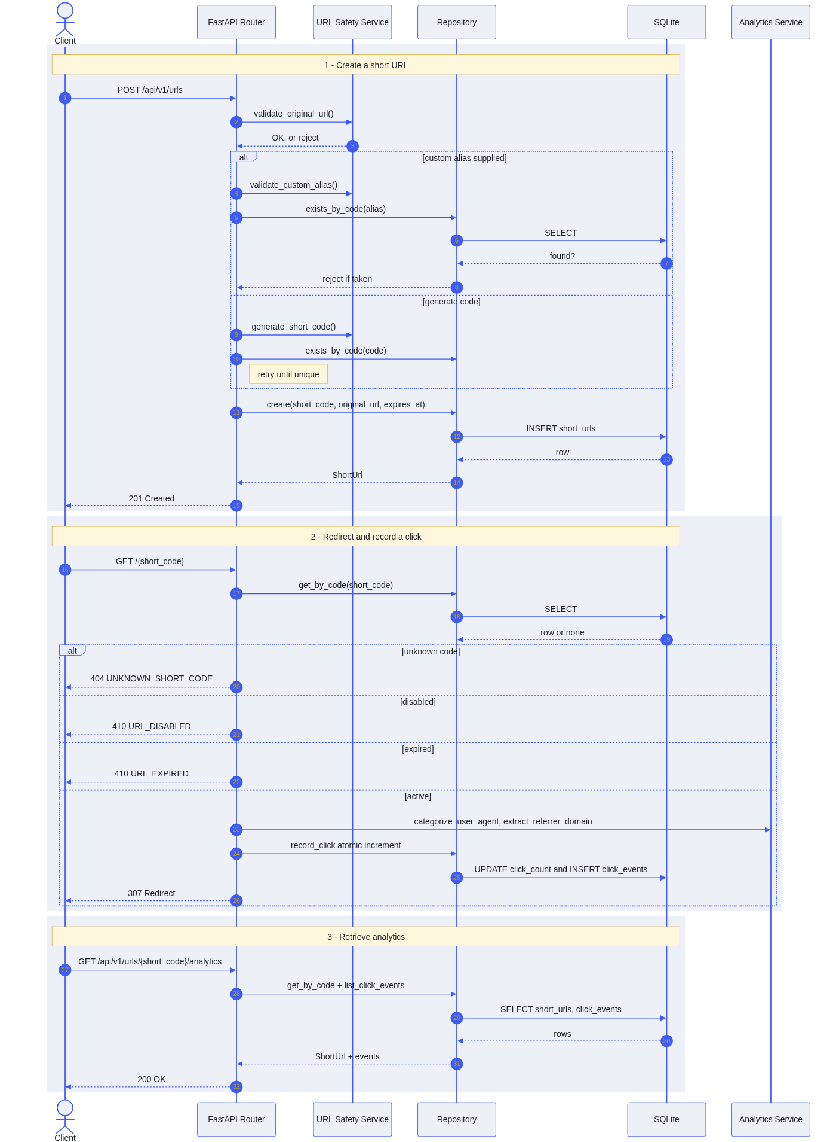
Application request flow - create, redirect, analytics

9. Security: Solution & Agentic

Solution-level
- Scheme allowlist: only http/https; javascript:/file:/data: rejected.
- SSRF protection: destination resolved and rejected if loopback, private (RFC 1918), link-local, or a known cloud-metadata address.
- Secure short codes: secrets.token_urlsafe, never a predictable counter.
- Privacy-conscious analytics: referrer reduced to domain, user-agent to a coarse category - never raw IP or precise location.
- Rate limiting: the one net-new control from the ambiguous scenario's approved interpretation.
- No leaked internals: every error is one structured envelope; stack traces never reach the client.

Agentic-level
- No tool access by construction: deterministic agents are plain functions - no shell, no network, no filesystem writes outside the artifact store.
- Automated architecture guardrail: a denylist check rejects any design referencing a disallowed component before it can reach Gate 2.
- Automated test-integrity check: a silently skipped test to force a pass is flagged as a policy violation.
- Human gates as the backstop: even a schema-valid, policy-compliant output can still be rejected by a human at any of the three gates.
- Stated, not assumed, limitation: an optional live-LLM mode would introduce a real tool-calling surface needing its own enforcement - documented now, not forgotten later.

10. Deliverables in the Code
Deliverable | Location | Evidence
Working prototype, runnable end-to-end | docker-compose.yml, Dockerfile | Validated live: /health, /docs, data survives a restart
Architecture overview | docs/architecture/, docs/decisions/ (13 ADRs) | Components, control flow, every key decision with alternatives considered
Three scenarios | scripts/run_greenfield.py, run_brownfield.py, run_ambiguous.py | Each independently reaches COMPLETED; evidence in artifacts/sample-runs/
Setup instructions | README.md, REVIEWER_GUIDE.md | Five-minute reviewer path, including failure-injection demos
Testing approach, limitations, trade-offs | docs/testing/traceability-matrix.md, docs/final-engineering-summary.md | 125 tests / 96% coverage, every requirement ID mapped to its test

11. Evaluation-Criteria Mapping
Criterion | Where it's demonstrated
Effectiveness of agentic orchestration | agentic/orchestrator.py + live retry/rollback/safe-stop failure-injection runs
Architecture / system design quality | 13 ADRs, each with rejected alternatives stated explicitly
Depth of decomposition and execution | Planning Agent's provable ID coverage; ordered build plan
Realism / quality of outputs | Real defects found and fixed by actually running the system - logged in commit history
Validation and risk management rigor | SECURITY.md, retry/rollback tests, two documented failure-injection demonstrations
Clarity and defensibility of decisions | ADRs' "alternatives considered"; gaps found in the original spec itself, fixed with stated rationale
Modular, testable, reliable, secure, scalable, safely changed | Clean app/ vs agentic/ boundary; 96% coverage; atomic counters; artifact versioning that never silently overwrites an approved version
Engineering judgment | Real trade-off calls made and written down - see Section 12

12. Limitations & Trade-offs
- Deterministic agents use a fixed rule set, not general-purpose language understanding - a stated scope boundary, not a discovered gap.
- Parallelism is in-process (threads), not distributed workers - real concurrency and a real join, but not production-grade isolation.
- Replanning operates at artifact-type granularity; finer-grained preservation is visible at the file level inside the development artifact instead.
- MTTR and approval-wait metrics are not implemented - stated directly in agentic/metrics.py rather than faked with placeholder numbers.
- No live-LLM mode is built out - deterministic mode satisfies every requirement on its own; this was a deliberately deferred, optional path.

Repository: github.com/bommulurianji2/agentic-sdlc-url-shortener · Release: v1.2.0-final-assessment

