URL Shortener — End-to-End Sequence Diagram
Agentic SDLC URL Shortener — application request flow (create, redirect, analytics)

Overview
The three request flows that make up the application's end-to-end behavior, from the client's first POST through to a recorded analytics event. Read the plain-English phase summaries below, then trace them against the rendered diagram, which groups the same three phases as shaded bands, in the same order.
Actors: Client, FastAPI Router, URL Safety Service, Repository, SQLite Database, Analytics Service.

Phase 1 — Create a short URL
- Client sends POST /api/v1/urls with an original URL and optional custom alias/expiry.
- The router validates the URL's scheme and checks it against the SSRF/private-network denylist.
- If a custom alias was supplied, it's validated and checked for uniqueness against the database; otherwise a secure random code is generated and checked the same way, retrying on collision.
- The repository inserts the new row into short_urls; the API responds 201 Created with the short URL.

Phase 2 — Redirect and record a click
- Client requests GET /{short_code}.
- The repository looks up the code. Unknown -> 404; disabled -> 410; expired -> 410 - each stops here with a distinct error code.
- For an active link, the referrer is reduced to its domain and the user-agent to a coarse category (browser/bot/other) - never stored raw.
- A click event is inserted and the click counter incremented in one atomic database update; the client receives a 307 redirect to the original URL.

Phase 3 — Retrieve analytics
- Client requests GET /api/v1/urls/{short_code}/analytics.
- The repository fetches the link's summary plus every recorded click event.
- The API responds 200 OK with total click count and per-click history.

Rendered Diagram
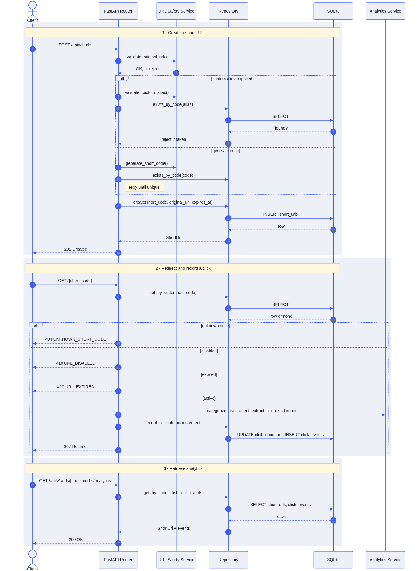

Repository: github.com/bommulurianji2/agentic-sdlc-url-shortener · Release: v1.2.0-final-assessment

