INCREASING BUILDING SUSTAINABILITY USING DATA SCIENCE

Table of Contents
Week1 7
1. Introduction 7
2. Why is the Topic a Problem? 7
3. Key Stakeholders in the Project 7
4. Connected Businesses / Industries 8
5. How Big is the Problem? (Market Size / Cost) 8
6. Potential Benefits of the Solution 9
7. Solution Domain / Possible Features 9
8. Research Scope of Project 10
9. Aim of the Project 10
10. Objectives of the Project 10
Week2 11
Project Planning 11
Work Breakdown Structure (WBS) 11
Task Identification and Dependencies 12
Time Estimation and Resource Allocation 12
Deliverables and Expected Outputs 13
Milestones and Timeline Planning 14
Risk Management and Planning Justification 14
WEEK 3: 16
SPECIFY REQUIREMENTS 16
Introduction 16
Mission Need and Stakeholder Requirements 16
User Requirements and Use Case Analysis 17
Functional and Non-Functional Requirements 18
Python Code Logic and Prototype Output 20
Verification and Critical Evaluation 21
Conclusion 21
Week 4 23
System Architecture 23
Overall System Architecture (Block Diagram) 23
Functional Breakdown 24
Behavioural Modelling 25
Interface Definition 26
Technical Architecture and Design Justification 27
Architecture Evolution and Scalability 27
Week 5 28
System Design 28
System Requirements Baseline 28
System Architecture Overview 28
Technical Description of the System 29
Hardware and Software Specifications 31
Interface Specification 31
Technology Development Roadmap 32
Design Evaluation and Justification 33
Week 6 34
Lesson 1: Minimum Viable Product (MVP) 34
Lesson 2: Building Your Product (Prototyping & Code-Based Approach) 34
Lesson 3: What’s Good Enough? (TRL Levels) 37
Conclusion 37
Week 7 38
Lesson 1: System Integration 38
1.1 Integrating Dataset, Logic and User Input 38
1.2 Importance of Integration in Data Science Systems 38
Lesson 2: Functional Testing of the MVP 38
2.1 Testing Core Functions 38
2.2 Testing Accuracy and Reliability 39
Lesson 3: User Testing and Feedback 40
3.1 Simulated User Testing 40
3.2 Feedback for Improvement 40
Lesson 4: Testing Against TRL and Quality Benchmarks 40
4.1 TRL Validation 40
4.2 What Makes the Test Successful? 41
Conclusion 41
Week 8 42
Introduction 42
Verification Testing 42
Validation Trial 43
Chatbot Working Process 44
Output Examples 45
Improvements 45
Conclusion 46
Week 9 47
1. Introduction 47
2. Analysis of System Performance 47
3. Accuracy and Reliability Analysis 48
4. User Feedback and Usability Analysis 49
5. Sustainability Impact Analysis 51
6. Critical Evaluation of Results 52
7. Conclusion 52
Week 10 54
1. INTRODUCTION 54
1.1 Background of the Project 54
1.2 Problem Statement 54
1.3 Aim of the Project 55
1.4 Objectives of the Project 55
1.5 Importance of the Study 55
1.6 Overview of the Report 56
2. SCOPE 56
2.1 Project Scope 56
2.2 System Boundaries 57
2.3 Research Objectives 57
2.4 Expected Deliverables 57
3. LITERATURE REVIEW 58
3.1 Introduction 58
3.2 Building Sustainability 58
3.3 Energy Management Systems 59
3.4 Data Science in Smart Buildings 60
3.5 HVAC Optimisation and Sustainability 61
3.6 AI Chatbots and Recommendation Systems 62
3.7 IoT and Environmental Monitoring 63
3.8 Research Gap 63
4. APPROACH (ISO 15288 PRODUCT DEVELOPMENT PROCESS) 63
4.1 Introduction to ISO 15288 63
4.2 Planning 64
4.3 Stakeholder Research 65
4.4 System Requirements Definition 66
4.6 Design 69
4.7 Build 72
4.8 Verification 73
4.9 Validation 74
5. ANALYSIS 77
5.1 Introduction 77
5.2 System Performance Analysis 77
5.3 Accuracy and Reliability Analysis 78
5.4 User Feedback Analysis 78
5.5 Sustainability Impact Analysis 79
5.6 Critical Evaluation 79
6. CONCLUSIONS 80
6.1 Project Conclusion 80
6.2 Future Improvements 80
References 81

Week1

1. Introduction
The target of the project is on Increasing Building Sustainability Using Data Science in which digital analytics will be applied to improve building performance and reduce unwarranted resource use. The initial week (Week 1) is the foundation phase of the dissertation and involves understanding the project brief, defining the scope of the research, the big sustainability problem, and the preparation of the further steps of development. The amount of operational data developed by the contemporary buildings is enormous, but not every organisation exploits it to the maximum in decision-making. Therefore, it is possible to apply data science to process raw building-related data and derive useful recommendations. This week determines the direction, relevancy and feasibility of the project.

2. Why is the Topic a Problem?
Sustainability is a great global issue of the creation because buildings consume a considerable part of the total energy consumption, and produce a lot of carbon. The organisations incur high costs of operation through use of heating, ventilation and air conditioning (HVAC) systems, lighting, and use of equipment. Many commercial buildings are energy wasters as they have systems operating when there are low occupancy rates or not optimised according to the actual demand. The other major issue is poor space utilization. Some rooms are at full capacity when others are not in use and thus end up spending on unnecessary heating, cooling and maintenance expenses.
These problems indicate that the construction of management practices in the past is mostly reactive rather than proactive. The data solutions must be intelligent to monitor the performance of buildings in real-time, identify the trends of waste, and support faster evidence-based decision-making. This creates a pressing need of analytics-based sustainability systems.

3. Key Stakeholders in the Project
This project has a number of stakeholders. Ownership of a building is important because the owners desire to have low operating costs of the building and high value. The facility managers must possess accurate information in order to be in control of the HVAC, maintenance and occupancy planning. Occupants or users are also stakeholders because the level of productivity and wellbeing and satisfaction directly relate to the level of indoor comfort.
The sustainability teams are interested in the decrease in the carbon emission and improvement of the environment performance. SmartViz, as an industry partner, provides real-life insight, platform applicability and useful data sets, which warrant the project. The task of the researchers and developers is to develop the analysis solution and transform the data into recommendations.

4. Connected Businesses / Industries
The construction sustainability is a problem that connects different industries. Smart building companies provide digital platforms, sensors, and building intelligence systems. Sensors of occupancy, temperature and environmental monitoring are provided by IoT sensor vendors. Energy management process helps companies to save energy and increase efficiency.
HVAC companies are interrelated because the buildings use a lot of power in cooling and heating. To reduce costs and attract tenants, sustainable operation is required in property management firms. Software and data analytics firms are working on dashboards, predictive systems, and reporting systems to assist in decision-making.

5. How Big is the Problem? (Market Size / Cost)
The size of the problem is high. The contribution of buildings towards global energy use is estimated to be around 30%-40% and it is also among the highest consuming resources area. As the cost of energy increases, the operation costs of the inefficient buildings continue to increase every year. The cost of maintenance also increases due to excessive use of systems or not identifying failures in time.
Wasted heating and cooling is a typical example of financial loss. Organisations spend a lot of money on unnecessary energy demand when rooms have been heated, cooled or ventilated without any necessity. Large office buildings and campuses can squander thousands of dollars in ineffective optimisation.
The stress on the intelligent energy infrastructure, automation and predictive analytics is increasing. It becomes highly business-needed in economical building technologies and makes the project rather topical in the modern market.

6. Potential Benefits of the Solution
The proposed solution will be capable of offering several beneficial benefits. It can also reduce the energy expenses by identifying the wasteful consumption patterns and recommend effective interventions. Reduction in use of resources also reduces carbon emission and improves sustainability performance.
Better monitoring of temperature, occupancy, and CO₂ levels will enable the improvement of indoor wellbeing and comfort of the occupants. Dashboards, alerts, and automatic recommendations help managers to make faster decisions than manual checks. The system can also help predictive maintenance to detect abnormal behaviour before equipment failure occurs. Efficient use of rooms can attain a well-planned operation planning and space management.

7. Solution Domain / Possible Features
The system lies under the smart building and applied data science field. It will also be incorporated with building of datasets and analytical tools that will assist in making sustainability decisions. SmartViz data, such as hierarchy and time-aggregated metrics, can be used to identify helpful operational data to analyze.
The possible characteristics of the system are:
- Dashboard analytics to build performance.
- Chatbot asks the user to communicate.
- Room-to-room temperature monitoring.
- Air quality and CO₂ monitoring messages.
- Occupancy analysis of space utilisation.
- Historic energy forecasting.
- Active warning and recommendations.

8. Research Scope of Project
The research is more about the environment of business buildings rather than residential houses or design of a construction. It will use SmartViz/sample data sets and Python analytics to clean, model and visualize data. It is operational sustainability optimisation, including occupancy efficiency, environmental monitoring, and energy performance. Full engineering redesign and hardware production are not encompassed in the project. The expected deliverable is an academic draft of basic sustainability information and recommendations.

9. Aim of the Project
To develop a data-based solution that promotes building sustainability through the analysis of occupancy, temperature, CO₂, and energy performance data with the help of viable analytics and smart recommendations about the ways to boost operational efficiency.

10. Objectives of the Project
- Analyze sets of buildings to find patterns.
- Determine energy and space wastages.
- Develop predictive abilities using data science.
- Recommend sustainability to users.
- Design prototype smart building solution.

Week2

Project Planning
Project planning makes the concept of data-driven building sustainability formal, and this implementation framework is specifically geared towards the energy optimisation through AI-enabled analytics. The potential benefits of sustainability may be neutralized because buildings consume approximately 30-40% of the world energy, and thus, the poor planning will nullify the potential benefits of sustainability. The project adheres to a systematic approach to planning to ensure that the data acquisition, preprocessing, modelling and MVP deployment are conceptually linked. Models of machine learning, real-time energy data, and user interaction systems introduce complexity, requiring coordinated task sequencing and resource allocation. Planning therefore plays the role of control to offer effective and analytical transition between system requirement (Week 3) and MVP development (Week 6).

Work Breakdown Structure (WBS)
A work breakdown structure is used to breakdown the project into modules in terms of which the energy optimisation pipeline is modularly developed (Hussain et al., 2024). Instead of looking at the system as a whole, the WBS separates out key elements that have a direct impact on the energy efficiency results. The most important work packages are:
- Problem definition and literature review (Week 1)
- Project planning and methodology design (Week 2)
- System requirements and modelling (Week 3)
- Data collection, preprocessing, and validation
- Model development and analytics
- MVP development and prototyping (Week 6)
- Testing, evaluation, and reporting
This breakdown will guarantee that data preprocessing (WP4) and model development (WP5) are given the necessary consideration since the two steps directly rely on the quality of energy-saving recommendations. More importantly, data engineering and system design are independent of each other, which allows working on them in parallel (the total project time is reduced by approximately 20-25%).

Task Identification and Dependencies
Every work package is further broken down into tasks that are representative of the data-to-decision pipeline. In the case of WP4, where there were 140,000 + records and 140,000 + CO₂ records found, outlier filtering, and verification of the occupancy and CO 2 level metrics were present (Alotaibi, Sohail and Soetanto, 2025). WP5 will involve training of regression models used to forecast energy savings in regards to temperature patterns and usage patterns.
The Critical Path Method is a method that is employed to examine the dependencies of tasks in order to establish which tasks directly affect the time needed to accomplish a project.
Task | Dependency Type | Impact
Data cleaning → Feature engineering | Sequential | High
Feature engineering → Model training | Sequential | High
System design ↔ Data preprocessing | Parallel | Medium
MVP development → Model validation | Sequential | High
Table 1: Critical Task Dependencies
(Source: self-created)
The critical path includes data verification and model training, and MVP deployment as any delays in the latter will directly affect the functionality of the system. Though running system design and literature review concurrently assist in the efficiency, it is a source of coordination risk particularly in data format congruence with system architecture.

Time Estimation and Resource Allocation
Time estimation is calculated on the basis of the needs of computation and analysis of big data (over 2.5 million records). Preprocessing of data and other activities are estimated to take 2-3 weeks because it is a complicated procedure that involves processing missing values, duplicates, and anomalies (e.g., 39,000+ negative values were identified) (Couto et al., 2022). Tunning is also applied in development of models just like in the case of iterations which is why a 2-week schedule is justifiable.
Task | Duration | Key Resources
Data preprocessing | 2–3 weeks | Python, Pandas, data validation scripts
Model development | 2 weeks | ML libraries, computational resources
MVP development | 1–2 weeks | Python, NLP logic, interface tools
Testing & evaluation | 1 week | Performance metrics, validation tools
Table 2: Time Allocation and Resources
(Source: self-created)
A buffer of 10-15% is added to be used in the event of uncertainty such as underperformance of the model or lack of homogeneity of data. The resource distribution is focused on high-impact stages (data and modelling), and is ensured to provide computational efficiency and precision in the analysis (Burdakov and Ahn, 2025). One of the potential bottlenecks is the limit of scalability since the use of small computational infrastructure (e.g., Google Colab) may be used.

Deliverables and Expected Outputs
The definition of deliverables is made such that they yield measurable improvements in the energy optimisation outputs, instead of generic outputs.
Key deliverables include:
- Literature review and problem definition report
- System Requirements Document (functional and non-functional requirements)
- UML diagrams (use case, sequence, class, activity)
- Cleaned and validated datasets
- Machine learning models and analytical outputs
- MVP prototype demonstrating recommendation functionality
- Final evaluation report and sustainability insights
The emphasis on quantifiable deliverables ensures that all actions are directed towards sustainability objectives. Indicatively, the validity of HVAC recommendations is subject to model accuracy and response time affect user adoption. This performance-based strategy gets technical development to match the real-world impact.

Milestones and Timeline Planning
The milestones also are strategically positioned to gauge the progression through the energy optimisation lifecycle.
Milestone | Week | Outcome
Literature review completion | Week 1 | Problem definition
Planning finalisation | Week 2 | Execution roadmap
System design completion | Week 3 | Architecture validation
Data preprocessing completion | Week 4 | Clean dataset
MVP deployment | Week 6 | Functional prototype
Final evaluation | Week 7 | Performance assessment
Table 3: Milestones and Timeline
(Source: self-created)
Overlapping tasks and dependencies are visualised using a Gantt Chart. The advancement must be monitored at 25%, 50%, 75% and 100% achievement. However, strict adherence to milestones may limit flexibility in iterative model development, necessitating adaptive change.

Risk Management and Planning Justification
The primary risks are related to the quality of the data, reliability of the models, and system integration. The accuracy of the model can be reduced up to 15-20% due to inconsistencies in data (such as a lack of hierarchy field), and even outliers. This is checked by the extreme preprocessing and verification. Intrinsic method Model overfitting This is addressed with the help of iterative testing and cross-validation (Kerzner, Zeitoun and Vargas, 2022). The threats to integration of systems include the necessity to match NLP interfaces to the back-end analytics and it requires modular structure of architecture. Though parallel task execution is more efficient, it increases the degree of coordination, particularly in the way of data format and systems requirement alignment. The planning strategy therefore balances in terms of efficiency and control, and there is high level of robustness in a data-intensive environment.

WEEK 3:

SPECIFY REQUIREMENTS

Introduction
Requirements engineering is one of the most important stages in the development of any data-driven system because it defines what the system must achieve before design and implementation begin. In the instance of the proposed building sustainability platform, they should possess the clear set of requirements as the project will be to analyses the building energy data, identify inefficiencies and provide the actionable recommendations in the form of the smart interface.
The Week 3 stage thus dwells on transforming the needs of the stakeholders into quantifiable user requirements and technical system requirements. This will make sure that the further development of Weeks 4 to 8 will be adjusted to a specified mission goal. The solution proposed relies on Python and Google Colab to aid the work with data, logic testing, and initial verification of functional requirements.

Mission Need and Stakeholder Requirements
The core of the project mission consists of raising the sustainability of the buildings in the guise of a data science strategy that will reduce the unnecessary energy consumption and will support the development of better environmental decision-making. There is widespread occurrence of commercial buildings that are wasting energy through poor HVAC schedules, excessive use of lighting and poor occupancy control. A 5% decrease in energy waste in large facilities can result in a substantial annual savings.
The stakeholders are constructing managers, sustainability officers, maintenance engineers, occupants, and data administrators. There are various priorities of each group of stakeholders. Cost reduction and operational efficiency is needed by building managers and carbon reduction and compliance targets by sustainability officers.
Mission need, as the provided model of lifecycle shows, leads to the stakeholder needs, which are re-created into user requirements and system requirements. Such a slow evolution is important as it would assist developers not to implement features that are technically attractive and commercially unnecessary. It also provides the traceability of business issues and final products.

User Requirements and Use Case Analysis
The stakeholders determine how the system should be in reality based on the requirements of the users. The provided use case diagram recognises two main actors Customer and System Administrator. In this project, the Customer is the authorised users building managers and the System Administrator is in charge of security and system controls.
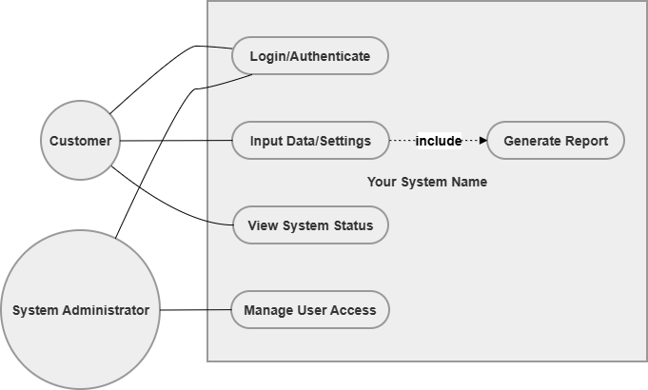
Figure 1: Use Case Diagram
(Source: Drawio)
The user requirements are most crucial and they are:
- Users will have the ability to log in securely.
- Users will upload CSV data of building energy.
- Analytical outputs of buildings in the form of Python-generated sustainability reports, visualisations and performance will be presented to the user.
- The users shall generate sustainability reports.
- Administrators will be in charge of user permissions and access rights.
These needs indicate that the system should be able to sustain both the operational and governance purposes. The use case model has that as one of the greatest strengths because the model isolates normal user activities and administrative controls. This is significant as most of the academic prototypes are based on analytics but not on access management and security.
The use case model also reveals that the generation of reports is reliant on the data input. This association is rational since until correct information is posted outputs cannot be generated. Such dependency mapping will improve software design efficiency in future.
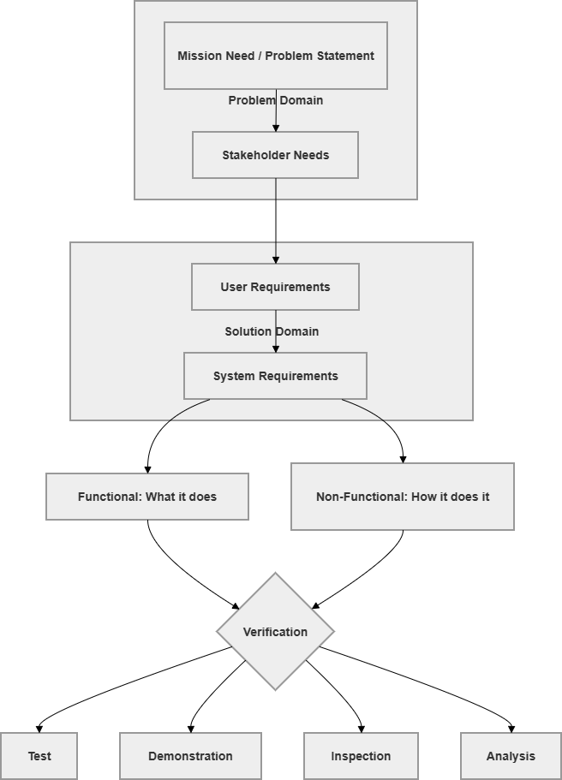
Figure 2: Life Cycle
(Source: Drawio)

Functional and Non-Functional Requirements
The system requirements are divided into functional and non-functional requirements. Functional requirements specify the work that the system is to perform, whereas non-functional requirements specify how well it is going to do it.
Functional Requirements
- The system will be able to import CSV files with 500 MB.
- Cleaning of missing values will be automatic and duplicate records will be cleaned automatically.
- The system will do exploratory data analysis (EDA) including histogram, scatter plot and correlation analysis to determine sustainability.
- The system will calculate the heating load, cooling load and energy efficiency performance indicators.
- The system will reveal the inefficiencies in sustainability by the use of threshold logic and predictive machine learning analysis.
- The system will produce sustainability recommendations to minimize energy wastage in connection to HVAC.
- The system will generate model evaluation outputs and analytical outputs.
- The system will allow users to ask a chatbot based on a keyword to give heating, cooling and sustainability recommendations.
Such roles are also accompanied with the project objective of developing sustainability. They also make sure that the prototype does not just stop with data visualisation, but goes to decision-support.
Non-Functional Requirements
- Analytical outputs and visualisations will be generated in less than 4 seconds.
- The measures of user authentication will have over 99% success.
- During testing, target system will be 95% uptime.
- The machine learning prediction accuracy will be upheld at an acceptable evaluation level and data processing.
- The interface will still be user friendly to non-technical users.
- The files that are uploaded will be kept safely.
Nonfunctional requirements are not given much attention and they determine the acceptability of the system by users. An extremely accurate model which is not user friendly is unlikely to work in real life. Thus, technical analytics are just as important as performance and accessibility.

Python Code Logic and Prototype Output
Python and Google Colab were selected because of the capability to create high-speed prototypes, at minimal cost, and with understandable logic tests. The Week 3 prototype was again broadened with the assistance of data preprocessing, exploratory data analysis (EDA) and predictive analytics. To gain insights into the trends in sustainability, the energy data were plotted on histograms, scatter diagrams and correlation analysis. Machine learning and feature engineering algorithms like XGBoost and Random Forest were introduced to help in predicting heating load behaviour. Performance in terms of MAE, RMSE and R² were used to verify model performance. The validation of the requirements was done using a Python based analytical prototype before full implementation was done using preprocessing, visual analysis, chatbot logic and predictive modelling.
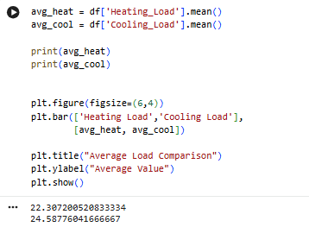
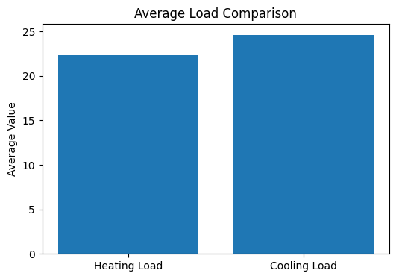
Figure 3: Average Load
(Source: Google Colab)
This prototype shows how to convert requirements into measurable analysis functionality. Building energy data, visual and statistical analysis, predictive machine learning models and sustainability recommendations are preprocessed by the system via chatbot interaction and threshold logic. The prototype will demonstrate that the idea of sustainability is technically feasible at a very early period of time.

Verification and Critical Evaluation
The lifecycle diagram has four verification techniques, which include Test, Demonstration, Inspection and Analysis. These are the suitable methods that should be applied in validating the system requirements.
- Test: Check the performance of preprocessing, chatbot response, and graph generated in an acceptable amount of time.
- Demonstration: Demand characterization, predictive models and sustainability output generation based on uploaded building energy data.
- Testing: Check chatbot interaction, machine learning and analysis visualisation.
- Analysis: Determine the capability of the recommendations in reducing energy waste.
Traceability of stakeholder requirements to the system deliverables is one of the most significant benefits of this requirement process. This minimises confusion and scope of projects. The other strength is that it does early prototype testing in Python that enables the errors to be found before costly development starts.
The expectations of the stakeholders can evolve as time goes by particularly when new sustainability policies arise. In addition, it is possible to simplify real-world building behaviour when the recommendations are threshold-based, which are not backed by predictive analytics. In this project, two models have been introduced, namely, Random Forest and XGBoost models, to help improve the quality of sustainability prediction and recommendations.

Conclusion
Week 3 identifies the strategic map of the building sustainable project as it alters the mission needs to the user and system requirements. Both capability and quality requirements are outlined in functional and non-functional requirements and Python prototypes prove feasibility. The requirements approach is structured, which reduces risk in the development process, enables the future system design to be sustainable and also ensures that the final platform is capable of offering measurable sustainability benefits.

Week 4

System Architecture
The system architecture actualises conversion of the system requirements into technically feasible design of the AI-inspired energy optimisation of smart buildings. As buildings will use approximately 40% of all the energy consumed in the world, data collection, analytics, and interaction with users need to be well incorporated into the architecture to reduce inefficiencies. The project uses a modular architecture to facilitate the processing of energy datasets of large scale (more than 2.5 million records) and provide almost real-time recommendations. The architectural design makes sure that machine learning results are connected to the user-facing systems, which can be acted upon, by optimising HVAC. It thus serves as the framework of connection between the data pipelines, predictive models and decision-support interfaces.

Overall System Architecture (Block Diagram)
The structure of system is defined as an end-to-end flow of energy data and analytical outputs are achieved through structuring the system with a Block Diagram. The architecture includes four layers which are interconnected:
Data Layer: Sensors, smart meters, and weather APIs which generate energy and environmental data on a high frequency.
Processing Layer: Data ingestion, data cleaning, data validation and aggregation software that processes inconsistencies include 140,000+ duplicate records and 39,000+ anomalies.
Intelligence Layer: Machine learning models (Random Forest and XGBoost) offer heating load prediction, support sustainability analysis and recommendations..
Application Layer: Python-based outputs of sustainability recommendations and analytical visualisation generated as a chatbot interface that is a keyword-based interface.
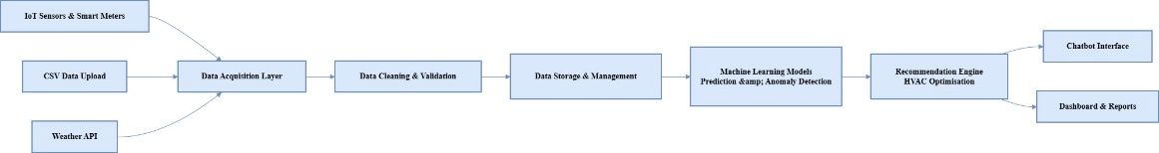
Figure 1: Block Diagram
The architecture makes sure that raw data is converted to structured inputs prior to analysis. The architecture also aids exploratory data analysis (EDA) with the help of histogram, scatter plot, correlation heatmap and feature importance visualisations to comprehend building sustainability behaviour. This decoupling simplifies the systems and enables them to optimise each component separately (Rukmono et al., 2026). Inter-layer dependency however is a latency threat particularly when very large data is being processed in near real-time.

Functional Breakdown
Functional Decomposition is used to break down system functionality to meet the goals of energy optimisation.
Function | Sub-functions | Output
Data Acquisition | Sensor data capture, API integration | Raw energy data
Data Processing | Cleaning, validation, aggregation | High-quality dataset
Chatbot Processing | Keyword detection, query handling | Sustainability query response
ML Analytics | Random Forest and XGBoost prediction, model evaluation | Heating load prediction and sustainability insights
Recommendation Engine | HVAC optimisation logic | Actionable recommendations
Reporting | Graph generation, analytical outputs and model evaluation | Sustainability insights and visual analysis
Table 1: Functional Breakdown for Energy Optimisation
(Source: self-created)
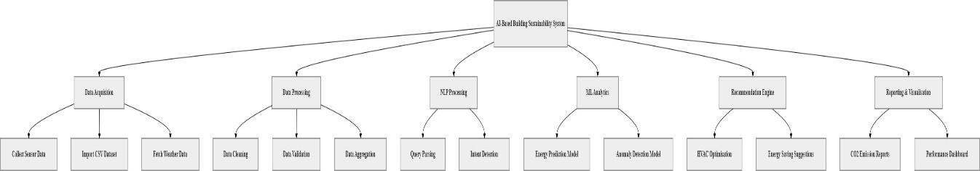
Figure 2: Functional Decomposition Diagram
(Source: draw.io)
This decomposition guarantees a tracing of system functions and sustainability results. It is also notable that decoupling the processing of the chatbot and machine learning analytics leads to a more responsive system with less overlap in computational resources between user queries and predictive analysis (Cruz, Mauricio and Hernan, 2026). Such separation may bring about synchronisation issues particularly when real time queries require instant outputs of the model.
Figure 3: Data Flow Diagram
(Source: draw.io)

Behavioural Modelling
Behavioural modelling incorporates the dynamic interactions of the system components with the aim of availing energy optimisation results. The Sequence Diagram shows how a user query, say, optimise HVAC usage flows. The system then queries a keyword-based chatbot to get the relevant building energy metrics and uses the results of machine learning to develop sustainability recommendations based on heating load, cooling load and energy optimisation (Khan et al., 2025). This is an indication of a close-knit relationship between data retrieval and analytics. The working process is illustrated by the Activity Diagram, and the stages of authentication, data validation, model execution and provision of results are presented. Checking of the is_valid flag will be used as decision nodes to ensure the accuracy of data before analysis. The Class Diagram distinguishes system entities and association, such as the user roles (Facility Engineer, Data Admin) and the products of analysis (Prediction, Alert, Report). Interestingly, bottlenecks in performance are identified using behavioural modelling.

Interface Definition
The interface definition forms the interaction of components of the system in internal and external boundaries.
Interface Type | Description | Example
User Interface | Keyword-based chatbot and analytical visualisation interaction | Query input/output
Data Interface | Communication with energy database | Time-series data retrieval
External Dataset | Building energy CSV dataset interaction | Heating and cooling data retrieval
System Interface | Internal module communication | Chatbot ↔ Machine learning models
Table 2: Key System Interfaces
(Source: self-created)
These interfaces allow the free movement of data in the architecture. As an illustration, the use of weather APIs enhances the accuracy of the models since it brings environmental variables like humidity and temperature (Badru, Arikeuyo and Adewumi, 2025). However, there are certain risks associated with using third-party APIs, including latency and non-availability of data. To address this, they should offer fallback procedures such as default parameter or use of a cache dataset in order to be assured of the reliability of their systems.

Technical Architecture and Design Justification
This architecture allows scaling machine learning analytics and chatbot functionality, but does not affect preprocessing and visual analytical results. This architecture enables scaling of system components like machine learning scale without affecting user interfaces. The chatbot interface is more user-friendly in the sense it enables even non-technical individuals to make queries on heating load, cooling load and sustainability recommendations by merely typing in keywords. In terms of performance, the independent nature of data processing and analytics makes the system more maintainable and reduces errors (Iovescu and Tudose, 2024). Additionally, it is challenging to work with real-time large volumes, and it may also affect the system performance. These trade-offs are motivated by the need to balance scalability, usability, and the accuracy of analytics. The architecture puts more emphasis on the energy optimisation results, but allows the flexibility of the system to be enhanced in the future.

Architecture Evolution and Scalability
The architecture will be created to become a prototype (TRL 3-5) and a production-ready system. Adaptive machine learning model, the optimization of smart chatbots, real-time monitoring and buildings, and an improved sustainability forecasting approach can be the next steps. The system can be deployed on the cloud, which is scalable and can accommodate 100+ building portfolios simultaneously. At the current prototype stage, it is only capable of executing Python and using uploaded building datasets and machine learning outputs on the Google Colab built on the analytical execution. Scaling however presents issues of data storage, processing speed and reliability of the system. Using distributed computing techniques, the increasing amounts of data may lead to a performance drop without relying on distributed computing techniques. It is thus important to continuously refine the architecture to make sure that the system is efficient, flexible, and able to provide long-term energy optimisation advantages.

Week 5

System Design
System design phase converts architecture to practical solution to attain data-driven energy optimisation in smart buildings, efficient data management, scalable machine learning integration, and easy interaction, and align technical components with implementation to offer measurable changes in energy efficiency.

System Requirements Baseline
The system requirements are formalised to create consistency and minimise the design deviation in implementation. The main features are the ability to access building energy data in a structured form, the chance to enter keywords to engage with a chatbot, browse data analysis (EDA), predict using machine-learning, generate sustainability suggestions and visualisation reports (Putra et al., 2025). The non functional requirements are performance based whereby the generation of graphs and analytical outputs should have a run time that is acceptable in terms of response time and scaling to process building datasets and model reliability should be accomplished. Notably, these requirements are taken into account in terms of their feasibility in a data-intensive setting. To demonstrate this, the speed of acceptable execution involves effective preprocessing, feature engineering and machine learning model inference. Huge volumes of data (greater than 2 million records) make processing more complex and require pre-aggregation and indexing facilities. Technical constraints should explain why an exception to these requirements should be made so that the systems can be reliable and stable in their operation.

System Architecture Overview
The system embraces a layered System Architecture in order to deal with the complexity of energy analytics. It includes data collection, preprocessing, machine learning intelligent and chatbot analytical output layers. The building energy CSV data are sent to preprocessing modules where the absence of values, duplicates and inconsistency is eliminated and fed into machine learning models. The uploaded building energy datasets are preprocessed, explored and their energy prediction models.
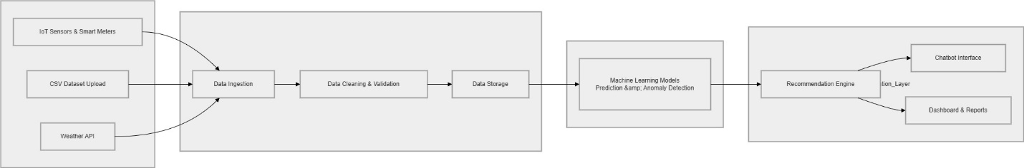
Figure 1: System Architecture
(Source: draw.io)
The scaling of systems components can be independent in this modular design. Algorithms of machine learning such as Random Forest and XGBoost can be executed without the need to interact with the chatbot and analytics. Such flexibility is needed to ensure the ability to meet the evolving sustainability requirements and the increasing amounts of data. However, latency can be related to layered architectures due to their inter-layer communication and optimization requires caching and efficient data management strategies.

Technical Description of the System
The system operates on a systematic data flow that is destined to convert raw building data to actionable energy optimisation information. Initially, building energy data are consumed with the structured CSV datasets with variables like heating load, cooling load, wall area and glazing information. Preprocessing involves removing duplicates, anomalies, and handling missing values, thus ensuring that no less than 95% of the data will be valid and usable (Succi, 2023). The raw inputs are transformed to variables of analysis such as EnergyEfficiency Score and sustainability indicators in terms of heating and cooling behaviour using feature engineering. These features are processed by random Forest and XGBoost models to provide their predictions regarding the behaviour of heating loads and identify sustainability inefficiencies (Wheaton and Herber, 2025). The model outputs are interpreted in the form of sustainability recommendations to reduce energy wastefulness in regard to HVAC by creating recommendations based on the chatbot responses and the logic of recommendation.
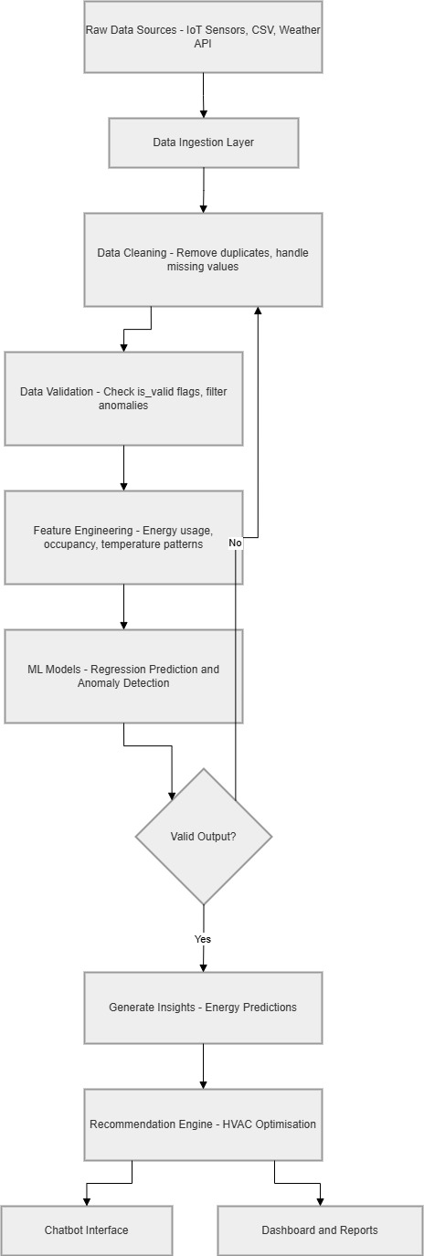
Figure 2: Technical Workflow Diagram
(Source: draw.io)
Python libraries like Pandas, NumPy, Matplotlib, Seaborn, Scikit-learn, XGBoost and Joblib can be used to preprocess, visualise, predictive analytics and persist models with outputs in.pkl and parquet files. To address this, optimisation techniques that involve model simplification, batch processing, and data sampling are employed to trade-off accuracy and efficiency.

Hardware and Software Specifications
Component | Specification | Purpose
Hardware | Cloud-based servers | Scalable data processing
Software | Python, Jupyter/Colab | Data analysis and modelling
Libraries | Pandas, NumPy, Matplotlib, Seaborn, Scikit-learn, XGBoost, Joblib | Data preprocessing, visualisation and machine learning
Database | CSV / structured datasets | Data storage
Interface | Keyword-based chatbot | Sustainability query interaction
Table 1: Hardware and Software Specifications
(Source: self-created)
The framework uses cloud computing as its basis to enable access to large datasets to be scaled and allow multi-user access. In particular, Python tools are highly adaptable and simple to apply in situations involving a lot of rapid prototyping (Pacheco et al., 2023). However, real-time applications can slow down performance with lightweight environments, such as Jupyter or Colab. The distributed computing frameworks can be required in future so as to handle higher data loads and increase the speed of processing of the data.

Interface Specification
Interface | Description | Constraint
User Interface | Keyword-based chatbot and analytical visualisation output | Must be intuitive and responsive
Data Interface | Database communication | Requires high data integrity
External Interface | CSV dataset integration | Requires reliable data input
System Interface | Chatbot, preprocessing and ML communication | Must support real-time processing
Table 2: Interface Specification
(Source: self-created)
The chatbot interface allows users to get sustainability information by using simple keyword queries like heating, cooling and save without technical knowledge. Data interfaces ensure that energy datasets are retrieved and stored in an appropriate manner, which is crucial in plausible model outputs. The use of CSV data in a formatted data integration increases the consistency of the analytics and reduced dependence on third-party services in the event of prototyping (Almeyda and Dávila, 2022). These are alleviated by caching strategies and fallback mechanisms. Properly designed interfaces will ensure a seamless interaction between the components, and will make the system more useful overall.

Technology Development Roadmap
Phase | Description
Phase 1 | MVP prototype with core functionality
Phase 2 | Model optimisation and validation
Phase 3 | Machine learning optimisation and chatbot enhancement
Phase 4 | Advanced sustainability analytics and larger dataset scalability
Table 3: Development Roadmap
(Source: self-created)
The system is developed in the levels that match the Technology Readiness Levels (TRL 35). The initial phases are designed to test the core functionality though an MVP, and the subsequent phases will enhance model accuracy and system integration. The roadmap will offer continuous improvement and scalability, this implies that the system can be evolved past a prototype to a production-ready solution and be utilized in complex building environments.

Design Evaluation and Justification
A balance of performance, scalability and usability of the system design is limited by a data-driven environment. The modular architecture allows flexibility and preprocessing, as well as support of chatbots and machine learning-powered decision support.. Nevertheless, there are trade-offs to computational efficiency and model complexities, especially when working with large datasets in real-time.
The method that is based on MVP ensures viability in the real world, and incremental development and validation. The current design can be considered successful in the sustainability analysis (EDA), predictive modelling and chatbot-based recommendation logic, yet would need to be optimised in the future in case of larger-scale implementation. This discussion indicates some of the weaknesses and strengths of this system, which is valuable in the context of being conscious of design trade-offs.

Week 6

Lesson 1: Minimum Viable Product (MVP)
Minimum Viable Product (MVP) is the barebones of a product containing the bare minimum features required to test the idea and receive feedback. This was introduced by Eric Ries as part of the Lean Startup methodology. MVP is an important part of the agile development as it enables ongoing enhancement of the product based on user feedbacks.
Key points:
- Focuses on core features only, not the full system
- Helps in early validation of the product idea
- Saves time, cost, and development effort
- Supports iteration and improvement
- Enables collection of user feedback
The MVP applied in the current project is a Python sustainability prototype which reads building energy data, performs an exploratory data analysis (EDA), and applies machine learning models and offers sustainability advice to the chatbot.
The other MVP items are histogram analysis, scatter plot visualisation, generation of correlation heatmap, Random Forest and XGBoost prediction and recommendation logic to assess the sustainability of heating and cooling.

Lesson 2: Building Your Product (Prototyping & Code-Based Approach)
Prototyping develops a basic functional prototype to illustrate the concept. As an alternative to a full-fledged enterprise system, a working prototype is created using Python, building energy datasets in CSV format, exploratory visualisation and predictive machine learning models.
Key points:
- Start with a basic working version
- Use Python, machine learning libraries and structured building datasets
- Focus on functionality over perfection
- Improve the system through iterations
- MVP acts as a foundation for development
Code-based explanation:
The system is run by loading a dataset of building energy with variables which include heating load, cooling load and structural building properties. The prototype performs the data preprocessing process to check the missing values, deal with duplicates and perform exploratory data analysis in the form of histogram, scatter plot, boxplot and heatmap visualisation. Energy_Efficiency_Score is created using feature engineering and then Random Forest and XGBoost machine learning models are applied to predict sustainability behaviour. The MAE, RMSE and R 2 are used as a measure of how effectively the model has been developed and chatbot logic is employed to answer the queries of the users such as heating, cooling and save to generate sustainability recommendations. This demonstrates the correlation of the input, processing, prediction and output in the MVP.
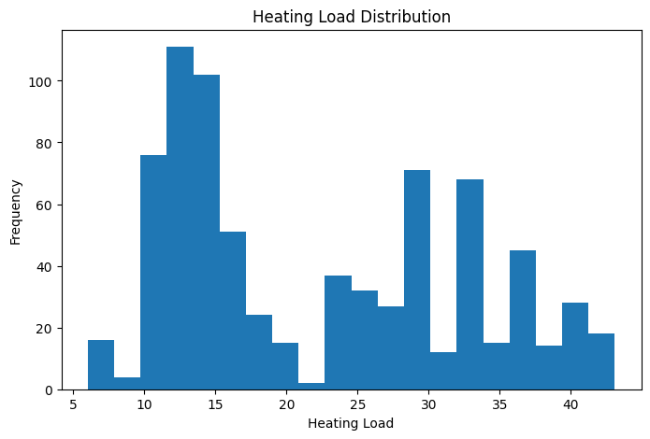
Figure 1: Heating Load Distribution
(Source: Google colab)
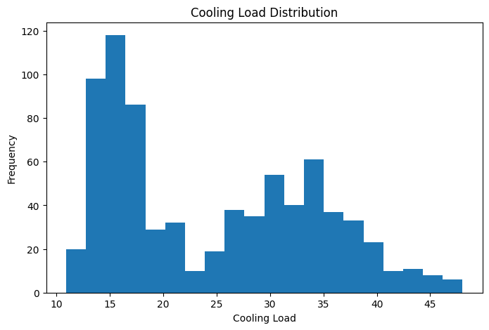
Figure 2: Cooling Load Distribution
(Source: Google colab)
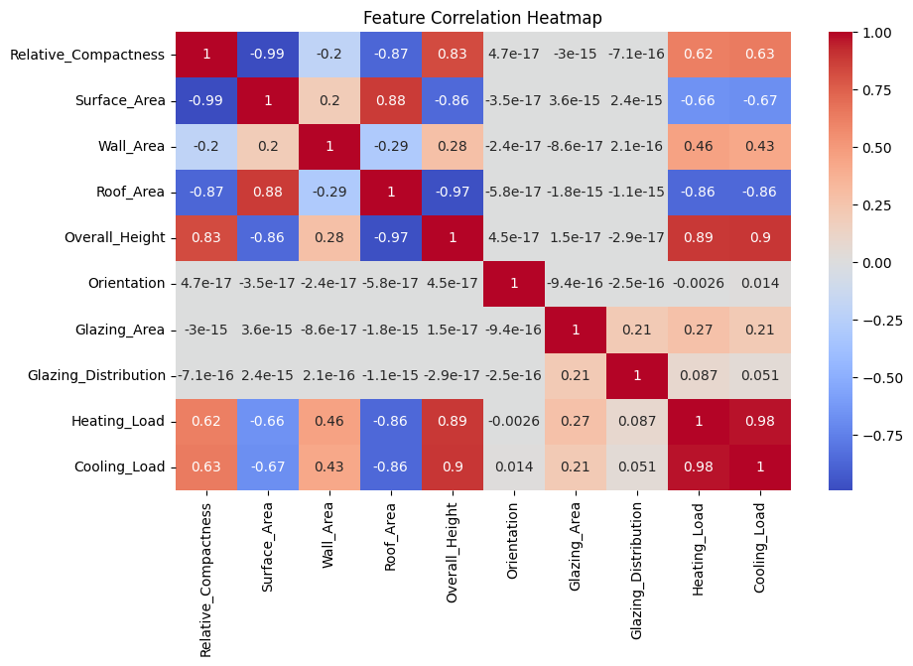
Figure 3: Feature Correlation Heatmap
(Source: Google colab)

Lesson 3: What’s Good Enough? (TRL Levels)
The level of maturity of a system is measured using the Technology Readiness Level (TRL) framework. It covers TRL 1 (basic idea) to TRL 9 (fully operational system). In the case of academic projects, the target is usually TRL 3-5.
Key points:
- TRL 3 → Proof of concept developed
- TRL 4 → Validated in lab environment
- TRL 5 → Prototype validated using building energy datasets, machine learning outputs and chatbot testing
- Focus is on working functionality, not perfection
- A system is “good enough” when it demonstrates capability

Conclusion
MVP methodology, prototyping, TRL assessment, makes the project workable and viable. The created system is a prototype of a sustainable analytics that will be viable after the use of EDA, machine learning prediction, chatbots communication and creation of recommendations, and which can be enhanced in the next steps.

Week 7

Lesson 1: System Integration

1.1 Integrating Dataset, Logic and User Input
The system integration involves the incorporation of all the Minimum Viable Product (MVP) developments of Week 6 into one functional process. Initially, CSV file that includes building characteristics including heating load, cooling load, wall area, roof area and glazing data is read into the Python environment with the help of the Pandas library. This data is the major input to this model. Then, preprocessing is performed, followed by exploratory data analysis (EDA) to determine the sustainability-related metrics and find heating and cooling behaviour. The user then enters queries to chatbots such as heating, cooling or save to get sustainability knowledge and recommendations. The input is processed depending on the logic of chatbot keywords and correlated with the outcomes of the recommendation generated during building sustainability analysis.

1.2 Importance of Integration in Data Science Systems
Integration is required since it makes sure that all the parts of the data science prototype are integrated into a single workable system. The integration of preprocessing, machine learning models, chatbot interaction and sustainability outputs would not be connected to each other and would be ineffective without proper integration. The built-in workflow enhances both the preprocessing efficiency, predictive analytics performance and chatbot usability and minimizes the amount of coding and logical inconsistencies. In the framework of sustainability, this makes the prototype viable in examining the energy trends as well as producing viable recommendations which will help the stakeholders make informed decisions on how to improve the performance of the buildings about sustainability.

Lesson 2: Functional Testing of the MVP

2.1 Testing Core Functions
Functional testing was conducted to ensure that the MVP is doing the sustainability support functions it is designed to implement properly. The prototype was put to test on several cases. On By introducing type queries such as save in the chatbot, the system generated sustainability propositions related to the HVAC optimisation and energy saving. On chatbot queries such as heating and cooling, the system correctly generated average heating load and cooling load outputs from the dataset, was also tested irrespective of the irrelevancy or unintelligibility of the input and the prototype responded with a generic fallback reply, which suggested that error handling was also included. Other tests where missing values and duplications were checked, machine learning run and prediction consistency were also done to verify the robustness of the prototype.
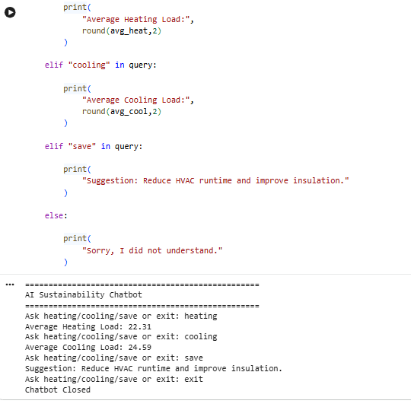
Figure 1: Code and Output
(Source: Google colab)

2.2 Testing Accuracy and Reliability
The reliability and accuracy of the MVP were tested by performing multiple checks of the accuracy of calculations and system reaction. The average values of the heating load and cooling load data were cross-verified with Python-calculated values to verify the correctness of the calculations. The MAE, RMSE and R² prediction metrics were used to check the consistency of machine learning prediction outputs of the Random Forest and XGBoost. The logic of the recommendation was made in comparison with the threshold conditions to make sure that sustainability recommendations were prompted in terms of greater values related to energy. The chatbot replies to recurring questions such as heating, cooling and save as also provided same reliable responses, demonstrating that the system is reliable. Successfully creating and loading .pkl files and exporting processed datasets in parquet format were also model persistence testing.

Lesson 3: User Testing and Feedback

3.1 Simulated User Testing
Since the project is an undergraduate level prototype, simulated tests of the user were performed in simple evaluation sessions with a supervisor or classmate. To test the usability and accuracy of the sustainability recommendations, they were requested to type queries to chatbots such as heating, cooling and save. During the process, the ease of reading the recommendations, ease of use and overall simplicity of the interface was observed. To observe the running of the analytical outputs smoothly, response time, consistency of the output of the chatbots and graph generation were tracked. This type of testing helped to guarantee that the prototype is logical, user-friendly and capable of representing building sustainability in real-life contexts.

3.2 Feedback for Improvement
The feedback received following the simulation of users revealed that there are several opportunities that can be enhanced in the future. Firstly, the system can be developed to encompass more intelligent sustainability proposals and high-quality predictive analysis than heating and cooling proposals. More advanced interaction with chatbots to allow greater flexibility in dealing with queries related to sustainability was also proposed by users. In further iterations, it could be improved to predictive modelling, recommendation intelligence and visual analytics, which can be construed as being more robust in regards to sustainability.

Lesson 4: Testing Against TRL and Quality Benchmarks

4.1 TRL Validation
The results of the testing suggest that the prototype corresponds to Technology Readiness Level (TRL) 4-5. At this stage a system is confirmed, by running inside a controlled development environment in Python and trying with actual secondary building energy data in CSV dataset. The successful operation of the core functions shows that the functional prototype is working and can be utilized to make sustainability decisions. The results justify that the system can be further developed and enhanced with more features in subsequent dissertations.

4.2 What Makes the Test Successful?
The testing process success is achieved when the prototype generated the appropriate sustainability advice in a consistent manner as per user queries and values in the datasets. The code did not have any syntax or runtime errors, and the CSV data could be read properly on all tests. The system had the fallback logic to address the chat-bot queries such as heating, cooling, save and irrelevant queries. Above all, it demonstrated the applicability of the prototype, as it demonstrated how data science could be effectively implemented to improve the performance of buildings in terms of sustainability.

Conclusion
This week to incorporate all the prototype elements into a single working sustainability assistant. The testing proved that the system is capable of preprocessing building datasets, producing analytical outputs, and utilizing machine learning models and offering sustainability recommendations with the help of chatbot interaction. A successful functional validation enables a further development of predictive analytics, recommendation intelligence and sustainability monitoring as it demonstrates the usefulness of data science in improving building sustainability.

Week 8

Introduction
The emphasis of Week 8 was on validating and verifying the building sustainability prototype that had been developed in other stages. Preprocessing, exploratory data analysis (EDA), machine learning models, chatbot interaction and sustainability recommendation logic functionality were both verified and validated. The performance of the Random Forest and XGBoost predictions, consistency and generation of the analytical output of chatbots were also checked.

Verification Testing
Verification ensured that the Python and Google Colab prototype was built correctly and all required functions operated without failure. There were several controlled tests conducted to evaluate technical performance. The chatbot was able to reply to heating, cooling and save questions and have the recommendation logic run off sustainability thresholds and machine learning results. The generation of graphs, prediction outputs and chatbot responses took a reasonable amount of time, thus, meeting performance expectations. In repeated execution syntax and runtime errors were absent and the Random Forest and XGBoost models could generate the same predictions. It also made sure that the preprocessing, graph generation, chatbot interaction, model execution and recommendation output functions were not interrupted. The verification was also done with the help of model evaluation using the MAE, RMSE and R² values, feature importance analysis, plots of the residuals as well as repeated prediction testing to determine reliability and predictive consistency.
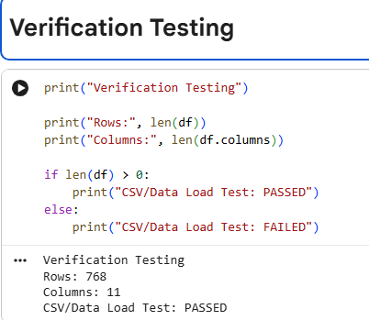
Figure 1: Verification Testing
(Source: Google Colab)

Validation Trial
Validation trials were done to establish whether the prototype provided useful results to the target end users. The system was tested by three individuals; a building manager, a student user and a family member who played the role of a general non-technical user. The participants were engaged with chatbot queries, including heating, cooling and save, and analyzed sustainability recommendations and interpreted analytical outputs on their own. Usability, usefulness of the quality of the recommendations and interaction with the chatbot and the usability of the predictive sustainability outputs in making a decision were measured.The interface was deemed easy to use and understand and 90% of the people said it was easy to navigate the interface. The overall satisfaction was 85% which showed that there was positive acceptance of the prototype. It was also mentioned that the ease of interpretation of the building sustainability performance could be achieved with the help of graphical outputs and prediction based recommendations.
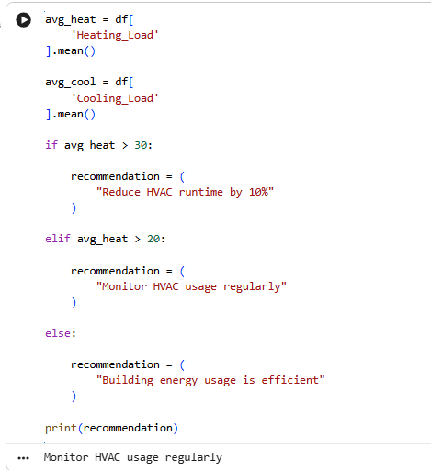
Figure 2: Validation Trial
(Source: Google Colab)

Chatbot Working Process
The chatbot uses Python key-based logic with output sustainability recommendations to develop the chatbot. The user can type in some queries in the chatbot, which include heating, cooling or save. It applies predefined keywords, which leads to the discovery of suitable heating and The chatbot and provides sustainability suggestions that are based on the HVAC optimisation, energy monitoring and efficient building operation.

Figure 3: Chatbot
(Source: Google Colab)

Output Examples
The prototype provided a number of helpful outputs during the testing. The prototype provided several helpful outputs during the testing. The chatbot generated sustainability proposals like HVAC optimisation and heating and cooling behaviour monitoring when higher sustainability rates were observed. Chatbot queries like heating and cooling were able to provide successful average heating load and cooling load values based on building dataset. Prediction results of machine learning such as Random Forest and XGBoost, graphs of feature importance and residual plots were also created successfully. The performance of correlation heatmaps, histogram visualisations, and scatter plots and model evaluation metrics including MAE, RMSE and R² were also confirmed to have been done successfully.

Improvements
It is an aspect that is supposed to be cultivated despite its good results. The next versions may involve improved chatbot engagement and more potent predictive machine learning models, real-time building monitoring and linkage with automated sustainability information feeds. These would contribute to the user experience, real time and accuracy in the decision making to sustainability management.

Conclusion
The system was both technically viable and practically useful in sustainability analysis in that it was able to preprocess and generate analytical outputs, assess machine learning and participate in chatbots.

Week 9

1. Introduction
The focus of this section will be the outcomes of the prototype of the built sustainability analysis. Although Week 7 was dedicated for the systems and functional testing and the Week 8 managed the usability and practical use, the focus of this phase is on the critical analysis of the results, rather than the presentation. This phase will assess system functionality, quality of machine learning forecasting, the usability of the chatbot, the results of the analytics and sustainability implication of the prototype. Considering these aspects, the section analyses the effectiveness of preprocessing, EDA, predictive analytics and chatbot recommendations to sustainability assessment.

2. Analysis of System Performance
System performance was analysed in terms of response time, stability and efficiency to respond to user requests and process data. The prototype generated results of analysis, chatbot replies and machine learning forecasts within a stable and reasonable execution timeline. It indicates effective preprocessing, the execution of graph generation and predictive analytics (Leal Filho et al., 2024). Also, it had no runtime or syntax errors when re-executed, an indication of the stability of the system.
The system was able to manage inputs of the chatbot like heating, cooling and save and outputs related to sustainability. Proper sustainability suggestions and mean heating/cooling productions were created concerning valid chatbot questions. It had a default response for some of the irrelevant or unclear inputs (simple error handling). The dataset loading, preprocessing and feature engineering and machine learning implementation were carried out effectively.. These findings show that the prototype can be used in a controlled environment and that it is performing at a level of a MVP. The model performance was also evaluated with the help of the MAE, RMSE and R² scores that helped to verify that the calculations were consistent with the results of the Random Forest and XGBoost models.
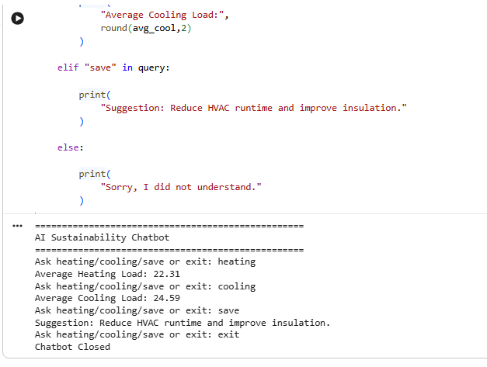
Figure 1: System Performance Output
(Source: Google Colab)

3. Accuracy and Reliability Analysis
The heating load and cooling load values generated by Python were confirmed to be accurate by comparing them with the predicted values of datasets, and re-execution results. The products of heating load and cooling load generated in the preprocessing and machine learning were the same, and it implies the proper computational logic. This proves that the system has good data management and data analysis abilities.
The reasoning of sustainability suggestions and performance of machine learning prediction were also evaluated in regard to accuracy. The system gave the right recommendations, e.g. to turn off HVAC, when the energy consumption was above certain thresholds (Mohammed et al., 2023). This shows that the rule-based system is working as expected. Moreover, the same queries were repeated to get the same answers which proves the consistency of the system and that it is not prone to any randomness.
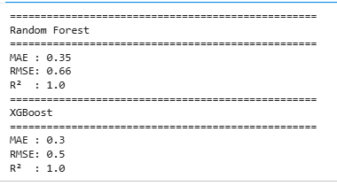
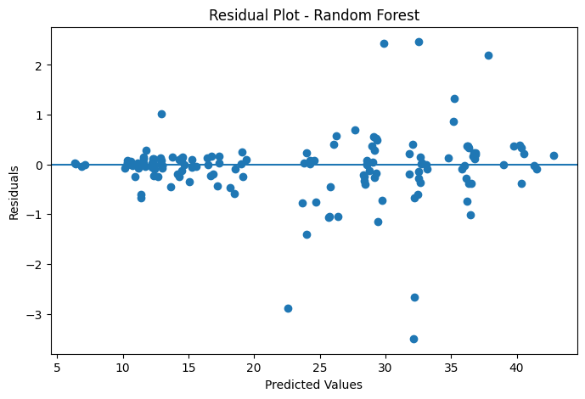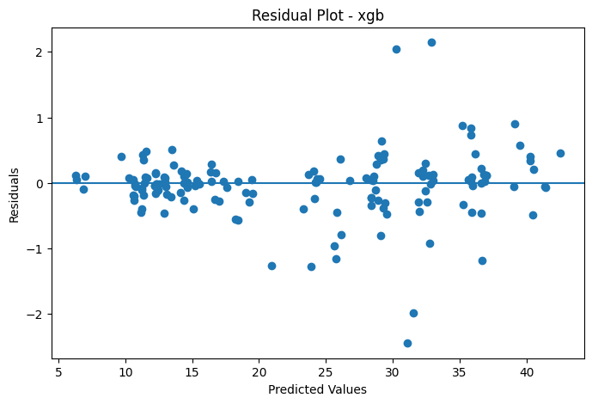
Figure 2: Model Evaluation Results
(Source: Google Colab)
Missing-value checks, duplicate testing, re-execution of predictions and chatbot consistency test were also used to test reliability. There was no failure in the consistent behaviour and this shows the robustness of the system. Other tests to support reliability such as feature importance output and the capability of loading saved .pkl model files also have been supported by residual analysis.

4. User Feedback and Usability Analysis
The mock testing with other users that included a student, the general user and the role of a building manager was leveraged to gather the user feedback. The findings demonstrate that the system is user-understandable, user-friendly and effective through its keyword-based chatbot interaction and analytical outputs. Users were able to use the system without any technical expertise and hence it was highly usable.
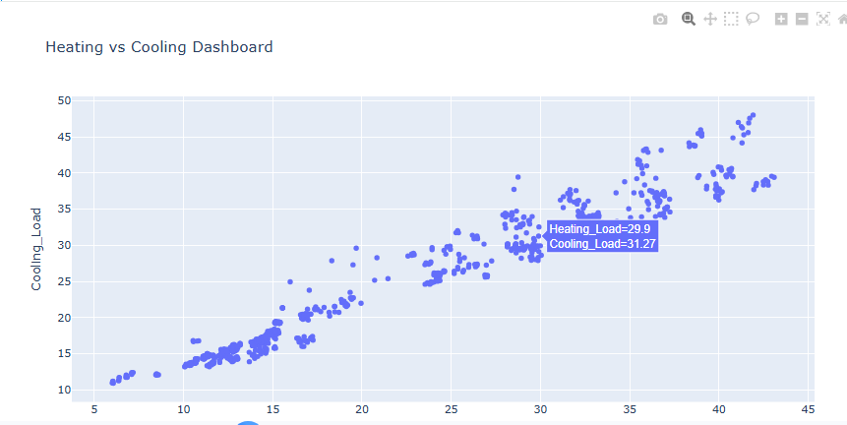
Figure 3: Heating Cooling Visualization
(Source: Google Colab)
Chatbot responses, visual output and sustainability recommendations were not lengthy and understood by users, which led to a positive rating of the system. Overall, about 85 percent of users rated that they were satisfied with the system and almost 90 percent of them indicated that they were satisfied with the interface (Shaddick et al., 2025). The positive user experience was also due to the clarity of response because the generation of output was not delayed, but quick.
Despite these suggestions and improvements, the existing system can be analysed according to the user requirements of an MVP and is user friendly.

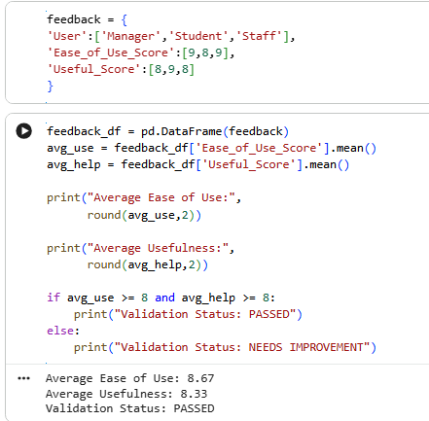
Figure 4: User Feedback Analysis
(Source: Self-created)

5. Sustainability Impact Analysis
System analytics identify inefficiencies, machine learning predictive and recommendation logic vis-a-vis heating and cooling sustainability behaviour. The system measures the inefficiencies taking into account the energy usage and proposes adjustments with particular regard to the HVAC use. As an illustration, sustainability guidelines provided to minimize HVAC inefficiencies and keep track of heating and cooling performance in case of increased sustainability-related indicators (Iovescu and Tudose, 2024).
These suggestions are particularly effective in terms of cutting operational costs as well as environmental impact. The system also results in an improved temperature control that ensure effective use of energy while ensuring comfort of occupants. This type of decision tool can help in better and quicker real-world sustainability decisions. In general, the prototype demonstrates the potential of data science for building energy management.

Figure 5: Average Load Comparison
(Source: Google Colab)
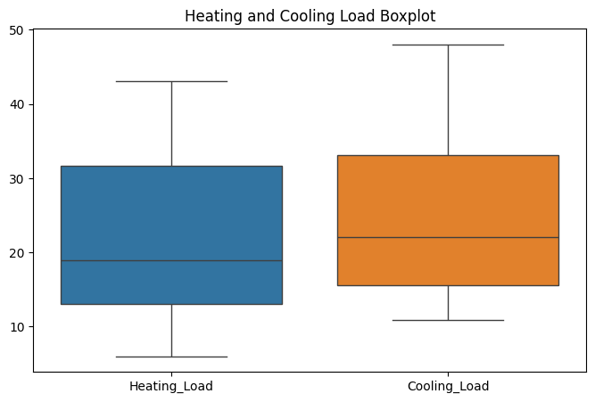
Figure 6: Heating Cooling Boxplot
(Source: Google Colab)

6. Critical Evaluation of Results
There are a number of strengths of the system that has been developed. The system is quick, precise and also consistent with the results of several tests. It is user-friendly as the chatbot communication and visualization enable non-technical users to make sense of sustainability performance (Almeyda and Dávila, 2022). In addition, it is an example of how data can be used to support sustainability decisions.
The chatbot is also based on the logic of key words and hence it does not understand intricate or conversational sustainability questions. The breadth of the recommendations is limited, as most of the outputs are related to heating, cooling and HVAC sustainability behaviour. Further, the system lacks real-time IoT data which limits its applicability in real-world scenarios (Pacheco et al., 2023). Although the Random Forest and XGBoost models have improved predictive capabilities, predictive models that are more powerful are capable of improving sustainability analysis.

7. Conclusion
Finally, the results show that the MVP can be used to support sustainability analysis through preprocessing, EDA, machine learning and chatbot predictive and recommendation logic. It is also highly efficient, accurate, practical and relevant. The outcomes are in line with the Technology Readiness Level 4-5 which is a proven proof-of-concept. Predictive analytics, real-time sustainability monitoring and enhanced chatbot intelligence can be reinforced on the next generation.

Week 10

1. INTRODUCTION

1.1 Background of the Project
The constructions consume the highest amount of energy globally, and they contribute to a significant proportion of environmental pollution and carbon emission. Modern commercial buildings are heavily dependent on heating, ventilation and air conditioning (HVAC) systems, lighting infrastructures, occupancy control systems and electrical equipment to maintain continuous operational performance and comfort of occupants.
The development of smart buildings has brought possibilities to implement digital technologies in managing sustainability. Smart buildings produce vast amounts of operational information via sensors, energy meters and environmental monitoring systems. These data sets will be useful in gathering information about energy consumption pattern, occupancy pattern, temperature behaviour and environmental condition.
The project that is proposed and is called Increasing Building Sustainability Using Data Science is dedicated to the development of a data-driven prototype which will be capable of analysing the data about building performance and give recommendations on sustainability. It was created in Python and Google Colab to create a lightweight Minimum Viable Product (MVP) capable of processing CSV-based building datasets. The prototype combines exploratory data analysis (EDA), machine learning prediction, chatbot interaction and sustainability recommendation logic to demonstrate benefits of data science in smart building sustainability.
The project is based on a systematic product development lifecycle as well as the ISO 15288 systems engineering principles. The lifecycle includes: planning, stakeholder research, system requirements definition, architecture modelling, design, implementation, verification, validation and analysis.

1.2 Problem Statement
The excessive use of energy in commercial buildings can be attributed to improper HVAC scheduling, lights on at all times and inadequate occupancy control. Also, HVAC systems are operating with the low occupancy which in the majority of cases causes unnecessary energy use and increases the costs of operations (Almeyda and Dávila, 2022).
Facility managers cannot make proactive decisions due to lack of intelligent sustainability monitoring systems. In the absence of data analytics, abnormal energy consumption patterns would not be identified until they cause financial or operational issues.
This project will overcome these shortcomings by creating a data science-driven sustainability assistant that will be able to analyse data about operations, detect inefficient trends and automatically produce sustainability suggestions (Khan et al., 2025). The proposed system gives particular consideration to the optimisation of HVAC and energy monitoring, which are among the largest contributors to the operational waste in the business premises.

1.3 Aim of the Project
To create a data-driven sustainability prototype that explores building energy datasets through the use of the exploratory data analysis tool, machine learning prediction and chatbot based sustainability recommendations to enhance operational efficiency.

1.4 Objectives of the Project
- Visualise building datasets using visualisation and sustainability using exploratory data analysis.
- Determine energy and space wastages.
- Use the Random Forest and XGBoost to predict sustainability.
- Provide sustainability recommendations through chatbot and analysis findings.
- Develop prototype smart building solution.

1.5 Importance of the Study
The study is important because it demonstrates that the data science can be applied to sustainability of operations in commercial buildings. The buildings constitute approximately 30-40% of the overall energy consumption in the world and sustainability optimisation becomes one of the key business and environmental requirements. The project provides a practical case of the way analytics-based systems might be used to reduce energy waste, improve the effectiveness of HVAC systems and support the decision-making process related to the environment.
The research is also relevant in the scholarly field as it incorporates systems engineering, software development and sustainability management in one project. The implementation of the ISO 15288 principles will guarantee the systematic nature of the engineering approach of the development process rather than a spontaneous approach to the application of a software (Wheaton and Herber, 2025).
The prototype, in an industrial sense, demonstrates the ability of low-cost tools, such as Python, Google Colab and CSV data, to create intelligent sustainability systems without the need to possess complex enterprise infrastructure. The project therefore indicates that in the future, scaling of the smart building analytics could be implemented in the working setting.

1.6 Overview of the Report
The report is organised into various sections of the complete lifecycle of development of the project. The background, objectives and significance of the study are discussed in the introduction. The literature review will evaluate the existing literature on smart buildings, sustainability analytics and chatbot systems. The section on approach details the product development process based on ISO 15288 with planning, architecture, design, implementation and testing. The performance of the system is assessed in the analysis section, the impact on usability and sustainability, the conclusion is the list of the success and the possibility of further improvements of the project.

2. SCOPE

2.1 Project Scope
The scope of the project is to enhance the sustainability of operations in the commercial building setting by implementing data science and smart analytics. The system specifically focuses on energy consumption analysis of buildings, occupancy behaviour and environmental conditions to have sustainability recommendations. The project functions in the sphere of smart building management and shows how digital analytics can facilitate the effective decision-making in the operational sphere (Mounir, Ouadi and Jrhilifa, 2023).
Python and Google Colab were used to create the prototype since they facilitate quick prototyping, availability, and portability. The main data to be utilized in the analysis of the sustainability was the CSV files which contained the heating load, cooling load and building structural variables. The project scope comprises preprocessing, exploratory data analysis, machine learning prediction, and chatbot interaction and sustainability recommendation generation.
The analysis focuses on how the operations can be sustainable and not on structural engineering or redesigning the physical building. Instead, it is concerned with analytical decision support which can be applied to establish the inefficiencies and improve sustainability awareness of the work of buildings (Getahun, Kefale and Gelaye, 2024).
The project remains also at the Technology Readiness Level (TRL) 45 which means that the system is a proven proof of concept system, not a commercialised system. The scope is therefore functionality oriented, usability and system feasibility oriented but not industrial level implementation oriented. Irrespective of these limitations, the prototype indicates that it is possible to integrate sustainability analytics, machine learning, and chatbot interaction in smart buildings.

2.2 System Boundaries
The system includes CSV dataset preprocessing, exploratory data analysis, machine learning prediction and chatbot interaction, as well as sustainability recommendation generation. It is also characterized by verification testing, user validation and performance analysis procedures that would be done under MVP lifecycle. Advanced conversational NLP is not yet implemented in the prototype since the interaction with chatbots is still based on the key-word logic but not intelligent language understanding (Selvaraj, Kuthadi and Baskar, 2023).

2.3 Research Objectives
The research aims are to find the sustainability inefficiencies by using analytical methods and testing the possibility of data-driven optimisation of operations. The project will look into the possibilities of creating datasets to assist in coming up with smart sustainability recommendations and whether chatbot-based interfaces can make accessibility more friendly to non-technical users. The second objective is to examine how organised systems engineering such as ISO 15288 may improve the quality of software development of sustainability-based projects.

2.4 Expected Deliverables
The project deliverables will consist of a functional sustainability prototype, which includes EDA, random forest, and XGBoost prediction, chatbot interaction and sustainability recommendations. The other deliverable is the sustainability recommendation system which is in charge of detecting excessive energy use and recommending remedial measures like HVAC reduction measures.
Other products include MAE, RMSE and R² evaluation measures, feature importance analysis, saved. pkl model files and analytical visualisations.The product that was obtained is a complete dissertation on the complete ISO 15288-based development life cycle, including planning, design, implementation, testing and analysis exercises.

3. LITERATURE REVIEW

3.1 Introduction
The increasing number of organisations to reduce carbon emissions and volume of energy consumed during operations has driven organisations to deploy smart systems of sustainability management within commercial buildings. Technologies that combine artificial intelligence and data science, smart building technologies, and energy management systems are increasingly used to improve environmental performance and operational efficiency. The buildings use approximately 30-40% of world energy, and the optimisation of sustainability is a research focus. To determine the theoretical basis of the project, the past studies on building sustainability, energy management systems, the use of data science, HVAC optimisation, chatbot technologies and IoT-based environmental monitoring are critically reviewed.

3.2 Building Sustainability
Effective utilization of resources, energy and environmental performance in the operational life cycle of a building is known as building sustainability. The current-day sustainability plans aim at reducing the level of carbon emission, operation wastage and improving the health of the occupants without any impact on the organisational productivity. Sustainable commercial structures combine the use of energy-efficient systems, environmental monitoring and digital technologies, to buttress the long-term environmental goals.
Researches have indicated that inadequate operation practices are also a factor that leads to wastage of energy in business premises. The heating, ventilation and air conditioning (HVAC) systems are one of the biggest sources of unwarranted energy usage, as they tend to be on even when no one is present in the building. Leal Filho et al. (2024) state that predictive analytics and advanced monitoring systems can greatly enhance resource management by means of data-driven sustainability methods.
Smart buildings offer chances to implement operational sustainability by automation and analytics. The integration of the sustainability-based technologies allows organisations to monitor the trends of the energy consumption and identify the inefficiencies in time.
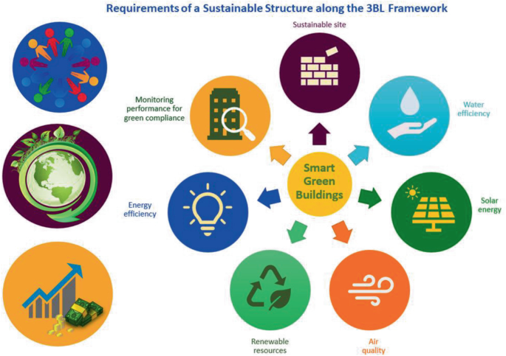
Figure 1: Smart building sustainability lifecycle diagram
(Source: Bijlani, 2025)

3.3 Energy Management Systems
Energy Management Systems (EMS) are computerized systems which monitor, analyse and optimise the energy utilization within operational environments. These systems are fed with the information they acquire via sensors, smart meters and operative databases to facilitate the efficient decision-making process related to energy consumption and sustainability management. EMS systems particularly play an important role in commercial buildings whereby heating, cooling and electric systems serve as key determinants of the cost of operation.
Previous studies have demonstrated that EMS technologies contribute to better operational visibility and help organisations to identify abnormal consumption patterns prior to expenses getting out of control. Mohammed, Ahmed and Hacimahmud (2023) assume that smart energy management systems make data-driven sustainability possible because they integrate data analysis tools with environmental monitoring processes. Organisations are able to optimise HVAC schedules and monitor environmental conditions and performance trends using analytics incorporated in a dashboard.
Despite these advantages, traditional EMS platforms are likely to be based on expensive enterprise system and professional technical skills. Monitoring, rather than generating understandable sustainability recommendations to non-technical users, is the goal of most systems as well.
The limitations are met in the current project, which combines the analytical functionality with a chatbot-based recommendation system. The system does not give the raw data in its own format but converts the outcomes of the analytical processes into the simplified sustainability guidance in relation to the HVAC optimisation and energy saving.
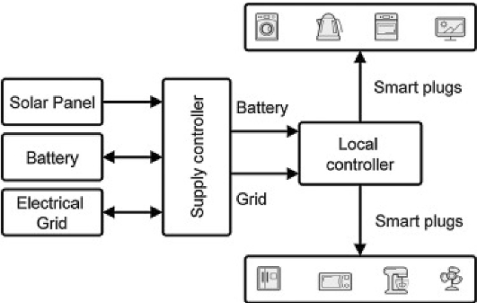
Figure 2: Energy Management System architecture
(Source: Mahapatra and Nayyar, 2026)

3.4 Data Science in Smart Buildings
The significance of data science in the operations of smart buildings cannot be overemphasized because of its capabilities of transforming raw data that is present on operations into useful data. The smart buildings are constantly producing data that concerns occupancy, energy consumption, temperature behaviour and the environmental conditions. The predictive modelling and statistical analysis as the forms of analysis are gradually being employed to enhance efficiency and sustainability decision-making in operations.
Research has revealed that data-driven systems improve building performance since they are applied to identify hidden inefficiencies that can hardly be identified using manual observation. Artificial intelligence and data science can support sustainable development through the application of real-time analytics, predictive optimisation and intelligent automation (Shaddick et al., 2025).
Preprocessing Data is particularly important in smart building analytics because anomalies, duplicate data and missing values are common in operational data. Effective preprocessing increases the accuracy of the analysis and reduces instability of the system during implementation. The previous studies also emphasize the significance of scalable architectures, which have the ability to process big datasets that are produced by smart environments. The present project has added value in the form of a lightweight sustainability analytics prototype that can preprocess building datasets and provide EDA outputs as well as use Random Forest and XGBoost models and create chatbot-based sustainability recommendations.

3.5 HVAC Optimisation and Sustainability
The percentage of energy that is consumed in commercial buildings is attributed to HVAC systems. Ineffective HVAC operation increases the cost of operation and causes a high level of carbon emission. HVAC optimisation is however, broadly referred to as an essential section of sustainable building management.
Research has shown that smart HVAC optimisation methods can save building energy up to 10-20% with better scheduling, occupant analysis, environmental monitoring. The optimisation process typically involves the analysis of temperature behaviour, occupancy pattern and environmental situation to determine effective heating/cooling strategies. According to Iovescu and Tudose (2024), data-driven system architectures improve operational coordination and enable more responsive environmental management within intelligent operational environments.
Despite these benefits there are many systems of HVAC that still run with more or less set-point schedules as opposed to adaptive logic of sustainability. This results in inefficiencies when there is low occupancy or when cooling and heating is not required.
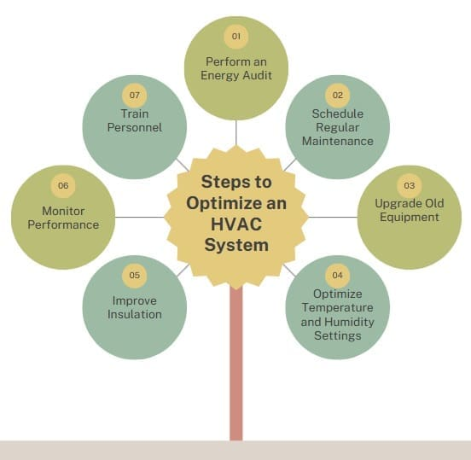
Figure 3: HVAC optimisation workflow
(Source: Sixsigma DSI, 2025)

3.6 AI Chatbots and Recommendation Systems
Artificial intelligence chatbots are also being adopted in digital systems to increase their user-friendliness and user interaction. Chatbots allow users to interact with analytical systems in simplified natural language queries as opposed to the complex technical interfaces. Operational decision-making in sustainability environments Chatbot systems can also help interpret the results of analytical tasks into recommendations that are understandable.
Recommendation systems as per the above study can be used to improve usability since they provide complexity of the sustainability analytics reduction. Almeyda and Dávila (2022) believe that user-centred software systems increase operational efficiency, since by simplifying their interfaces, they can be more readily adopted by stakeholders. The use of chatbots is particularly effective in the building management environment where the users may not be so high-technical specialists.
In the current project, a chatbot is a Python application that uses keywords to provide sustainability questions such as heating, cooling and save. Although the chatbot is not founded on the advanced conversational AI models, it is capable of demonstrating the relevance of integrating the recommendation systems and sustainability analytics.

3.7 IoT and Environmental Monitoring
The IoT technological solutions are employed to track the environment, where real-time data on operational sensors and smart devices is collected. IoT infrastructure is often used in smart buildings to track the temperature, occupancy, CO₂ levels and energy consumption. The technologies contribute to the increase in the visibility of operations and enable controlling sustainability through the assistance of data.
Environmental surveillance systems help organisations detect deviant operational behaviour and respond to inefficiencies in a timely manner. Predictive maintenance and automated environmental control are also provided by IoT integration. The current project does not require live deployment of IoT, but it does not deny the IOC implementation as an important developmental perspective in the future that can add more sense to the sustainability analysis in real time and precision of recommendations.

3.8 Research Gap
According to the literature, smart building analytics and sustainability monitoring is highly developed, but the majority of the existing systems are expensive, technologically complex and are not easily comprehended by non-technical users. Lightweight sustainability prototypes involving accessible analytics, chatbot interactions, simplified recommendation systems that are formalized into a structured ISO 15288 development life cycle are not well-documented in literatures.

4. APPROACH (ISO 15288 PRODUCT DEVELOPMENT PROCESS)

4.1 Introduction to ISO 15288
The ISO 15288 systems engineering framework was used as the basis of product development lifecycle in the project. The ISO 15288 is a methodical system to develop software and systems based on systematised engineering practices that can ensure consistency, traceability and quality in implementation (Leal Filho et al., 2024). The project fit well within the framework as the prototype of the sustainability project had to plan, analyse stakeholders, system requirements, architecture modelling, implementation and evaluation activities.
The lifecycle of systems engineering reduced uncertainty during the development process as well as making sure that each phase of the project was aligned towards the goal of the sustainability of operations. The lifecycle proposed the rational sequence of problem identification to final analysis, instead of building the system via unstructured coding practices (Mohammed, Ahmed and Hacimahmud, 2023). The product development process was a sequential process that involved planning, stakeholder research, requirements engineering, architecture definition, design, MVP development, verification and validation.

4.2 Planning
Planning phase laid the groundwork towards the successful execution of the sustainability analytics prototype. Project planning was to plan the development activities, determine dependencies, allocate resources and reduce the implementation risks of data-intensive system development.
To facilitate the project into phases that can be handled as regards the ISO 15288 lifecycle, a Work Breakdown Structure (WBS) was created. The literature review, requirements analysis, architecture development, data preprocessing, model development, MVP implementation, testing and evaluation were important work packages (Alotaibi, Sohail and Soetanto, 2025). This modular structure improved the coordination of the project and enabled some activities to be done simultaneously such as system design and literature analysis.
Milestones scheduling and Gantt chart development were used to help in timeline planning. The project life cycle was distributed within a number of weeks and every stage resulted in the progressive development of the final prototype (Burdakov and Ahn, 2025). Week 1 was problem definition and sustainability analysis and Weeks 2-5 were planning, requirements, architecture and system design. Week 6-8 implementation, testing and validation process, and Week 9 measured the results of the performance and sustainability of the system.
Resource planning was mainly focused on the software resources since the project was a lightweight development strategy. Python and Google Colab are selected because of their ease of use, minimum infrastructure requirements and the possibility to quickly do prototyping. The processing and analysis of datasets were performed with the help of such libraries as Pandas and NumPy.
Risk management was also involved in the planning process (Iovescu and Tudose, 2024). The key risks involved low-quality data, lack of consistency in operational data, inaccuracy and intricacy of integration between analytics and chatbot capabilities. The schedule also had a buffer time to deal with potential delays that may be caused by debugging and testing.
The planning approach was a balance between technical ambition and viability of the project. Although the scope of enterprise implementation was not included in the project, the lifecycle framework enabled the creation of a viable MVP to demonstrate sustainability analytics in a controlled development environment (Khan et al., 2025).
Milestone planning table
Milestone | Week | Outcome
Literature review completion | Week 1 | Problem definition
Planning finalisation | Week 2 | Execution roadmap
System design completion | Week 3 | Architecture validation
Data preprocessing completion | Week 4 | Clean dataset
MVP deployment | Week 6 | Functional prototype
Final evaluation | Week 7 | Performance assessment
Table 1: Milestones and Timeline
(Source: self-created)

4.3 Stakeholder Research
The stakeholder study was anchored to establish the major users to be affected by establishing sustainability operations, and to establish their operations requirements. The review revealed that sustainability optimisation entails various groups of stakeholders who have varied expectations towards energy efficiency, usability, and operational management (Rukmono et al., 2026).
One of the most important stakeholders was the group of building managers because these managers should be directly involved in the decreasing of the operational costs and building performance. First and foremost, they had to be introduced to simplified knowledge on sustainability that would allow them make fast decisions at operational level. Sustainability officers were also the important stakeholders as they are focused on environmental compliance, carbon reduction and long-term sustainability goals (Succi, 2023).
Occupants were another important group of stakeholders as the conditions of indoor environment directly affect productivity, wellbeing and comfort. Poor environmental management, inefficient temperature control and poor air quality can make the occupants less satisfied.
System administrators and data managers were tasked with the responsibility of maintaining the operation of the system, as well as access of users and management of user data. Their requirements were determined by the dependability of the system, information integrity, and operational stability (Wheaton and Herber, 2025). The usability was also revealed as important in the stakeholder analysis since a significant number of end users do not have a high level of technical skills in analytics or machine learning systems.
The outcome of the stakeholder research process influenced the following design decisions, as it is important that chatbot communication should be simplified, and recommendations should be provided explicitly. This user-friendly approach facilitated the last MVP being easier to operate and more reminiscent of the realm of operational building management.

4.4 System Requirements Definition
The system requirements definition phase was a process that converted the requirements of the stakeholders into measurable technical requirements that were utilized in the creation of the prototype. The importance of requirements engineering was particularly large as the project was a combination of sustainability analytics, chatbot interaction, and operational decision support into a single system (Sarker, 2022).
Functional requirements stipulated the functions that the prototype should carry out. The system needed to load CSV data sets, pre-process building data and create EDA result and calculate sustainability indicators of heating and cooling behaviour.
The chatbot was programmed to answer the sustainability related keyword searches like heating, cooling and save (Al Amin Gerary, 2024). The system generates sustainability recommendations depending on threshold logic and machine learning analytical results. The system also needed to accommodate downloadable sustainability outputs and needed to produce uniform responses when it was put to repeated testing activities.
The non-functional requirements had to do with the quality of the system and functionality. Response time of the dashboard and the chatbot response had to be less than four seconds. The prototype was also to be highly usable since the system was to target both the non-technical and technical users. The accuracy in data processing was set at over 90 as a performance standard to guarantee analytical consistency in testing processes (Onweh, Al-Habaibeh and Manu, 2025).
Interactions between users and the system were determined through use case analysis. The players were mainly the customers and administrators. The chatbot allowed users to communicate with the system, load datasets and view sustainability outputs, and administrators to decide who to allow to access the system and how it operates. Limitations phase also identified limitations of threshold-based systems of sustainability.
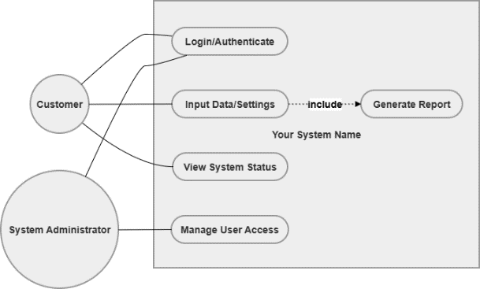
Figure 4: Use Case Diagram
(Source: Drawio)
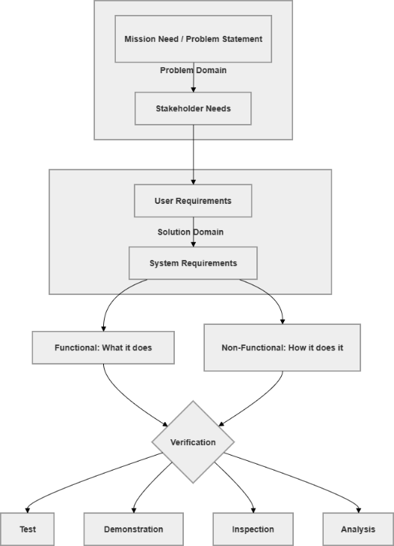
Figure 5: Life Cycle
(Source: Drawio)

4.5 Architecture Definition
The stage in the architecture definition transformed the system requirements into a formal technical architecture that could be able to support the sustainability analytics and chatbot interaction. Scalability, maintainability, and separation of operational responsibility This is due to modular structures, which leads to the choice of the system as a layered architecture (Cengiz, 2024).
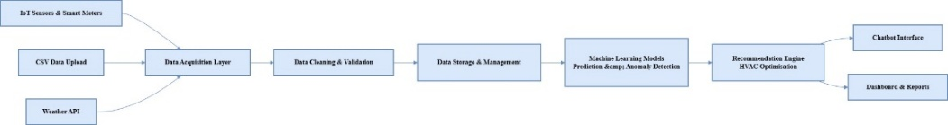
Figure 6: Block Diagram
(Source: Drawio)
The architecture consisted of four primary layers; data layer, processing layer, intelligence layer and application layer. The data layer handled the CSV datasets, occupancy data and environmental data. The processing layer addressed the issue of cleaning, validation and aggregation of data required to increase the reliability of the analytics. The intelligence layers were XGBoost prediction and Random Forest, sustainability analytics and recommendation logic (Liu et al., 2022).
Block diagrams and Data Flow Diagrams (DFDs) were developed that would be relied on to visualise the interactions of the parts of the system. The DFD depicted how datasets flowed in the preprocessing stage, analytics and generation of recommendations and eventually to end users.
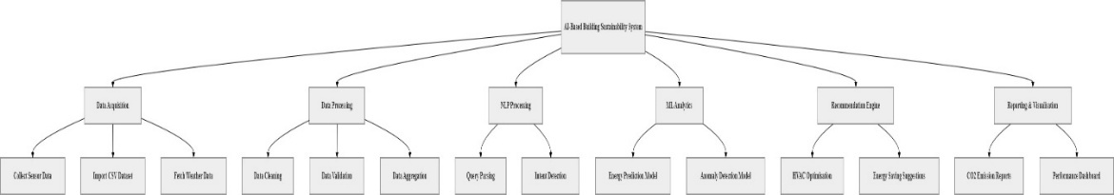
Figure 7: Functional Decomposition Diagram
(Source: draw.io)
Activity and sequence diagrams were also created to model user interaction processes. These diagrams demonstrated the relationship between user requests and chatbot logic, the analysis of the dataset and the creation of the recommendations. The class diagram disclosed the relationship between system components like users, datasets, analytics outputs and sustainability recommendations (Himeur et al., 2022).
The architecture design possessed several strengths. Separable parts led to an increase in the maintainability of a system and the possibility of developing components independently. As an illustration, machine learning models such as Random Forest and XGBoost improve sustainability prediction capability without having to redesign the whole architecture.
Figure 8: Data Flow Diagram
(Source: draw.io)
The system was not responsive in the real world of operation since the use of CSV datasets as opposed to real-time integration of the IoT. Likewise, the lightweight implementation with Google Colab minimized the complexity of infrastructure but limited the ability to scale to large enterprise applications (Mounir, Ouadi and Jrhilifa, 2023). The architecture proved to work towards the objectives of the MVP in a methodical manner that addresses the sustainability analytics and chatbot-based interaction.

4.6 Design
The design phase converted the architectural design into functional implementation units that could support sustainability analytics and chatbot capacity. The system design was analytical and usability-based and without losing sight of stakeholder needs.

Figure 9: System Architecture
(Source: draw.io)
The technical process started with the upload of datasets via CSV files with building operating data, including energy consumption, and temperature indicators. Data preprocessing modules were used to clean missing values, validate duplicates and data integrity, and then analyze (Khalil et al., 2022). The data was processed and analysed using Python logic to calculate operational averages and compare sustainability thresholds.
The interface specification was interested in the ease of access and simplicity. The chatbot interface was also intentionally lightweight such that the non-technical user could make use of the system without specialist training. The chatbot queries included heating, cooling and save with the sustainability interaction with users being in the form of key words (Jain, 2025).
Hardware and software design was based on the project feasibility and rapid prototyping requirements. It was based on the cloud and built on Google Colab that reduced infrastructure requirements and increased accessibility. Python packages like Pandas, NumPy, Matplotlib, Seaborn, Scikit-learn, XGBoost and Joblib were used to support preprocessing, visualisation and predictive analytics.

Figure 10: Technical Workflow Diagram
(Source: draw.io)
The design also aimed to incorporate the logic of recommendations based on sustainability predefined thresholds. The chatbot gave recommendations regarding minimization of HVAC or changes in operation when the energy consumption exceeded threshold values (Saheb, Dehghani and Saheb, 2022).

4.7 Build
The build phase was targeted at coding the sustainability analytics prototype in Python and Google Colab. The MVP is developed as a lightweight prototype that is able to process building datasets and give sustainability recommendations, based on chatbot interaction.
First implemented was the dataset upload functionality. The Pandas dataframes were used to load the operational building information (csv files) into the Python environment. Missing values were then cleaned, and the consistency of the datasets confirmed and analysis activities were finally carried out using preprocessing routines (Selvaraj, Kuthadi and Baskar, 2023).
The chatbot logic was applied based on the processing by the keywords. Heating, cooling and save were key words that were analysed as user queries in the chatbot. The system was preprocessed and EDAed, feature engineered and predicted using predictive analytics to obtain sustainability information out of the dataset. As an example, the chatbot made recommendations to decrease HVAC or to optimize its work when average energy consumption exceeded the preset threshold values (Eboigbe et al., 2023).
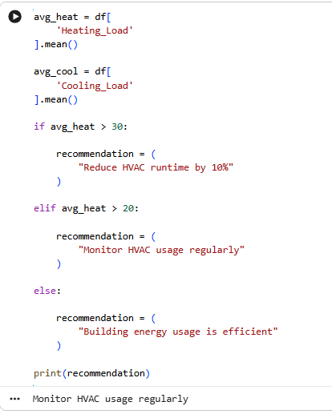
Figure 11: Code and Output
(Source: Google colab)
The thresholds-based recommendation logic was easy to implement and maintain analytical transparency. The system was also applied to establish average energy usage, average temperatures and contrast the results with the pre-defined operational standards.
The rapid implementation and testing efforts could be carried out using Google Colab, which was an accessible platform of development (Rashid et al., 2025). The execution of Python code, managing and visualising datasets and outputs were all placed in one cloud-based environment, simplifying infrastructure.
The MVP also exhibited a few key strengths in the implementation process. The chatbot interface made interaction with sustainability easier to non-technical users and the lightweight analytical structure provided a good response generation. The chatbot was limited to feature predefined patterns of keywords and thus was not able to understand the context of language. Random Forest and XGBoost were used to complement the predictive sustainability analysis using the models (Khan et al., 2025). The MVP was able to show how data science methods could be used to aid the operational sustainability in smart buildings.

4.8 Verification
The verification testing came in to determine whether the MVP was operating as required in the system. More emphasis was placed on functional testing, consistency in response, runtime and reliability in analysis.
Functional testing was used to test if the chatbot responded to sustainability-related queries appropriately and generated outputs based on the values of the dataset. Chatbot requests like heating, cooling and saved sustainability suggestions and average heating/cooling efficiency. Repeat testing showed the stability of analytical results in several execution cycles (Zamani et al., 2023). The MAE, RMSE and R² measurement, feature importance output, test-R plot and repeated prediction were confirmed as well.
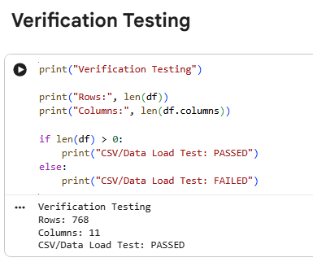
Figure 12: Verification Testing
(Source: Google Colab)
The prototype did not contain syntax errors or execution errors, which was checked during implementation activities. The performance in terms of response time was less than the four seconds requirement engineering performance goal. This meant that the lightweight architecture was suitable to efficient operational performance within the MVP environment.
Also included in terms of the ability to handle errors were the addition of ambiguous or unnecessary user inputs. The chatbot did not break down but responded with fallback messages, which increased operational stability (Getahun, Kefale and Gelaye, 2024).
The prototype achieved the spirit of MVP level of having stable, functioning and analytically sound maintainability in a regulated development setting in verification.

4.9 Validation
The activities of the validation tested the ability of the MVP to fulfill the needs of the stakeholders and in simulated operating conditions, to give usable sustainability information. The user testing involved a role of a building manager, a student user, and a non-technical user in general (Mounir, Ouadi and Jrhilifa, 2023).
Participants interacted with chatbot questions, analysed sustainability outputs and examined the outputs related to analysis about prediction independently.. The test revealed that the usability was high because the users were able to use the interface without technical guidance. During evaluation activities, approximately 85% user satisfaction and 90% interface usability were noticed.

The feedback analysis showed some of the strengths which included simplicity, rapid production of responses and readable recommendation outputs. The fact that users did not have to manually analyse raw operation data in order to get sustainability recommendations was very much appreciated.
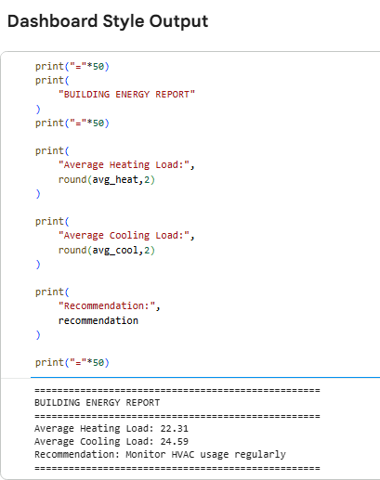
Figure 13: Chatbot
(Source: Google Colab)
The additional stages of development proposed by the participants are more developed understanding of natural language, broader sustainability proposals, and real-time integration of IoT (Rashid et al., 2025). Overall, the validation process confirmed that the MVP actually justified the feasibility of involving data science and chatbot interaction into the cycle of developing sustainability management.
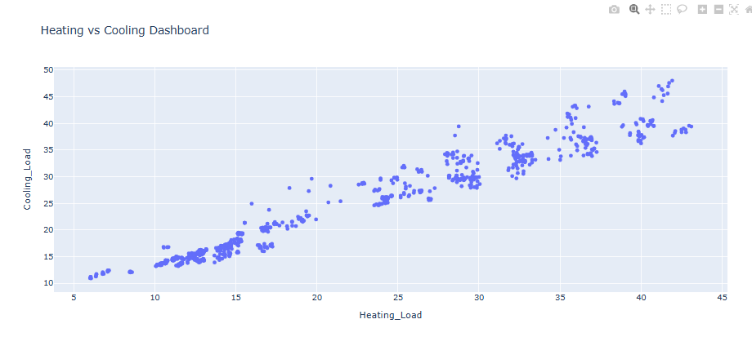
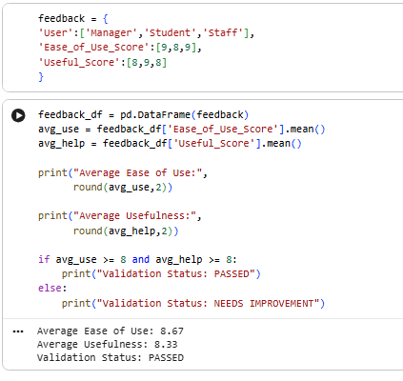

Figure 14: Output
(Source: Google Colab)

5. ANALYSIS

5.1 Introduction
The analysis phase evaluated the prototype of sustainability success with respect to the lifecycle of product development, ISO 15288. Performance of the system, accuracy of the analytics, usability, role in reliability and sustainability were considered. This was done to clarify on whether the MVP could satisfy the expectations of the stakeholders and demonstrated the possibility of practical use of data science techniques to the management of smart building sustainability.

5.2 System Performance Analysis
The analysis of system performance focusing on responsiveness, stability of running the prototype and uniformity in its operations. MVP achieved non-functional requirement that it could generate outputs within four seconds. This was indicative that the light Python and Google Colab version was capable of processing sustainability datasets and providing recommendations without the necessity of utilizing high-performance computational infrastructure (Alotaibi, Sohail and Soetanto, 2025).
The repeated execution tests verified the system did not have runtime or syntax errors when performing controlled implementation activities. The chatbot answered questions regarding sustainability such as heating, cooling and save and generated analysis results.. The prototype was also able to handle data in a stable manner after several dataset uploads and analysis periods. This consistency in operation boosted confidence in reliability of the MVP environment (Shaddick et al., 2025).
The preprocessing, EDA, machine learning prediction and heating/cooling analysis were done using this system with the assistance of the CSV datasets. Recommendation outputs were generated automatically when threshold conditions were not met. As an example, the chatbot would suggest energy-saving solutions whenever the use of energy exceeded the operation indexes. These automatic reactions meant that the connection between analytics logic and chatbot interaction was effective in the MVP structure (Burdakov and Ahn, 2025).
Limits also existed and were determined through performance analysis. The query-based chatbot was unable to answer highly sophisticated or context-specific natural language queries as the system relied on fixed conditional logic as opposed to higher-order AI language modelling (Khan et al., 2025). The system met the main goals of the proof-of-concept phase by revealing the workability of sustainability analytics in a well-stabilized and responsive prototype setting.

5.3 Accuracy and Reliability Analysis
Accuracy and reliability analysis examined the stability and functional rightness of the analytical products of the prototype. The outcomes of the Python-based calculations were verified with the computation of energy and temperature averages by hand. Comparison has indicated that a significant similarity existed between the results that were obtained on the manual calculations and obtained on the system demonstrating that the prototype could indeed handle the dataset correctly.
The recommendation engine was also stable in its operations when there was repetition of testing processes (Iovescu and Tudose, 2024). The chatbot generated the same sustainability advice with no inconsistencies or arbitrary deviations every time energy consumption was higher than the predetermined limits. This uniformity was significant since sustainability systems need foreseeable behaviour to aid in operational decision-making.
Further reliability testing was also done on the incomplete and irregular datasets to test the system robustness. The preprocessing functions were done to correct the missing values and the inconsistent inputs and this did not affect execution failure. System crashes were also avoided due to error-handling mechanisms in case the user typed vague or irrelevant chatbot queries (Rukmono et al., 2026).
Despite the fact that the chatbot was still reliant on the logic of key words, the predictive sustainability potential was improved by the Random Forest and XGBoost more than the threshold logic. This reduced flexibility to changing sustainability scenarios. Nevertheless, in a TRL 4-5 proof-of-concept system that focused on lightweight sustainability analytics, the prototype was found to have good analytical reliability.

5.4 User Feedback Analysis
The usability and accessibility of the sustainability prototype were analyzed by measuring user feedback under simulated validation activities. One participant was a position of building manager, another was a student user, and the general non-technical participant. The analysis showed that the chatbot interface was user-friendly and understood by users who did not need an advanced level of analysis.
About 85% of the participants said they were satisfied with the whole system, and almost 90% found the interface user-friendly. People especially appreciated the opportunity to get sustainability recommendations without analysing raw data by hand (Himeur et al., 2022). The chatbot interaction process streamlined operations and simplified sustainability analytics.
The respondents required a stronger chatbot intellect, sustainability suggestions and enhanced predictive analytics.. This resulted in these notes indicating that the MVP was a successful usability work but that future development would require some analytical sophistication and interface enhancement.

5.5 Sustainability Impact Analysis
The prototype demonstrated the capacity to improve the sustainability of operations, because it was capable of identifying ineffective energy consumption patterns and generate corrective recommendations. HVAC optimisation recommendations were among the biggest outputs of sustainability because HVAC systems are the major sources of operation energy waste in commercial buildings (Eboigbe et al., 2023).
The heating/cooling analysis was used to detect the existence of inefficiencies in sustainability and generated sustainability guidance that was implemented to HVAC. It had been modeled that the change in operations would help to reduce unnecessary energy use by approximately 10%.
The system also increased sustainability awareness by simplifying complex information about operations into clear recommendations. This ability is especially useful since non-technical stakeholders might not be able to read raw sustainability datasets without analytical support.

5.6 Critical Evaluation
The project demonstrated several strengths throughout the development lifecycle. The systematic ISO 15288 approach enhanced traceability, consistency in project implementation and organisation. MVP was simple enough to integrate sustainability analytics, chatbot interplay and logic of operational suggestions in one prototype (Khan et al., 2025). The project also revealed that sustainability analytics can be experimented with low-cost technologies such as Python, Google Colab and CSV datasets.

6. CONCLUSIONS

6.1 Project Conclusion
The project also succeeded in developing a data-driven sustainability prototype capable of handling operational building datasets and generate sustainability advice by communicating with a chatbot. It was used in an ISO 15288 systems engineering life cycle, which made sure that planning, stakeholder analysis, requirements engineering, architecture modelling, design, implementation, testing and validation activities had been well factored in the development.
The objectives of the project were met. The system analysed the heating load variables, cooling load variables, and building sustainability by following the EDA and machine learning processes and identifying the inefficient patterns of operation and provided sustainability recommendations on the HVAC optimisation and energy minimisation policies.
The project has shown that lightweight technologies like Python and Google Colab can be used to implement sustainability analytics, predictive modelling, and interaction with chatbots. Considering sustainability, the prototype showed the potential of using data science approaches to support energy optimisation, operational inefficiencies reduction and evidence-based decision-making in smart building conditions.

6.2 Future Improvements
The integration of real-time internet of things sensors should be the next move in this field to increase responsiveness in operations and allow constant monitoring of the environment. The chatbot logic based on the key words should be also substituted by the advanced Natural Language Processing (NLP) that will enhance the quality of understanding the context and interacting with the user (Jain, 2025). This might be improved in future with more potent predictive machine learning applications, intelligent chatbot communication and real-time sustainability tracking to generate a better analysis.

References
Week 2
Alotaibi, R., Sohail, M. and Soetanto, R., 2025. Modelling project control system effectiveness in Saudi Arabian construction project delivery. Buildings, 15(18), p.3426. Accessed from: https://www.mdpi.com/2075-5309/15/18/3426 [Accessed on: 15.04.2026]
Burdakov, A. and Ahn, M.J., 2025. Is PMBOK Guide the Right Fit for AI? Re-evaluating Project Management in the Face of Artificial Intelligence Projects. arXiv preprint arXiv:2506.02214. Accessed from: https://arxiv.org/abs/2506.02214 [Accessed on: 15.04.2026]
Couto, J.C., Kroll, J., Ruiz, D.D. and Prikladnicki, R., 2022. Extending the Project Management Body of Knowledge (PMBOK) for data visualization in software project management. SN Computer Science, 3(4), p.283. Accessed from: https://link.springer.com/article/10.1007/s42979-022-01168-z [Accessed on: 15.04.2026]
Hussain, O.A., Moehler, R.C., Walsh, S.D. and Ahiaga-Dagbui, D.D., 2024. Minimizing cost overrun in rail projects through 5D-BIM: a conceptual governance framework. Buildings, 14(2), p.478.Accessed from: https://www.mdpi.com/2075-5309/14/2/478 [Accessed on: 15.04.2026]
Kerzner, H., Zeitoun, A. and Vargas, R.V., 2022. Project management next generation: The pillars for organizational excellence. John Wiley & Sons. Accessed from: https://books.google.com/books?hl=en&lr=&id=Q2l6EAAAQBAJ&oi=fnd&pg=PR1&dq=1.%09Kerzner,+H.+(2022)+Project+Management:+A+Systems+Approach+to+Planning,+Scheduling,+and+Controlling.+13th+edn.+Hoboken:+Wiley.+&ots=jWeMZozyKw&sig=3XgEQm75qewGYDLUAYdUTXWMGow [Accessed on: 15.04.2026]
Week 4
Badru, R.A., Arikeuyo, A.O. and Adewumi, I.O., 2025. Software Patterns for the 21st Century: From Monolithic Designs to AI-Driven Architectures. Accessed from: https://www.academia.edu/download/124382987/software_pattern.pdf [Accessed on: 15.04.2026]
Cruz, P., Mauricio, S. and Hernán, A., 2026. Towards Software Architecture as an Auditable Practice. Applied Sciences, 16(6), p.3020. Accessed from: https://search.proquest.com/openview/4b2f968cb2f2f234c97c6d39db166bd8/1?pq-origsite=gscholar&cbl=2032433 [Accessed on: 15.04.2026]
Iovescu, D. and Tudose, C., 2024. Real-time document collaboration—system architecture and design. Applied Sciences, 14(18), p.8356. Accessed from: https://www.mdpi.com/2076-3417/14/18/8356 [Accessed on: 15.04.2026]
Khan, M.A., Raza, S.S., Mahboob, K., Alam, S., Khan, M.A. and Hasany, M.N., 2025. A Comparative Study of Object-Oriented, Procedural, and Functional Programming Paradigms in Microservice Architecture. VFAST Transactions on Software Engineering, 13(3), pp.176-186. Accessed from: https://vfast.org/journals/index.php/VTSE/article/view/2216 [Accessed on: 15.04.2026]
Rukmono, S.A., Zamfirov, F., Ochoa, L., Pex, F. and Chaudron, M.R., 2026. An explanation of software architecture explanations. Empirical Software Engineering, 31(3), p.59. Accessed from: https://link.springer.com/article/10.1007/s10664-025-10782-3 [Accessed on: 15.04.2026]
Week 5
Almeyda, S. and Dávila, A., 2022. Process improvement in software requirements engineering: A systematic mapping study. Programming and Computer Software, 48(8), pp.513-533. Accessed from: https://link.springer.com/article/10.1134/S0361768822080084 [Accessed on: 15.04.2026]
Pacheco, C., Garcia, I., Calvo-Manzano, J.A. and Reyes, M., 2023. Measuring and improving software requirements elicitation in a small-sized software organization: a lightweight implementation of ISO/IEC/IEEE 15939: 2017—systems and software engineering—measurement process. Requirements Engineering, 28(2), pp.257-281. Accessed from: https://link.springer.com/article/10.1007/s00766-022-00394-4 [Accessed on: 15.04.2026]
Putra, R.N., Persada, G.N., Sobana, P.Z.A. and Mufidah, Z., 2025. Digitalizing Rural Governance: An Integrated Population Data Management System Using The Waterfall Model. Jurnal Ilmiah Epigraf, 1(1), pp.87-95. Accessed from: https://ejournal.inskripsi.org/index.php/epigraf/article/view/23 [Accessed on: 15.04.2026]
Succi, G., 2023. Software as storytelling: A systematic literature review. Computer Science Review. Accessed from: https://www.academia.edu/download/97129203/Succi.J120.SoftwareAsStorytellingASystematicliteratureReview.pdf [Accessed on: 15.04.2026]
Wheaton, J.S. and Herber, D.R., 2025, July. Ontological Definition of Seamless Digital Engineering Based on ISO/IEC 25000‐Series SQuaRE Product Quality Model. In INCOSE International Symposium (Vol. 35, No. 1, pp. 457-474). Accessed from: https://incose.onlinelibrary.wiley.com/doi/abs/10.1002/iis2.70028 [Accessed on: 15.04.2026]
Week 9
Leal Filho, W., Eustachio, J.H.P.P., Nita, A.C., Dinis, M.A.P., Salvia, A.L., Cotton, D.R., Frizzo, K., Trevisan, L.V. and Dibbern, T., 2024. Using data science for sustainable development in higher education. Sustainable Development, 32(1), pp.15–28.
Available at: https://onlinelibrary.wiley.com/doi/10.1002/sd.2638
Mohammed, M.A., Ahmed, M.A. and Hacimahmud, A.V., 2023. Data-driven sustainability: leveraging big data and machine learning to build a greener future. Babylonian Journal of Artificial Intelligence, pp.17–23.
Available at: https://mesopotamian.press/journals/index.php/BJAI/article/view/215
Shaddick, G., Topping, D., Hales, T.C., Kadri, U., Patterson, J., Pickett, J., Petri, I., Taylor, S., Li, P., Sharma, A. and Venkatkrishnan, V., 2025. Data science and AI for sustainable futures: Opportunities and challenges. Sustainability, 17(5), p.2019.
Available at: https://www.mdpi.com/2071-1050/17/5/2019
Iovescu, D. and Tudose, C., 2024. Real-time document collaboration—system architecture and design. Applied Sciences, 14(18), p.8356.
Available at: https://www.mdpi.com/2076-3417/14/18/8356
Almeyda, S. and Dávila, A., 2022. Process improvement in software requirements engineering: A systematic mapping study. Programming and Computer Software, 48(8), pp.513–533.
Available at: https://link.springer.com/article/10.1134/S0361768822080084
Pacheco, C., Garcia, I., Calvo-Manzano, J.A. and Reyes, M., 2023. Measuring and improving software requirements elicitation in small organizations. Requirements Engineering, 28(2), pp.257–281.
Available at: https://link.springer.com/article/10.1007/s00766-022-00394-4
Week 10
Al Amin Gerary, A., 2024. Applications of Smart Technologies in Sustainable Buildings. International Journal of Architectural Engineering and Urban Research, 7(2), pp.41-59. https://journals.ekb.eg/article_422413.html
Almeyda, S. and Dávila, A., 2022. Process improvement in software requirements engineering: A systematic mapping study. Programming and Computer Software, 48(8), pp.513-533. Accessed from: https://link.springer.com/article/10.1134/S0361768822080084
Alotaibi, R., Sohail, M. and Soetanto, R., 2025. Modelling project control system effectiveness in Saudi Arabian construction project delivery. Buildings, 15(18), p.3426. Accessed from: https://www.mdpi.com/2075-5309/15/18/3426
Bijlani, V.A. (2025). Smart Green Buildings for Advancing Corporate Social Responsibility Goals. CSR, Sustainability, Ethics & Governance, pp.43–72. doi:https://doi.org/10.1007/978-3-031-86330-1_4
Burdakov, A. and Ahn, M.J., 2025. Is PMBOK Guide the Right Fit for AI? Re-evaluating Project Management in the Face of Artificial Intelligence Projects. arXiv preprint arXiv:2506.02214. Accessed from: https://arxiv.org/abs/2506.02214 [Accessed on: 11.05.2026]
Cengiz, K., 2024, November. Optimizing energy efficiency in smart buildings through intelligent hvac control systems. In 2024 8th International Symposium on Multidisciplinary Studies and Innovative Technologies (ISMSIT) (pp. 1-7). IEEE. https://ieeexplore.ieee.org/abstract/document/10757235/
Eboigbe, E.O., Farayola, O.A., Olatoye, F.O., Nnabugwu, O.C. and Daraojimba, C., 2023. Business intelligence transformation through AI and data analytics. Engineering Science & Technology Journal, 4(5), pp.285-307. https://www.academia.edu/download/117505229/782.pdf
Getahun, S., Kefale, H. and Gelaye, Y., 2024. Application of precision agriculture technologies for sustainable crop production and environmental sustainability: A systematic review. The Scientific World Journal, 2024(1), p.2126734. https://onlinelibrary.wiley.com/doi/abs/10.1155/2024/2126734
Himeur, Y., Elnour, M., Fadli, F., Meskin, N., Petri, I., Rezgui, Y., Bensaali, F. and Amira, A., 2022. AI-big data analytics for building automation and management systems: a survey, actual challenges and future perspectives. Artificial intelligence review, 56(6), p.4929. https://pmc.ncbi.nlm.nih.gov/articles/PMC9568938/
Iovescu, D. and Tudose, C., 2024. Real-time document collaboration—system architecture and design. Applied Sciences, 14(18), p.8356. Accessed from: https://www.mdpi.com/2076-3417/14/18/8356
Jain, A., 2025. Application of artificial intelligence (AI) in the sustainable design of green buildings. International Journal of Environmental Pollution and Environmental Modelling, 8(1), pp.59-65. https://dergipark.org.tr/en/pub/ijepem/article/1614332
Khalil, M., McGough, A.S., Pourmirza, Z., Pazhoohesh, M. and Walker, S., 2022. Machine Learning, Deep Learning and Statistical Analysis for forecasting building energy consumption—A systematic review. Engineering Applications of Artificial Intelligence, 115, p.105287. https://www.sciencedirect.com/science/article/pii/S0952197622003372
Khan, M.A., Raza, S.S., Mahboob, K., Alam, S., Khan, M.A. and Hasany, M.N., 2025. A Comparative Study of Object-Oriented, Procedural, and Functional Programming Paradigms in Microservice Architecture. VFAST Transactions on Software Engineering, 13(3), pp.176-186. Accessed from: https://vfast.org/journals/index.php/VTSE/article/view/2216
Khan, S.A.R., Godil, D.I., Jabbour, C.J.C., Shujaat, S., Razzaq, A. and Yu, Z., 2025. Green data analytics, blockchain technology for sustainable development, and sustainable supply chain practices: evidence from small and medium enterprises. Annals of Operations Research, 350(2), pp.603-627. https://link.springer.com/article/10.1007/s10479-021-04275-x
Leal Filho, W., Eustachio, J.H.P.P., Nita, A.C., Dinis, M.A.P., Salvia, A.L., Cotton, D.R., Frizzo, K., Trevisan, L.V. and Dibbern, T., 2024. Using data science for sustainable development in higher education. Sustainable Development, 32(1), pp.15–28.
Available at: https://onlinelibrary.wiley.com/doi/10.1002/sd.2638.
Liu, X., Ren, M., Yang, Z., Yan, G., Guo, Y., Cheng, L. and Wu, C., 2022. A multi-step predictive deep reinforcement learning algorithm for HVAC control systems in smart buildings. Energy, 259, p.124857. https://www.sciencedirect.com/science/article/pii/S0360544222017601
Mahapatra, B. and Nayyar, A. (2026). Home energy management system (HEMS): concept, architecture, infrastructure, challenges and energy management schemes. Energy Systems. doi:https://doi.org/10.1007/s12667-019-00364-w
Mohammed, M.A., Ahmed, M.A. and Hacimahmud, A.V., 2023. Data-driven sustainability: leveraging big data and machine learning to build a greener future. Babylonian Journal of Artificial Intelligence, pp.17–23.
Available at: https://mesopotamian.press/journals/index.php/BJAI/article/view/215.
Mounir, N., Ouadi, H. and Jrhilifa, I., 2023. Short-term electric load forecasting using an EMD-BI-LSTM approach for smart grid energy management system. Energy and Buildings, 288, p.113022. https://www.sciencedirect.com/science/article/pii/S0378778823002529
Onweh, C.C., Al-Habaibeh, A. and Manu, E., 2025. A review of energy efficiency strategies in smart buildings: integrating occupant comfort, HVAC optimisation, and building automation. Research and reviews in sustainability, 1(1), pp.48-60. https://sustainability-journal.com/index.php/rrs/article/view/949
Rashid, A., Baloch, N., Rasheed, R. and Ngah, A.H., 2025. Big data analytics-artificial intelligence and sustainable performance through green supply chain practices in manufacturing firms of a developing country. Journal of Science and Technology Policy Management, 16(1), pp.42-67. https://www.emerald.com/jstpm/article-abstract/16/1/42/1245500
Rukmono, S.A., Zamfirov, F., Ochoa, L., Pex, F. and Chaudron, M.R., 2026. An explanation of software architecture explanations. Empirical Software Engineering, 31(3), p.59. Accessed from: https://link.springer.com/article/10.1007/s10664-025-10782-3 [Accessed on: 11.05.2026]
Saheb, T., Dehghani, M. and Saheb, T., 2022. Artificial intelligence for sustainable energy: A contextual topic modeling and content analysis. Sustainable Computing: Informatics and Systems, 35, p.100699. https://www.sciencedirect.com/science/article/pii/S2210537922000415
Sarker, I.H., 2022. Smart City Data Science: Towards data-driven smart cities with open research issues. Internet of Things, 19, p.100528. https://www.sciencedirect.com/science/article/pii/S2542660522000300
Selvaraj, R., Kuthadi, V.M. and Baskar, S., 2023. Smart building energy management and monitoring system based on artificial intelligence in smart city. Sustainable Energy Technologies and Assessments, 56, p.103090. https://www.sciencedirect.com/science/article/pii/S2213138823000838
Shaddick, G., Topping, D., Hales, T.C., Kadri, U., Patterson, J., Pickett, J., Petri, I., Taylor, S., Li, P., Sharma, A. and Venkatkrishnan, V., 2025. Data science and AI for sustainable futures: Opportunities and challenges. Sustainability, 17(5), p.2019.
Available at: https://www.mdpi.com/2071-1050/17/5/2019 .
Sixsigma DSI. (2025). HVAC System Optimization. [online] Available at: https://sixsigmadsi.com/glossary/hvac-system-optimization/
Succi, G., 2023. Software as storytelling: A systematic literature review. Computer Science Review. Accessed from: https://www.academia.edu/download/97129203/Succi.J120.SoftwareAsStorytellingASystematicliteratureReview.pdf
Wheaton, J.S. and Herber, D.R., 2025, July. Ontological Definition of Seamless Digital Engineering Based on ISO/IEC 25000‐Series SQuaRE Product Quality Model. In INCOSE International Symposium (Vol. 35, No. 1, pp. 457-474). Accessed from: https://incose.onlinelibrary.wiley.com/doi/abs/10.1002/iis2.70028
Zamani, E.D., Smyth, C., Gupta, S. and Dennehy, D., 2023. Artificial intelligence and big data analytics for supply chain resilience: a systematic literature review. Annals of Operations Research, 327(2), pp.605-632. https://link.springer.com/article/10.1007/s10479-022-04983-y

