
Vortex Shedding Analysis Report
Generated: 2026-04-10 15:40:43
Input Parameters
Parameter | Value
Material | A36 Steel
Young's modulus E (GPa) | 200.0
Density (kg/m^3) | 7850
Outer diameter D (mm) | 200.0
Wall thickness t (mm) | 6.00
Length L (m) | 6.00
Damping ratio (zeta) | 0.0100
Axial force (kN) | 0.0
Wind climate | Port of Santos, Brazil
Mean wind (m/s) | 5.3
Calculated Section Properties
Property | Value
Moment of inertia I (mm^4) | 17219936
Cross-sectional area A (mm^2) | 3656.8
Mass per unit length mu (kg/m) | 28.71
Radius of gyration r (mm) | 68.6
Detailed Results — All Boundary Conditions
Boundary condition | Mode | f (Hz) | V_crit (m/s) | F (kN) | sigma_max (MPa)
Fixed-Free (Cantilever) | 1 | 5.39 | 5.39 | 5.899 | 25.7
Fixed-Free (Cantilever) | 2 | 33.69 | 33.69 | 230.423 | 348.4
Hinged-Hinged (Simple) | 1 | 15.11 | 15.11 | 46.378 | 202.0
Hinged-Hinged (Simple) | 2 | 60.49 | 60.49 | 742.805 | 1123.3
Fixed-Fixed (Built-in) | 1 | 34.30 | 34.30 | 238.878 | 1040.4
Fixed-Fixed (Built-in) | 2 | 94.48 | 94.48 | 1812.388 | 2740.7
Free-Free | 1 | 34.30 | 34.30 | 238.878 | 1040.4
Free-Free | 2 | 94.48 | 94.48 | 1812.388 | 2740.7
Fixed-Hinged | 1 | 23.58 | 23.58 | 112.907 | 491.8
Fixed-Hinged | 2 | 76.57 | 76.57 | 1190.203 | 1799.8
Hinged-Free | 1 | 23.58 | 23.58 | 112.907 | 491.8
Hinged-Free | 2 | 76.57 | 76.57 | 1190.203 | 1799.8
Damping Uncertainty (zeta 0.005 - 0.020)
Boundary condition | Mode | sigma_min (MPa) | sigma_nom (MPa) | sigma_max (MPa)
Fixed-Free (Cantilever) | 1 | 9.0 | 25.7 | 73.3
Fixed-Free (Cantilever) | 2 | 122.7 | 348.4 | 994.2
Hinged-Hinged (Simple) | 1 | 71.1 | 202.0 | 576.4
Hinged-Hinged (Simple) | 2 | 395.4 | 1123.3 | 3205.0
Fixed-Fixed (Built-in) | 1 | 366.3 | 1040.4 | 2968.6
Fixed-Fixed (Built-in) | 2 | 964.8 | 2740.7 | 7820.1
Free-Free | 1 | 366.3 | 1040.4 | 2968.6
Free-Free | 2 | 964.8 | 2740.7 | 7820.1
Fixed-Hinged | 1 | 173.1 | 491.8 | 1403.1
Fixed-Hinged | 2 | 633.6 | 1799.8 | 5135.5
Hinged-Free | 1 | 173.1 | 491.8 | 1403.1
Hinged-Free | 2 | 633.6 | 1799.8 | 5135.5
Risk Assessment per Boundary Condition
Boundary condition | Level | Wind percentile | Stress / yield
Fixed-Free (Cantilever) | WARNING | 55.8% | 10.3%
Hinged-Hinged (Simple) | CRITICAL | 99.7% | 80.8%
Fixed-Fixed (Built-in) | UNREACHABLE | 100.0% | 416.2%
Free-Free | UNREACHABLE | 100.0% | 416.2%
Fixed-Hinged | UNREACHABLE | 100.0% | 196.7%
Hinged-Free | UNREACHABLE | 100.0% | 196.7%
Engineering Recommendations (worst case: CRITICAL)
• IMMEDIATE ACTION: Increase member size or add substantial bracing
• Consider higher grade steel (e.g., A572-50 → A992)
• Perform detailed fatigue analysis before deployment
Mode Shape Plots
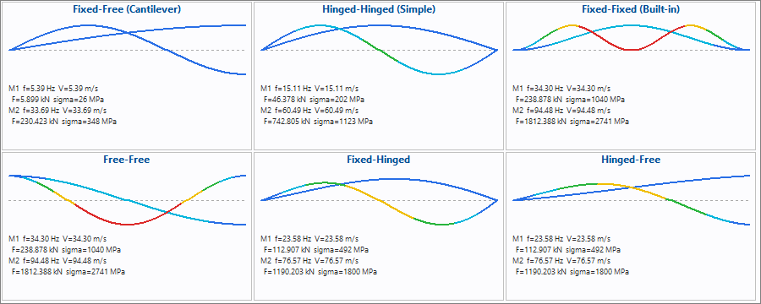
Wind Speed Distribution
