Supplementary Information

Gut microbial resource use can be low-dimensional yet functionally complex
Eric Bonabeau
School of Complex Adaptive Systems, Arizona State University, Tempe, Arizona, USA
Address correspondence to Eric Bonabeau, ebonabea@asu.edu.

Contents
Supplementary Methods include the consumer-resource derivation and validity conditions, trait-factorized rank bound, absolute-scale identification result, numerical verification, cohort benchmark, effective-niche comparison, sample-size calibration, hCom2* reproduction and low-rank/support-preserving analyses, Ho support validation, and reproducibility and claim-boundary details. Supplementary Tables 1–11 and Supplementary Figs. 1–3 provide the corresponding numerical results and diagnostics.

Supplementary Methods

S1.1 Dynamics and assumptions
Consider consumers indexed by $i$ and resources indexed by $α$. The restricted consumer–resource model follows the competition-based frameworks of MacArthur and Chesson^{1, 2} and assumes logistic resource renewal, bilinear consumption, linear conversion of uptake into consumer growth, and no secretion or explicit cross-feeding.
dnidt=niα​wαciαRα-mi (S1)
For consumer $i$, $n_{i}\left(t\right)$ is absolute abundance, $t$ is time, and $m_{i}$ is the per-capita loss or maintenance rate. For resource $α$, $R_{α}\left(t\right)$ is its concentration, $c_{iα}≥0$ is the uptake coefficient for consumer $i$, and $w_{α}>0$ converts uptake of that resource to growth. The index $α$ is summed over resources. This is a restricted growth law without secretion, cross-feeding, or consumer-dependent conversion weights.
dRαdt=εRαrα-qαRα-j​cjαnj (S2)
The parameter $ε>0$ multiplies resource dynamics and controls their separation from consumer timescales; $r_{α}>0$ is the renewal parameter and $q_{α}>0$ is resource self-limitation. The sum j​cjαnj is the total depletion pressure exerted by all consumers $j$ on resource $α$. The factor $R_{α}$ makes renewal density dependent, so the positive resource equilibrium can disappear under sufficient consumption pressure.

S1.2 Positive quasi-steady branch
Rα*=rα-j​cjαnjqα (S3)
The quantity $R_{α}^{*}$ is the positive quasi-steady concentration of resource $α$ for fixed consumer abundances. Its numerator subtracts aggregate uptake demand j​cjαnj from the resource renewal parameter $r_{α}$, and its denominator is the self-limitation coefficient $q_{α}$. This expression is admissible only when its numerator is strictly positive; it is not the positive-branch solution after depletion.
Equation S3 applies only when the numerator is positive. Near resource depletion the positive branch approaches its boundary and the reduced description can fail.
dnidt=nibi-j​Aijnj (S4)
This is the reduced generalized Lotka–Volterra consumer system. The coefficient $b_{i}$ is consumer $i$’s resource-supported intrinsic per-capita growth rate, and $A_{ij}$ is the reduction in consumer $i$’s per-capita growth per unit abundance of consumer $j$. The index $j$ ranges over all consumers, including $i$ itself; therefore diagonal entries $A_{ii}$ represent self-limitation and off-diagonal entries represent shared-resource competition.
bi=α​wαciαrαqα-mi (S5)
The term $b_{i}$ combines the growth contribution of all resources at their supply-limited concentrations, $w_{α}c_{iα}r_{α}/q_{α}$, and subtracts consumer loss $m_{i}$. Here $r_{α}/q_{α}$ is the positive resource equilibrium in the absence of consumers, $c_{iα}$ is uptake by consumer $i$, and $w_{α}$ is the associated conversion weight. Thus $b_{i}$ is not an independent fitted interaction parameter in this reduction.
Aij=α​wαciαcjαqα (S6)
Each $A_{ij}$ is the sum of resource-mediated competitive effects between consumers $i$ and $j$. The product $c_{iα}c_{jα}$ describes shared use of resource $α$; $w_{α}/q_{α}$ weights its contribution. With nonnegative uptake and positive weights, every $A_{ij}$ is nonnegative and $A$ is symmetric. These sign and reciprocity restrictions are specific predictions of this consumer-resource reduction.

S1.3 Properties of the interaction matrix
Under these assumptions the interaction matrix is symmetric and positive semidefinite. Each resource contributes a rank-one positive semidefinite term, so the interaction rank cannot exceed the dimension of the resource-use span.
Two further properties are testable independently of any rank estimate. Every entry of Equation S6 is nonnegative, so the reduced dynamics in Equation S4 contain competition only: shared depletion of self-renewing resources cannot generate facilitation within this model. The matrix is also symmetric, so interactions are reciprocal. Positive semidefiniteness follows directly: for any vector $x$ of length $S$,
$x^{⊤}Ax = {\left\|W^{1/2}C^{⊤}x\right\|}^{2} ≥ 0$ (S7)
Here $x∈R^{S}$ is an arbitrary vector over the $S$ consumers, $C∈R^{S×P}$ is the consumer-by-resource uptake matrix with entries $c_{iα}$, and $A$ is the $S×S$ interaction matrix. The $P×P$ diagonal matrix $W=diag\left(w_{α}/q_{α}\right)$ contains positive resource weights. The superscript $⊤$ denotes transpose, $W^{1/2}$ is its positive diagonal square root, and $∥⋅∥$ is the Euclidean norm. The squared norm proves positive semidefiniteness, not population stability.
This identity concerns the interaction matrix alone. It does not establish that the reduced system has a feasible positive equilibrium, nor that every trajectory converges. Facilitation, strong asymmetry, directional cross-feeding, consumer-specific yields, and nonreciprocal consumption all fall outside this reduction, and observing any of them is more informative than a rank estimate on its own.

S1.4 Domain of validity of the reduction
Equations S4 to S6 are exact on the quasi-steady manifold. For finite $ε$ the full trajectory only approximately follows it. Suppose the reduced consumer trajectory stays in a compact set in which every resource remains a fixed positive distance from depletion, so that every resource satisfies the uniform positive-margin condition:
$r_{α} - \sum_{j}{c_{jα}n_{j}} ≥ δ > 0$ (S8)
The constant $δ>0$ is a fixed lower bound on the renewal-minus-uptake margin for every resource $α$ along the reduced trajectory. The consumer abundances $n_{j}$ can change in time, whereas $r_{α}$ and $c_{jα}$ are parameters of the model. The inequality therefore assumes that no retained resource approaches its depletion boundary; $δ$ is a mathematical separation margin, not a measurement-error tolerance.
At the quasi-steady state, the derivative of the resource equation with respect to its own concentration is
$\frac{∂\left(\frac{dR_{α}}{dt}\right)}{∂R_{α}} = - εq_{α}{R^{*}}_{α}$ (S9)
The derivative is the local slope of the resource $α$ time derivative with respect to its own concentration, evaluated on the positive quasi-steady branch $R_{α}=R_{α}^{*}$ with consumer abundances held fixed. Its value $-εq_{α}R_{α}^{*}$ is the linear restoring rate: because all three factors are positive, small perturbations decay. As $R_{α}^{*}$ approaches zero this restoring rate vanishes, explaining the loss of uniform fast–slow separation near depletion.
Because the self-limitation coefficient and the equilibrium concentration are both positive, this derivative is negative, and under Equation S8 it is bounded away from zero. Small resource displacements therefore decay rapidly back toward the manifold, which is the content of the statement that the positive resource manifold is normally hyperbolic and attracting. Singular-perturbation theory ^{3, 4} then gives a finite-time consumer trajectory error of order $ε$⁻¹ when resources start on the manifold; if they start away from it, an initial fast relaxation occurs first. The approximation is not uniform as a resource approaches depletion, because the restoring rate in Equation S9 also approaches zero. Lotka-Volterra reductions of microbial consumer-resource systems become unreliable for feasibility, stability, and transients when coupling is strong and timescales are insufficiently separated, particularly with cross-feeding or high niche overlap ⁵. Timescale separation should therefore be estimated or bounded in an application rather than assumed.

Trait factorization and interaction-rank bound
A convenient low-dimensional representation writes the uptake matrix as a product of consumer and resource feature factors.
$C=FH^{⊤}$ (S10)
The matrix $C∈R^{S×P}$ contains uptake coefficients for $S$ consumers (rows) and $P$ resources (columns). The factors $F∈R^{S×d}$ and $H∈R^{P×d}$ encode consumer and resource features, respectively, on $d$ shared trait coordinates; $H^{⊤}$ is the transpose of $H$. The decomposition represents uptake through those shared features. Here $H$ is a trait-factor matrix, not necessarily the factor denoted $H$ in the later NMF approximation.
$A=F\left(H^{⊤}WH\right)F^{⊤}$ (S11)
The matrix $A∈R^{S×S}$ is the reduced consumer-interaction matrix. The diagonal resource-weight matrix $W=diag\left(w_{α}/q_{α}\right)∈R^{P×P}$ is positive, and the inner $d×d$ matrix $H^{⊤}WH$ records the weighted overlaps among resource-feature directions. Multiplication by $F$ and $F^{⊤}$ transfers those overlaps to consumer interactions. The symbols $F$, $H$, and $W$ refer to the trait factorization in this section, not the later NMF fitting factors.
In particular, $rank\left(A\right)≤rank\left(F\right)$, showing how many chemically distinct resources can collapse onto fewer competitive directions when uptake is feature structured.
Theorem 1 (trait-factorized reduction). Under the consumer-resource model of Equations S1 and S2, the positive quasi-steady condition of Equation S3, and the factorization of Equation S10, the interaction matrix takes the form of Equation S11, and
$rank A ≤ min\left(rank F, rank H, P, S\right)$ (S12)
The operator $rank\left(⋅\right)$ counts linearly independent matrix directions. In this bound, $A$ is the consumer-interaction matrix, $F$ is the consumer-feature factor, $H$ is the resource-feature factor, $P$ is the number of resources, and $S$ is the number of consumers. The result limits interaction rank by the available trait and matrix dimensions; it does not assert that the bound is attained or that the factor axes are uniquely identifiable.
Proof. Substituting Equation S10 into Equation S6 gives the interaction matrix of Equation S11. Write the inner factor as the product of the resource-feature matrix, the positive diagonal matrix of resource weights, and the transpose of the resource-feature matrix. Because every resource weight is positive, that inner factor is positive semidefinite, so the interaction matrix is a congruence transform of a positive semidefinite matrix and is itself positive semidefinite. For the rank bound, multiplication cannot increase rank beyond the smallest factor dimension, so the rank is at most the rank of the consumer-feature matrix and at most the rank of the resource-feature matrix; it is also at most the number of resources, since each resource contributes one rank-one term to Equation S6, and at most the number of consumers, since the matrix is of that order. □
A community can therefore contain hundreds of consumers and hundreds of measured metabolites while its competitive effects occupy only a few independent directions. Three points bear on interpretation. Rank counts independent interaction axes, not resources: chemically distinct resources are redundant for competition when used in correlated ways. Low rank can reflect functional redundancy, because consumers with similar trait rows have similar interaction profiles even when taxonomically distinct. And the low-dimensional subspace is mechanistic only if its axes are anchored biologically, since a latent factor learned from observational data can be rotated or rescaled without changing the fitted uptake matrix. The implication runs one way: trait-factorized consumer-resource dynamics are sufficient to produce low-rank structure, but an observed low-rank quantity does not establish that this mechanism generated it.

S2.1 Resource supply changes growth but not the interaction rank
The reduction separates two roles of resource parameters. Supply enters the reduced growth vector in Equation S5, whereas the interaction matrix in Equation S6 is built only from uptake, resource value, and self-limitation. A change to the supply vector, including one that makes supplies correlated across samples, therefore alters growth rates and equilibrium abundances but leaves the interaction matrix, its rank, and its subspace untouched. Correlated supply is reported as the dominant cause of low effective niche dimensionality in abundance-based simulations ⁶, while intrinsic metabolic trade-offs constrain uptake and so correspond to the feature structure of Theorem 1. The two dimensions are controlled by different parameters of the same model: one by structure in resource supply, the other by structure in uptake. Both can be small at once, and neither implies the value of the other.

Identification and loss of absolute scale

S3.1 Equilibrium identification
$\frac{∂R_{α}^{*}}{∂n_{j}}=-\frac{c_{jα}}{q_{α}}$ (S13)
The derivative $∂R_{α}^{*}/∂n_{j}$ is the equilibrium change in resource $α$ per unit controlled change in absolute consumer abundance $n_{j}$, with resource parameters and other abundances fixed. It equals the negative consumer-specific uptake coefficient $c_{jα}$ divided by the positive self-limitation coefficient $q_{α}$. Its negative sign follows from depletion, independently of the other consumers’ abundances as long as the positive branch remains valid.
Controlled variation in absolute consumer abundance therefore identifies each resource-specific uptake column up to a positive resource-specific scale. If the self-limitation coefficient is known independently, absolute uptake can be recovered within the model.
Suppose many equilibrated or near-equilibrated conditions are observed, with measured resource concentrations regressed on measured absolute consumer abundances. Write the conditional mean of resources as an intercept plus a linear term in absolute abundance, where "population regression" means the ideal linear relationship recoverable with unlimited data under the stated assumptions rather than any particular finite-sample estimator.
Theorem 2 (controlled absolute-scale identification). Assume the equilibria share a fixed resource renewal vector, fixed self-limitation, and a fixed uptake matrix; that consumer abundances and resource concentrations are measured on absolute scales; that disturbances have zero conditional mean; and that experimental variation in abundance spans the consumer directions to be estimated. Then the population slope matrix is
$M = -C diag\left(1/q\right), rank M = rank C$ (S14)
Consequently, the uptake matrix is identified up to a positive, resource-specific self-limitation scale, and the population slope matrix has the same rank as the uptake matrix.
The slope matrix $M$ has consumer-by-resource entries $M_{jα}=∂R_{α}^{*}/∂n_{j}$, so $M$ and the uptake matrix $C$ have the same $S×P$ orientation. The diagonal matrix $diag\left(1/q_{α}\right)$ rescales each resource column by its inverse self-limitation coefficient. Since every $q_{α}$ is positive, that diagonal scaling is invertible, and the population slope and uptake matrices have identical rank. This identification requires absolute abundance, absolute resource measurement, fixed resource parameters, and sufficiently informative imposed abundance variation.
Proof. Equation S3 expresses each equilibrium concentration as a resource-specific intercept minus a term linear in absolute consumer abundance, with coefficient given by Equation S13. Under the conditional-mean and design assumptions, the population slope is exactly that coefficient. Multiplication by an invertible positive diagonal matrix rescales each resource column but does not change matrix rank. □
The corresponding experiment perturbs the abundance of one or more consumers, allows resources to relax toward equilibrium, and measures how each concentration changes. If self-limitation is independently known, uptake itself is recoverable; if not, each resource column is known only up to positive scale, but the rank and the subspace are preserved. The assumptions are restrictive. Supply and self-limitation must be fixed or measured across conditions, total consumer abundance must be retained, variation in abundance should be exogenous or imposed rather than generated by the same unmeasured factors that alter supply, and the system must be close to the positive quasi-steady regime. If metabolites can be both consumed and secreted, net concentration changes cannot by themselves be read as uptake, and isotope tracing, defined media, or other mass-balance measurements are needed. Absolute-scale equilibrium perturbation is not the only route to mechanistic information: longitudinal and stochastic methods constrain interactions under different assumptions and target different estimands ^{7, 8}.

S3.2 Compositional data
$n_{j}=Tp_{j}$ (S15)
The total abundance T=j​nj is the absolute microbial load and $p_{j}=n_{j}/T$ is the relative abundance of consumer $j$ when $T>0$. Each $p_{j}$ is nonnegative and the proportions sum to one. This decomposition separates the scale of the community from its composition; compositional sequencing supplies the $p_{j}$ but generally not $T$.
Rα*=rα-Tj​cjαpjqα (S16)
The equilibrium concentration $R_{α}^{*}$ depends on supply $r_{α}$, self-limitation $q_{α}$, and total resource depletion Tj​cjαpj. Here $c_{jα}$ is the uptake coefficient for consumer $j$ and resource $α$, $p_{j}$ is its relative abundance, and $T$ is the unobserved or separately measured total load. Even with exact compositional proportions, the depletion term cannot be evaluated without its absolute scale. This limitation reflects the statistical properties of compositional data described by Aitchison and Gloor et al.^{9, 10}
Relative composition does not determine total load. Because total load multiplies the complete consumption term in Equation S16, cross-sectional relative abundance cannot identify the equilibrium slope without additional absolute-scale information.

S3.3 Two-consumer, one-resource counterexample
With one resource and two consumers, any observed composition and any positive total load correspond to an absolute abundance vector, and all such vectors share the same composition. Yet the equilibrium concentration is
$R^{*} = \frac{r}{q} - \frac{T}{q}\left(c_{2} + \left(c_{1} - c_{2}\right)p_{1}\right)$ (S17)
This example has one resource with renewal parameter $r$, self-limitation $q$, and two consumer uptake coefficients $c_{1}$ and $c_{2}$. Their proportions are $p_{1}$ and $p_{2}=1-p_{1}$, and $T$ is their combined absolute abundance. The expression $c_{2}+\left(c_{1}-c_{2}\right)p_{1}$ is composition-weighted uptake per unit total load; multiplying by $T/q$ gives the depletion-induced reduction from the no-consumer equilibrium $r/q$. Thus the same $p_{1}$ can yield different $R^{*}$ as $T$ changes.
A single observed composition is therefore compatible with a continuum of absolute resource states as total load varies. If load is correlated with composition across samples, the regression coefficient of resource on composition absorbs that covariance, and the apparent slope can differ substantially from the uptake contrast. Measuring total load restores the missing scale.

S3.4 Cross-sectional heterogeneity can create low rank
Total load is not the only obstacle. Cross-sectional cohorts combine individuals differing in diet, host and disease state, medication, exposure, and technical batch, and in this model variation in resource supply alone is enough to confound the equilibrium relation. If the supply vector is correlated with composition, a regression of metabolites on taxa combines supply variation with consumption variation, and host and technical factors add further latent structure. Such nuisance structure can itself be low dimensional, so it can create, rotate, or cancel low-rank associations independently of the uptake matrix. Low rank in a cross-sectional compositional analysis is therefore compatible with consumer-resource biology without being a unique signature of it. The narrower statement is that cross-sectional compositions do not identify the absolute equilibrium slope of Equation S14 when total load is unobserved, which should not be generalized into a claim that compositional data carry no information about any model-defined niche dimension.

Numerical verification of the consumer-resource reduction
Thirty independent systems were generated with six consumers, five resources, three consumer features, and two resource features. Feature entries and the entries of the coupling matrix were drawn from positive uniform distributions, so the uptake matrix was nonnegative and exactly factorized as in Equation S10. For each seed the interaction matrix was computed in two independent ways, directly from Equation S6 and from the factorized expression in Equation S11, and the relative factorization error, numerical rank, symmetry error, and extreme eigenvalue were recorded. Because there are two resource features, Theorem 1 predicts rank at most two.
Across all $30$ seeds the two computations agreed to a maximum relative error of $2.2×10⁻¹⁶$, the numerical rank was exactly $2$ in every system, and the extreme eigenvalue of the opposite sign was at most $1.0×10⁻¹⁶$ in magnitude, consistent with a positive semidefinite, competition-only matrix up to numerical error. The smallest resource concentration across the integrations was $0.38$, so no system approached depletion.
Both the full consumer-resource system of Equations S1 and S2 and the reduced system of Equations S4 to S6 were then integrated over the same finite interval for resource-to-consumer timescale factors of $16$, $32$, $64$, $128,$ and $256$. Resources were initialized at the quasi-steady values of Equation S3, removing the initial fast relaxation layer so that the test isolated finite-timescale tracking error. Both systems were evaluated at $101$ common time points, and for each seed and each timescale factor the error was the maximum absolute difference in log consumer abundance over all consumers and time points. The median error fell in inverse proportion to the timescale factor, with a median log-log slope of $-1.000$ and a $2.5\%$ to $97.5\%$ seed percentile range of $-1.010$ to $-0.989$, matching the first-order rate predicted by singular-perturbation theory (Supplementary Table 1).
Supplementary Table 1 Trajectory error of the reduced model against the full consumer-resource system. Values are the median and the $2.5th$ to $97.5th$ percentile of the maximum absolute log-abundance error over thirty independent systems. Error falls in inverse proportion to the timescale factor.
Timescale factor | Median error | 2.5th percentile | 97.5th percentile
16 | 9.67 × 10⁻³ | 1.57 × 10⁻³ | 3.32 × 10⁻²
32 | 4.90 × 10⁻³ | 7.97 × 10⁻⁴ | 1.67 × 10⁻²
64 | 2.47 × 10⁻³ | 4.01 × 10⁻⁴ | 8.39 × 10⁻³
128 | 1.24 × 10⁻³ | 2.01 × 10⁻⁴ | 4.20 × 10⁻³
256 | 6.19 × 10⁻⁴ | 1.01 × 10⁻⁴ | 2.10 × 10⁻³

Eight-cohort predictive benchmark
The eight paired microbiome-metabolome cohorts¹¹ were analyzed by matched group-aware nested validation. Taxon and metabolite preprocessing was learned inside each outer training fold. Repeated participants and family structure were respected where available. Reduced-rank regression, principal-components regression, and ridge regression used identical folds.
Supplementary Table 2 Five-fold cohort benchmark. Entries are mean plus or minus standard deviation across outer folds; the RRR dimension is the median selected predictive rank.
Cohort | RRR | PCR | Ridge | RRR dimension
Erawijantari gastric cancer | $$0.064±0.036$$ | $$0.062±0.044$$ | $$0.064±0.051$$ | $$2$$
Franzosa IBD | $$0.215±0.017$$ | $$0.220±0.018$$ | $$0.212±0.018$$ | $$5$$
He infants | $$0.091±0.021$$ | $$0.091±0.023$$ | $$0.090±0.018$$ | $$2$$
Jacobs IBD families | $$0.112±0.045$$ | $$0.100±0.077$$ | $$0.098±0.039$$ | $$1$$
Kang autism | $$-0.015±0.196$$ | $$-0.032±0.191$$ | $$-0.027±0.194$$ | $$1$$
Wandro preterms | $$0.181±0.076$$ | $$0.145±0.051$$ | $$0.143±0.047$$ | $$1$$
Wang ESRD | $$0.096±0.016$$ | $$0.094±0.016$$ | $$0.057±0.027$$ | $$2$$
Yachida CRC | $$0.098±0.034$$ | $$0.103±0.028$$ | $$0.071±0.034$$ | $$2$$

Effective niche dimension on the same cohorts
Supplementary Table 3 Effective niche dimension of the eight paired cohorts. Values are means plus or minus standard deviations over one hundred subsamples.
Cohort | Samples | Genera | Subsample | Niche dimension | Metabolite-space dimension | RRR dimension
Erawijantari | $$96$$ | $$90$$ | $$50$$ | $$3.30±0.15$$ | $$12.6$$ | $$2$$
Franzosa | $$220$$ | $$115$$ | $$50$$ | $$3.50±0.28$$ | $$10.4$$ | $$5$$
He | $$277$$ | $$56$$ | $$50$$ | $$3.10±0.18$$ | $$9.5$$ | $$2$$
Jacobs | $$90$$ | $$85$$ | $$50$$ | $$4.05±0.28$$ | $$14.9$$ | $$1$$
Kang | $$44$$ | $$78$$ | $$31$$ | $$3.74±0.26$$ | $$8.0$$ | $$1$$
Wandro | $$75$$ | $$29$$ | $$50$$ | $$1.43±0.07$$ | $$9.0$$ | $$1$$
Wang | $$287$$ | $$102$$ | $$50$$ | $$3.91±0.30$$ | $$12.0$$ | $$2$$
Yachida | $$347$$ | $$90$$ | $$50$$ | $$3.46±0.21$$ | $$13.5$$ | $$2$$
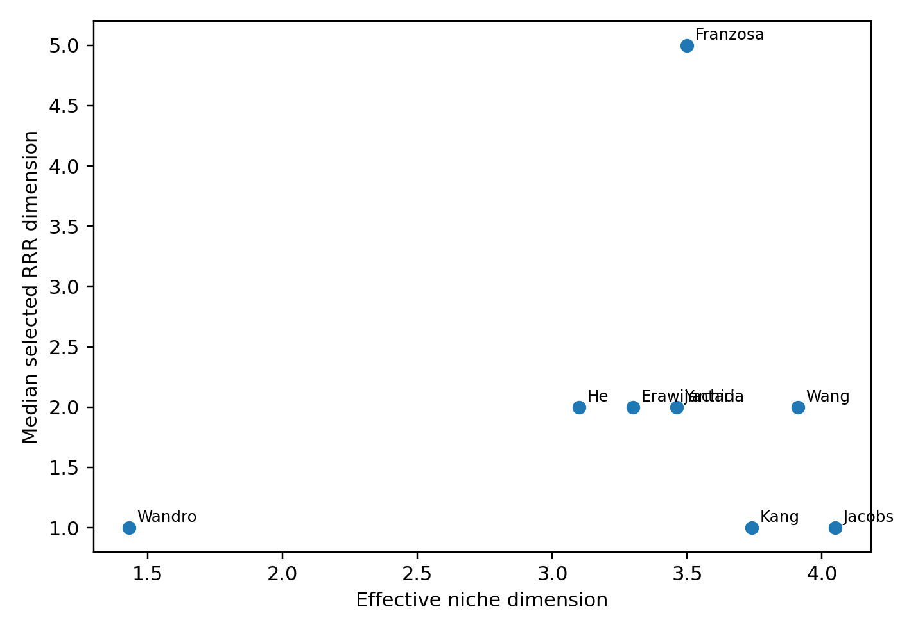
Supplementary Fig. 1 Effective niche dimension and predictive RRR dimension order the same eight cohorts differently.

Sample-size-matched rank-selection calibration
Synthetic coefficient matrices used twenty-four predictors and twenty-four outcomes with true rank ten and equal-strength nonzero directions. Each condition used one hundred independent datasets. The first tested population signal at which median selected rank reached at least five depended strongly on the rank-selection sample size.
Supplementary Table 4 Sample-size-matched calibration for true rank ten. Entries are median selected ranks across one hundred independent datasets. Rank-selection sample size is the number of observations available to the five-fold inner cross-validation. Population signal is the fraction of outcome variance carried by the complete low-rank term; with ten equal-strength directions the per-direction share is one tenth of that value.
Cohort | Rank-selection n | 0.10 | 0.15 | 0.20 | 0.30 | 0.50
Kang autism | 35 | 0 | 0 | 0 | 2 | 10
Wandro preterms | 60 | 0 | 0 | 0 | 7 | 10
Jacobs IBD families | 72 | 0 | 0 | 1 | 8 | 10
Erawijantari gastric cancer | 77 | 0 | 0 | 1 | 9 | 10
Franzosa IBD | 176 | 0 | 9 | 10 | 10 | 10
He infants | 222 | 4 | 10 | 10 | 10 | 10
Wang ESRD | 230 | 4 | 10 | 10 | 10 | 10
Yachida CRC | 278 | 9 | 10 | 10 | 10 | 10
The abrupt movement across columns is the point of the calibration: the same population signal can be almost entirely rejected by cross-validation in a small training set and almost completely retained in a larger one.
Supplementary Table 5 Signal threshold for the median selected rank to reach at least five in a true rank-ten system.
Cohort | Rank-selection sample size | Total population signal | Per-direction share
Kang autism | $$35$$ | $$0.50$$ | $$5.0\%$$
Wandro preterms | $$60$$ | $$0.30$$ | $$3.0\%$$
Jacobs IBD families | $$72$$ | $$0.30$$ | $$3.0\%$$
Erawijantari gastric cancer | $$77$$ | $$0.30$$ | $$3.0\%$$
Franzosa IBD | $$176$$ | $$0.15$$ | $$1.5\%$$
He infants | $$222$$ | $$0.15$$ | $$1.5\%$$
Wang ESRD | $$230$$ | $$0.15$$ | $$1.5\%$$
Yachida CRC | $$278$$ | $$0.10$$ | $$1.0\%$$
The cohort preprocessing also caps the number of retained taxa and metabolites at one quarter of the outer-training sample size. A sensitivity analysis applied that cap to the smaller simulations, using dimensions $8$, $15$, $18$, and $19$ for the Kang, Wandro, Jacobs, and Erawijantari sample sizes while retaining $24$ for the larger designs. Reducing the number of fitted variables improved rank recovery in the small designs but did not remove the dependence on sample size: at population signal $0.20$ the Wandro-sized design moved from median rank $0$ with $24$ predictors and outcomes to $4.5$ with the $15$-variable cap, and the Erawijantari-sized design from $1$ to $3$. The Kang-sized cap is $8$, so a rank-ten coefficient matrix is not representable there at all (Supplementary Table 6).
Supplementary Table 6 Sensitivity to the one-quarter training-sample feature cap at population signal $0.20$ for true rank ten. Fixed results are the primary calibration; capped results reduce predictor and outcome dimensions in the smaller designs.
Cohort | Rank-selection n | Fixed p = q | Median rank | Capped p = q | Median rank, capped
Kang autism | 35 | 24 | 0 | 8 | not representable
Wandro preterms | 60 | 24 | 0 | 15 | 4.5
Jacobs IBD families | 72 | 24 | 1 | 18 | 3.5
Erawijantari gastric cancer | 77 | 24 | 1 | 19 | 3.0
Franzosa IBD | 176 | 24 | 10 | 24 | 10.0
He infants | 222 | 24 | 10 | 24 | 10.0
Wang ESRD | 230 | 24 | 10 | 24 | 10.0
Yachida CRC | 278 | 24 | 10 | 24 | 10.0

Supplementary Table 7 Selected dimension count can overstate recovery of the true signal subspace.
Sample size | Population signal | Per-direction share | Dimensions retained | Signal variance captured
$$60$$ | $$0.10$$ | $$1.0\%$$ | $$0.01$$ | $$0.01$$
$$176$$ | $$0.10$$ | $$1.0\%$$ | $$0.09$$ | $$0.07$$
$$278$$ | $$0.10$$ | $$1.0\%$$ | $$0.84$$ | $$0.69$$
$$176$$ | $$0.15$$ | $$1.5\%$$ | $$0.84$$ | $$0.69$$
$$176$$ | $$0.20$$ | $$2.0\%$$ | $$0.98$$ | $$0.85$$

hCom2 baseline reproduction and geometry
The deposited hCom2* computational system^{12–14} was independently reconstructed from the public sixty-three-strain consumption and production arrays, resource clustering, and serial-dilution abundance data. The reproduced baseline matches the deposited abundance prediction benchmark closely.
Supplementary Table 8 hCom2* baseline reproduction. Thirty-eight fitted resources are nonzero in the reproduced baseline.
Passage | Pearson | Spearman | Base-10 log RMSE
Passage 1 | $$0.5757$$ | $$0.5262$$ | $$1.360$$
Passage 2 | $$0.7704$$ | $$0.8117$$ | $$1.448$$
Passage 3 | $$0.7730$$ | $$0.7959$$ | $$1.697$$

Supplementary Table 9 Geometry of the exact hCom2* model-input consumption matrix and diagnostic variants.
Matrix | Participation dimension | Entropy dimension | $$d_{90}$$ | $$d_{95}$$ | Leading energy | Numerical rank
Original | $$3.270$$ | $$8.650$$ | $$17$$ | $$24$$ | $$0.540$$ | $$63$$
Binary support | $$2.928$$ | $$8.180$$ | $$18$$ | $$27$$ | $$0.576$$ | $$63$$
Row-normalized | $$3.504$$ | $$9.340$$ | $$18$$ | $$26$$ | $$0.519$$ | $$63$$

hCom2*: low-rank approximation and predictive performance
$G_{k}=\frac{{RMSE}_{null}-{RMSE}_{k}}{{RMSE}_{null}-{RMSE}_{full}}$ (S18)
The retained-improvement statistic $G_{k}$ compares a dimension-$k$ prediction with two fixed baselines. ${RMSE}_{k}$ is the passage-three root-mean-square log-abundance error after refitting with the rank-$k$ approximation; ${RMSE}_{full}$ uses the original model-input consumption matrix; and ${RMSE}_{null}$ is the monoculture null-model error. The denominator is the full model’s improvement over the null and is required to be nonzero. A value of one retains that full improvement, while values below one lose part of it.
Non-negative matrix factorization (NMF) ¹⁵ approximates a nonnegative consumption matrix $C$ by $WH$ with nonnegative factors $W$ and $H$. At each candidate inner dimension $k$, the ordinary hCom2* low-rank analysis minimized
$$\min_{W,H≥0} {{‖C-WH‖}_{F}}^{2}$$
For the ordinary NMF objective, $C∈R_{≥0}^{S×P}$ is the nonnegative uptake matrix, $W∈R_{≥0}^{S×k}$ and $H∈R_{≥0}^{k×P}$ are fitting factors, and $k$ is their inner dimension. The squared Frobenius norm ∥C-WH∥F2=i,α​Ciα-WHiα2 is the sum of squared entrywise reconstruction errors. This $W$ is an NMF factor; it must not be confused with the diagonal resource-weight matrix $W$ in Eqs. S7 and S11.
The analysis used coordinate-descent NMF with twenty deterministic initializations, tolerance $10⁻⁴$, and at most $5000$ iterations. The primary seed at each $k$ was selected by reconstruction loss only. NMF imposes nonnegativity but not exact preservation of the observed zero/nonzero support, so this ordinary approximation can both remove measured links and create small positive values at originally zero entries. Lee and Seung introduced NMF as a parts-based nonnegative representation; here it is used strictly as a low-rank matrix approximation, not as a mechanistic model.
The ordinary NMF experiment selected factorization seeds by matrix reconstruction error only and refit resource concentrations independently for every reconstructed matrix. The final missing ranks between fifty and sixty locate the first tested passing ordinary rank at fifty-two.
Supplementary Table 10 Selected ordinary-NMF results around the functional threshold.
Rank | P3 Pearson | P3 RMSE | Retained improvement | Seed pass fraction
$$40$$ | $$0.658$$ | $$2.022$$ | $$0.811$$ | $$0$$
$$50$$ | $$0.678$$ | $$2.019$$ | $$0.813$$ | $$0.25$$
$$51$$ | $$0.720$$ | $$1.815$$ | $$0.931$$ | $$0.40$$
$$52$$ | $$0.759$$ | $$1.708$$ | $$0.994$$ | $$0.50$$
$$55$$ | $$0.778$$ | $$1.663$$ | $$1.020$$ | $$0.50$$
$$57$$ | $$0.777$$ | $$1.624$$ | $$1.043$$ | $$0.75$$
$$59$$ | $$0.774$$ | $$1.652$$ | $$1.026$$ | $$0.95$$
$$60$$ | $$0.781$$ | $$1.624$$ | $$1.042$$ | $$1.00$$

The functional threshold depends on how strictly the twenty deterministic factorization seeds must agree, so it is reported under three criteria rather than as a single number (Table 1 in the main text). Under the primary rule the reported dimension is the first rank at which the reconstruction-selected seed passes. The two stricter criteria are the lowest tabulated rank at which a majority of seeds pass and the lowest rank at which all seeds pass. The gap between the two approximation families is large under all three: six against fifty-two, six against fifty-seven, and twelve against sixty. The ordering of the two families is therefore not an artifact of seed selection, although the specific value fifty-two is.
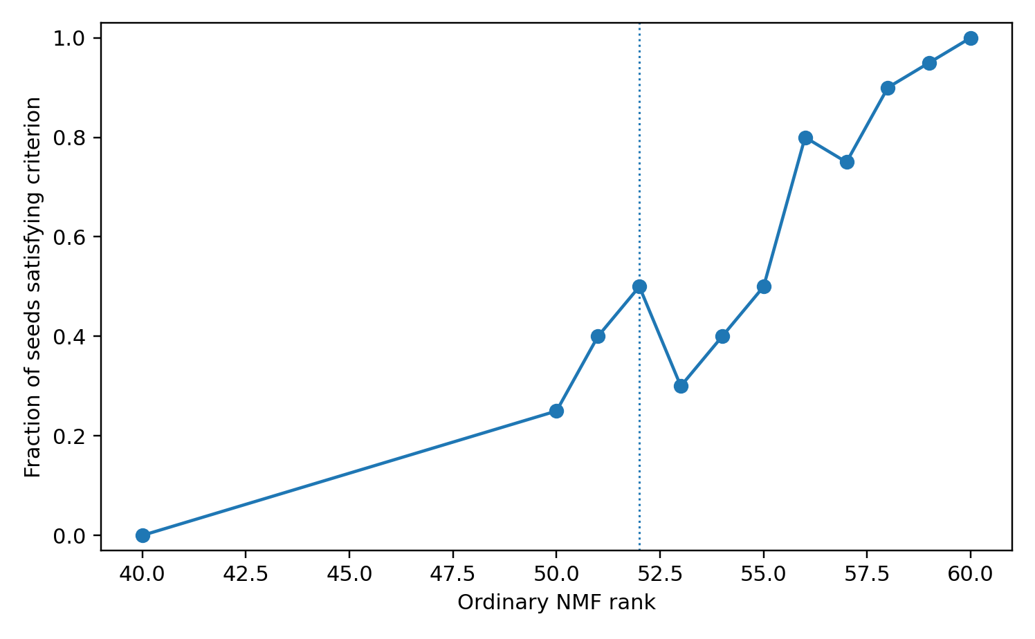
Supplementary Fig. 2 Fraction of ordinary-NMF seeds meeting the functional-sufficiency rule at high ranks.

S9.1 Support-preserving latent strengths
${\hat{C}}_{ij}=S_{ij} sigmoid​\left(α_{i}+β_{j}+u_{i}^{⊤}v_{j}\right)$ (S19)
The matrix entry ${\hat{C}}_{ij}$ is reconstructed uptake strength for consumer or strain $i$ and resource $j$. The fixed support indicator $S_{ij}$ is one for an observed positive link and zero otherwise. The intercepts $α_{i}$ and $β_{j}$ are fitted consumer- and resource-specific strength biases, respectively; $u_{i},v_{j}∈R^{k}$ are latent vectors of dimension $k$, with $u_{i}^{⊤}v_{j}$ their inner product. The logistic sigmoid $sigmoid\left(z\right)=1/\left(1+e^{-z}\right)$ returns a value strictly between zero and one. The mask enforces the original zeros, so the fitted $k$ concerns variation in strengths conditional on the observed topology, not the rank of the complete masked matrix.
The support mask is fixed to the experimentally observed positive edges, and only positive edge magnitudes are modeled. The selected latent-strength model first satisfies the functional criterion at latent dimension $k=6$ under the reconstruction-selected-seed rule. This value is conditional on retaining the complete observed support mask: it is not the rank or total dimension of the complete consumption matrix. The masked nonlinear reconstruction retains ordinary numerical rank $63$. Under increasingly strict seed-agreement criteria, support-preserving thresholds are $6$, $6$, and $12$, compared with ordinary-NMF thresholds of $52$, $57$, and $60$ (Table 1 in the main text).
Supplementary Table 11 Support-preserving latent-strength models.
Latent dimension | P3 Pearson | P3 RMSE | Retained improvement | Seed pass fraction
$$0$$ | $$0.560$$ | $$2.602$$ | $$0.473$$ | $$0$$
$$3$$ | $$0.684$$ | $$2.074$$ | $$0.781$$ | $$0.10$$
$$5$$ | $$0.743$$ | $$1.813$$ | $$0.932$$ | $$0.30$$
$$6$$ | $$0.786$$ | $$1.646$$ | $$1.029$$ | $$0.60$$
$$10$$ | $$0.779$$ | $$1.733$$ | $$0.979$$ | $$0.75$$
$$12$$ | $$0.793$$ | $$1.616$$ | $$1.047$$ | $$1.00$$
$$20$$ | $$0.772$$ | $$1.687$$ | $$1.006$$ | $$1.00$$

S9.2 Weak-edge and energy-retention checks
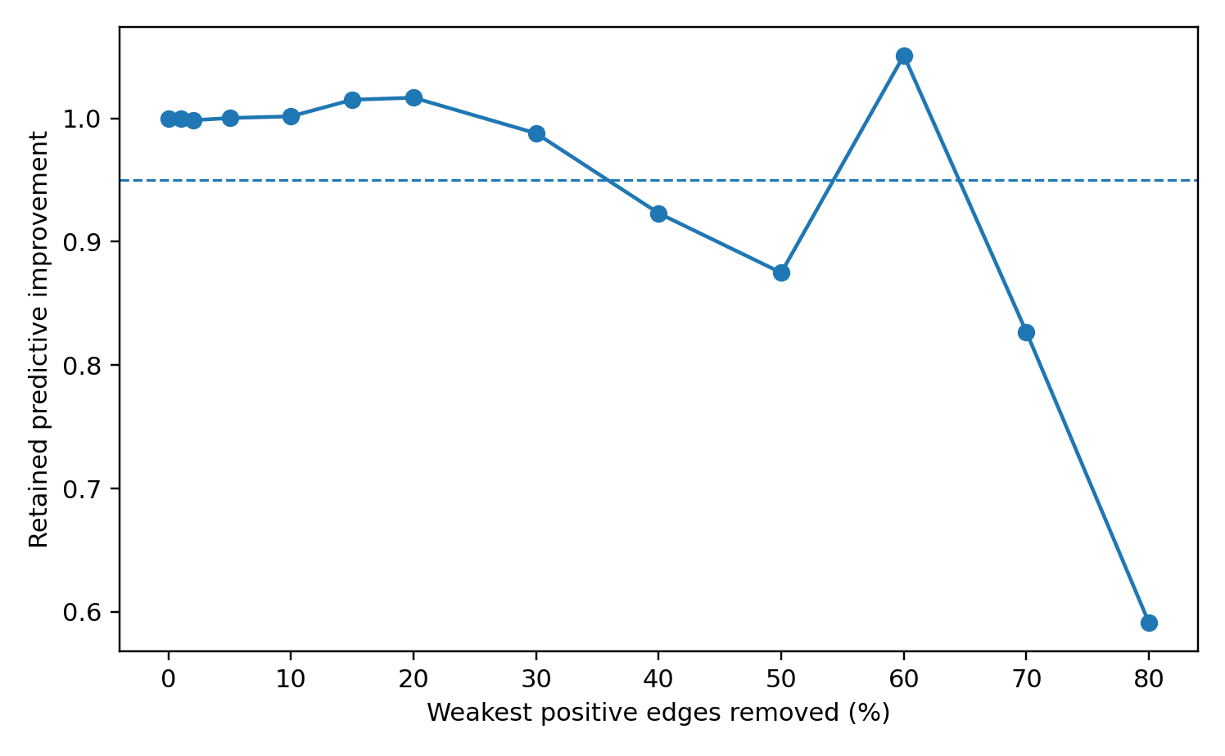
Supplementary Fig. 3 Removing the globally weakest positive consumption edges does not produce the predicted high-leverage tail effect. The dashed line marks $95\%$ retained improvement.
The weakest $10\%$ of positive edges can be removed while retaining more than $99.98\%$ of Frobenius energy and essentially all predictive improvement. Conversely, random removal of the same number of edges is generally more damaging. The result does not imply that support is unimportant: support-preserving latent models retain all observed links, whereas ordinary NMF creates and removes links during low-rank approximation.

Independent support validation in Ho et al.
The archived Ho et al. consumer-resource model¹⁶ was reproduced from the public support matrices, inferred resource levels, kinetic parameters, and one hundred eighty-five assembly observations. The primary external outcome set was frozen as the sixty-four random three-to-thirteen-species assemblies before new control errors were examined.
Ho independently validates the importance of the resource-sharing support, but not heterogeneous low-dimensional strength variation. In the deposited Ho model, positive consumption rates are constrained to be equal within each species, so a row-bias-only strength representation is exact by construction. The formal low-dimensional strength fit is therefore an identity implied by the model parameterization rather than an independent empirical replication of the heterogeneous hCom2* strength result.

Claim boundaries and reproducibility
The hCom2* passage three benchmark is not historically untouched because model settings in the source study were selected using that passage. Factorization seeds and new resource fits exclude passage three outcomes, but the benchmark remains a reproduction-and-perturbation analysis of a published computational system. In Ho, the main independent evidence comes from the frozen sixty-four-assembly set and the species-identity shuffle; the degree-preserving family has reduced validity. Neither system identifies a universal scalar dimension or literal number of ecological niches.

Supplementary References
1. MacArthur, R. Species packing and competitive equilibrium for many species. Theor. Popul. Biol. 1, 1–11 (1970).
2. Chesson, P. MacArthur's consumer-resource model. Theor. Popul. Biol. 37, 26–38 (1990).
3. Tikhonov, A. N. Systems of differential equations containing small parameters in the derivatives. Mat. Sb. 31, 575–586 (1952).
4. Fenichel, N. Geometric singular perturbation theory for ordinary differential equations. J. Differ. Equ. 31, 53–98 (1979).
5. Mustri, M. P., Duan, Q. & Pawar, S. Accuracy of the Lotka-Volterra model fails in strongly coupled microbial consumer-resource systems. PLoS Comput. Biol. 21, e1013719 (2025).
6. Srinivasan, K., Plata, G. & Dixit, P. D. Low-dimensional coexistence in complex microbial ecosystems. PRX Life 4, 033026 (2026).
7. Stein, R. R. et al. Ecological modeling from time-series inference: insight into dynamics and stability of intestinal microbiota. PLoS Comput. Biol. 9, e1003388 (2013).
8. Chen, X., Crocker, K., Kuehn, S., Walczak, A. M. & Mora, T. Inferring resource competition in microbial communities from time series. PRX Life 3, 023019 (2025).
9. Aitchison, J. The statistical analysis of compositional data. J. R. Stat. Soc. B 44, 139–160 (1982).
10. Gloor, G. B., Macklaim, J. M., Pawlowsky-Glahn, V. & Egozcue, J. J. Microbiome datasets are compositional: and this is not optional. Front. Microbiol. 8, 2224 (2017).
11. Muller, E., Algavi, Y. M. & Borenstein, E. The gut microbiome-metabolome dataset collection: a curated resource for integrative meta-analysis. npj Biofilms Microbiomes 8, 79 (2022).
12. Han, S. et al. A metabolomics pipeline for the mechanistic interrogation of the gut microbiome. Nature 595, 415–420 (2021).
13. Jin, X. et al. Culturing of a complex gut microbial community in mucin-hydrogel carriers reveals strain- and gene-associated spatial organization. Nat. Commun. 14, 3510 (2023).
14. Mahajan, T. & Maslov, S. Coarse-grained model of serial dilution dynamics in synthetic human gut microbiome. PLoS Comput. Biol. 21, e1013222 (2025).
15. Lee, D. D. & Seung, H. S. Learning the parts of objects by non-negative matrix factorization. Nature 401, 788–791 (1999). https://doi.org/10.1038/44565
16. Ho, P.-Y., Nguyen, T. H., Sanchez, J. M., DeFelice, B. C. & Huang, K. C. Resource competition predicts assembly of gut bacterial communities in vitro. Nat. Microbiol. 9, 1036–1048 (2024).

