Team Members

[Venkatesh Bonageri](https://uncc.instructure.com/groups/17907/users/53827)

Sai Nishanth Dilly

Vikas Deshpande

The assignment was to create an Beacon based application to display the discounts of the products in the real time scenario. We are using MYSQL as database, NodeJS and the Android application to develop the application.

**MYSQL:**

The backend (MYSQL) has been deployed in Amazon Web Services. It contains a table data in the database inclass02 with the below schema

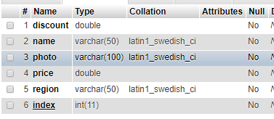

**NodeJS:**

The NodejS has been deployed to an Amazon Web Services EC2. The client will send the region details to the api based on the beacon data and the API connects to the EC2 MYSQL instance and fetch all the rows of the table based on the region and is populated in the JSON format which is readable from the Mobile Application. If no beacons are detected then the app will not send any region details and the api will return all the elements present in the database.

The nodejs url **http://34.228.153.214:8080/shop**

**Android Mobile Application:**

The app is having only one activity. It will check for the nearest beacon and will send the region details based on this to the api and will receive the data in the json format. The app will parse the json and will display the list in the recycler view.

**Screenshots**

When no beacon is detected

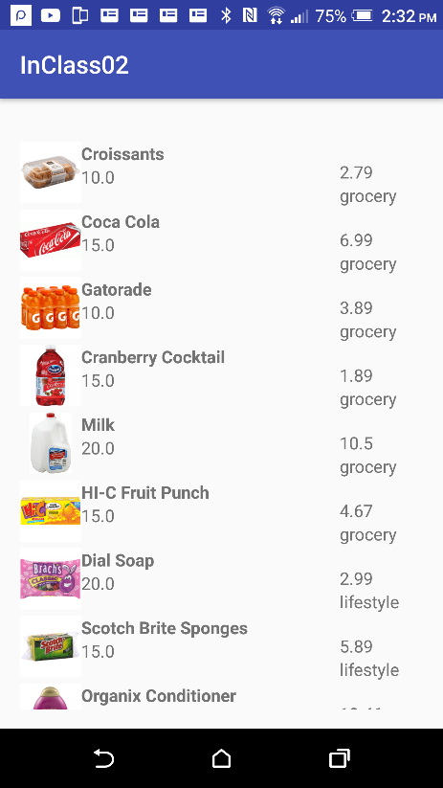

When lifestyle beacon is detected

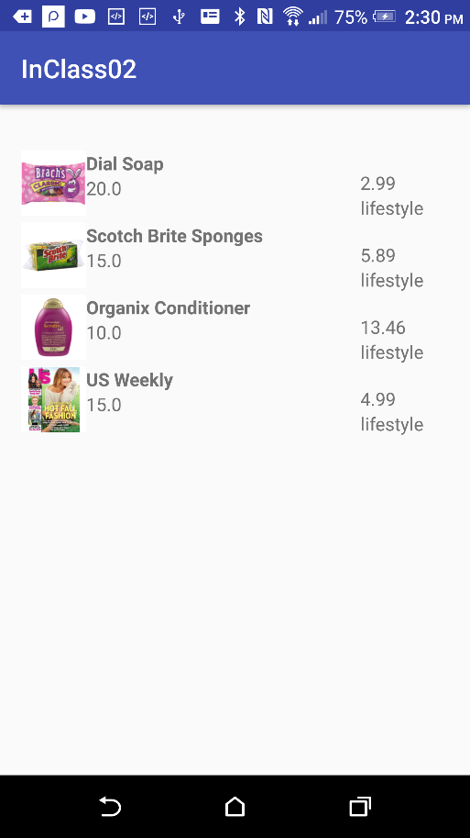

When produce beacon is detected

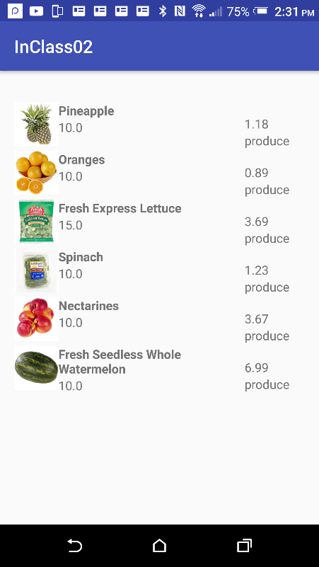

When grocery beacon is detected

