Weekly Meal Planner & Grocery Generator
Java Project · Classroom Review

Section 1
Weekly Meal Planner & Grocery Generator
A small object-oriented workflow that turns weekly meal choices into one practical, categorized shopping list.
Planning · aggregation · readable output

THIS WEEK
Plan → combine → shop

MEALS
7 days
Choices mapped by day

LIST
1 source
Ingredients grouped once

Section 2

THE PROJECT FRAME
Meal planning becomes a repeatable Java workflow
The application turns a familiar household task into a clear sequence of objects, collections, and rules.

WEEKLY INPUT → SHOPPING OUTPUT

THE WEEKLY BOARD
Problem. Planning seven days and one accurate shopping list is repetitive and easy to overlook.
Goal. Accept meal choices, organize them by day, and consolidate ingredients.
Project frame. A classroom-scale Java application for object-oriented design, collections, and rule-based processing.

02

Section 3

SYSTEM OVERVIEW
The system connects weekly choices to one shopping list

INPUTS
Choices in
Meals, selected days, servings, and optional dietary preferences.

PLANNER
Rules assign
Selected meals are mapped across the week.

GENERATOR
Ingredients merge
Duplicate items combine and group by category.

OUTPUT
Actionable result
A day-by-day plan plus one consolidated grocery list.

03

Section 4

THE WORKFLOW
Four stages turn meal choices into action
Each stage narrows the gap between a selected meal and a list ready to use.

WEEKLY CALENDAR
Collect
Load meal and ingredient data.

MEAL CARDS
Plan
Map meals to Monday through Sunday.

INGREDIENT GROUPS
Aggregate
Merge repeated ingredients and add quantities.

GROCERY LIST
Present
Print the weekly plan and categorized grocery list.

04

Section 5

OBJECT MODEL
Three Java classes keep the design understandable

01

DATA OBJECT
Meal
Stores a name, category, and ingredient collection.

02

DATA OBJECT
Ingredient
Stores item name, quantity, and unit so repeated items can combine.

03

PLAN OBJECT
MealPlan
Maps each day to a meal and exposes the week's ingredients.
Design choice: separate data objects from planning and grocery-generation logic for easier testing.

05

Section 6

CODE:
import java.util.Scanner;

public class WeeklyMealPlanner {

// Scanner object for taking user input
static Scanner sc = new Scanner(System.in);

// Days of the week
static String[] days = {
"Monday", "Tuesday", "Wednesday",
"Thursday", "Friday", "Saturday", "Sunday"
};

// Stores the meal selected for each day
static String[] weeklyMeals = new String[7];

// Available meals
static String[] meals = {
"Vegetable Rice",
"Chicken Rice",
"Vegetable Pasta",
"Dal and Rice",
"Chapati and Curry",
"Idli and Sambar",
"Vegetable Sandwich"
};

public static void main(String[] args) {

int choice;

// Initialize all days
for (int i = 0; i < weeklyMeals.length; i++) {
weeklyMeals[i] = "Not Selected";
}

do {
System.out.println("\n==============================================");
System.out.println(" WEEKLY MEAL PLANNER");
System.out.println(" AND GROCERY GENERATOR");
System.out.println("==============================================");

System.out.println("1. View Available Meals");
System.out.println("2. Select Meals for the Week");
System.out.println("3. View Weekly Meal Plan");
System.out.println("4. Generate Grocery List");
System.out.println("5. Display Grocery List");
System.out.println("6. Exit");

System.out.print("\nEnter your choice: ");
choice = sc.nextInt();

switch (choice) {

case 1:
viewMeals();
break;

case 2:
selectMeals();
break;

case 3:
viewWeeklyPlan();
break;

case 4:
generateGroceryList();
break;

case 5:
displayGroceryList();
break;

case 6:
System.out.println("\nThank you for using the Weekly Meal Planner!");
System.out.println("Have a great week.");
break;

default:
System.out.println("\nInvalid choice. Please try again.");
}

} while (choice != 6);

sc.close();
}

// Displays available meals
static void viewMeals() {

System.out.println("\n------------- AVAILABLE MEALS -------------");

for (int i = 0; i < meals.length; i++) {
System.out.println((i + 1) + ". " + meals[i]);
}
}

// Allows the user to select meals for each day
static void selectMeals() {

System.out.println("\n------------- SELECT WEEKLY MEALS -------------");

viewMeals();

for (int i = 0; i < days.length; i++) {

System.out.println("\n" + days[i]);

System.out.print("Enter meal number (1-7): ");
int mealChoice = sc.nextInt();

if (mealChoice >= 1 && mealChoice <= meals.length) {

weeklyMeals[i] = meals[mealChoice - 1];

System.out.println(
"Selected: " + weeklyMeals[i]
);

} else {

System.out.println("Invalid meal number.");
System.out.println("Meal not changed.");
}
}

System.out.println("\nWeekly meal plan updated successfully.");
}

// Displays the selected weekly meal plan
static void viewWeeklyPlan() {

System.out.println("\n------------- WEEKLY MEAL PLAN -------------");

for (int i = 0; i < days.length; i++) {

System.out.printf(
"%-12s : %s%n",
days[i],
weeklyMeals[i]
);
}
}

// Generates the grocery list
static void generateGroceryList() {

System.out.println("\n------------- GROCERY LIST GENERATION -------------");

System.out.println("Generating grocery list...");
System.out.println("Checking ingredients for selected meals...");

System.out.println("Grocery list generated successfully.");
}

// Displays grocery items according to selected meals
static void displayGroceryList() {

System.out.println("\n================================================");
System.out.println(" GROCERY LIST");
System.out.println("================================================");

boolean mealSelected = false;

// Check whether at least one meal is selected
for (int i = 0; i < weeklyMeals.length; i++) {

if (!weeklyMeals[i].equals("Not Selected")) {
mealSelected = true;
break;
}
}

if (!mealSelected) {

System.out.println("No meals selected yet.");
System.out.println("Please select meals first.");

return;
}

System.out.println("\nVEGETABLES");
System.out.println("--------------------------------");
System.out.println("- Carrots");
System.out.println("- Tomatoes");
System.out.println("- Onions");
System.out.println("- Potatoes");
System.out.println("- Green vegetables");

System.out.println("\nFRUITS");
System.out.println("--------------------------------");
System.out.println("- Bananas");
System.out.println("- Apples");

System.out.println("\nGRAINS");
System.out.println("--------------------------------");
System.out.println("- Rice");
System.out.println("- Wheat flour");
System.out.println("- Pasta");

System.out.println("\nDAIRY");
System.out.println("--------------------------------");
System.out.println("- Milk");
System.out.println("- Curd");

System.out.println("\nPROTEIN");
System.out.println("--------------------------------");
System.out.println("- Chicken");
System.out.println("- Dal");

System.out.println("\nOTHER ITEMS");
System.out.println("--------------------------------");
System.out.println("- Cooking oil");
System.out.println("- Salt");
System.out.println("- Spices");

System.out.println("\n================================================");
System.out.println("Grocery list displayed successfully.");
System.out.println("================================================");
}
}

06

Section 7

SAMPLE OUTPUT · SHOPPING VIEW
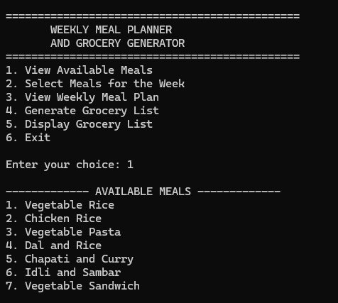

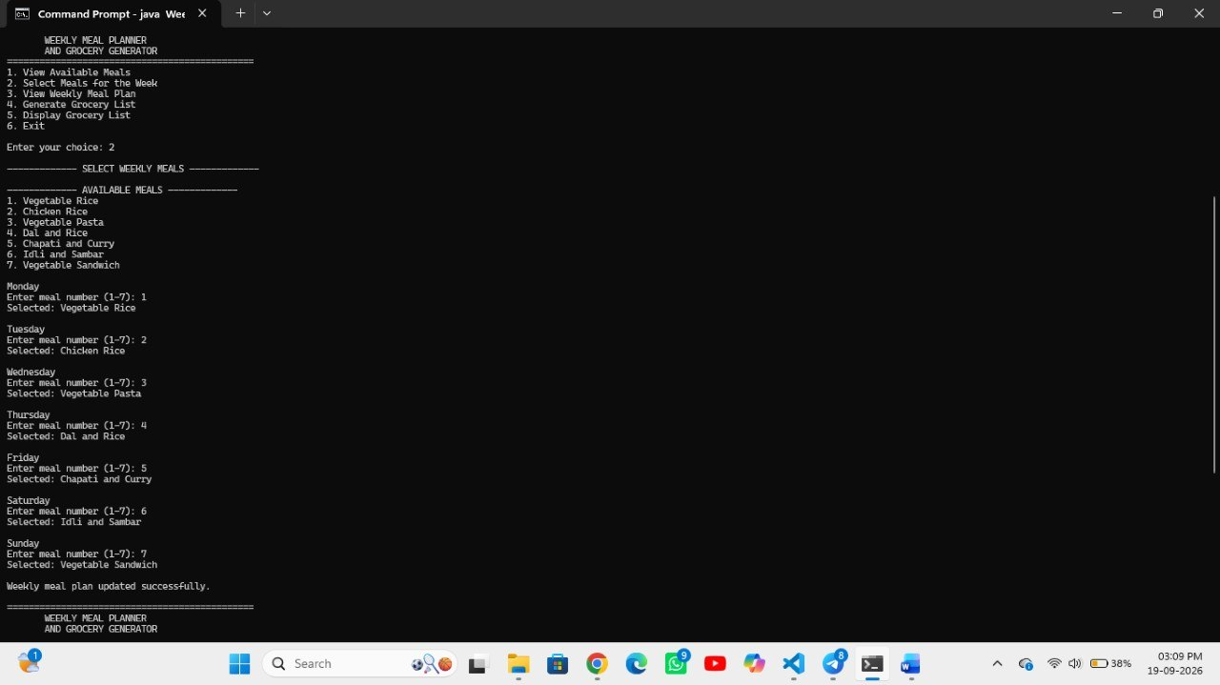

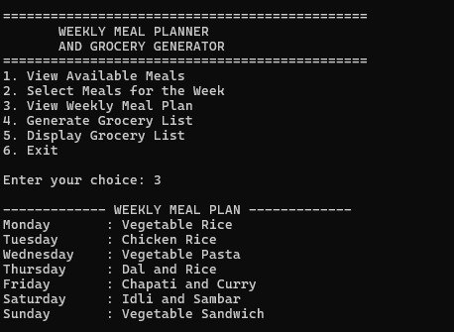

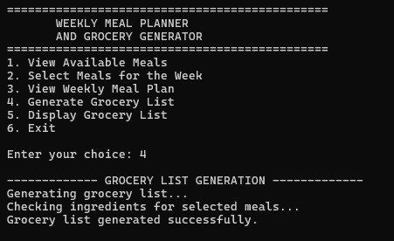

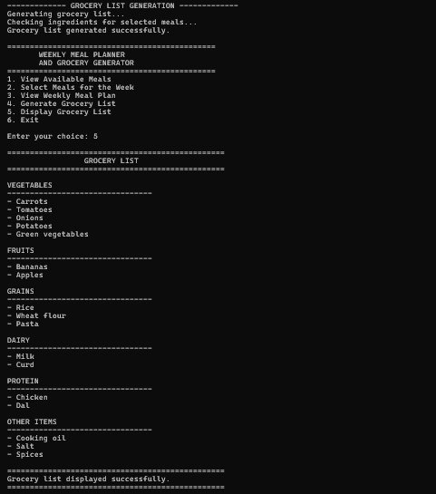
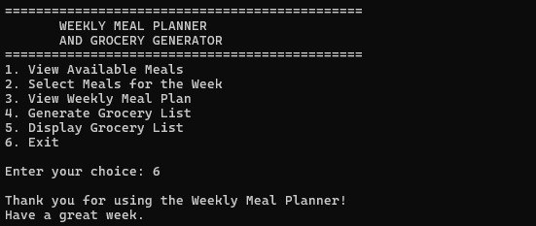

07

Section 8

THE PAYOFF
Consolidate decisions once. Reuse the structure.
One weekly plan reduces repetition, while merged ingredients keep shopping cleaner.

LESS REPETITION
One plan covers the full week instead of daily ad hoc choices.

CLEANER SHOPPING
Duplicate ingredients merge into one list entry.

REUSABLE STRUCTURE
Change meals and ingredients without rewriting aggregation logic.

LEARNING VALUE
Classes, lists, maps, loops, and separation of concerns in Java.

Section 9

BOUNDARIES
Simple rules also create meaningful limits
The first version is useful precisely because its assumptions are visible.

KEEP THE LIST TRUSTWORTHY
Limited intelligence. Rules may repeat meals or miss nuanced preferences.
Data upkeep. Names, ingredients, units, and quantities require manual maintenance.
No live context. The basic version ignores inventory, prices, availability, and seasonality.
Nutrition gap. Safe recommendations require validated data, not casual inference.

09

Section 10

VALIDATION CHECKLIST · GROCERY LIST EDGES
Testing should focus on the edges of the list
Trustworthy output depends less on the happy path than on the cases where data collides, disappears, or arrives malformed.

DUPLICATES
Combine correctly. Pasta or onions appearing in multiple meals should produce one summed entry.

EMPTY INPUT
Explain the absence. No selected meals should return a helpful message.

UNITS
Make the rule explicit. Decide how grams, kilograms, cups, and packages interact.

INVALID DATA
Reject unsafe inputs. Missing names and negative quantities should stop generation.
Practical checks connect implementation choices to output a shopper can trust.

10

