**IFB299 Personal Portfolio**

Group #96

Sarah Deriche, n9683542

<https://github.com/bonanaben/IFB299>

**Artefact 1** – **Data Flow Diagram**

[IFB299](https://github.com/bonanaben/IFB299)/[Sarah](https://github.com/bonanaben/IFB299/tree/master/Sarah)/Flow Diagram.png

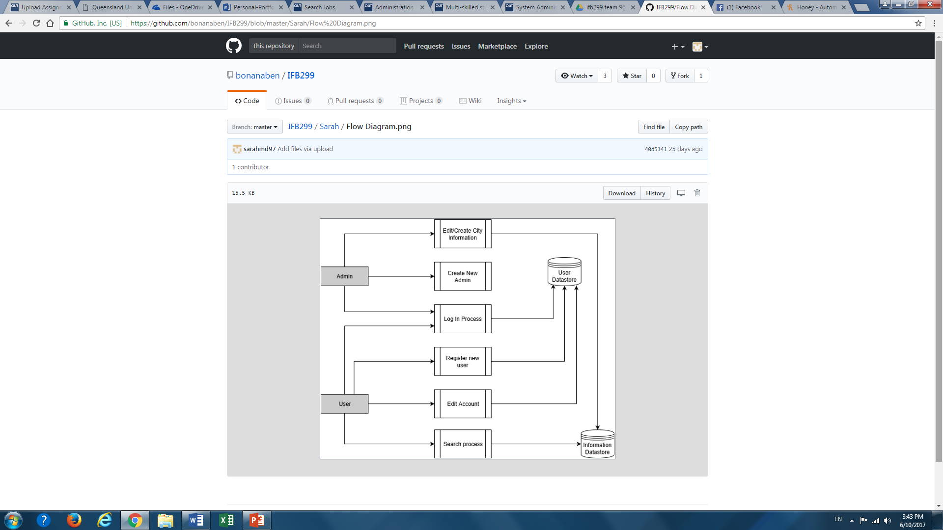

A data flow diagram is used to give both the client and developers a brief overview of the whole system. This type of diagram shows the flow of data from external entities into the system, how data moves from a process to another, as well as the logical storage involved.

**Relevant story from sprint 1:** Story # 03, 04, 06, 07, 13.

**Artefact 2 – Architecture**

[IFB299](https://github.com/bonanaben/IFB299)/[Sarah](https://github.com/bonanaben/IFB299/tree/master/Sarah)/archJust.pdf

Designing an architecture diagram gives a deeper understanding of how the system is built and connected i.e. to create a design for the website at a system level using a type of architecture pattern that is suitable to the product and in our case we chose a 3-tier architecture due to the product being a web based application. This section consists of a brief justification to which an architecture design is chosen along with their respective logical and physical views.

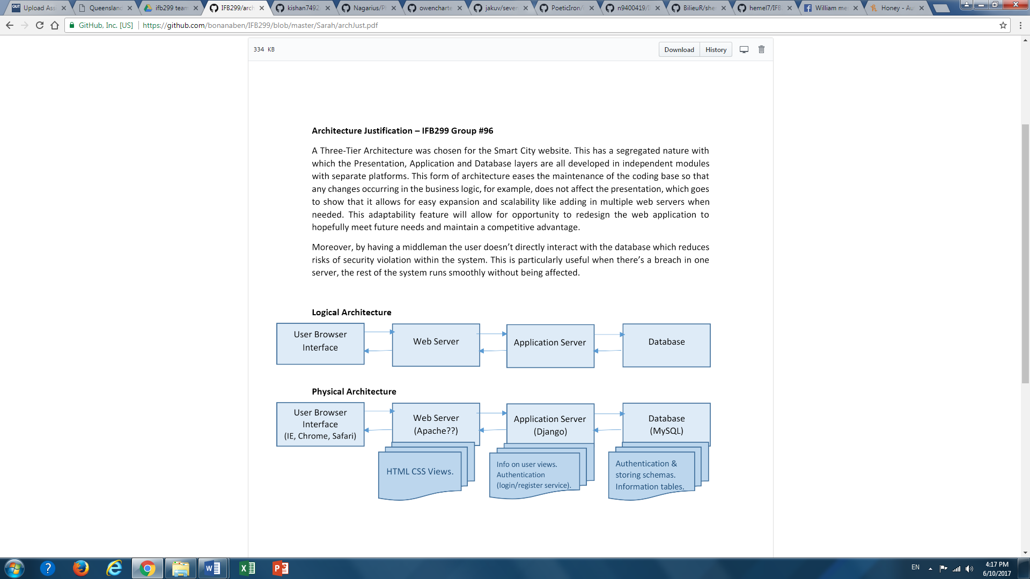

Web hosting server

Designing an architecture diagram gives a deeper understanding of how the system is built and connected i.e. to create a design for the website at a system level using a type of architecture pattern that is suitable to the product and in our case we chose a 3-tier architecture due to the product being a web based application. This section consists of a brief justification to which an architecture design is chosen along with their respective logical and physical views.

**Artefact 3** – **Component Diagram**

[IFB299](https://github.com/bonanaben/IFB299)/[Sarah](https://github.com/bonanaben/IFB299/tree/master/Sarah)/Component diaa.png

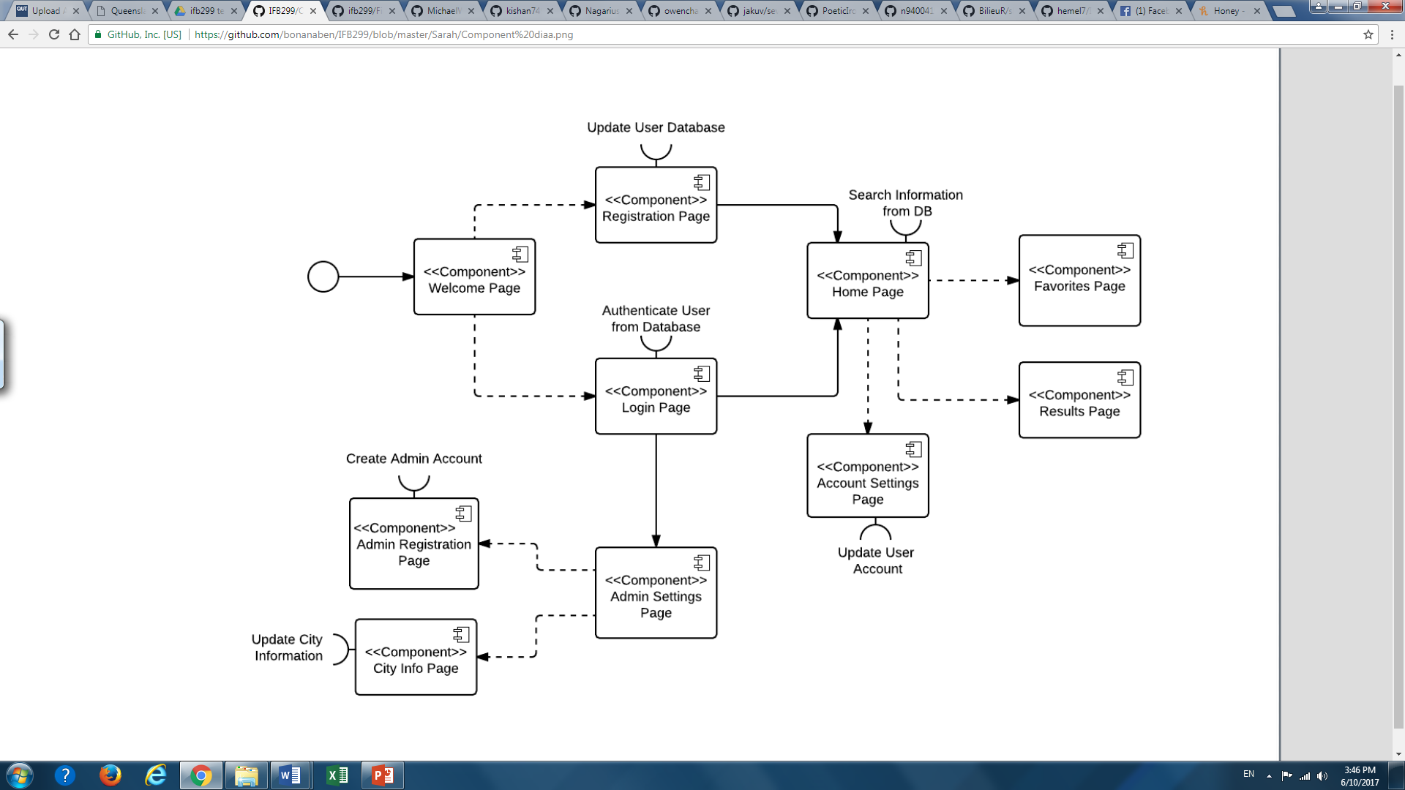

~~Ais first divided into layers using software architecture patterns then each layer is divided into software components.~~

– It depicts its web pages, their connections with each other and database connections.

This is a way to model some parts of our system after designing our architecture

**Artefact 4** – **Meeting Minutes**

[IFB299](https://github.com/bonanaben/IFB299)/[Sarah](https://github.com/bonanaben/IFB299/tree/master/Sarah)/meeting min/

This provides a written record of what was discussed and agreed upon at a group meeting, including actions and decisions made that might have taken place, so that all members have the same recollections from the meeting and ideas about delegated tasks. Managing good meeting minutes helps to ensure everyone is aware of what needs to be achieved by what due date and go about the project efficiently.

**Artefact 5** – **Webpage design**

[IFB299](https://github.com/bonanaben/IFB299)/[Sarah](https://github.com/bonanaben/IFB299/tree/master/Sarah)/Sarah.pdf

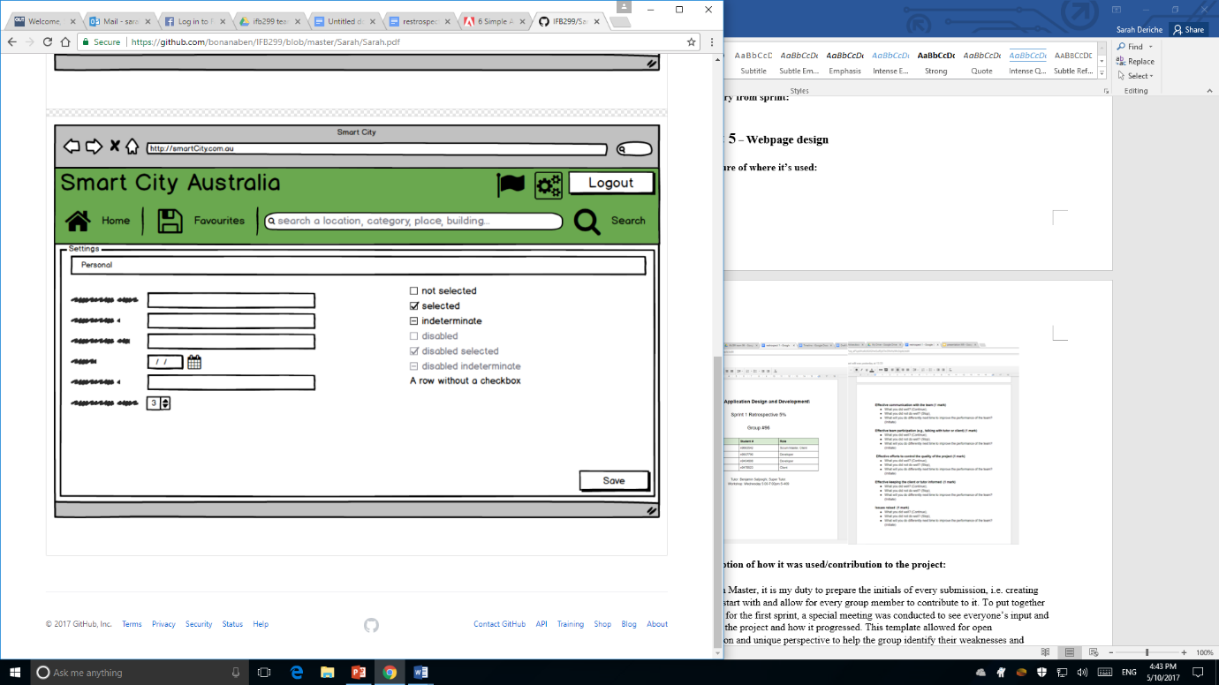 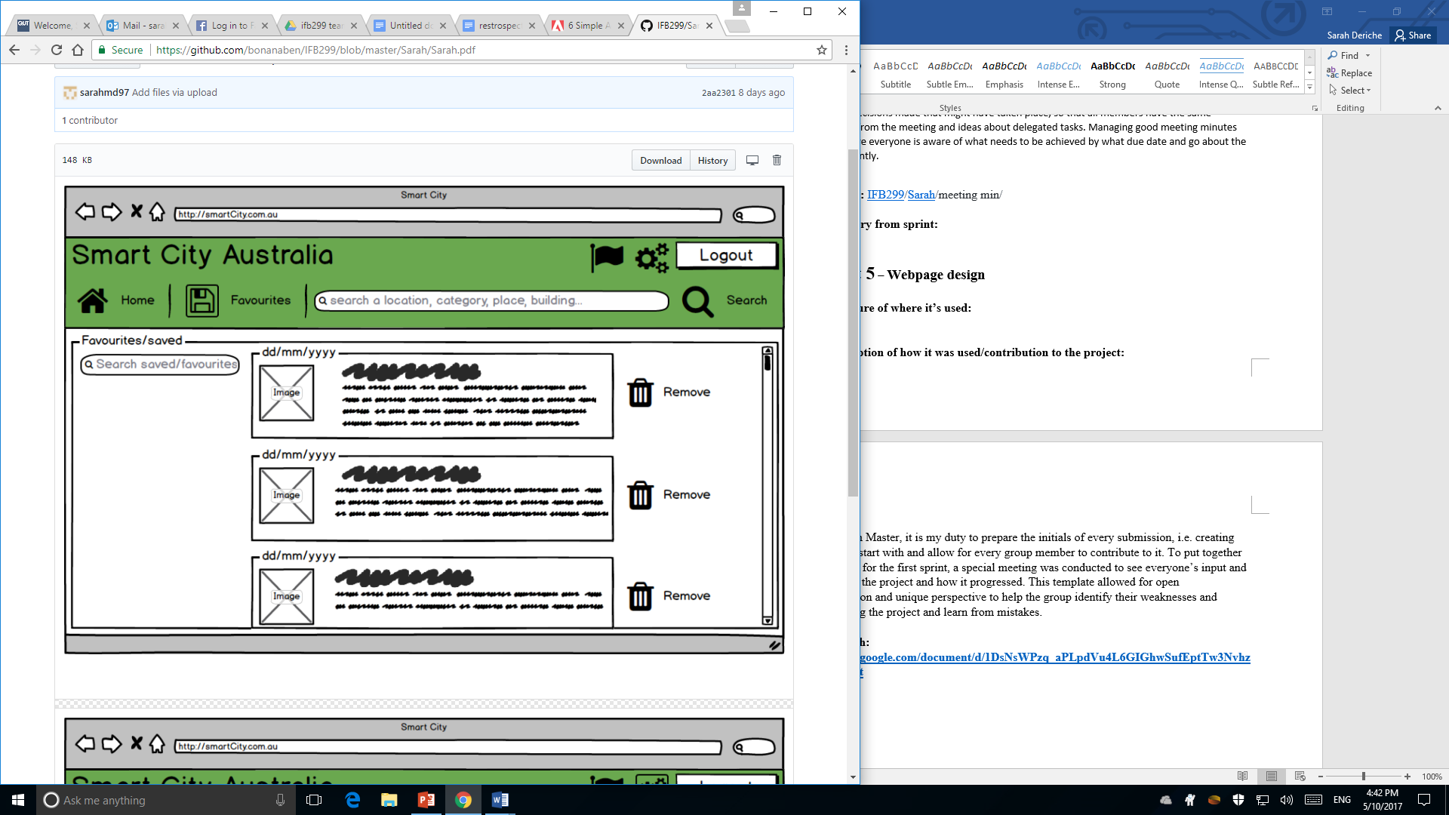

To begin the process of website designing, mock-ups needed to be created as they are essential to lay out the first look and feel of the site. These two pictures represent the visualization of the intent design, however, many changes were made after this due to its sheer simplicity and serving the purpose to only show a draft look of where icons could be placed and what features are included. This allowed us to try out various design elements, layouts, and colours before devoting to the coding section.

**Relevant story from sprint:** #15 favourites, #13 navigation bar, #2 homepage

**Artefact 6** – **Client Requirement**

**Screen capture of where it’s used:**

**Brief description of how it was used/contribution to the project:**

Starting off in the beginning of this group project, we were required to come up with a bunch of client requirements that would make up the starting point of the project in order to build a website that suits the client, therefore as a so-called

**Artefact 7** – **Sprint 1 Retrospective preparation**

* <https://docs.google.com/document/d/1DsNsWPzq_aPLpdVu4L6GIGhwSufEptTw3NvhzWx3qxk/edit>
* [IFB299](https://github.com/bonanaben/IFB299)/**retrospective 1 .docx**

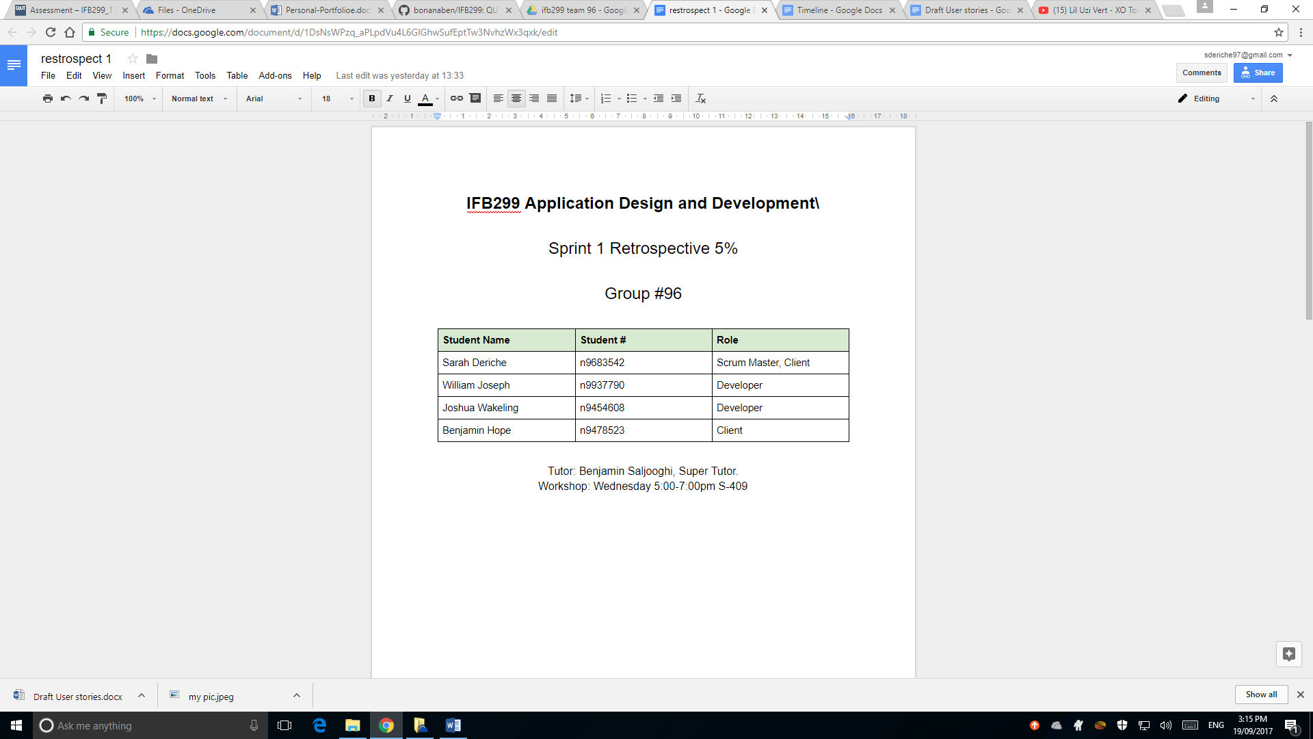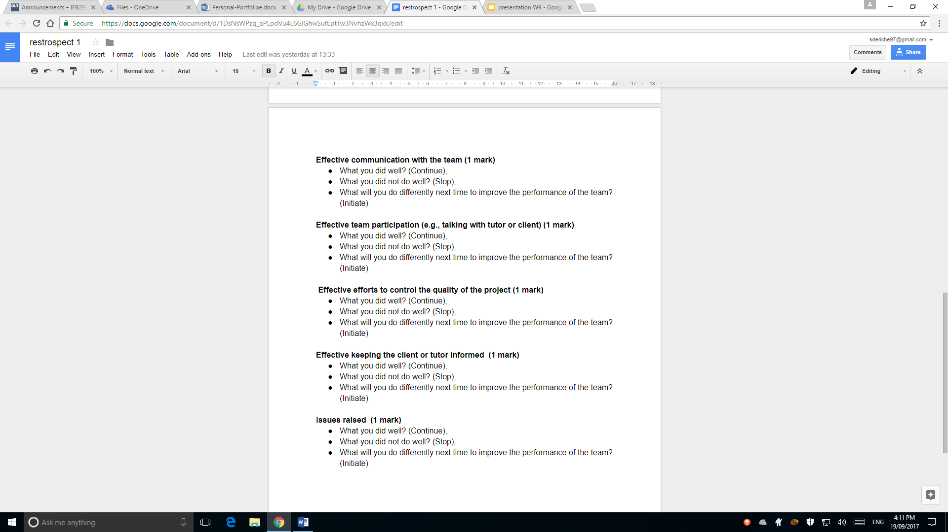

As the Scrum Master, it is my duty to prepare the initials of every submission, i.e. creating templates to start with and allow for every group member to contribute to it. To put together retrospective for the first sprint, a special meeting was conducted to see everyone’s input and their view of the project and how it progressed. This template format allowed for open discussion and unique perspective on each part to help the group identify their weaknesses and strength along the project and learn from mistakes.