|  |  |
| --- | --- |
|  | Portfolio |
|  |  |
|  | William Joseph – n9937790  IFB299  Due Date:  10/6/17 |

Contents

Artefacts: 2

Artefact – Colour Scheme 2

Artefact – Information 3

Artefact – mock-ups 4

Artefact – User Stories ideas 5

Artefact – User Stories 6

# Artefacts:

Below are the links to the Artefacts and the IFB299 group Github folder

<https://github.com/bonanaben/IFB299/tree/master/William>

<https://github.com/bonanaben/IFB299>

All artefacts will be referred to above links, all artefacts which have contributed to the project will be found in the IFB299 group, under the folder name “William”.

## Artefact – Colour Scheme

[Colour scheme.docx](https://github.com/bonanaben/IFB299/blob/master/William/Colour%20scheme.docx)

This is a document which is the rough colour scheme in which should be followed for the website as it helps the developers understand the colours which are appropriate, especially for different user types logging in. the scheme is rough (no exact colour #) however gives a basic understanding of what to expect.

Below is an example of a colour scheme, the colours on the left represent what is written on the right.

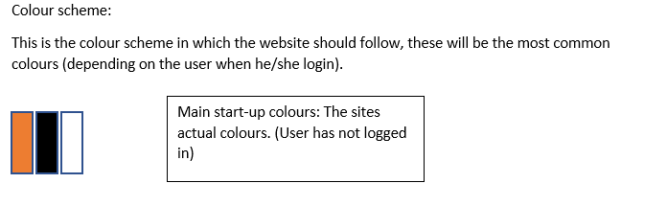

## Artefact – Information

[information.docx](https://github.com/bonanaben/IFB299/blob/master/William/information.docx)

Information is simply a document which contains all the data and data types to be expected within the website, mainly for the database.

Below is the data for the user’s business and tourist, where is contains the data expected e.g. Name, Last Name. and the data type e.g. (Short text) also shows whether it is an integer or a string for developers (font colour)

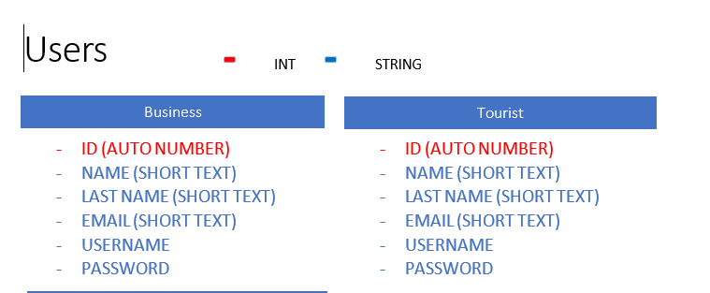

This artefact has contributed to the information systems students as well in completing IS related artefacts

## Artefact – mock-ups

[mock-ups.pdf](https://github.com/bonanaben/IFB299/blob/master/William/mock-ups.pdf)

Mock-ups was the first thing that has been done in order to understand the website visually, although this is final, changes have been made slightly to fit the user experience, although most of the current actual website is based on the mock-ups created by each of us, containing either similar or close to, but all mock-ups pages are related to the actual website

Below is one of the mock-ups, this mock-ups is for the welcome page where the user has not logged in or signed up to use the website, however shows what the user should expect in terms of a rough design

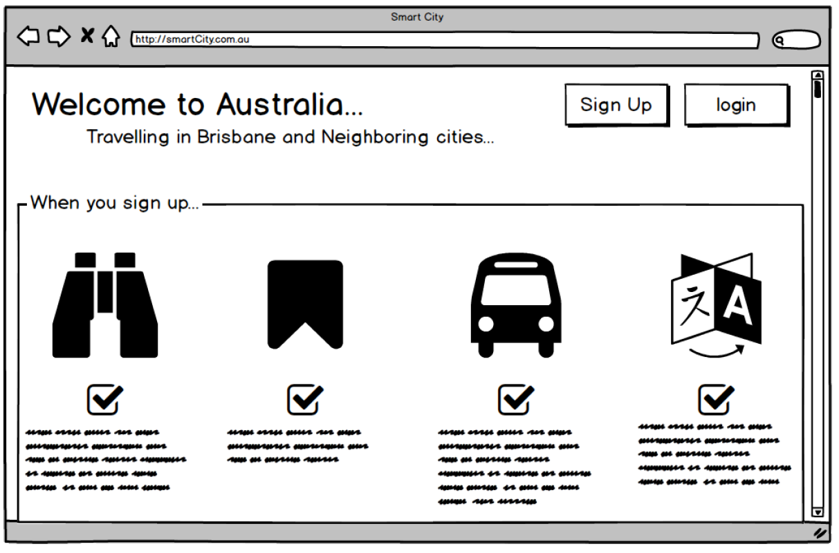

These mock-ups should have all the necessary functions and features.

## Artefact – User Stories ideas

[usr stories.docx](https://github.com/bonanaben/IFB299/blob/master/William/usr%20stories.docx)

This document was a ideas for helping with the creation of user stories, this document has ideas which helped in making more user stories, although not all of them were not used, it however gave some ideas to the making of actual user stories (not all of them worded exactly the same in the actual user stories, this was considered just ideas)

Below is an example of one of the ideas and it being used in the actual user stories

In the usr stories.docx

* As a user I want for my account information to be kept secure, and not given to the public at any circumstances

And in the Final User stories

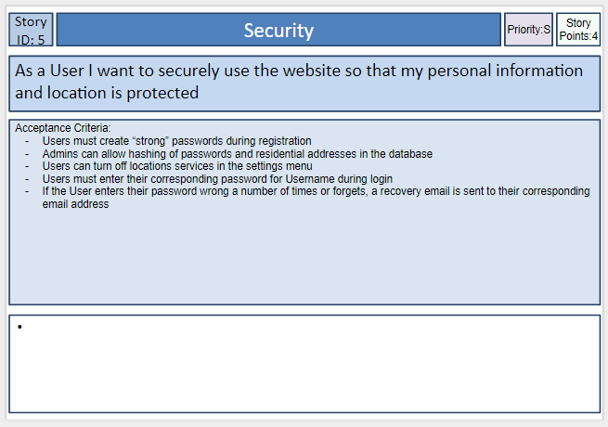

Although it is differently worded, however there is a similarity and but are related

## Artefact – User Stories

Link?

User stories which is part of the first submission of the project, user stories in which I have completed which had contributed to the project which how the user understands, wants, feels the website should have, e.g. account information being secure.