High Level Architecture

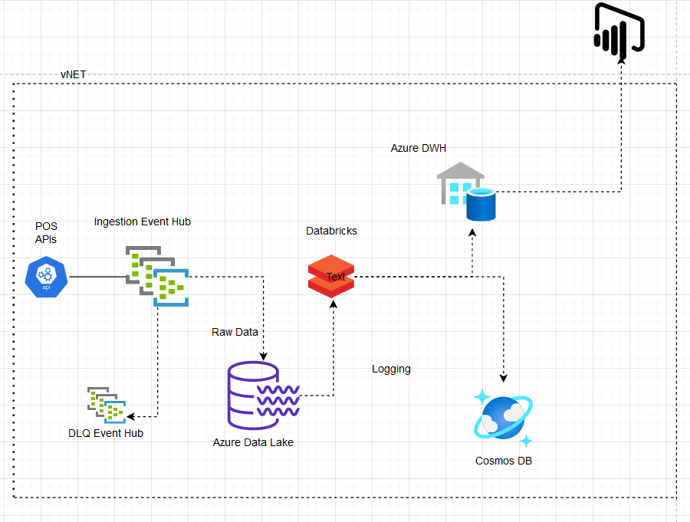

The real time APIs from POS system will ingest data into Azure Event Hub.

Azure Event Hubs provides a data ingestion service for real time data. It can handle billions of events and provides high level of consistency. In addition, Event Hubs provides a distributed stream processing platform with low latency suitable for real time big data.

A DLQ(dead letter queue) should be configured to captured exceptions and errors to be processed later.

Azure event hub should be provided permissions to access azure data lake and store the data into files partitioned by year, month and date.

Every 15 minutes, Azure Databricks runs a scheduled job to read files received in the last 15 minutes. It then performs data cleansing, data transformation and aggregation.

Thereafter the transformed data is stored into azure SQL Datawarehouse using the synapse connector which uses blob storage as staging location.