26th June 2019

New version of the agents file: agents_240619

- Added new columns (column name on Excel)
  - A: serial number (S/N)
  - B: language (lang)
  - C: verb synset (verbsynset)
  - D: verb lemma (verb)
  - E: verb definition in english (verb_def)
  - F: verb field (verb field)
  - G: noun synset (nounsynset)
  - H: noun lemma (noun)
  - I: noun definition in english (noun_def)
  - J: noun field (noun field)
  - K: type of match between verb and noun (match type)
  - Removed the column that said cmn all over - should this be put back in?
  - L: results of the 1st round of link checking (link)
  - M: results of the 2nd round of link checking (link_2nd check)
  - N: unsure of link checking (unsure)
  - O: nature of morphosemantic link if link=yes, 1st round of checking (link type)
  - P: nature of morphosemantic link if link=yes, 2nd round (link type_2nd check)
  - Q: remarks column
  - R: other AN suffixes (other suffix)
    - To mark out the -ant suffixes in English, i.e cool-coolant
  - S: presence of error in either noun/verb, related to WordNet (error)
    - E.g 者 for non-human nouns in Japanese
  - T: details on error, specified for either noun or verb error (error remarks)
  - U: synset ID of alternate senses (alternate senses)
    - Other possible verb senses that the AN could be linked to, but was not generated by the matching algorithm
    - Also includes cases where ANs were derived from Ns, i.e oil-oiler (as in the big vehicle that carries transport noun oil, has nothing to do with the verb oil (to apply oil))
  - V: noun synsets that did not have any good links to verbs (unmatched)
    - More on this below

- Introduced two new sheets:
  - numbers (1st check): a summary of the total results of the 1st check
    - tabulated according to the match type
(eng: deriv/er, deriv/or, deriv/er/or/…..
cmn: 人/器/...
Jpn: 者/器/機/…)
and for each match type how many good/bad links, how many agent/instrument/body-part/…... -type good links + broken down according to language
    - Also tabulated according to noun fields for each language
(eng: act/animal/phenomenon/person/relation/time….
cmn: “
jpn: “ )
    - All cells are automated
  - numbers (2nd check): same as the first file, but total results of the 2nd check.
    - So far only numbers are available for Japanese, since english and chinese are not complete

Results of Japanese tagging (after 2nd check)

1st check:
- A total of 923 good links and 1417 bad links were found, which seemed rather high still
  - The data has 486 unique jpn noun synsets:
  - This gives a ratio of 1.90 AN links per noun synset (which is practically saying each AN comes from 2 verb senses - not a very precise lexical enhancement)
- Partly due to me not having used the ‘entailment’ criteria very strictly
  - especially in cases where the noun synset definition is very coarse, and so it encompasses many of the verb synsets matched to it
  - See this instance:
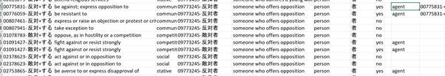
Here, there are 4 candidate verb synsets to link 09773245-n ‘someone who offers opposition’ to.

2nd check:
- Reduced the number of links to 792 good, 1548 bad.
  - This gives a ratio of 1.62 AN links per noun synset
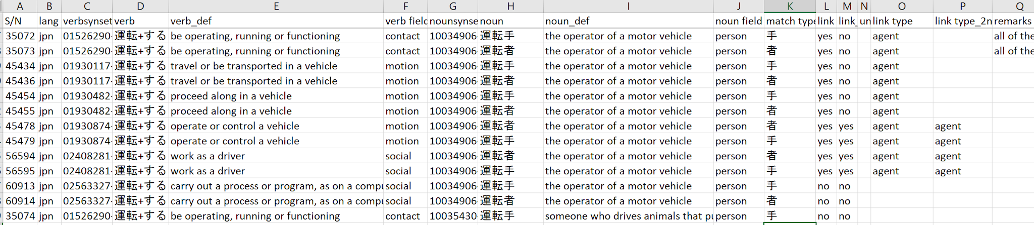
  - Basically, where possible, the most relevant verb was selected.
For example, given the above noun 10034096-n ‘the operator of the motor vehicle’, there are 5 verb senses available:
    - 01526290-v ‘be operating, running or functioning’
    - 01930117-v ‘travel or be transported in a vehicle’
    - 01930482-v ‘proceed along in a vehicle’
    - 01930874-v ‘operate or control a vehicle’
    - 02408281-v ‘work as a driver’
All 5 were accepted initially, but the first three were removed since they did not directly entail the action of operating the vehicle, leaving only the last two as suitable links. (arguably, the last one could also be rejected, since that one has an occupational, iterative component)

- Of the 486 unique japanese AN senses, 66 could not be matched.
These are in the last sheet of the agents_240619 excel, titled ‘unmatched ANs (jpn)’
  - 11 (2.26%) were due to errors in the WordNet, mostly due to 機/器 suffixes being used for humans and animals
01595624-n  飛行機 | ‘any of various swallows with squarish or slightly forked tail and long pointed wings; migrate around Martinmas’ | 機 used for animal
10783539-n  指示器 | ‘A person who winks’ | 器 used for person
10522759-n  節約家 | ‘someone who saves something from danger or violence’ | Highly doubt that 節約家 is used in the sense of ‘someone who rescues (saves)’, probably an incorrect calque

  - 55 (11.32%) noun synsets had no suitable verb synsets to link with
    - Some of them are derived from native-stratum verbs
Derivational pairs with native-stratum verbs (i.e 落つ > 落ち人 ‘an exile who flees for safety’, 押す > 押し手 ‘the hand that is on the left side of the body’) were more likely to be unmatched, as compared to Sino-Japanese stratum counterparts (出演+する > 出演者 ‘a theatrical performer’).
      - I can’t crunch out the exact numbers to corroborate this, but this would reflect the trend that agentive suffixation is less productive in the case of native-stratum verbs and ANs generated are more idiomatic.
      - Take a look at this as well:
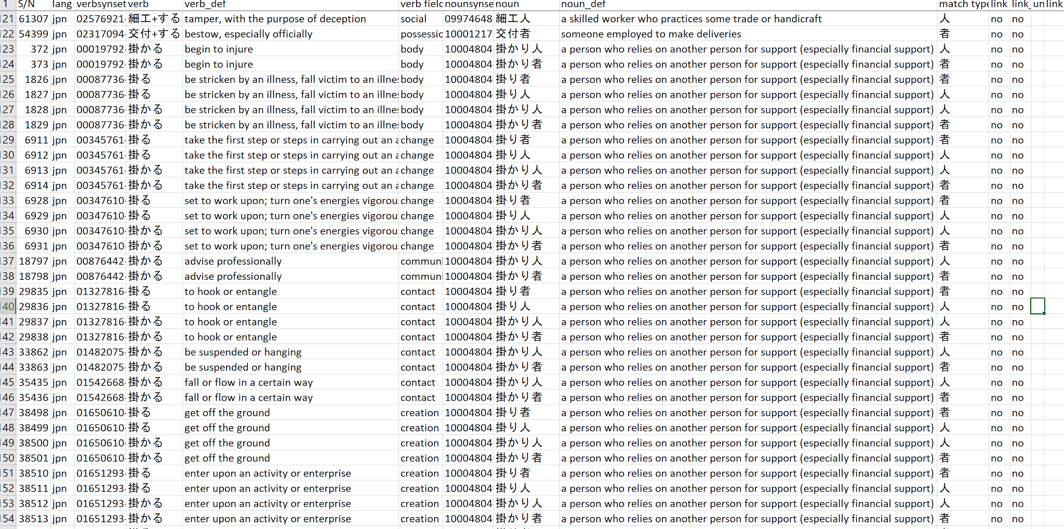

Analysis of link types (after 2nd round of link checking)

By match types:

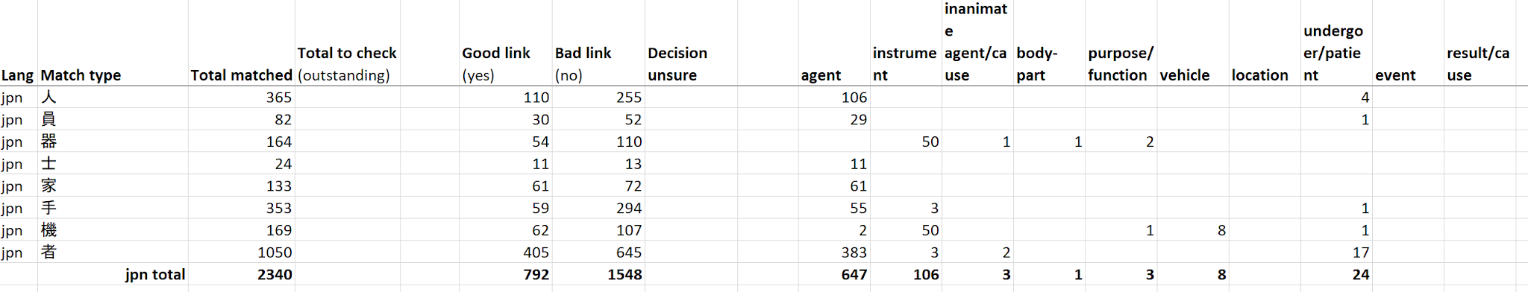

Basically the results mostly confirms the existing descriptions of Japanese agent suffixes being particularly specialized
- for example, 人/者/士/家/手 is mostly reserved for human referents
The results above show they are almost exclusively agents, with a minority of -者 (17/405) denoting undergoer/patients.
- Predicting whether -者 refers to an agent or patient is however a tricky issue that has received some discussion:
  - Blin (2017) https://hal.archives-ouvertes.fr/hal-01571625/document suggests that whether or not it is an agent/patient role depends on the argument structure of the verb (In the first place Blin doesn’t actually subscribe to the theta roles of agent/patient; he opts for a more syntacto-centric approach that describes -者 compounds in terms of their co-referentiality with arguments of the origin verb)
- Unsurprisingly, the ‘stray numbers’ amongst above largely are the result of AN derivation from the native Japanese stratum:
  - 3 instrument 手 come from 切り手 ‘tool for cutting’, 押し手 ‘device used to make an impression (as in a stamp)’
  - The 1 undergoer/patient 手 comes from 読み手 ‘one of a series of texts for students learning to read’

By noun field
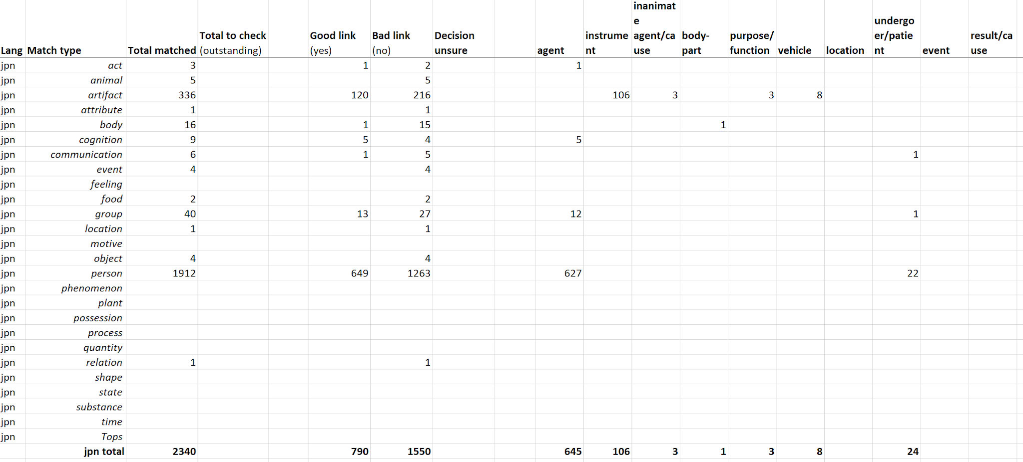

- Looking at the positive links according to noun field also reveals some very regular patterns, quite similar to the ones described above, and they can be formulated in a fairly small amount of rules that cover most of our data, e.g
  - PERSON nouns with agentive suffixes are most likely to be AGENTS, and in a minority of cases UNDERGOER/PATIENT
  - ARTIFACT nouns with agentive suffixes are most likely to be INSTRUMENTS, and in a minority of cases VEHICLES
- Compare these results to the English counterpart, where even though there are many more links to check, it already seems more difficult to formulate rules that predict the semantic nature of ANs from their noun field:
  - Echoes Fellbaum’s observations in her 2009 paper
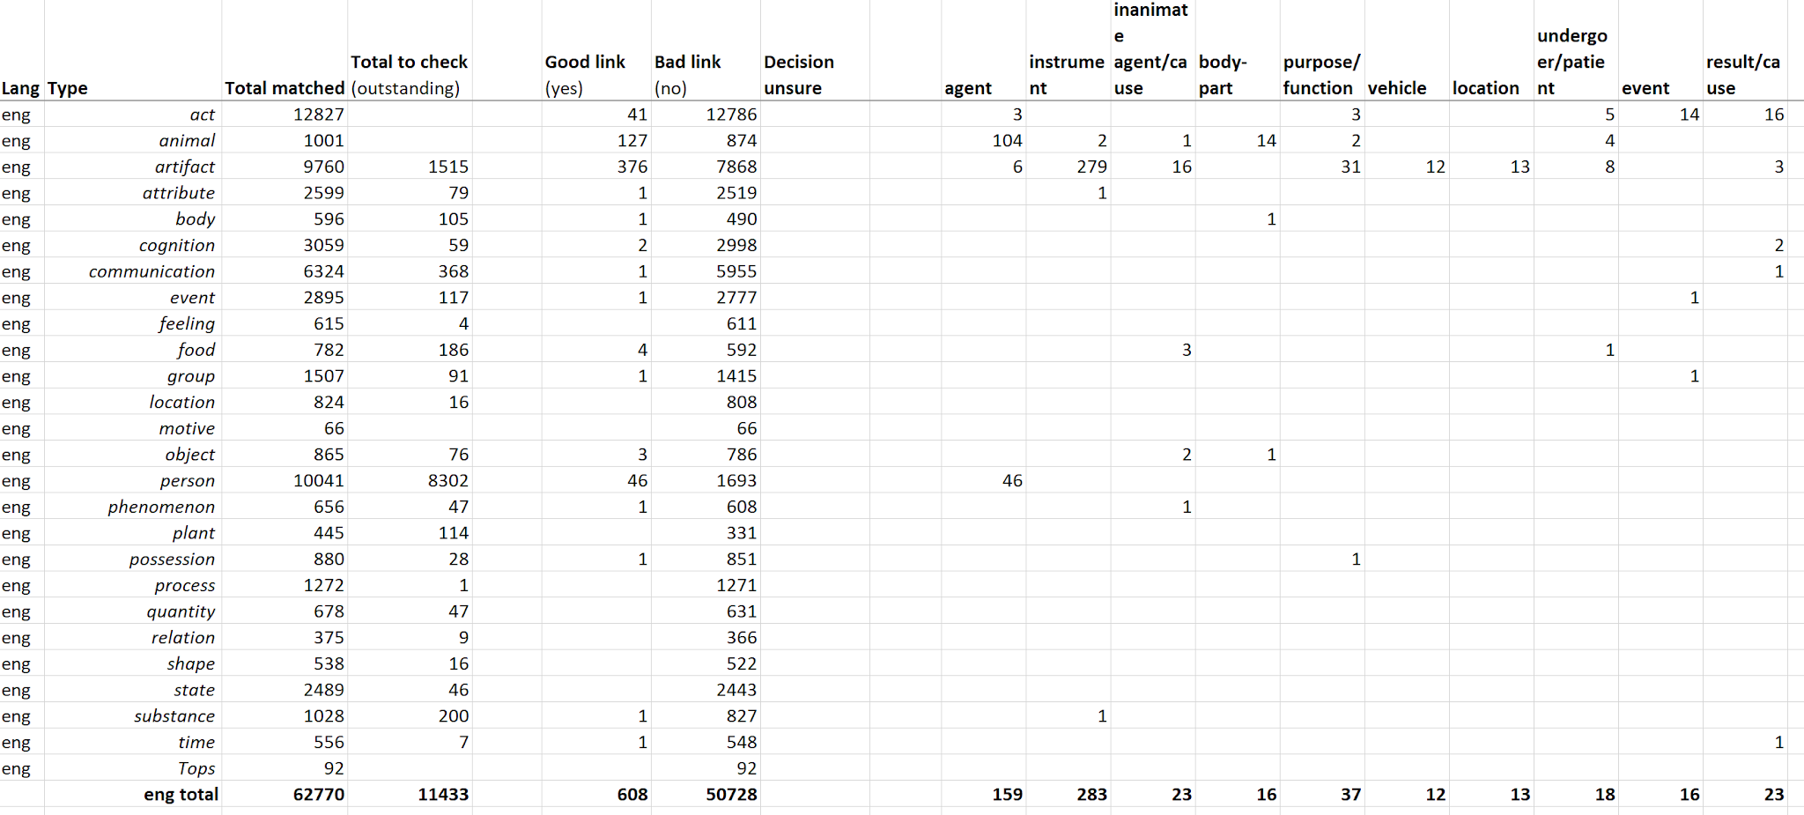
- note that INSTRUMENTS outnumber AGENTS here simply because a huge number of PERSON-noun field ANs have not been checked yet

