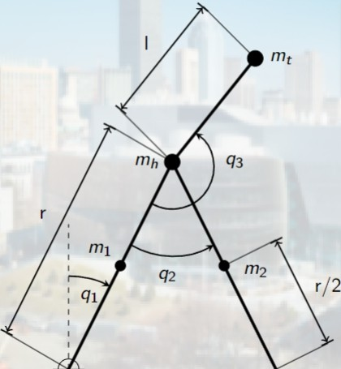( Q J J:WOject - Three link robot modeling and control