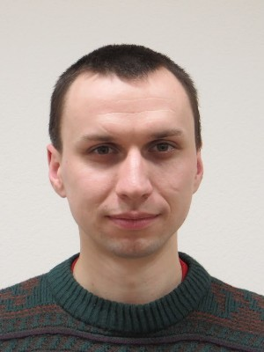
Bondarchuk Sergey Anatol'yevich

Programmer Qt C++

Date of Birth: 27 December 1982
City: Kiev
Phone: 063 388 57 41
Email: bondarchuk.sa.radionix@gmail.com
Skype: bondarchuk.sa.radionix

Experience

Software Engineer
With 07.2015 for 09.2017 (2 years 2 months)
LLC "Radioniks" (Research and Production Enterprise of military-industrial complex of Ukraine. Development, production, modernization, maintenance and repair of on-board electronic systems and opto-electronic equipment.)
Development and writing of software for Ubuntu 14.04.

Education
Zhytomir military Institute. Automation, systems engineering. Zhytomyr city.
With 09.2004 on 08.2008

European University. Economics, Business Economics, Zhytomyr city.
With 09.1998 on 06.2004

Professional skills
Qt C++ - 2 year+
Qml, Git.

Languages
English — pre-intermediale.

