Output:

FIRST 5 ROWS
Row ID Order ID Order Date Ship Date Ship Mode Customer ID \
0 1 CA-2016-152156 11/8/2016 11/11/2016 Second Class CG-12520
1 2 CA-2016-152156 11/8/2016 11/11/2016 Second Class CG-12520
2 3 CA-2016-138688 6/12/2016 6/16/2016 Second Class DV-13045
3 4 US-2015-108966 10/11/2015 10/18/2015 Standard Class SO-20335
4 5 US-2015-108966 10/11/2015 10/18/2015 Standard Class SO-20335

Customer Name Segment Country City ... \
0 Claire Gute Consumer United States Henderson ...
1 Claire Gute Consumer United States Henderson ...
2 Darrin Van Huff Corporate United States Los Angeles ...
3 Sean O'Donnell Consumer United States Fort Lauderdale ...
4 Sean O'Donnell Consumer United States Fort Lauderdale ...

Postal Code Region Product ID Category Sub-Category \
0 42420 South FUR-BO-10001798 Furniture Bookcases
1 42420 South FUR-CH-10000454 Furniture Chairs
2 90036 West OFF-LA-10000240 Office Supplies Labels
3 33311 South FUR-TA-10000577 Furniture Tables
4 33311 South OFF-ST-10000760 Office Supplies Storage

Product Name Sales Quantity \
0 Bush Somerset Collection Bookcase 261.9600 2
1 Hon Deluxe Fabric Upholstered Stacking Chairs,... 731.9400 3
2 Self-Adhesive Address Labels for Typewriters b... 14.6200 2
3 Bretford CR4500 Series Slim Rectangular Table 957.5775 5
4 Eldon Fold 'N Roll Cart System 22.3680 2

Discount Profit
0 0.00 41.9136
1 0.00 219.5820
2 0.00 6.8714
3 0.45 -383.0310
4 0.20 2.5164

[5 rows x 21 columns]

COLUMN NAMES
Index(['Row ID', 'Order ID', 'Order Date', 'Ship Date', 'Ship Mode',
'Customer ID', 'Customer Name', 'Segment', 'Country', 'City', 'State',
'Postal Code', 'Region', 'Product ID', 'Category', 'Sub-Category',
'Product Name', 'Sales', 'Quantity', 'Discount', 'Profit'],
dtype='object')

DATA INFO
<class 'pandas.core.frame.DataFrame'>
RangeIndex: 9994 entries, 0 to 9993
Data columns (total 21 columns):
# Column Non-Null Count Dtype
--- ------ -------------- -----
0 Row ID 9994 non-null int64
1 Order ID 9994 non-null object
2 Order Date 9994 non-null object
3 Ship Date 9994 non-null object
4 Ship Mode 9994 non-null object
5 Customer ID 9994 non-null object
6 Customer Name 9994 non-null object
7 Segment 9994 non-null object
8 Country 9994 non-null object
9 City 9994 non-null object
10 State 9994 non-null object
11 Postal Code 9994 non-null int64
12 Region 9994 non-null object
13 Product ID 9994 non-null object
14 Category 9994 non-null object
15 Sub-Category 9994 non-null object
16 Product Name 9994 non-null object
17 Sales 9994 non-null float64
18 Quantity 9994 non-null int64
19 Discount 9994 non-null float64
20 Profit 9994 non-null float64
dtypes: float64(3), int64(3), object(15)
memory usage: 1.6+ MB
None

TRAINING DATA SIZE: 7995
TEST DATA SIZE: 1999

MODEL TRAINED SUCCESSFULLY

MODEL PERFORMANCE
---------------------------
MAE : 263.9342250835709
MSE : 484558.5987664192
RMSE : 696.1024341046505
R2 Score : -0.001656944358746637
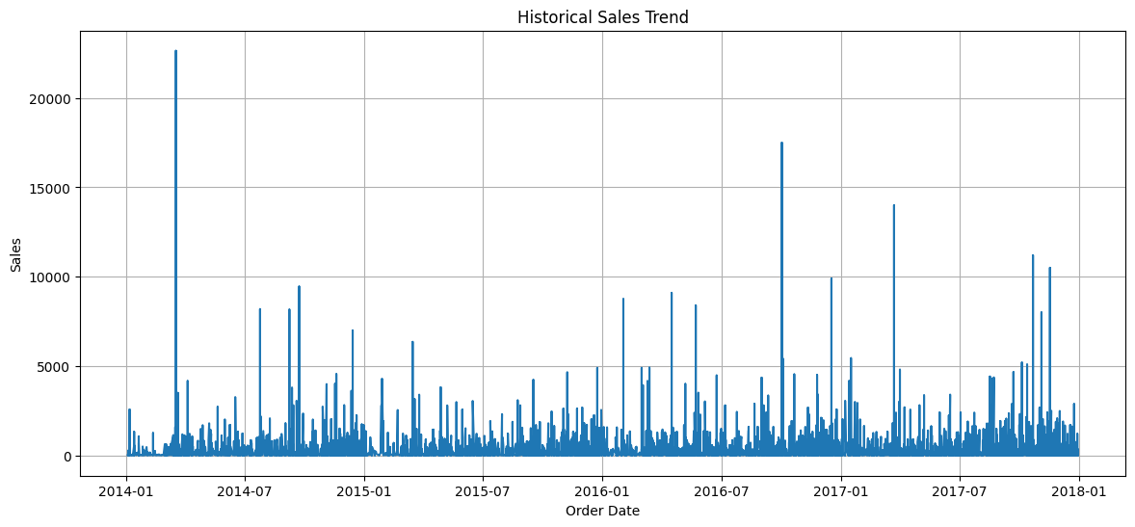
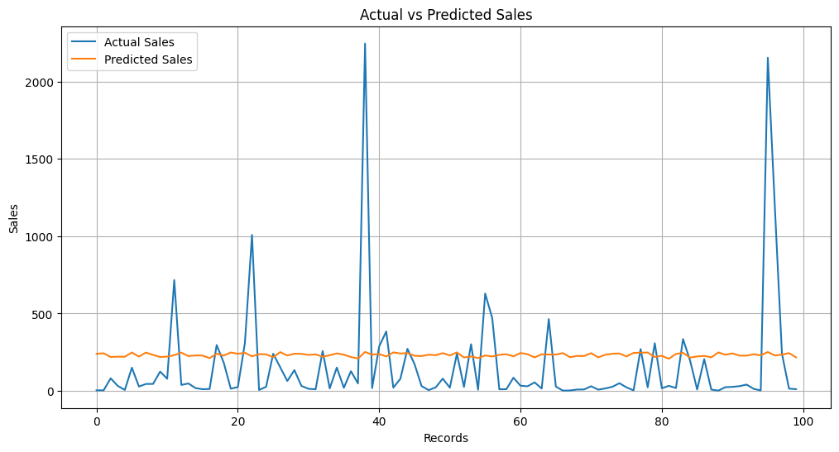

FUTURE SALES PREDICTIONS
Year Month Day DayOfWeek WeekOfYear IsWeekend PredictedSales
0 2025 7 1 1 27 0 196.296001
1 2025 7 2 2 27 0 194.686516
2 2025 7 3 3 27 0 193.077031
3 2025 7 4 4 27 0 191.467546
4 2025 7 5 5 27 1 196.726337
5 2025 7 6 6 27 1 195.116852
6 2025 7 7 0 27 0 201.656199
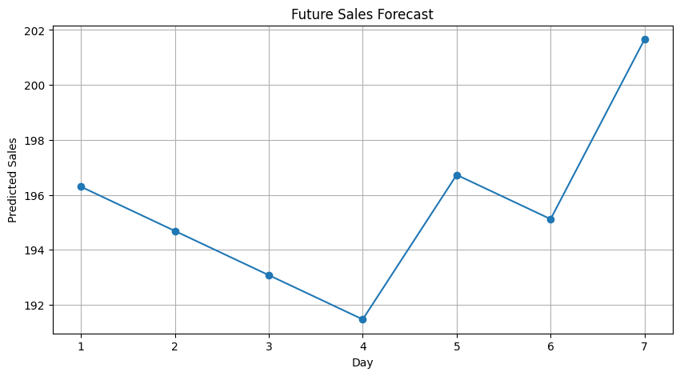

Predictions saved successfully!

BUSINESS INSIGHTS
---------------------------
1. Historical sales trends analyzed.
2. Linear Regression used for forecasting.
3. Weekend effect included as feature.
4. Future sales predicted successfully.
5. Results exported to CSV file.

