Bondoc Ana-Maria

Grupa 241

Proiect SGBD

Gestiunea unei companii aeriene



**CERINTA 1**

Prezentați pe scurt baza de date (utilitatea ei).

Companiile aeriene mari utilizează numeroase sisteme software pentru diverse scopuri, cum ar fi planificarea flotei, întreținerea aeronavelor, publicațiile tehnice, planificarea zborurilor, programarea echipajului, planificarea personalului, prețurile, gestionarea veniturilor, rezervările de pasageri, rezervarea online, răspunsul vocal interactiv, managementul relațiilor cu clienții, mărfurile, rezervări, autoservire aeroport, urmărire zboruri, navigare, greutate și centrare, geantă electronică de zbor, contabilitate venituri, registru general, management document etc.

Cele mai multe dintre aceste sisteme sunt furnizate de furnizori externi care utilizează diverse baze de date, inclusiv Oracle, SQL Server și MySQL. Bănuiesc că fiecare companie aeriană importantă din SUA folosește cel puțin o instanță din fiecare sistem major de baze de date, găzduit în sediul propriu sau al furnizorilor lor.

Baza de date proiectată în acest proiect asigură buna funcționare a zborurilor efectuate de diverse avioane, aparținând unor companii aeriene. Piloții duc la bun sfârșit zborurile, pe diferite rute, împreună cu echipajul de la bord.

**CERINTA 2**

Realizați diagrama entitate-relație (ERD).

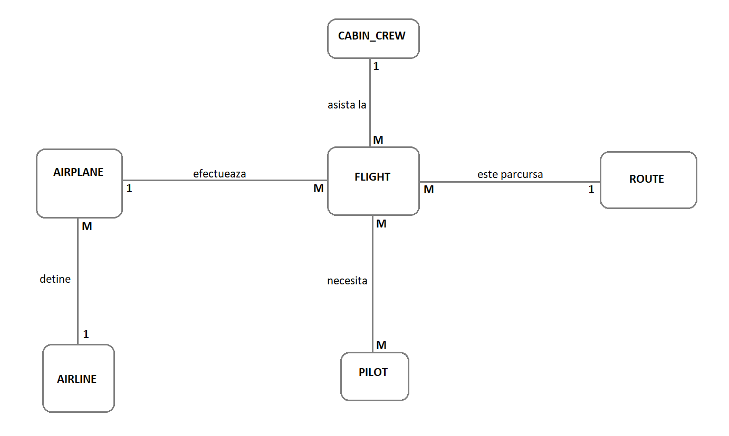

**CERINTA 3**

Pornind de la diagrama entitate-relație realizați diagrama conceptuală a modelului propus, integrând toate atributele necesare.

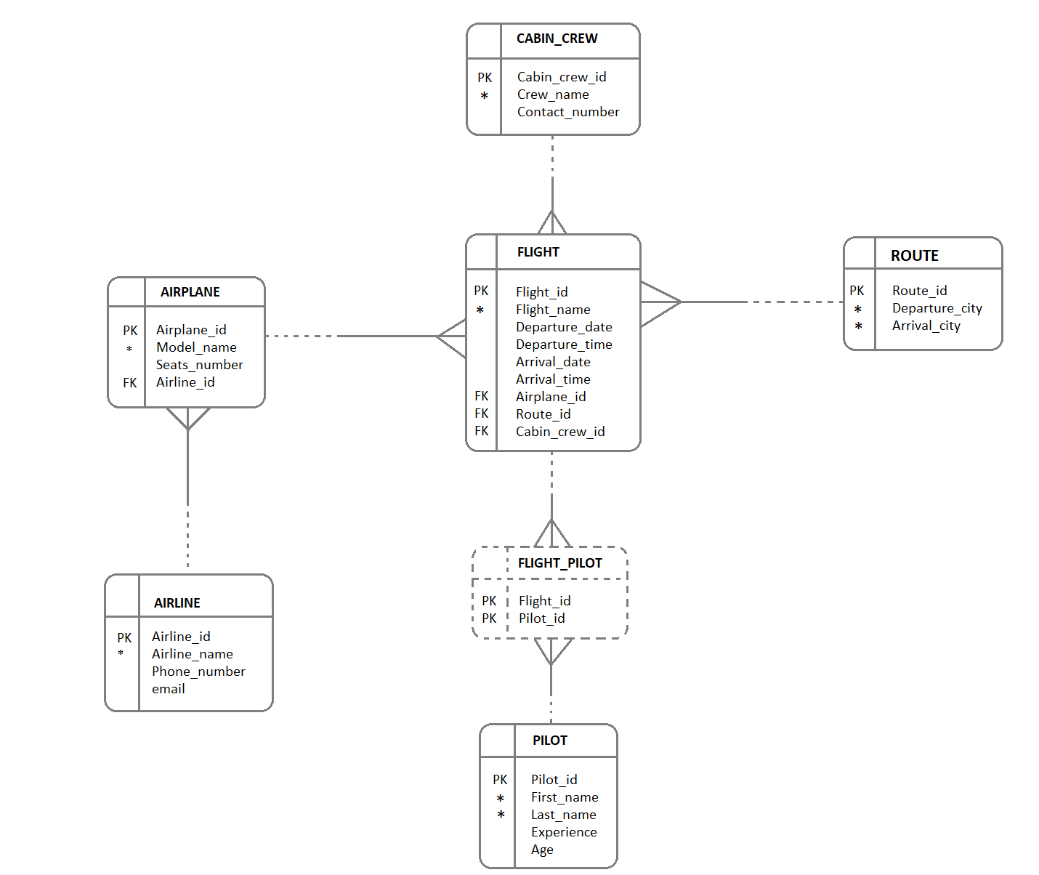

**CERINTA 4**

Implementați în Oracle diagrama conceptuală realizată: definiți toate tabelele, implementând toate constrângerile de integritate necesare (chei primare, cheile externe etc).

--------------------------------------------------------------------------------

--crearea tabelelor cu cheile primare-------------------------------------------

--------------------------------------------------------------------------------

CREATE TABLE airline (

airline_id NUMBER(9) NOT NULL,

airline_name VARCHAR2(30) NOT NULL,

phone_number VARCHAR2(11),

email VARCHAR2(30)

);

ALTER TABLE airline ADD CONSTRAINT airline_pk PRIMARY KEY ( airline_id );

--------------------------------------------------------------------------------

CREATE TABLE airplane (

airplane_id NUMBER(9) NOT NULL,

model_name VARCHAR2(30) NOT NULL,

seats_number NUMBER(9),

airline_id NUMBER(9) NOT NULL

);

ALTER TABLE airplane ADD CONSTRAINT airplane_pk PRIMARY KEY (airplane_id);

--------------------------------------------------------------------------------

CREATE TABLE cabin_crew (

cabin_crew_id NUMBER(9) NOT NULL,

crew_name VARCHAR2(30) NOT NULL,

contact_number VARCHAR2(11)

);

ALTER TABLE cabin_crew ADD CONSTRAINT cabin_crew_pk PRIMARY KEY ( cabin_crew_id );

--------------------------------------------------------------------------------

CREATE TABLE flight (

flight_id NUMBER(9) NOT NULL,

flight_name VARCHAR2(30) NOT NULL,

departure_date DATE,

departure_time varchar(6),

arrival_date DATE,

arrival_time varchar(6),

airplane_id NUMBER(9) NOT NULL,

route_id NUMBER(9) NOT NULL,

cabin_crew_id NUMBER(9) NOT NULL

);

ALTER TABLE flight

ADD CONSTRAINT flight_pk PRIMARY KEY ( flight_id);

--------------------------------------------------------------------------------

CREATE TABLE flight_pilot (

flight_id NUMBER(9) NOT NULL,

pilot_id NUMBER(9) NOT NULL );

ALTER TABLE flight_pilot

ADD CONSTRAINT flight_pilot_pk PRIMARY KEY ( flight_id,

pilot_id );

--------------------------------------------------------------------------------

CREATE TABLE pilot (

pilot_id NUMBER(9) NOT NULL,

first_name VARCHAR2(30) NOT NULL,

last_name VARCHAR2(30) NOT NULL,

experience NUMBER(3),

age NUMBER(3)

);

ALTER TABLE pilot ADD CONSTRAINT pilot_pk PRIMARY KEY ( pilot_id );

--------------------------------------------------------------------------------

CREATE TABLE route (

route_id NUMBER(9) NOT NULL,

departure_city VARCHAR2(30) NOT NULL,

arrival_city VARCHAR2(30) NOT NULL

);

ALTER TABLE route ADD CONSTRAINT route_pk PRIMARY KEY ( route_id );

--------------------------------------------------------------------------------

--adaugare foreign key----------------------------------------------------------

--------------------------------------------------------------------------------

ALTER TABLE airplane

ADD CONSTRAINT airplane_airline_fk FOREIGN KEY ( airline_id )

REFERENCES airline ( airline_id);

ALTER TABLE flight

ADD CONSTRAINT flight_airplane_fk FOREIGN KEY ( airplane_id )

REFERENCES airplane ( airplane_id);

ALTER TABLE flight

ADD CONSTRAINT flight_cabin_crew_fk FOREIGN KEY ( cabin_crew_id )

REFERENCES cabin_crew ( cabin_crew_id );

ALTER TABLE flight_pilot

ADD CONSTRAINT pilot_flight_fk FOREIGN KEY ( flight_id )

REFERENCES flight ( flight_id );

ALTER TABLE flight_pilot

ADD CONSTRAINT flight_pilot_fk FOREIGN KEY ( pilot_id )

REFERENCES pilot ( pilot_id );

ALTER TABLE flight

ADD CONSTRAINT flight_route_fk FOREIGN KEY ( route_id )

REFERENCES route ( route_id );

**CERINTA 5**

Adăugați informații coerente în tabelele create (minim 5 înregistrări pentru fiecare entitate independentă; minim 10 înregistrări pentru tabela asociativă).

--------------------------------------------------------------------------------

---inserare date in tabele------------------------------------------------------

--------------------------------------------------------------------------------

--AIRLINE-----------------------------------------------------------------------

INSERT INTO airline(airline_id, airline_name, phone_number, email)

VALUES(1, 'WizzAir', '0754178694', 'wizzair@mail.com');

INSERT INTO airline(airline_id, airline_name, phone_number, email)

VALUES(2, 'RyanAir', '0754578914', 'ryanair@mail.com');

INSERT INTO airline(airline_id, airline_name, phone_number, email)

VALUES(3, 'BlueAir', '0710174494', 'blueair@mail.com');

INSERT INTO airline(airline_id, airline_name, phone_number, email)

VALUES(4, 'Lufthansa', '0724475910', 'lufthansa@mail.com');

INSERT INTO airline(airline_id, airline_name, phone_number, email)

VALUES(5, 'Tarom', '0755178451', 'tarom@mail.com');

--AIRPLANE----------------------------------------------------------------------

INSERT INTO airplane(airplane_id, model_name, seats_number, airline_id)

VALUES(1, 'Airbus A300', 356, 2);

INSERT INTO airplane(airplane_id, model_name, seats_number, airline_id)

VALUES(2, 'Airbus A321', 412, 4);

INSERT INTO airplane(airplane_id, model_name, seats_number, airline_id)

VALUES(3, 'Antonov An-26', 589, 4);

INSERT INTO airplane(airplane_id, model_name, seats_number, airline_id)

VALUES(4, 'Boeing 747', 221, 3);

INSERT INTO airplane(airplane_id, model_name, seats_number, airline_id)

VALUES(5, 'Boeing 709', 812, 3);

--CABIN_CREW--------------------------------------------------------------------

INSERT INTO cabin_crew(cabin_crew_id, crew_name, contact_number)

VALUES(1, 'Luggage Team', '07234589611');

INSERT INTO cabin_crew(cabin_crew_id, crew_name, contact_number)

VALUES(2, 'Cleaning Team', '0723444597');

INSERT INTO cabin_crew(cabin_crew_id, crew_name, contact_number)

VALUES(3, 'Medical Team', '0724775558');

INSERT INTO cabin_crew(cabin_crew_id, crew_name, contact_number)

VALUES(4, 'Cabin Team', '0755210036');

INSERT INTO cabin_crew(cabin_crew_id, crew_name, contact_number)

VALUES(5, 'Emergency Team', '0724774104');

--ROUTE-------------------------------------------------------------------------

INSERT INTO route(route_id, departure_city, arrival_city)

VALUES(1, 'Bucuresti', 'Paris');

INSERT INTO route(route_id, departure_city, arrival_city)

VALUES(2, 'Amsterdam', 'Barcelona');

INSERT INTO route(route_id, departure_city, arrival_city)

VALUES(3, 'Praga', 'Londra');

INSERT INTO route(route_id, departure_city, arrival_city)

VALUES(4, 'Madrid', 'Viena');

INSERT INTO route(route_id, departure_city, arrival_city)

VALUES(5, 'Frankfurt', 'Sibiu');

--PILOT-------------------------------------------------------------------------

INSERT INTO pilot(pilot_id, first_name, last_name, experience, age)

VALUES(1, 'Andrei', 'Dinu', 6, 34);

INSERT INTO pilot(pilot_id, first_name, last_name, experience, age)

VALUES(2, 'Andrei', 'Horceag', 15, 47);

INSERT INTO pilot(pilot_id, first_name, last_name, experience, age)

VALUES(3, 'Mihai', 'Bondoc', 10, 51);

INSERT INTO pilot(pilot_id, first_name, last_name, experience, age)

VALUES(4, 'Adrian', 'Munteanu', 2, 31);

INSERT INTO pilot(pilot_id, first_name, last_name, experience, age)

VALUES(5, 'Razvan', 'Popa', 6, 34);

--FLIGHT------------------------------------------------------------------------

INSERT INTO flight(flight_id, flight_name, departure_date, departure_time, arrival_date, arrival_time,

airplane_id, route_id, cabin_crew_id)

VALUES(1, 'F2378', '12.12.2022', '12:45', '12.12.2022', '14:00', 2, 4, 2);

INSERT INTO flight(flight_id, flight_name, departure_date, departure_time, arrival_date, arrival_time,

airplane_id, route_id, cabin_crew_id)

VALUES(2, 'D0122', '31.08.2021', '23:00', '01.09.2021', '03:00', 3, 2, 5);

INSERT INTO flight(flight_id, flight_name, departure_date, departure_time, arrival_date, arrival_time,

airplane_id, route_id, cabin_crew_id)

VALUES(3, 'G3295', '03.05.2022', '09:30', '03.05.2022', '17:00', 1, 1, 4);

INSERT INTO flight(flight_id, flight_name, departure_date, departure_time, arrival_date, arrival_time,

airplane_id, route_id, cabin_crew_id)

VALUES(4, 'H4512', '08.01.2023', '17:00', '09.01.2023', '02:00', 5, 3, 1);

INSERT INTO flight(flight_id, flight_name, departure_date, departure_time, arrival_date, arrival_time,

airplane_id, route_id, cabin_crew_id)

VALUES(5, 'J0065', '03.03.2023', '13:05', '04.03.2023', '13:00', 4, 5, 3);

--FLIGHT_PILOT------------------------------------------------------------------

INSERT INTO flight_pilot(flight_id, pilot_id)

VALUES(1, 2);

INSERT INTO flight_pilot(flight_id, pilot_id)

VALUES(1, 4);

INSERT INTO flight_pilot(flight_id, pilot_id)

VALUES(2, 1);

INSERT INTO flight_pilot(flight_id, pilot_id)

VALUES(2, 4);

INSERT INTO flight_pilot(flight_id, pilot_id)

VALUES(3, 1);

INSERT INTO flight_pilot(flight_id, pilot_id)

VALUES(3, 5);

INSERT INTO flight_pilot(flight_id, pilot_id)

VALUES(4, 3);

INSERT INTO flight_pilot(flight_id, pilot_id)

VALUES(4, 2);

INSERT INTO flight_pilot(flight_id, pilot_id)

VALUES(5, 1);

INSERT INTO flight_pilot(flight_id, pilot_id)

VALUES(5, 4);

**CERINTA 6**

Formulați în limbaj natural o problemă pe care să o rezolvați folosind un subprogram stocat independent care să utilizeze două tipuri diferite de colecții studiate. Apelați subprogramul.

--EXERCITIUL 6-------------------------------------------------------------------

-- Definiti un subprogram prin care sa obtinem data si ora decolarii si aterizarii

-- a zborurilor care au ca unul din piloti pe Andrian Munteanu

CREATE OR REPLACE PROCEDURE InformatiiZbor

IS

TYPE zboruri is varray(101) of number;

type ZBOR is record

(flight_id flight.flight_id%type,

departure_date flight.departure_date%type,

departure_time flight.departure_time%type,

arrival_date flight.arrival_date%type,

arrival_time flight.arrival_time%type);

record ZBOR;

v_zboruri zboruri;

BEGIN

--selectam zborurile care au ca unul din piloti pe Adrian Munteanu

select distinct

f.flight_id

bulk collect into

v_zboruri

from flight_pilot f

where (select last_name

from pilot p

where p.pilot_id=f.pilot_id) = 'Munteanu'

and (select first_name

from pilot p

where p.pilot_id=f.pilot_id) = 'Adrian';

FOR I IN v_zboruri.FIRST..v_zboruri.LAST LOOP

select flight_id, departure_date, departure_time, arrival_date, arrival_time

into record

from flight

where flight_id=v_zboruri(i);

DBMS_OUTPUT.PUT_LINE('Zborul cu id-ul ' || record.flight_id || ' decoleaza pe data de ' || record.departure_date ||

' la ora ' || record.departure_time || ' si ajunge pe data de ' || record.arrival_date || ' ora ' || record.arrival_time);

end loop;

end InformatiiZbor;

begin

InformatiiZbor();

end;

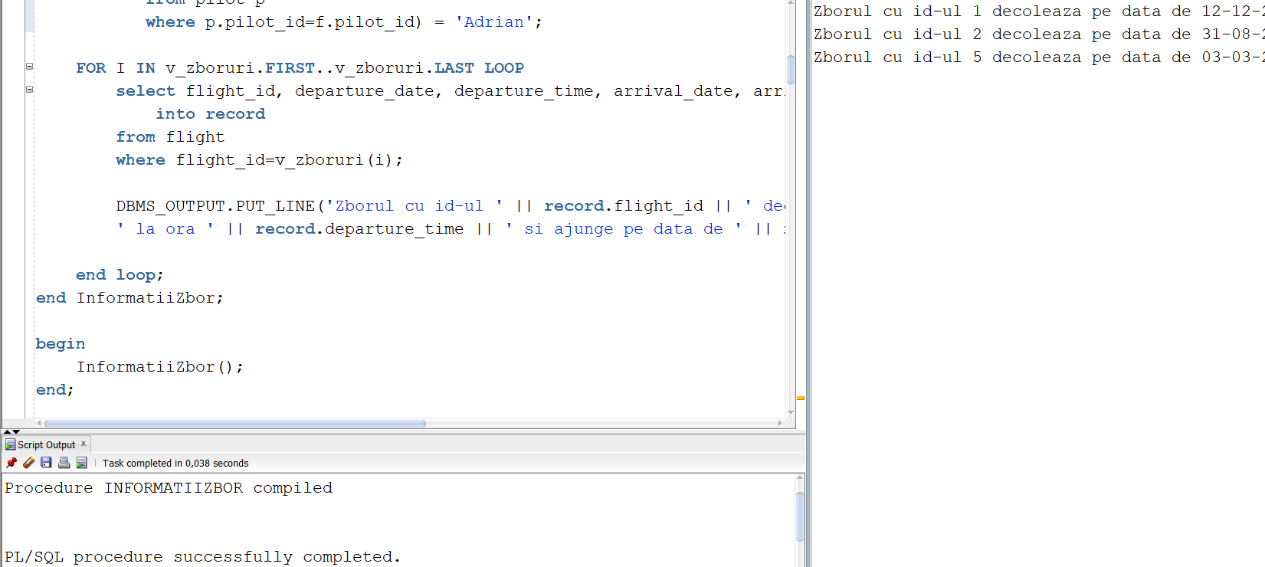

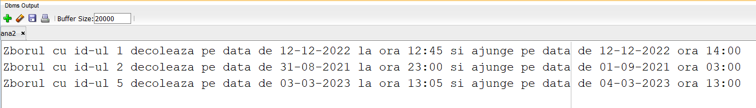

**CERINTA 7**

Formulați în limbaj natural o problemă pe care să o rezolvați folosind un subprogram stocat independent care să utilizeze 2 tipuri diferite de cursoare studiate, unul dintre acestea fiind cursor parametrizat. Apelați subprogramul.

--EXERCITIUL 7-------------------------------------------------------------------

-- Obtineti companiile aeriane (numele acesteia si numarul de avioane)

-- care detin cel putin x avioane (x nr introdus de la tastatura)

-- si afiseaza toate avioanele cu zborurile efectuate la momentul actual

CREATE OR REPLACE PROCEDURE CompaniiAeriene

IS

v_x number(4) := &p_x;

v_nr number(4);

v_nume airline.airline_name%TYPE;

CURSOR c (parametru NUMBER) IS

SELECT airline_name nume, COUNT(airplane_id) nr

FROM airline a, airplane b

WHERE a.airline_id=b.airline_id

GROUP BY airline_name

HAVING COUNT(airplane_id) > parametru;

v_nr2 number(4);

v_nume2 airline.airline_name%TYPE;

CURSOR c2 IS

SELECT model_name nume2, COUNT(flight_id) nr2

FROM airplane a, flight f

WHERE a.airplane_id=f.airplane_id

GROUP BY model_name;

BEGIN

OPEN c(v_x);

LOOP

FETCH c INTO v_nume, v_nr;

EXIT WHEN c%NOTFOUND;

DBMS_OUTPUT.PUT_LINE('Compania aeriana '|| v_nume || ' detine ' || v_nr || ' avioane');

END LOOP;

CLOSE c;

DBMS_OUTPUT.PUT_LINE(' ');

OPEN c2;

LOOP

FETCH c2 INTO v_nume2, v_nr2;

EXIT WHEN c2%NOTFOUND;

DBMS_OUTPUT.PUT_LINE('Avionul '|| v_nume2 || ' a efectuat ' || v_nr2 || ' zboruri');

END LOOP;

CLOSE c2;

end CompaniiAeriene;

begin

CompaniiAeriene();

end;

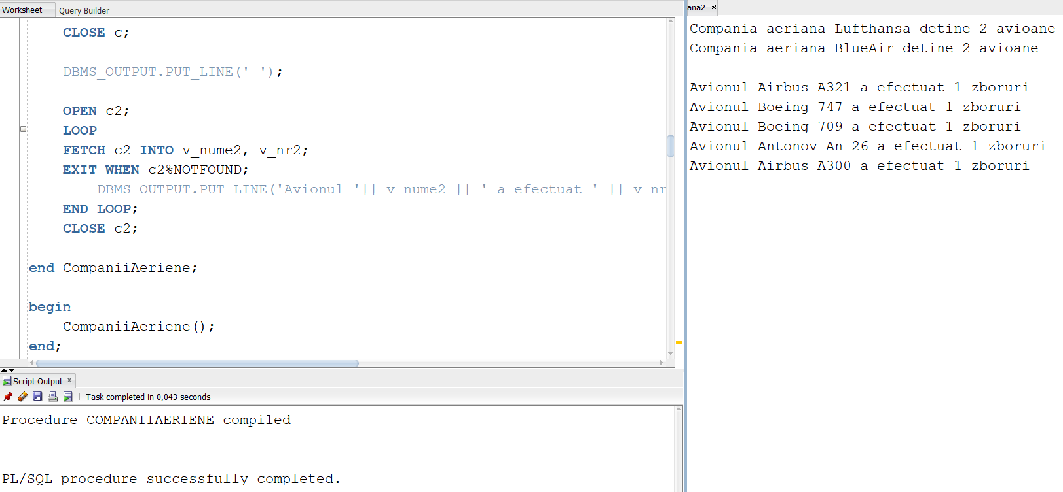

**CERINTA 8**

Formulați în limbaj natural o problemă pe care să o rezolvați folosind un subprogram stocat independent de tip funcție care să utilizeze într-o singură comandă SQL 3 dintre tabelele definite. Definiți minim 2 excepții. Apelați subprogramul astfel încât să evidențiați toate cazurile tratate.

--EXERCITIUL 8-------------------------------------------------------------------

-- Sa se se afiseze media varstei pilotilor care au dus la

-- bun sfarsit zborul a carui nume este dat de la tastatura

CREATE OR REPLACE FUNCTION functie

(v_flight_name flight.flight_name%TYPE)

RETURN NUMBER IS

varsta pilot.age%type;

data_decolare flight.departure_date%type;

BEGIN

--select pentru aruncarea exceptiilor

select departure_date into data_decolare from flight

where flight_name = v_flight_name;

SELECT avg(age) into varsta from

pilot p join flight_pilot fp on p.pilot_id = fp.pilot_id

join flight f on fp.flight_id = f.flight_id

WHERE flight_name = v_flight_name;

return varsta;

EXCEPTION

WHEN NO_DATA_FOUND THEN

RAISE_APPLICATION_ERROR(-20000, 'Nu exista zboruri cu numele dat');

WHEN TOO_MANY_ROWS THEN

RAISE_APPLICATION_ERROR(-20001, 'Exista mai multe zboruri cu numele dat');

WHEN OTHERS THEN

RAISE_APPLICATION_ERROR(-20002,'Alta eroare!');

END functie;

DECLARE

v_name flight.flight_name % TYPE := '&p_name';

BEGIN

DBMS_OUTPUT.PUT_LINE('Media varstei pilotilor care au dus la bun sfarsit zborul ' || v_name || ' este de ' || functie(v_name) || ' de ani');

END;

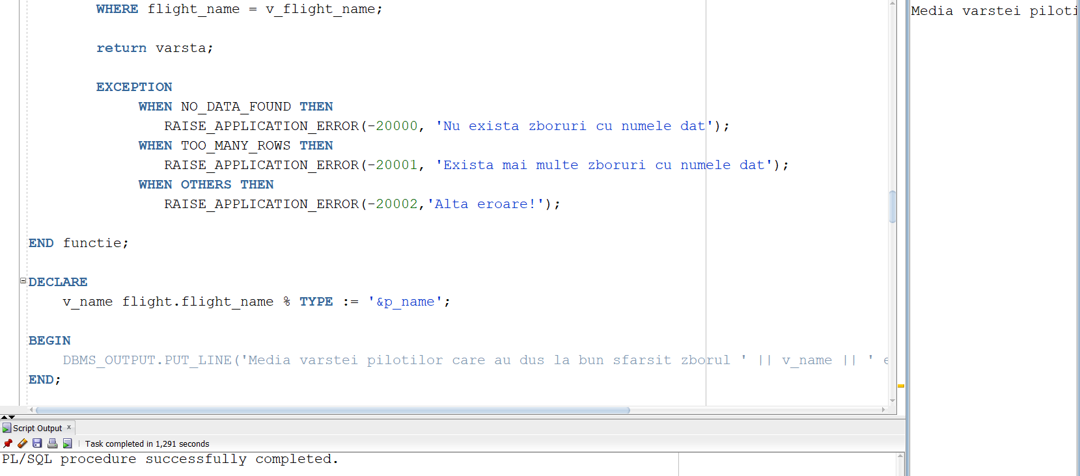

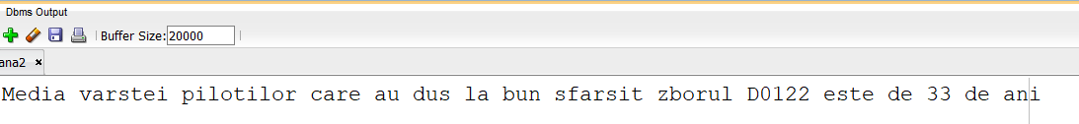

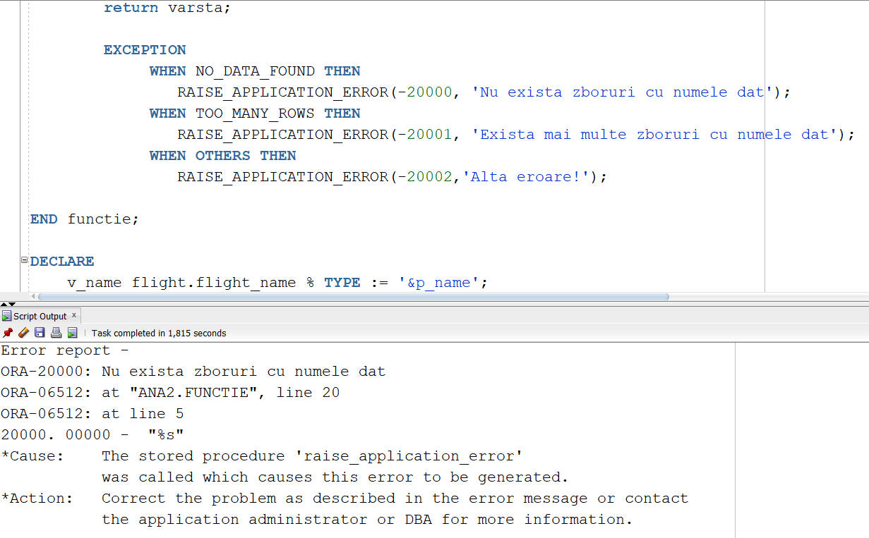

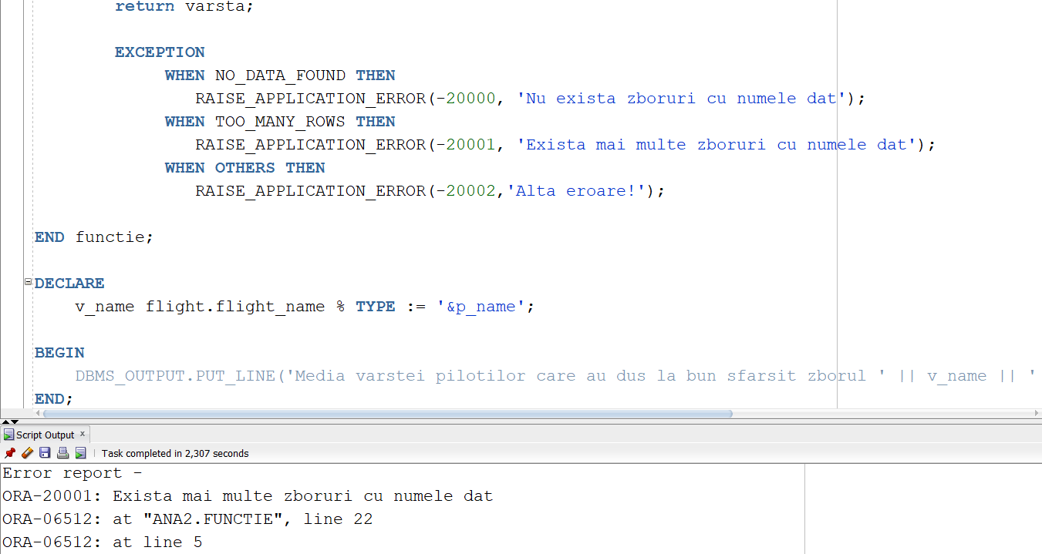

**CERINTA 9**

Formulați în limbaj natural o problemă pe care să o rezolvați folosind un subprogram stocat independent de tip procedură care să utilizeze într-o singură comandă SQL 5 dintre tabelele definite. Tratați toate excepțiile care pot apărea, incluzând excepțiile NO_DATA_FOUND și TOO_MANY_ROWS. Apelați subprogramul astfel încât să evidențiați toate cazurile tratate.

--EXERCITIUL 9---------------------------------------------------------------------

-- Sa se se afiseze numele, numele pilotului, numele echipei de la bord,

-- si orasul de delocare si aterizare ale unui zbor carui nume este dat

-- de la tastatura

CREATE OR REPLACE PROCEDURE procedura

(v_flight_name flight.flight_name%TYPE)

IS

data_decolare flight.departure_date%type;

nume_zbor flight.flight_name%type;

prenume_pilot pilot.first_name%type;

nume_pilot pilot.last_name%type;

nume_echipaj cabin_crew.crew_name%type;

oras_decolare route.departure_city%type;

oras_aterizare route.arrival_city%type;

BEGIN

--select pentru aruncarea exceptiilor

select departure_date into data_decolare from flight

where flight_name = v_flight_name;

SELECT

flight_name, first_name, last_name, crew_name, departure_city, arrival_city

into nume_zbor, prenume_pilot, nume_pilot, nume_echipaj, oras_decolare, oras_aterizare

from flight f

join flight_pilot fp on f.flight_id = fp.flight_id

join pilot p on fp.pilot_id = p.pilot_id

join cabin_crew c on c.cabin_crew_id = f.cabin_crew_id

join route r on r.route_id = f.route_id

WHERE flight_name = v_flight_name;

DBMS_OUTPUT.PUT_LINE(nume_zbor);

DBMS_OUTPUT.PUT_LINE('Pilot: ' || nume_pilot|| ' ' || prenume_pilot) ;

DBMS_OUTPUT.PUT_LINE('Echipaj: ' || nume_echipaj);

DBMS_OUTPUT.PUT_LINE('Decolare: ' || oras_decolare || ', Aterizare: ' || oras_aterizare);

EXCEPTION

WHEN NO_DATA_FOUND THEN

RAISE_APPLICATION_ERROR(-20000, 'Nu exista zboruri cu numele dat');

WHEN TOO_MANY_ROWS THEN

RAISE_APPLICATION_ERROR(-20001, 'Exista mai multe zboruri cu numele dat');

WHEN OTHERS THEN

RAISE_APPLICATION_ERROR(-20002,'Alta eroare!');

END procedura;

DECLARE

v_name flight.flight_name % TYPE := '&p_name';

BEGIN

procedura(v_name);

END;

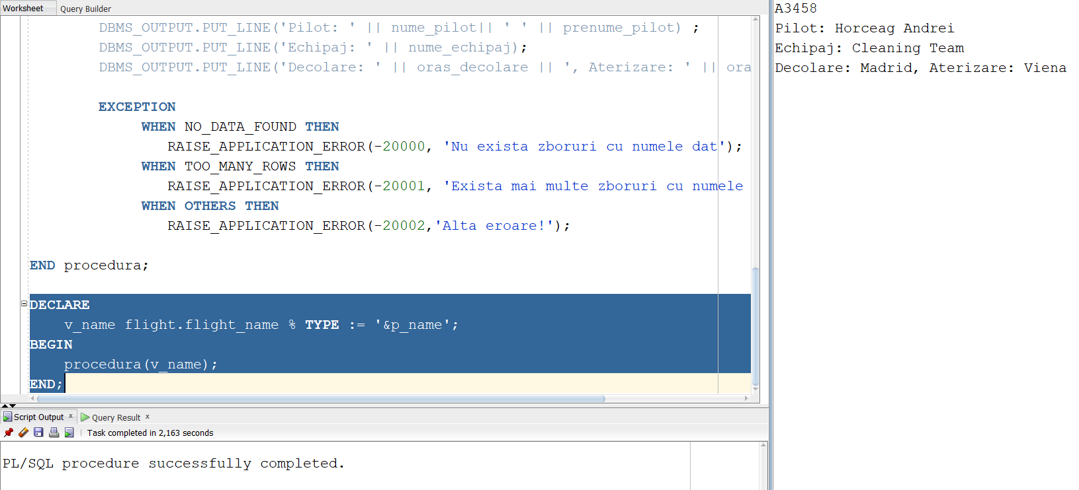

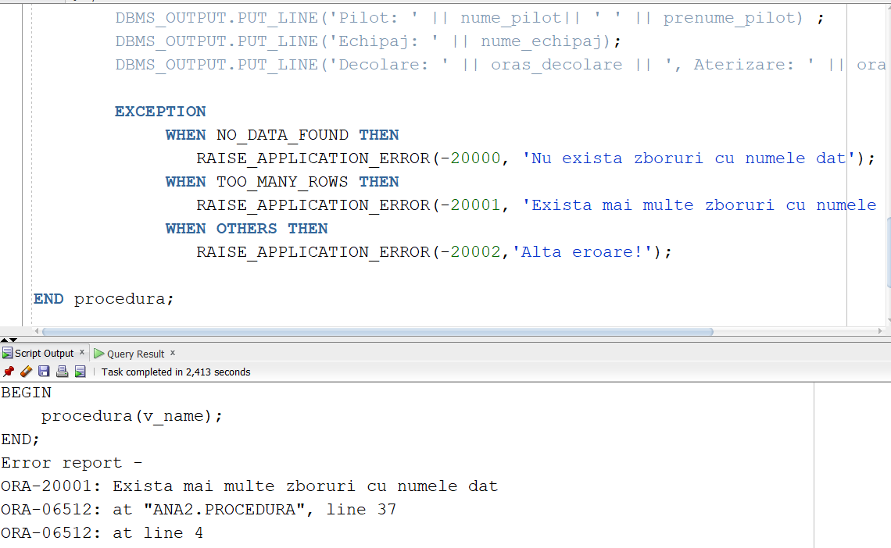

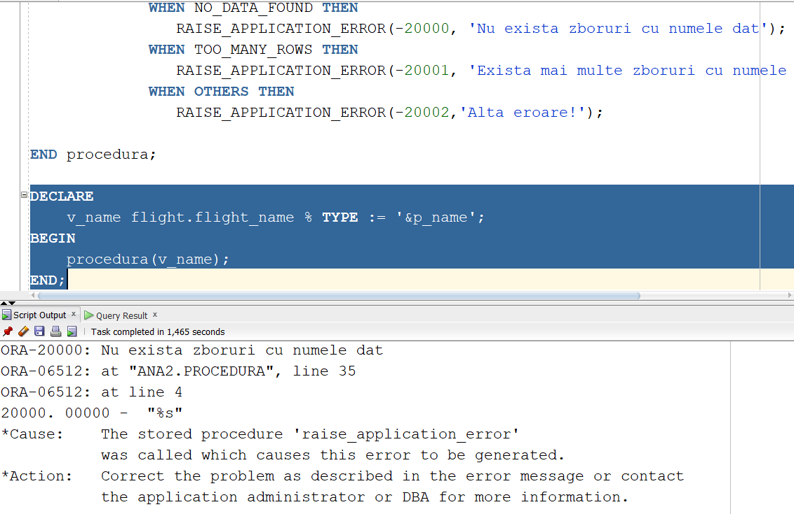

**CERINTA 10**

Definiți un trigger de tip LMD la nivel de comandă. Declanșați trigger-ul.

--EXERCITIUL 10--------------------------------------------------------------------

-- Definiți un declanșator prin care să nu se permită inserarea, stergerea

-- sau actualizarea tabelei route in afara programului de lucru

CREATE OR REPLACE TRIGGER trig

BEFORE INSERT OR DELETE OR UPDATE on route

BEGIN

IF TO_CHAR(SYSDATE,'HH24') NOT BETWEEN 17 AND 20 THEN

IF INSERTING THEN

RAISE_APPLICATION_ERROR(-20001,'Inserarea in tabele este permisa doar in timpul programului de lucru!');

ELSIF DELETING THEN

RAISE_APPLICATION_ERROR(-20002,'Stergerea din tabel este permisa doar in timpul programului de lucru!');

ELSE

RAISE_APPLICATION_ERROR(-20003,'Actualizarile in tabel sunt permise doar in timpul programului de lucru!');

END IF;

END IF;

END;

--INSERARE

INSERT INTO route(route_id, departure_city, arrival_city)

VALUES(6, 'Munchen', 'Napoli');

--STERGERE

DELETE FROM route WHERE departure_city = 'Bucuresti';

--ACTUALIZARE

UPDATE route

SET departure_city = 'Munchen'

WHERE arrival_city = 'Sibiu';

DROP TRIGGER trig;

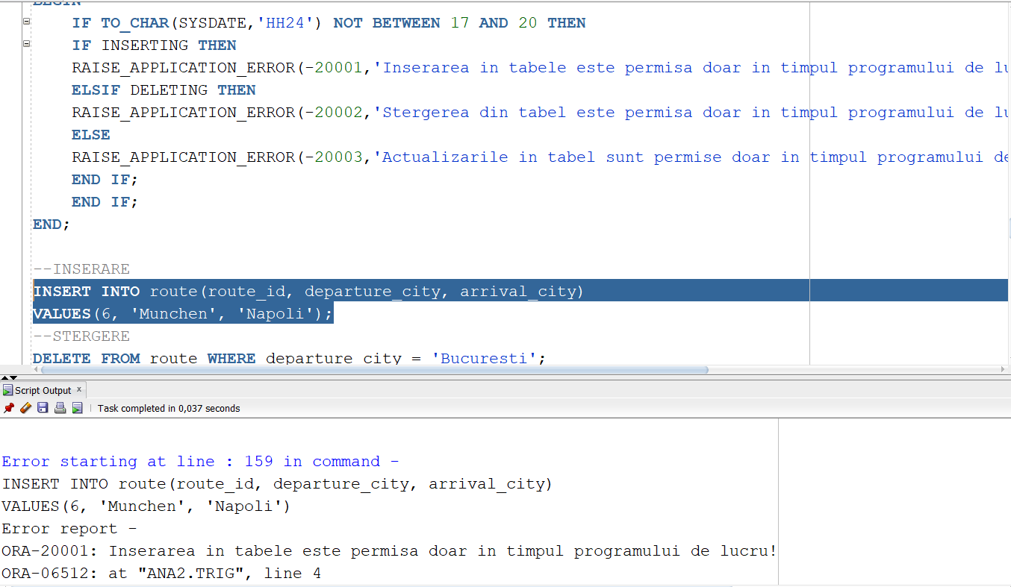

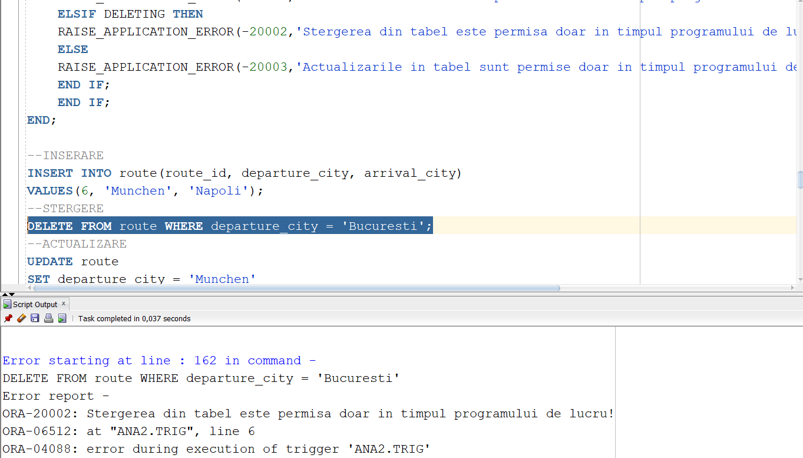

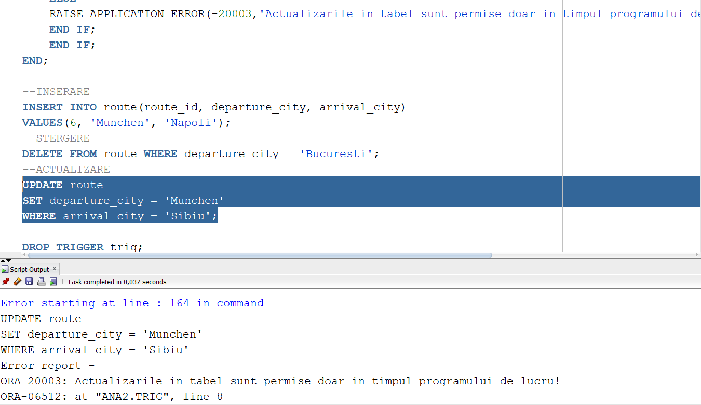

**CERINTA 11**

Definiți un trigger de tip LMD la nivel de linie. Declanșați trigger-ul.

--EXERCITIUL 11--------------------------------------------------------------------

-- Definiți un declanșator prin care să nu se permită micsorarea sau marirea

-- numarului de locuri din tabela airplane

CREATE OR REPLACE TRIGGER trig2

BEFORE UPDATE OF seats_number ON airplane

FOR EACH ROW

WHEN (NEW.seats_number <> OLD.seats_number)

BEGIN

RAISE_APPLICATION_ERROR(-20002,'Numarul de locuri al unui avion nu poate fi modificat');

END;

UPDATE airplane

SET seats_number = seats_number + 200;

UPDATE airplane

SET seats_number = seats_number - 100;

DROP TRIGGER trig2;

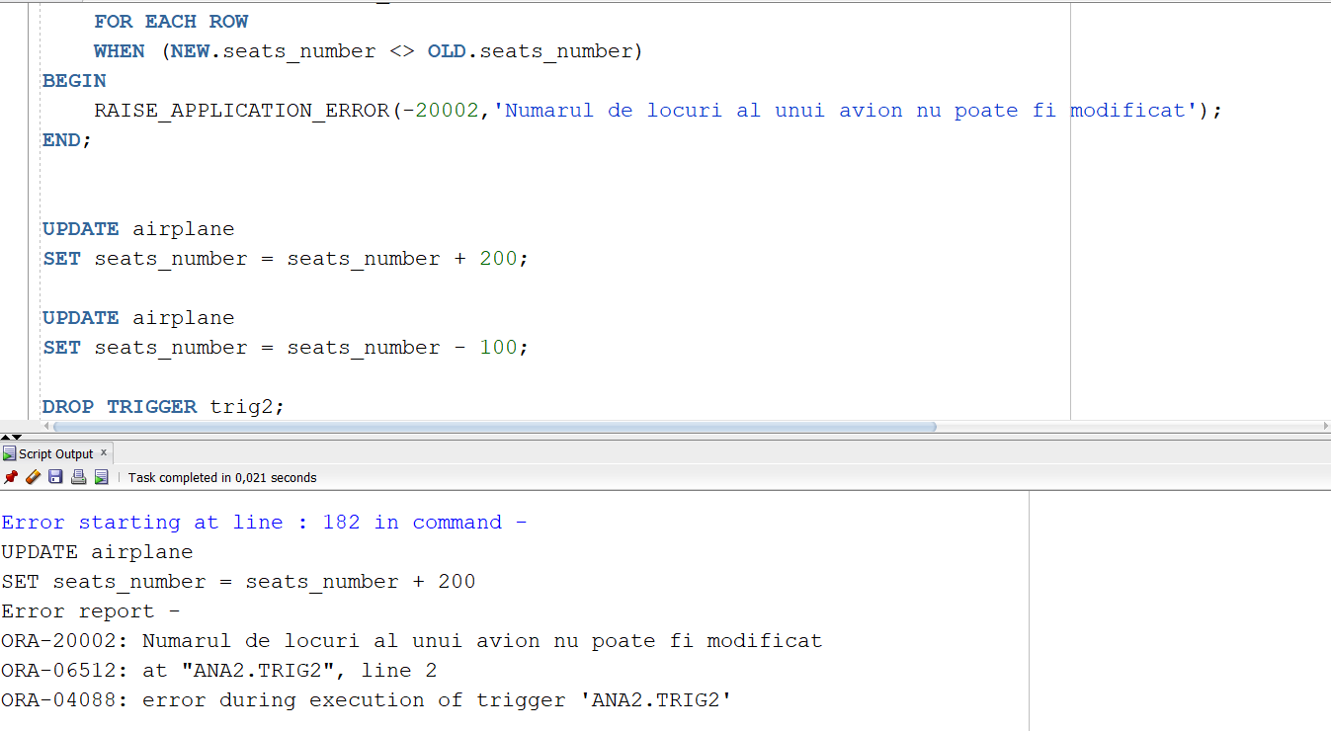

**CERINTA 12**

Definiți un trigger de tip LDD. Declanșați trigger-ul.

--EXERCITIUL 12----------------------------------------------------------------------------

-- Definiți un declanșator care să introducă date în tabela audit_user după ce

-- utilizatorul a folosit o comandă LDD

CREATE TABLE audit_user

(

bd_name VARCHAR2(30),

ddl_date TIMESTAMP(3),

ddl_user VARCHAR2(30),

object_type VARCHAR(30),

object_name VARCHAR2(30),

ddl_event VARCHAR2(30)

);

CREATE OR REPLACE TRIGGER trig_audit

AFTER CREATE OR DROP OR ALTER ON SCHEMA

BEGIN

INSERT INTO audit_user VALUES(

SYS.DATABASE_NAME,

SYSTIMESTAMP(3),

SYS.LOGIN_USER,

SYS.DICTIONARY_OBJ_TYPE,

SYS.DICTIONARY_OBJ_NAME,

SYS.SYSEVENT

);

END;

--CREATE

CREATE TABLE tabel (coloana_1 number(2));

--ALTER

ALTER TABLE tabel ADD (coloana_2 number(2));

INSERT INTO tabel VALUES (1,2);

--CREATE INDEX

CREATE INDEX ind_tabel ON tabel(coloana_1);

SELECT * FROM audit_user;

DROP TRIGGER trig_audit;

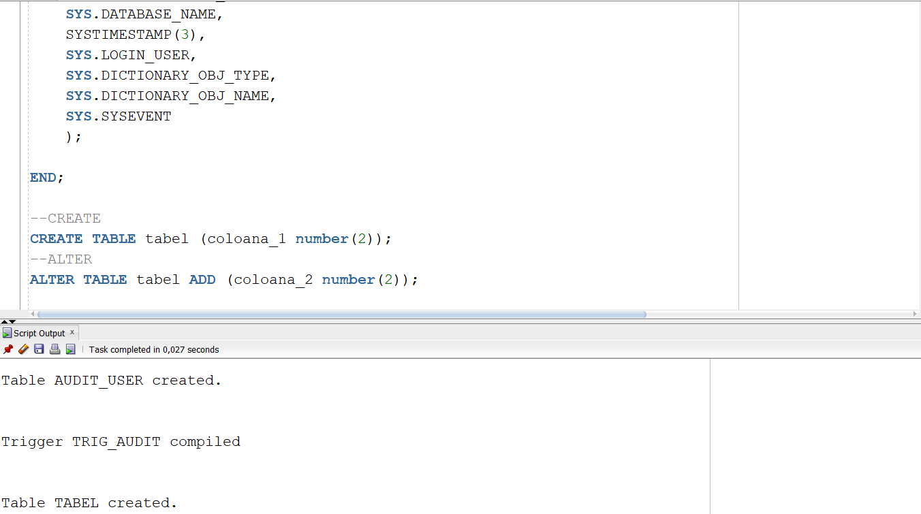

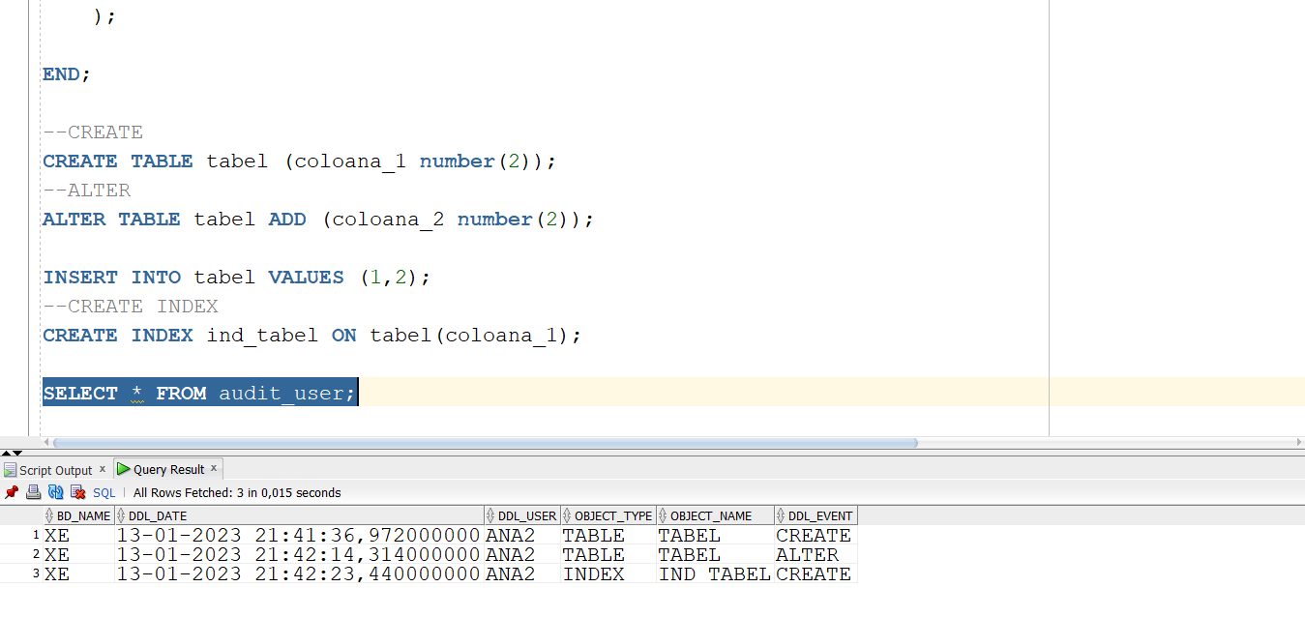

**CERINTA 13**

Definiți un pachet care să conțină toate obiectele definite în cadrul proiectului.

--EXERCITIUL 13-----------------------------------------------------------------

CREATE OR REPLACE PACKAGE pachet as

--6

PROCEDURE InformatiiZbor;

--7

PROCEDURE CompaniiAeriene;

--8

FUNCTION functie(v_flight_name flight.flight_name%TYPE) RETURN NUMBER;

--9

PROCEDURE procedura(v_flight_name flight.flight_name%TYPE);

end pachet;

CREATE OR REPLACE PACKAGE BODY pachet AS

--6

PROCEDURE InformatiiZbor

IS

TYPE zboruri is varray(101) of number;

type ZBOR is record

(flight_id flight.flight_id%type,

departure_date flight.departure_date%type,

departure_time flight.departure_time%type,

arrival_date flight.arrival_date%type,

arrival_time flight.arrival_time%type);

record ZBOR;

v_zboruri zboruri;

BEGIN

--selectam zborurile care au ca unul din piloti pe Adrian Munteanu

select distinct

f.flight_id

bulk collect into

v_zboruri

from flight_pilot f

where (select last_name

from pilot p

where p.pilot_id=f.pilot_id) = 'Munteanu'

and (select first_name

from pilot p

where p.pilot_id=f.pilot_id) = 'Adrian';

FOR I IN v_zboruri.FIRST..v_zboruri.LAST LOOP

select flight_id, departure_date, departure_time, arrival_date, arrival_time

into record

from flight

where flight_id=v_zboruri(i);

DBMS_OUTPUT.PUT_LINE('Zborul cu id-ul ' || record.flight_id || ' decoleaza pe data de ' || record.departure_date ||

' la ora ' || record.departure_time || ' si ajunge pe data de ' || record.arrival_date || ' ora ' || record.arrival_time);

end loop;

end InformatiiZbor;

--7

PROCEDURE CompaniiAeriene

IS

v_x number(4) := &p_x;

v_nr number(4);

v_nume airline.airline_name%TYPE;

CURSOR c (parametru NUMBER) IS

SELECT airline_name nume, COUNT(airplane_id) nr

FROM airline a, airplane b

WHERE a.airline_id=b.airline_id

GROUP BY airline_name

HAVING COUNT(airplane_id) > parametru;

v_nr2 number(4);

v_nume2 airline.airline_name%TYPE;

CURSOR c2 IS

SELECT model_name nume2, COUNT(flight_id) nr2

FROM airplane a, flight f

WHERE a.airplane_id=f.airplane_id

GROUP BY model_name;

BEGIN

OPEN c(v_x);

LOOP

FETCH c INTO v_nume, v_nr;

EXIT WHEN c%NOTFOUND;

DBMS_OUTPUT.PUT_LINE('Compania aeriana '|| v_nume || ' detine ' || v_nr || ' avioane');

END LOOP;

CLOSE c;

DBMS_OUTPUT.PUT_LINE(' ');

OPEN c2;

LOOP

FETCH c2 INTO v_nume2, v_nr2;

EXIT WHEN c2%NOTFOUND;

DBMS_OUTPUT.PUT_LINE('Avionul '|| v_nume2 || ' a efectuat ' || v_nr2 || ' zboruri');

END LOOP;

CLOSE c2;

end CompaniiAeriene;

--8

FUNCTION functie

(v_flight_name flight.flight_name%TYPE)

RETURN NUMBER IS

varsta pilot.age%type;

data_decolare flight.departure_date%type;

BEGIN

--select pentru aruncarea exceptiilor

select departure_date into data_decolare from flight

where flight_name = v_flight_name;

SELECT avg(age) into varsta from

pilot p join flight_pilot fp on p.pilot_id = fp.pilot_id

join flight f on fp.flight_id = f.flight_id

WHERE flight_name = v_flight_name;

return varsta;

EXCEPTION

WHEN NO_DATA_FOUND THEN

RAISE_APPLICATION_ERROR(-20000, 'Nu exista zboruri cu numele dat');

WHEN TOO_MANY_ROWS THEN

RAISE_APPLICATION_ERROR(-20001, 'Exista mai multe zboruri cu numele dat');

WHEN OTHERS THEN

RAISE_APPLICATION_ERROR(-20002,'Alta eroare!');

END functie;

--9

PROCEDURE procedura

(v_flight_name flight.flight_name%TYPE)

IS

data_decolare flight.departure_date%type;

nume_zbor flight.flight_name%type;

prenume_pilot pilot.first_name%type;

nume_pilot pilot.last_name%type;

nume_echipaj cabin_crew.crew_name%type;

oras_decolare route.departure_city%type;

oras_aterizare route.arrival_city%type;

BEGIN

--select pentru aruncarea exceptiilor

select departure_date into data_decolare from flight

where flight_name = v_flight_name;

SELECT

flight_name, first_name, last_name, crew_name, departure_city, arrival_city

into nume_zbor, prenume_pilot, nume_pilot, nume_echipaj, oras_decolare, oras_aterizare

from flight f

join flight_pilot fp on f.flight_id = fp.flight_id

join pilot p on fp.pilot_id = p.pilot_id

join cabin_crew c on c.cabin_crew_id = f.cabin_crew_id

join route r on r.route_id = f.route_id

WHERE flight_name = v_flight_name;

DBMS_OUTPUT.PUT_LINE(nume_zbor);

DBMS_OUTPUT.PUT_LINE('Pilot: ' || nume_pilot|| ' ' || prenume_pilot) ;

DBMS_OUTPUT.PUT_LINE('Echipaj: ' || nume_echipaj);

DBMS_OUTPUT.PUT_LINE('Decolare: ' || oras_decolare || ', Aterizare: ' || oras_aterizare);

EXCEPTION

WHEN NO_DATA_FOUND THEN

RAISE_APPLICATION_ERROR(-20000, 'Nu exista zboruri cu numele dat');

WHEN TOO_MANY_ROWS THEN

RAISE_APPLICATION_ERROR(-20001, 'Exista mai multe zboruri cu numele dat');

WHEN OTHERS THEN

RAISE_APPLICATION_ERROR(-20002,'Alta eroare!');

END procedura;

end pachet;

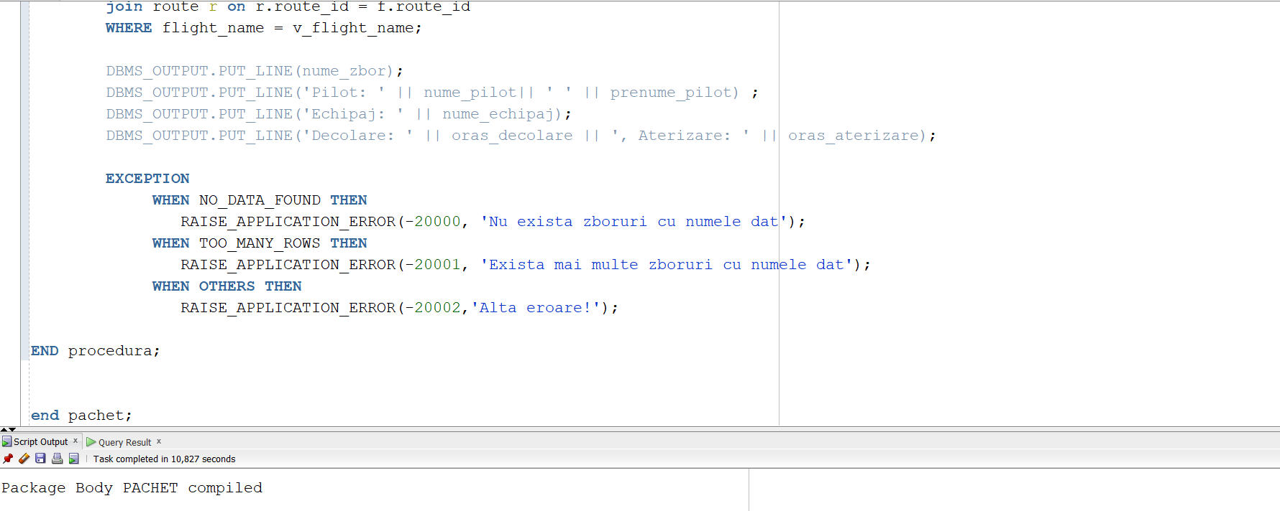

**CERINTA 14**

Definiți un pachet care să includă tipuri de date complexe și obiecte necesare unui flux de acțiuni integrate, specifice bazei de date definite (minim 2 tipuri de date, minim 2 funcții, minim 2 proceduri).

--EXERCITIUL 14-----------------------------------------------------------------

CREATE OR REPLACE PACKAGE pachet2 as

--functii

FUNCTION f_airplane(id_avion airplane.airplane_id%TYPE)

RETURN VARCHAR2;

FUNCTION f_airline(nume_companie airline.airline_name%TYPE)

RETURN NUMBER;

--proceduri

PROCEDURE p3(nume_pilot pilot.last_name%TYPE, prenume_pilot pilot.first_name%TYPE);

PROCEDURE InformatiiRuta;

end pachet2;

CREATE OR REPLACE PACKAGE BODY pachet2 AS

--functii

FUNCTION f_airplane(id_avion airplane.airplane_id%TYPE)

RETURN VARCHAR2 is nume VARCHAR2(30);

BEGIN

SELECT model_name INTO nume

FROM airplane

WHERE id_avion = airplane_id;

return nume;

EXCEPTION

WHEN NO_DATA_FOUND THEN

RAISE_APPLICATION_ERROR(-20000, 'Date introduse gresit!');

return null;

WHEN OTHERS THEN

RAISE_APPLICATION_ERROR(-20001,'Alta eroare!');

return null;

END f_airplane;

FUNCTION f_airline(nume_companie airline.airline_name%TYPE)

RETURN NUMBER is numar NUMBER;

BEGIN

SELECT airline_id INTO numar

FROM airline

WHERE nume_companie = airline_name;

return numar;

EXCEPTION

WHEN NO_DATA_FOUND THEN

RAISE_APPLICATION_ERROR(-20000, 'Date introduse gresit!');

return null;

WHEN TOO_MANY_ROWS THEN

RAISE_APPLICATION_ERROR(-20000,'Exista mai multe companii aeriene cu numele dat');

return null;

WHEN OTHERS THEN

RAISE_APPLICATION_ERROR(-20001,'Alta eroare!');

return null;

END f_airline;

--proceduri

PROCEDURE p3(nume_pilot pilot.last_name%TYPE, prenume_pilot pilot.first_name%TYPE)

IS experienta pilot.experience%TYPE;

BEGIN

SELECT experience INTO experienta

FROM pilot

WHERE last_name = nume_pilot and first_name = prenume_pilot;

DBMS_OUTPUT.PUT_LINE('Experienta de ' || experienta || ' ani');

EXCEPTION

WHEN NO_DATA_FOUND THEN

DBMS_OUTPUT.PUT_LINE('Nu exista pilot cu numele dat');

WHEN TOO_MANY_ROWS THEN

DBMS_OUTPUT.PUT_LINE('Exista mai multi piloti cu numele dat');

WHEN OTHERS THEN

DBMS_OUTPUT.PUT_LINE('Alta eroare!');

END p3;

PROCEDURE InformatiiRuta

IS

TYPE rute is varray(101) of number;

type RUTA is record

(oras_decolare route.departure_city%type,

oras_aterizare route.arrival_city%type);

record RUTA;

v_rute rute;

id_ruta route.route_id%type;

BEGIN

--selectez id-ul rutelor care are unul din orase Bucuresti

SELECT DISTINCT

route_id

bulk collect into

v_rute

FROM route

WHERE departure_city = 'Bucuresti' or arrival_city = 'Bucuresti';

FOR I IN v_rute.FIRST..v_rute.LAST LOOP

select departure_city, arrival_city

into record

from route

where route_id=v_rute(i);

DBMS_OUTPUT.PUT_LINE('Ruta: ' || record.oras_decolare || ' - ' || record.oras_aterizare);

end loop;

end InformatiiRuta;

end pachet2;

