How to deploy contracts

1) Start up your Mist wallet
2) Once started, click the “Contracts” button

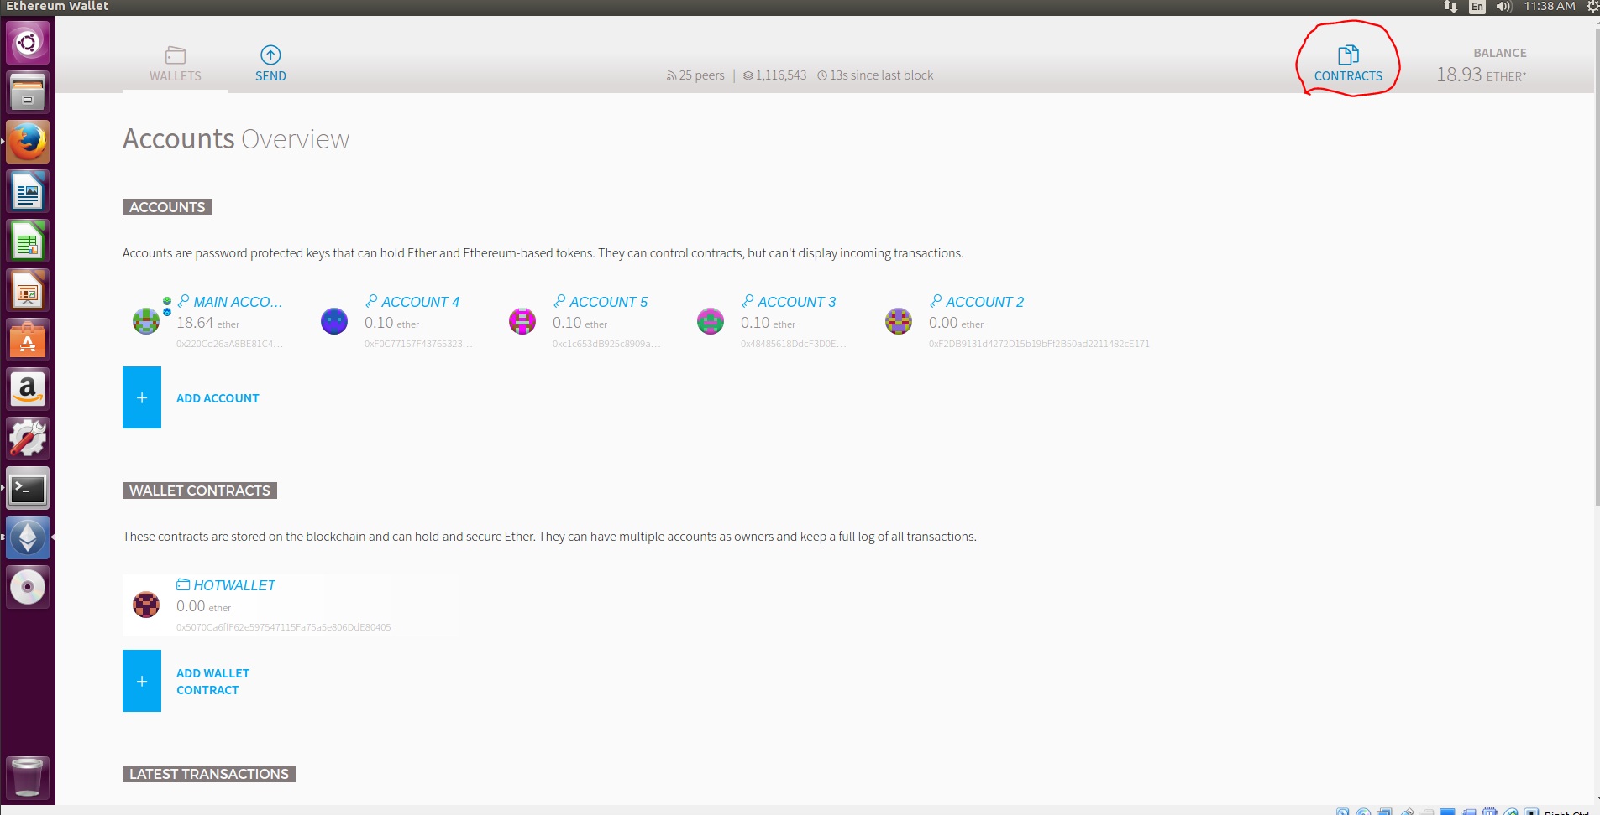
3) Once in the contracts menu, click “Deploy Contract”

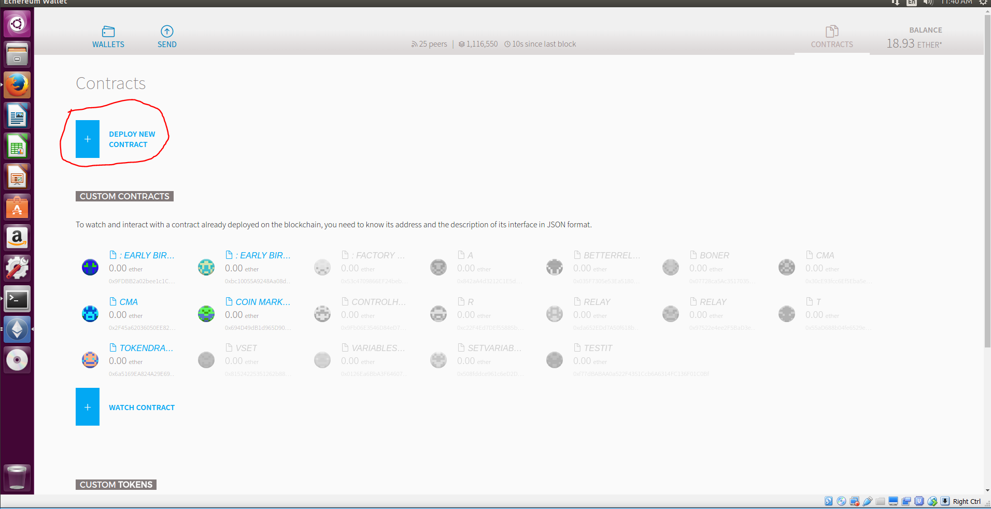

4) Click ‘Contract Byte Code, copying the contents of the .bin file, pasting it into the text box

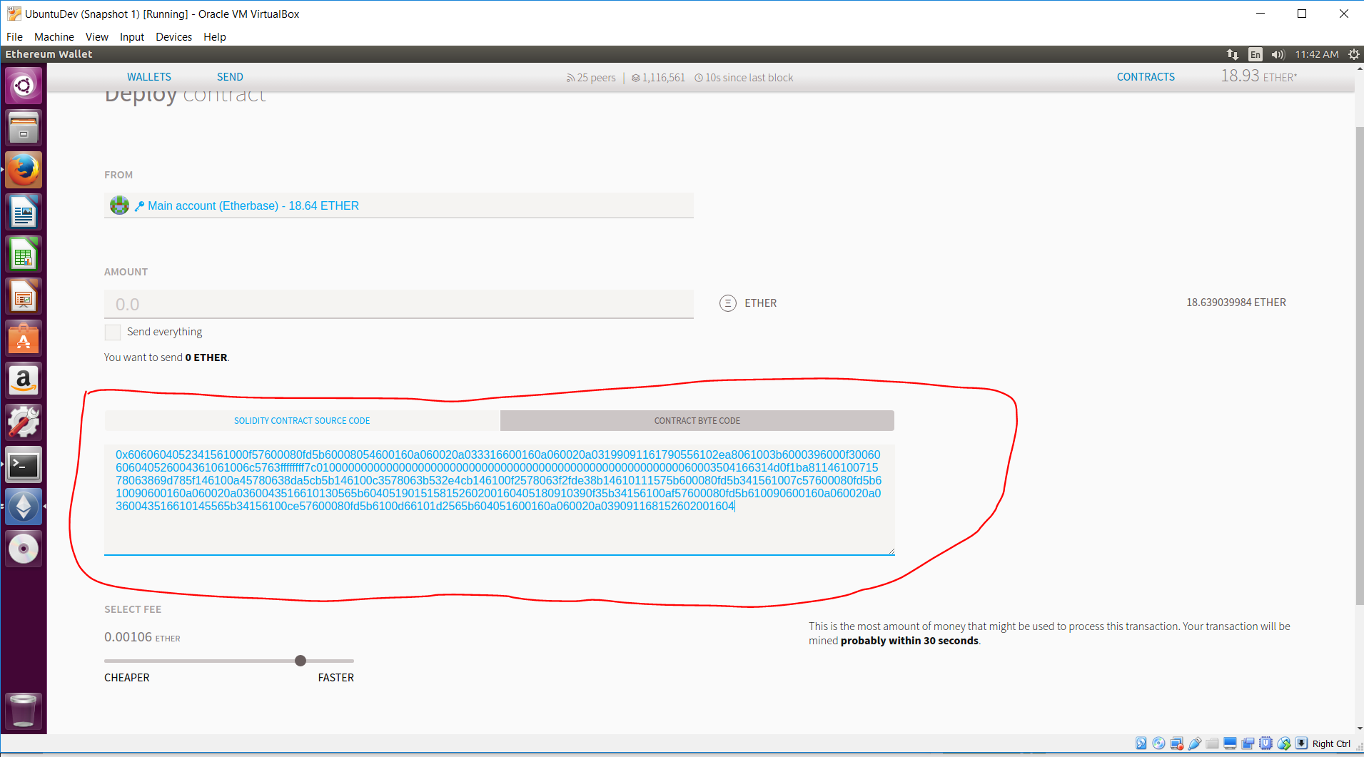
5) In the ‘From’ field, select the account you want to use to deploy the contract from and subsequently, be the default owner (this is changeable later)

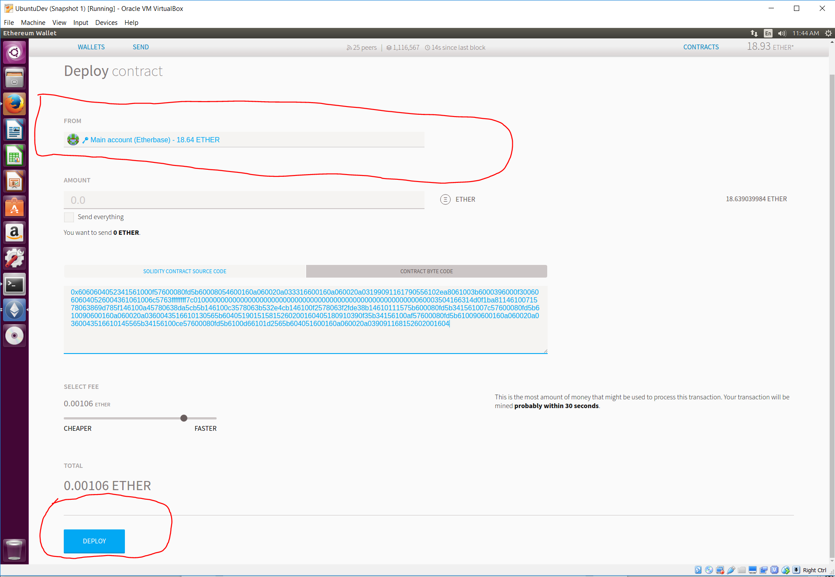
6) After the contract has been deployed, you will need to watch the contract in order to contro lit. To do that, go back to the contracts menu, clicking the “Watch Contract” button
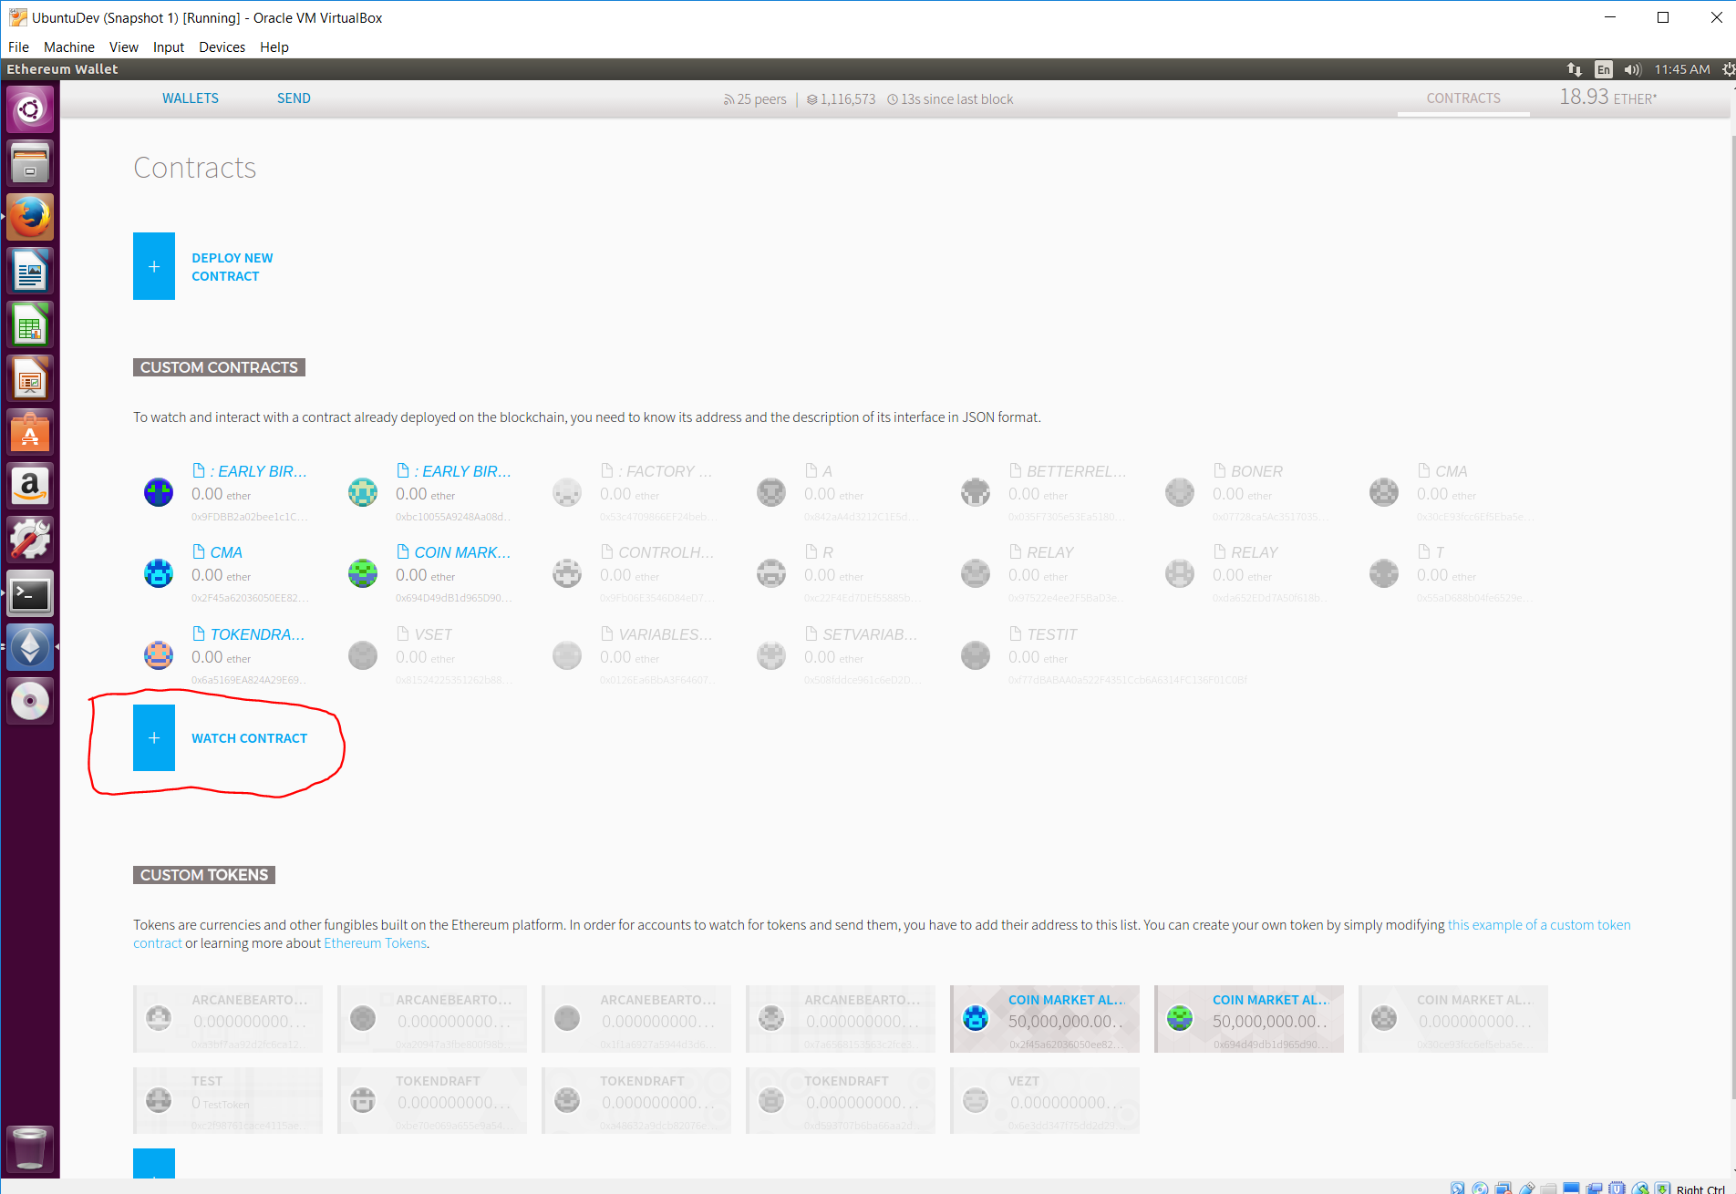
7) Paste the address of the contract into the ‘Contract Address’ tex box, picking any name you want. Where it asks for the ‘JSON Interface’, take the contents of the associated .abi file, and paste it into that interface
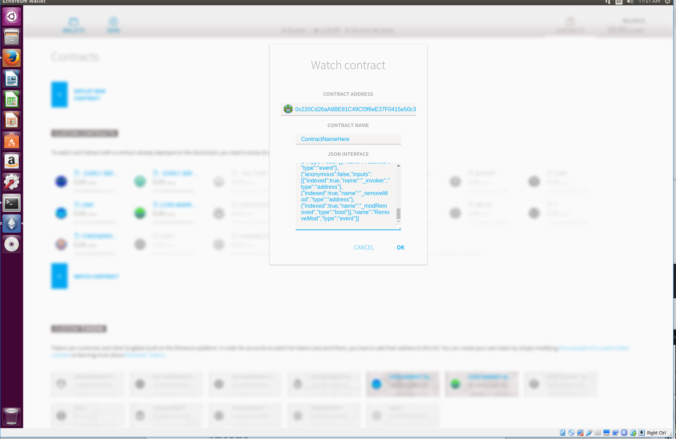
8) Your contract is now deployed and controllable

