How To Watch A Token Deploy With Bytecode

1) After deploying your token contract with bytecode, you’ll notice that the coin doesn’t automatically show up in your wallet balance. By following the previous document you’ll have deployed, and watched the contract itself. But that doesn’t make the token balance show up in your wallet.

2) Open Mist, and navigate to the ‘Contracts’ tab
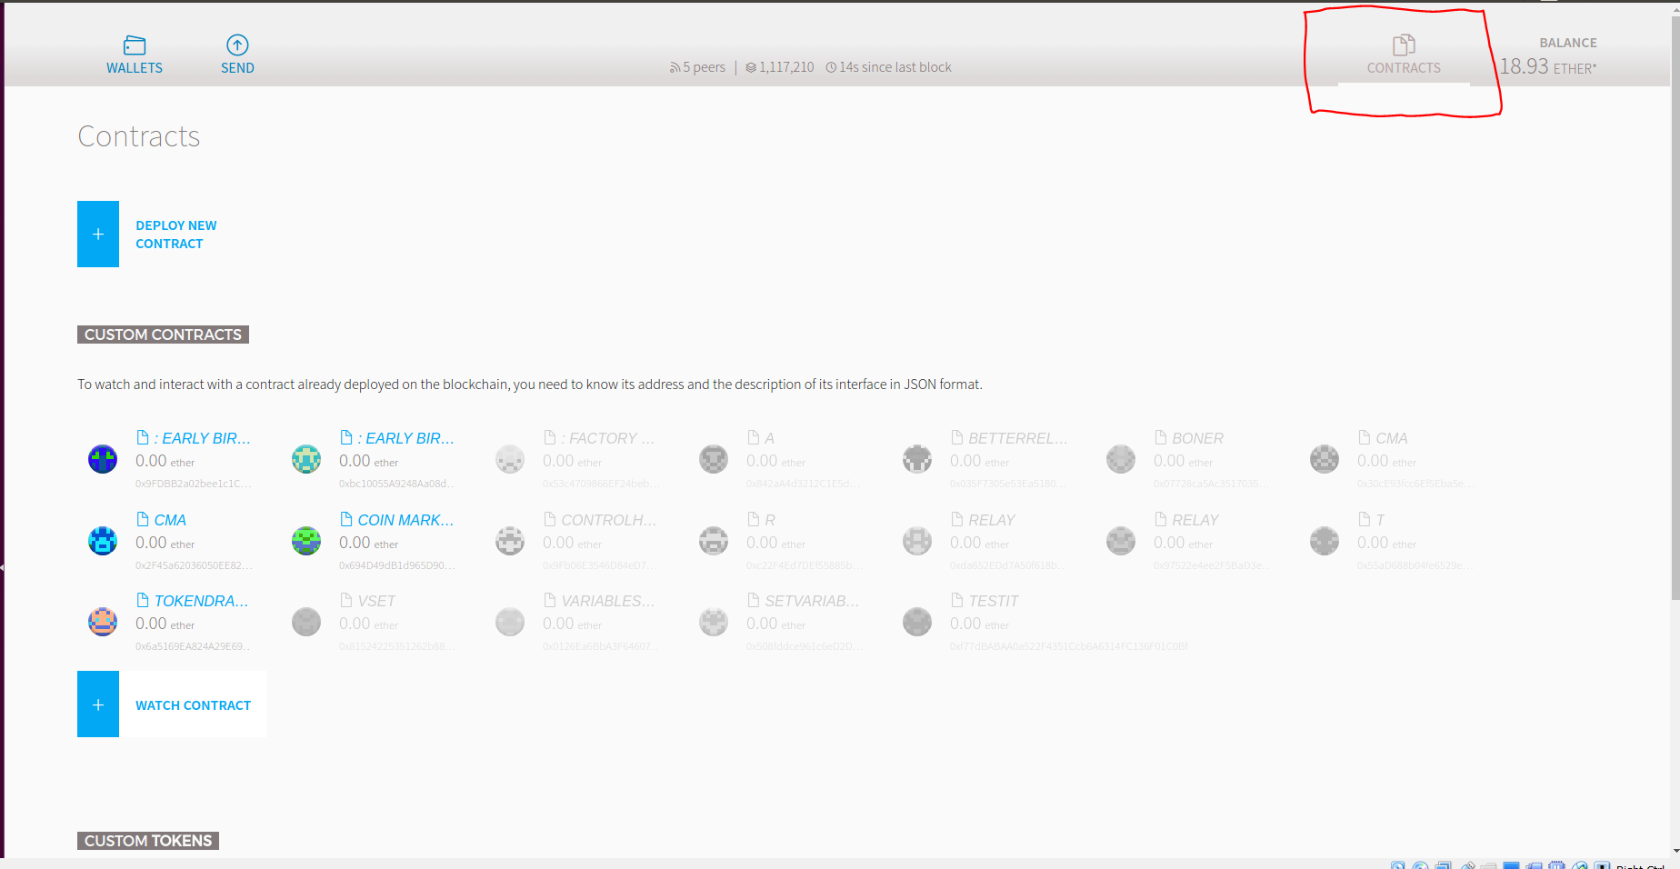
3) At the bottom of this window, there is a button called ‘Watch Token’ that lets you watch custom tokens. To do this, simply click the button, pasting the token contract address into the address field and it’ll populate the relevant fields automatically!

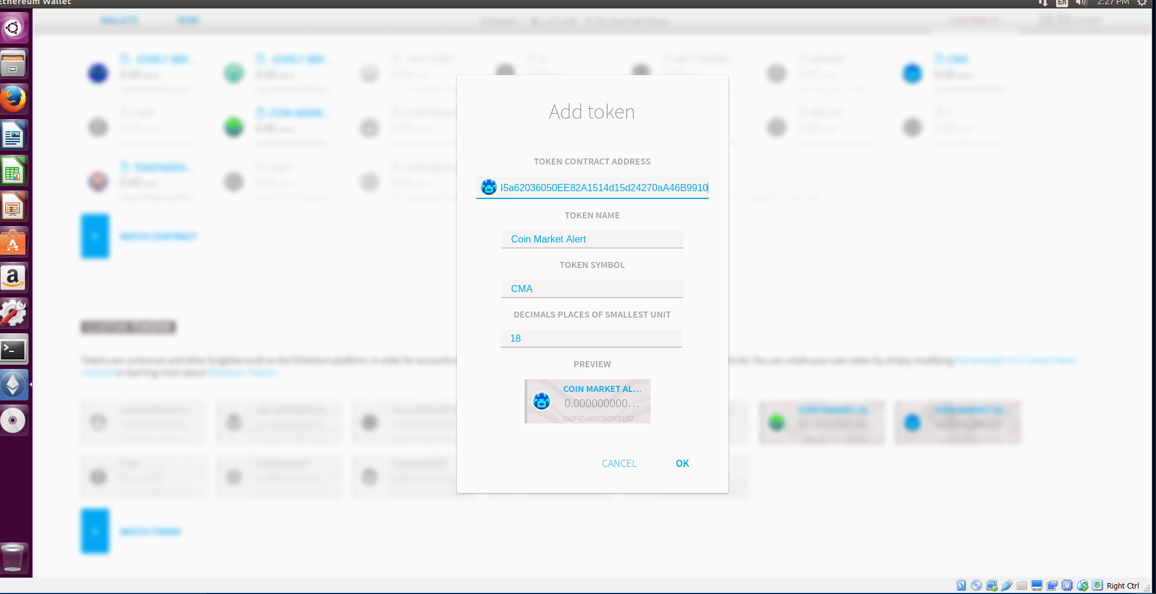

4) After that, your balance will be displayed in your wallet!

