Brendan O’Neil 11/11/2020

## ExodusPoint Case Study – CFTC Bond Futures Data

In this document I work through my process for analyzing a dataset for predictive features, constructing signals and backtesting them.

### Reading and Cleaning Data

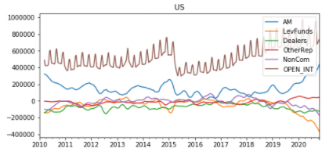First step is to read the data out of the excel file[1] and visually inspect it for oddities using basic timeseries plots and scatterplots. The only thing that stood out to me was a sharp decline in the open interest for the US contract in early 2015, it sounded vaguely familiar and I found the CME document explaining why[2].

Next I consider the swap data, given what happens to the deliverable basket for US I decide to adjust its relevant swap data to be the 15y swap rate 2010 –March 2015, and then linearly interpolate the swap maturity from 20y starting March 16, 2015 down to the 15y rate at current (using weighting determined by that interpolation, and subtract the ‘roll’ from all subsequent datapoints to get a clean series)[3]. I use a simple average between the 20y and 30y rate for WNs and accept 2y, 5y and 7y are close enough for TU, FV and TY, respectively.

I look at a PCA and correlation matrices of the weekly changes in positioning to get a sense for the relationships involved. I consider Asset Managers, Leveraged Funds, Dealers and NonCommercial data since Other Reportables are relatively small and Commercial is close to just the other side of NonCommercial positioning. NonCommercial is considered as a proxy for speculators in general with respect to the CoT data. With the TY contract, for example, **PC1 and PC2 explain around 85%** of the variance in positioning changes. One might interpret them as:

**PC1: Asset Manager changes in positioning are offloaded to speculators**

**PC2: Buyside manager changes in positioning are taken down by dealers**

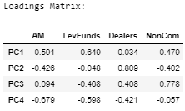We will find later issues with collinearity in the data, even after removing some of the market participants, and techniques like principal components regression are commonly used to deal with this issue. In the interest of time and maintaining a better intuition in the data I decided to go another route.

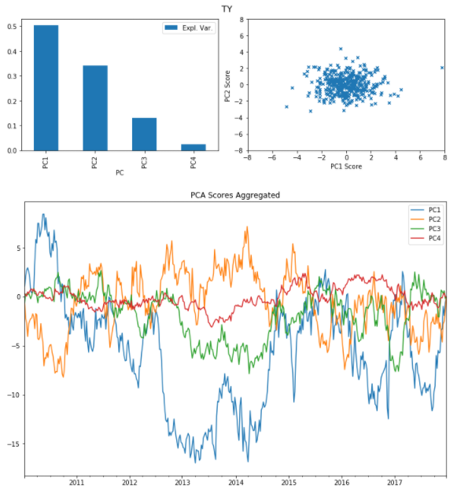

### Initial Contemporaneous Analysis

The first question I would like to answer is whether the CoT positioning data has significant explanatory value in analyzing contemporaneous changes in yields (as proxied by swaps). Before I start looking at the data more closely I remove all of the samples from 2018 onward- I will **want an untouched out of sample period to test my in-sample findings** on unseen data, about 25% of the data is reasonable.[4]

For starters I want to normalize my data to some extent to make it more comparable across contracts. I try both weighting the positions by dv01[5] and as a percentage of the average trailing open interest[6]. For the rest of the work I consider the dv01 weighted values[7]. For all contracts looking at weekly changes in positioning, we get the relationships we might expect- changes in AM positioning are taken down by speculators and dealers on average.

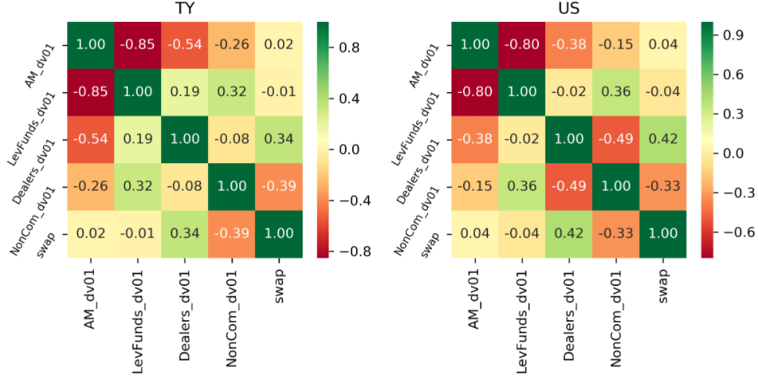

#### Ordinary Least Squares

I regress 1wk Tuesday changes in the relevant swap series for each contract against its corresponding futures contract positioning changes from AM, LevFunds, Dealers and the swap change lagged 1 week, to account for autocorrelation of changes in yield. As we see below, there might be some relationship with changes in dealer positioning and the lagged change, but there are clearly **large collinearity issues**, so we can only conclude that the t-statistics are not robust and the betas are unlikely to be numerically stable. As discussed before, we could try principal components regression to deal with this, but I prefer to use a regularization technique like Ridge or Lasso.

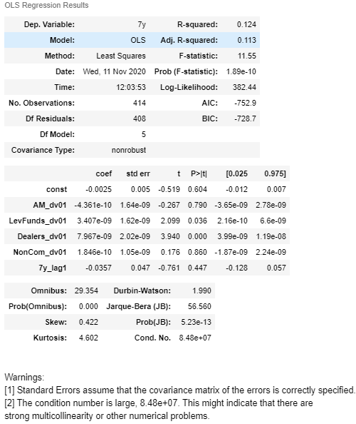

#### Lasso

I like to use Lasso in these cases. It is different from OLS in that it penalizes each beta in the objective function so that the betas are shrunk until their explanatory power outweighs the penalization. This helps significantly in cases such as this, where for example AM and LevFunds positioning are highly negatively correlated. **Lasso also behaves like a simple feature selector** in that it will shrink betas to 0 for data it does not find useful out of sample. How much penalization to use is evaluated using a time series cross validation process, where the model is fit on a rolling window and evaluated on a subsequent period of (somewhat) out of sample data. The penalization parameter that best fits the out of sample periods on average is selected. The penalization (regularization) parameter is called alpha, in the charts to the right increasing alpha means more penalization of betas. For this to work properly we first need to normalize our features to z-scores so that the penalization affects them equally. [8]

In the case of 1wk changes in TY positions and swap rates on the right, the **betas load negatively on AM** (increase in AM positioning implies rally) for -1.5bps per z-score AM positioning change**,** and **positively on Dealers** for 1.2bps. Note how small the predictions are (in blue) versus the actual changes in orange below— **r^2 is very low**.

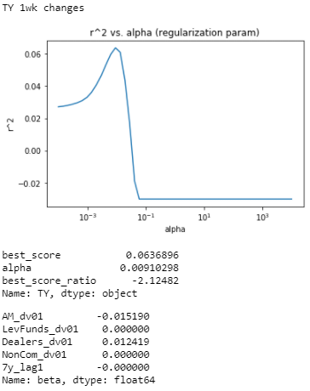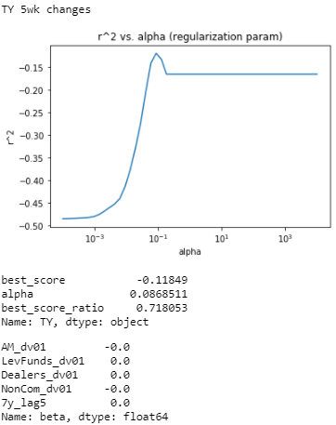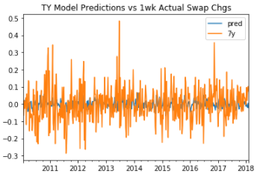**For 5wk changes** **nothing is selected** and the results are very poor. No fits do better out of sample than just taking the simple average of swap changes over the training period. This is incidated in a negative r^2 and 0 betas for the best model. **Other contracts exhibit similarly poor concurrent results.**

### Forward-looking Regressions

The next question is whether changes in positioning can predict future changes in swap rates. Since the coincident results were quite weak, I believe if there is going to be predictive power it will result from accumulations of positions over a rolling window. First, CoT data is collected on Tuesdays, but generally reported on Fridays. For this to be of value in predicting future changes **I need to align the data with when it is reported**, for simplicity I will shift it 3 business days forward in time. While the 1wk changes in positioning are clearly stationary, as we take changes over longer timeframes we are likely to run into issues with stationarity- in short we want to **avoid the problems associated with non-stationary data** and spurious regression. To analyze the stationarity of various window lengths of positioning data and swap rate changes, we apply augmented Dickey-Fuller tests[9] to evaluate whether the data is statistically different from a random walk. For brevity I do not show these here, I find that between 13 and 26 weeks the ADF p-values start to trend into the single percentage points, so I set a cutoff at not analyzing more than 13wk changes to be safe.

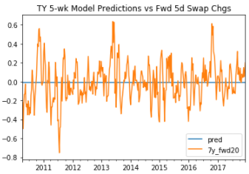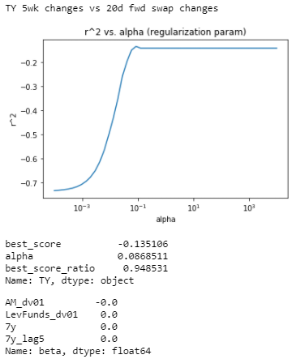**For all contracts, almost no combination of CoT data, change sampling frequency nor subsequent swap rate change window performs meaningfully different from guessing the average**. While I could mine the data for some relationship, the fact that it is not even somewhat consistent suggests to me there is little there.

### Extreme Value Analysis and Classification

Small changes in positioning might be contributing too much noise to the analysis. We can try filtering for only large changes in positioning data. We are also not necessarily interested in predicting the value of future changes in swap rates, but most importantly whether they rally or sell-off. For this purpose, **I** **change the problem to** **predicting the sign of the future change**, *weighted by the absolute value of the change[10]*. The intuition here is that we are interested in whether we can profit from our predictions, and we want to assign more weight to larger profits (and penalize larger losses). I use a simple logistic regression to start.

I run the same type of cross validation process with the filtered data for the adjusted problem across all the contracts on a few sets of position change windows and future swap change periods. The results are not particularly exciting, if there is any value in this data for outright duration it is not clear how different it is from a coin flip.

Below is a snap of the results of trying to predict the sign of subsequent 1mo swap changes using the normalized 13wk changes in LevFunds positioning, filtered for when it is greater in magnitude than +/- 1.0 z-score. Changing the forward window, the length of positioning changes, the filtering z-score and which positioning data to use, yield wildly different betas and weighted accuracy scores[11]. I will move forward, with reservations, using this setup for the US contract because the betas are intuitive**- the betas load positively on past changes in rate and negatively on past changes in LevFunds positioning** (so an increase in LevFunds correlates to future rallies in yield). This suggests **there might be a momentum indicator value**, though weak considering FV and TY are worse than coin flip and WN is barely any better.

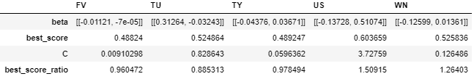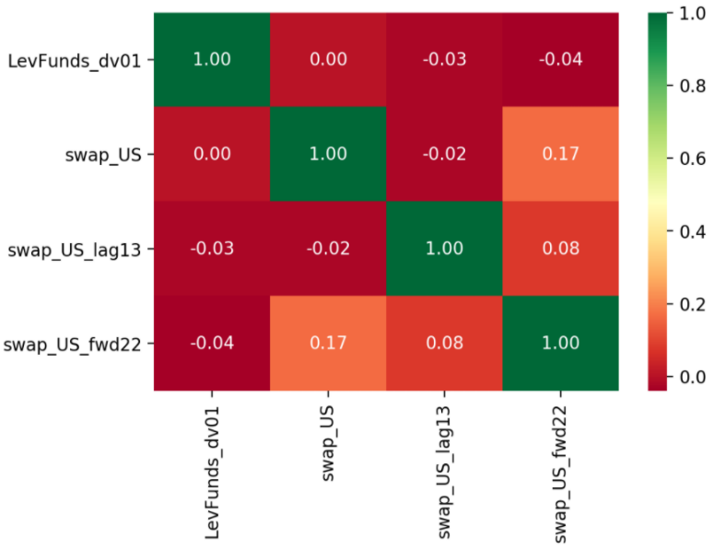At the bottom is the correlation matrix for 13wk changes in LevFunds z-score, 13wk changes in the interpolated swap rate corresponding to the US contract, the same value lagged 13wk and the forward 22d swap change, filtered for when the LevFunds change z-score is above +1 or below -1.

Below is the same setup, showing the **average changes in yield after the threshold is hit**, up to 60 trading days. It confirms, in-sample, that an 8-13wk change in US LevFunds positions greater than +/- 1.0 z-score is followed by a rally/sell-off in the 15-20y swap rate over the next couple months on average.

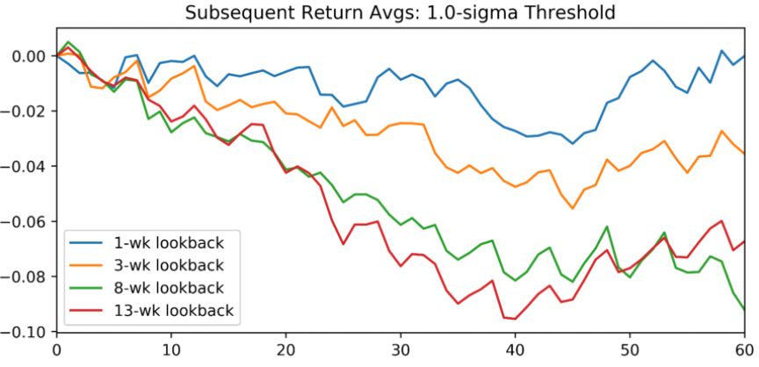

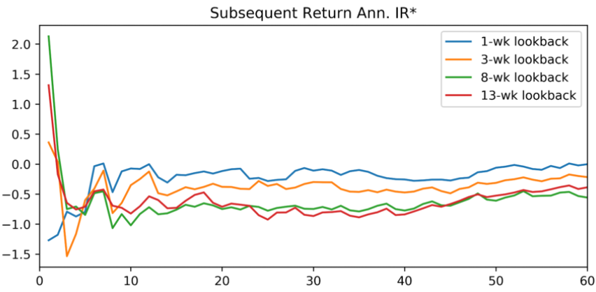

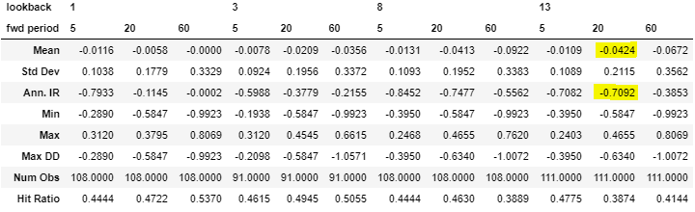

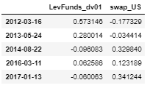The betas (right) of the logistic regression are **inconsistent over time**, which is concerning. This implies we would not have seen the same relationship at different points in time, so that if we were to have tried to run this strategy, we would be making very different decisions in real time.

### Backtest

To backtest the results of this research, I build an indicator series[12] composed of:

* Sign of the trailing 13wk LevFunds z-score filtered > +/- 1.0z AND
* Sign of the trailing 13wk change in swap rate filtered > +/- 0.1z

To trade this proxy for momentum, we will go ‘long’ the swap rate (short duration) when the LevFunds z-score is below -1.0 and the sign of the trailing 13wk swap rate change is positive, and short when the inverse is true. On the first pass, we hold the position for 40 trading days and close. This equity curve is to the right.

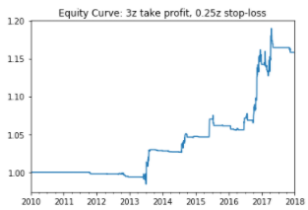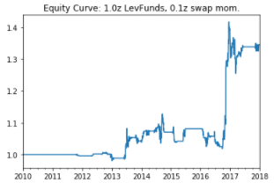Since it is a momentum type strategy, I set some take profit and stop loss rules on the strategy- when a trade is up 3x the daily std of 6m trailing rate moves, I take profit, and when it is down more than 0.25x the trailing vol, I cut losses (at the close rate, so the loss will be worse). It performs marginally better in sample.

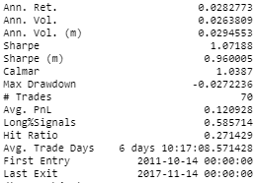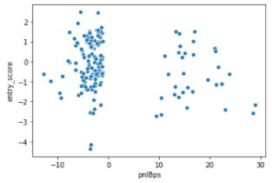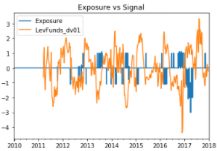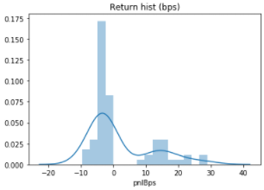Clearly the strategy has a high positive skew with most trades losing a little and a handful of big winners. Looking at the summary statistics, we see mostly positive results with a low hit rate, as expected since we optimized the strategy in-sample.

We also see some interesting results from the scatter and signal-response plot[13] of PnL against the entry signal z-score of LevFunds positioning changes. In an ideal scenario, we would see an S-curve from the bottom left to top right, indicating that highly negative entries correspond to larger negative future returns (that we would profit from by being short), and conversely that highly positive signals correspond to larger positive future returns.

In this case we see that **the bulk of the PnL is generated from large negative signals**, and large positive signals produce the worst bucket of strategy returns on average.

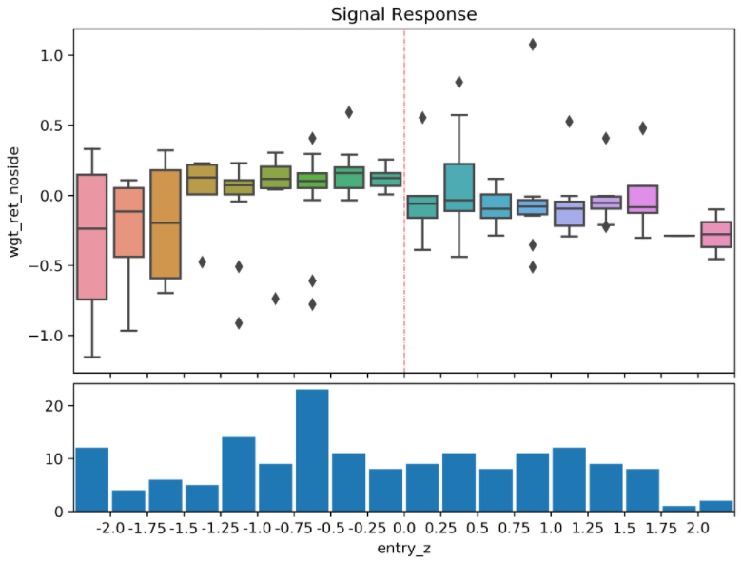

### Out of Sample Analysis and Conclusion

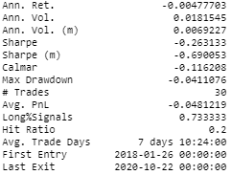The out of sample results are quite poor. There is a similar return profile but not enough winners to make up for the many small losers. In the end this is not particularly surprising given the in-sample results were not very stable under small modifications to the parameters. This is an important point with respect to avoiding overfitting a backtest- if there is the relationship between the data and future returns that is hypothesized, **the strategy should do similarly well in the local area of the parameter space**. This was not the case. Prior to setting take-profit and stop-loss conditions on the strategy, almost all the PnL was comprised of the days after the 2016 US elections.

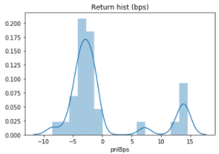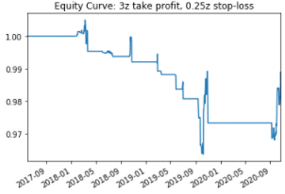

I found the same issues with coming up with a relationship to backtest in the first place- the **regression betas were not stable over time** for the same contract, **or between contracts** over the full data set. Simply looking at scatterplots of various positioning indicators versus forward returns suggested there would be little substance. There was not even a particularly meaningful relationship between contemporaneous changes in positioning and yields (although previous changes in swap rates seemed that they might have predictive power over changes in AM positioning).

Though careful to use rigorous methodology for evaluating relationships in a cross-validated framework, I was particularly guilty of **multiple testing bias** to identify any positioning indicator that might produce meaningful in-sample results. One can be rigorous in the practice of evaluating relationships on a rolling out-of-sample basis, but if you run 20 tests on the same data you have effectively completely polluted that check on your research. Further, I think one needs to consider that if the hypothesis is correct, why the opportunity has not been arbitraged away by market participants- the answer to this is not evident.

Finally, I tried similar methodologies for evaluating positioning signals for trading swap curves which were equally unsuccessful. I also tried richer models with many features (e.g. multiple positioning change horizons on all participants, polynomial transformations) for curves and outright to no avail. The next idea I would have looked at is using positioning to indicate when to close out a trade, e.g. if the signal flips sign, or trading butterflies. After that, I would have tried to use the positioning data to improve a more basic momentum strategy. The idea there would be to develop a momentum strategy and then use classification algorithms to evaluate whether a model based on positioning data can predict whether to lever up, scale down or cut a momentum trade early. I think, however, that if there was value in the data for trading duration or curves it would have been relatively clear by now.

Additional information that could make this potentially more valuable would be:

* Basis and invoice spreads positioning: i.e. how much of the change in positioning is due to trades that are unlikely to affect duration performance.
* Changes in positioning relative to flows in benchmarked fixed income mandates or index extension: how overweight/underweight the active fixed income community is more relevant to whether they might get squeezed or take profits. If we could adjust the positioning data for basis and spreads trades it would be most valuable for asset managers relative to their benchmark. I have seen studies trying to regress mutual fund performance against duration, curve, corporate spreads, etc. to try to gauge this.

### Appendix

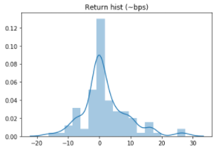The below charts show the results from a similarly overfit strategy on the US-FV curve, taking z-scores of the US and FV changes in LevFunds positioning changes over trailing 5wks and trading a momentum strategy off of it with no take-profit/stop-loss. Included in the sandbox-signals notebook under the “curve” headings.

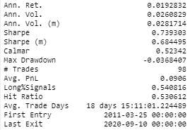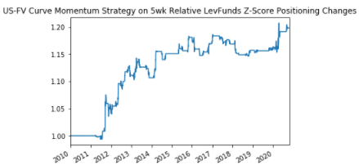 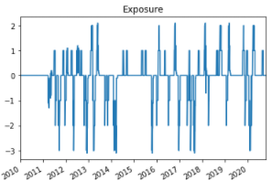

#### Notes on code:

* Most of the presentation material can be found in the python jupyter notebook under ExPtTest named sandbox-signals, including some other avenues I pursued.
* A substantial portion of the backtest evaluation code I had already written for my own understanding while independently studying Marcos Lopez de Prado’s book *Advances in Financial Machine Learning* over the past year or so. It is housed primarily in Research.signals.py, Preprocessing.etf_trick, Preprocessing.labeling, and Preprocessing.sampling. Since the backtest here was straightforward I could have written simpler code to achieve the same thing, but I figured I had it so I would use the time on other pieces of the presentation. For this reason, there is a substantial amount of largely irrelevant code included in labeling.py, sampling.py and signals.py.
* The regression and classification ‘machine-learning’ type code is housed primarily in Modelling.classification.py, some of this I had written before, but a substantial portion for fitting and scoring with sample weights I wrote to use on this project- I had been meaning to for some time because sci-kit learn does not implement that and it’s pretty useful for markets research.

#### Decision Boundaries

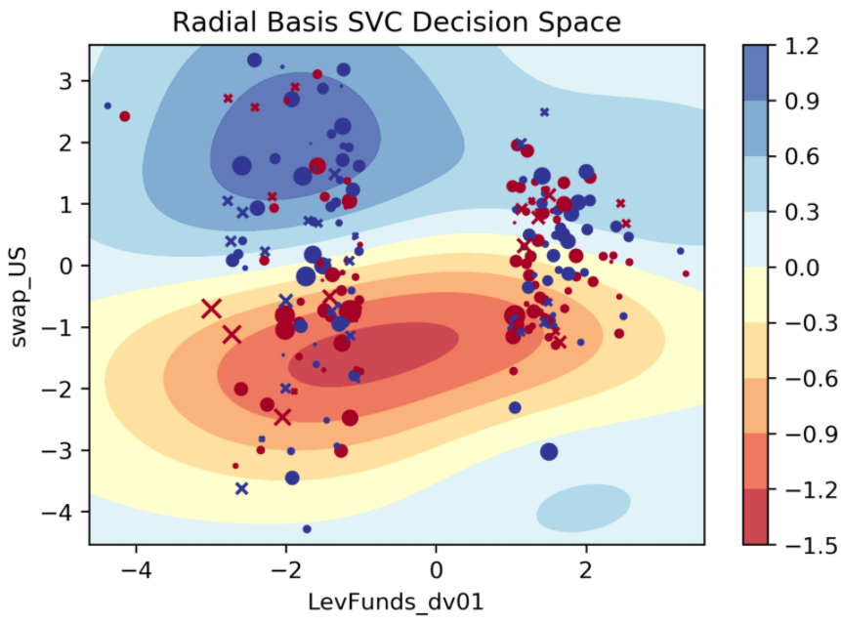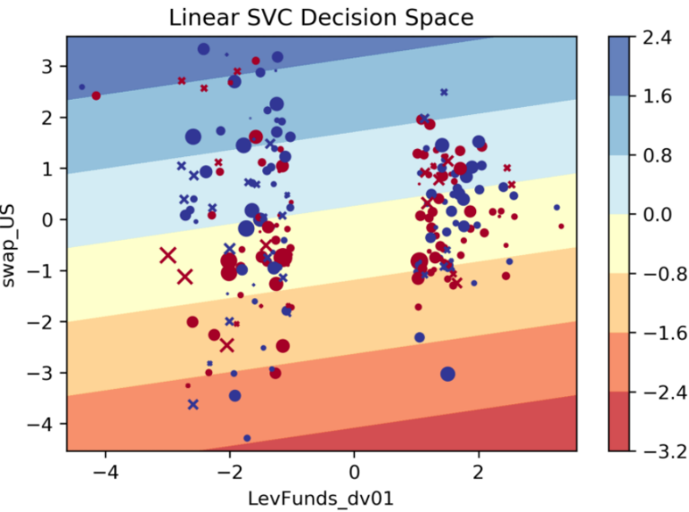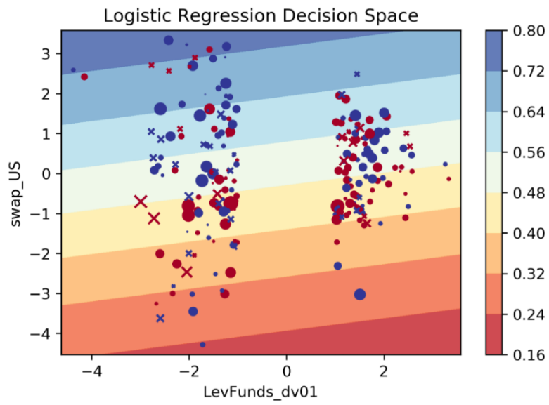Below are some decision boundaries from logistic regression and support vector classifiers on predicting the (weighted) sign of future swap moves, using just LevFunds 13wk positioning changes. In blue are subsequent 1mo sell-offs, in red are rallies, X markers are test set (2018+), circles are training set, size of markers represents the absolute size of the move. The gradient represents probabilities and the SVC decision function.

1. Code in eptest_main.py, primary function read_ep_data
2. https://www.cmegroup.com/trading/interest-rates/mar-15-jun-15-roll-analysis.html
3. Code in eptest_main.py, function get_interp_swaps
4. Preferably I would also want samples from different ‘regimes’, e.g. in the beginning and middle of the dataset, but in the interest of time and since the data is weekly and only ~11 years post-GFC, I just reserve the end. I use another technique called cross-validation to ‘stretch’ the in-sample period to consider quasi-out of sample periods.
5. Contracts*Dur*px/100*ct_size/10e4
6. To mollify the periods of open interest on the front contract that are after the roll is mostly complete
7. Obviously does not matter within contract at the same time but hopefully introduces some consistency over time. Also, I wanted to explore cross-contract dv01 relationships, but ended up settling on z-score changes anyway
8. This code is housed in classification.py, main function run_cv
9. Code in eptest_main.py, function test_adfuller calls statsmodels function
10. Code in classification.py, main function run_cv_weighted, implements my own cross-validation
11. Accuracy being whether the algorithm predicted the correct future sign of swap rate changes
12. Code in signals.py, function zscore_signal
13. The signal response plot is a boxplot showing the mean and distribution of strategy outcomes, bucketed by the signal z-score, weighted by how unique the trade is (e.g. if two trades triggered back-to-back they would be weighted ½ each). I flip the sign of the negative signals so that the ideal outcome is an S-curve rather than parabola. I relax the signal to be any z-score to see the response from any strength of signal.