Branch and Bound

* Definitions:
  + Branch and Bound is a state space search method in which all the children of a node are generated before expanding any of its children.
  + **Live-node**: A node that has not been expanded.
  + It is similar to backtracking technique but uses BFS-like search.

1

1

2

3

4

5

2

3

4

5

Live Node: 2, 3, 4, and 5

6

7

8

9

1

2

3

4 5

8

9 6

7

FIFO Branch & Bound (BFS) Children of E-node are inserted in a queue.

LIFO Branch & Bound (D-Search) Children of E-node are inserted in a stack.

* Dead-node: A node that has been expanded
* Solution-node
* LC-Search (Least Cost Search):
  + The selection rule for the next E-node in FIFO or LIFO branch-and-bound is sometimes “blind”. i.e. the selection

rule does not give any preference to a node that has a very good chance of getting the search to an answer node quickly.

* + The search for an answer node can often be speeded by using an “intelligent” ranking function, also called **an**

^

**approximate cost function** C

^

* + Expanded-node (E-node): is the live node with the best C

value

* Requirements
  + Branching: A set of solutions, which is represented by a node, can be partitioned into mutually exclusive sets. Each subset in the partition is represented by a child of the original node.
  + Lower bounding: An algorithm is available for calculating a lower bound on the cost of any solution in a given subset.
* Searching: Least-cost search (LC)
  + Cost and approximation
    - Each node, X, in the search tree is associated with a cost: C(X)
    - C(X) = cost of reaching the current node, X (E- node), from the root **+** the cost of reaching an answer node from X.

C(X) = g(X) + h(X)

^

* + - Get an approximation of C(x), C

^

1. such that

C (x) C(x), and

^

C (x) = C(x) if x is a solution-node.

^

* + The approximation part of C

1. is

h(x)=the cost of reaching a solution-node from X, not known.

* + Least-cost search:

^

The next E-node is the one with least C

* Example: 8-puzzle

^

* + Cost function: C

where

= g(x) +h(x)

h(x) = the number of misplaced tiles and g(x) = the number of moves so far

* + Assumption: move one tile in any direction cost 1.

**Initial State**

**Final State**

|  |  |  |
| --- | --- | --- |
| **1** | **2** | **3** |
| **5** | **6** |  |
| **7** | **8** | **4** |

|  |  |  |
| --- | --- | --- |
| **1** | **2** | **3** |
| **5** | **8** | **6** |
|  | **7** | **4** |

|  |  |  |
| --- | --- | --- |
| **1** | **2** | **3** |
| **5** | **6** |  |
| **7** | **8** | **4** |

^

C  1  4  5

|  |  |  |
| --- | --- | --- |
| **1** | **2** | **3** |
| **5** | **6** | **4** |
| **7** | **8** |  |

^

C  2  1  3

|  |  |  |
| --- | --- | --- |
| **1** | **2** | **3** |
| **5** | **8** | **6** |
| **7** |  | **4** |

^

C  3  2  5

^

C  1  2  3

**1 2 3**

**5 6**

**7 8 4**

^

C  2  3  5

|  |  |  |
| --- | --- | --- |
| **1** | **2** | **3** |
|  | **5** | **6** |
| **7** | **8** | **4** |

^

C  3  0  3

^

C  1  4  5

|  |  |  |
| --- | --- | --- |
| **1** | **2** |  |
| **5** | **6** | **3** |
| **7** | **8** | **4** |

^

C  2  3  5

|  |  |  |
| --- | --- | --- |
| **1** |  | **3** |
| **5** | **2** | **6** |
| **7** | **8** | **4** |

|  |  |  |
| --- | --- | --- |
| **1** | **2** | **3** |
| **5** | **8** | **6** |
| **7** | **4** |  |

|  |  |  |
| --- | --- | --- |
| **1** | **2** | **3** |
| **5** | **8** | **6** |
|  | **7** | **4** |

Note: In case of tie, choose the leftmost node.

* Algorithm:

/* live_node_set: set to hold the live nodes at any time */

/* lowcost: variable to hold the cost of the best cost at any given node */

Begin

Lowcost = ;

While live_node_set  do

* choose a branching node, k, such that k live_node_set; /* k is a E-node */
* live_node_set= live_node_set - {k};
* Generate the children of node k and the corresponding lower bounds;

Sk={(i,zi): i is child of k and zi its lower bound}

* For each element (i,zi) in Sk do
  + If zi > U
  + then

- Kill child i; /* i is a child node */

* + Else

If child i is a solution Then

Else

U =zi; current best = child i;

Add child i to live_node_set;

Endif; Endif;

* Endfor; Endwhile;
* Travelling Salesman Problem: **A Branch and Bound algorithm**
  + Definition: Find a tour of minimum cost starting from a node S going through other nodes only once and returning to the starting point S.
  + Definitions:
    - A row(column) is said to be reduced iff it contains at least one zero and all remaining entries are non- negative.
    - A matrix is reduced iff every row and column is reduced.
  + **Branching**:
    - Each node splits the remaining solutions into two groups: those that include a particular edge and those that exclude that edge
    - Each node has a lower bound.
    - Example: Given a graph G=(V,E), let <i,j>  E,

L

**All Solutions**

L1

L2

**Solutions with <i,j>**

**Solutions without <i,j>**

* + **Bounding**: How to compute the cost of each node?
    - Subtract of a constant from any row and any column does not change the optimal solution (The path).
    - The cost of the path changes but not the path itself.
    - Let A be the cost matrix of a G=(V,E).
    - The cost of each node in the search tree is computed as follows:
      * Let R be a node in the tree and A(R) its reduced matrix
      * The cost of the child (R), S:
        + Set row i and column j to infinity
        + Set A(j,1) to infinity
        + Reduced S and let RCL be the reduced cost.
        + C(S) = C(R) + RCL+A(i,j)
    - Get the reduced matrix A' of A and let L be the value subtracted from A.
    - L: represents the lower bound of the path solution
    - The cost of the path is exactly reduced by L.
  + What to determine the branching edge?
    - The rule favors a solution through left subtree rather than right subtree, i.e., the matrix is reduced by a dimension.
    - Note that the right subtree only sets the branching edge to infinity.
    - Pick the edge that causes the greatest increase in the lower bound of the right subtree, i.e., the lower bound of the root of the right subtree is greater.
* Example:
  + The reduced cost matrix is done as follows:
    - Change all entries of row i and column j to

infinity

* + - Set A(j,1) to infinity (assuming the start node is 1)
    - Reduce all rows first and then column of the resulting matrix
* Given the following cost matrix:

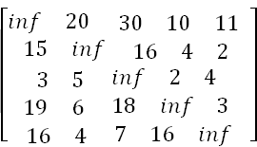

* State Space Tree:

25

Vertex = 2

Vertex = 5

Vertex = 3

Vertex = 4

5

4

3

2

1

35

53

25 31

Vertex = 2

Vertex = 3

Vertex = 5

28 50 36

7

6

8

Vertex = 3 Vertex = 5

52 28

9

|  |  |
| --- | --- |
| 10 | |
|  |  |
| 11 | |

Vertex = 3

28

* The TSP starts from node 1: **Node 1**
  + Reduced Matrix: To get the lower bound of the path starting at node 1
    - Row # 1: reduce by 10

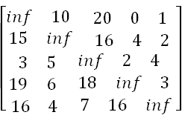

* + - Row #2: reduce 2

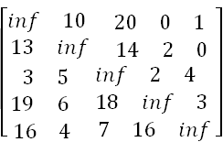

* + - Row #3: reduce by 2

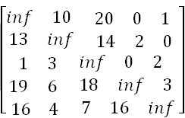

* + - Row # 4: Reduce by 3:

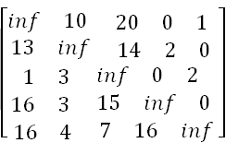

* + - Row # 4: Reduce by 4

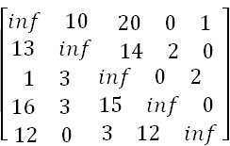

* + - Column 1: Reduce by 1

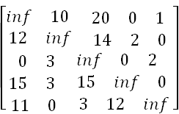

* + - Column 2: It is reduced.
    - Column 3: Reduce by 3

⎡𝑖𝑛𝑓 10 17 0 1

12 𝑖𝑛𝑓 11 2 0

0 3 𝑖𝑛𝑓 0 2

⎢ 15 3 12 𝑖𝑛𝑓 0

⎣ 11 0 0 12 𝑖𝑛𝑓 ⎦

|  |  |  |  |
| --- | --- | --- | --- |
| ⎡𝑖𝑛𝑓 | 10 | 17 0 | 1 |
| 12 | 𝑖𝑛𝑓 | 11 2 | 0 |
| 0 | 3 | 𝑖𝑛𝑓 0 | 2 |
| ⎢ 15 | 3 | 12 𝑖𝑛𝑓 | 0 |
| ⎣ 11 | 0 | 0 12 | 𝑖𝑛𝑓 ⎦ |

* + - Column 4: It is reduced.
    - Column 5: It is reduced.
    - The reduced cost is: RCL = 25
    - So the cost of node 1 is:
      * Cost(1) = 25
    - The reduced matrix is:

**cost(1)** = 25

⎤

⎢ 15

⎣ 11

3

0

12 𝑖𝑛𝑓

0

12

0 ⎥

𝑖𝑛𝑓 ⎦

|  |  |  |  |  |
| --- | --- | --- | --- | --- |
| ⎡𝑖𝑛𝑓 | 10 | 17 | 0 | 1 |
| 12 | 𝑖𝑛𝑓 | 11 | 2 | 0 |
| 0 | 3 | 𝑖𝑛𝑓 | 0 | 2 |

* Choose to go to vertex 2: **Node 2**

- Cost of edge <1,2> is: A(1,2) = 10

* Set row #1 = inf since we are choosing edge <1,2>
* Set column # 2 = inf since we are choosing edge

<1,2>

* Set A(2,1) = inf
* The resulting cost matrix is:

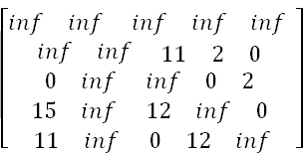

* The matrix is reduced:
  + RCL = 0
* The cost of node 2 (Considering vertex 2 from vertex 1) is:
* **Cost(2) = cost(1) + A(1,2) = 25 + 10 = 35**
* Choose to go to vertex 3: **Node 3**
* Cost of edge <1,3> is: A(1,3) = 17 (In the reduced matrix
* Set row #1 = inf since we are starting from node 1
* Set column # 3 = inf since we are choosing edge

<1,3>

* Set A(3,1) = inf
* 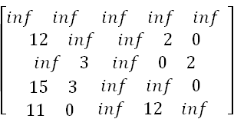The resulting cost matrix is:
* Reduce the matrix:
  + Rows are reduced
  + The columns are reduced except for column # 1:
    - Reduce column 1 by 11:

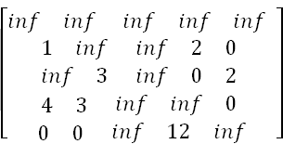

* The lower bound is:
  + RCL = 11
* The cost of going through node 3 is:

o cost(3) = cost(1) + RCL + A(1,3) = 25 + 11 + 17

= 53

Choose to go to vertex 4: **Node 4**

* + Remember that the cost matrix is the one that was reduced at the starting vertex 1
  + Cost of edge <1,4> is: A(1,4) = 0
  + Set row #1 = inf since we are starting from node 1
  + Set column # 4 = inf since we are choosing edge

<1,4>

* + Set A(4,1) = inf
  + The resulting cost matrix is:

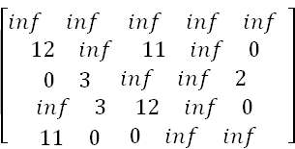

* + Reduce the matrix:
    - Rows are reduced
    - Columns are reduced
  + The lower bound is: RCL = 0
  + The cost of going through node 4 is:
    - cost(4) = cost(1) + RCL + A(1,4) = 25 + 0

+ 0 = 25

* Choose to go to vertex 5: **Node 5**
  + Remember that the cost matrix is the one that was reduced at starting vertex 1
  + Cost of edge <1,5> is: A(1,5) = 1
  + Set row #1 = inf since we are starting from node 1
  + Set column # 5 = inf since we are choosing edge

<1,5>

* + Set A(5,1) = inf
  + The resulting cost matrix is:

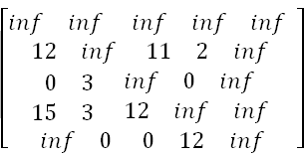

* + Reduce the matrix:
    - Reduce rows:
      * Reduce row #2: Reduce by 2

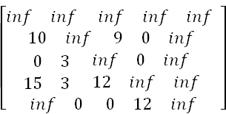

* + - * Reduce row #4: Reduce by 3

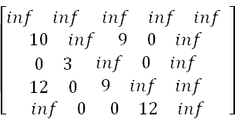

* + - Columns are reduced
  + The lower bound is:
    - RCL = 2 + 3 = 5
  + The cost of going through node 5 is:
    - cost(5) = cost(1) + RCL + A(1,5) = 25 + 5 + 1 = 31
* In summary:
  + So the live nodes we have so far are:
    - 2: cost(2) = 35, path: 1->2
    - 3: cost(3) = 53, path: 1->3
    - 4: cost(4) = 25, path: 1->4
    - 5: cost(5) = 31, path: 1->5
  + Explore the node with the lowest cost: Node 4 has a cost of 25
  + Vertices to be explored from node 4: 2, 3, and 5
  + Now we are starting from the cost matrix at node 4 is:

Cost(4) = 25

⎡𝑖𝑛𝑓 𝑖𝑛𝑓

12 𝑖𝑛𝑓

0 3

⎢

⎣

𝑖𝑛𝑓

11

3

0

𝑖𝑛𝑓

11

𝑖𝑛𝑓

12

𝑖𝑛𝑓 𝑖𝑛𝑓 ⎤

𝑖𝑛𝑓 0

𝑖𝑛𝑓 2

𝑖𝑛𝑓 0

0

𝑖𝑛𝑓

𝑖𝑛𝑓

⎥

⎦

* Choose to go to vertex 2: **Node 6** (path is 1->4->2)
  + Cost of edge <4,2> is: A(4,2) = 3
  + Set row #4 = inf since we are considering edge

<4,2>

* + Set column # 2 = inf since we are considering edge <4,2>
  + Set A(2,1) = inf
  + The resulting cost matrix is:

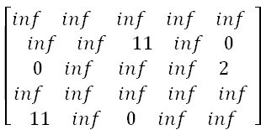

* + Reduce the matrix:
    - Rows are reduced
    - Columns are reduced
  + The lower bound is: RCL = 0
  + The cost of going through node 2 is:
    - cost(6) = cost(4) + RCL + A(4,2) = 25 + 0 + 3 = 28
* Choose to go to vertex 3: **Node 7** ( path is 1->4->3 )
  + Cost of edge <4,3> is: A(4,3) = 12
  + Set row #4 = inf since we are considering edge

<4,3>

* + Set column # 3 = inf since we are considering edge <4,3>
  + Set A(3,1) = inf
  + The resulting cost matrix is:

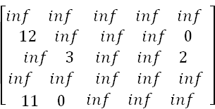

* + Reduce the matrix:
    - Reduce row #3: by 2:

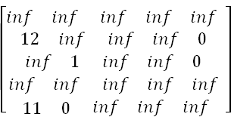

* + - Reduce column # 1: by 11

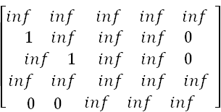

* + The lower bound is: RCL = 13
  + So the RCL of node 7 (Considering vertex 3 from vertex 4) is:
    - Cost(7) = cost(4) + RCL + A(4,3) = 25 + 13

+ 12 = 50

* Choose to go to vertex 5: **Node 8** ( path is 1->4->5 )
  + Cost of edge <4,5> is: A(4,5) = 0
  + Set row #4 = inf since we are considering edge

<4,5>

* + Set column # 5 = inf since we are considering edge <4,5>
  + Set A(5,1) = inf
  + 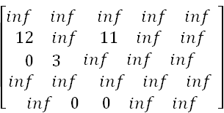The resulting cost matrix is:
  + Reduce the matrix:
    - Reduced row 2: by 11

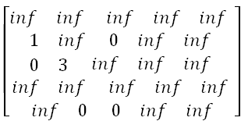

* + - Columns are reduced
  + The lower bound is: RCL = 11
  + So the cost of node 8 (Considering vertex 5 from vertex 4) is:
    - Cost(8) = cost(4) + RCL + A(4,5) = 25 + 11

+ 0 = 36

* In summary:
  + So the live nodes we have so far are:
    - 2: cost(2) = 35, path: 1->2
    - 3: cost(3) = 53, path: 1->3
    - 5: cost(5) = 31, path: 1->5
    - 6: cost(6) = 28, path: 1->4->2
    - 7: cost(7) = 50, path: 1->4->3
    - 8: cost(8) = 36, path: 1->4->5
  + Explore the node with the lowest cost: Node 6 has a cost of 28
  + Vertices to be explored from node 6: 3 and 5
  + Now we are starting from the cost matrix at node 6 is:

Cost(6) = 28

⎡𝑖𝑛𝑓 𝑖𝑛𝑓 𝑖𝑛𝑓

𝑖𝑛𝑓 𝑖𝑛𝑓 11

0 𝑖𝑛𝑓 𝑖𝑛𝑓

⎢ 𝑖𝑛𝑓 𝑖𝑛𝑓 𝑖𝑛𝑓

𝑖𝑛𝑓 0

𝑖𝑛𝑓

𝑖𝑛𝑓

𝑖𝑛𝑓

𝑖𝑛𝑓

𝑖𝑛𝑓

𝑖𝑛𝑓 ⎤

0

2

𝑖𝑛𝑓 ⎥

⎣

11

𝑖𝑛𝑓

⎦

* Choose to go to vertex 3: **Node 9** ( path is 1->4->2->3

)

* + Cost of edge <2,3> is: A(2,3) = 11
  + Set row #2 = inf since we are considering edge

<2,3>

* + Set column # 3 = inf since we are considering edge <2,3>
  + Set A(3,1) = inf
  + The resulting cost matrix is:

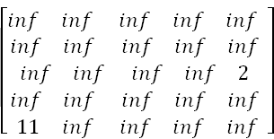

* + Reduce the matrix:
    - Reduce row #3: by 2

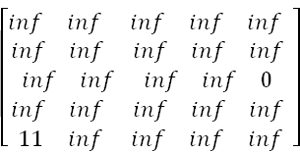

* + - Reduce column # 1: by 11

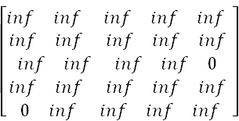

* + The lower bound is: RCL = 2 +11 = 13
  + So the cost of node 9 (Considering vertex 3 from vertex 2) is:
    - Cost(9) = cost(6) + RCL + A(2,3) = 28 + 13

+ 11 = 52

* Choose to go to vertex 5: **Node 10** ( path is 1->4->2-

>5 )

* + Cost of edge <2,5> is: A(2,5) = 0
  + Set row #2 = inf since we are considering edge

<2,3>

* + Set column # 3 = inf since we are considering edge <2,3>
  + Set A(5,1) = inf
  + The resulting cost matrix is:

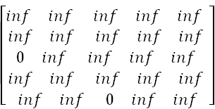

* + Reduce the matrix:
    - Rows reduced
    - Columns reduced
  + The lower bound is: RCL = 0
  + So the cost of node 10 (Considering vertex 5 from vertex 2) is:
    - Cost(10) = cost(6) + RCL + A(2,3) = 28 + 0

+ 0 = 28

* In summary:
  + So the live nodes we have so far are:
    - 2: cost(2) = 35, path: 1->2
    - 3: cost(3) = 53, path: 1->3
    - 5: cost(5) = 31, path: 1->5
    - 7: cost(7) = 50, path: 1->4->3
    - 8: cost(8) = 36, path: 1->4->5
    - 9: cost(9) = 52, path: 1->4->2->3
    - 10: cost(2) = 28, path: 1->4->2->5
  + Explore the node with the lowest cost: Node 10 has a cost of 28
  + Vertices to be explored from node 10: 3
  + Now we are starting from the cost matrix at node 10 is:



* Choose to go to vertex 3: **Node 11** ( path is 1->4->2-

>5->3 )

* + Cost of edge <5,3> is: A(5,3) = 0
  + Set row #5 = inf since we are considering edge

<5,3>

* + Set column # 3 = inf since we are considering edge <5,3>
  + Set A(3,1) = inf
  + The resulting cost matrix is:

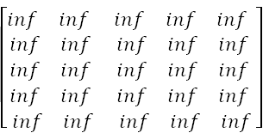

* + Reduce the matrix:
    - Rows reduced
    - Columns reduced
  + The lower bound is: RCL = 0
  + So the cost of node 11 (Considering vertex 5 from vertex 3) is:
    - Cost(11) = cost(10) + RCL + A(5,3) = 28 + 0 + 0 = 28

**Advantages**:

* **Optimality**: It finds an optimal solution if the problem is of limited size and enumeration can be done in reasonable time.
* **Efficiency**: It is often better than backtracking because it can discard many subproblems without explicitly solving them, due to its bounding function.
* **Less Complexity**: It is less complex compared to other algorithms because it doesn’t explore all the nodes in the tree.
* **Effective for Discrete Optimization Problems**: It is effective for discrete optimization problems, such as 0-1 Integer Programming and Network Flow problems.

**Disadvantages**:

* **Time-Consuming**: It can be extremely time-consuming: the number of nodes in a branching tree can be too large.
* **Exponential Time Complexity**: It often leads to exponential time complexities in the worst case.
* **Difficult Parallelization**: The load balancing aspects for Branch and Bound algorithm make its parallelization difficult.
* **Limited to Small Size Network**: It is limited to small size network. In the problem of large networks, where the solution search space grows exponentially with the scale of the network, the approach becomes relatively prohibitive.

**CONCLUSION:**

In conclusion, the Branch and Bound algorithm is a powerful tool for solving discrete and combinatorial optimization problems. It provides us with a systematic way of exploring the solution space in an efficient manner, by effectively pruning branches that do not lead to an optimal solution. This allows us to find the optimal solution in a reasonable amount of time, even for problems with a large number of variables. However, it's important to note that the efficiency of the algorithm heavily depends on the problem at hand, the bounding function used, and the strategy for exploring nodes. In some cases, the algorithm can still be time-consuming and may not be practical for problems of large size or where the solution space grows exponentially. As a student, studying the Branch and Bound algorithm has provided me with valuable insights into optimization techniques and problem-solving strategies. It has challenged me to think critically about how to approach complex problems and has equipped me with the skills to develop efficient algorithms. I look forward to applying these learnings in future projects and exploring further improvements and variations of the Branch and Bound algorithm. Thank you for your attention and I am open to any questions or discussions you may have.