Thiết Kế Hệ Thống
I. Sơ Đồ Lớp Tổng Thể (UML Class Diagram)
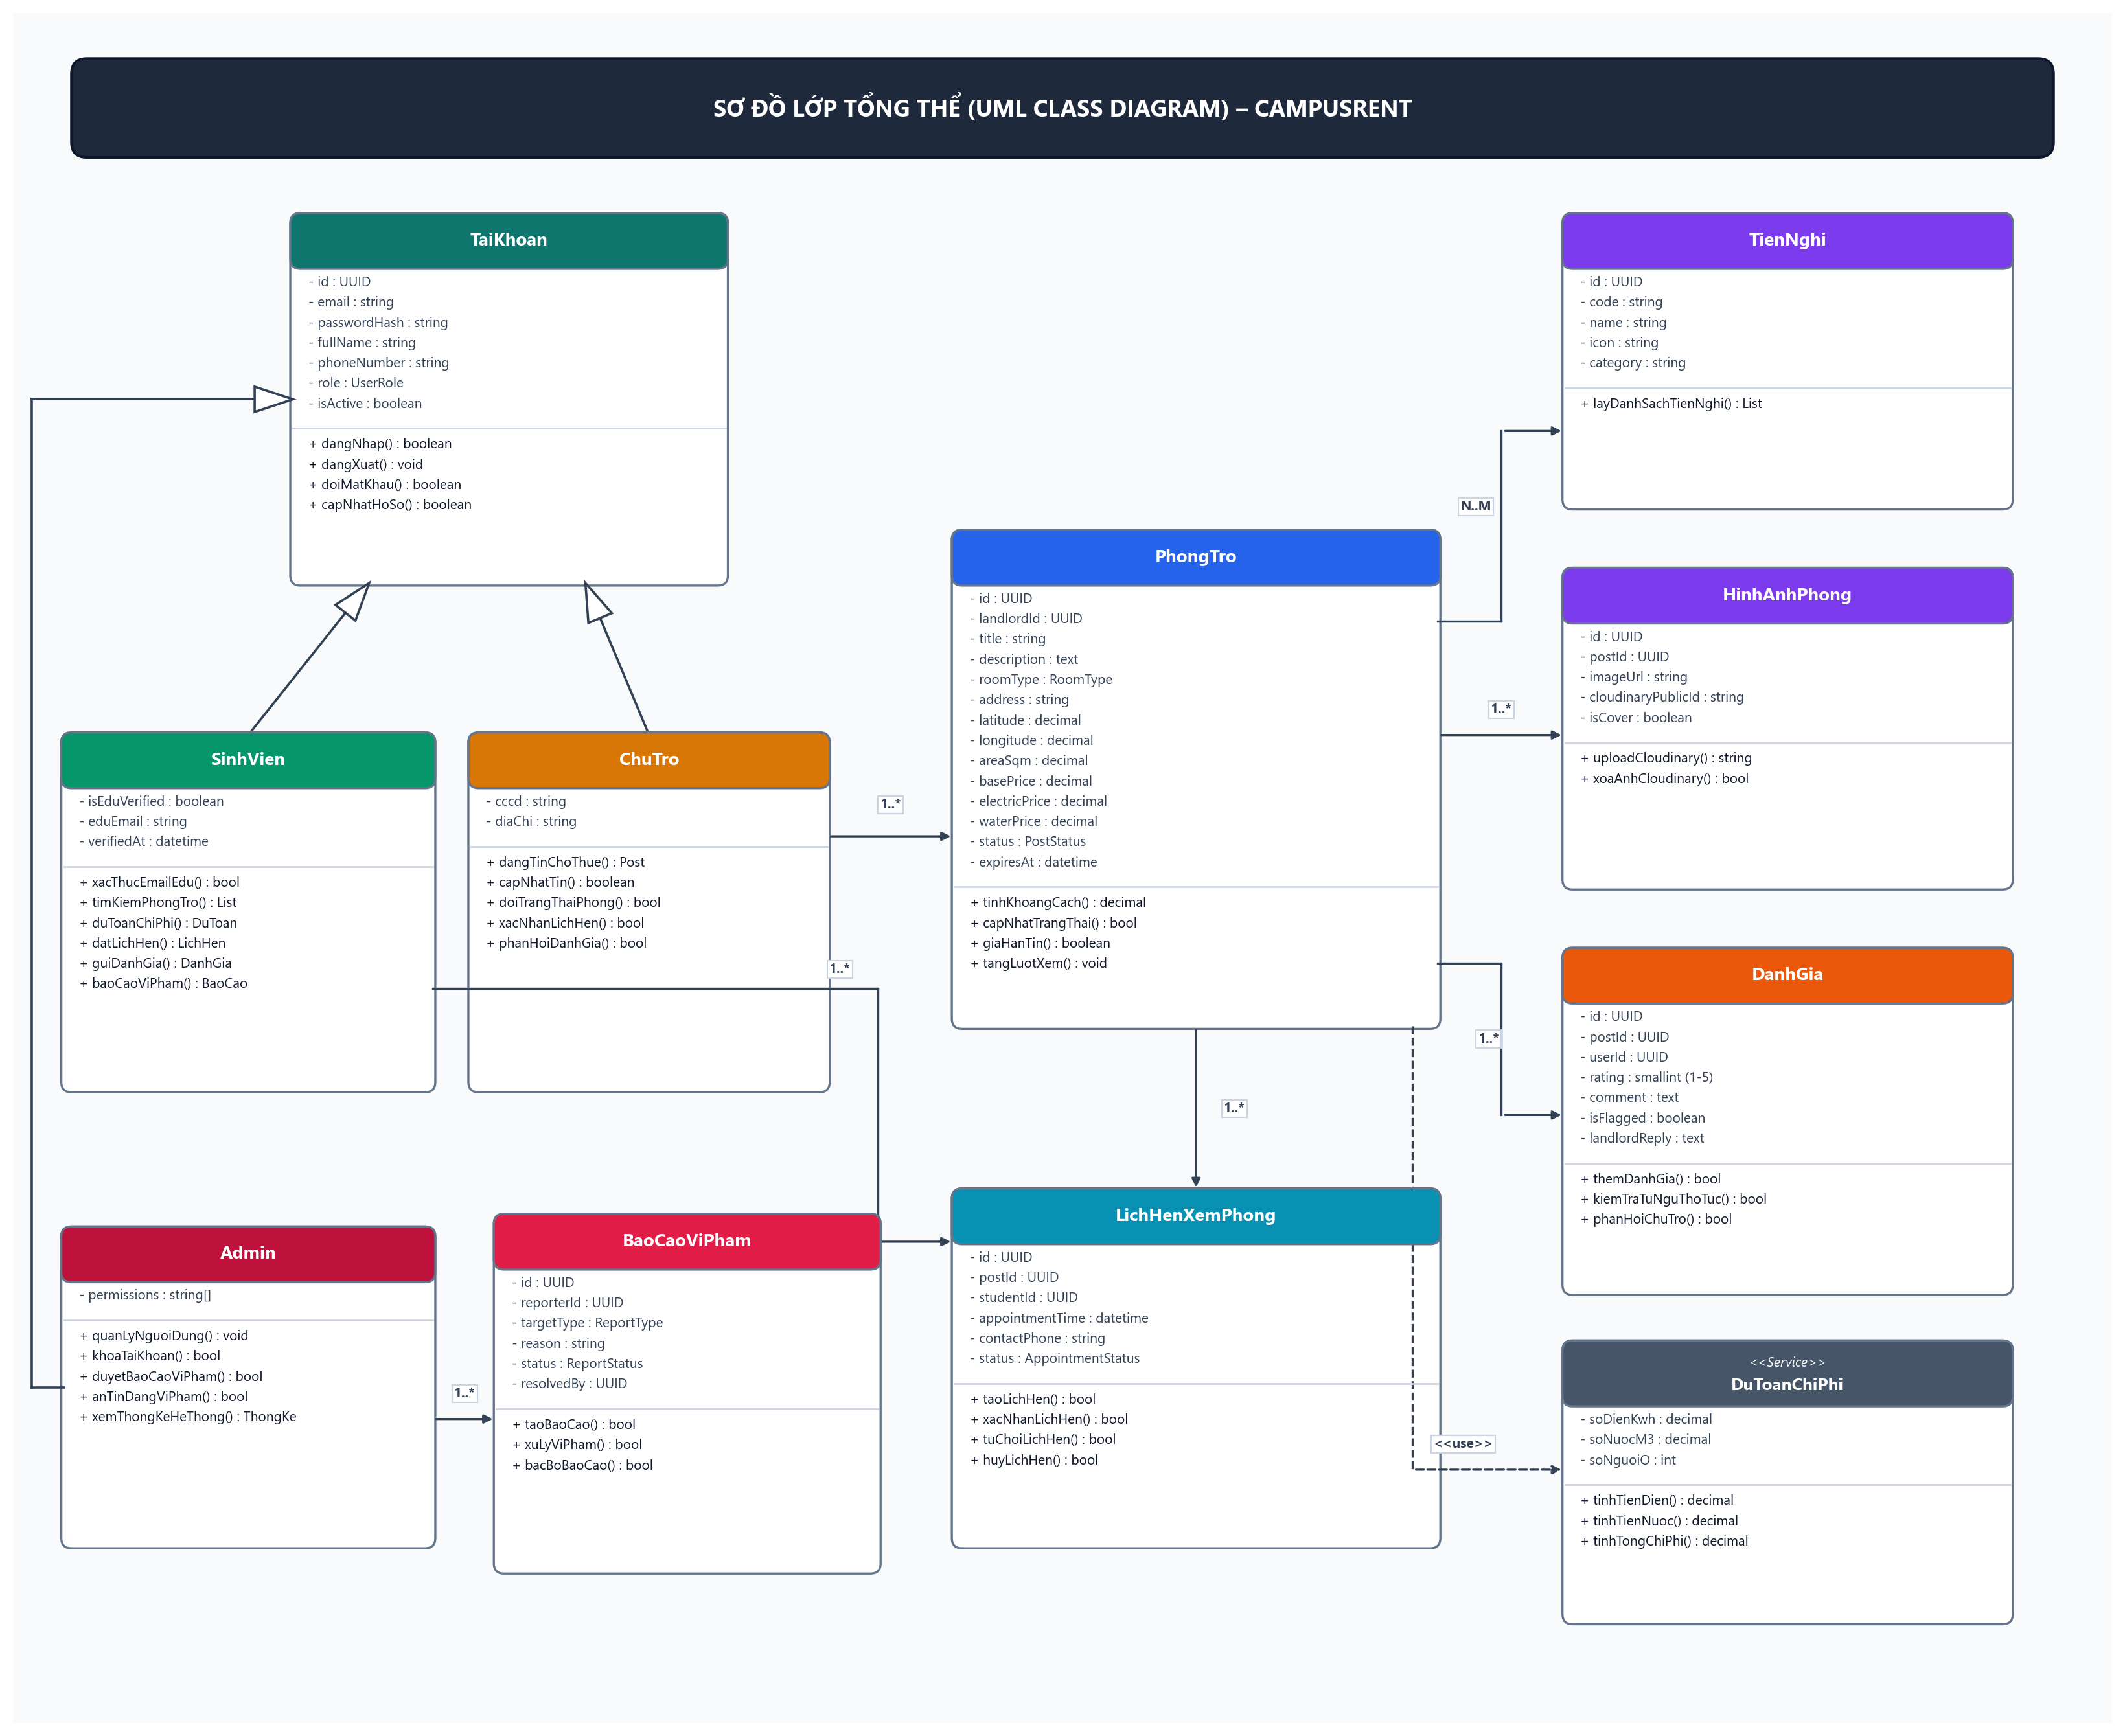

II. Chi Tiết Thiết Kế Các Lớp
1. Class TaiKhoan
Plain Text
TaiKhoan
-------------------------------
- id : UUID
- email : string
- passwordHash : string
- fullName : string
- phoneNumber : string
- avatarUrl : string
- role : UserRole
- isActive : boolean
- createdAt : datetime
- updatedAt : datetime
-------------------------------
+ dangNhap(email, matKhau) : boolean
+ dangXuat() : void
+ doiMatKhau(mkCu, mkMoi) : boolean
+ capNhatHoSo(hoTen, sdt, avatar) : boolean
2. Class SinhVien
Plain Text
SinhVien
-------------------------------
- isEduVerified : boolean
- eduEmail : string
- verifiedAt : datetime
-------------------------------
+ xacThucEmailEdu(eduEmail, otp) : boolean
+ timKiemPhongTro(toado, banKinh, boLoc) : List<PhongTro>
+ duToanChiPhi(phongId, soDien, soNuoc, soNguoi) : DuToanChiPhi
+ datLichHen(phongId, thoiGian, sdt, ghiChu) : LichHenXemPhong
+ guiDanhGia(phongId, soSao, binhLuan) : DanhGia
+ luuTinYeuThich(phongId) : boolean
+ baoCaoViPham(doiTuongId, loai, lyDo) : BaoCaoViPham
Kế thừa:
Plain Text
TaiKhoan
▲
|
SinhVien
3. Class ChuTro
Plain Text
ChuTro
-------------------------------
- cccd : string
- diaChiThuongTru : string
-------------------------------
+ dangTinChoThue(thongTinPhong, danhSachAnh) : PhongTro
+ capNhatTin(phongId, thongTin) : boolean
+ doiTrangThaiPhong(phongId, trangThai) : boolean
+ xacNhanLichHen(lichHenId) : boolean
+ tuChoiLichHen(lichHenId, lyDo) : boolean
+ phanHoiDanhGia(danhGiaId, noiDung) : boolean
Kế thừa:
Plain Text
TaiKhoan
▲
|
ChuTro
4. Class Admin
Plain Text
Admin
-------------------------------
- permissions : string[]
-------------------------------
+ quanLyNguoiDung() : void
+ khoaTaiKhoan(userId, lyDo) : boolean
+ moKhoaTaiKhoan(userId) : boolean
+ duyetBaoCaoViPham(baoCaoId, quyetDinh) : boolean
+ anTinDangViPham(phongId, lyDo) : boolean
+ xemThongKeHeThong() : ThongKeHeThong
+ cauHinhThamSoHeThong() : void
Kế thừa:
Plain Text
TaiKhoan
▲
|
Admin
5. Class PhongTro
Plain Text
PhongTro
-------------------------------
- id : UUID
- landlordId : UUID
- title : string
- description : text
- roomType : RoomType
- streetAddress : string
- ward : string
- district : string
- city : string
- fullAddress : string
- latitude : decimal
- longitude : decimal
- areaSqm : decimal
- maxTenants : int
- floorNumber : int
- totalFloors : int
- basePrice : decimal
- deposit : decimal
- electricPrice : decimal
- electricBilling : UtilityBillingType
- waterPrice : decimal
- waterBilling : UtilityBillingType
- internetPrice : decimal
- serviceFee : decimal
- status : PostStatus
- viewsCount : int
- expiresAt : datetime
- publishedAt : datetime
-------------------------------
+ hienThiChiTiet() : ThongTinChiTiet
+ tinhKhoangCach(toaDoDich) : decimal
+ capNhatTrangThai(status) : boolean
+ giaHanTin(soNgay) : boolean
+ tangLuotXem() : void
6. Class TienNghi
Plain Text
TienNghi
-------------------------------
- id : UUID
- code : string
- name : string
- icon : string
- category : string
-------------------------------
+ layDanhSachTienNghi() : List<TienNghi>
+ themTienNghi(code, name, icon) : boolean
7. Class HinhAnhPhong
Plain Text
HinhAnhPhong
-------------------------------
- id : UUID
- postId : UUID
- imageUrl : string
- cloudinaryPublicId : string
- displayOrder : int
- isCover : boolean
-------------------------------
+ uploadCloudinary(file) : string
+ xoaAnhCloudinary(publicId) : boolean
8. Class LichHenXemPhong
Plain Text
LichHenXemPhong
-------------------------------
- id : UUID
- postId : UUID
- studentId : UUID
- appointmentTime : datetime
- contactPhone : string
- note : text
- status : AppointmentStatus
- createdAt : datetime
-------------------------------
+ taoLichHen() : boolean
+ xacNhanLichHen() : boolean
+ tuChoiLichHen(lyDo) : boolean
+ huyLichHen() : boolean
+ hoanThanhLichHen() : boolean
9. Class DanhGia
Plain Text
DanhGia
-------------------------------
- id : UUID
- postId : UUID
- userId : UUID
- rating : smallint (1-5)
- comment : text
- isFlagged : boolean
- flagReason : string
- landlordReply : text
- repliedAt : datetime
- createdAt : datetime
-------------------------------
+ themDanhGia() : boolean
+ kiemTraTuNguThoTuc() : boolean
+ suaDanhGia(noiDungMoi) : boolean
+ xoaDanhGia() : boolean
+ phanHoiChuTro(noiDung) : boolean
10. Class TinYeuThich
Plain Text
TinYeuThich
-------------------------------
- userId : UUID
- postId : UUID
- createdAt : datetime
-------------------------------
+ themYeuThich() : boolean
+ xoaYeuThich() : boolean
11. Class DuToanChiPhi
Plain Text
DuToanChiPhi
-------------------------------
- postId : UUID
- soDienKwh : decimal
- soNuocM3 : decimal
- soNguoiO : int
- tongTienDien : decimal
- tongTienNuoc : decimal
- tongChiPhiThang : decimal
- chiPhiBinhQuanDauNguoi : decimal
-------------------------------
+ tinhTienDien(kwh, donGia, cachTinh) : decimal
+ tinhTienNuoc(m3, donGia, cachTinh) : decimal
+ tinhTongChiPhi() : decimal
+ xuatBangDuToan() : BangDuToan
12. Class BanDoHaversine
Plain Text
BanDoHaversine
-------------------------------
- banKinhMacDinh : decimal (1km, 3km, 5km)
-------------------------------
+ tinhKhoangCach(lat1, lon1, lat2, lon2) : decimal
+ locPhongTrongBanKinh(danhSachPhong, tam, r) : List<PhongTro>
+ uocTinhThoiGianDiChuyen(khoangCachKm) : ThoiGianDiChuyen
13. Class BaoCaoViPham
Plain Text
BaoCaoViPham
-------------------------------
- id : UUID
- reporterId : UUID
- targetType : ReportTargetType
- postId : UUID
- reviewId : UUID
- reportedUserId : UUID
- reason : string
- description : text
- status : ReportStatus
- resolvedBy : UUID
- resolutionNotes : text
- resolvedAt : datetime
-------------------------------
+ taoBaoCao() : boolean
+ tiepNhanBaoCao(adminId) : boolean
+ giaiQuyetViPham(ghiChu) : boolean
+ bacBoBaoCao(ghiChu) : boolean
14. Class ThongKeHeThong
Plain Text
ThongKeHeThong
-------------------------------
- tongSoTinDang : int
- soTinDangKhaDung : int
- soTinDaChoThue : int
- tongSoSinhVien : int
- tongSoChuTro : int
- soBaoCaoChoXuLy : int
-------------------------------
+ taoBaoCaoThongKe(tuNgay, denNgay) : ThongKe
+ quetTinQuaHan30Ngay() : int
+ xuatFileExcel() : byte[]
+ xuatFilePDF() : byte[]
15. Bảng Định Nghĩa Các Enum Trạng Thái
UserRole (Vai trò người dùng)
Plain Text
STUDENT
LANDLORD
ADMIN
RoomType (Loại hình phòng trọ)
Plain Text
ROOM
SHARED_ROOM
MINI_APARTMENT
STUDIO
HOUSE
DORMITORY
PostStatus (Trạng thái bài đăng)
Plain Text
DRAFT
PENDING_APPROVAL
AVAILABLE
RENTED
HIDDEN
EXPIRED
UtilityBillingType (Cách tính biểu phí điện nước)
Plain Text
PER_UNIT
PER_PERSON
FIXED
FREE
AppointmentStatus (Trạng thái lịch hẹn)
Plain Text
PENDING
ACCEPTED
REJECTED
CANCELLED
COMPLETED
ReportTargetType (Loại đối tượng bị báo cáo)
Plain Text
POST
REVIEW
USER
ReportStatus (Trạng thái xử lý báo cáo)
Plain Text
PENDING
IN_REVIEW
RESOLVED
DISMISSED

