Bonevie Tutor 18/12/2025
James Llyod Hampac
Year& Section : BSCS – 3A

Campus Navigator
Introduction
Navigating a university campus can be challenging for students, faculty, and visitors. Freshmen and transferees often struggle to locate classrooms and adjust to schedules, while visitors may find it difficult to reach administrative offices or event venues. Faculty members also face inefficiencies when linking schedules with assigned classrooms (Ali, Hussain, & Ahmed, 2021). A centralized Campus Navigator that combines interactive maps and schedule management can directly address these challenges by providing accurate directions and time-sensitive reminders (Garcia & Torres, 2020).
Currently, many universities rely on traditional tools such as bulletin boards, signage, and printed schedules. While these resources offer basic guidance, they are static, quickly outdated, and lack personalization (Chen & Zhang, 2020). Students cannot search for specific classrooms in real time, and faculty are not promptly notified of venue or schedule changes. Studies highlight that conventional approaches are insufficient for dynamic, modern learning environments that demand flexibility and instant updates (Santos & Velasco, 2021).
Without an effective navigation and scheduling system, campus members experience recurring issues. Students and visitors waste time asking for directions, leading to tardiness and stress (Nguyen, Le, & Pham, 2019). During enrollment and orientation, congestion worsens as newcomers get lost. Sudden schedule or room changes further disrupt productivity, negatively affecting punctuality, academic performance, and overall user experience (Wang & Liu, 2019).
To address these challenges, the system can employ graph-based algorithms such as Dijkstra’s Algorithm or A* to compute the shortest path between campus locations, with rooms and buildings represented as nodes and pathways as edges weighted by distance or travel time. For scheduling, travel times can be automatically calculated, prompting users to leave on time and enhancing campus mobility efficiency (Patel & Sharma, 2018; Omar & Dizon, 2022).
Integrating machine learning makes the campus navigation app act like a personal campus assistant. On the Map and floor-plan screens, lightweight machine learning models estimate walking times using distance, crowd density, time of day, and historical walking patterns to provide realistic arrival predictions. A simple NLP model lets students type queries like “Room 204” or “Chemistry lab” to jump to a location or open its floor plan. The system can train models on Schedule and User patterns to surface likely routes, send reminders for classes, and notify students of sudden building changes. Prioritize on-device or privacy-preserving cloud ML and clear user controls so predictions adapt to behavior while protecting student data (Fujimoto & Tanaka 2020; Khan, Ali & Rehman 2022)
Background & Purpose / Needs or Gaps
Campus navigation remains a persistent challenge for students, visitors, and faculty. Despite technological advancements, many institutions continue to rely on static bulletin boards, printed schedules, or verbal directions, which often lead to confusion, delays, and inefficiency.
The primary need the Campus Navigator addresses is the lack of an interactive, real-time campus guidance system. By integrating mapping, scheduling, and AI-assisted directions, the project seeks to improve time management, convenience, and accessibility. It bridges the gap between physical and digital campus experiences, transforming how users interact with their academic environment.
Additionally, the system promotes environmental sustainability by reducing printed materials, supporting universities’ digital transformation initiatives. It also lays the foundation for future smart campus features, such as IoT-based location tracking and intelligent notifications.

Project Description
Campus-Go is a mobile campus navigation and class scheduling app designed to help students, faculty, and visitors move around the university efficiently. It provides an interactive map of buildings and rooms, along with tools for creating and managing class schedules.
One of its key capabilities is the Schedule Conflict Detection system, which instantly alerts users when they attempt to create overlapping class times or double-booked rooms. The system checks for conflicts based on day, time, and room assignments—ensuring that schedules are valid before saving. This prevents errors in planning and maintains clean, reliable timetables for students and instructors.
Visitors can access the map without logging in, making it useful during exams, orientations, and enrollment. The system uses shortest-path algorithms like Dijkstra’s or A* to generate optimized routes with estimated travel time. Optional AI features support voice commands and smart suggestions, while administrators maintain building and map data. Overall, Campus-Go improves campus accessibility, reduces confusion, and supports a more digital, organized university experience.

Goals
Design and develop an intelligent, mobile-based Campus Navigator application that provides real-time navigation, scheduling, and personalized assistance for students, faculty, and visitors. Implement a schedule conflict detection mechanism that prevents overlapping classes and double-booked rooms.

Objectives
- Create a digital map of the university campus with interactive markers for buildings, classrooms, and offices.
- Implement a shortest-path algorithm (Dijkstra’s or A*) for accurate route generation and real-time navigation.
- Integrate scheduling features that notify users of upcoming classes and calculate walking times between locations.
- Develop an AI-based assistant capable of interpreting text commands.
- Evaluate system performance and usability through user testing and feedback collection.
- Detect and prevent schedule conflicts by validating time, day, and room assignments before saving user schedules.

Methodology
The project will adopt Agile Development, ensuring iterative progress and active user involvement:
- Planning Phase: Define requirements, conduct campus mapping, and design database structure.
- Design Phase: Develop UI/UX wireframes and system flowcharts.
- Development Phase: Implement core modules, including map rendering, pathfinding algorithms, and schedule integration.
- Testing Phase: Conduct functionality and usability tests with real user scenarios.
- Deployment Phase: Release a prototype and collect feedback for refinement.

Timeline (5 Months)
Month | Activity
1 | Requirement gathering, system design, and campus mapping
2 | UI/UX design and algorithm setup (pathfinding and scheduling)
3 | Backend and frontend integration; initial development
4 | System testing, debugging, and AI assistant integration
5 | Final testing, documentation, and project presentation

Impact of the Project
The Campus Navigator will improve accessibility and time management for all campus members. It will reduce confusion, late arrivals, and congestion by providing optimized routes and timely reminders. The project contributes to the university’s digital transformation, offering an AI-driven solution that enhances learning experiences and operational efficiency. Long-term expansion may include real-time crowd detection, event management, and smart campus analytics.

How It Works
Students and Faculty can sign up using their BISU email or ID and immediately access their personalized dashboard. They can create and manage class schedules, including day, time, subject, room, and instructor, while the app highlights any scheduling conflicts. The interactive campus map allows users to locate classrooms and buildings; tapping a room on their schedule automatically shows its location on the map. This integration ensures that users can efficiently plan their day and navigate the campus without confusion.
Visitors do not need to log in and can directly access the interactive map to explore buildings, offices, and classrooms. Users can search for locations by typing commands (e.g., “Find Room D3”). The app calculates the optimal route using Dijkstra’s or A* algorithm, providing step-by-step directions and estimated travel times (Khan, Ali, & Rehman, 2022). For students and faculty, notifications alert them before class start times and account for travel time. AI-driven features offer adaptive recommendations and making navigation personalized and user-friendly (Fujimoto & Tanaka, 2020).

User Interface
The Campus-Go app features a clean, intuitive, and user-friendly interface designed for seamless navigation and schedule management. The core screens include:

In Figure 1, presents the tools available for system administrators, who manage all campus-related data within the application. Through this dashboard, admins can add or update building locations on the map, edit room details, and assign departments to each structure. Additionally, the dashboard allows administrators to view registered users of the application, enabling them to monitor who is actively using the system.
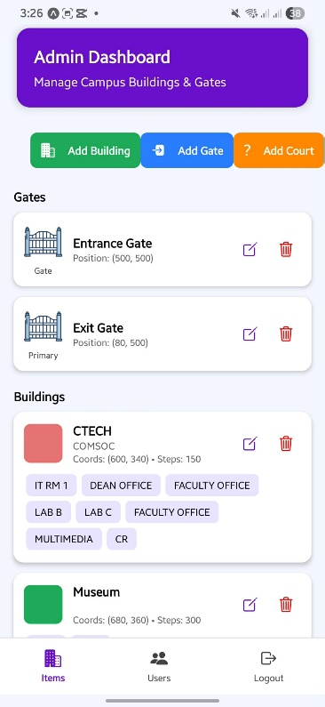
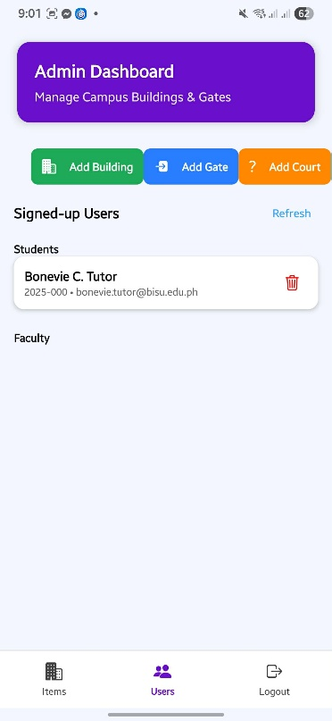
Figure 1. Admin Dashboard

As shown in Figure 2, displays the secure entry interface for students and faculty. Users can register using their BISU email or ID number and immediately gain access to their personalized dashboard without requiring administrator approval. Once logged in, they can create and modify their class schedules, specifying details such as time, day, subject, room, and instructor. The dashboard organizes these schedules neatly for easy viewing.
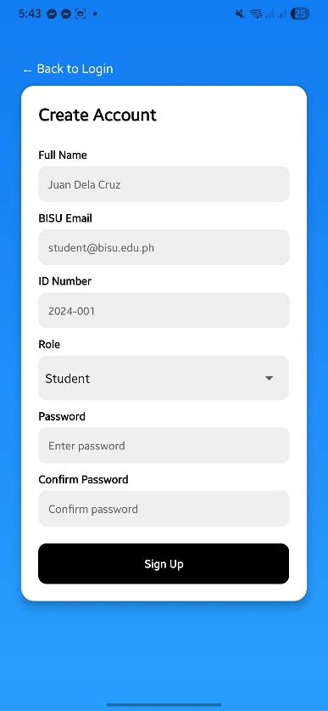
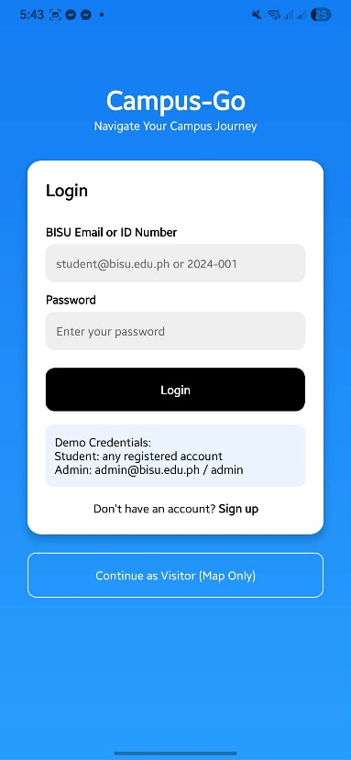
Figure 2. Sign-Up and Log-In Screen

Shown in Figure 3 is the Continue as Visitor – Map-Only Mode, interface designed for visitors who do not have school accounts. This mode provides direct access to the interactive campus map, allowing guests to search for building names, office locations, or specific facilities such as the Registrar’s Office or the College of Technology. This feature is especially useful during admission periods, campus tours, and orientations.
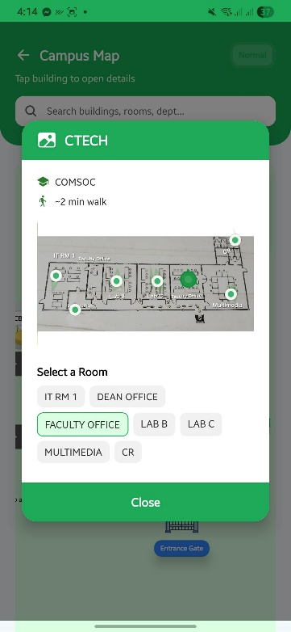
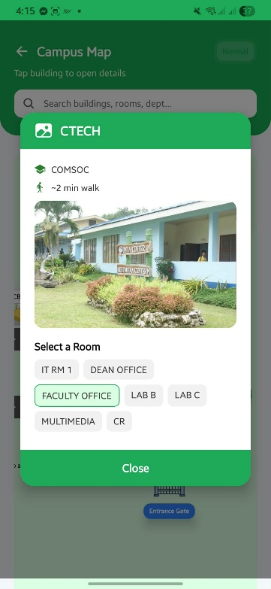
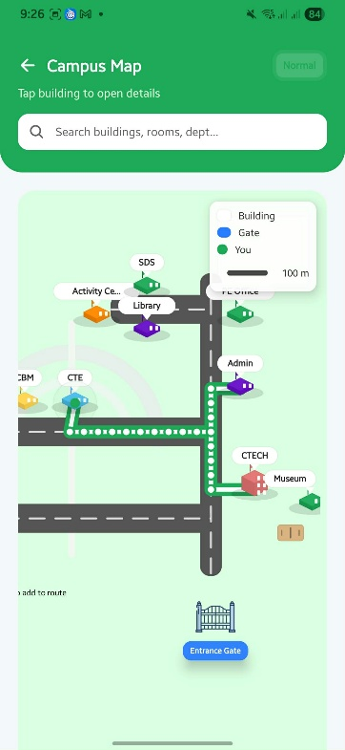
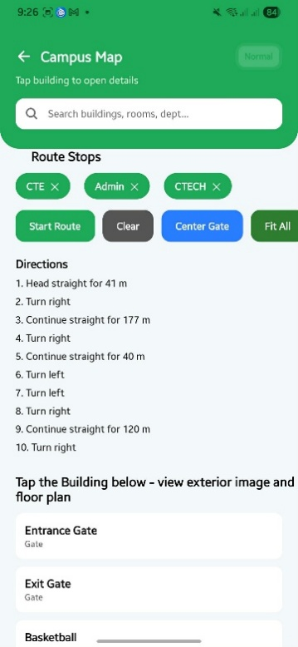
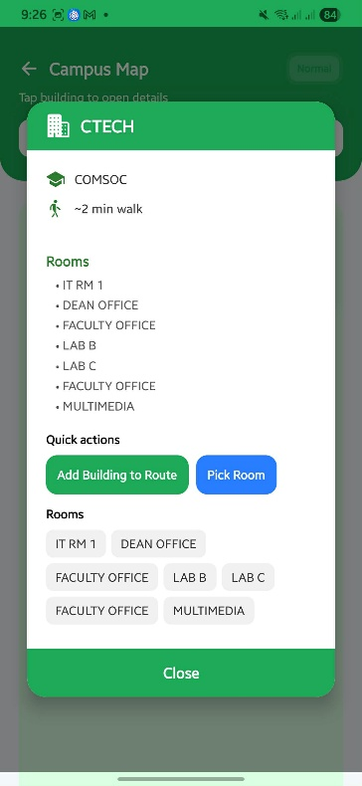
Figure 3. Continue as Visitor – Map-Only Mode

Figure 4 illustrates User Dashboard, displays the main control panel for students and faculty. From here, users can view their schedules, track upcoming classes, and locate their assigned rooms using the interactive map.

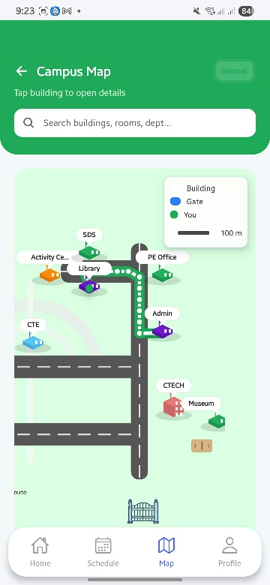
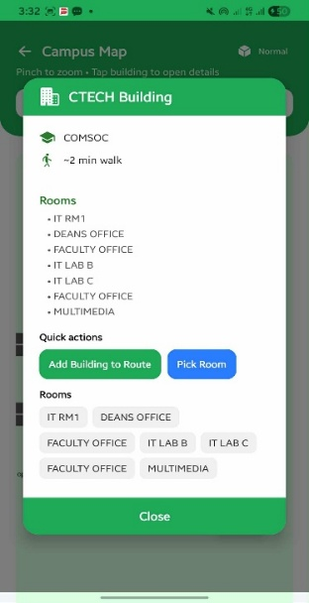
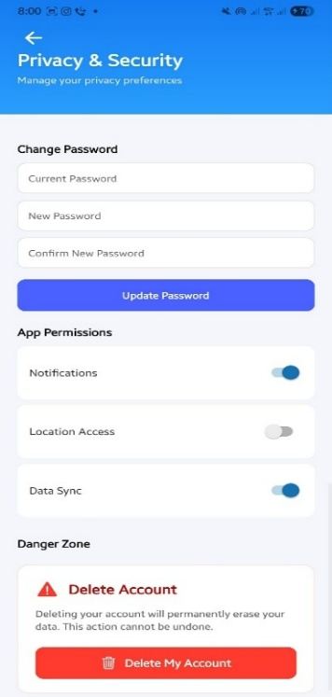
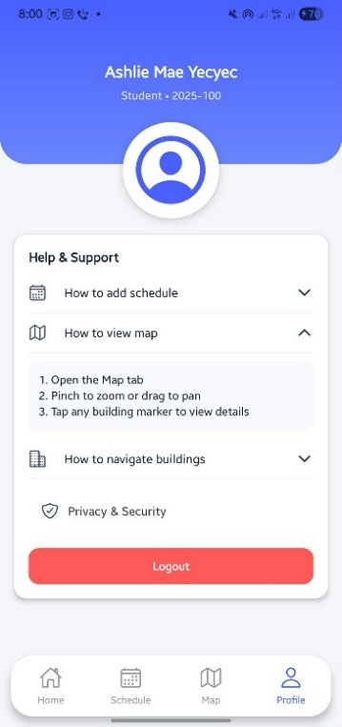
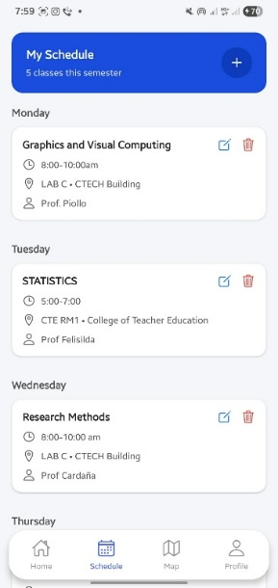
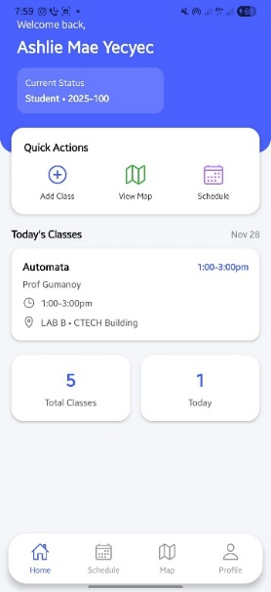
Figure 4. User Dashboard

References

Ali, M., Hussain, T., & Ahmed, R. (2021). Smart campus navigation using mobile technologies. Journal of Information Systems, 45(3), 112–121.
Chen, L., & Zhang, Y. (2020). Enhancing student engagement through real-time digital mapping systems. Educational Technology Research Journal, 38(2), 98–110.
Fujimoto, K., & Tanaka, S. (2020). Integrating AI assistants into higher education navigation apps. Journal of Smart Learning Technologies, 5(3), 203–221.
Garcia, M., & Torres, J. (2020). Mobile mapping technologies for university environments. International Journal of Campus Technology, 9(2), 14–27.
Khan, H., Ali, S., & Rehman, A. (2022). AI-based personalization in educational mobile applications. Journal of Artificial Intelligence in Education, 15(1), 74–85.
Nguyen, P., Le, D., & Pham, T. (2019). Campus mobility and navigation: Problems and prospects. International Journal of Smart Education, 12(4), 55–68.
Omar, S., & Dizon, A. (2022). Predictive analytics in student mobility and scheduling. Educational Data Science Journal, 7(4), 101–118.
Patel, R., & Sharma, S. (2018). Algorithmic solutions for path optimization in navigation systems. Computing Review, 27(1), 43–52.
Santos, R., & Velasco, P. (2021). User-centered design approaches for smart campus applications. Journal of UX and Information Systems, 33(1), 58–72
Wang, Y., & Liu, H. (2019). Improving indoor navigation through hybrid positioning systems. Mobile Computing Review, 44(3), 77–89.

