Computer Assignment 3

Algorithm
- Blur image by Gaussian Blur remove noise (Variance 40)
- Image Thresholding use threshold 225-255 is Object and 80-255 is Background
- Calculate area by use Moment(0,0) back and white image from step 2
- Calculate Area result in cm^2 by (area_obj/area_background)*groundtruth

Blur Image
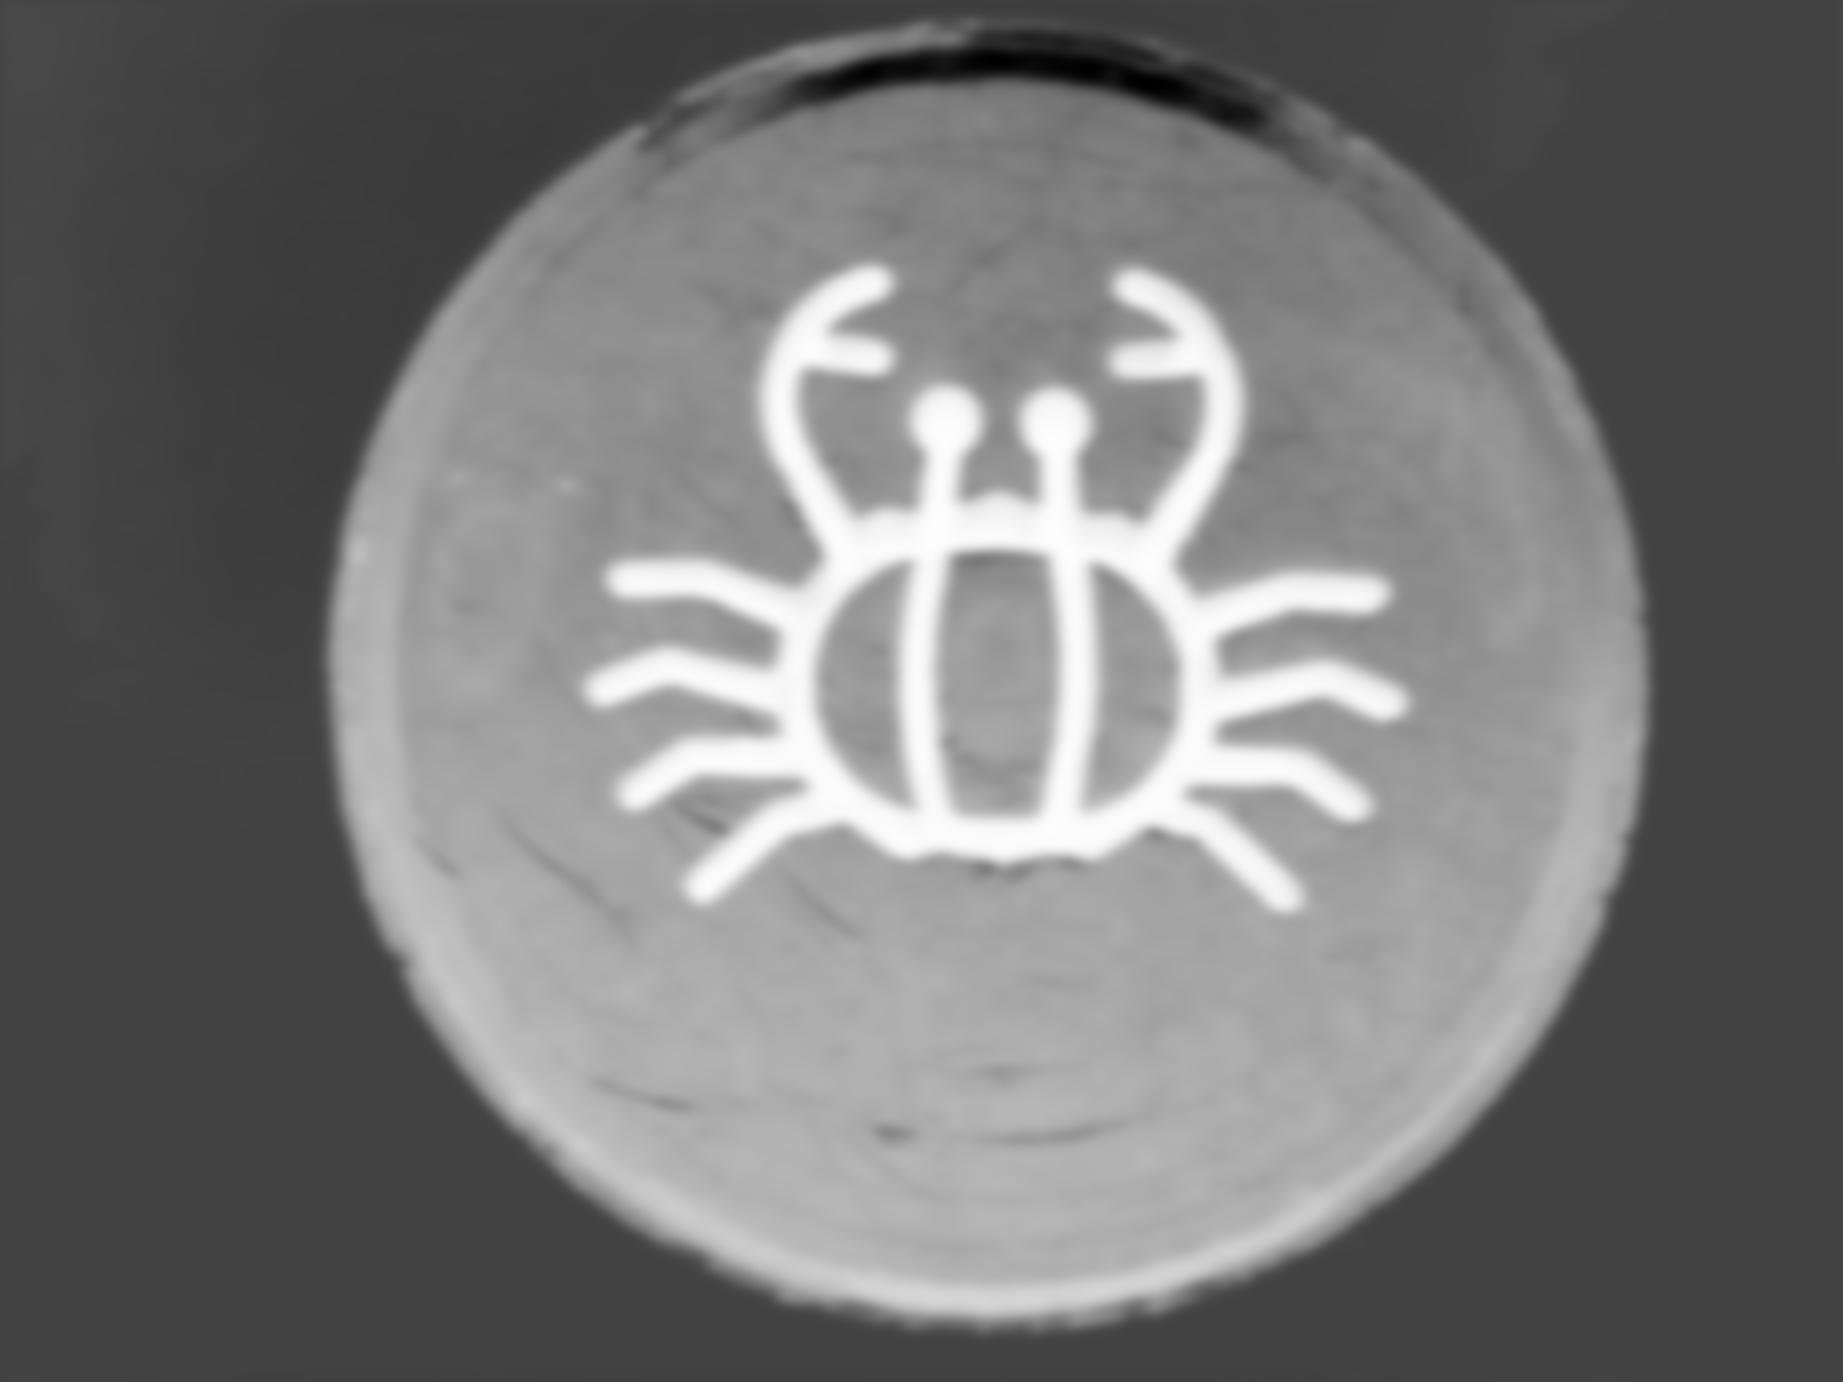
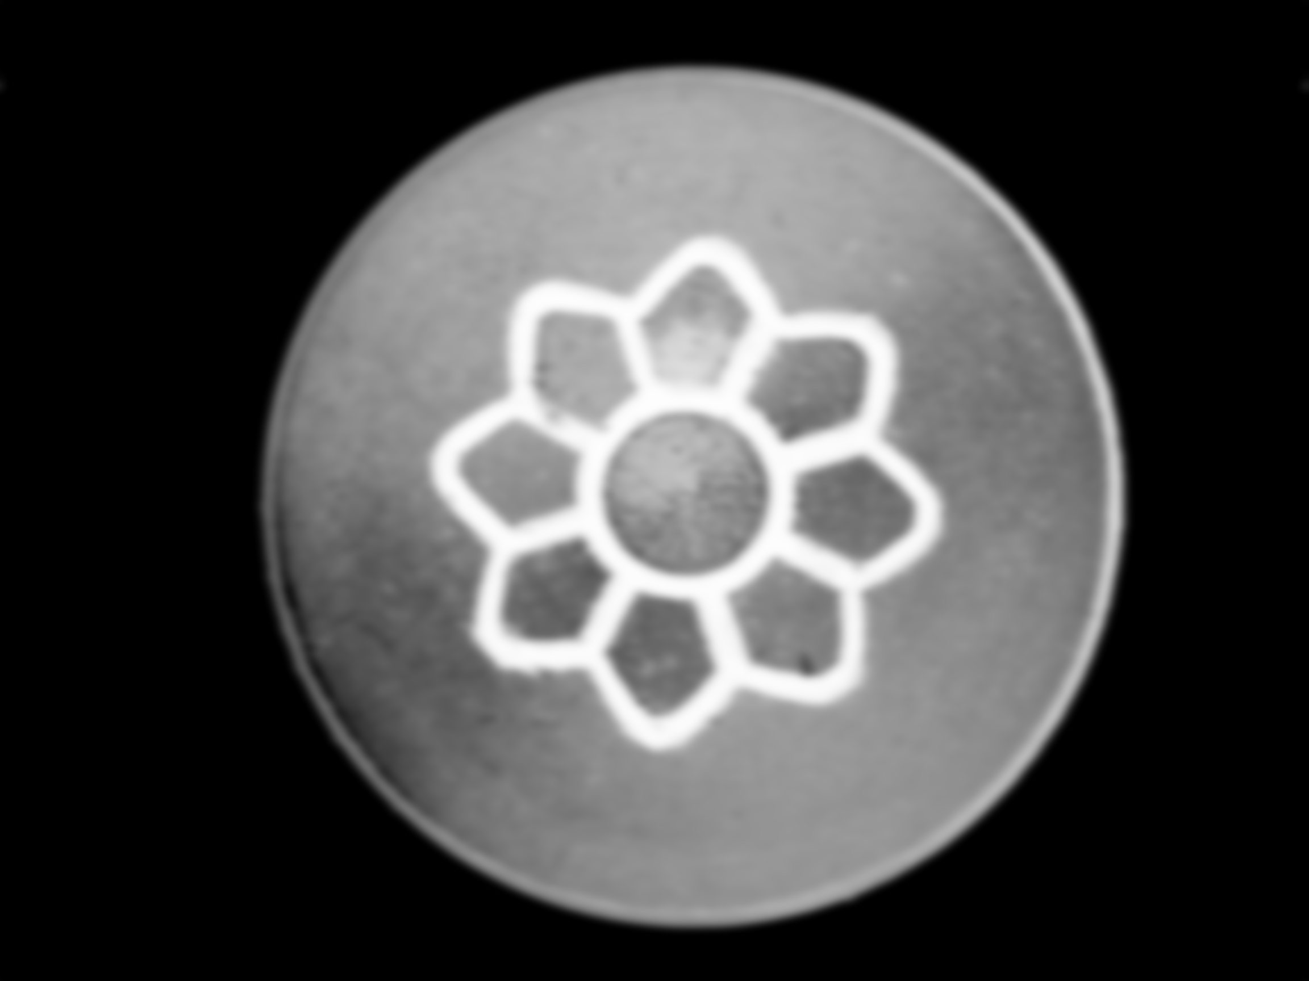

(Flower Snack Blur) (Crab Blur)

Back and White Object image
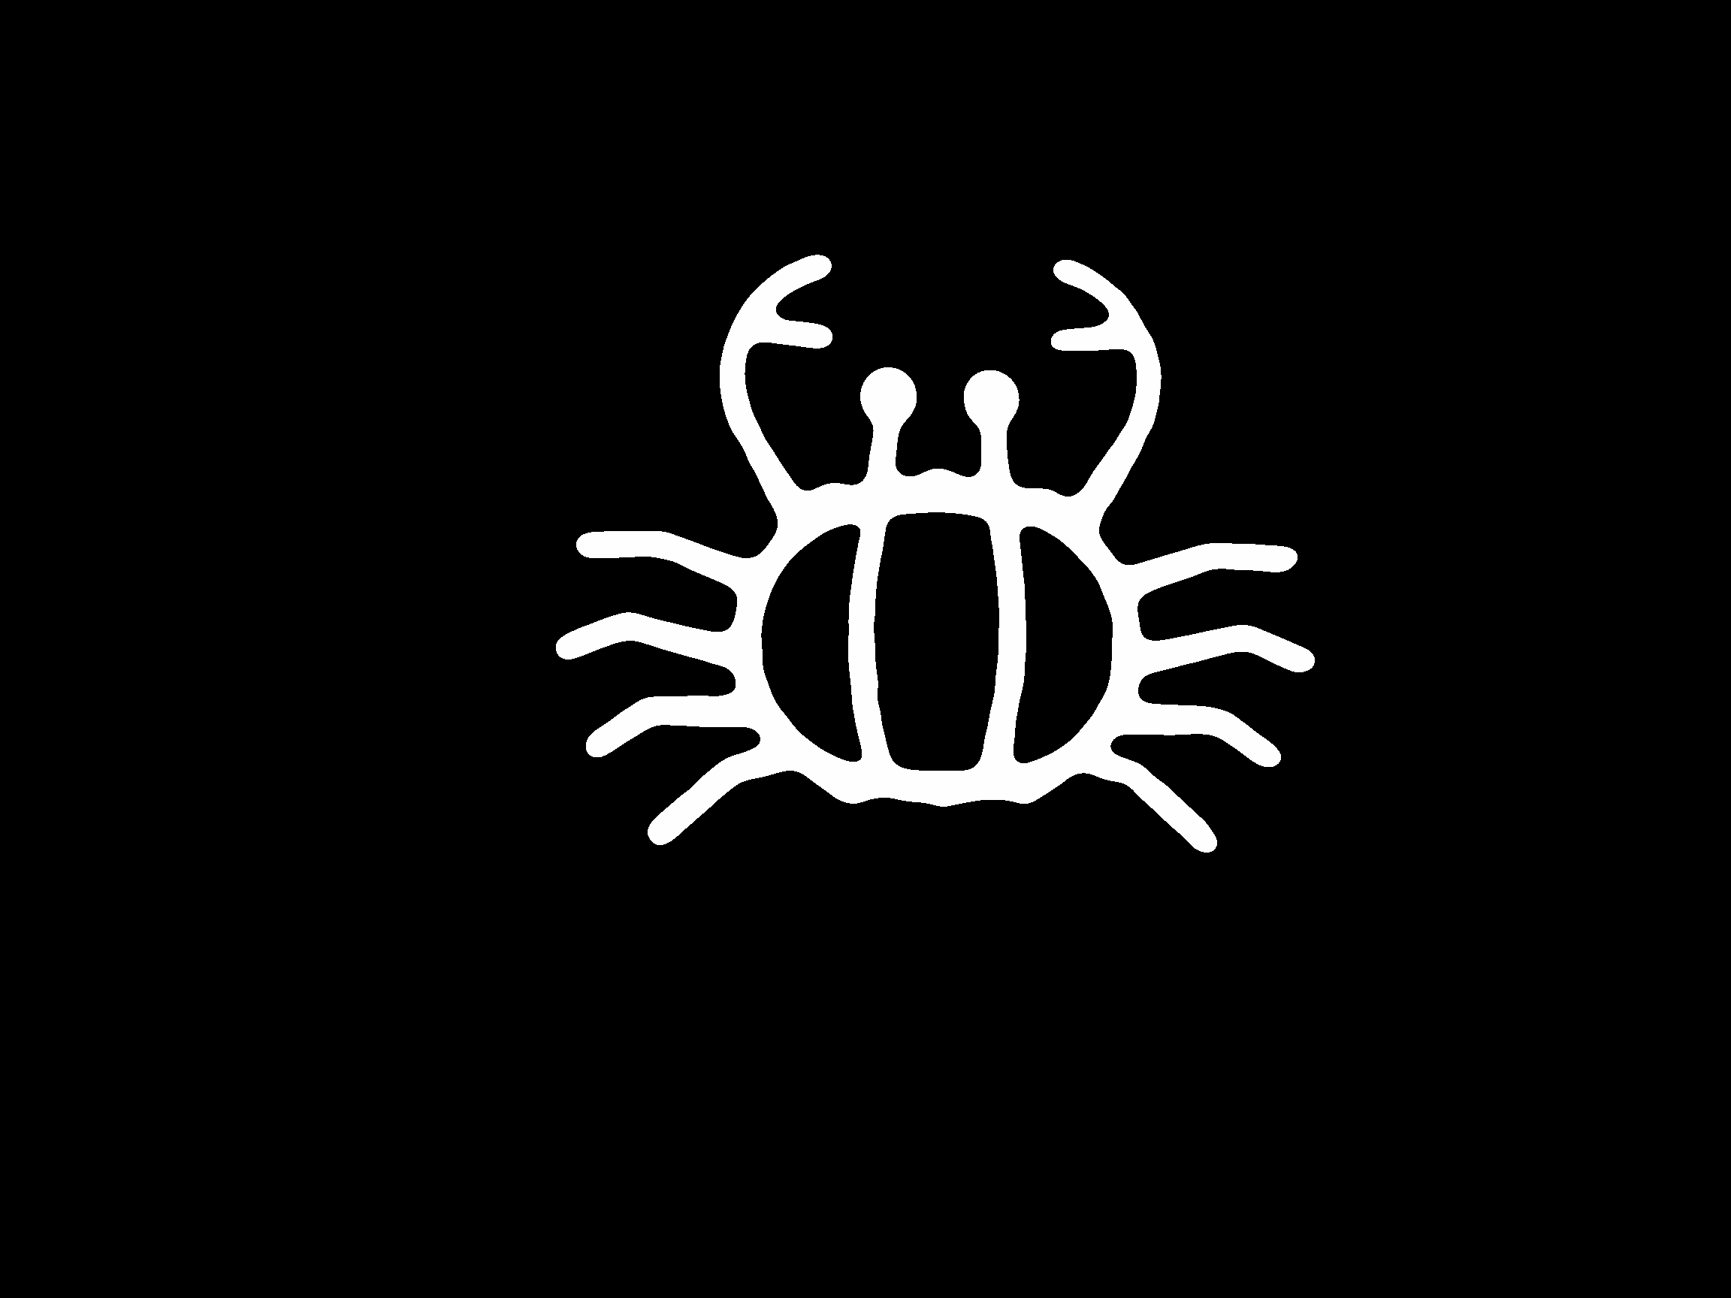


(Flower Snack Object) (Crab Object)

Back and White Background image




(Flower Snack Background) (Crab Background)

Code
Use Python dip.py,opener.py,cal.py are same old version

hw3_p1.py
import opener
import dip
import numpy as np

print "Process Flower_Snack.pgm"
gt = 2.60
mat = opener.pgm2mat('dataset/Flower_Snack.pgm')
fmat = np.fft.fft2(mat)

idmark = dip.filterdesign(fmat.shape, 'gaussian', [40])
imat = np.fft.ifft2(dip.filter(fmat, idmark))
inmat = dip.norm(np.abs(imat))

bw_obj = dip.mat2bw(inmat,range(225,256))
bw_bg = 255 - dip.mat2bw(inmat, range(0,80))

area_obj = dip.moment(bw_obj, 0, 0)
area_bg = dip.moment(bw_bg, 0, 0)
print "Area Object: "+ str(area_obj)+" px"
print "Area Background: "+ str(area_bg)+" px"
print "Area Groundtruth Background: "+ str(gt)+" cm^2"
print "Area Cal Object: "+ str((1.0*area_obj/area_bg)*gt)+" cm^2"

opener.mat2pgm('report/h3_p1_Flower_Snack_blur.pgm',dip.norm(inmat))
opener.mat2pgm('report/h3_p1_Flower_Snack_obj.pgm',dip.norm(bw_obj))
opener.mat2pgm('report/h3_p1_Flower_Snack_bg.pgm',dip.norm(bw_bg))

print "Process Crab.pgm"
gt = 2.766
mat = opener.pgm2mat('dataset/Crab.pgm')
fmat = np.fft.fft2(mat)

idmark = dip.filterdesign(fmat.shape, 'gaussian', [40])
imat = np.fft.ifft2(dip.filter(fmat, idmark))
inmat = dip.norm(np.abs(imat))

bw_obj = dip.mat2bw(inmat,range(225,256))
bw_bg = 255 - dip.mat2bw(inmat, range(0,80))

area_obj = dip.moment(bw_obj, 0, 0)
area_bg = dip.moment(bw_bg, 0, 0)
print "Area Object: "+ str(area_obj)+" px"
print "Area Background: "+ str(area_bg)+" px"
print "Area Groundtruth Background: "+ str(gt)+" cm^2"
print "Area Cal Object: "+ str((1.0*area_obj/area_bg)*gt)+" cm^2"

opener.mat2pgm('report/h3_p1_Crab_blur.pgm',dip.norm(inmat))
opener.mat2pgm('report/h3_p1_Crab_obj.pgm',dip.norm(bw_obj))
opener.mat2pgm('report/h3_p1_Crab_bg.pgm',dip.norm(bw_bg))

