The Boston Korean School was founded with the purpose of providing Korean-American students with the opportunity to learn the Korean language and culture.

Through the comprehensive curriculum, students will enhance their knowledge in Korean history, culture and language with a solid sense of self-identity as Korean-Americans. To serve this purpose, the school offers a variety of extracurricular activities aligned with language education.

Classes are held every Saturday at the Korean Church of Boston in Brookline, MA. Students are grouped into different classes by age and prior knowledge of Korean language.

Classes start at 9:30am and end at 12:25pm. Optional afternoon classes are offered from 12:40pm to 1:40pm. These afternoon classes include Taekwondo, and Korean Arts & Crafts.

Please visit our English version web site:
www.bostonkoreanschool.org

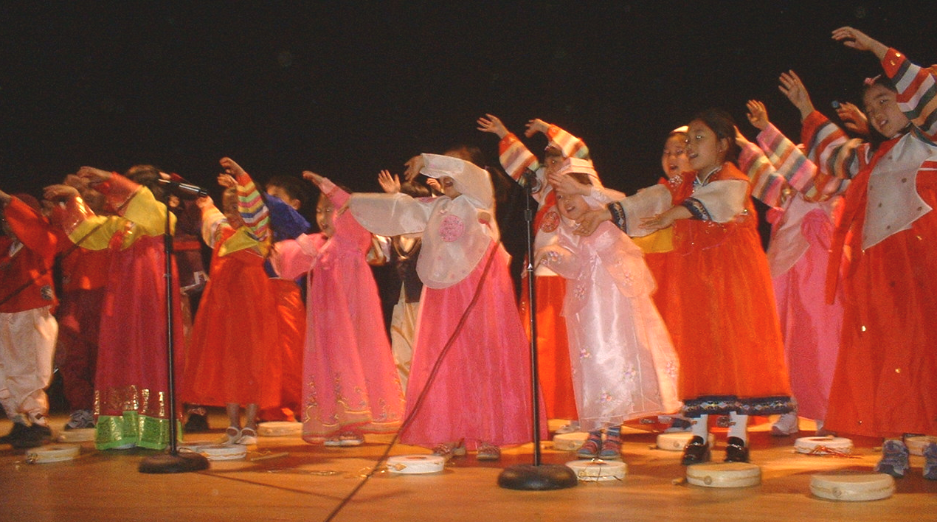

가을학기 개학:
2005년9월 10일
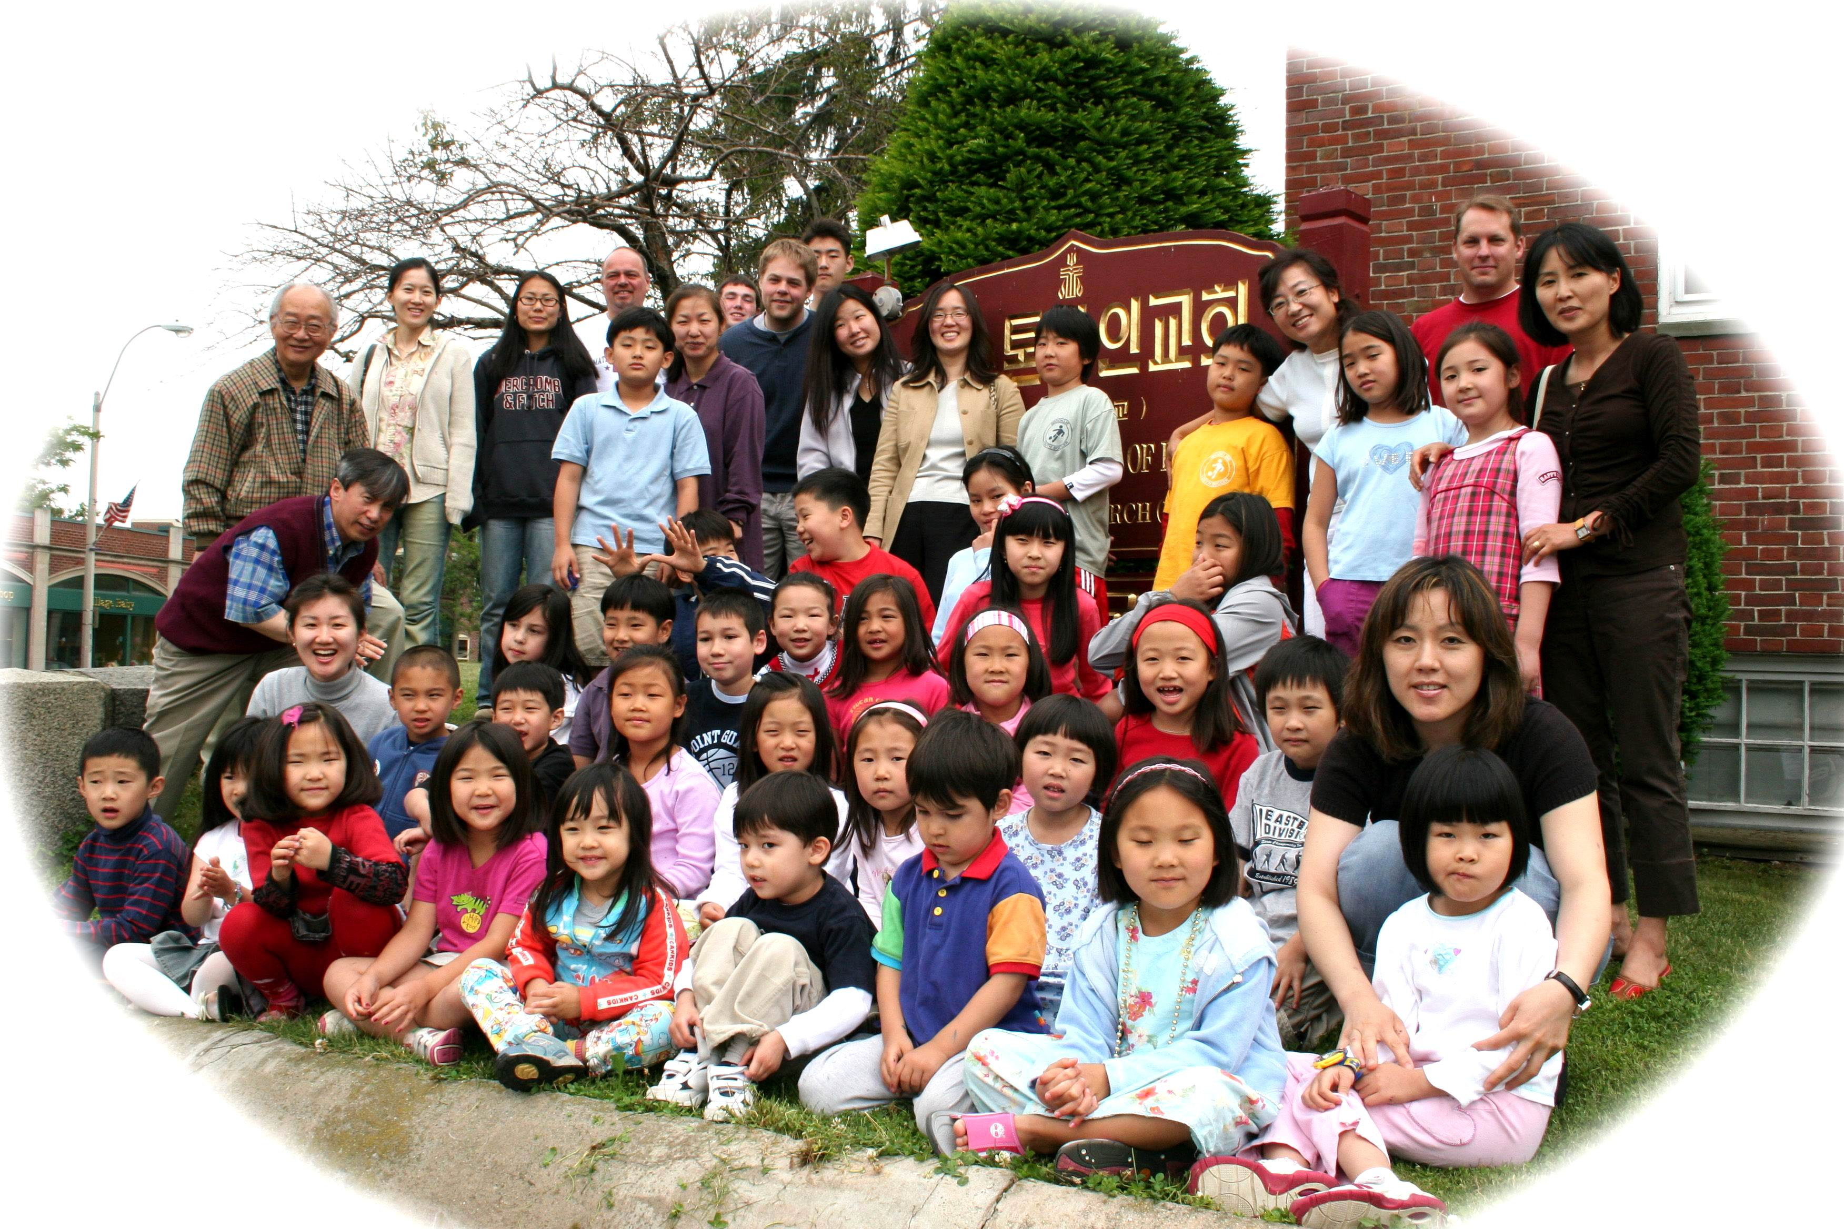
Fall semester begins September 10, 2005

모집대상: 만 3. 5세 이상
Age: From 3 1/2 yr old to 8th grade

수업시간 및 내용 (Curriculum and school hour)
매 학기에 16 토요일 수업(16 Saturdays/semester)
매주 토요일 9시30분 ~ 1시 40분
Every Saturday from 9:30 am to 1:40 pm

●오전수업: 9:30 ~ 12:25
Morning period: 9:30 am ~ 12:25 pm
한국어, 한국 문화와 역사, 서예,
한국요리, 동요, 농악, 미술, 및 공작
Korean language, Culture, History, Calligraphy, Cooking, Children‘s song, Arts & Crafts.
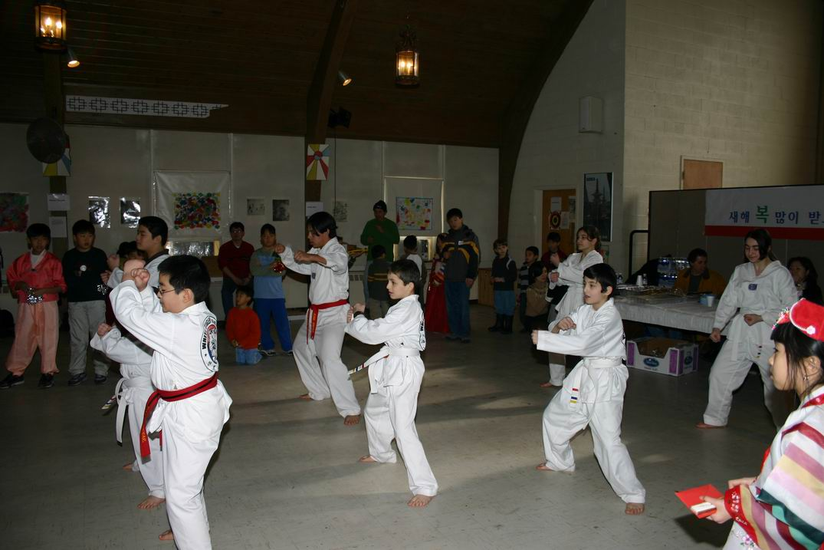
●오후 특별활동(선택): 12:40 ~ 1:40
Afternoon period (optional): 12:40 pm ~ 1:40 pm
태권도, 미술 (Taekwondo, Korean Arts & Crafts)

교재: 재미 한인 학교 협의회와 국제 교육
진흥원 발간 교재 사용
Textbooks: Standardized core textbooks published by The Korean School Association in the U.S.

등록금(Tuition)
학기당 첫째자녀: $200 (First child)
(Per semester) 둘째자녀: $180 (Second child)
셋째자녀: $100 (Third child)
특별활동(선택): $100 (점심 포함)
Optional: Afternoon class $100 (Lunch included)

문의(Contact Information)
Principal: 강상철 (978) 509-8708 Mr. Sang Kang
Curriculum Director: 한세진 Mrs. Sejin Choi
Board Director: 김정선 박사 Dr. Jason Kim

성인반(외국인): 기초 ~ 중급
Adult Classes: Basic ~ Intermediate
수업시간: 10:00 ~ 12:00 (매주 토요일)
Class Hour: 10 am ~ Noon (Every Saturday)
등록금(Tuition): $200

Boston Korean School Registration Form

Student's Name (Korean) | 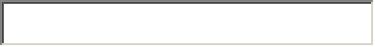
Student's Name (English)
Student's Age | 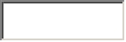
Student's Grade
Place of Birth
(State, Country)
Street Address
City, State, Zip Code
Telephone
Email
Parent's Name
Emergency Contact Information | 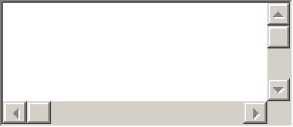
Special Request
(Dietary, Medical, etc.)

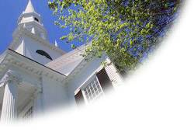

Registration:
Mail registration form and a check (Payable to: Boston Korean School) to
Boston Korean School
Attn: Registration
32 Harvard Street
Brookline, MA 02445

Or you can fax it to (617) 739-1366
Or register on the web

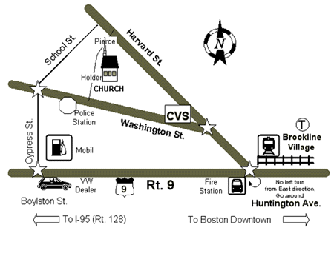

바른 우리말, 빛나는 우리얼,
미국속의 참 한국인

보스톤 한국학교

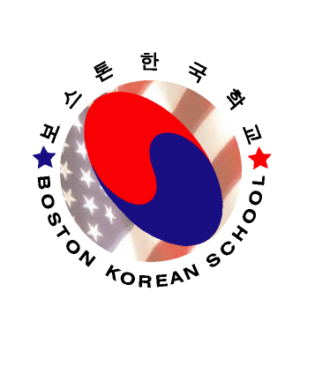

The Boston Korean School
c/o Korean Church of Boston (PCUSA)

32 Harvard St . Brookline, MA 02445
Tel : 617-739-2663
Fax : 617-739-1366

www.bostonkoreanschool.org

