Temperature comparison project of cabinets produced with different materials

Motivation

The project started with the search for new cabinets to be used in the field instead of the current one made of plastic. Such a cabinet did not present a good durability, deteriorating due to bad weather: difficulty opening and closing the doors, broken locks, yellowing of the cabinet. In addition, this box is made to measure, having a price three times higher than the metal box researched. In figure 1 below, we have the image of the plastic box next to the structure installed in the field.

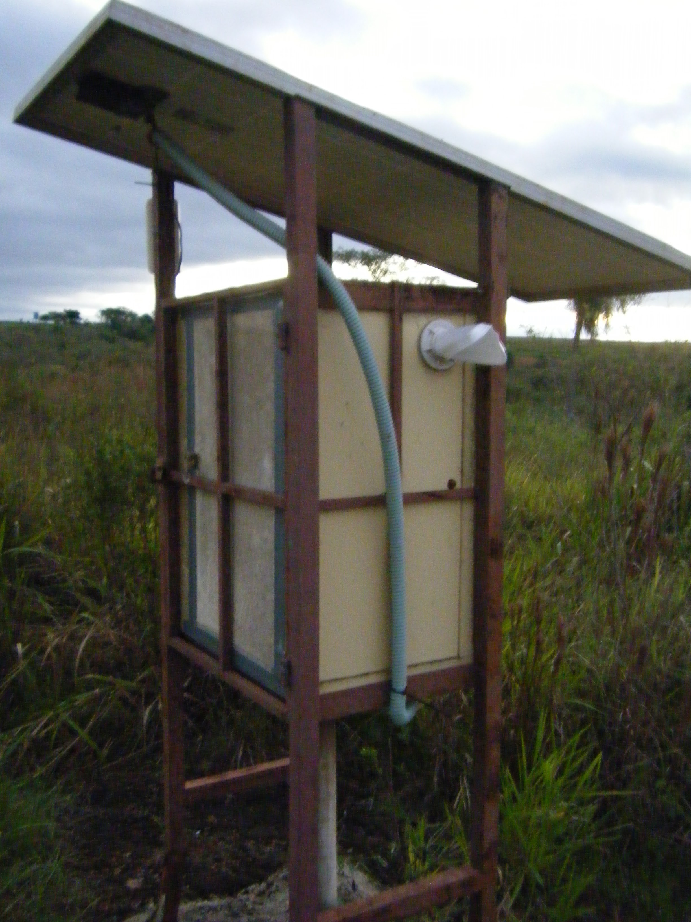
Figure 1: Plastic cabinet with to the structure installed in the field (Amambaí-MS-BRAZIL)

Planning

Through the need to search for new cabinets, a metal one was found that would meet the requirements. However, one of the doubts was the retention of heat on the part of the metal box, which could be greater compared to the plastic box and can put our equipment working at high temperatures, affecting the behavior of the devices or even damaging them.

It was then realized the need to measure the temperature differences between the two types of cabinet. With that, we assembled a team to put the project into practice.

First, the assembly structure was thought about: it would be necessary to set up a station simulating field conditions and having the same pattern in construction. Thus, we would place the two complete structures (structure + cabinet + solar panel) next to each other.

In a second step, it was thought about how to measure these temperatures, that is, which devices would be used in the project. Thus, we ended up using what we already had internally: arduino with data shield logger and temperature sensors. In addition, a battery would be needed to power the circuit and cables to interconnect.

Execution

First, we separate the materials needed for the measurement part:
• 1 Arduino UNO
• 1 shield data logger (attached to Arduino)
• 1 SD Card
• 1 Protoboard
• 3 DHT11: temperature and humidity sensors
• Cables

With the devices in hand, we set up a test circuit on the protoboard with the 3 temperature sensors side by side. After that, we started assembling the programming on the Arduino IDE. This first test aimed to check if there was a discrepancy in the sensors in the measurement in the same environment. In addition, we did the test to check if the information was being recorded in the data logger.

With the confirmation that there was no significant difference in temperatures in the same environment and that we had the information recorded on the SD Card, we then proceeded to the final code and the assembly of the final circuit to be used in the boxes.

Figure 2 shows the Arduino and data logger already assembled inside the metal box.
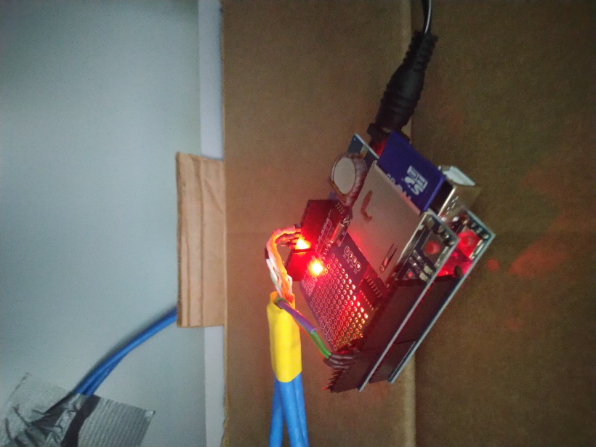
Figure 2: Arduino with data logger already assembled in the metal case

We also set up the structures, side by side, simulating a real condition of our stations in the field as shown in figure 3.
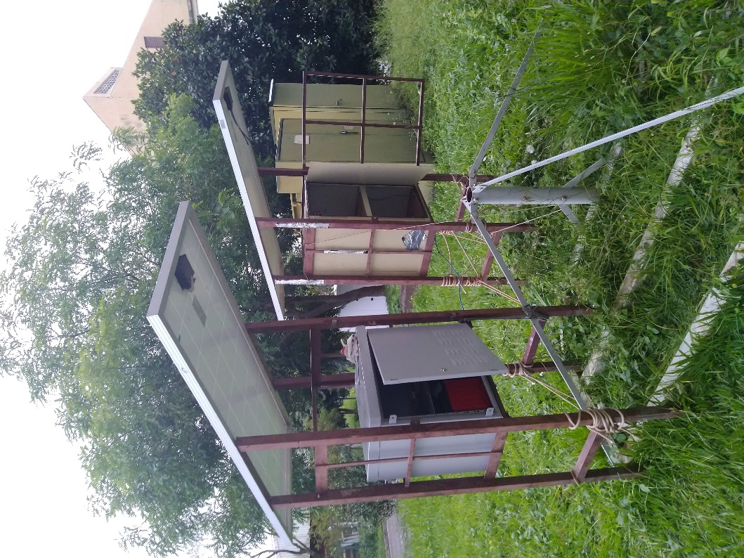
Figure 3: assembly of the structures next to each other

Regarding the sensors, we set up one inside each box and one outside the boxes to be able to compare. In figure 4, we have an image that shows these 3 sensors inside the boxes.

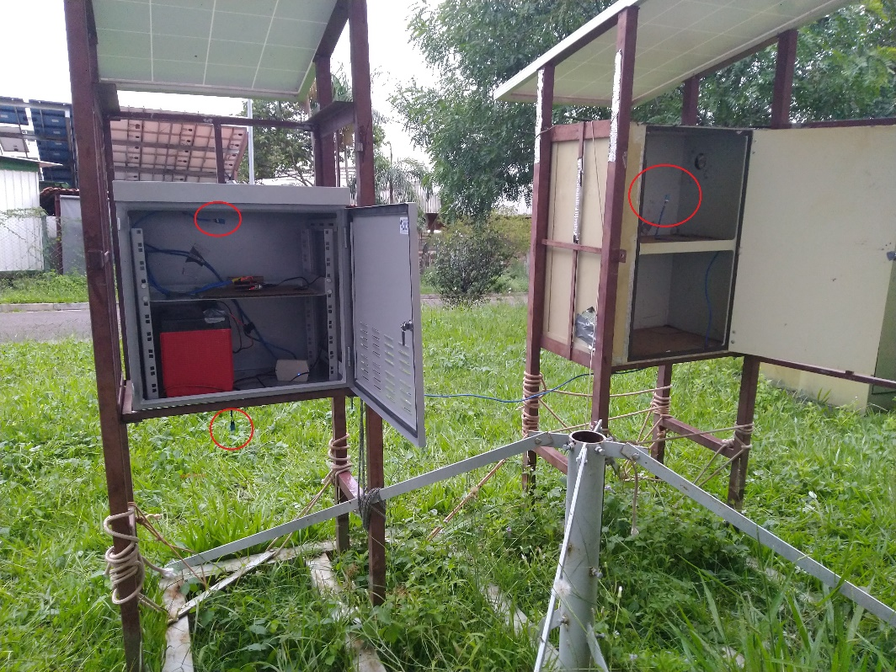
Figure 4: the 3 dht11 sensors installed

Monitoring

Data acquisition was made between 01/17/2020 (from 7:05 pm) and 01/22/2020 (until 12:25 pm), with intense sunny and cloudy days.

Conclusion

During this period, there was no significant difference between indoor temperatures. In figure 5, we have the graph that the blue line represents the internal temperature of the plastic box, the orange the internal temperature of the metal box and the gray the external temperature.

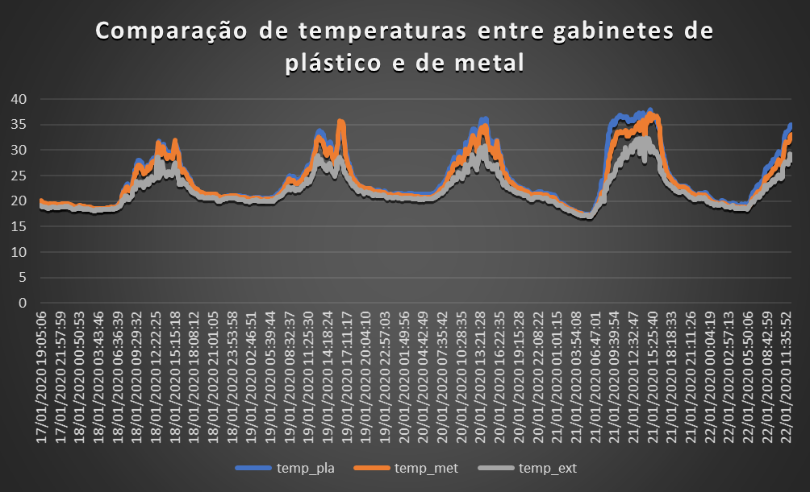
Figure 5: difference in temperatures during the entire period measurement

Bringing a shorter monitoring period and also the largest discrepancy measured throughout the period, the biggest real difference noted was on 01/21 between 8:30 and 9:45, where there was a difference of 5.3 ºC being the plastic with the highest temperature throughout this time, which can be seen in the graph in figure 6. There were also periods when the temperature of the metal box was higher than that of the plastic box, but did not exceed the value of 3 ºC.
What should be noted is that this temperature difference is not significant enough to damage equipment in the field, and you can use any of the boxes for the season. Anyway, the signage to use the metal box was beneficial, due to its value and durability informed by the manufacturer, having to spend 5 years in the field taking due care and doing the necessary maintenance.
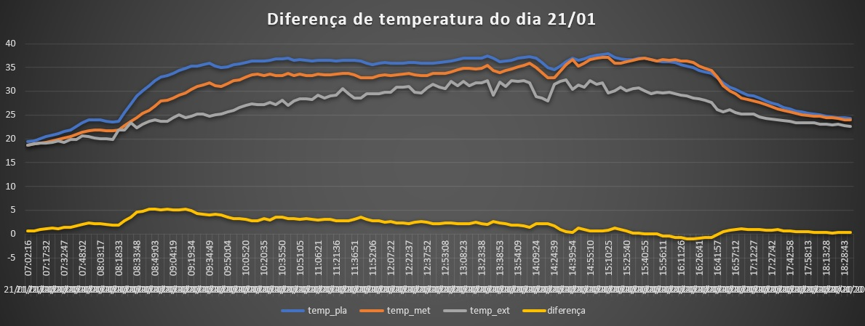
Figure 6: diferença de temperatura durante o dia 21/01

