Consumption measurement of ViaSat's SurfBeam 2 radio to adapt the photovoltaic system at Vale stations: new configuration

Motivation

Through the first test using only a current sensor, it was possible to measure the device's consumption. However, there was also a need to measure how much energy is produced with the system assembled. With this information, the necessary configuration can be optimized to meet the real needs of the load. For this, some modifications were made to the initial project, which we will detail below.

Planning

As reported, a change in the project was necessary to also measure what was being produced, in addition to also measuring how much was being consumed. We continue to use an arduino with a data logger (to store each measurement), but we added another current sensor and a voltage sensor to measure the batteries. We then multiply the voltage read in the battery by the sensor with the current read in the output of the panels to know the power produced and, we multiply this same voltage with the current consumed by the load (SurfBeam radio 2) to know how much power is being consumed. In figure 1 we have the DC voltage sensor.

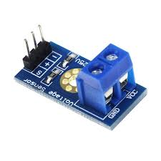

Figure 1: DC voltage sensor

Execution

We purchased the additional materials needed for the new configuration:
- 1 DC 25V voltage sensor
- 1 current sensor ASC712 30A
- 1 16 x 2 display
- Cables

We then made a new programming, now for two current sensors and a voltage sensor. In this new programming we also added the display for real time visualization of currents, voltage and powers (consumed and generated). In figure 2 we have an example of the 16 x 2 display used in the project.
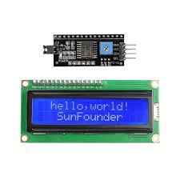
Figure 2: 16 x 2 display with interface for arduino.

The second step was to re-assemble the physical circuit with arduino, sensors and display. There are now two current sensors: one at the output of the panels (post controllers) and another at the input of the load, including inverter and load. The voltage sensor measures the battery's direct voltage. In figure 3 we have the example drawing with this configuration.

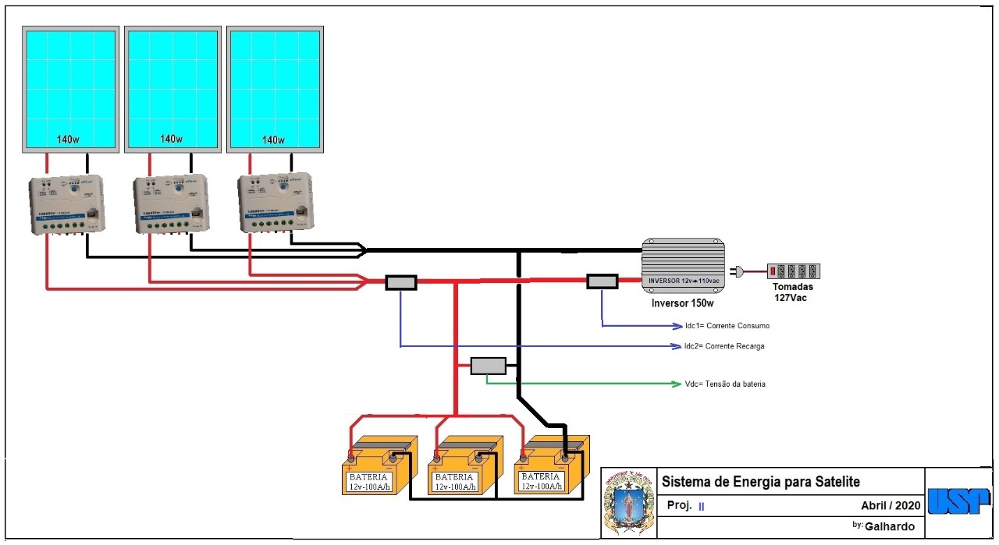
Figure 3: Example of configuration with current and voltage sensors.

Monitoring

The acquisition of these first data was made between 12/05/2020 (from 16:07) and 15/05/2020 (until 16:27) with a total of 14756 data read.

Results

During this short monitoring period (from 12/05 to 15/05), we had no sunny days in São Paulo. Anyway, we had some important information in this research. We managed to produce, even on a day without sun, 55% of the load requirement. With that, we dimension the panels now knowing that using two panels close to 375 W each will produce enough energy for the radio. It is worth mentioning that this availability is greater than 25% of what we are making available for the test.
In addition, it is important to note that we will continue with the project at 24 Volts and not at 12 Volts, as these 375 Watts panels work with voltages greater than 30 Volts, having a lower loss when we transform to a voltage close to the panels' work. We will use, in this case, four 12 Volt 105Ah batteries, two to two connected in series and closing the circuit in parallel, thus having 2 sets of 24 Volts with one more battery than we used in the tests.
We will also use the MPPT, a more efficient controller that can deliver up to 30% more energy than the PWM (used in test), as it makes better use of the maximum power point of the solar panels.
In short, we will be delivering more power to the panels with a larger battery bank and a more efficient project than carried out in the test, with improvements in the working voltage and equipment used.

Next Steps

The project continues monitoring and we will have information with sunny days to better understand the system's behavior.
In this first moment, we will follow the project using a 300 Watt inverter, which has a loss close to 10%. In a next step, we will test the use of a step up from 24 Volts to 30 Volts (operating voltage of the radio), thus removing the inverter from the project and using surge protections.
The intention is to leave the test system assembled and vary the equipment and methods used, such as number of panels, working voltage, different controllers, etc., in order to understand the differences and adapt / optimize our projects installed in the field.

