Consumption measurement of ViaSat's SurfBeam 2 radio to adapt the photovoltaic system at Vale stations

Motivation

The consumption measurement project was necessary due to the use of a new satellite transmission method by ViaSat's SurfBeam 2 radio system, which consumes a much larger amount of energy than the USP seismological stations installed in Brazil. To give you an idea, a station with sensor, digitizer and transmission via 3G radio consumes around 8 Watts / h. ViaSat's system has an informed consumption of up to 81 Watts / h, that is, a consumption 10 times greater than a complete station, not to mention the additional seismological measurement devices next to ViaSat's radio. In figure 1 below is an image of the antenna and radio of the ViaSat system.

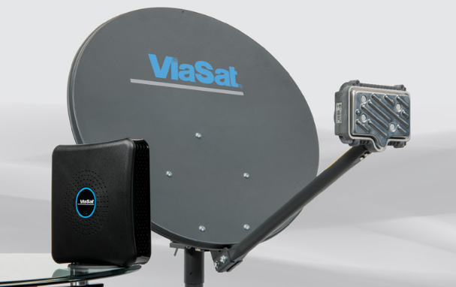
Figure 1: ViaSat antenna and radio

Planning

First was necessary to measure the actual consumption in Watts of SurfBeam 2 to understand the photovoltaic needs of the project. Knowing the actual consumption of the system, the specific calculation can be made with respect to the number of solar panels to be used, the number of batteries for the required autonomy of the system, the specific voltage regulator for the current generated and the correct wire gauge for the project.
With that, we thought about assembling the complete ViaSat system at IAG / USP and a way to measure consumption. The method thought and implemented was using an arduino with a data logger (to store each measurement) using a current sensor. With the current measured, multiplying by the nominal voltage (127V) we would have the consumption of the device. In figure 2 we have the arduino with the data logger attached and in figure 3 the current sensor.

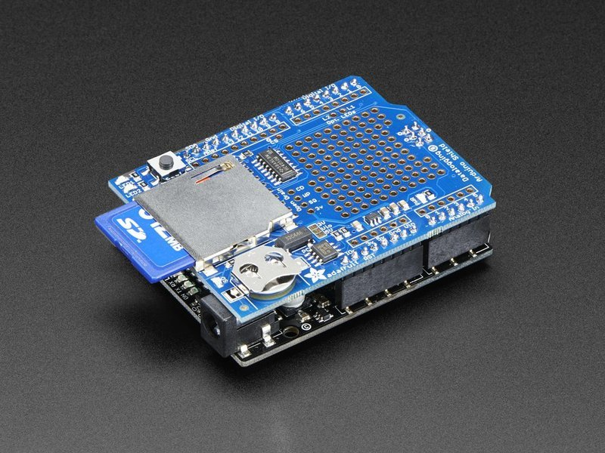

Figure 2: data logger coupled to arduino

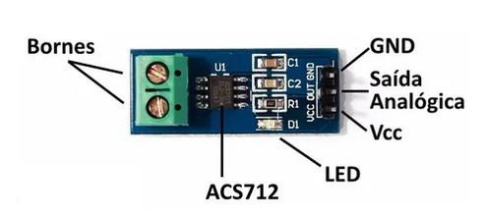

Figura 3: Current Sensor ACS712

Execution

First, we separate the materials needed for the measurement part:
• 1 Arduino UNO
• 1 shield data logger (attached to Arduino)
• 1 SD Card
• 1 current sensor ASC712 30A
• Cables
With the devices in hand, we first set up the code for operation of the consumption meter. The second step was to assemble the physical circuit with arduino and sensor and do the primary tests. The test was done with a soldering iron of 32 Watts, having a very close result (31.7 Watts).
At IAG / USP, we set up the complete ViaSat system in an initial test: two 140W solar panels, 2 115Ah batteries, a 20A voltage regulator, a transformer (12VDC → 127VAC), modem, antenna and cables. We coupled the electronic circuit (arduino + data logger + sensor) to the measurement output.
In this first test, the system did not support the load and we ended up adding another 115Ah battery for autonomy and two more 140W solar panels to recharge them. In figure 4 you can see the circuit with the batteries under test. In figure 5 the test with 3 solar panels and the ViaSat antenna.

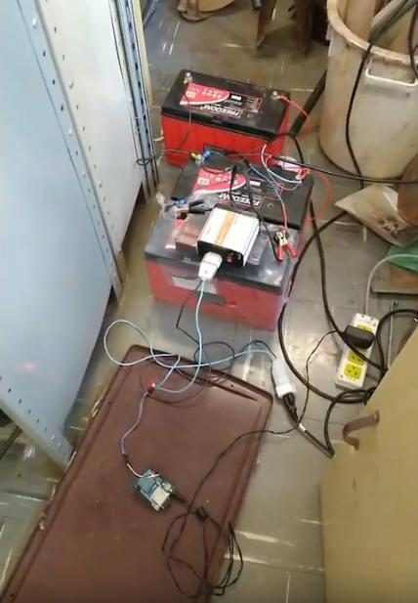

Figure 4: Electronic system mounted in test. Arduino and current sensor, voltage inverter and the three batteries.

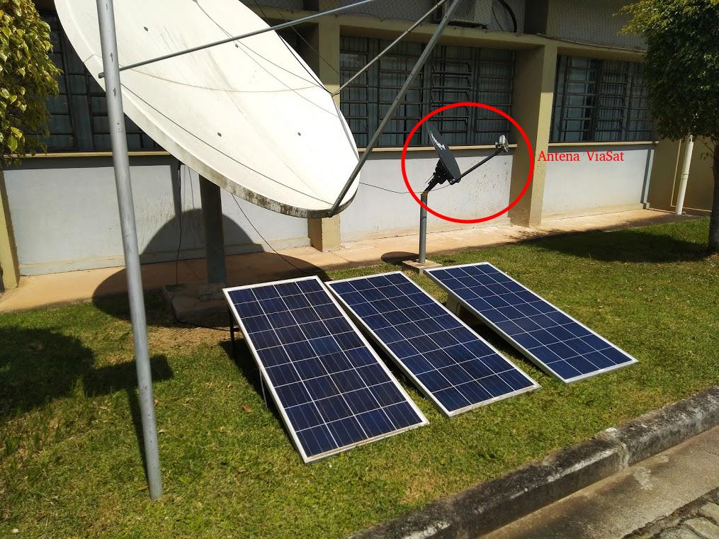

Figure 5: Outside: ViaSat antenna and one of the tests with 3 panels

In figure 6 we have the 4 solar panels assembled.

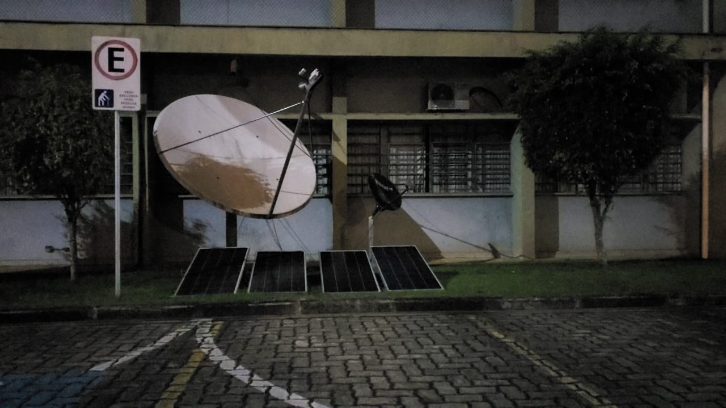

Figur6 6: Outside: the 4 solar panels

Monitoring

Data acquisition was made between 03/23/2020 (from 10:48 am) and 03/28/2020 (until 4:00 am) with a total of 40,910 data read. Among these data, 17215 had the measurement at zero (system off) and 23695 data during the operation of the system (valid data).
Results

During the monitoring period and using valid data (23695), the radio's average consumption was made and an average value of 58.89 Watts / hour was obtained. That is, a difference of 26.11 Watts less than specified.
With this value, we then calculated our photovoltaic needs and arrived at the value of 4 panels of 140W and 3 batteries of 115Ah to support the system. Even so, the system is still not supporting the system load. See figure 7 below where the blank spaces mean the system has shut down.

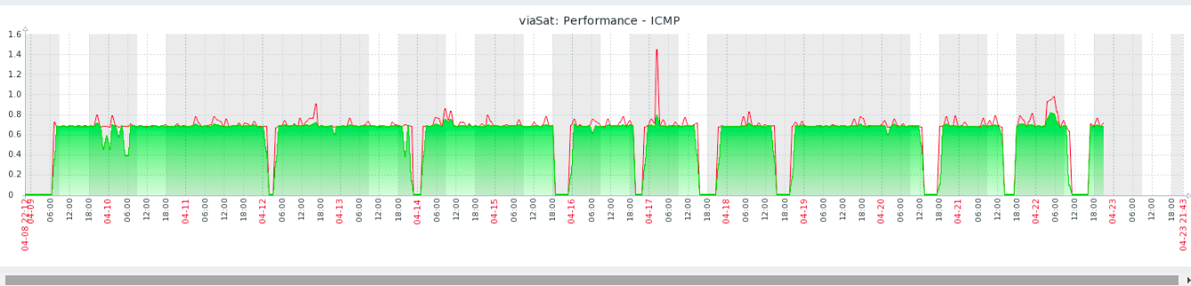
Figure 7: Monitoring the operation of the ViaSat system. Blanks was when the system shut down

Next Steps

To check the system accurately, we will add sensors to the project to check how much energy is being produced by the solar panels and also how much is being consumed by the load. It is worth noting that between the load and the batteries is the inverter, which is not being measured at this time. With the insertion of these new sensors (2 voltage sensors and 2 current sensors) we will be able to know what is being produced and what is being consumed with the full load (radio + inverter). With these values ​​in hand, we will know where our bottleneck is and make the necessary changes to the project to meet the needs. We are waiting for the sensors to arrive next week (27/04/2020), and this new stage will be implemented in the same week.
If, in this second test, the inverter presents a large consumption of energy, we will do a new experiment removing the inverter from the system and connecting the radio to the battery directly, using a step up from 12 VDC to 30 VDC, which is the working voltage of the system. With this new approach, consumption measurements would be made again to adapt the photovoltaic system.

