**1. O INTRODUCTION** 1

1.1 BACKGROUND OF THE ORGANIZATION 1

1.2 GENERAL OPERATION OF THE ORGANIZATION 1

Employment Department 2

Sales Department 2

1.4 Scope of the project 2

1.5 Objective of Proposed System 2

1.6 Current System 2

Problems of current System 2

1.7 Proposed System 3

Current System 3

3

3

3

Not available Available 3

3

3

3

3

**2. O SYSTEM ANALYSIS** 4

2.1 FACT FINDING METHOD USED 4

Observation 5

2.2 FEASIBILITY STUDY AND ITS REPORT 5

Technical feasibility 6

Social feasibility 6

**3. O CHAPTER SYSTEM DESIGN** 9

3.1 Objectives of Design 9

File Design 9

1. Master files 9

2. Product file 9

3. Sales file 9

4. Stock files 9

5. Suppliers file 9

This will contains login credentials 9

Login file 9

**Field name** 9

**type** 9

**size** 9

**indexes** 9

**Description** 9

archer 9

22 9

User name 9

**email** 9

archer 9

33 9

Primary key 9

User email 9

**password** 9

archer 9

8 9

User password 9

Input design 11

Out Design 15

Control design 16

Text design 17

c) Data validation 17

**4. O SYSTEM IMPLEMENTATION** 18

**4.1 Hardware and software specification** 18

4.2 USER TRAINING 18

4.3 CHANGE OVER 18

4.4 system security 19

4.5 user guide 19

**5. O CONCLUSION** 21

5.1 Overall conclusion 21

5.2 Achievements 21

5.3 Limitations/constraints 21

5.4 Future improvements 21

**6. O APPENDICES** 22

Program listing 22

Bibliography 28

INDEX 29

# **1. O INTRODUCTION**

Many small enterprise business carry out their daily operation as a result I have decided to computerize 10KSH COMPUTER SALES LIMITED. I come up with a system application for their enterprise

## 1.1 BACKGROUND OF THE ORGANIZATION

It’s a small enterprise business established 2012 and it promise sits on an approximately area of 0.2acres. It was started up with aim of selling computer and other electronic gadget.

## 1.2 GENERAL OPERATION OF THE ORGANIZATION

The enterprise has two department which carry different operation of the business.

Selling of laptops, computer pars and other electronic gadget, the operation is carried by sale department, employee department which deals with employing and payment of employment

1.3 ORGANIZATION STRUCTURE

As it’s said the organization has two department that collectively work together to achieve

The wellbeing of the business

THE ORGANISATION CHART

Business Owner

Assistant Manager

Sales Department

Employee Department

### Employment Department

This department deals with monitoring the operation of the employee, employment of new employees and their payment

### Sales Department

The department deals with buying and selling of laptops, computer parts another electronic gadget

## 1.4 Scope of the project

In order the business to be able to monitor the performance of their business and be able to know how making profit is or loss I decided to computerize sales department

## 1.5 Objective of Proposed System

The following are objectives of the proposed project:

* 1. Advertise the operations online worldwide.
  2. Monitor the operation of the company through generating report about the sales.
  3. To monitor performance of its employees.
  4. Store information and details of their clients and employees.

## 1.6 Current System

The current system operates as follows:

Any sales of any product is made is recorded in a sales files, which is used to produce reports

### Problems of current System

The currentsystem has the following shortcomings:

1. The files are stored in cabinets and occupy a lot of space.
2. The data securing is poor since unauthorized people can have access to files and make changes
3. The process of retrieving data is slow since one has to look for the file one by one in the cabinet.

## 1.7 Proposed System

The proposed system will not completely do away with the current system but it seeks to modify the current procedures.

As a result it will make them have more customers and and clients throughout the country, retrieval of the information is made as the system will generate report easily, the security of the information is maintained because only admin has access to the system.

It will make it easy to mentor the performance of the organization.

### Current System

# 

Check product availability

1

# 

Order product

# 

# Not available Available

Not available

Open sales

File

# 

# 

# 

Prepare receipt

# 

# **2. O SYSTEM ANALYSIS**

## 2.1 FACT FINDING METHOD USED

**Questionnaire**

Permission was sought in advance from the managing director with those involved in sales and management in the company.

The following staffs were involved and sample questions asked where hereby given;

**Managing director**

Q1) what are your and responsibilities?

Managing and directing the company

Ensuring every department in the company is working and running correctly.

Q2) how is the organization of the company?

Managing director- who directs and monitors operations of the company, after here is

Deputy managing director who assist the managing director. Technician officer who is in charge of all employees who give services to our clients.

Sales manager under department of sales who keeps records on sales and products bought.

Q3) Do you process any document?

I only keep records on sales imported from outside the country but mostly processing of document is done in the technician and sales department.

**Sales officer**

Q1) what duties do you perform?

Monitor buying and selling of our products which are computer laptops and its parts.

Q2) what records do you process?

ANSWER; I keep records on sales especially incoming and outgoing sales

I also keep records on the performance of the company.

Q3) how and where do you record sale details?

ANSWER; Recording is done manually in the files and records are kept safely in a

Cabinet according to date of sale for easy generation of report.

Q4) what document is given after any sale is made?

Q5) what are reports and when do you generate?

ANSWER; Sales report and the report is generated monthly.

**Technician officer**

Q1) what are your duties?

ANSWER; I monitor the working of the technicians, assigning jobs to them from our

Employees.

Q2) what records do you process?

ANSWER; I keep records/details of technicians, how technicians work, client

Requests, assigned work to the clients.

Q3) Do you generate any reports?

ANSWER; I give out report on technician performance and work report.

### Observation

In order to completely understand the current system, I spent sometime within the institution to observe how the daily activities are carried out

I got to observe the following;

The employee has to submit their application letter to the managing director, copy of national ID, two passports and their recommendation letters.

Clients has to come to the company to submit their requests and the technician officer assigns the request to one of the technicians.

They sale their laptops to their customer and the sales are recorded.

## 2.2 FEASIBILITY STUDY AND ITS REPORT

Feasibility study is an analysis that takes all of a project’s relevant factors into account including economic, technical, legal, scheduling, considerations to ascertain the likely hood of completing the project successfully.

**Economic feasibility**

The study established that they would be more cost effective compared to the current system.

This is because the cost of buying the necessary equipment like computers, hiring the experts as time is going by will be lower compared to the manual that keeps on increasing with time.

### Technical feasibility

The company has never had a computerized system before. Therefore, everything is done manually. Due to this the proposed, the proposed system seeks to put a close to the ever increasing expenses experienced as a result of using the current system.

This is because of the many staffs needed, stationery and even storage space required for the files. The study has fully determined that the company is fully capable of acquiring the required hardware components and the software needed to run and support the new system however, there is need for skilled personnel to operate the new system.

### Social feasibility

As the saying goes; people are resistant to change, some of the staffs resisted the change but after further verification was made they came to realize that the new system would relieve them some of their heavy duties which they are carrying out in their current system.

There will be accessing of computer services and as a result the idea will enhance creation of job.

**Proposed system DFD**

Computer sales and

Management services management Client

System

**Zero level DFD computer sales and services**

Advertisement

Management

Computer

Management Service

Management

Computer sales

Employee system user

Management management

Login management

**First level DFD computer sales and service**

Computer sales

Management report

Stock report

Stock management computer sales

Login management check stock

Supplier’s management

**Second level DFD computer level sales and service**

Login to Check rules

Admin System of access

Forgot Manage advertisement

Password

Manage service

Manage

Modules Manage accounts details

Send email

To users

Manage stock

Manage

Manage system admin Manage rules of user Manage customer details

# 

# **3. O CHAPTER 3: SYSTEM DESIGN**

## 3.1 Objectives of Design

* To ensure faster manipulation of data
* To produce timely report
* To enhance security to prevent unauthorized not to access information
* To produce a system that is flexible

## File Design

The file will be stored in hard disk and organized as follows

1. Master files
2. Product file
3. Sales file
4. Stock files
5. Suppliers file
   * 1. **Master file**

This will contains login credentials

Login file

|  |  |  |  |  |
| --- | --- | --- | --- | --- |
| **Field name** | **type** | **size** | **indexes** | **Description** |
| |  |  | | --- | --- | |  | **name** | | archer | 22 |  | User name |
| **email** | archer | 33 | Primary key | User email |
| **password** | archer | 8 |  | User password |

* + 1. **Product file**

|  |  |  |  |  |
| --- | --- | --- | --- | --- |
| **Field name** | **type** | **size** | **indexes** | **Description** |
| ***product ID*** | in | 11 | Primary key | Product id |
| |  |  | | --- | --- | | ***name*** |  | | archer | 23 |  | Product name |
| ***brand*** | archer | 12 |  | brand |
| ***type*** | archer | 113 |  | Product category |
| ***specs*** | text |  |  | Specification |
| ***prince*** | double |  |  | Product price |
| ***sty*** | double |  |  | Product Quantity |
| ***available*** | in | 22 |  | Available item |

* + 1. **Sales File**

|  |  |  |  |  |
| --- | --- | --- | --- | --- |
| **Field name** | **type** | **size** | **indexes** | **Description** |
| Product ID | in | 11 | Foreign key | Product id |
| product name | archer | 45 |  | Product name |
| **price** | double |  |  | Product cost |
| **sty** | in | 11 |  | Quantity |
| **total amount** | double |  |  | Total amount |
| **payment method** | archer | 33 |  | Payment method |

* + 1. **Supplies files**

|  |  |  |  |  |
| --- | --- | --- | --- | --- |
| **Field name** | **type** | **size** | **indexes** | **Description** |
| **same** | archer | 44 |  | Supplier name |
| **phone** | in | 11 |  | phone |
| **nationality** | archer | 22 |  | nationality |
| **supply** | archer | 33 |  | Product supplied |
| **email** | archer | 22 |  | email |

## Input design

The data will be directly keyed in using a keyboard

**Account Creation Form**

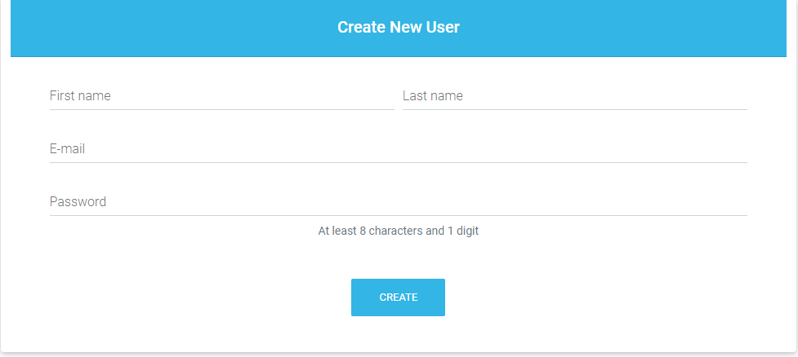

**Stock Form**

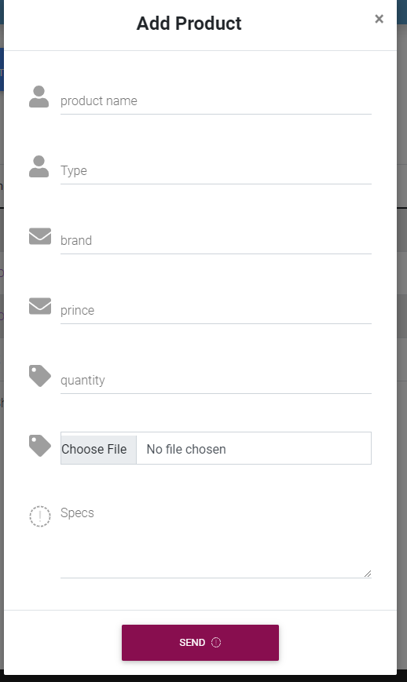

**Supplier Form**

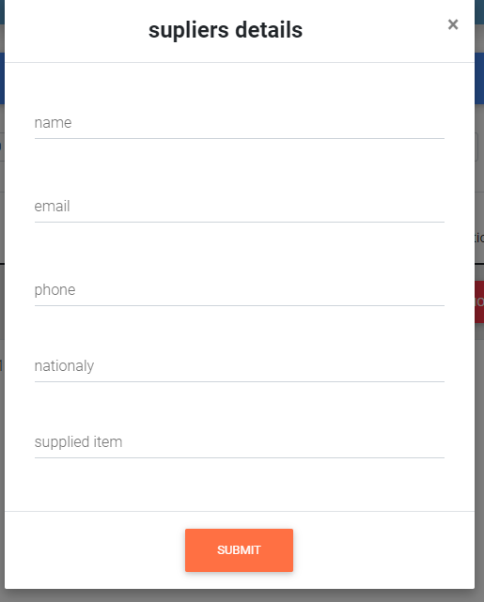

* 1. **Process Design**

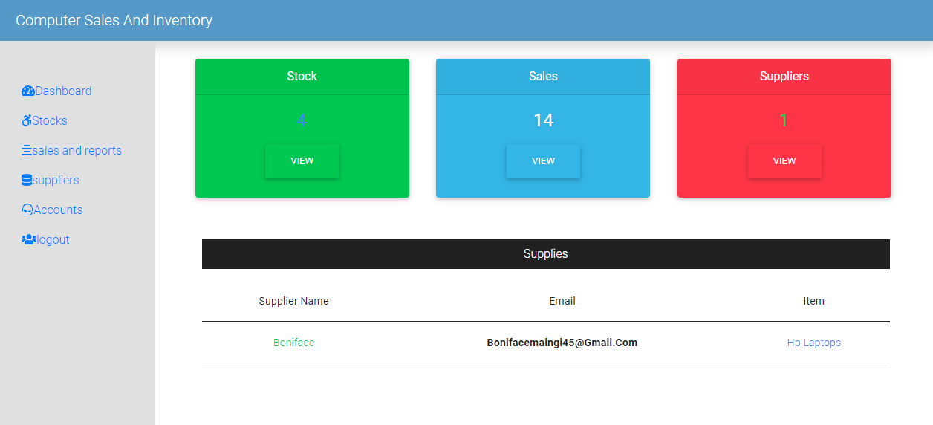

## Output Design

The System is aimed in printing report about sales made in a day and a month

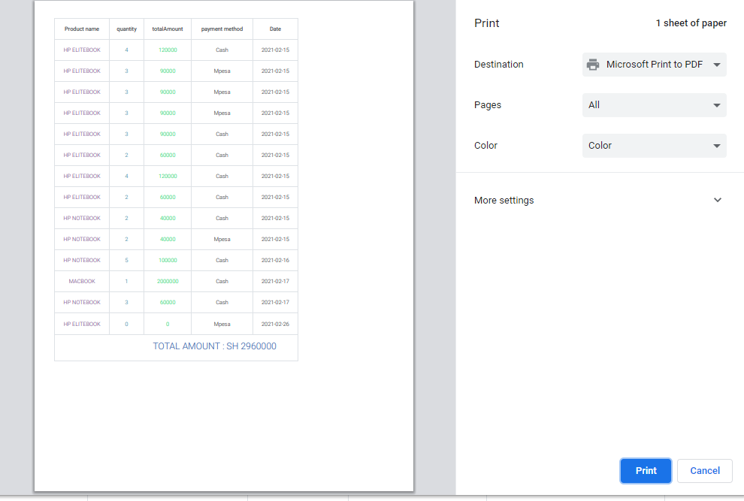

## Control design

This system will employ security control measures this include

* Physical controls

The computer rooms will have grilles in order to curb hardware theft

* Logical control

Passwords will be entered in order to open the proposed system where clients should register in order to be login to their account, admin will be required to enter password in order to login to admin part of the system

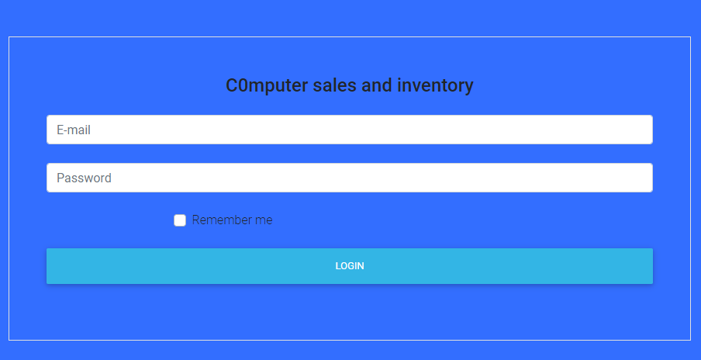

## Text design

The system will be subjected to wrong and right data inputs with the aim of making it fail

This will be done through

A) Use of real data

b) Use of test data

## c) Data validation

|  |  |  |
| --- | --- | --- |
| FIELD NAME | RIGHT DATA | WRONG DATA |
| Product id | 1 | one |
| Product Name | alibi | 123 |
| Product Price | 4000 | Four thousand |
| Quantity | 12 | twelve |
| Supplier name | Mach aria | 345 |

# **4. O SYSTEM IMPLEMENTATION**

# **4.1 Hardware and software specification**

The proposed system will run on a server specifically a web server because is a web based system

The organization will use dedicated server to allow access of their application inside and outside the organization by clients

Specification for dedicated server computer

* Network operating system eg Microsoft windows server 2003/2008
* XAMPP Server
* RAM of at least 32gigabyte
* HARD DISK of at least 1 terabyte
* MICROPROCESSOR

Documentation is written using Microsoft word 2016

# 4.2 USER TRAINING

A public training will be done through social media to train their clients on how to use their application. A link will be made available to their clients for the access of their web based system

The organization will need to train an IT professional who will install and configure the server to allow web server functions

# 4.3 CHANGE OVER

This is where the system is put into operation

In my case, the parallel changeover method will be used i.e. the two systems (the old and new)

Will be ran together in parallel and output compared.

This facilitates modification to the system whenever flaws are detected. This will continue until the

The new system works as per the expectation.

This stage will need a lot of care because it will lead to the conversion of manual to the new automated system.

The required hardware and software should be provided and thus the company should cater for all the cost for the proper functioning of the system. The computer should be provided with power throughout in order to avoid data loss. A generator may be needed to ensure the above in case of power loss.

# 4.4 system security

Reliable ways to enhance the system security will be put in place. This is because the information will be protected and will improve the overall computer health.

The following will ensure system security:

1. Placing limits on who can access what is on the system
2. In case of system change keeping track of made changes to the system is essential. The changes to the system should also be made.
3. All the software will need routine updating and maintenance in order to deliver peak performance and keep the system secure.
4. The system will also be protected with strong passwords and only authorized users will have access to the data of the system
5. The users of the system will also be educated on system since numerous system security breaches happen due to the carelessness and error of the users.
6. Back-up The system data will have to be backed up continually in order to retrieve the data in case an attack happens.

# 4.5 user guide

This is a document or manual intended to give assistance to people using a particular system.

The user will be provided with domain name which will enable them access the web based application

1. Ensure your computer is connected to internet

1. open browser of your choose
2. Type domain name of the application that is **ComputerSales.ag.ke**
3. A login window appears
4. Enter Admin Login Credit ails
5. Dashboard window appears
6. Admin will be able to operate the system

# **5. O CONCLUSION**

## 5.1 Overall conclusion

Being the first time coming up with a project, I would say that the level of success was somehow exceptional though I did not achieve exactly what I wished for. Coming up with a project was somehow challenging but I tried my level best to create it.Though the project is functioning quite well, there are some crucial objects which I was unable to come up with.

## 5.2 Achievements

The following objectives were met:

1. Data retrieval is taking shorter time compared to previous system
2. Reports processing is fast and can be done at any time
3. There is improved data security due to passwords
4. There is reduced paper work
5. I also hope there will be reduced costs with time in the organization due

Due too few personnel that will be involved in the system.

The objectives that were not met include:

1. Networking the system so that it can be possible to use it in various departments was a problem

## 5.3 Limitations/constraints

There were some few hurdles that prevented me from the achieving the above

Objective.

1. The time given to complete the project was so much limited.
2. There was lack of resources eg I could not access the labs where I could do research on the internet.
3. There are limited books that cover modern programming languages
4. I had limited knowledge in programming

## 5.4 Future improvements

In the future I wish to make the system a multi-user and whenever funds are

Available the number of computers will be increased and the system will be

Converted in a LAN so that there will be an incorporation of other departments.

# **6. O APPENDICES**

## Program listing

<?php

include "conn.php";

session_start();

if(!isset($_SESSION['email'])){

echo "<script>location.href='login.php';</script>";

}

?>

<!DOCTYPE html>

<html>

<head>

<title>Dashboard</title>

</head>

<link href="https://cdn.jsdelivr.net/npm/bootstrap@5.0.0-beta2/dist/css/bootstrap.min.css" rel="stylesheet">

<link href="https://cdnjs.cloudflare.com/ajax/libs/font-awesome/5.15.2/css/all.min.css">

<link href="https://cdnjs.cloudflare.com/ajax/libs/font-awesome/5.15.2/css/brands.min.css">

<!-- Font Awesome -->

<link rel="stylesheet" href="https://use.fontawesome.com/releases/v5.8.2/css/all.css">

<!-- Google Fonts -->

<link rel="stylesheet" href="https://fonts.googleapis.com/css?family=Roboto:300,400,500,700&display=swap">

<link href="https://cdn.datatables.net/1.10.23/css/dataTables.bootstrap4.min.css">

<!-- Bootstrap core CSS -->

<link href="https://cdnjs.cloudflare.com/ajax/libs/twitter-bootstrap/4.5.0/css/bootstrap.min.css" rel="stylesheet">

<!-- Material Design Bootstrap -->

<link href="https://cdnjs.cloudflare.com/ajax/libs/mdbootstrap/4.19.1/css/mdb.min.css" rel="stylesheet">

<link href="style.css">

<link rel="stylesheet" href="https://use.fontawesome.com/releases/v5.7.0/css/all.css" integrity="sha384-lZN37f5QGtY3VHgisS14W3ExzMWZxybE1SJSEsQp9S+oqd12jhcu+A56Ebc1zFSJ" crossorigin="anonymous">

<link rel="stylesheet" type="text/css" href="../css/style.css">

<style>

li a:active{

background-color:green;

}

.navbar{

background-color: #5499C7 !important;

}

.sidebar{

height: 90vh;

}

</style>

<body>

<nav class="navbar navbar-dark fixed top bg-success flex-md-nowrap p-2 shadow d-print-none" > <a class="navbar-brand col-sm-3 col-md-2 mr-0" href="dashboard.jsp">Computer Sales And Inventory<a/>

</nav>

<div class="container-fluid">

<div class="row">

<div class="col-md-2 bg-light sidebar py-5 d-print-none">

<div class="sidebar-sticky">

<ul class="nav flex-column">

<li class="nav-item "><a href="dashboard.php" class="nav-link active"><i class="fas fa-tachometer-alt"></i>Dashboard</a></li>

<li class="nav-item"><a href="stock.php" class="nav-link"><i class="fab fa-accessible-icon"></i>Stocks</a></li>

<li class="nav-item"><a href="Sales.php" class="nav-link"><i class="fas fa-align-center"></i>sales report</a></li>

<li class="nav-item"><a href="supply.php" class="nav-link"><i class="fas fa-database"></i>suppliers</a></li>

<li class="nav-item"><a href="Account.php" class="nav-link"><i class=" fab fa-teamspeak"></i>Accounts</a></li>

<li class="nav-item"><a href="logout.php" class="nav-link "><i class="fas fa-users"></i>logout</a></li>

</ul>

</div>

</div>

<div class="col-sm-9 col-md-10 mt-4 ">

<div class="row text-center mx-4">

<div class="col-md-12">

<form action="sales.php" method="post" class="d-print-none">

<div class="form-group">

<div class="form-row">

<div class="col-md-3">

<div class="form-group">

<input type="date" name="from_date" class="form-control">

</div>

</div> <span>TO</span>

<div class="col-md-3">

<div class="form-group">

<input type="date" name="to_date" class="form-control">

</div>

</div>

</div>

<div class="col-md-4">

<div class="form-group">

<button type="submit" name="name" class="btn btn-info">Report</button>

</div>

</div>

</div>

</form>

<table class="table table-striped table-bordered">

<thead>

<th>Product name</th>

<th>quantity</th>

<th>totalAmount</th>

<th>payment method</th>

<th>Date</th>

</thead>

<tbody>

<?php

if(isset($_POST['name'])){

$from_date = $_POST['from_date'];

$to_date = $_POST['to_date'];

$select = "SELECT * FROM slaes WHERE date BETWEEN '$from_date' AND '$to_date'";

$qr=mysqli_query($conn,$select);

while ($row = mysqli_fetch_assoc($qr)) {

?>

<tr>

<td class="text-uppercase text-secondary"><?php echo $row["productname"];?></td>

<td class="text-info"><?php echo $row["qty"];?></td>

<td class="text-success text-capitalize"><?php echo $row["totalamount"];?></td>

<td><?php echo $row["paymentmethod"];?></td>

<td><?php echo $row["date"];?></td>

</tr>

<?php

}

?>

<tr>

<?php

$select1 = "SELECT SUM(totalamount) as `TotalAmount` FROM slaes WHERE date BETWEEN '$from_date' AND '$to_date' ";

$qr = mysqli_query($conn,$select1);

$total = mysqli_fetch_array($qr);

?>

<td colspan="5" class=" text-primary">

<h4 style="margin-left: 200px;"><?php echo "TOTAL AMOUNT : SH ".$total['TotalAmount']; ?></h4>

</td>

<?php

?>

</tr>

<?php

}else{

}

?>

</tbody>

</table>

</div>

<div align="center">

<input type="button" name="btn" class="btn btn-danger d-print-none" onclick="window.print()" value="Print">

</div>

</div>

</div><!--end of 2nd column-->

</div><!--end of row-->

</div>

<!--footer -->

<div class="container-fluid bg-dark text-white d-print-none">

<div class="row">

<div class="col-md-8">

<span><strong style="">Follow us:</strong></span>

<a href="" target="_blank" class="pr-2 fi-color"><i class="fab fa-facebook-f"></i></a>

<a href="" target="_blank" class="pr-2 fi-color"><i class="fab fa-twitter"></i></a>

<a href="" target="_blank" class="pr-2 fi-color"><i class="fab fa-youtube"></i></a>

<a href="" target="_blank" class="pr-2 fi-color"><i class="fab fa-google-plus-g"></i></a>

</div>

<div class="col-md-4 text-right">

<small>Designed by @allii&copy; 2021</small>

<small><a href="#" class="btn btn-info">computer sales</a></small>

</div>

</div>

</div>

<script src="https://cdn.jsdelivr.net/npm/@popperjs/core@2.6.0/dist/umd/popper.min.js"></script>

<script src="https://cdn.jsdelivr.net/npm/bootstrap@5.0.0-beta2/dist/js/bootstrap.min.js"></script>

<script src="https://cdnjs.cloudflare.com/ajax/libs/font-awesome/5.15.2/js/all.min.js"></script>

<script src="https://cdnjs.cloudflare.com/ajax/libs/font-awesome/5.15.2/js/brands.min.js"></script>

<script type="text/javascript" src="https://cdnjs.cloudflare.com/ajax/libs/mdbootstrap/4.19.0/js/mdb.min.js"></script>

<script src="https://cdn.datatables.net/1.10.23/js/jquery.dataTables.min.js"></script>

<script src="https://cdn.datatables.net/1.10.23/js/dataTables.bootstrap4.min.js"></script>

<script>

$(document).ready( function () {

$('#mytable').DataTable();

} );

</script>

</body>

</html>

## Bibliography

(ALLI HAJJ ALII, 2021)

## INDEX

C

**Computer**. *See*

Control design, 17

F

feasibility, 7

S

system, 2, 3, 4, 6, 7, 8, 9, 10, 17, 18, 19, 20, 21, 22, 23