PROJECT

**Location and transportation**

Yahoo Sunnyvale (1350 North Mathilda Avenue, Sunnyvale, California) is located at a Sensitive Land Protection (C1) area in previous building sites or renovation

Figure 1 shows the Yahoo Building inside and outside.

 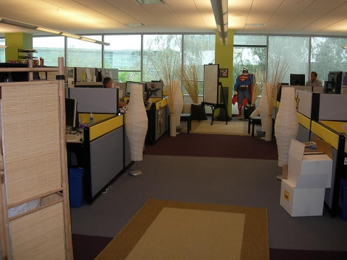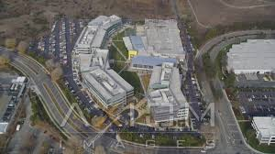

Figure 1

**Sensitive Land Production**: Sensitive Land Protection has to fulfill 2 criteria for this option.

**Prime Farmland**: importance defined by the U.S. Code of Federal Regulations, Title 7, Volume 6, Parts 4000 to 699, Section 657.5 and identified in a state Natural Resources Conservation Service soil survey.

**Floodplains**: A flood hazard area shown on a legally adopted flood hazard map or otherwise legally designated by the local jurisdiction or the state. For projects in places without legally adopted flood hazard maps or legal designations, locate on a site that is entirely outside any floodplain subject to a 1% or greater chance of flooding in any given year.

**Habitat**: Land identified as habitat.

**Water Bodies:** Areas on or within 100 feet (30 meters) of a water body, except for minor improvements

**Wetlands**: Areas on or within 50 feet (15 meters) of a wetland, except for minor improvements.

The Yahoo historic building is a High Priority Site (C2). Figure 2 shows the historic building..

 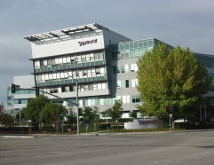

Figure 2

The intent is to encourage project location in areas with development constraints and promote the health of the surrounding area. One option is to locate the project on an infill location in a historic district. This rewards investing in historic areas, a proven strategy for maintaining and enhancing community character.

**Access to Quality Transit** (C5)

To encourage development in locations shown to have multimodal transportation choices or otherwise reduced motor vehicle use, thereby reducing greenhouse gas emissions, air pollution, and other environmental and public health harms associated with motor vehicle use. Table 1 shows the number of trip people took daily.

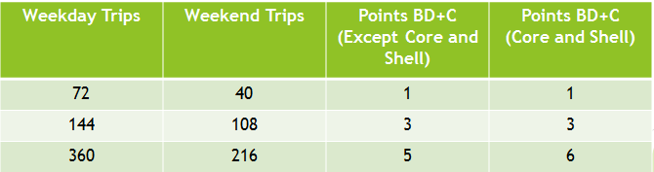

Table 1

**Transit-served location:** Locate any functional entry of the project within a 1/4-mile or locate building with 0.5 miles of a rail transit or .25 miles of two bus lines. Qualifying transit routes must have paired route service (service in opposite directions). For each qualifying transit route, only trips in one direction are counted towards the threshold. If a qualifying transit route has multiple stops within the required walking distance, only trips from one stop are counted towards the threshold. The more people use public transport the fewer parking spaces are needed. Figure 3 shows examples of modern public transport.

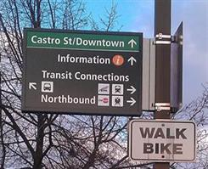 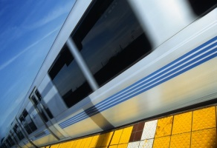

Figure 3

**Pedestrian Access;** The project has an attendance boundary such that the specified percentages of students live within no more than a 3/4-mile walking distance. Show that the project is no more than 1 1/2-mile (2400-meter) walking distance (for grades 9 and above or ages 15 and above) of a functional entry of a school building.

**Bicycle Facilities**(C1) To promote bicycling and transportation efficiency and reduce vehicle distance traveled. To improve public health by encouraging utilitarian and recreational physical activity. Provide bicycle storage and changing facilities that accommodate 5% of building occupants. This gives no consideration to other factors that affect cycling activity, such as the quality of cycling facilities and roadway conditions in the area. There is no consideration of policies and programs that encourage shifts from driving to cycling or discourage automobile travel. Alone, this is likely to reduce motor vehicle trips to the site by 1-3%. As bicycles are frequently stolen, providing places to secure them is going to encourage people to bike more. Figure 4 shows how bike storage can be organized in urban areas.

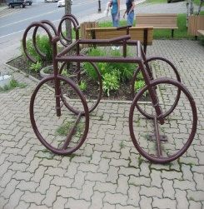 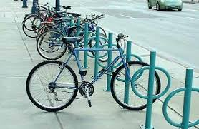

Figure 4

**Reduced Parking Footprint**(C1):The intent isto minimize the environmental harms associated with parking facilities, including automobile dependence, land consumption, and rainwater runoff. Dark colored parking lot surfaces trap heat. Water runoff from impervious surfaces can overwhelm storm water systems. Cost landowners/developers is $15,000 per parking space. Additional parking space can be obtained or created by the deforestation of the tree around the two Yahoo buildings and the modification of the storm-water system. Figure 5 shows the different kinds of parking lots around Yahoo. Table 2 shows the number of parking places necessary for tenants and guests.

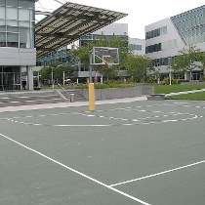 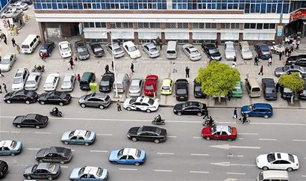 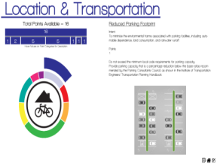

Figure 5

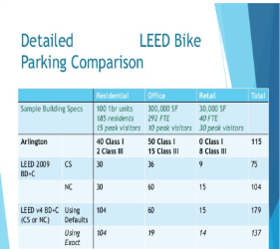

Table 2

**Green Vehicles** (C1): The intent to reduce pollution by promoting alternatives to conventionally fueled automobiles. Provide high efficiency hybrid or alternative fuel vehicles for 3% of building occupants.

**Conclusion:**

For these reasons, the LEED rating system must encourage development that the building is located in accessible, multimodal locations (with common destinations are close together, has good walking and cycling conditions, and high quality public transit services). It should includes programs and financial incentives that encourage use of efficient travel modes. The project has reduced parking supply and efficient parking management

**Water Efficiency:**

**Outdoor Water Use Reduction** (presq): Reduce outdoor water use by providing landscaping that requires little or no irrigation. Our project must use no irrigation or use 30% less than a baseline model. 50% reduction is acceptable. Plant species and the use of drip irrigation systems and moisture sensors are used as strategies to meet this goal.

**Indoor Water Use Reduction** (presq): our project would provide fixtures and fittings that will reduce indoor water use by 20% over a baseline case. (C6):We can also reduce the amount of water needed for indoor fixtures and fittings, similar to the prerequisite above. Additionally, the use of water saving fixtures, such as dual-flush toilets, low-flow urinals, and sensor operated faucets are very important to earn the credit. Figure 5 shows a sink faucet with aerator.

**Building-Level Water Metering**(presq): we can also provide a water meter to measure water use on a monthly and annual basis, can be done automatically.

**Outdoor Water Use Reduction**(C2): We can reduce the amount of water needed for irrigation by 50% or more over the baseline calculation.

**Water Metering** (C1) : The irrigation, indoor plumbing fixtures and fittings, domestic hot water must be monitoring. Figure 6 shows a water meter.

#### inddor water efficiency Figure 5 water meteringFigure 6

**Conclusion:**

While LEED BD+C certified projects achieve points based on modeled expectations, benchmark data clearly shows these buildings are performing LEED Gold.

References:

-www.greenbuildingelements.com

-http://www.vtpi.org/leed_rec.pdf Recommendations for Improving LEED Transportation and Parking Credits27 January 2015

-<https://greenbuildingelements.com/2014/09/11/leed-water-efficiency/> Water Efficiency Published on September 11th,2014 / by on Dawn Killough

.

Appendix A

EXAMPLE OF CALCULATION :

Yahoo Building assumption with 350 Occupants (FTE), half male(175) and half female(175)

|  |  |  |  |  |  |  |  |
| --- | --- | --- | --- | --- | --- | --- | --- |
| Fixture | FTE use per day | Baseline water use | Daily use per person | Total daily use baseline | Design water use | Daily use per person | Total Daily use design |
| WC FEMALE | 3 | 1.6gpf | 4.8gal | X 175 =840 gal | 1.28gpf  waterSense | 3.84gal | X 175 =672 gal |
| WC MALE | 1 | 1.6gpf | 1.6gal | X 175 =280 gal | 1.28gpf  WaterSense | 1.28gal | X 175 =224 gal |
| URINAL (MALE) | 2 | 1.0gpf | 2gal | X175 =350 gal | 0.5gpf  WaterSense | 1gal | X 175 = 175  gal |
| Lav. faucet | 3 | 0,5gpm x 1/4minute=  0.125gal | 0.375gal | X 350 = 131,25gal | 0,5gpm x 1/4minute=  0.125gal | 0.375 gal | X 375 = 140.625  gal |
| TOTAL |  |  |  | 1601,25 gal |  |  | 1211,625gal |
|  |  |  |  |  |  |  |  |

Annuals weekdays: 260

Total Fixture daily water potable use design =1211,625 gal

Total Fixture daily water potable use baseline = 1601,25gal

Total daily potable water use = 2812.875 gal

Total annual water portable use =731,347.5 gal

Total annual wastewater generation = 731,347.5 gal

Project Occupancy Assumption:

FTE Occupancy:

-150,000 sq.ft /429 sq.ft per person = 350 FTE Occupants.

Building F= 175 Occupancy

Building G = 175 Occupancy

All Sanitation Fixtures:

24 Dual-flush toilets x $ 180 =$ 4320 ($2400 installations)

12 Wall-hung urinals x $ 200 =$ 2400( $ 1200 installations)

24 Hot & Cold faucets x $ 80 =$ 1920( $ 2400 installations)

12 Sink bath large X $ 250 = $ 3000( $ 1200 installations)

Others = $ 400

Total cost of materials : $ 12040

Installations Cost: $7200

TOTALS COST = $19640

NB: All Sanitation Fixtures supply are within the compliance of international environmental and water conservation standards.