Supplementary Materials for “Responding to the local emergence of partial artemisinin resistance in northwest Tanzania: a modelling study”

Table of Contents

S1. Supplementary Methods

S2. Supplementary Figures

S3. Supplementary Tables

S1. Supplementary Methods
S1.1 Seasonal transmission calibration
Monthly malaria case data from Kagera region, Tanzania, for the period 2017–2023 were used to estimate the seasonal pattern of malaria transmission. For each calendar month, routine case-reporting data were aggregated across years using the number of RDT-positive malaria cases and the total number of mRDT tests performed. Separate datasets were first prepared for children under 5 years of age and individuals aged 5 years and older. To obtain the overall seasonal profile used for model calibration, under-5 and over-5 case counts were summed within each year-month, and the corresponding mRDT test counts were also summed.
For each year-month, malaria test positivity was calculated as:

$${\text{positivity}}_{y,m} =\frac{{RDT-positive cases}_{y,m}}{{mRDT tests}_{y,m}}$$

where (y) denotes year and (m) denotes calendar month. This produced a monthly time series of malaria positivity for Kagera from 2017 through 2023. To estimate the typical seasonal pattern while reducing the influence of unusually high or low months, the median positivity was calculated for each calendar month across all available years. The resulting monthly median values were then normalized by the overall median positivity across all year-month observations:

$$w_{m}=\frac{median positivity in month m}{overall median positivity}$$

where (w_{m}) is the relative seasonal weight for month (m). A value of (w_{m} = 1) indicates transmission equal to the annual average level, values greater than 1 indicate months with higher-than-average transmission, and values less than 1 indicate months with lower-than-average transmission.
The monthly seasonal weights were then used to adjust the baseline transmission parameter in the model. Because the model operates on a daily time step, each day was assigned the weight of its corresponding calendar month, with the same value applied to all days within that month. The seasonally adjusted transmission parameter was therefore calculated as:

$$β\left(t\right)=β_{0}×w_{t}$$

where $β_{0}$ is the baseline transmission parameter and $w_{t}$ is the seasonal weight for the calendar month containing day (t). The monthly weights were normalized around 1, so this adjustment changed the timing of transmission across the year while preserving the overall annual transmission level.
The fitted seasonal profile showed clear seasonal variation in malaria transmission in Kagera. Transmission was lowest during the March–May and August–October periods and increased during the middle and end of the year, with the strongest seasonal peak occurring around June and elevated transmission also observed in November–December. This calibrated profile was then used in the model to represent seasonal fluctuations in malaria transmission over the simulation period.
Supplementary Figure 1 shows the monthly malaria case-derived seasonal curve and the corresponding fitted daily transmission multiplier used in the model.

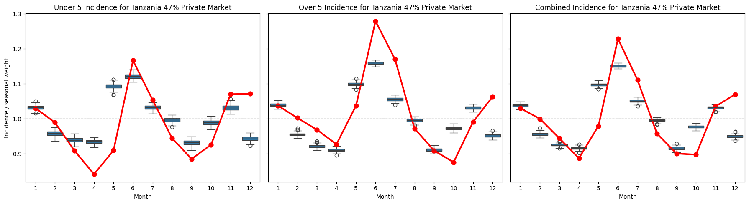
Supplementary Figure 1. Seasonal transmission calibration for northwest Tanzania under the 47% private-market scenario. Red points and lines show the monthly seasonal transmission weights estimated from Kagera routine malaria case-reporting data from 2017 to 2023. Monthly weights were calculated from RDT-positive case counts and mRDT testing totals, using median monthly malaria test positivity across years and normalizing each month by the overall median positivity. Boxplots show the distribution of monthly malaria incidence generated by the calibrated simulation for Kagera region, stratified by children under 5 years of age, individuals 5 years and older, and the combined population. The dashed horizontal line indicates a seasonal weight of 1.0, corresponding to the annual average transmission level. The monthly seasonal weights were applied to the model’s daily transmission parameter by assigning each day the weight of its corresponding calendar month.

S1.2 Treatment-seeking assumptions and private-sector scenarios
Drug-use distributions for both public- and private-sector treatment were obtained from DHS survey data [1–5]. During the burn-in and baseline transition period from 2003 to 2016, the contribution of private-market treatment was decreased over time from 100% to the target private-market share used in each scenario. Under the 47% private-market scenario, the resulting baseline treatment distribution assigned 53% of treatments to public-sector AL and 47% to the private-market treatment mixture. Under the 10% private-market scenario, 90% of treatments were assigned to the public-sector policy and 10% to the private-market treatment mixture. After 2016, the relative public- and private-sector treatment shares were held constant for the remainder of the baseline and intervention periods.
Private-sector antimalarial use was represented as a multiple first-line therapy distribution based on observed treatment preferences. In the private market, 78% of treatments were assumed to be artemether-lumefantrine (AL), 13% sulfadoxine-pyrimethamine, 6% dihydroartemisinin-piperaquine, 2% quinine, and 1% artesunate-amodiaquine. These private-market treatment probabilities were kept fixed across intervention scenarios, so changes in national treatment policy affected only the public-sector treatment allocation.
Two private-sector market-share scenarios were evaluated. In the primary scenario, 47% of antimalarial treatment occurred in the private sector; in the reduced private-market scenario, 10% of antimalarial treatment occurred in the private sector. Private-sector treatment preferences were assumed to remain constant after public-sector policy changes, with continued high use of AL.

S1.3 Model calibration to northwest Tanzania
The model was recalibrated to four regions in northwest Tanzania using Tanzania-specific population, prevalence, incidence, treatment-seeking, and private-sector treatment assumptions. Population density data were aggregated to 5 km by 5 km resolution and cropped to the four modeled regions: Kagera, Kigoma, Geita, and Mwanza. Pixel-level transmission intensity was first calibrated to reproduce Malaria Atlas Project estimates of PfPR2–10 in 2022 across the model domain. The quality of this prevalence calibration is shown in Supplementary Figure XX, which compares simulated PfPR2–10 with Atlas-estimated PfPR2–10 at the pixel level and summarizes district-level model bias across 100 stochastic simulations.
After the initial prevalence calibration, regional transmission intensity was rescaled to better match reported malaria incidence. Incidence targets were obtained from Tanzania’s national malaria program and used to adjust the calibrated transmission parameter while preserving the spatial pattern of prevalence across the four regions. As in previous calibration exercises, the model generated more clinical cases than would be expected for a given prevalence level, so prevalence and transmission levels were scaled downward to match reported incidence. In the 47% private-market scenario, this rescaling produced an average PfPR2–10 of 4.5% across the four regions and an annual incidence of 124 cases per 1000 individuals. In the 10% private-market scenario, stronger downward rescaling was required, resulting in an average PfPR2–10 of 2.7% and an annual incidence of 116 cases per 1000 individuals.

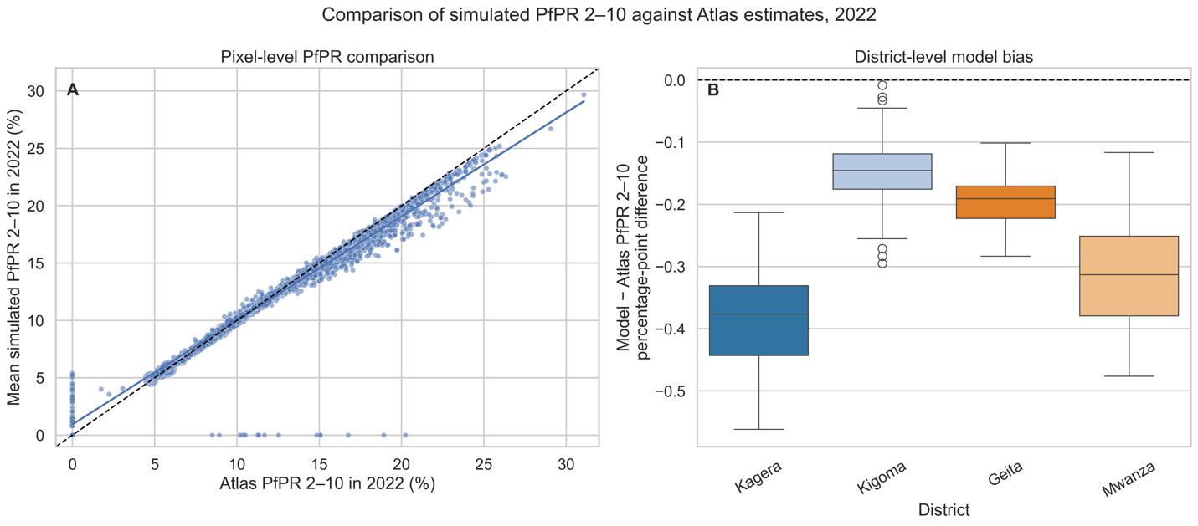
Supplementary Figure 2. Calibration of simulated PfPR2–10 against Malaria Atlas Project estimates for northwest Tanzania in 2022. Panel A shows the pixel-level comparison between Atlas-estimated PfPR2–10 and simulated PfPR2–10 across the four modeled regions. Each point represents the mean PfPR2–10 for one model pixel in 2022 from one simulation run, with results shown across 100 stochastic simulations. Point size is proportional to the average simulated population size. The dashed black line indicates perfect agreement between simulated and Atlas-estimated PfPR2–10, and the solid blue line shows the fitted linear trend. Panel B shows district-level model bias across the 100 simulation runs, calculated as simulated PfPR2–10 minus Atlas-estimated PfPR2–10 in percentage points, for Kagera, Kigoma, Geita, and Mwanza. Although most values are below zero, indicating slight underestimation by the model, the absolute differences are small, generally within approximately 0.5 percentage points.

S1.4 Baseline resistance allele frequencies and mutation initialization
Genotype frequencies for resistance-associated alleles, including pfmdr1 86Y, pfmdr1 184F, and pfcrt 76T, were compiled from published molecular-marker data from northwest Tanzania [6–9]. Baseline resistance allele frequencies were initialized in 2003 at 0.015 for pfcrt 76T and 0.02 for pfmdr1 86Y. These initial frequencies were calibrated so that simulated allele-frequency trajectories were consistent with the available molecular-marker observations, with the primary calibration selected to visually approximate the observed data points. Under this calibration, simulated allele frequencies in 2025 were approximately 0.08 for pfcrt 76T and 0.05 for pfmdr1 86Y. Mutation was activated on January 1, 2018, with a per-treatment mutation probability of 0.001983, as in previous model applications.
The resulting allele-frequency trajectories are shown in Supplementary Figure 3-6, which presents monthly frequencies for each resistance-associated genotype over time under both the 47% and 10% private-market scenarios. An alternative low-frequency calibration was also generated by reducing pfcrt 76T and pfmdr1 86Y frequencies as much as possible while maintaining consistency with the available molecular-marker data. Under this calibration, simulated 2025 frequencies were approximately 0.05 for pfcrt 76T and 0.01 for pfmdr1 86Y, providing a lower-bound baseline resistance scenario for sensitivity analysis.
The model was also calibrated to reproduce the observed spatial pattern of pfkelch13 561H in 2022 [10]. Available data indicated that 561H was concentrated in Kagera, where its frequency was approximately 22% in 2022, while frequencies in the other modeled regions were 0% or unavailable. To match this pattern in the 47% private-market scenario, importation of 561H-carrying infections into Kagera was included. In the simulation, importation was implemented as a conversion from a naïve parasite strain to a 561H-carrying resistant strain, rather than as the introduction of additional infections, to avoid substantially altering the transmission dynamics of the model. An adaptive importation process was used, increasing from 2 converted 561H cases per day in 2018 to 8 converted cases per day in 2021 in order to re-produce the rapid increase of 561H in Kagera while maintain the low 561H frequency in other regions. Under the 10% private-market scenario, the simulated 561H frequency naturally fell within the target range without requiring additional importation.

The initial strategy set contained 102 strategies; however, duplicate strategies were removed when some three-year and four-year cycling schedules produced equivalent treatment sequences over the six-year evaluation period. Duplicate region-specific strategies were also removed when they were equivalent to non-region-specific strategies; for example, “Kagera ASAQ, other regions ASAQ, delay 0 years” was equivalent to a full switch to ASAQ. After removing these duplicates, the final strategy set contained 87 unique strategies for the six-year evaluation period. Strategies included continued first-line use of artemether–lumefantrine, switches to alternative ACTs, multiple first-line therapy approaches, and rotational deployment strategies.

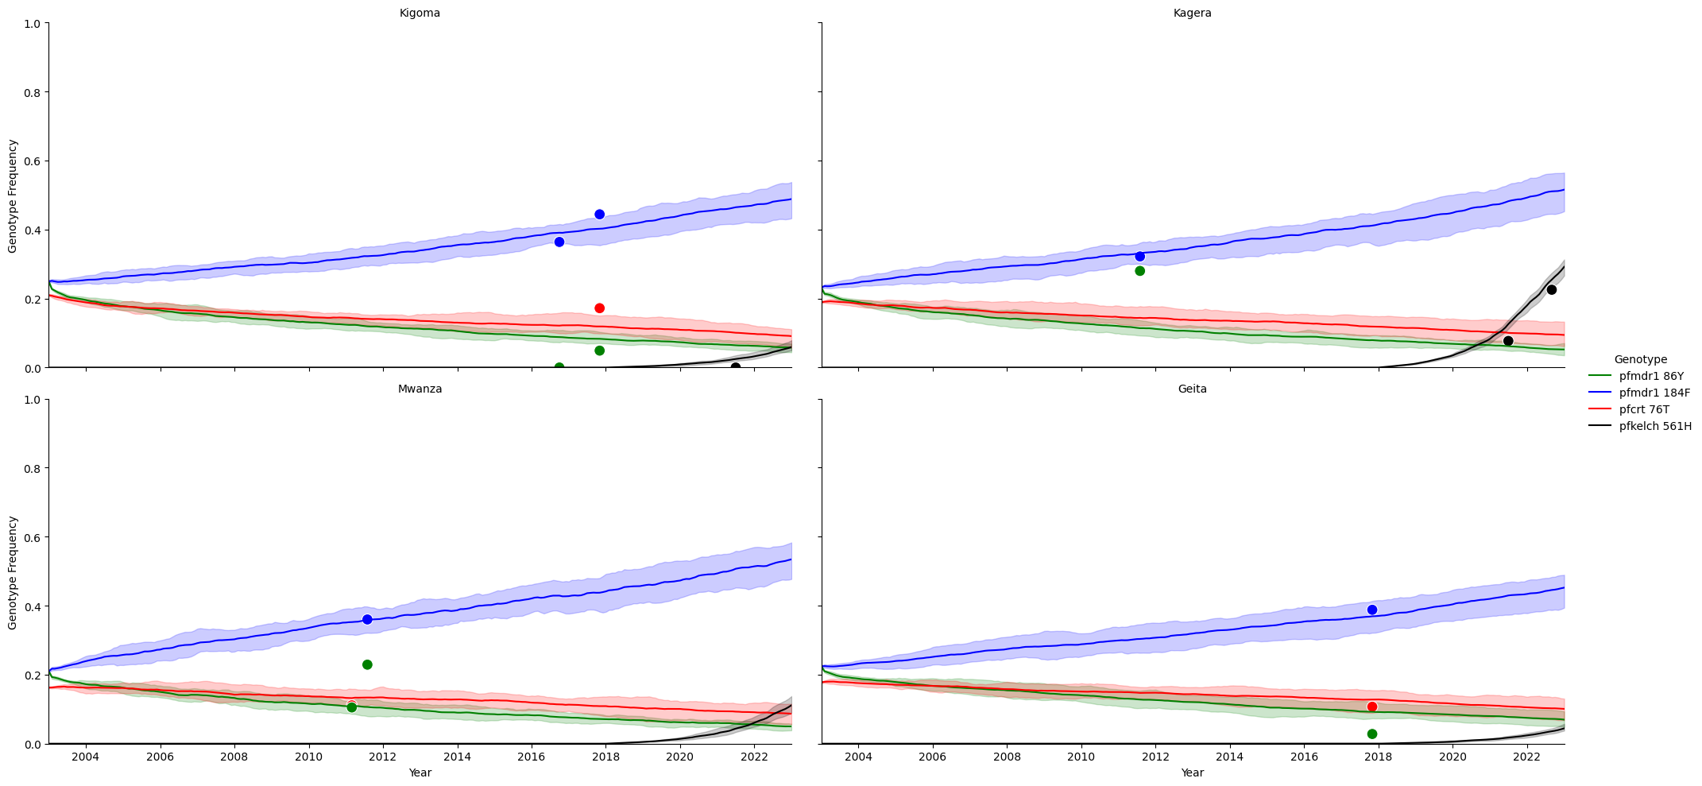
Supplementary Figure 3. Calibration of resistance-associated genotype frequencies across the four modeled regions of northwest Tanzania under the 47% private-market scenario. Lines show simulated monthly genotype frequencies over time for pfmdr1 86Y, pfmdr1 184F, pfcrt 76T, and pfkelch13 561H in Kagera, Kigoma, Mwanza, and Geita under the normal pfmdr1 86Y and pfcrt 76T baseline-frequency scenario. Points show reference genotype-frequency estimates used for calibration, including published molecular-marker estimates from northwest Tanzania for pfmdr1 86Y, pfmdr1 184F, and pfcrt 76T, and available regional estimates for pfkelch13 561H. Shaded bands show the 90% percentile interval across simulations. The model reproduced the overall temporal trends in partner-drug resistance-associated alleles and the observed spatial concentration of pfkelch13 561H in Kagera, where 561H frequency was substantially higher than in the other modeled regions.

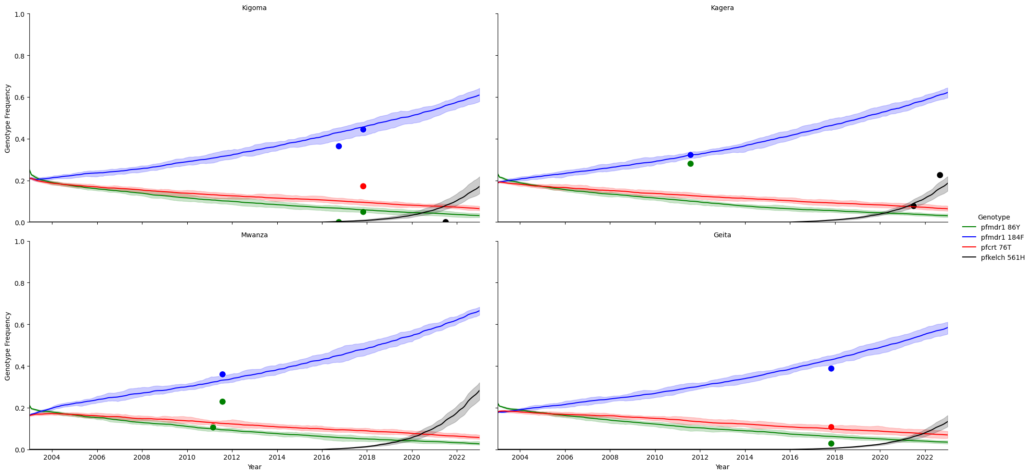
Supplementary Figure 4. Calibration of resistance-associated genotype frequencies across the four modeled regions of northwest Tanzania under the 10% private-market scenario. Lines show simulated monthly genotype frequencies over time for pfmdr1 86Y, pfmdr1 184F, pfcrt 76T, and pfkelch13 561H in Kagera, Kigoma, Mwanza, and Geita under the normal pfmdr1 86Y and pfcrt 76T baseline-frequency scenario. Points show reference genotype-frequency estimates used for calibration, including published molecular-marker estimates from northwest Tanzania for pfmdr1 86Y, pfmdr1 184F, and pfcrt 76T, and available regional estimates for pfkelch13 561H. Shaded bands show the 90% percentile interval across simulations. The model reproduced the overall temporal trends in partner-drug resistance-associated alleles and the observed spatial concentration of pfkelch13 561H in Kagera, where 561H frequency was substantially higher than in the other modeled regions.

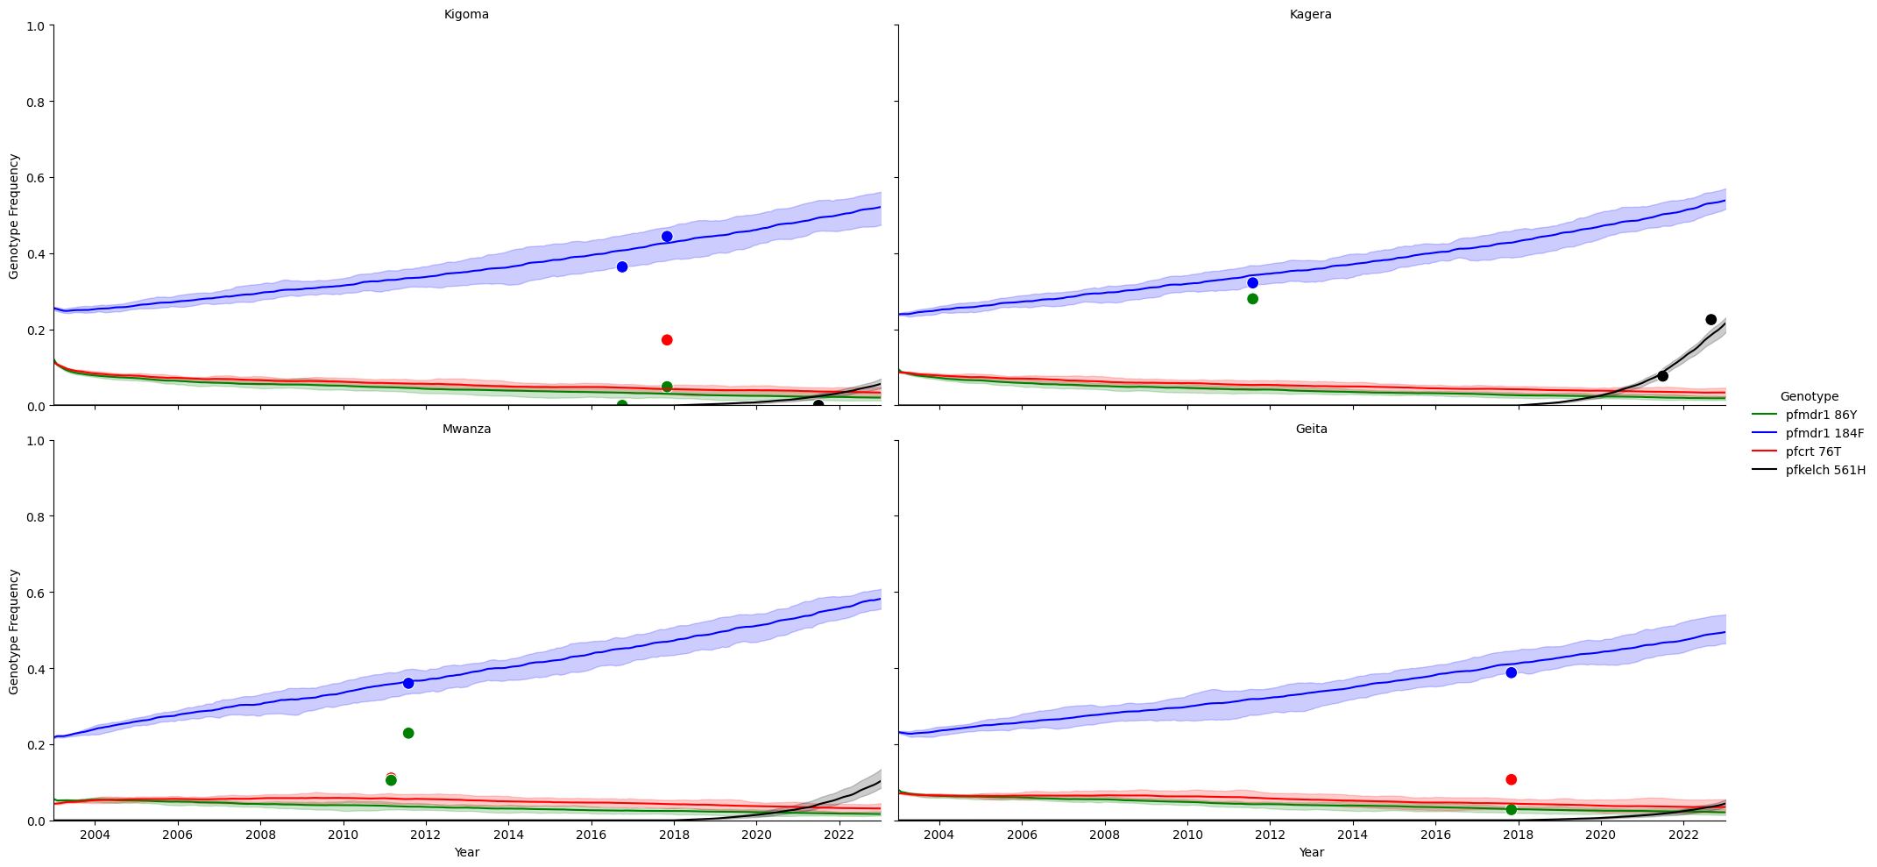
Supplementary Figure 5. Calibration of resistance-associated genotype frequencies across the four modeled regions of northwest Tanzania under the lower pfmdr1 86Y and pfcrt 76T frequency and 47% private-market scenario. Lines show simulated monthly genotype frequencies over time for pfmdr1 86Y, pfmdr1 184F, pfcrt 76T, and pfkelch13 561H in Kagera, Kigoma, Mwanza, and Geita. Points show reference genotype-frequency estimates used for calibration, including published molecular-marker estimates from northwest Tanzania for pfmdr1 86Y, pfmdr1 184F, and pfcrt 76T, and available regional estimates for pfkelch13 561H. Shaded bands show the 90% percentile interval across simulations. This sensitivity scenario was calibrated to keep 2025 pfmdr1 86Y and pfcrt 76T frequencies as low as possible while maintaining consistency with the available genotype-frequency data and the observed spatial concentration of pfkelch13 561H in Kagera.

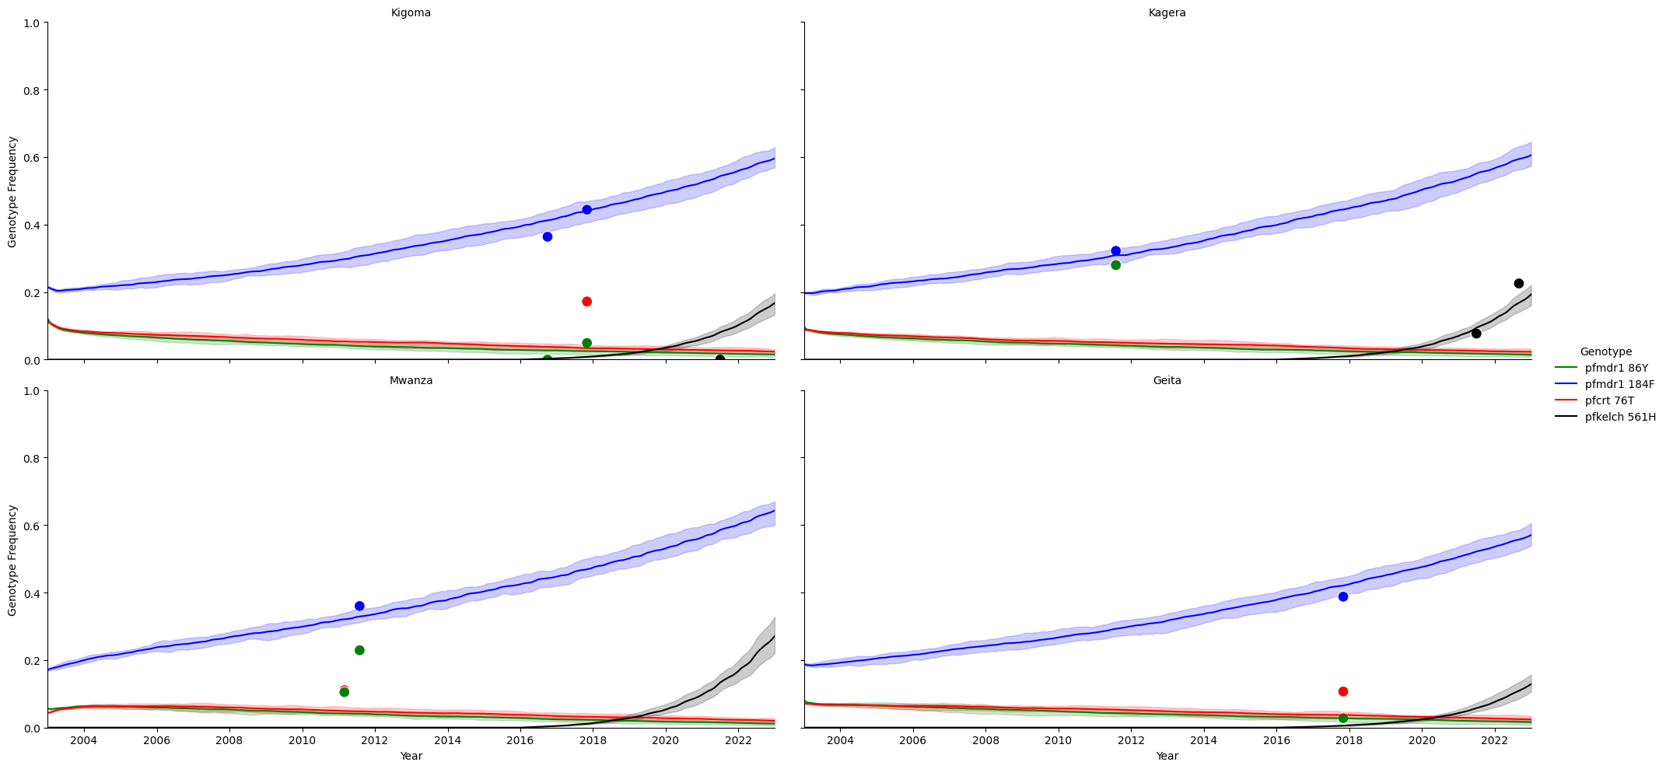
Supplementary Figure 6. Calibration of resistance-associated genotype frequencies across the four modeled regions of northwest Tanzania under the lower pfmdr1 86Y and pfcrt 76T frequency and 10% private-market scenario. Lines show simulated monthly genotype frequencies over time for pfmdr1 86Y, pfmdr1 184F, pfcrt 76T, and pfkelch13 561H in Kagera, Kigoma, Mwanza, and Geita. Points show reference genotype-frequency estimates used for calibration, including published molecular-marker estimates from northwest Tanzania for pfmdr1 86Y, pfmdr1 184F, and pfcrt 76T, and available regional estimates for pfkelch13 561H. Shaded bands show the 90% percentile interval across simulations. This sensitivity scenario was calibrated to keep 2025 pfmdr1 86Y and pfcrt 76T frequencies as low as possible while maintaining consistency with the available genotype-frequency data and the observed spatial concentration of pfkelch13 561H in Kagera.

S2. Supplementary Figures
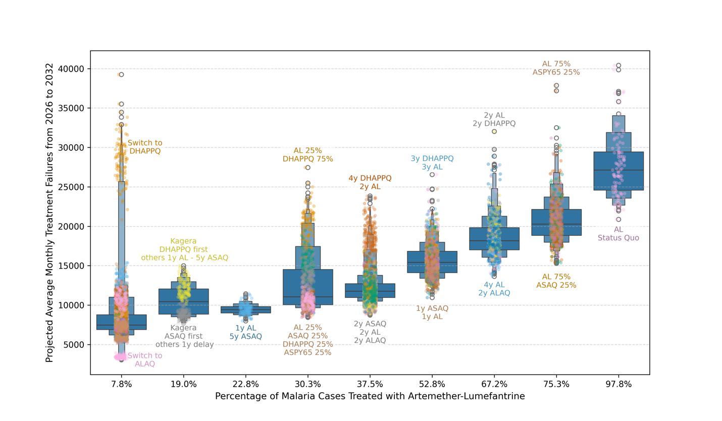
Supplementary Figure 7. Relationship between population-level artemether–lumefantrine use and projected treatment failures under the 10% private-market scenario with normal pfmdr1 86Y and pfcrt 76T baseline frequencies. This figure is analogous to Figure 3 in the main text. Strategies are grouped by the average percentage of malaria cases treated with artemether-lumefantrine (AL) across both public- and private-sector treatment. Each boxplot summarizes projected treatment failure outcomes across strategies with the same population-level AL use, with jittered points representing individual simulation outcomes. A positive association was observed between AL use and projected treatment failure burden (Pearson r = 0.76, p < 2.2 × 10⁻¹⁶), indicating that greater reliance on AL remained associated with higher treatment failures even when private-sector treatment was reduced to 10%.
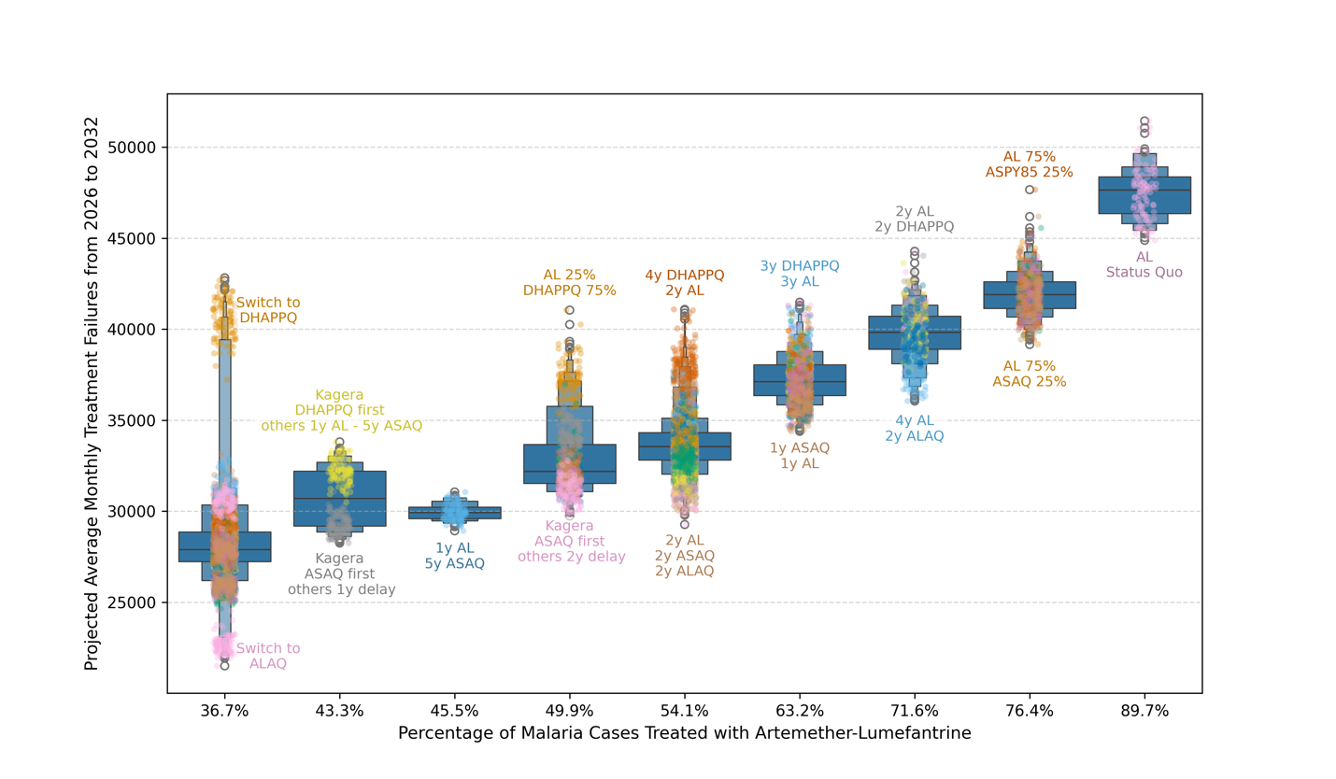
Supplementary Figure 8. Relationship between population-level artemether–lumefantrine use and projected treatment failures under the 47% private-market scenario with lower pfmdr1 86Y and pfcrt 76T baseline frequencies. This figure is analogous to Figure 3 in the main text. Strategies are grouped by the average percentage of malaria cases treated with artemether-lumefantrine (AL) across both public- and private-sector treatment. Each boxplot summarizes projected treatment failure outcomes across strategies with the same population-level AL use, with jittered points representing individual simulation outcomes. A strong positive association was observed between AL use and projected treatment failure burden (Pearson r = 0.90, p < 2.2 × 10⁻¹⁶), indicating that greater reliance on AL remained associated with higher treatment failures even under lower baseline pfmdr1 86Y and pfcrt 76T frequencies.
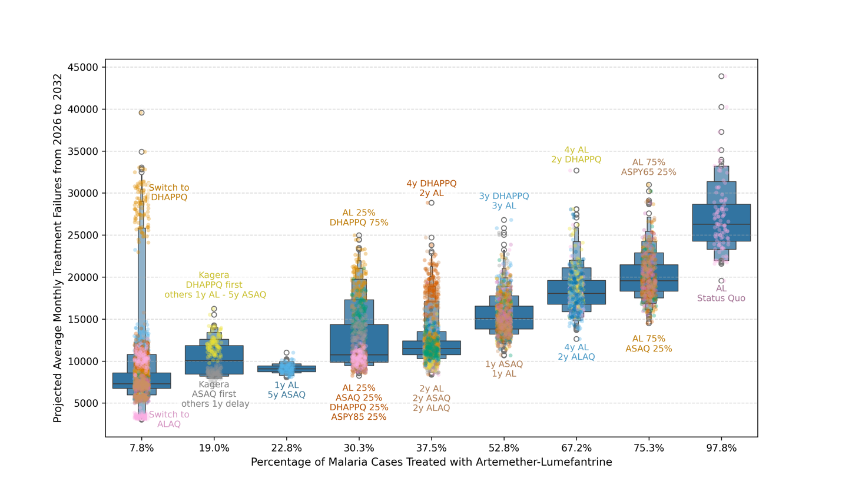
Supplementary Figure 9. Relationship between population-level artemether–lumefantrine use and projected treatment failures under the 10% private-market scenario with lower pfmdr1 86Y and pfcrt 76T baseline frequencies. This figure is analogous to Figure 3 in the main text. Strategies are grouped by the average percentage of malaria cases treated with artemether-lumefantrine (AL) across both public- and private-sector treatment. Each boxplot summarizes projected treatment failure outcomes across strategies with the same population-level AL use, with jittered points representing individual simulation outcomes. A positive association was observed between AL use and projected treatment failure burden (Pearson r = 0.75, p < 2.2 × 10⁻¹⁶), indicating that greater reliance on AL remained associated with higher treatment failures under the reduced private-market and lower baseline-resistance scenario.
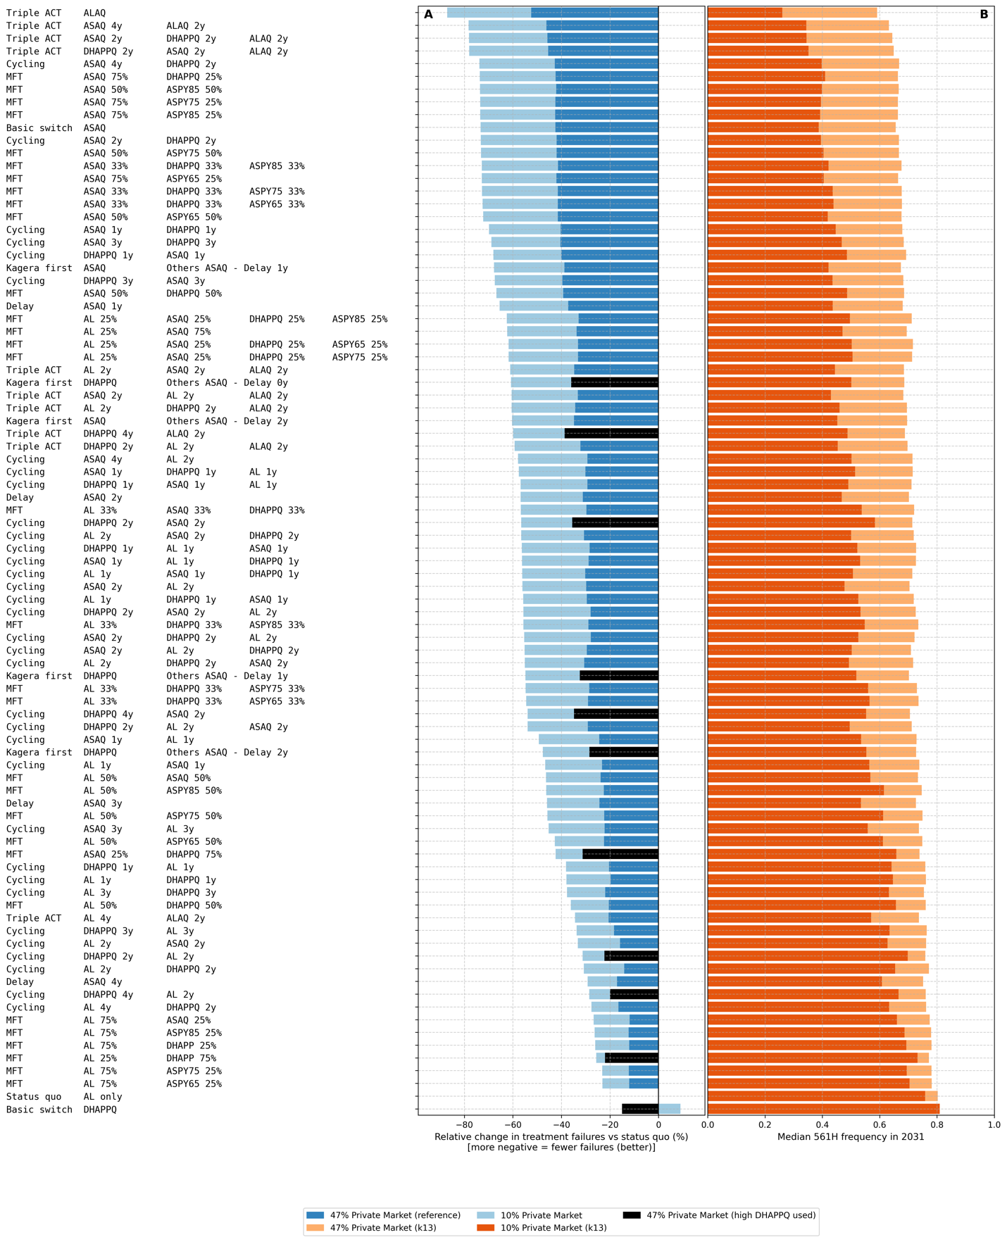
Supplementary Figure 10. Comparative impact of private-sector market reduction on six-year treatment failure outcomes and pfkelch13 allele frequency under the lower pfmdr1 86Y and pfcrt 76T baseline-frequency scenario. This figure is analogous to Figure 4 in the main text. Each row represents one evaluated ACT deployment strategy, including cycling, multiple first-line therapy, triple ACT, ASPY-containing, delayed-deployment, and region-specific strategies. Panel A shows the relative change in median monthly average treatment failures compared with the status quo under the 47% and 10% private-market scenarios. Panel B shows the corresponding pfkelch13 allele frequency at the end of the evaluation period under the same two private-market assumptions. Values annotated beside each row indicate the additional gain or loss associated with reducing private-sector treatment from 47% to 10%. Results show that reducing private-sector antimalarial treatment generally improved strategy performance and lowered pfkelch13 allele frequencies even under lower baseline pfmdr1 86Y and pfcrt 76T frequencies.

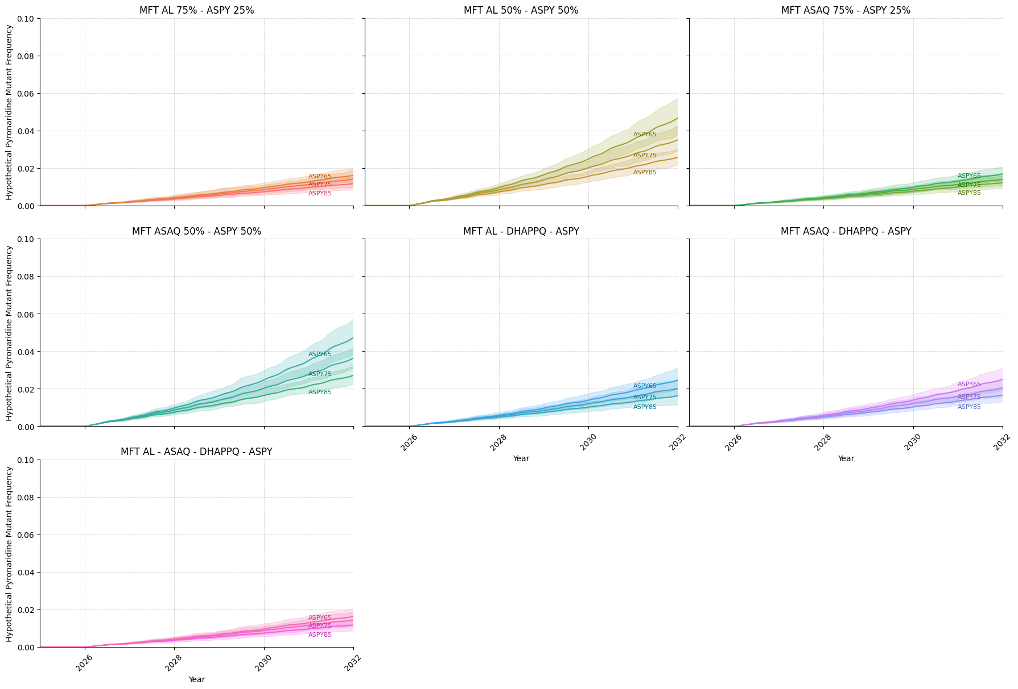
Supplementary Figure 11. Projected frequency of hypothetical pyronaridine-resistant parasites under ASPY-containing multiple first-line therapy strategies. Each panel shows the monthly frequency of a hypothetical pyronaridine-resistant genotype from 2025 to 2032 under the 47% private-market scenario. ASPY-containing strategies were grouped by treatment composition, including two-drug MFT strategies with AL or ASAQ plus ASPY, three-drug MFT strategies with ASPY and either AL/DHA-PPQ or ASAQ/DHA-PPQ, and a four-drug MFT strategy including AL, ASAQ, DHA-PPQ, and ASPY. Within each panel, separate lines correspond to three assumed pyronaridine-resistance phenotypes, in which ASPY efficacy on double-resistant genotypes was reduced to 85%, 75%, or 65%. Shaded regions show the 90% simulation range. Across ASPY-containing strategies, hypothetical pyronaridine-resistant genotypes remained at low frequency over the six-year evaluation period, with the highest frequencies occurring when ASPY was used for 50% of treatments.
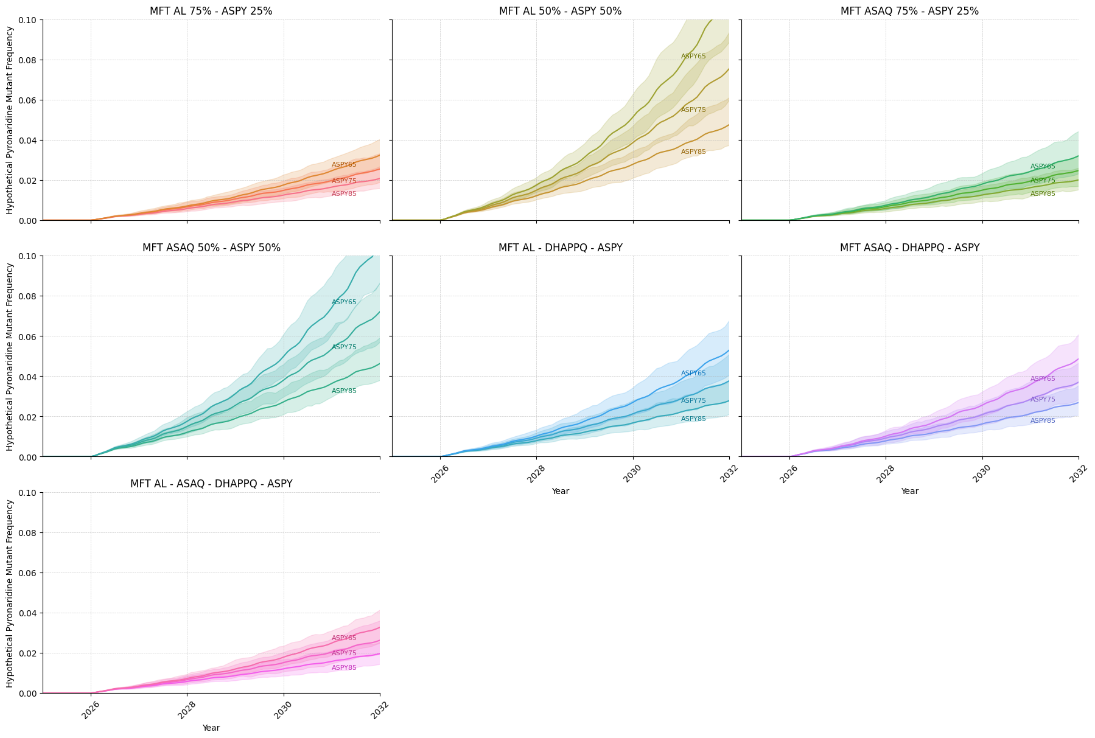
Supplementary Figure 12. Projected frequency of hypothetical pyronaridine-resistant parasites under ASPY-containing multiple first-line therapy strategies. Each panel shows the monthly frequency of a hypothetical pyronaridine-resistant genotype from 2025 to 2032 under the 10% private-market scenario. ASPY-containing strategies were grouped by treatment composition, including two-drug MFT strategies with AL or ASAQ plus ASPY, three-drug MFT strategies with ASPY and either AL/DHA-PPQ or ASAQ/DHA-PPQ, and a four-drug MFT strategy including AL, ASAQ, DHA-PPQ, and ASPY. Within each panel, separate lines correspond to three assumed pyronaridine-resistance phenotypes, in which ASPY efficacy on double-resistant genotypes was reduced to 85%, 75%, or 65%. Shaded regions show the 90% simulation range. Across ASPY-containing strategies, hypothetical pyronaridine-resistant genotypes remained at low frequency over the six-year evaluation period, with the highest frequencies occurring when ASPY was used for 50% of treatments.

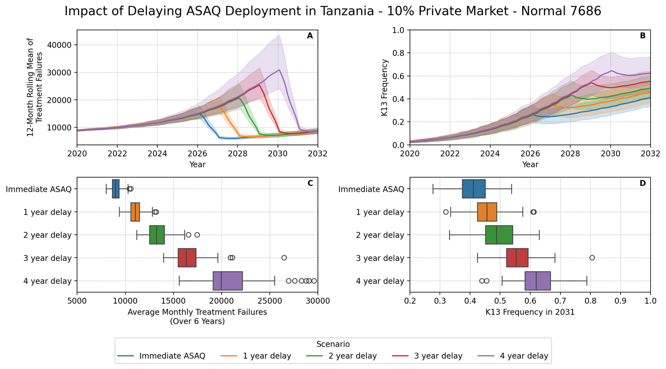
Supplementary Figure 13. Effect of delayed ASAQ deployment on treatment failures and pfkelch13 allele frequency under the 10% private-market scenario with normal pfcrt 76T and pfmdr1 86Y baseline frequencies. This figure is analogous to Figure 5 in the main text. Scenarios compare immediate deployment of artesunate–amodiaquine (ASAQ) with 1-, 2-, 3-, and 4-year delays before switching from artemether–lumefantrine to ASAQ. Panel A shows the 12-month rolling mean of treatment failures from 2020 to 2032, and Panel B shows the corresponding pfkelch13 allele frequency over time. Shaded regions show the 90% simulation range. Panel C summarizes the average monthly treatment failures over the six-year evaluation period, and Panel D summarizes pfkelch13 allele frequency in 2031. Delaying ASAQ deployment increased projected treatment failures and resulted in higher pfkelch13 allele frequencies, with longer delays producing larger increases.

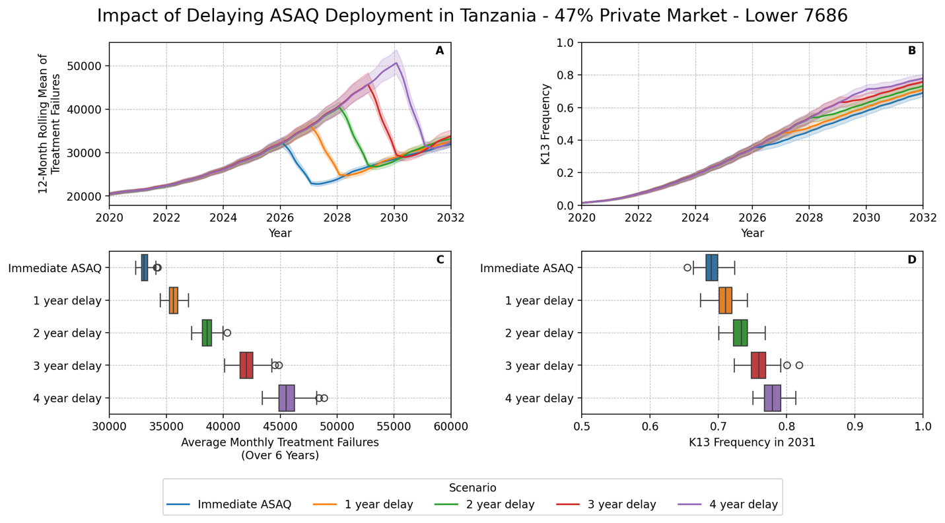
Supplementary Figure 14. Effect of delayed ASAQ deployment on treatment failures and pfkelch13 allele frequency under the 47% private-market scenario with lower pfcrt 76T and pfmdr1 86Y baseline frequencies. This figure is analogous to Figure 5 in the main text. Scenarios compare immediate deployment of artesunate–amodiaquine (ASAQ) with 1-, 2-, 3-, and 4-year delays before switching from artemether–lumefantrine to ASAQ. Panel A shows the 12-month rolling mean of treatment failures from 2020 to 2032, and Panel B shows the corresponding pfkelch13 allele frequency over time. Shaded regions show the 90% simulation range. Panel C summarizes the average monthly treatment failures over the six-year evaluation period, and Panel D summarizes pfkelch13 allele frequency in 2031. Delayed ASAQ deployment increased projected treatment failures and was associated with higher pfkelch13 allele frequencies, with longer delays producing progressively larger increases.

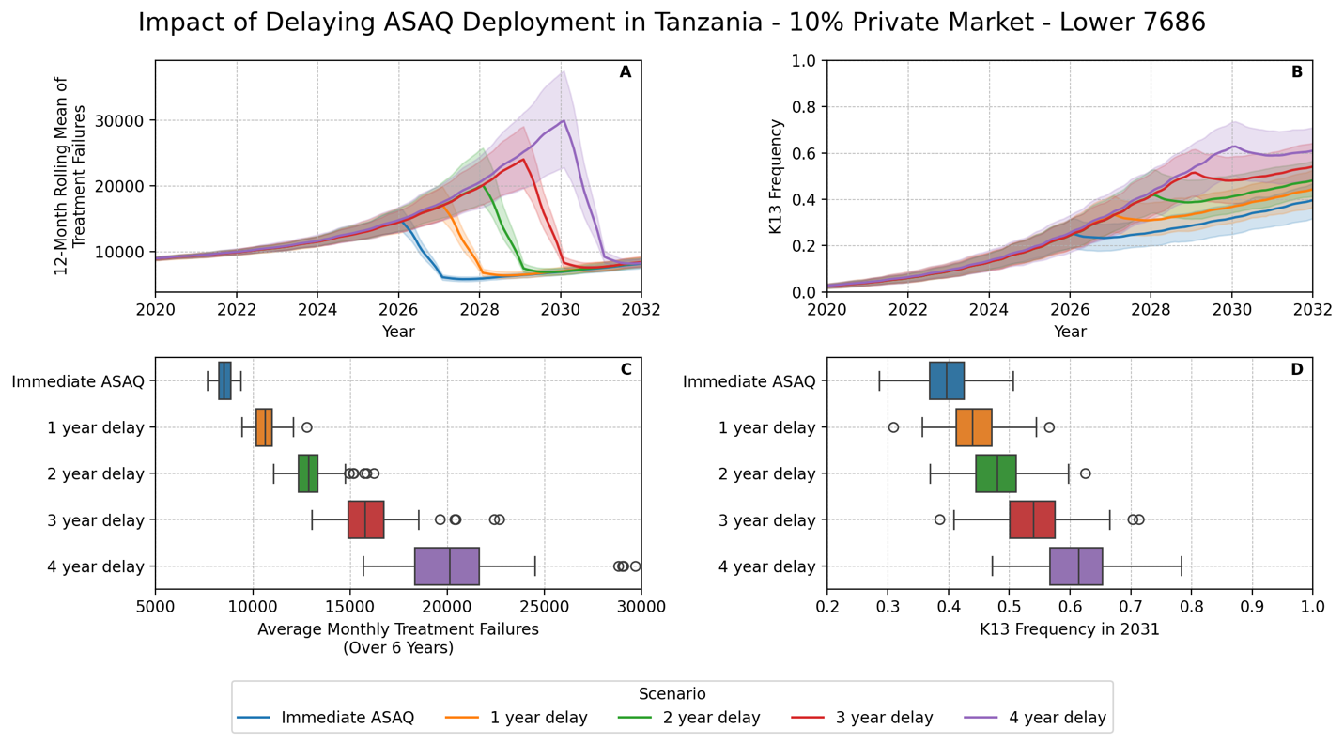
Supplementary Figure 15. Effect of delayed ASAQ deployment on treatment failures and pfkelch13 allele frequency under the 10% private-market scenario with lower pfcrt 76T and pfmdr1 86Y baseline frequencies. This figure is analogous to Figure 5 in the main text. Scenarios compare immediate deployment of artesunate–amodiaquine (ASAQ) with 1-, 2-, 3-, and 4-year delays before switching from artemether–lumefantrine to ASAQ. Panel A shows the 12-month rolling mean of treatment failures from 2020 to 2032, and Panel B shows the corresponding pfkelch13 allele frequency over time. Shaded regions show the 90% simulation range. Panel C summarizes the average monthly treatment failures over the six-year evaluation period, and Panel D summarizes pfkelch13 allele frequency in 2031. Delayed ASAQ deployment increased projected treatment failures and was associated with higher pfkelch13 allele frequencies, with longer delays producing progressively larger increases.

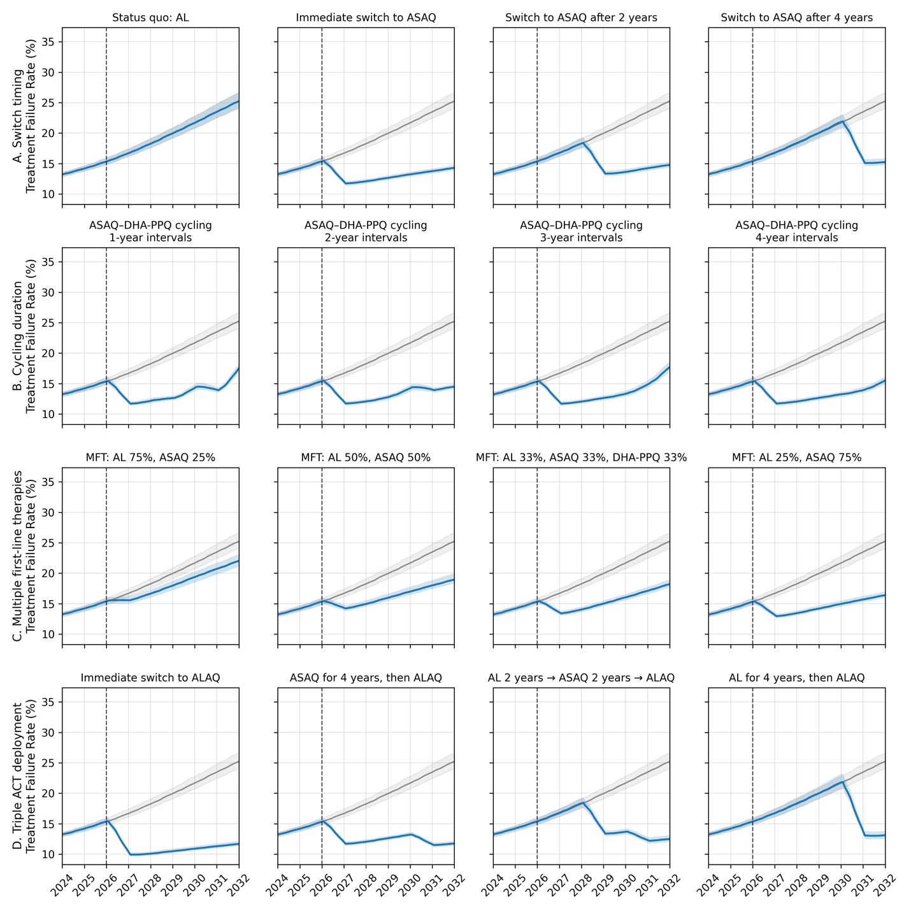
Supplementary Figure 16. Projected treatment failure rate trajectories under representative antimalarial treatment strategies in Kagera, Tanzania, 2024–2032. Monthly treatment failure rate trajectories are shown for selected strategies grouped by intervention type: (A) timing of switching from artemether–lumefantrine (AL) to artesunate–amodiaquine (ASAQ); (B) ASAQ–dihydroartemisinin–piperaquine (DHA-PPQ) cycling strategies with 1-, 2-, 3-, and 4-year cycling intervals; (C) multiple first-line therapy (MFT) strategies with different proportions of AL, ASAQ, and DHA-PPQ use; and (D) triple ACT strategies involving deployment of artemether–lumefantrine–amodiaquine (ALAQ), either immediately or following interim use of AL and/or ASAQ. Blue lines show the median projected treatment failure rate for each intervention strategy, and blue shaded areas indicate the 90% interval. Grey lines and shaded areas show the corresponding status quo trajectory, defined as continued AL first-line use, and its 90% simulation interval. A vertical dashed line marks January 1, 2026, the start of intervention implementation. Trajectories are displayed as 12-month rolling means to reduce short-term seasonal variation and highlight longer-term differences among strategies.

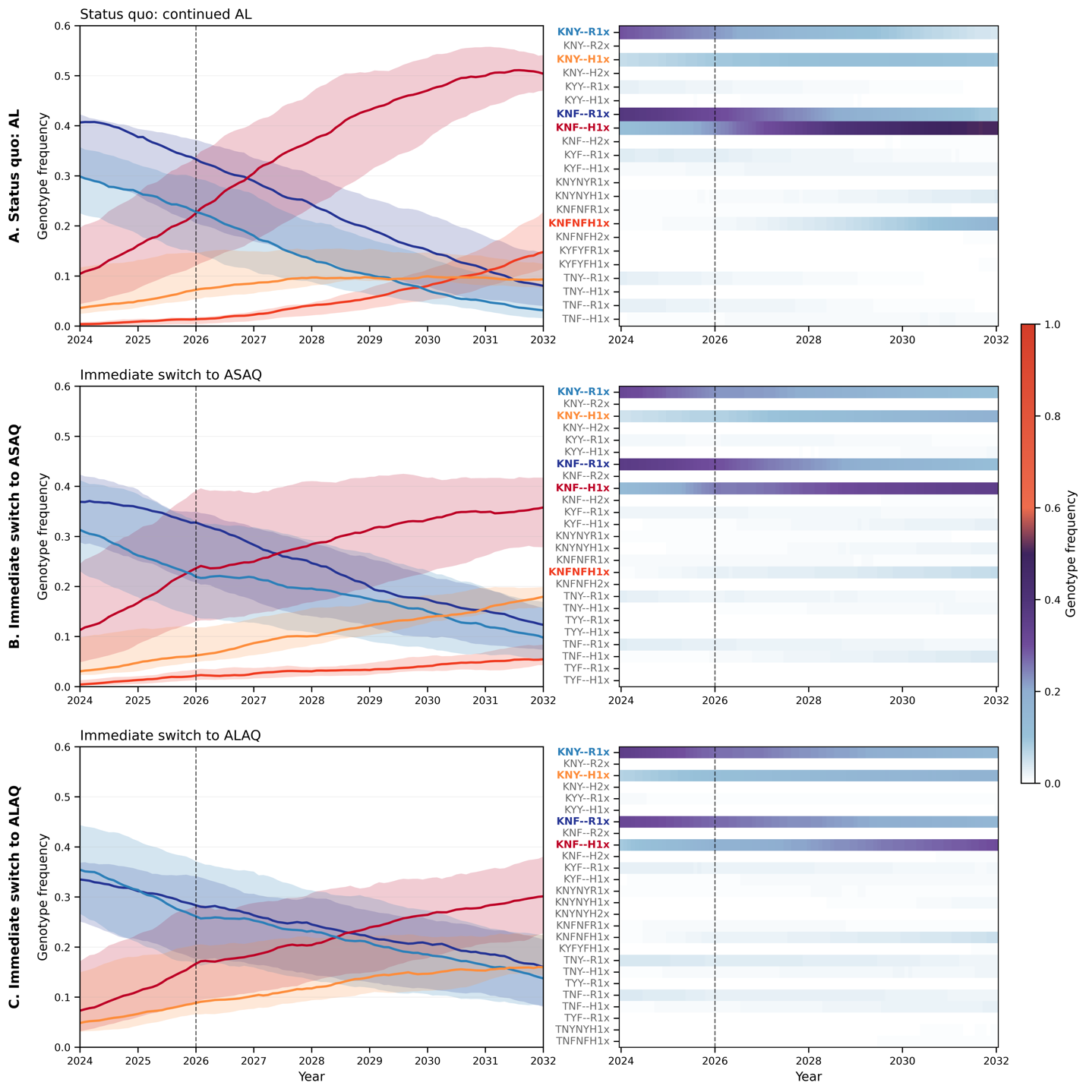
Supplementary Figure 17. Representative genotype-frequency trajectories under alternative antimalarial treatment strategies in Kagera, Tanzania. Genotype dynamics are shown from 2024 to 2032 under (A) continued artemether–lumefantrine (AL) use as the status quo, (B) an immediate switch to artesunate–amodiaquine (ASAQ), and (C) an immediate switch to the triple ACT artemether–lumefantrine–amodiaquine (ALAQ). For each strategy, the left panel shows temporal trajectories for major genotypes whose median frequency exceeded 0.05 at any point during the plotted period; solid lines show the median genotype frequency across locations and shaded areas show the 90% interval across locations. The right panel shows the corresponding genotype-frequency heatmap for all genotypes exceeding a frequency of 0.0015 during the analysis period, using a common color scale from 0 to 1 across all three strategies. Dashed vertical lines indicate January 1, 2026, when the intervention strategies were initiated. Each row shows a representative single simulation realization for the corresponding treatment strategy.

S3. Supplementary Tables
Scenario ID | Private-market share (%) | Monthly treatment failures, median (90% interval) | Reduction vs. status quo, median (90% interval), %
000-status-quo | 47% | 46,768 (44,972–49,124) | 0.0 (-5.0–3.8)
000-status-quo | 10% | 27,140 (22,572–35,862) | 0.0 (-32.1–16.8)
001-basic-ASAQ | 47% | 27,620 (26,893–28,289) | 40.9 (39.5–42.5)
001-basic-ASAQ | 10% | 7,366 (6,754–8,228) | 72.9 (69.7–75.1)
002-basic-DHAPPQ | 47% | 39,910 (38,318–41,775) | 14.7 (10.7–18.1)
002-basic-DHAPPQ | 10% | 28,693 (24,052–32,888) | -5.7 (-21.2–11.4)
003-Cycling-1y-AL-ASAQ | 47% | 36,487 (35,477–37,955) | 22.0 (18.8–24.1)
003-Cycling-1y-AL-ASAQ | 10% | 14,306 (12,361–16,868) | 47.3 (37.8–54.5)
004-Cycling-1y-AL-DHAPPQ | 47% | 37,752 (36,266–39,606) | 19.3 (15.3–22.5)
004-Cycling-1y-AL-DHAPPQ | 10% | 16,739 (13,674–20,152) | 38.3 (25.8–49.6)
005-Cycling-1y-ASAQ-AL | 47% | 36,006 (34,761–37,686) | 23.0 (19.4–25.7)
005-Cycling-1y-ASAQ-AL | 10% | 13,559 (11,908–16,635) | 50.0 (38.7–56.1)
006-Cycling-1y-ASAQ-DHAPPQ | 47% | 28,445 (27,656–29,479) | 39.2 (37.0–40.9)
006-Cycling-1y-ASAQ-DHAPPQ | 10% | 8,158 (7,210–9,147) | 69.9 (66.3–73.4)
007-Cycling-1y-DHAPPQ-AL | 47% | 37,613 (36,112–39,144) | 19.6 (16.3–22.8)
007-Cycling-1y-DHAPPQ-AL | 10% | 16,398 (14,303–19,715) | 39.6 (27.4–47.3)
008-Cycling-1y-DHAPPQ-ASAQ | 47% | 28,688 (27,867–29,606) | 38.7 (36.7–40.4)
008-Cycling-1y-DHAPPQ-ASAQ | 10% | 8,632 (7,736–9,647) | 68.2 (64.5–71.5)
009-Cycling-1y-AL-ASAQ-DHAPPQ | 47% | 33,149 (32,249–34,381) | 29.1 (26.5–31.0)
009-Cycling-1y-AL-ASAQ-DHAPPQ | 10% | 11,779 (10,304–13,352) | 56.6 (50.8–62.0)
010-Cycling-1y-AL-DHAPPQ-ASAQ | 47% | 33,308 (32,280–34,478) | 28.8 (26.3–31.0)
010-Cycling-1y-AL-DHAPPQ-ASAQ | 10% | 11,923 (10,439–13,814) | 56.1 (49.1–61.5)
011-Cycling-1y-ASAQ-AL-DHAPPQ | 47% | 33,743 (32,678–35,350) | 27.9 (24.4–30.1)
011-Cycling-1y-ASAQ-AL-DHAPPQ | 10% | 11,992 (10,560–13,863) | 55.8 (48.9–61.1)
012-Cycling-1y-ASAQ-DHAPPQ-AL | 47% | 33,083 (32,133–34,321) | 29.3 (26.6–31.3)
012-Cycling-1y-ASAQ-DHAPPQ-AL | 10% | 11,189 (9,986–12,868) | 58.8 (52.6–63.2)
013-Cycling-1y-DHAPPQ-AL-ASAQ | 47% | 33,937 (32,850–35,624) | 27.4 (23.8–29.8)
013-Cycling-1y-DHAPPQ-AL-ASAQ | 10% | 11,768 (10,395–14,122) | 56.6 (48.0–61.7)
014-Cycling-1y-DHAPPQ-ASAQ-AL | 47% | 33,373 (32,189–34,547) | 28.6 (26.1–31.2)
014-Cycling-1y-DHAPPQ-ASAQ-AL | 10% | 11,264 (9,933–12,612) | 58.5 (53.5–63.4)
015-Cycling-2y-AL-ASAQ | 47% | 39,796 (38,637–41,189) | 14.9 (11.9–17.4)
015-Cycling-2y-AL-ASAQ | 10% | 17,786 (15,160–21,851) | 34.5 (19.5–44.1)
016-Cycling-2y-AL-DHAPPQ | 47% | 40,526 (38,669–41,986) | 13.3 (10.2–17.3)
016-Cycling-2y-AL-DHAPPQ | 10% | 18,705 (16,073–23,366) | 31.1 (13.9–40.8)
017-Cycling-2y-ASAQ-AL | 47% | 33,313 (32,327–34,619) | 28.8 (26.0–30.9)
017-Cycling-2y-ASAQ-AL | 10% | 11,816 (10,899–13,610) | 56.5 (49.9–59.8)
018-Cycling-2y-ASAQ-DHAPPQ | 47% | 27,748 (26,866–28,422) | 40.7 (39.2–42.6)
018-Cycling-2y-ASAQ-DHAPPQ | 10% | 7,234 (6,538–7,898) | 73.3 (70.9–75.9)
019-Cycling-2y-DHAPPQ-AL | 47% | 36,728 (35,355–38,241) | 21.5 (18.2–24.4)
019-Cycling-2y-DHAPPQ-AL | 10% | 18,345 (14,788–21,392) | 32.4 (21.2–45.5)
020-Cycling-2y-DHAPPQ-ASAQ | 47% | 30,379 (29,554–31,839) | 35.0 (31.9–36.8)
020-Cycling-2y-DHAPPQ-ASAQ | 10% | 11,564 (9,797–12,994) | 57.4 (52.1–63.9)
021-Cycling-2y-AL-ASAQ-DHAPPQ | 47% | 32,642 (31,555–33,998) | 30.2 (27.3–32.5)
021-Cycling-2y-AL-ASAQ-DHAPPQ | 10% | 11,841 (10,362–14,305) | 56.4 (47.3–61.8)
022-Cycling-2y-AL-DHAPPQ-ASAQ | 47% | 33,019 (32,140–34,238) | 29.4 (26.8–31.3)
022-Cycling-2y-AL-DHAPPQ-ASAQ | 10% | 11,750 (10,283–14,989) | 56.7 (44.8–62.1)
023-Cycling-2y-ASAQ-AL-DHAPPQ | 47% | 32,997 (32,180–34,393) | 29.4 (26.5–31.2)
023-Cycling-2y-ASAQ-AL-DHAPPQ | 10% | 11,853 (10,649–13,657) | 56.3 (49.7–60.8)
024-Cycling-2y-ASAQ-DHAPPQ-AL | 47% | 34,208 (32,958–35,777) | 26.9 (23.5–29.5)
024-Cycling-2y-ASAQ-DHAPPQ-AL | 10% | 11,934 (10,714–13,922) | 56.0 (48.7–60.5)
025-Cycling-2y-DHAPPQ-AL-ASAQ | 47% | 33,748 (32,518–34,651) | 27.8 (25.9–30.5)
025-Cycling-2y-DHAPPQ-AL-ASAQ | 10% | 12,218 (10,736–14,156) | 55.0 (47.8–60.4)
026-Cycling-2y-DHAPPQ-ASAQ-AL | 47% | 34,017 (32,988–35,373) | 27.3 (24.4–29.5)
026-Cycling-2y-DHAPPQ-ASAQ-AL | 10% | 12,021 (10,458–14,636) | 55.7 (46.1–61.5)
028-Cycling-3y-AL-DHAPPQ | 47% | 36,945 (35,574–38,527) | 21.0 (17.6–23.9)
028-Cycling-3y-AL-DHAPPQ | 10% | 16,761 (14,772–20,100) | 38.2 (25.9–45.6)
029-Cycling-3y-ASAQ-AL | 47% | 36,758 (35,530–38,267) | 21.4 (18.2–24.0)
029-Cycling-3y-ASAQ-AL | 10% | 14,364 (12,667–18,502) | 47.1 (31.8–53.3)
030-Cycling-3y-ASAQ-DHAPPQ | 47% | 28,326 (27,540–29,442) | 39.4 (37.0–41.1)
030-Cycling-3y-ASAQ-DHAPPQ | 10% | 8,278 (7,548–9,281) | 69.5 (65.8–72.2)
031-Cycling-3y-DHAPPQ-AL | 47% | 38,669 (37,499–40,801) | 17.3 (12.8–19.8)
031-Cycling-3y-DHAPPQ-AL | 10% | 17,277 (15,211–21,002) | 36.3 (22.6–44.0)
032-Cycling-3y-DHAPPQ-ASAQ | 47% | 28,636 (27,910–29,452) | 38.8 (37.0–40.3)
032-Cycling-3y-DHAPPQ-ASAQ | 10% | 8,472 (7,492–9,800) | 68.8 (63.9–72.4)
040-Cycling-4y-AL-DHAPPQ | 47% | 39,240 (37,748–41,248) | 16.1 (11.8–19.3)
040-Cycling-4y-AL-DHAPPQ | 10% | 18,659 (16,093–22,481) | 31.3 (17.2–40.7)
041-Cycling-4y-ASAQ-AL | 47% | 33,706 (32,721–34,926) | 27.9 (25.3–30.0)
041-Cycling-4y-ASAQ-AL | 10% | 11,418 (10,489–13,552) | 57.9 (50.1–61.4)
042-Cycling-4y-ASAQ-DHAPPQ | 47% | 27,332 (26,584–28,274) | 41.6 (39.5–43.2)
042-Cycling-4y-ASAQ-DHAPPQ | 10% | 7,070 (6,527–7,544) | 74.0 (72.2–75.9)
043-Cycling-4y-DHAPPQ-AL | 47% | 37,581 (36,006–39,811) | 19.6 (14.9–23.0)
043-Cycling-4y-DHAPPQ-AL | 10% | 18,408 (15,039–22,138) | 32.2 (18.4–44.6)
044-Cycling-4y-DHAPPQ-ASAQ | 47% | 30,838 (29,535–32,024) | 34.1 (31.5–36.8)
044-Cycling-4y-DHAPPQ-ASAQ | 10% | 12,514 (10,348–14,558) | 53.9 (46.4–61.9)
051-mft-AL25-ASAQ75 | 47% | 31,428 (30,659–32,461) | 32.8 (30.6–34.4)
051-mft-AL25-ASAQ75 | 10% | 10,205 (9,212–11,518) | 62.4 (57.6–66.1)
052-mft-AL25-DHAPPQ75 | 47% | 36,970 (35,590–39,124) | 21.0 (16.3–23.9)
052-mft-AL25-DHAPPQ75 | 10% | 20,394 (17,260–23,666) | 24.9 (12.8–36.4)
053-mft-ASAQ25-DHAPPQ75 | 47% | 32,804 (31,483–34,003) | 29.9 (27.3–32.7)
053-mft-ASAQ25-DHAPPQ75 | 10% | 15,211 (13,129–17,667) | 44.0 (34.9–51.6)
054-mft-AL75-ASAQ25 | 47% | 41,447 (39,638–43,145) | 11.4 (7.7–15.2)
054-mft-AL75-ASAQ25 | 10% | 19,528 (17,062–23,377) | 28.0 (13.9–37.1)
055-mft-AL75-DHAPPQ25 | 47% | 41,529 (40,227–43,168) | 11.2 (7.7–14.0)
055-mft-AL75-DHAPPQ25 | 10% | 20,151 (16,904–25,797) | 25.8 (4.9–37.7)
056-mft-ASAQ75-DHAPPQ25 | 47% | 27,439 (26,757–28,193) | 41.3 (39.7–42.8)
056-mft-ASAQ75-DHAPPQ25 | 10% | 7,178 (6,614–7,753) | 73.6 (71.4–75.6)
057-mft-AL50-ASAQ50 | 47% | 36,071 (34,921–37,673) | 22.9 (19.4–25.3)
057-mft-AL50-ASAQ50 | 10% | 14,053 (12,488–16,955) | 48.2 (37.5–54.0)
058-mft-AL50-DHAPPQ50 | 47% | 37,537 (36,373–39,091) | 19.7 (16.4–22.2)
058-mft-AL50-DHAPPQ50 | 10% | 17,019 (14,499–19,757) | 37.3 (27.2–46.6)
059-mft-ASAQ50-DHAPPQ50 | 47% | 28,685 (27,574–29,867) | 38.7 (36.1–41.0)
059-mft-ASAQ50-DHAPPQ50 | 10% | 8,805 (7,773–10,051) | 67.6 (63.0–71.4)
060-mft-AL-ASAQ-DHAPPQ | 47% | 33,358 (32,391–34,348) | 28.7 (26.6–30.7)
060-mft-AL-ASAQ-DHAPPQ | 10% | 11,652 (10,403–13,254) | 57.1 (51.2–61.7)
061-tact-AL4y-ALAQ | 47% | 37,636 (35,853–39,731) | 19.5 (15.0–23.3)
061-tact-AL4y-ALAQ | 10% | 17,523 (14,780–21,680) | 35.4 (20.1–45.5)
062-tact-ASAQ4y-ALAQ | 47% | 25,611 (25,008–26,212) | 45.2 (44.0–46.5)
062-tact-ASAQ4y-ALAQ | 10% | 6,007 (5,551–6,437) | 77.9 (76.3–79.5)
063-tact-DHAPPQ4y-ALAQ | 47% | 29,059 (28,031–30,329) | 37.9 (35.2–40.1)
063-tact-DHAPPQ4y-ALAQ | 10% | 10,828 (9,504–12,323) | 60.1 (54.6–65.0)
064-tact-AL2y-ASAQ2y-ALAQ | 47% | 31,015 (29,807–32,393) | 33.7 (30.7–36.3)
064-tact-AL2y-ASAQ2y-ALAQ | 10% | 10,604 (9,164–13,132) | 60.9 (51.6–66.2)
065-tact-AL2y-DHAPPQ2y-ALAQ | 47% | 31,071 (30,100–32,658) | 33.6 (30.2–35.6)
065-tact-AL2y-DHAPPQ2y-ALAQ | 10% | 10,592 (9,325–12,437) | 61.0 (54.2–65.6)
066-tact-ASAQ2y-AL2y-ALAQ | 47% | 31,568 (30,479–32,861) | 32.5 (29.7–34.8)
066-tact-ASAQ2y-AL2y-ALAQ | 10% | 10,510 (9,072–12,922) | 61.3 (52.4–66.6)
067-tact-ASAQ2y-DHAPPQ2y-ALAQ | 47% | 25,808 (25,060–26,514) | 44.8 (43.3–46.4)
067-tact-ASAQ2y-DHAPPQ2y-ALAQ | 10% | 5,867 (5,412–6,643) | 78.4 (75.5–80.1)
068-tact-DHAPPQ2y-AL2y-ALAQ | 47% | 32,183 (31,113–33,210) | 31.2 (29.0–33.5)
068-tact-DHAPPQ2y-AL2y-ALAQ | 10% | 10,883 (9,622–12,980) | 59.9 (52.2–64.5)
069-tact-DHAPPQ2y-ASAQ2y-ALAQ | 47% | 25,953 (25,344–26,616) | 44.5 (43.1–45.8)
069-tact-DHAPPQ2y-ASAQ2y-ALAQ | 10% | 5,934 (5,413–6,511) | 78.1 (76.0–80.1)
070-tact-ALAQ-immediate | 47% | 22,409 (21,940–23,267) | 52.1 (50.3–53.1)
070-tact-ALAQ-immediate | 10% | 3,425 (3,177–3,791) | 87.4 (86.0–88.3)
071-mft-AL_75-ASPY85_25 | 47% | 41,576 (40,056–43,428) | 11.1 (7.1–14.4)
071-mft-AL_75-ASPY85_25 | 10% | 20,308 (17,254–27,069) | 25.2 (0.3–36.4)
072-mft-AL_75-ASPY75_25 | 47% | 41,609 (39,564–43,523) | 11.0 (6.9–15.4)
072-mft-AL_75-ASPY75_25 | 10% | 20,583 (17,473–24,964) | 24.2 (8.0–35.6)
073-mft-AL_75-ASPY65_25 | 47% | 41,643 (39,921–43,813) | 11.0 (6.3–14.6)
073-mft-AL_75-ASPY65_25 | 10% | 21,162 (17,554–25,773) | 22.0 (5.0–35.3)
074-mft-AL_50-ASPY85_50 | 47% | 36,308 (35,054–37,937) | 22.4 (18.9–25.0)
074-mft-AL_50-ASPY85_50 | 10% | 14,935 (13,093–19,172) | 45.0 (29.4–51.8)
075-mft-AL_50-ASPY75_50 | 47% | 36,576 (35,395–38,399) | 21.8 (17.9–24.3)
075-mft-AL_50-ASPY75_50 | 10% | 15,050 (12,868–17,899) | 44.5 (34.1–52.6)
076-mft-AL_50-ASPY65_50 | 47% | 36,621 (35,425–38,371) | 21.7 (18.0–24.3)
076-mft-AL_50-ASPY65_50 | 10% | 15,109 (13,296–18,127) | 44.3 (33.2–51.0)
077-mft-ASAQ_75-ASPY85_25 | 47% | 27,489 (26,922–28,106) | 41.2 (39.9–42.4)
077-mft-ASAQ_75-ASPY85_25 | 10% | 7,159 (6,663–7,632) | 73.6 (71.9–75.4)
078-mft-ASAQ_75-ASPY75_25 | 47% | 27,621 (26,915–28,347) | 40.9 (39.4–42.4)
078-mft-ASAQ_75-ASPY75_25 | 10% | 7,184 (6,602–7,972) | 73.5 (70.6–75.7)
079-mft-ASAQ_75-ASPY65_25 | 47% | 27,556 (26,931–28,675) | 41.1 (38.7–42.4)
079-mft-ASAQ_75-ASPY65_25 | 10% | 7,285 (6,709–7,953) | 73.2 (70.7–75.3)
080-mft-ASAQ_50-ASPY85_50 | 47% | 27,464 (26,905–28,221) | 41.3 (39.7–42.5)
080-mft-ASAQ_50-ASPY85_50 | 10% | 7,095 (6,515–7,738) | 73.9 (71.5–76.0)
081-mft-ASAQ_50-ASPY75_50 | 47% | 27,615 (27,003–28,300) | 41.0 (39.5–42.3)
081-mft-ASAQ_50-ASPY75_50 | 10% | 7,174 (6,675–7,886) | 73.6 (70.9–75.4)
082-mft-ASAQ_50-ASPY65_50 | 47% | 27,865 (27,027–28,614) | 40.4 (38.8–42.2)
082-mft-ASAQ_50-ASPY65_50 | 10% | 7,408 (6,846–8,221) | 72.7 (69.7–74.8)
083-mft-AL-DHAPPQ-ASPY85 | 47% | 33,630 (32,537–35,529) | 28.1 (24.0–30.4)
083-mft-AL-DHAPPQ-ASPY85 | 10% | 11,780 (10,382–13,769) | 56.6 (49.3–61.7)
084-mft-AL-DHAPPQ-ASPY75 | 47% | 33,439 (32,179–34,842) | 28.5 (25.5–31.2)
084-mft-AL-DHAPPQ-ASPY75 | 10% | 11,943 (10,555–14,006) | 56.0 (48.4–61.1)
085-mft-AL-DHAPPQ-ASPY65 | 47% | 33,850 (32,686–35,281) | 27.6 (24.6–30.1)
085-mft-AL-DHAPPQ-ASPY65 | 10% | 12,113 (10,772–14,048) | 55.4 (48.2–60.3)
086-mft-ASAQ-DHAPPQ-ASPY85 | 47% | 27,602 (26,984–28,959) | 41.0 (38.1–42.3)
086-mft-ASAQ-DHAPPQ-ASPY85 | 10% | 7,237 (6,602–7,942) | 73.3 (70.7–75.7)
087-mft-ASAQ-DHAPPQ-ASPY75 | 47% | 27,740 (27,001–28,555) | 40.7 (38.9–42.3)
087-mft-ASAQ-DHAPPQ-ASPY75 | 10% | 7,345 (6,639–8,121) | 72.9 (70.1–75.5)
088-mft-ASAQ-DHAPPQ-ASPY65 | 47% | 27,739 (27,062–28,724) | 40.7 (38.6–42.1)
088-mft-ASAQ-DHAPPQ-ASPY65 | 10% | 7,410 (6,718–8,009) | 72.7 (70.5–75.2)
089-mft-AL-ASAQ-DHAPPQ-ASPY85 | 47% | 31,654 (30,701–32,700) | 32.3 (30.1–34.4)
089-mft-AL-ASAQ-DHAPPQ-ASPY85 | 10% | 10,164 (9,070–11,789) | 62.6 (56.6–66.6)
090-mft-AL-ASAQ-DHAPPQ-ASPY75 | 47% | 31,669 (30,731–33,059) | 32.3 (29.3–34.3)
090-mft-AL-ASAQ-DHAPPQ-ASPY75 | 10% | 10,192 (9,052–11,726) | 62.4 (56.8–66.6)
091-mft-AL-ASAQ-DHAPPQ-ASPY65 | 47% | 31,805 (30,820–32,886) | 32.0 (29.7–34.1)
091-mft-AL-ASAQ-DHAPPQ-ASPY65 | 10% | 10,145 (9,145–11,922) | 62.6 (56.1–66.3)
093-region-specific-Kagera-ASAQ-Others-ASAQ-Delay-1y | 47% | 29,198 (28,529–30,184) | 37.6 (35.5–39.0)
093-region-specific-Kagera-ASAQ-Others-ASAQ-Delay-1y | 10% | 8,847 (7,982–10,081) | 67.4 (62.9–70.6)
094-region-specific-Kagera-ASAQ-Others-ASAQ-Delay-2y | 47% | 31,035 (30,362–32,139) | 33.6 (31.3–35.1)
094-region-specific-Kagera-ASAQ-Others-ASAQ-Delay-2y | 10% | 10,542 (9,433–12,447) | 61.2 (54.1–65.2)
095-region-specific-Kagera-DHAPPQ-Others-ASAQ-Delay-0y | 47% | 30,484 (29,820–31,386) | 34.8 (32.9–36.2)
095-region-specific-Kagera-DHAPPQ-Others-ASAQ-Delay-0y | 10% | 10,693 (9,241–12,250) | 60.6 (54.9–66.0)
096-region-specific-Kagera-DHAPPQ-Others-ASAQ-Delay-1y | 47% | 32,133 (31,216–33,138) | 31.3 (29.1–33.3)
096-region-specific-Kagera-DHAPPQ-Others-ASAQ-Delay-1y | 10% | 12,067 (10,790–14,303) | 55.5 (47.3–60.2)
097-region-specific-Kagera-DHAPPQ-Others-ASAQ-Delay-2y | 47% | 34,124 (33,159–35,154) | 27.0 (24.8–29.1)
097-region-specific-Kagera-DHAPPQ-Others-ASAQ-Delay-2y | 10% | 13,827 (12,198–16,884) | 49.1 (37.8–55.1)
098-Delay-ASAQ-1y | 47% | 30,041 (29,382–31,079) | 35.8 (33.5–37.2)
098-Delay-ASAQ-1y | 10% | 9,429 (8,600–10,868) | 65.3 (60.0–68.3)
099-Delay-ASAQ-2y | 47% | 32,617 (31,640–33,853) | 30.3 (27.6–32.3)
099-Delay-ASAQ-2y | 10% | 11,671 (10,369–13,642) | 57.0 (49.7–61.8)
100-Delay-ASAQ-3y | 47% | 35,646 (34,610–37,104) | 23.8 (20.7–26.0)
100-Delay-ASAQ-3y | 10% | 14,733 (12,951–17,783) | 45.7 (34.5–52.3)
101-Delay-ASAQ-4y | 47% | 39,229 (37,843–41,066) | 16.1 (12.2–19.1)
101-Delay-ASAQ-4y | 10% | 18,371 (15,870–25,950) | 32.3 (4.4–41.5)

Supplementary Table 1. Projected treatment failures under alternative treatment strategies and private-market scenarios. The table summarizes treatment failures over the six-year evaluation period under the 47% and 10% private-market scenarios. For each strategy, the median monthly number of treatment failures, calculated as the six-year total divided by 72 months, and the 90% simulation interval are reported. The percentage reduction in treatment failures was calculated relative to the corresponding status quo within each private-market scenario, defined as AL first-line use under the same private-market setting. Positive values indicate fewer treatment failures relative to the corresponding status quo.

References
1. USAID. DHS Program, Spatial Data Repository - Boundaries [Internet]. 2026. Available from: https://spatialdata.dhsprogram.com/boundaries/#countryId=TZ&view=table
2. National Bureau of Statistics - NBS/Tanzania, ORC Macro. Tanzania Demographic and Health Survey 2004-2005 [Internet]. Dar es Salaam, Tanzania: NBS/Tanzania and ORC Macro; 2005. Available from: http://dhsprogram.com/pubs/pdf/FR173/FR173.pdf
3. National Bureau of Statistics - NBS/Tanzania, ICF Macro. Tanzania Demographic and Health Survey 2010 [Internet]. Dar es Salaam, Tanzania: NBS/Tanzania and ICF Macro; 2011. Available from: http://dhsprogram.com/pubs/pdf/FR243/FR243.pdf
4. Ministry of Health CD Gender, Elderly and Children MoHCDGEC/Tanzania Mainland, Ministry of Health - MoH/Zanzibar, National Bureau of Statistics - NBS/Tanzania, Office of Chief Government Statistician - OCGS/Zanzibar, ICF. Tanzania Demographic and Health Survey and Malaria Indicator Survey 2015-2016 [Internet]. Dar es Salaam, Tanzania: MoHCDGEC, MoH, NBS, OCGS, and ICF; 2016. Available from: http://dhsprogram.com/pubs/pdf/FR321/FR321.pdf
5. Ministry of Health/Tanzania Mainland, Ministry of Health/Zanzibar, National Bureau of Statistics - NBS/Tanzania, Office of the Chief Government Statistician - OCGS/Tanzania, ICF. Tanzania Demographic and Health Survey and Malaria Indicator Survey 2022 Final Report [Internet]. Dodoma, Tanzania, and Rockville, Maryland, USA: MoH, NBS, OCGS, and ICF; 2023. Available from: https://www.dhsprogram.com/pubs/pdf/FR382/FR382.pdf
6. Kamugisha E, Jing S, Minde M, Kataraihya J, Kongola G, Kironde F, et al. Efficacy of artemether-lumefantrine in treatment of malaria among under-fives and prevalence of drug resistance markers in Igombe-Mwanza, north-western Tanzania. Malar J. 2012 Dec;11(1):58. doi:10.1186/1475-2875-11-58
7. Kavishe RA, Paulo P, Kaaya RD, Kalinga A, Van Zwetselaar M, Chilongola J, et al. Surveillance of artemether-lumefantrine associated Plasmodium falciparum multidrug resistance protein-1 gene polymorphisms in Tanzania. Malar J. 2014 Dec;13(1):264. doi:10.1186/1475-2875-13-264
8. Ishengoma DS, Mandara CI, Francis F, Talundzic E, Lucchi NW, Ngasala B, et al. Efficacy and safety of artemether-lumefantrine for the treatment of uncomplicated malaria and prevalence of Pfk13 and Pfmdr1 polymorphisms after a decade of using artemisinin-based combination therapy in mainland Tanzania. Malar J. 2019 Dec;18(1):88. doi:10.1186/s12936-019-2730-1
9. Moser KA, Madebe RA, Aydemir O, Chiduo MG, Mandara CI, Rumisha SF, et al. Describing the current status of Plasmodium falciparum population structure and drug resistance within mainland Tanzania using molecular inversion probes. Mol Ecol. 2021 Jan;30(1):100–13. doi:10.1111/mec.15706
10. Juliano JJ, Giesbrecht DJ, Simkin A, Fola AA, Lyimo BM, Pereus D, et al. Country wide surveillance reveals prevalent artemisinin partial resistance mutations with evidence for multiple origins and expansion of high level sulfadoxine-pyrimethamine resistance mutations in northwest Tanzania [Internet]. Infectious Diseases (except HIV/AIDS); 2023 [cited 2026 Sep 4]. Available from: http://medrxiv.org/lookup/doi/10.1101/2023.11.07.23298207 doi:10.1101/2023.11.07.23298207

