**What is the difference between parametric models and non-parametric models ?**

<https://vitalflux.com/difference-between-parametric-vs-non-parametric-models/>

**List Ensemble methods**

<https://corporatefinanceinstitute.com/resources/knowledge/other/ensemble-methods/>

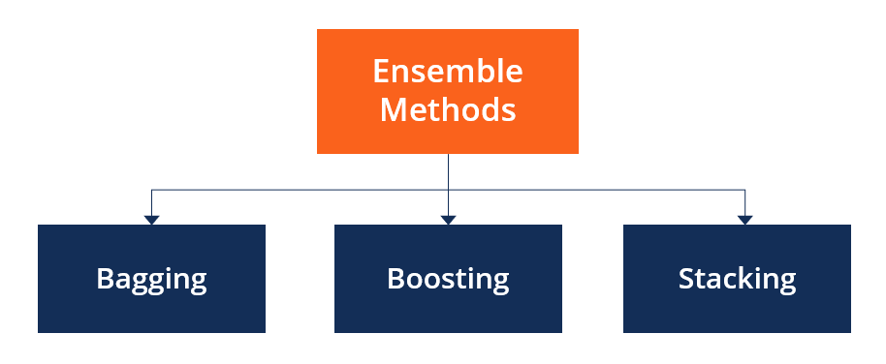

**How to choose the right estimator ?**

<https://scikit-learn.org/stable/tutorial/machine_learning_map/index.html>

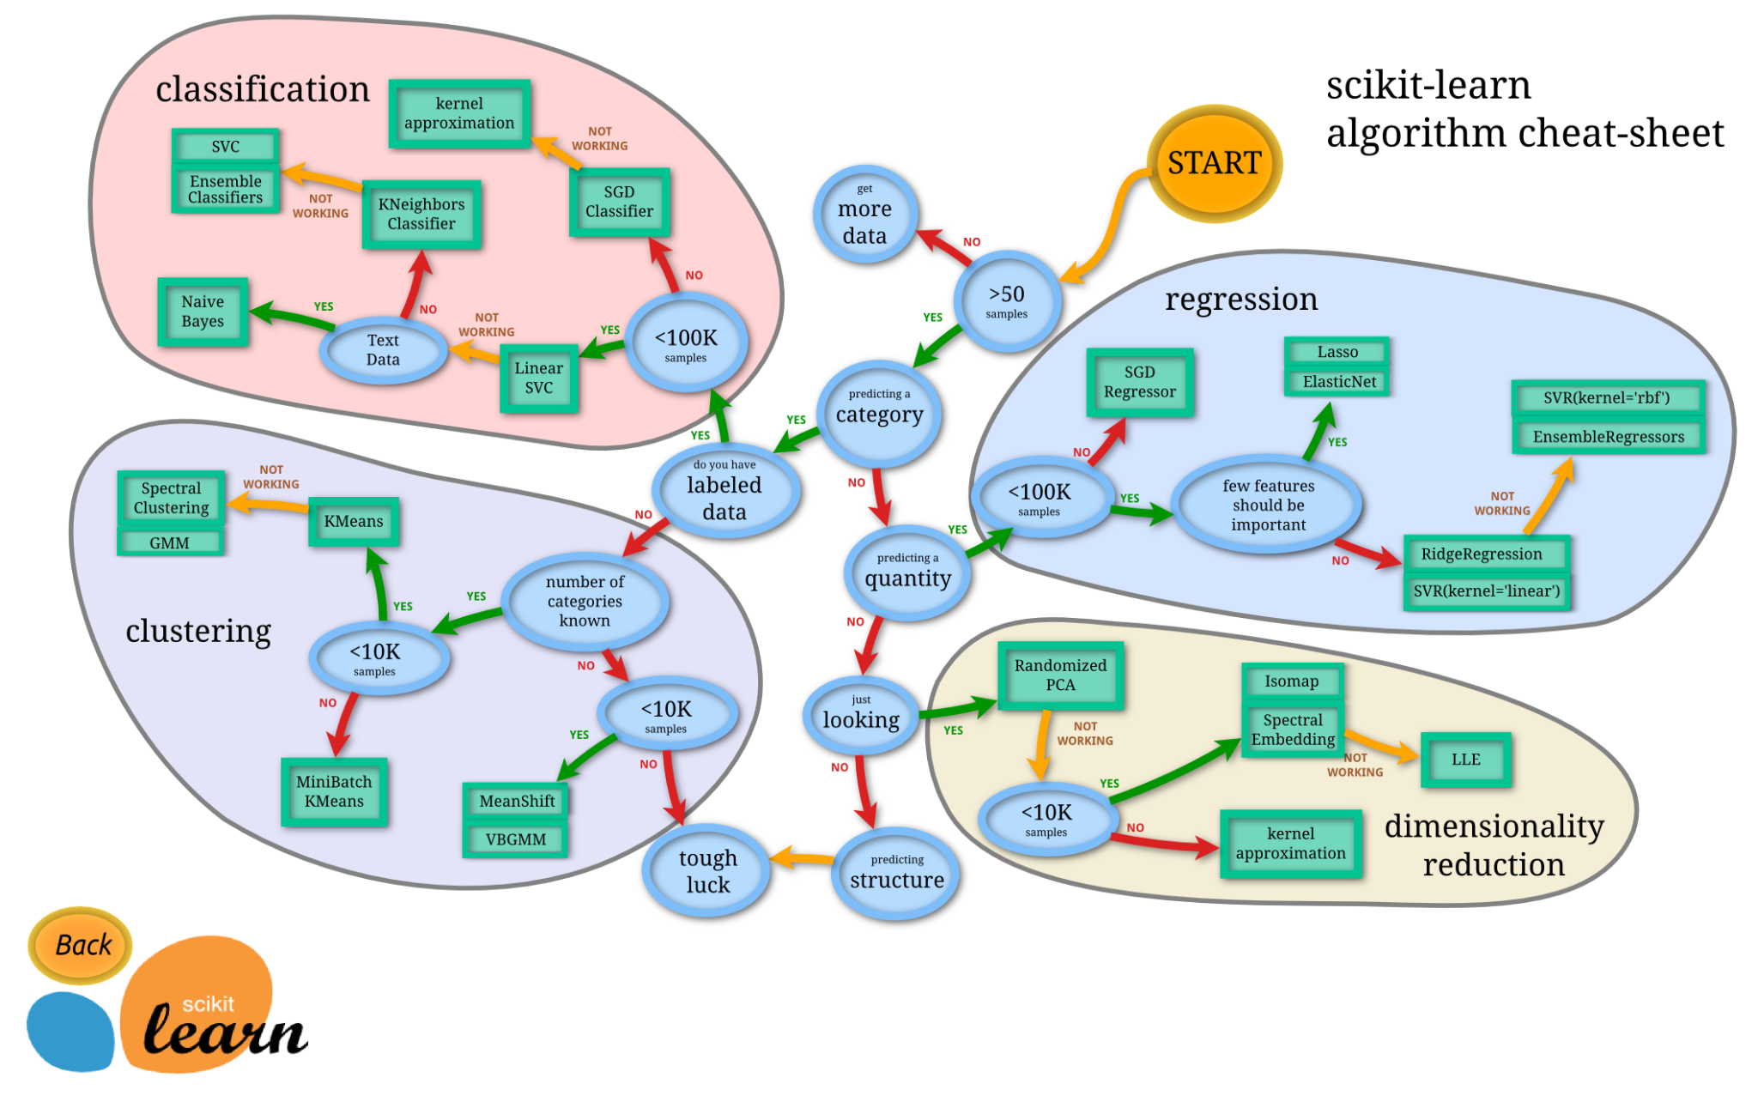

**Know the steps to make** [**Machine Learning explainability**](https://www.kaggle.com/learn/machine-learning-explainability)

**Model insights**

* What types of information are explainable and how ?
* What features of the data did the model find most important ?
* For any single prediction of a model, how does each feature of the data affect that particular prediction ?
* How does each feature affect the model's predictions in a broad sense (what is its typical effect when considered over a large number of possible predictions) ?

**Permutation Importance** [other [source](https://scikit-learn.org/stable/modules/permutation_importance.html)]

Feature permutation importance measures the predictive value of a feature for any black box estimator, classifier, or regressor. It does this by evaluating how the prediction error increases when a feature is not available. Any scoring metric can be used to measure the prediction error.

**Partial Plots**

While feature importance shows what variables most affect predictions, partial dependence plots show how a feature affects predictions.

This is useful to answer questions like:

* Controlling for all other house features, what impact do longitude and latitude have on home prices ? To restate this, how would similarly sized houses be priced in different areas ?
* Are predicted health differences between two groups due to differences in their diets, or due to some other factor ?

**SHAP values** (an acronym from SHapley Additive exPlanations)

=> break down a prediction to show the impact of each feature. Where could you use this?

A model says a bank shouldn't loan someone money, and the bank is legally required to explain the basis for each loan rejection

A healthcare provider wants to identify what factors are driving each patient's risk of some disease so they can directly address those risk factors with targeted health interventions.