Xie Zhou 912143385

ECS165 HW2

1a)

A+ = {A}

B+ = {B,C}

C+ = {C}

D+ = {D}

E+ = {E}

AB+ = {A,B,C,D,E} <- key

AC+ = {A,C,D,E}

AD+ = {A,D}

AE+ = {A,D,E}

BC+ = {B,C}

BD+ = {B,D}

BE+ = {A,B,C,D,E} <- key

CD+ = {C,D}

CE+ = {C,E}

DE+ = {D,E}

ABC+ = ABD+ = ABE+ = {A,B,C,D,E} <- superkey

ACD+ = {A,C,D,E}

ACE+ = {A,C,D,E}

ADE+ = {A,D,E}

BCD+ = {B,C,D}

BCE+ = BDE+ = {A,B,C,D,E} <- superkey

CDE+ = {C,D,E}

ABCD+ = {A,B,C,D,E} <- superkey

ABCE+ = {A,B,C,D,E}<- superkey

ACDE+ = {A,C,D,E}

BCDE+ = {A,B,C,D,E}<- superkey

ABCDE+ = {A,B,C,D,E} <- superkey

Keys of R are AB, BE

1b)

check FD’s (closure without each left hand side attributes, checking if follow)

AC+ = {A,C} so AC->E doesn’t follow the rest

AE+ = {A,E} so AE->D doesn’t follow the rest

B+ = {B} so B->C doesn’t follow the rest

BE+ = {B,E,C} so BE->A doesn’t follow the rest

check attributes:

C+ = {C} C in AC

A+ = {A} A in AC

E+ = {E} E in AE

A+ = {A} A in AE

E+ = {E} E in BE

B+ = {B,C} B in BE

Therefore, the original set of FD’s:

AC->E

AE->D

B->C

BE->A

is a minimal basis for the FD’s.

1c)

BCNF violations follow from the FD’s:

AC->E

AE->D

B->C

AC->D

BD->C

ACD->E

ACE->D

Their left-hand-side attributes are not superkeys. (keys: AB, BE)

1d)

Choose AC to be X

Then X+ = AC+ = {A,C,D,E}

R1(A,C,D,E)

{

~~AC->D~~ (deleted b/c it follows)

AC->E

AE->D <- violation

~~ACD->E~~ (deleted b/c it follows)

~~ACE->D~~ (deleted b/c it follows)

}

key:

AC+ = {A,C,D,E}

AE+ = {A,D,E}

R1’s key: AC

R2(A,B,C)

{

B->C <- violation

}

key:

AB+ = {A,B,C}

R2’s key: AB

BCNF violation in R1, further decompose R1:

Choose AE to be X,

Then X+ = AE+ = {A,D,E}

R3(A,D,E)

{

AE->D

}

key:

AE+ = {A,D,E}

R3’s key: AE

R4(A,C,E)

{

AC->E

}

key:

AC+ = {A,C,E}

R4’s key: AC

BCNF violation in R2, further decompose R2:

Choose B to be X,

Then X+ = B+ = {B,C}

R5(B,C)

{

B->C

}

key:

B+ = {B,C}

R5’s key: B

R6(A,B)

{

}

key:

AB+ = {A,B}

R5’s key: AB

Therefore the BCNF decomposition:

R3(A,D,E)

R4(A,C,E)

R5(B,C)

R6(A,B)

with FD’s:

AE->D

AC->E

B->C

1e)

3NF violations that follow from FD’s:

AE->D

B->C

AC->D

BD->C

ACE->D

Left hand sides are not superkeys and right hand sides are not primes.

1f)

Find minimal basis:

from part b):

AC->E

AE->D

B->C

BE->A

Create relations with schemas:

R1(A,C,E) AC-> E key: AC

R2(A,D,E) AE->D key: AE

R3(B,C) B->C key: B

R4(A,B,E) <- ABE is a superkey BE->A key:BE

So 3NF decomposition is:

R1(A,C,E)

R2(A,D,E)

R3(B,C)

R4(A,B,E)

with FDs:

AC-> E

AE->D

B->C

BE->A

1g)

List of all MVD’s that follow FD’s:

B->->C <-violation

AB->->C

AB->->D

AB->->E

AC->->D <-violation

AC->->E <-violation

AE->->D <-violation

BD->->C <-violation

BE->->A

BE->->C

BE->->D

ABC->->D

ABC->->E

ABD->->C

ABD->->E

ACD->->E <-violation

ACE->->D <-violation

BCE->->A

BDE->->A

BDE->->C

B->->ADE <-violation

AB->->DE

AB->->CE

AB->->CD

AC->->BE <-violation

AC->->BD <-violation

AE->->BC <-violation

BD->->AE <-violation

BE->->CD

BE->->AD

BE->->AC

ACD->->B <-violation

ACE->->B <-violation

Therefore, 4NF violations:

B->->C

AC->->D

AC->->E

AE->->D

BD->->C

ACD->->E

ACE->->D

B->->ADE

AC->->BE

AC->->BD

AE->->BC

BD->->AE

ACD->->B

ACE->->B

1h)

Choose AC->E to be the 4NF violation,

R1(A,C,E)

{

AC->E

AC->->E

}

key: AC

R2(A,B,C,D)

{

~~ABC->D~~ (deleted for minimal basis)

~~ABD->C~~ (deleted for minimal basis)

~~AB->D~~ (deleted for minimal basis)

AB->C

AC->D

BD->C

B->->C <- violation

AB->->C

AB->->D

AC->->D <- violation

BD->->C <- violation

}

key: AB

4NF violation in R2, further decomposition of R2:

Choose B->C

R3(B,C)

{

B->C

B->->C

}

key: B

R4(A,B,D)

{

AB->D

AB->->D

}

key: AB

Therefore, 4NF decomposition:

R1(A,C,E)

R3(B,C)

R4(A,B,D)

FDs and MVDs:

AC->E

B->C

AB->D

AC->->E

B->->C

AB->->D

1i)

S(A,B,C) = πR(A,B,C,D,E)

B->C

~~AB->C~~ (follow from the rest)

B->->C

~~AB->->C~~ (trivial)

B->->A

2a)

Use chase test to prove: CH->R holds in Courses.

|  |  |  |  |  |  |
| --- | --- | --- | --- | --- | --- |
| C | T | H | R | S | G |
| c | t1 | h | r1 | s1 | g1 |
| c | t2 | h | r2 | s2 | g2 |

apply C->T

|  |  |  |  |  |  |
| --- | --- | --- | --- | --- | --- |
| C | T | H | R | S | G |
| c | t1 | h | r1 | s1 | g1 |
| c | t1 | h | r2 | s2 | g2 |

apply HT->R

|  |  |  |  |  |  |
| --- | --- | --- | --- | --- | --- |
| C | T | H | R | S | G |
| c | t1 | h | r1 | s1 | g1 |
| c | t1 | h | r1 | s2 | g2 |

The R column agrees.

Therefore, CH->R holds.

2b)

Use chase test to prove: CHR->G holds in Courses.

|  |  |  |  |  |  |
| --- | --- | --- | --- | --- | --- |
| C | T | H | R | S | G |
| c | t1 | h | r | s1 | g1 |
| c | t2 | h | r | s2 | g2 |

apply C->T

|  |  |  |  |  |  |
| --- | --- | --- | --- | --- | --- |
| C | T | H | R | S | G |
| c | t1 | h | r | s1 | g1 |
| c | t1 | h | r | s2 | g2 |

The only FD and MVD associated with G are:

CS->G

CS->->G

Since elements in columns C+S do not agree, no further changes for column G.

Column G will never agree.

Therefore, CHR->G does not hold in Courses.

2c)

C+ = {C,T}

T+ = {T}

H+ = {H}

R+ = {R}

S+ = {S}

G+ = {G}

CT+ = {C,T}

CH+ = {C,T,H,R}

CR+ = {C,T,R}

CS+ = {C,S,G}

CG+ = {C,G}

TH+ = {C,T,H,R}

TR+ = {T,R}

TS+ = {T,S}

TG+ ={T,G}

HR+ = {C,H,R}

HS+ = {C,T,H,R,S,G} <-key

HG+ = {H,G}

RS+ = {R,S}

RG+ = {R,G}

SG+ = {S,G}

CTH+ ={C,T,H,R}

CTR+ = {C,T,R}

CTS+ = {C,T,S,G}

CTG+ = {C,T,G}

CHR+ = {C,T,H,R}

CHS+ = {C,T,H,R,S,G} <- superkey

CHG+ = {C,T,H,R,G}

CRS+ = {C,T,R,S,G}

CRG+ = {C,T,R,G}

CSG+ = {C,T,S,G}

THR+ = {T,H,R}

THS+ = {T,H,R,S}

THG+ = {T,H,R,G}

TRS+ = {T,R,S}

TRG+ = {T,R,G}

TSG+ = {T,S,G}

HRS+ = {C,T,H,R,S,G} <-superkey

HRG+ = {C,T,H,R,G}

HSG+ = {H,S,G}

RSG+ = {R,S,G}

………….

Key for Courses: HS

R1(C,T,H)

{

C->T

TH->D

}

key: TH

R2(C,H,R,G)

{

CH->R

CHG->R(deleted, follow others)

HRG->C

}

key: CHG,HRG

R3(C,H,S)

{

HS->C

}

key: HS

So relations and FDs to run chase test for lossless join:

R1(C,T,H) R2(C,H,R,G) R3(C,H,S)

C->T, TH->C, CH->R, HRG->C, HS->C

|  |  |  |  |  |  |
| --- | --- | --- | --- | --- | --- |
| C | T | H | R | S | G |
| c | t | h | r1 | s1 | g1 |
| c | t2 | h | r | s2 | g |
| c | t3 | h | r3 | s | g3 |

Since attribute G is not on the right hand side of any FDs, it is not possible to have G column marked with all lowercase letters.

Therefore, R1, R2, R3 decomposition doesn’t have a lossless join.

2d)

Find minimal basis:

FD’s (check if any follows from the rest):

C+ = {C}

HR+ = {H,R}

HT+ = {H,T}

HS+ ={H,S}

CS+ = {C,T,S}

attributes (check FD with any attribute removed from lhs still follows the rest)

H+ = {H} R+ ={R} in HR

H+ = {H} T+ = {T} in HT

H+ = {H} S+ = {S} in HS

C+ = {C,T} S+ = {S} in CS

Therefore, the original set of FDs is a minimal basis:

C->T

HR->C

HT->R

HS->R <- schema with superkey

CS->G

Create relations with schemas:

R1(C,T) C->T key: C

R2(C,H,R) CH->R, HR->C key: CH, HR

R3(T,H,R) TH->R key: TH

R4(H,R,S) HS->R key: HS

R5(C,S,G) CS->G key: CS

Therefore, 3NF decomposition:

R1(C,T)

R2(C,H,R)

R3(T,H,R)

R4(H,R,S)

R5(C,S,G)

with FDs:

C->T

CH->R

HR->C

TH->R

HS->R

CS->G

2e)

Find relations that are not in BCNF:

R1(C,T) C->T key: C

R2(C,H,R) CH->R, HR->C key: CH, HR

R3(T,H,R) TH->R key: TH

R4(H,R,S) HS->R key: HS

R5(C,S,G) CS->G key: CS

Because among all the FDs, the left hand sides are all superkeys,

all the relations are in BCNF

2f)

Find relations that are not in 4NF:

R1(C,T) C->->T trivial

R2(C,H,R) CH->->R, HR->->C trivial

R3(T,H,R) TH->->R trivial

R4(H,R,S) HS->->R trivial

R5(C,S,G) CS->->G trivial

Because all the MVDs follow from the FDs are trivial MVDs, there are no non-trivial MVDs. Hence, there are not violations.

All relations are in 4NF.

3)

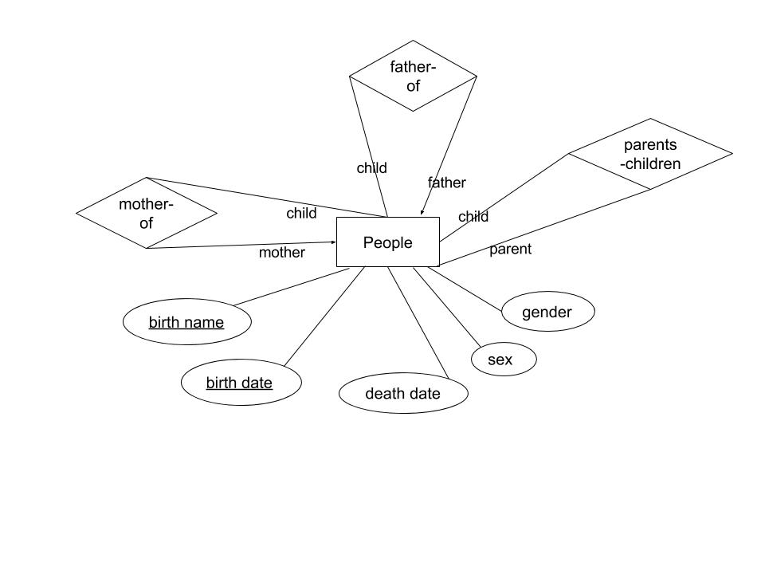

Note:

A person only has one mother and one father

A right-end arrow on the line “mother” from relation “mother-of” to entity “People”;

a lower-end arrow on the line “father” from relation “father-of” to entity “People”.

Birth name + birth date is the key.